Appendix 1: Construction of fire impact funnels
We first assign a direction to the axis of each fire impact funnel as South, North, East, West, Northeast, Northwest, Southeast, or Southwest (denoted as S, N, E, W, NE, NW, SE, SW). For example, if the funnel axis has an azimuth direction of 185 degrees, we will classify it as orientated from the “North” or “N”. Starting from the WUI end, we will add raster cells one-by-one into the impact funnel following a predefined sequence (figure A1.a). During the process of building a funnel, we iteratively call equations (A.1) and (A.2) to add raster cells (indexed as c) into the funnel by assigning either 0 or 1 value to a variable $x_{c}$ to track whether direct fire spread path without encountering any firelines can be found from cell c to the targeted WUI. If this path exists, we set $x_{c}=1$; otherwise, $x_{c}=0$. Cells not part of the funnel will have $x_{c}=null$. Since this algorithm is designed to use raster maps as inputs, all the input map layers such as firelines, WUI, roads, SDI, PCL need to be converted to raster maps first.

$x^{WUI}$=1 (A.1)

$$x_{c}=\left\{\begin{aligned}1, if \sum_{c^{'}}^{ }{x_{c^{'}}×(}{1-line}_{c^{'}}) ≥1 \\ 0, &otherwise\end{aligned}\right. ∀ c added to the funnel (A.2)$$

- Set $x_{c}=null$ for all cells within a quasi-ellipse shaped fire interaction zone as the initial state.
- Variable $x^{WUI}$ is set to 1 for the raster cell(s) representing the fire impact point(s) to the corresponding WUI block.
- An impact funnel will be formed by keeping adding new cells $c$ into the funnel. $c^{'}$ denotes cells directly adjacent to cell $c$ from the WUI end.
- Parameter ${line}_{c^{'}}$ denotes whether firelines exist in cell c’. Zero denotes no fireline in cell $c^{'}$; 1 denotes fireline existing in $c^{'}$.
For example, assuming we have a raster map with row index (denoted as row_ID) and column index (denoted as col_ID) for each cell; (row_ID=0, col_ID=0) represents the location of the top-left conner of the raster map; row_ID increases by moving downward and col_ID increases by moving rightward across the map. If we assume a fire was discovered from the north of a studied WUI (figure A1), for a cell at the location (row_ID, col_ID), three directly adjacent cells $c^{'}$ are from the WUI side of cell $c$ with its location indexed as (row_ID + 1, col_ID - 1), (row_ID + 1, col_ID) and (row_ID + 1, col_ID + 1). The sequence shown in figure A1.a guarantees that variable $x_{c}$ is assigned a value of either zero or one (equation A.2) only after $x_{c^{'}}$ for all its three directly adjacent cell $c'$ from the WUI side of the funnel have already been calculated. $x_{c^{'}}$is assigned a value of zero under two scenarios according to Equation A1 and A2: 1) $x_{c^{'}}$ of all the three adjacent cells $c'$ have been assigned a value of zero, or 2) fireline exists in all the three adjacent cell $c'$.
Using the example in figure A1, after a funnel is built, we can tally the value of $x_{c}$ for cells at the wider end of the funnel. Any cell c along the wider side of the funnel edge with $x_{c}=1$ is identified as a cell that can spread fire to the studied WUI following a combination of vertical and diagonal spread directions (figure A1). The number of cells along the edge with $x_{c}=1$ divided by the number of cells along the winder end of the funnel edge is called “leak ratio” (table 2). If firelines can separate a WUI and a fire perimeter in a funnel, the leak ratio of the funnel would be zero; in other cases, the leak ratio would be between zero and one.
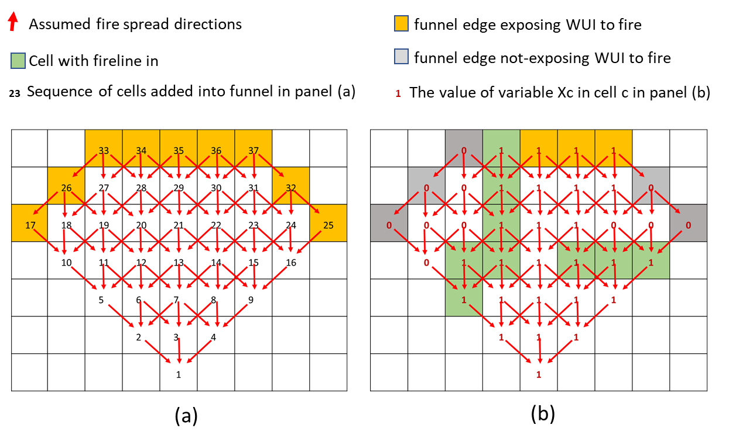
Figure A1. In this demo, we assume fire would spread towards a WUI from the north end of the funnel and a WUI is located at the south end of the funnel. (a) shows the sequence of cells being added into the funnel. A) also shows a case that fire from the wider end of the funnel edge can spread to the WUI without encountering any fireline. (b) shows a case with firelines built in the funnel and the calculation of “leak ratio” after considering the effect of fireline is about 4÷9 = ~0.44.

Appendix II:
Table A1: The weather station codes used for each fire through the Synoptic Data portal.
Fire Name | Weather Station IDs
Brianhead | BHCU1; BRHU1; COOPPAGU1; CTMU1; CVYU1; PGLU1; PNGU1; UCC19; UCC20; UTR20; YKEU1;
Carr | BDYC1; CLCC1; CQ098; CTBSN; HDLC1; LSHC1; MMOC1; OBRC1; RFSC1; SFKC1; SHDC1; SLFC1; TCAC1; TRWC1;
Crescent Mountain | COOPMZAW1; COOPSTEW1; MAZ22; RAIW1; RDHW1; STRW1; USGSHY657; USGSHY666; WAP55; WAP67;
Ferguson | C1522; CNFC1; CQ160; CQ168; D0826; EPWC1; GFTC1; JSDC1; MAGC1; MBBC1; MIAC1; WCFC1; WWNC1; YVVC1; YWAC1;
Gold Hill | BANM8; BIFM8; COOPLIBM8; COOPTRSM8; KS59; LBBM8; MTYAK; S599; TROM8; TS259; TT166; TT481; YKAM8; ZONM8;
Hirz | BNKC1; CTANT; CTVOL; GISC1; GRDC1; HRZC1; LSHC1; SLFC1; SMSC1; UP595; UP627; UP670;
Klondike | AGFO3; E4806; E7191; K3S8; ODT23;
Lolo Peak | COOPSTEM8; E0591; ITD28; LOLM8; LPSI1; MOMM8; MTM01; SMTM8; STVM8; TS934;
Meyers | BRLM8; CLVM8; COOPSLAM8; DALM8; DEEM8; GPRM8; ITD87; MTGTL; PHGM8; PTNM8; SKAM8; SUAM8; TEPM8; TT282;
Silver Creek | ARPC2; BUFC2; C9561; COLC2; COOPKMLC2; CSU61; GSPC2; KC07; LYNC2; PCPC2; RESC2; YCAC2;
West Valley | CAVU1; CDCU1; COOPNHRU1; FG016; GAPU1; LGFU1; LPRU1; TS716; UTBLK; UTTP3; VEYU1; WRRU1;

Appendix III
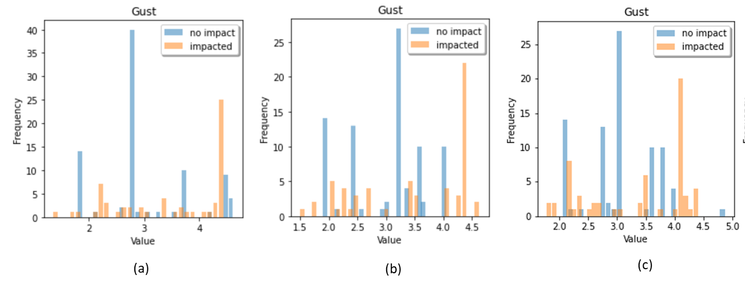
Figure A2. Histogram showing the distributions of average hourly wind gust speed within the (a) one-day, (b) two-day, or (c) three-day windows before a fire first impacted a WUI block (for impacted WUI) or before a fire was finally contained (for not-impacted WUI). Analysis suggests that using a two-day window provides the cleanest classification results based on the given samples.

Appendix IV: Additional descriptive statistics of the explanatory variables
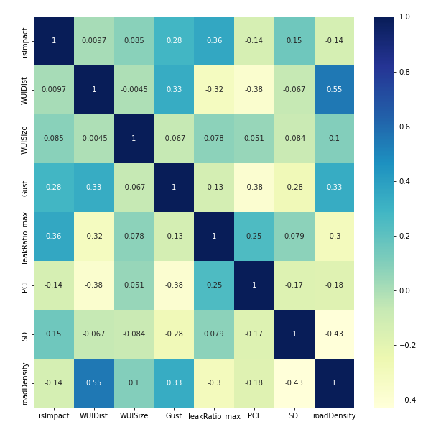
Figure A3. Correlation heat map between the explanatory variables and predicted variables.
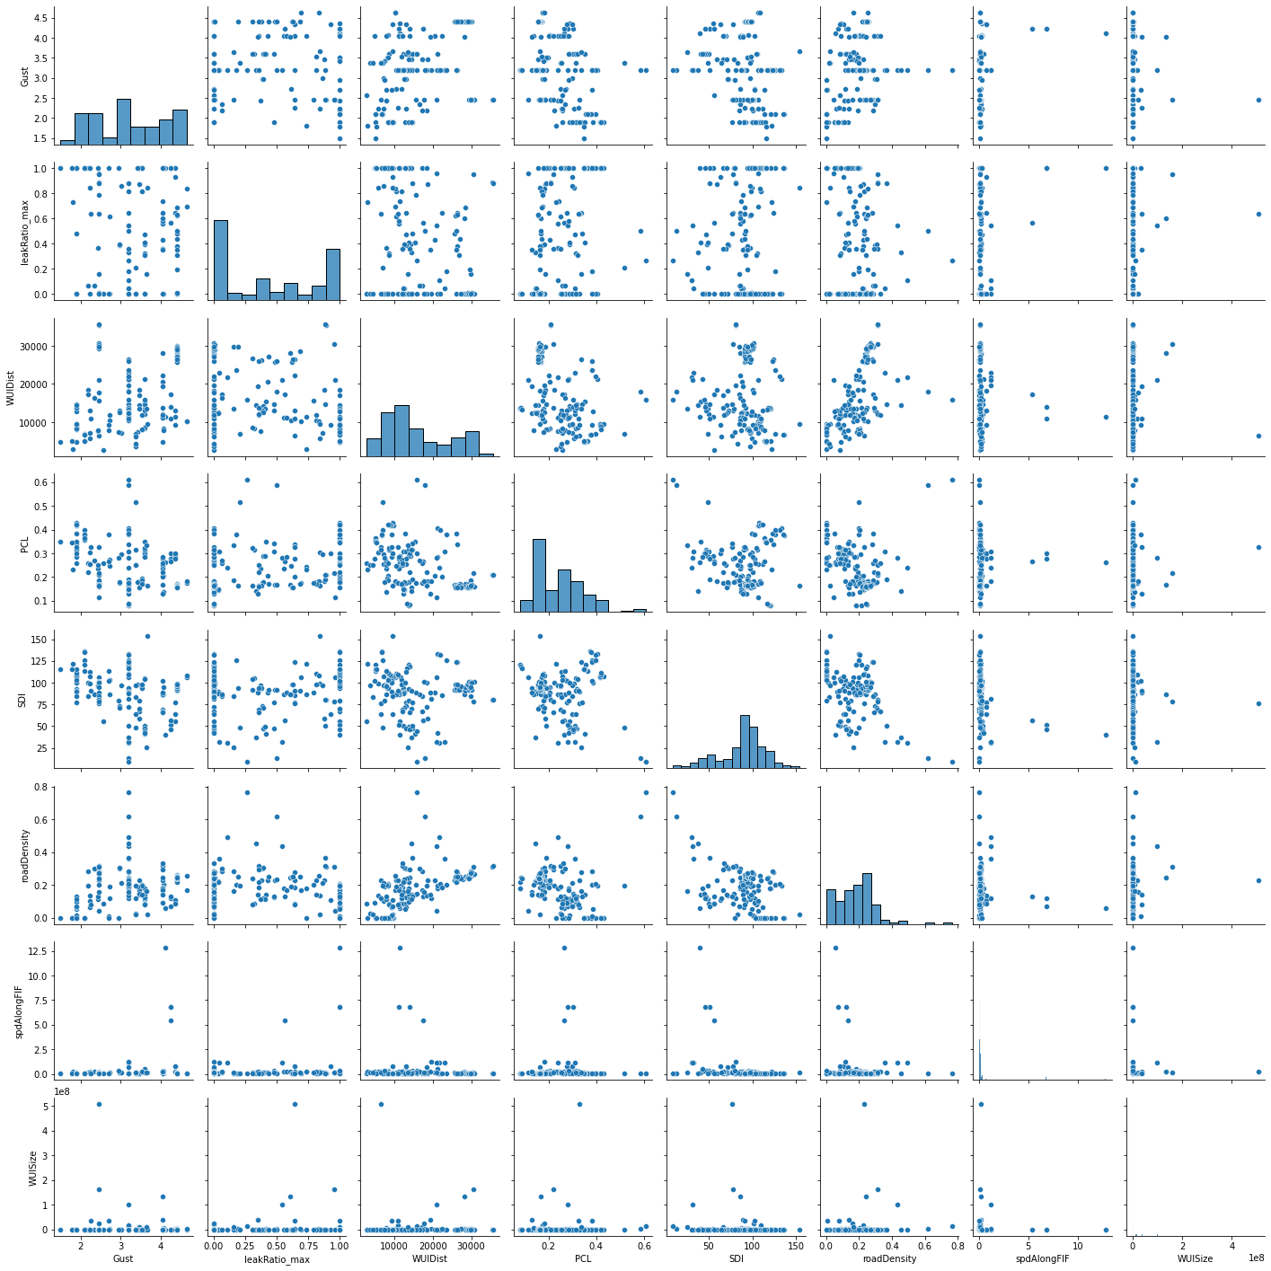
Figure A4. Scattered plots between pairs of explanatory variables selected in our analysis.

