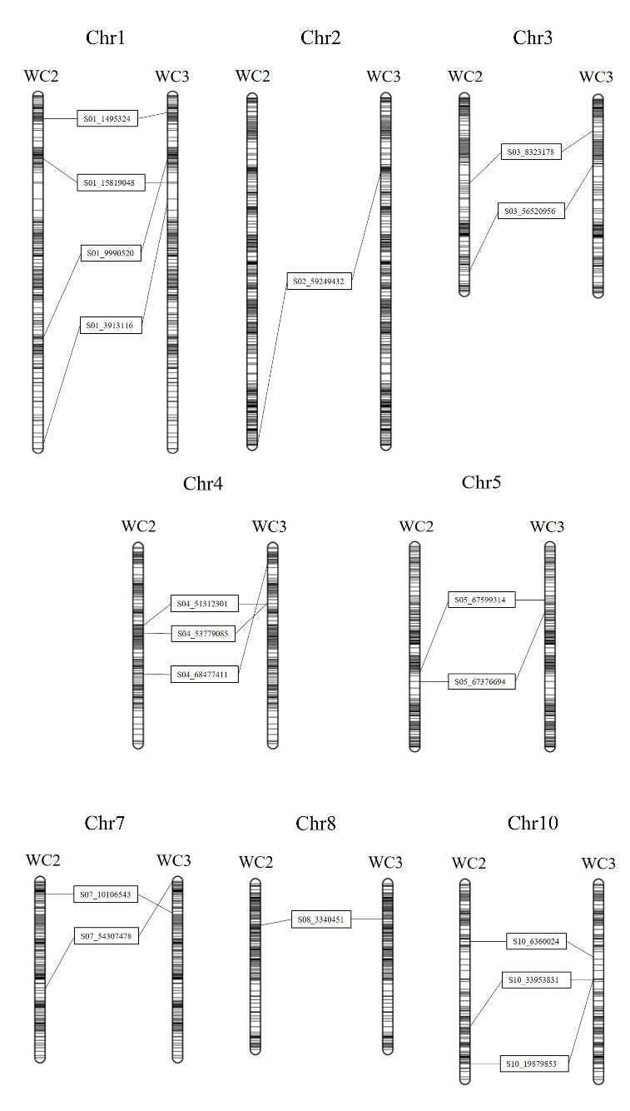
Supplementary Fig. S1. Alignment between the map from WC2 (sorghum Tx623A × sudangrass S722; this study) and WC3 (sorghum Tx623A × sudangrass Sa; Jin et al. 2021) based on 18 shared SNP markers.

