6. APPENDICES
6.1 Appendix 1
6.1.1 Assumptions
The radial displacement w and the tangential displacement v are two physical amounts to be calculated to solve the mathematical equations that describe the applanation. For symmetry reasons, the tangential displacement v is zero at the centerline (θ = 0). Several assumptions can be made about v:
1) the cornea moves freely along the applanation surface without being restrained by contact with the cone, while it is pushed in a radial direction towards the centre of curvature of the cornea;
2) that the cornea adheres to the cone as it is pushed so there is no horizontal displacement along the applanation surface of the cone;
3) an intermediate situation between the two previous ones.
In any case, it seems that the corneal displacement in a tangential direction can be considered negligible along the applanated area. In fact, this area is so small that the difference between the applanated corneal arch and the underlying chord is approximately 0.6% of the length of the arch and less than 0.8% of the diameter of the applanated area.
We can simplify assuming that v = 0, which is equivalent to considering that, during the GAT, corneal deformation is obtained by moving each portion of the applanated surface of the cornea only towards the center of curvature of the cornea.

6.1.2 Estimation of the tangential displacement during applanation
The tangential displacement of the cornea with respect to the cone during applanation can be calculated by assuming that the cornea adheres to the cone so that each portion moves only perpendicular to the applanating surface of the cone.
The displacement v in the tangential direction is given by the product of the vertical displacement z with the ratio between the radial distance r and the corneal radius of curvature a:
$$v=z∙\frac{r}{a}=\left(\sqrt{a^{2}-r^{2}}-\sqrt{a^{2}-g^{2}}\right)∙\frac{r}{a}$$
The radial displacement w is equal to
$$w=z∙\frac{\sqrt{a^{2}-r^{2}}}{a}$$
It can be inferred that the ratio between the displacement w in the radial direction and the displacement v in the tangential direction is approximately equal to the factor a/r, which is equal to 4.67 when
r = g
and tends to infinity in correspondence with the apex (r = 0). Consequently, the displacement in the tangential direction v is much smaller than the displacement in the radial direction w and can be neglected.

6.2 Appendix 2
6.2.1 Calculation of the elastic reaction of the cornea
The formulas describing the elastic deformation of the cornea may be solved in a simple way by assuming that each portion of corneal tissue moves in a radial direction towards the center of curvature of the corneal apex during applanation.
$$\frac{w}{a}=1-\sqrt{\frac{a^{2}-g_{}^{2}}{a^{2}-r^{2}}}$$
In the hypothesis that the tangential displacement v is negligible,
$$N_{r}=N_{θ}=-\frac{E∙h}{1-ν}∙\frac{w}{a}$$
$$M_{r}=-D∙\frac{d^{2}w}{dr^{2}}$$
$$M_{θ}=-D∙\frac{1}{r}∙\frac{dw}{dr}$$
$$D=\frac{E∙h^{2}}{12∙\left(1-ν^{2}\right)}$$
$$\frac{d^{2}\left(r∙M_{r}\right)}{dr^{2}}-\frac{dM_{θ}}{dr}-\frac{d\left(r∙Q_{r}\right)}{dr}=0$$
$$\frac{d^{2}\left(r∙M_{r}\right)}{dr^{2}}-\frac{dM_{θ}}{dr}+\frac{r}{a}∙\left(-\frac{2E∙h}{1-ν}∙\frac{w}{a}\right)=-r∙p$$
$$\int_{0}^{+g}{2π\frac{d^{2}\left(r∙M_{r}\right)}{dr^{2}}∙dr}-\int_{0}^{+g}{2π\frac{dM_{θ}}{dr}∙dr}+\int_{0}^{+g}{2π\frac{r}{a}∙\left(-\frac{2E∙h}{1-ν}∙\frac{w}{a}\right)∙dr}=-\int_{0}^{+g}{2πr∙p∙dr=F2}$$
$$\int_{0}^{+g}{2π\frac{r}{a}∙\left(-\frac{2E∙h}{1-ν}∙\frac{w}{a}\right)∙dr}≅-\int_{0}^{+g}{2πr∙p∙dr}$$
$$-\frac{2E∙h}{1-ν}∙\frac{1}{a}\left[πg^{2}+2π\left(a^{2}-g_{}^{2}\right)-2πa\sqrt{a^{2}-g_{}^{2}}\right]≅-\int_{0}^{+g}{2πr∙p∙dr}$$
$$-\frac{2E∙h}{1-ν}∙\frac{1}{a}\left[πg^{2}+2π\left(a^{2}-g_{}^{2}\right)-2πa^{2}\left(1-\frac{1}{2}∙\frac{g^{2}}{a^{2}}+\frac{1}{8}∙\frac{g^{4}}{a^{4}}\right)\right]≅-\int_{0}^{+g}{2πr∙p∙dr}$$
$$-\frac{E∙h}{1-ν}∙\frac{π}{2}∙\frac{g^{4}}{a^{3}}≅-\int_{0}^{+g}{2πr∙p∙dr}=F2$$
The minus sign is because the force F2 is opposite to the pressure that applanates the cornea.
Considering that the Poisson's ratio for a soaked cornea is practically equal to 0.5, the value of the overall elastic reaction force exerted by the applanated cornea against the tonometer cone can be estimated as follows:
$$\frac{E∙h∙g^{4}}{a^{3}}∙π≅F2$$
The average elastic reaction pressure exerted by the applanated cornea against the applanating surface can be estimated as follows:
$$\frac{F2}{π∙g^{2}}≅\frac{E∙h∙g^{2}}{a^{3}}$$

6.3 Appendix 3
6.3.1 The tear meniscus
To calculate the radius AD of the tear meniscus to estimate the force of attraction exerted on the cone due to the tear film, a reference is made to figure 18.

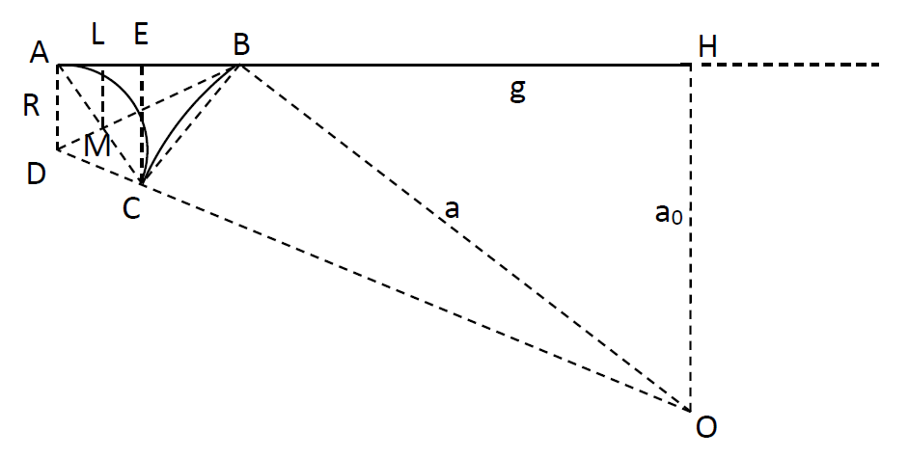
Figure 18

The radius R of the meniscus of the tear film will be calculated assuming that the volume of tear film displaced during applanation is equal to the volume of the solid of revolution described by rotating the curvilinear triangle ABC around the (cylindrical) axis of symmetry OH of the applanated surface. The displaced tear film volume accumulates all around the perimeter of the applanated surface, between the non-applanated corneal surface and the surface of the tonometer cone not in contact with the cornea.
The volume of the solid of revolution is given, according to the second Guldinus theorem, by the product of the area of the curvilinear triangle ABC by the circumference described by the center of gravity of the curvilinear triangle rotating around the axis OH.
The area of the curvilinear triangle ABC and the position of its center of gravity are obtained by difference by calculating the area of the straight triangle ABC and the position of its center of gravity, the area of the circular sector AC and the position of its center of gravity, the area of the circular sector BC and the position of its center of gravity.

6.3.2 Area of the straight triangle ABC
BOH = arcsin(g/a);
BOC+BOH = arccos((HO-AD)/DO) = arccos((a*cos(BOH)-R)/(R+a));
From the above equation, it can be shown that the angle BOC is very small because the radius of the meniscus R is much smaller than the radius of curvature a of the cornea:
cos(BOH)-cos(BOC+BOH) = R/(R+a) + R/(R+a)*cos(BOH) <= 2*R/(R+a)<<1;
For sum and difference formulas for cosine,
cos(BOH)-cos(BOC+BOH) = cos(BOH)-cos(BOH)cos(BOC)+sin(BOH)sin(BOC) ≅ BOC* sin(BOH);
and thus
BOC ≅ R/(R+a)*(1+cos(BOH))/sin(BOH) ≅ R/a*(1+cos(BOH))/sin(BOH);
AB = DO*sin(COH)-BH = (R+a)*sin(BOC+BOH)-g ≅ (R+a)*(BOC*cos(BOH)+sin(BOH))-g;
CE = HO-CO*cos(COH) = a*cos(BOH)-a*cos(BOC+BOH) ≅ a*(BOC*sin(BOH));
AreaABC = AB*CE/2.

6.3.3 Volume of the solid of revolution with straight triangle section
The center of gravity of the straight triangle ABC lies on segment BD and is distant from vertex B for a distance equal to 2/3 of the distance BM and therefore orthogonally projected on AH at 2/3 of the distance BL.
ADM = 1/2*ADC = 1/2*(π-COH) = 1/2*(π-BOH-BOC);
DL = R*cos(ADM) = R*sin(COH/2) = R*sin((BOH+BOC)/2);
BL = BD-DL;
The distance between the center of gravity of the linear triangle ABC and the OH axis is equal to the sum between BH and 2/3 of BL, that is:
BH+2/3*BL = g+2/3*BL;
According to the second Guldinus theorem, the volume of the solid of revolution described by the linear triangle ABC when it rotates around the OH axis is given by:
AreaABC*2π*(g+2/3*BL)≅ 1/2*a*(R*(1+cos(BOH))*sin(BOH))*2π*(g+2/3*BL).

6.3.4 Area of the circular sector AC
AreaAC = R²*ADM-R²*sin(2*ADM)/2.

6.3.5 Volume of the solid of revolution with circular sector section
ABD = 1/2*π-ADM = 1/2*(BOH+BOC);
The center of gravity of the circular sector AC is from vertex D for a length equal to:
2r*sin³(ADM)/(3(ADM-sin(ADM)*cos(ADM)));
Therefore, it is spaced from the axis OH by a distance DIST given by:
DIST = AH-cos(ABD)*2R*sin³(ADM)/(3(ADM-sin(ADM)*cos(ADM))) = (R+a)*sin(COH)-cos(ABM)*2R*sin³(ADM)/(3(ADM-sin(ADM)*cos(ADM)));
According to the second Guldinus theorem, the volume of the solid of revolution described by the circular sector AC when it rotates around the OH axis is given by:
AreaAC*2π*DIST ≅ (R²*ADM-R²*sin(2*ADM)/2)*2π*((R+a)*sin(COH)-cos(ABD)*2R* sin³(ADM)/(3(ADM-sin(ADM)*cos(ADM)))).

6.3.6 Volume of the solid of revolution with a curvilinear triangle section
The volume of the solid of revolution with a curvilinear triangle section ABC is the volume of the tear meniscus around the applanated surface and is substantially equal to the volume of tear film displaced during the applanation tonometry. It is given by the difference between the two volumes previously calculated:
Volume of the solid of revolution ≅ 1/2*a*(R*(1+cos(BOH))*sin(BOH))*2π*(g+2/3*BL)-((R²*ADM-R²*sin(2*ADM)/2)*2π*((R+a)*sin(COH)-cos(ABD)*2R*sin³(ADM)/(3(ADM-sin(ADM)*cos(ADM))))).

6.3.7 Volume of the displaced tear film
The applanated corneal surface is practically a spherical shell; thus, the volume of the displaced tear film is estimated as the volume of a spherical shell cap, whose base plane is identified by the applanated corneal surface and whose thickness is equal to the thickness t of the tear film immediately before applanation. The volume of a spherical shell cap of thickness t corresponding to the volume of the displaced tear film is:
Displaced volume = 2πa*a*(1-cos(BOH))*t.

6.3.8 Radius of curvature R
The radius of curvature R is implicitly defined by the equation obtained by equating the volume of the meniscus and the volume of the displaced tear film:
1/2*a*(R*(1+cos(BOH))*sin(BOH))*2π*(g+2/3*BL)-((R²*ADM-R²*sin(2*ADM)/2)*2π* ((R+a)*sin(COH)-cos(ABD)*2R*sin³(ADB)/(3(ADB-sin(ADB)*cos(ADB))))) = 2πa*a(1-cos(BOH))*t;

