Supplementary Materials for

TRIM22 suppresses zika virus replication by targeting NS1 and NS3 for proteasomal degradation
Shulong Zu^{1,2,3,4}, Chunfeng Li⁵, Lili Li^{2,3}, Yong-Qiang Deng⁴, Xiang Chen⁴, Dan Luo⁴, Qing Ye⁴, Yi-Jiao Huang⁴, Xiao-Feng Li⁴, Rong-Rong Zhang⁴, Nina Sun^{1,2,3}, Xianqi Zhang¹, Saba R. Aliyari⁶, Karin Nielsen-Saines⁷, Jae U Jung⁸, Heng Yang^{2,3*}, Cheng-Feng Qin^{4*}, Genhong Cheng^{6*}
¹Center for Systems Medicine, Institute of Basic Medical Sciences, Chinese Academy of Medical Sciences and Peking Union Medical College, Beijing 100005, China
² Institute of Systems Medicine, Chinese Academy of Medical Sciences and Peking Union Medical College, Beijing 100005, China.
³Suzhou Institute of Systems Medicine, Suzhou, Jiangsu 215123, China.
⁴State Key Laboratory of Pathogen and Biosecurity, Beijing Institute of Microbiology and Epidemiology, Academy of Military Medical Sciences, Beijing 100071, China.
⁵Institute for Immunity, Transplantation and Infection, Department of Pathology, Department of Microbiology and Immunology, Stanford University, Stanford, CA 94305, USA.
⁶Department of Microbiology, Immunology and Molecular Genetics, University of California, Los Angeles, CA 90095, USA.
⁷Division of Pediatric Infectious Diseases, David Geffen School of Medicine, University of California, Los Angeles, Los Angeles, CA 90095, USA.
⁸Department of Cancer Biology and Global Center for Pathogens Research and Human Health, Lerner Research Institute, Cleveland Clinic, Cleveland, OH 44195, USA.
G.C., C-.F.Q. H.Y. and are senior co-authors of this paper.
*Corresponding author. Email: gcheng@mednet.ucla.edu (G.C.); qincf@bmi.ac.cn (C-.F.Q.); yhmyt@hotmail.com (H.Y.)
Supplementary figures
Figure S1. ISGs are induced by ZIKV infection in A549 cells. a-c qRT-PCR analysis of MX1, IDO1 and RSAD2 mRNA in A549 cells stimulated with increasing dose of ZIKV (FSS13025) infection.

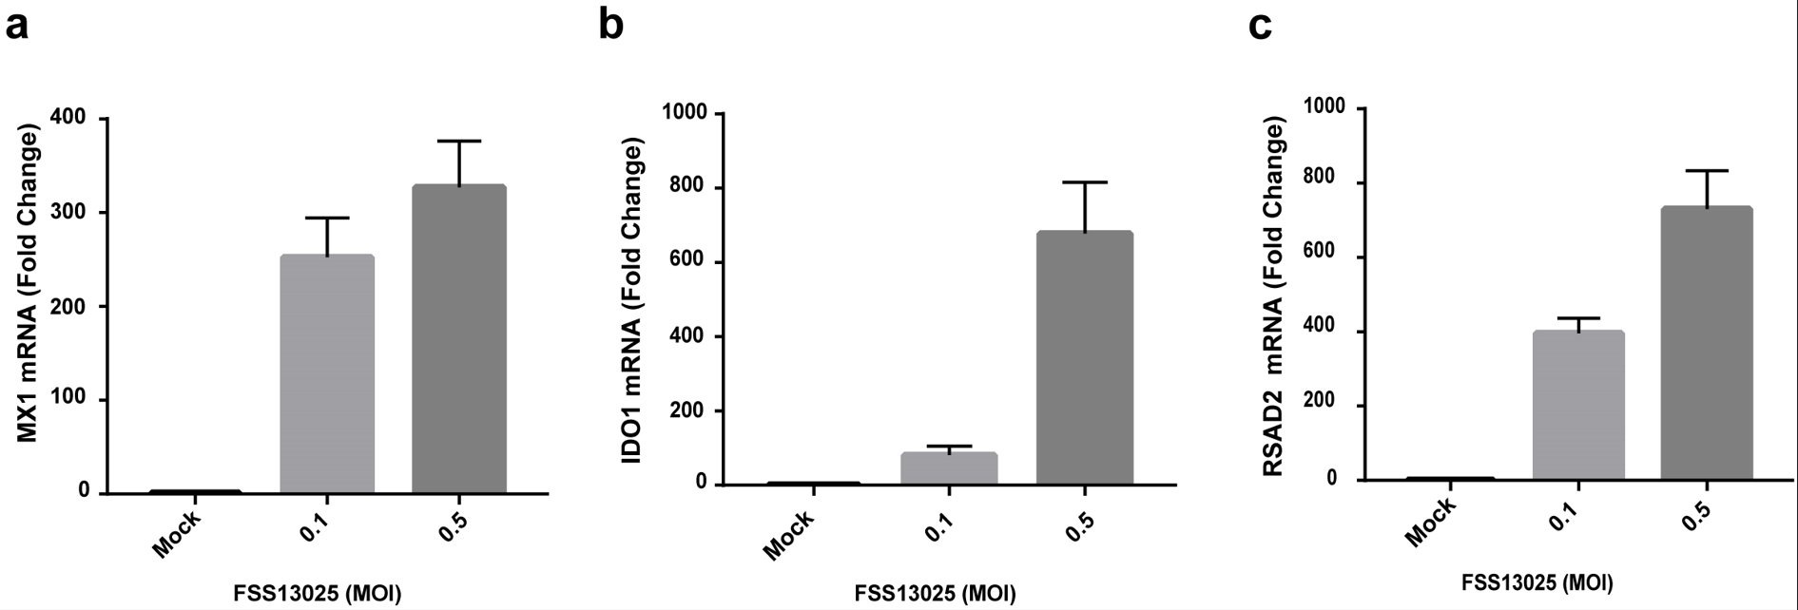

Figure S2. TRIM22 inhibits ZIKV infection in vitro. Vero cells in 24-well plate were transfected with increasing amount of pM01-TRIM22 plasmid, 12 hours later, the cells were infected with ZIKV GZ01 at MOI=0.01, IFA of ZIKV E protein was conducted at 24 hours post-infection. Scale bar, 100 μm.

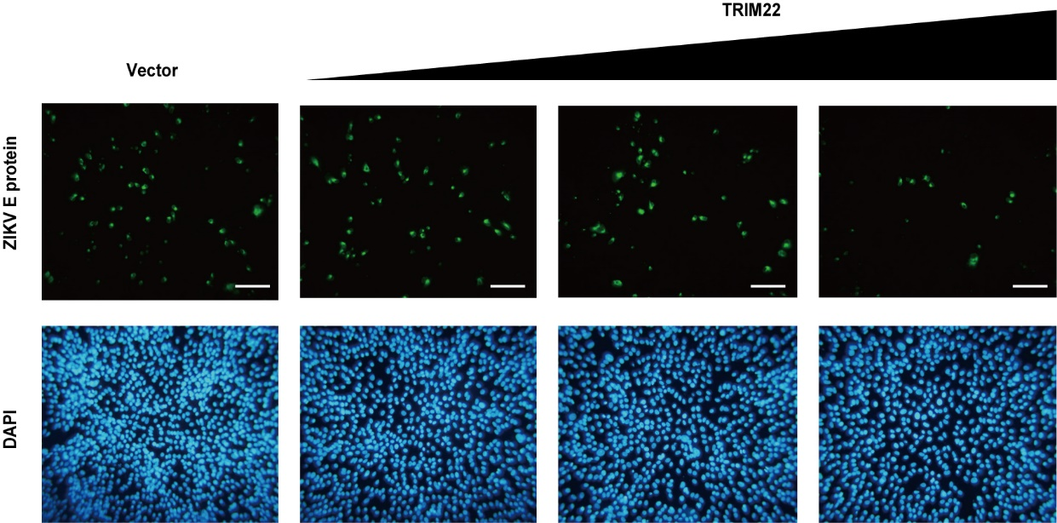

Figure S3. Model of BiLC system and IFA used to test the interactions between TRIM22 and ZIKV proteins. a Work model of GlucN-TRIM22 and GlucC-ZIKV NS1 or NS3 in BiLC system. b IFA of A549 cells that were co-transfected with pHA-TRIM22 and pHis-NS1 or pHis-NS3 plasmids, stained with HA and His tag antibody, then imaged by fluorescence microscope. Scale bar, 10 μm.
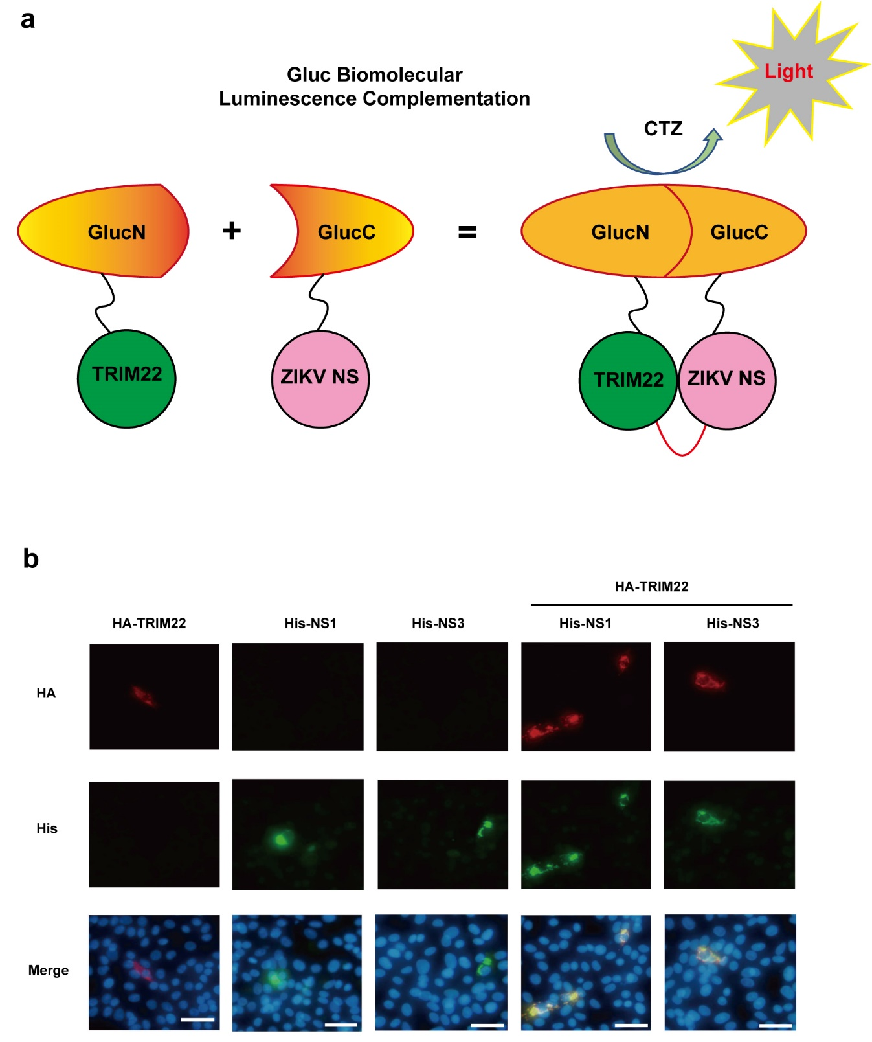

Figure S4. TRIM22 inhibits YFV infection in vitro. a TRIM22 was over expressed in A549 cells, the cells were subsequently infected with YFV at MOI=0.01, 12 hours post transfection, YFV load in culture supernatant was measured by qRT-PCR. b TRIM22^{-/-}A549 cells were infected with YFV, the cell lysates were measured by qRT-PCR. qRT-PCR data are means ± SEM from three independent experiments. **P < 0.05, **P < 0.01 and ***P < 0.001 by Student’s t test.
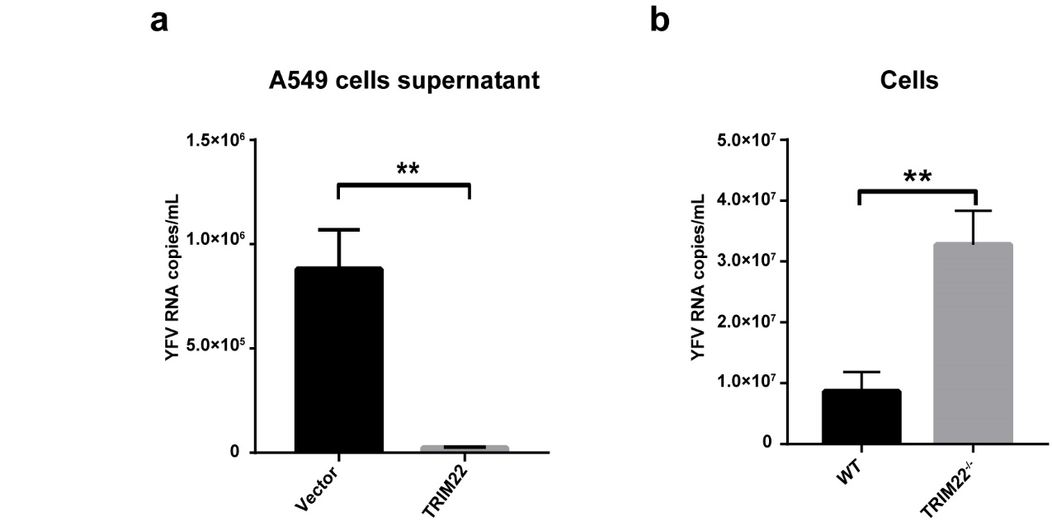

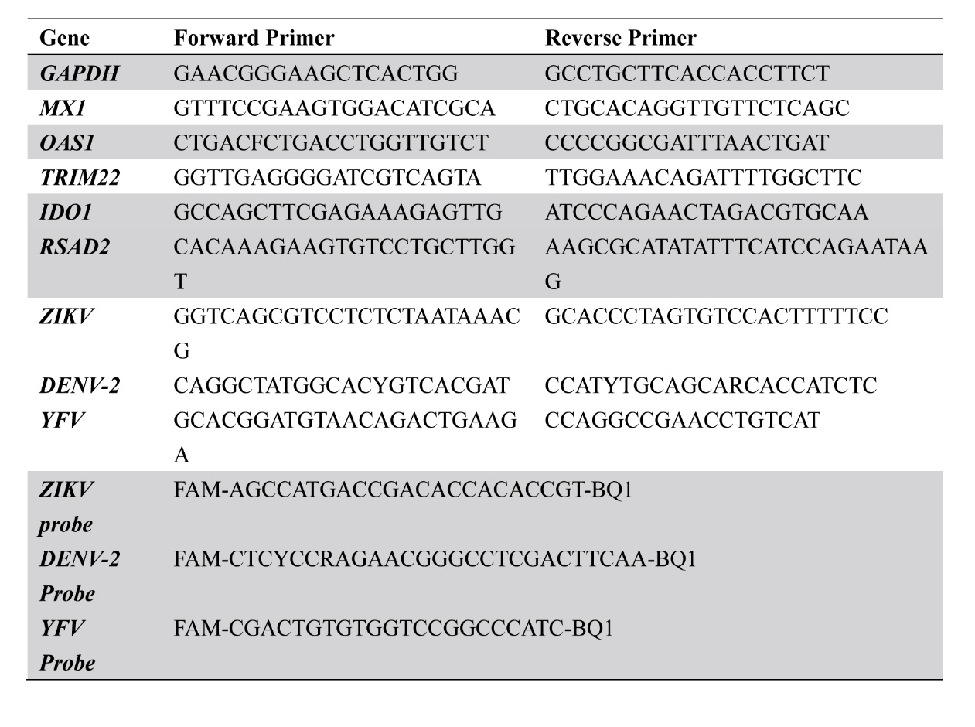
Table S1. The list of ISG, ZIKV, DENV and YFV primers used in this study

