Supporting Information
Average Development Time (Appendix S1), Average Degree-day Accumulation (Appendix S2), Pupal Mass (Appendix S3), and Adult Mass (Appendix S4) are available online. The authors are solely responsible for the content and functionality of these materials. Queries (other than absence of the material) should be directed to the corresponding author.

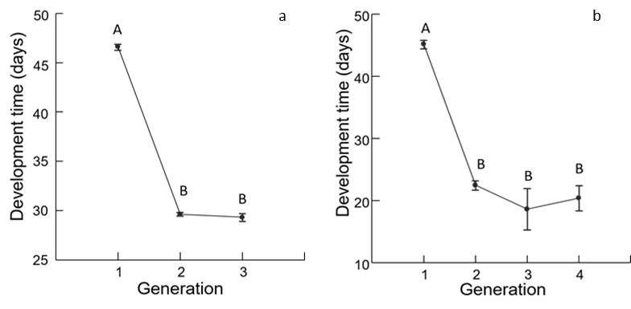
Appendix S1 Average development time (days as larvae and pupae) by flight (Year 1: 1a, p < 0.0001, F = 724.282, R² = 0.86, df = 3, n = 704; Year 2: 1b, p < 0.0001, F = 4148.879, R² = 0.77, df = 2, n = 1,311). Error bars represent ANOVA (p <0.05). For all treatments with the same uppercase letter, the difference between the means is not statistically significant. Treatments with different uppercase letters are significantly different

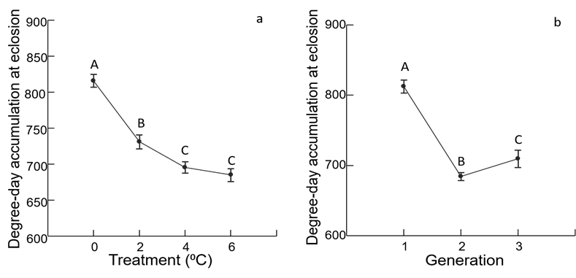
Appendix S2 Average degree-day accumulation at eclosion by treatment (a, ANOVA p < 0.0001, F = 169.597, R² = 0.28, df = 3, n = 1300) and generation (b, ANOVA p < 0.0001, F = 274.153, R² = 0.30, df =3, n =1300) for Year 1 individuals (3 generations only). Error bars and uppercase letters follow Appendix S1

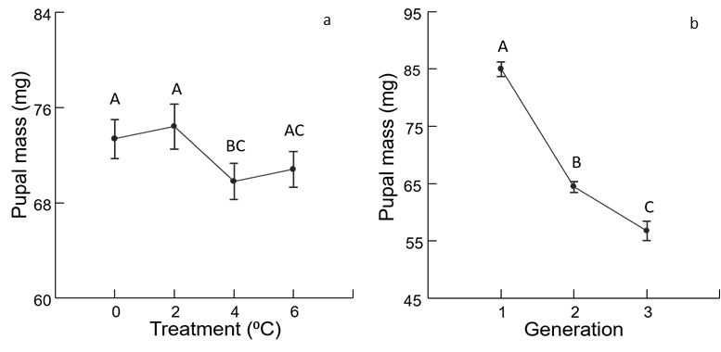
Appendix S3 Pupal mass (mg) by treatment (a) (ANOVA p = 0.045, F-ratio = 4.38, R² = 0.01, df = 3, n = 1157) and flight (b) (ANOVA p < 0.0001, F-ratio = 436.9, R² = 0.45, df = 2, n = 1157) for Year 1 individuals. Error bars and uppercase letters follow Appendix S1

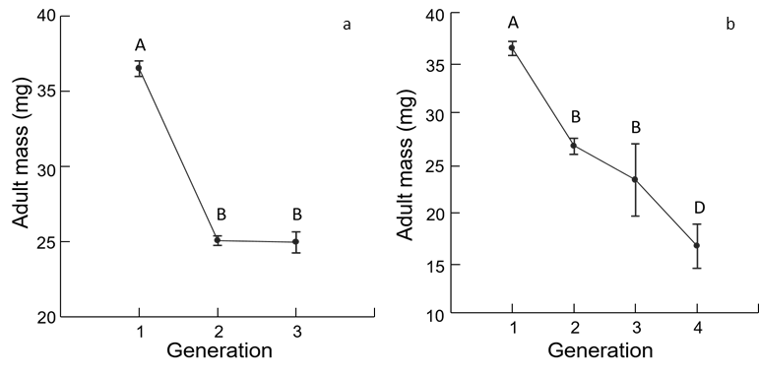

Appendix S4 Adult mass (mg) by generation (a) (ANOVA, p < 0.0001, F= 703.92, R² = 0.52, df = 2, n = 1,307) for Year 1. Adult mass (mg) by generation (b) (ANOVA p < 0.0001, F= 10.136, R² = 0.41, df = 3, n = 768) for Year 2. Error bars and uppercase letters follow Appendix S1

