Appendix
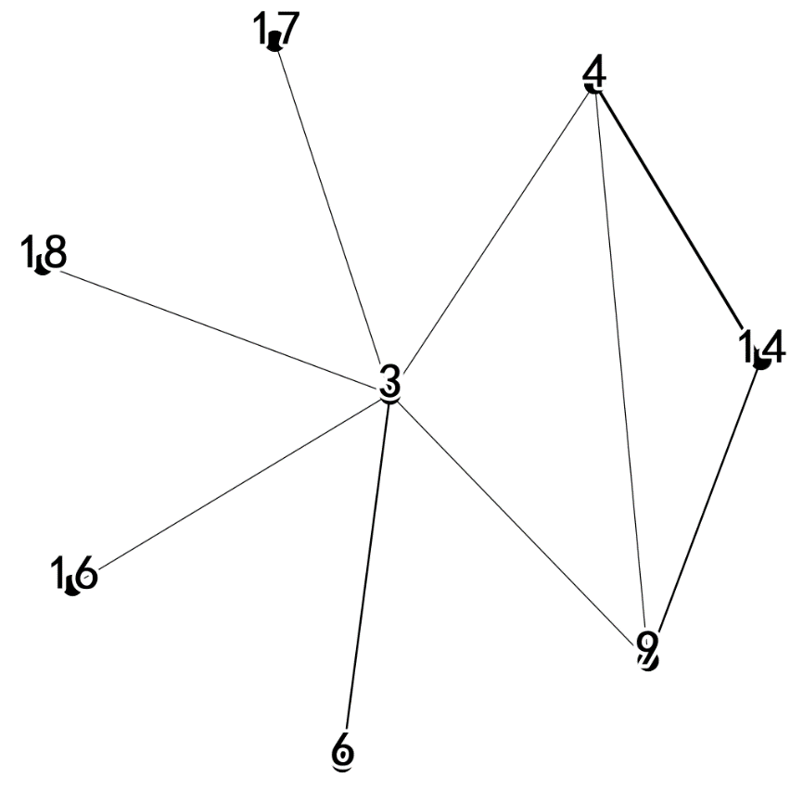
Figure 1 Cooperation network of the main subjects in the promulgation of energy saving and emission reduction policies, 2013-2015
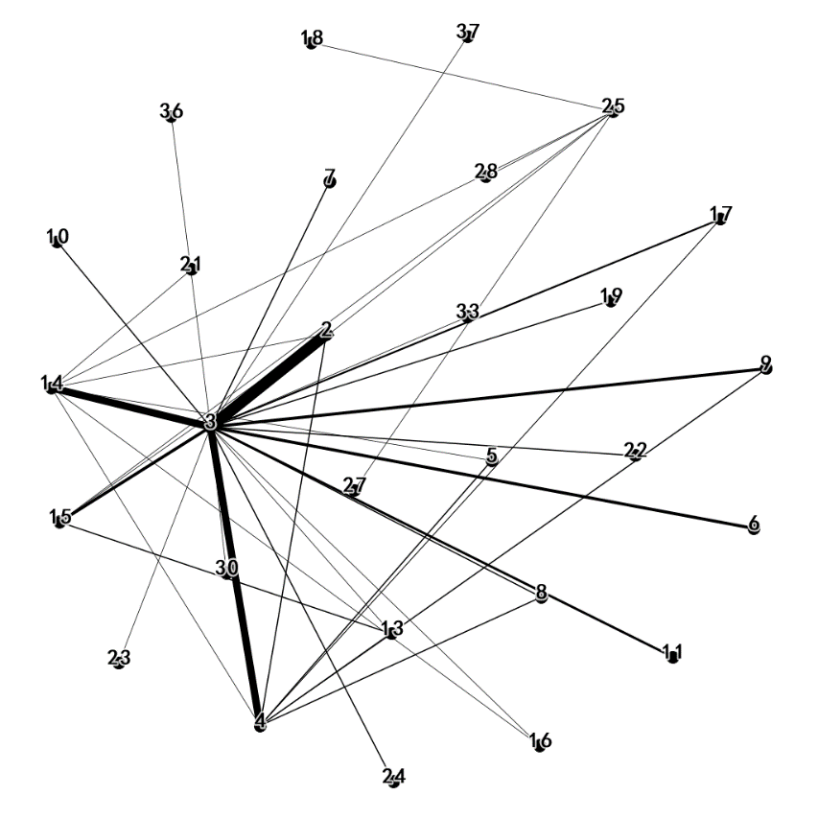
Figure 2 Cooperation network of the main subjects in the promulgation of energy saving and emission reduction policies, 2016-2018

