Urban Disease Emergence (URBAN-ZOO) Project
Protocol for selecting the “99 household” neighbourhoods

Document information:
Protocol operational: no
Version: 1.1
Created: 24 October 2013
Last saved: 1 May 2015
Primary author: Timothy Robinson

Secondary authors: Sohel Ahmed, Jusper Kiplimo, James Akoko,
Melissa Ward, Eric Fèvre, Mark Woolhouse

Total number of pages: x



Background

A significant component of the Urban Zoo project is the sampling of households across socio-economic strata of Nairobi. A process is required to select neighbourhoods within the city of Nairobi in which households can be identified for participation in the study. These households will form the basis for the microbiological sampling of city residents, their food, their animals and their wider environment, and will be the end points of the value chain studies conducted in economics thread. In addition, the neighbourhoods selected will form the basis for the socio-economic data collection at the neighbourhood level. It is therefore essential to have solid criteria for selection of these neighbourhoods. It is noted that selection of neighbourhoods will be purposeful, in order to capture diversity in socioeconomic status; within the selected neighbourhoods, the selection of sub-locations is also purposeful but within each of the 33 selected sub-locations a random procedure will be used to identify three specific households: one with no livestock and the other two representing a diversity of livestock keeping.

It is important to stress at the outset that the primary objectives of the 99 household survey are:

- To map E. coli diversity across Nairobi city, and
- To explore the links between microbial diversity and urban livestock.

While we have flexibility in our approach, it is useful to come back to earlier suggestions for how to proceed. In the original ESEI submission, we stated that:

“…within the city of Nairobi, we will study a diversity of neighbourhoods and social groups, stratified by poverty status. Poverty status is a function of ability to pay to sustain a basic nutritional requirement and to pay for basic non-food needs (Ndeng’e et al., 2003). Using this indicator, which is expressed in terms of the percentage of the population below the urban poverty line, Nairobi can be divided into 9 strata, and we will carry out a cross-sectional sample of 11 households in each stratum (giving a total of 99 sample sites; see “Justification of the Budget” for further details). At each site, detailed investigations involving parallel lines of enquiry which we call threads (six in all: economic; public health and demography; environmental, livestock and peri-domestic wildlife; microbiology and microbial genetics; livestock demography; planning and social) will take place. [This description was based on the use of the city wide poverty map for Nairobi; however, that poverty data layer is of insufficient spatial resolution to be helpful in site selection].

and

“Sampling of humans for all 99 sample sites – Ninety nine sample sites will be distributed throughout the city, 11 per poverty incidence zone. In each, participants of all ages will be recruited and interviewed at home. Interview and other metadata will be captured electronically using PDA units and netbooks. For each participant we will record: location, details of age, sex, ethnic origin, travel history, residential history, fertility (for women), educational qualifications and occupation. We will undertake a clinical examination and measure weight, height (World Health Organization, 1995), Mid-Upper Arm Circumference (James et al., 1994), haemoglobin level, temperature, as well as a recent history of a range of symptoms (e.g. headache, splenomegaly, membrane palour, weight loss, diarrhoea, vomiting, chest pain, tiredness, known disease episodes, etc.). For each participant, we will also collect comprehensive information on household economic data for a wealth ranking (Morris et al., 2000), food consumption habits, food sources, livestock keeping (in the city or in rural homes), animal contact, hygiene habits, water sources, water treatment etc. At each sampling location, we will undertake an environmental and small animal ecology sampling (see below), as well as undertake the participatory data collection activities (see planning and social thread). Statistical associations between outcomes (clinical and microbiological variables) and predictors (social, environmental and ecological variables) will be investigated using generalised linear mixed models (Dohoo et al., 2003).

Choosing a basic data layer

We have explored many options for data layers that can be helpful in this exercise. We would have liked to use fine scale data from the 2009 National Census, but only course resolution data are actually available (https://opendata.go.ke/) from that exercise. Essentially, we need an indicator of socio-economic diversity. In 2012, we identified a project that had been operational in Nairobi focussing on water availability and distribution, funded by UN-HABITAT and the Global Water Operators’ Partnerships Alliance (GWOPA), and implemented by the Institut Français de Recherche en Afrique (IFRA). The technical report (Ledant, 2011) and other documents from this project are available online (http://access-to-water-in-nairobi.gwopa.org/). Tim Robinson and Eric Fèvre participated in the official launch of the report in Nairobi in October 2013, and Urban Zoo has been granted access to the raw data layers produced. It appears that this is the best available socio-economic dataset for Nairobi, which specifically supplies a disaggregated dataset at the same neighbourhood scale of interest to Urban Zoo. An early proposal was to cross-tabulate socio-economic date with livestock keeping data at as fine a scale as possible. Unfortunately the livestock data are at a much coarser spatial resolution so it has not been possible to be as rigorous as proposed although the livestock data have been taken into consideration when purposefully selecting neighbourhoods and sub-locations.

The UN-HABITIAT/GWOPA/IFRA data

The methods followed for the project are based on the assumption that “neighbourhoods sharing similar residential physical patterns also share similar socio-economical characteristics and Water and Sanitation Services access” (Ledant 2011). The project used 18 pansharpened very high resolution (60cm) Quickbird images that cover the whole 696 km² of Nairobi Municipality. These were use to identify different structures within Nairobi’s built environment, and ultimately to identify 17 dominant residential land-use types based on distinct characteristics (e.g. % of tree covers and roof types) as reported below. The neighbourhood types found were validated using IFRA-UN Habitat’s local knowledge and other information such as Nairobi GIS land-use maps produced by Columbia University and University of Nairobi, and Google Map Maker data. To validate the mapping exercise and assess whether physical residential patterns were associated with socio-economic and infrastructural characteristics, the project ran 817 targeted socio-economic questionnaires across the 17 neighbourhood types, targeted primarily at the large contiguous neighbourhoods. The number of households sampled was proportional to population density data at neighbourhood scale, densimetrically redistributed from the Census 2009 sub-location data. Table 1 lists and describes the 17 neighbourhood types.

Table 1. The 17 neighbourhood types identified in the UN-HABITIAT/GWOPA/IFRA study (Source: Ledant 2011)

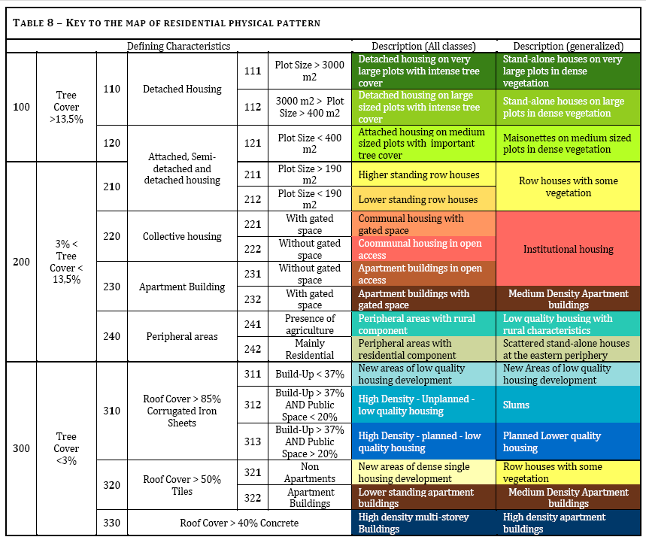

Based on these data a series of maps has been produced by the Urban Zoo project. These maps show built up areas (Figure 1), neighbourhood types (Figures 2 and 6a), and income level (Figures 3, 4, 5 and 6b).

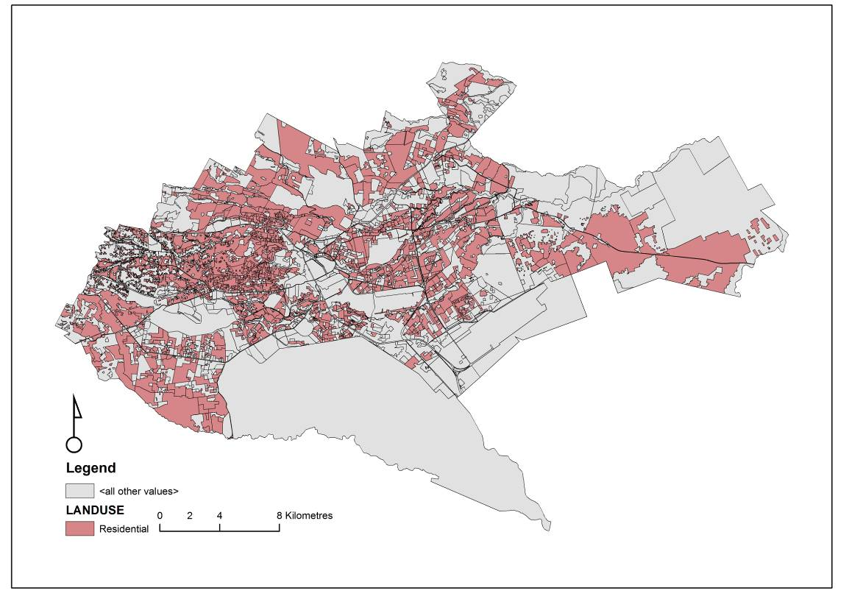

Figure 1. Residential areas of Nairobi, as distinct from industrial, business and others.

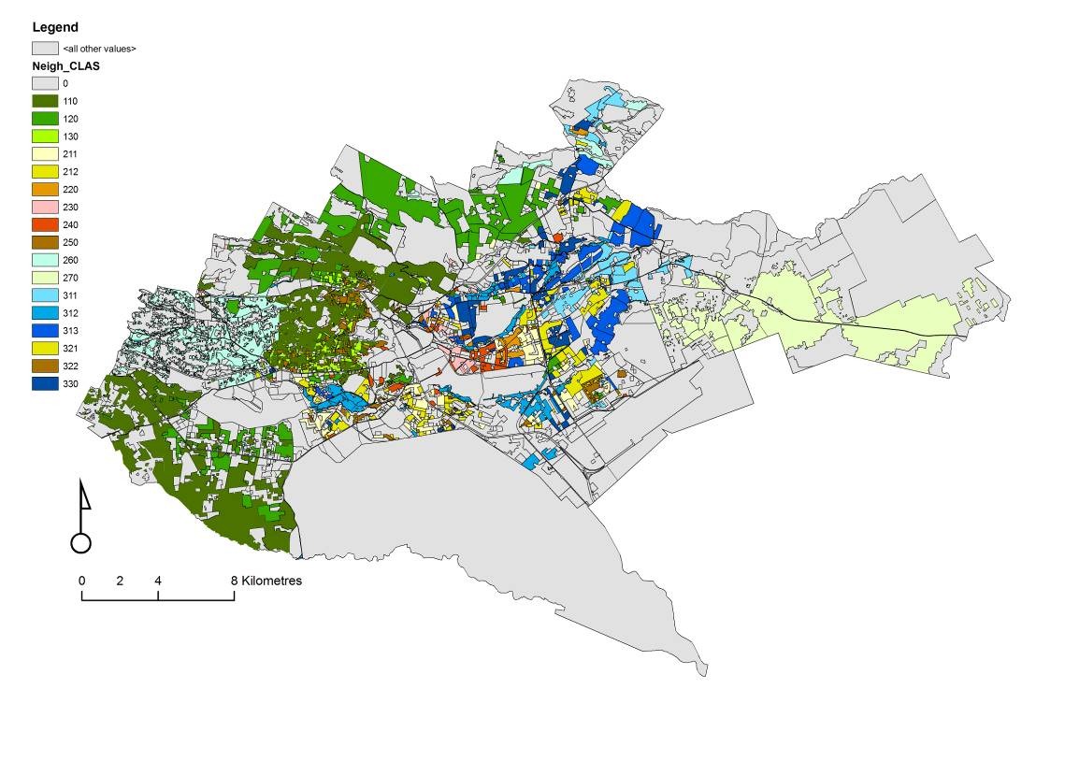
Figure 2. Spatial distribution of 17 neighbourhood types (as per Table 1).

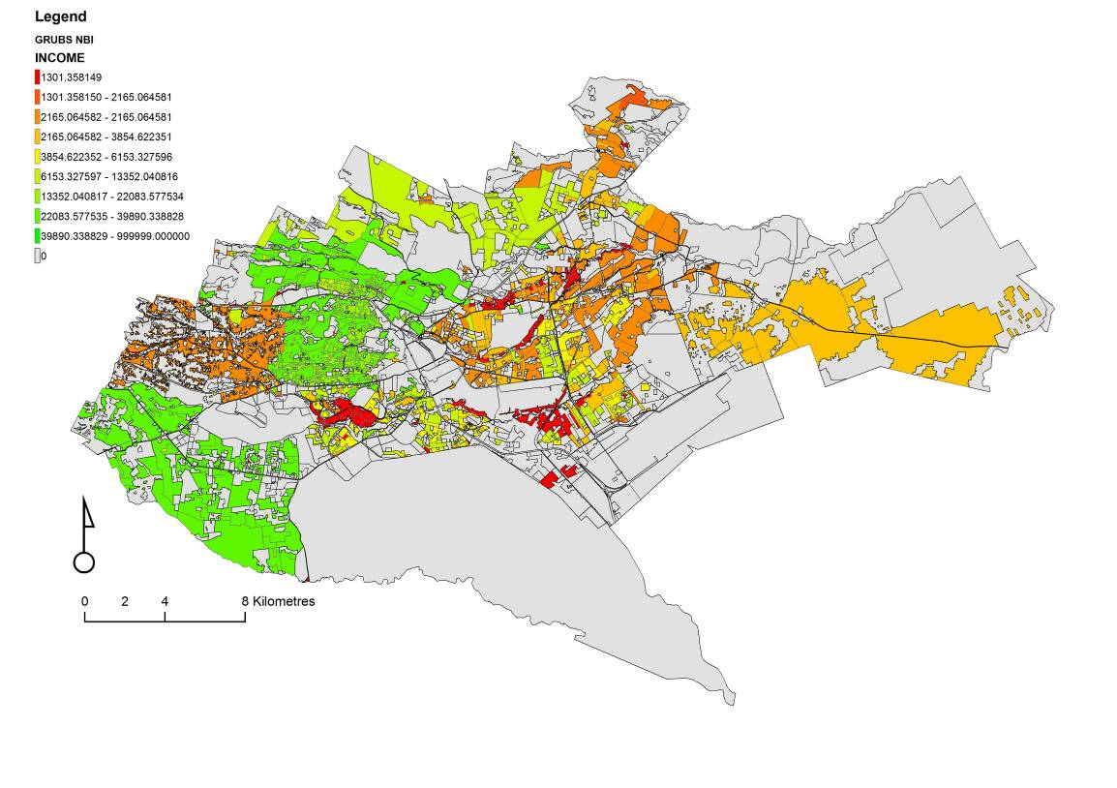
Figure 3. Spatial distribution of income in Nairobi (classes of income are continuous and defined only for mapping purposes).

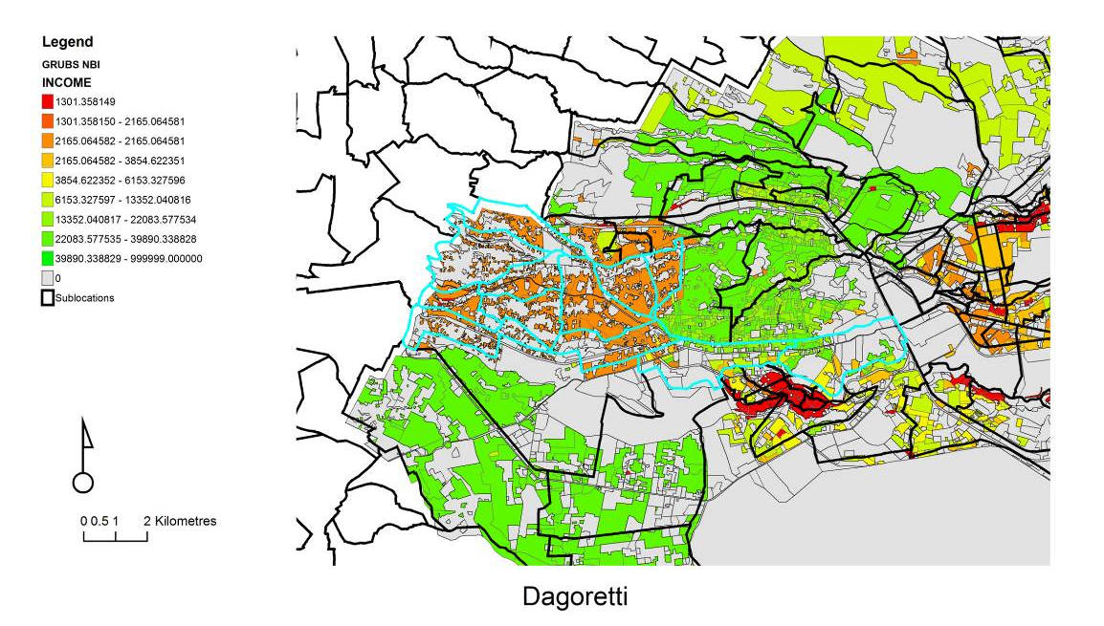
Figure 4. Zoomed in area of Dagoretti (in blue outline), an area known for high densities of livestock in Nairobi.

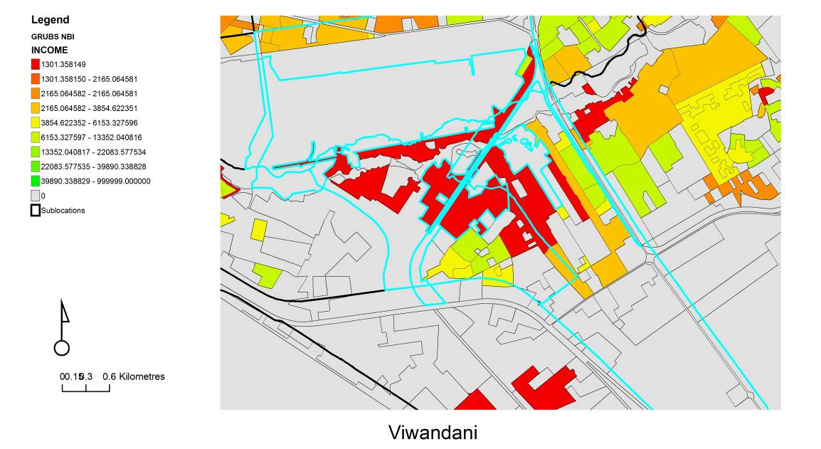
Figure 5. Viwendani, one of the two sites in the Urban Zoo case control study (Public Health thread), showing income levels. Viwendani is a low-income settlement, or slum.

a). b).
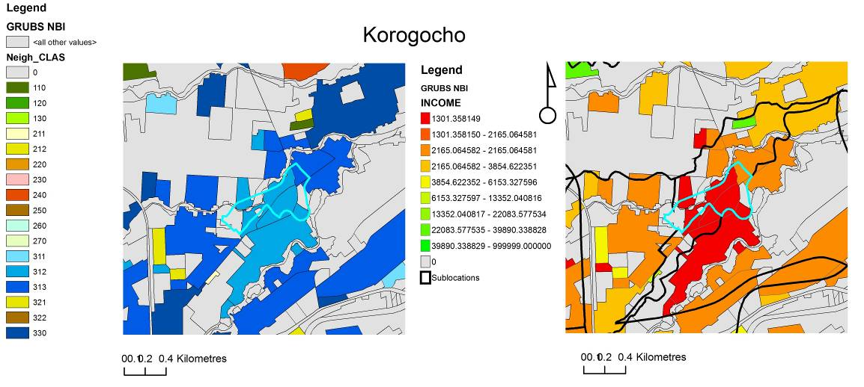

Figure 6. Korogocho, the second site in the Urban Zoo case control study, showing a) neighbourhood type and b) income. Neighbourhood type is largely “high density unplanned low quality (slum)” and “high density planned low quality” housing. Grey areas are non residential.

Selection Procedure

The aim for the selection procedure was to identify 33 sub-locations from each of which 3 households would be selected to contribute to the 99 households included in the study. There are some pre-selected sub-locations determined by other project activities. For instance, we are already working in the informal settlements of Korogocho and Viwendani, these have been included at the low income end of the scale. Based on on-going surveys and local knowledge of the project team, we want to encompass areas we know have lots of livestock in at least some parts of the city. Dagoretti was pre-selected on these grounds and is classified as a ‘peripheral area with rural component’, of low income, and has high levels of peri-urban livestock keeping and in which ILRI has many years of experience working.

Whilst the selection of neighbourhoods and sub-locations within them is purposeful – in order to in order to obtain the spread and variety of conditions that we would like to have in our sample, within the selected 33 sub-locations we will randomly select a triplet of households: one from each of the categories: 1) no livestock, 2) small-stock and 3) large stock.

Selection of 33 sub-locations

In pursuit of selecting these 33 sub-locations we developed the following protocol.

- The 17 neighbourhood types were wealth-ranked based on average income, and then merged into 7 wealth groups based on visual inspection of the data as shown in Table 2.

Table 2. Neighbourhood types showing average income and wealth groupings.
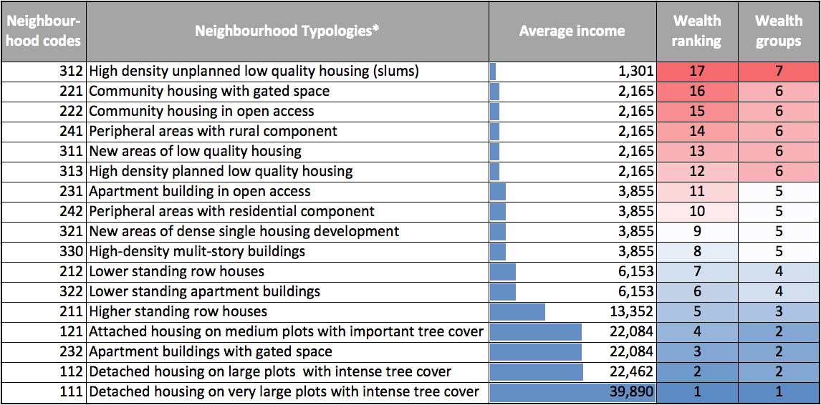

- Maps were printed showing the distribution of all 17 individual neighbourhood types and these were arranged by the 7 wealth groupings. Based on visual inspection 2-3 areas of relatively ‘contiguous’ neighbourhood types were circled on each map. Whilst selecting these areas for each wealth group care was taken to give as much geographical spread across the city as possible.
- These selections were then overlain on sub-location maps, which yielded 70 sub-locations, from which 33 needed to be selected. A population-weighted approach was used to decide how many sub-locations should be chosen from each wealth group because of the extremely high densities of people in the poorer neighbourhood types with respect to the wealthier ones. However, it was decided that we should place a greater emphasis on data collection from the lower end of the wealth ranking (wealth groups 5, 6 and 7), so these were given higher allocations of sub-locations, and that we should ensure that each neighbourhood type was adequately represented, so diverse wealth groupings would include more households. Table 3 shows the numbers of sub-locations selected for each wealth group. Wealth group 6 in particular showed a very high diversity of neighbourhood types and is at the lower end of the wealth ranking, and this is reflected in the allocation of 11 sub-locations across that wealth group.
Table 3. Numbers of sub-locations selected by wealth group.
Wealth group | Initial number of sub-locations | Number of neighbourhood types | Target number of sub-locations
1 | 8 | 1 | 3
2 | 8 | 3 | 4
3 | 5 | 1 | 3
4 | 3 | 2 | 3
5 | 9 | 4 | 5
6 | 24 | 5 | 11
7 | 13 | 1 | 4
Total | 70 | 17 | 33
The distribution of the 70 sub-locations, by wealth group is shown in Figure 7.
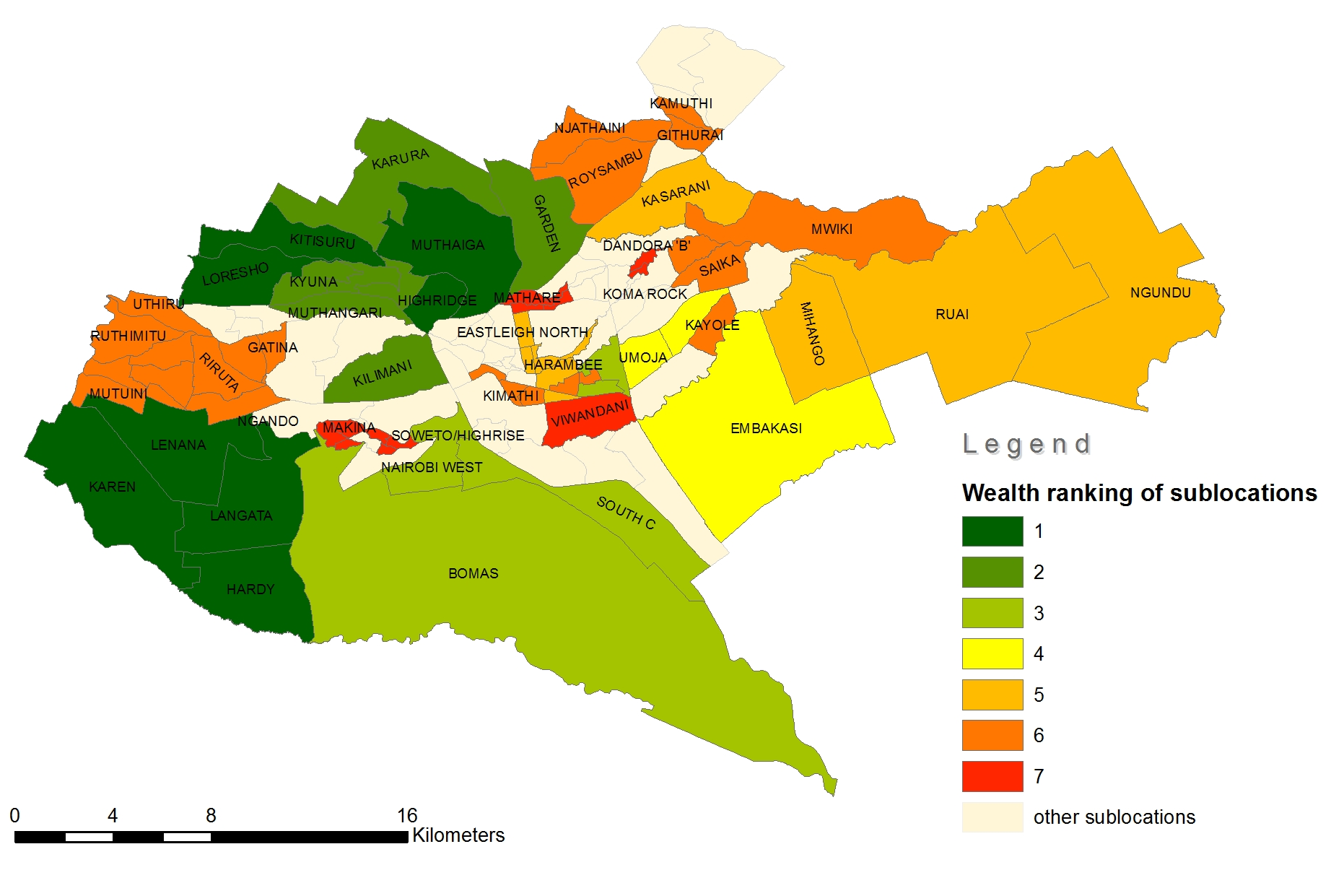
Figure 7. The 70 sub-locations by wealth group. [to be re-drawn]
- At the next stage of the screening, the 70 sub-locations were intersected with data on neighbourhood type and population. To estimate which was the dominant neighbourhood type for each sub-location the population within each neighbourhood type was extracted and expressed as the percentage of the total population in that sub-location. The results of this are shown in Table 4 for each of the 70 sub-locations.
Table 4. Selected sub-locations.
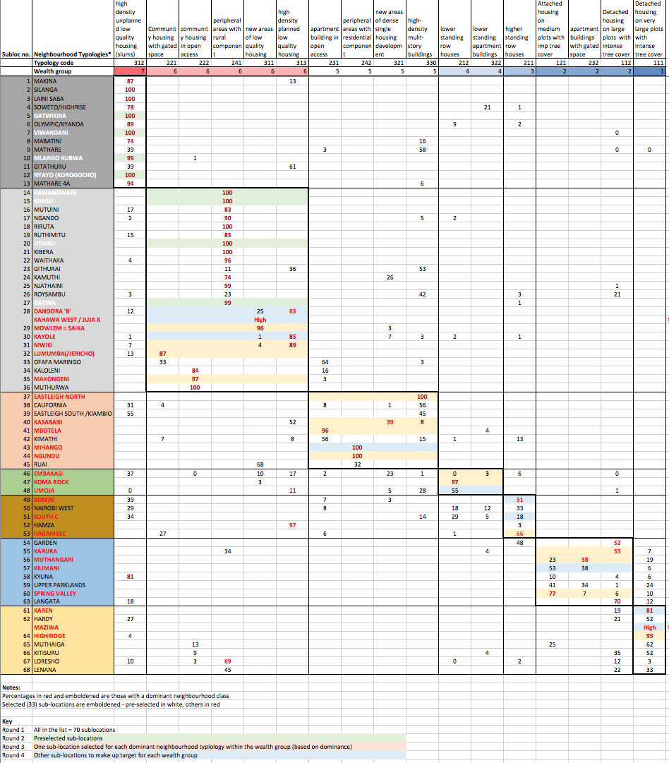
- In a second round of screening pre-selected sub-locations were chosen (pale green cells in Table 4, n = 8). These are in the informal housing areas and in Dagoretti.
- In a third round of screening one sub-location from each neighbourhood type was chosen based on the weighted population value – choosing the highest value. This ensured that at least one sub-location was selected from each of the 17 neighbourhood types (pale orange cells in Table 4, n = 8 + 15 =23).
- In a fourth round of screening other sub-locations were chosen to make the numbers of sub-locations for each wealth class up to the target (Table 3). These were chosen to give an even spread across neighbourhood types and ideally, sub-locations that were dominant for a particular neighbourhood type were chosen (pale blue cells in Table 4, n = 8 + 15 + 10 = 33).
Selection of 3 households within each selected sub-location

Within each of the selected 33 sub-locations we will randomly select a triplet of households – one from each of the categories: 1) no livestock (NL), 2) monogastric stock (MG) and 3) ruminant stock (RM) – from within the designated dominant household type. Household selection is a balance between maintaining randomisation as far as possible and being pragmatic.

There was some debate about the definitions of the different livestock keeping households; specifically whether to use large or small as a distinction or whether to distinguish monogastric from ruminant livestock. The latter was chosen in the end, due to the functional differences between these types, the main species being pigs and chickens under monogastrics and cattle, sheep and goats under ruminants. This posed the risk, though, that the less ubiquitous species (pigs for monogastrics and cattle for ruminants) would be under-represented in the survey. This is because there would be a higher likelihood of a household keeping chickens but no pigs as the search is made for a monogastric household from a randomly selected point (see below). The same is likely for small ruminants as opposed to cattle for a ruminant household. To ensure that these rarer types are adequately covered we alternate between small and large monogastric/ruminant households in selection of households. A small monogastric household is one that keeps chickens; a large monogastric household is one that keeps pigs; a small ruminant household is one that keeps sheep or goats; and a large ruminant household one which keeps cattle. All of these households may or may not keep other types of livestock. Thus half of the MG households (16 or 17) will definitely keep pigs and half of the RM households (16 or 17) will definitely keep cattle. To assign these livestock keeping categories the 33 sub-locations were listed randomly (within each of the 7 wealth groupings to ensure an even spread of large and small MG and RM households with each) and assigned, alternately, MG-Small/RM-Large and MG-Large/RM-Small. The list of 33 sub-locations was then fully randomised to determine the order in which they will be visited. The final visiting order was fully randomised to avoid any temporal effects (seasonal or otherwise) to be clustered within particular household typologies. The final list of the 33 sub-locations, with associated visiting order and livestock keeping categories is presented in Table 5.

Table 5. Selected sub-locations showing order of visit and categories of ruminant and monogastric (small or large) for the livestock keeping households.
Wealth Group | Sub-location  ID | Sub-locaton  Name | Order Of Visit | Ruminant Category | Monogastric  Category
3 | 53 | HARAMBEE | 1 | RM-S | MG-L
7 | 7 | VIWANDANI | 2 | RM-L | MG-S
6 | 29 | MOWLEM = SAIKA | 3 | RM-L | MG-S
1 | 61 | KAREN | 4 | RM-L | MG-S
2 | 55 | KARURA | 5 | RM-L | MG-S
6 | 35 | MAKONGENI | 6 | RM-L | MG-S
6 | 15 | KIRIGU | 7 | RM-S | MG-L
7 | 10 | MLANGO KUBWA | 8 | RM-L | MG-S
6 | 30 | KAYOLE | 9 | RM-S | MG-L
5 | 41 | MBOTELA | 10 | RM-S | MG-L
2 | 57 | KILIMANI | 11 | RM-S | MG-L
6 | 20 | UTHIRU | 12 | RM-L | MG-S
3 | 51 | SOUTH C | 13 | RM-S | MG-L
6 | 28 | DANDORA 'B' | 14 | RM-L | MG-S
5 | 37 | EASTLEIGH NORTH | 15 | RM-S | MG-L
6 | 28.1 | KAHAWA WEST / JUJA K | 16 | RM-L | MG-S
4 | 48 | UMOJA | 17 | RM-L | MG-S
6 | 31 | MWIKI | 18 | RM-S | MG-L
6 | 32 | LUMUMBA (JERICHO) | 19 | RM-S | MG-L
7 | 12 | NYAYO (KOROGOCHO) | 20 | RM-S | MG-L
5 | 43 | MIHANGO | 21 | RM-L | MG-S
5 | 40 | KASARANI | 22 | RM-S | MG-L
4 | 46 | EMBAKASI | 23 | RM-S | MG-L
2 | 60 | SPRING VALLEY | 24 | RM-S | MG-L
6 | 27 | GATINA | 25 | RM-L | MG-S
6 | 14 | KAWANGWARE | 26 | RM-S | MG-L
3 | 49 | BOMAS | 27 | RM-L | MG-S
7 | 5 | GATWIKIRA | 28 | RM-S | MG-L
1 | 64 | HIGHRIDGE | 29 | RM-S | MG-L
2 | 56 | MUTHANGARI | 30 | RM-L | MG-S
4 | 47 | KOMA ROCK | 31 | RM-L | MG-S
5 | 44 | NGUNDU | 32 | RM-L | MG-S
1 | 62.1 | MAZIWA | 33 | RM-L | MG-S
Notes: RM-S = small ruminants; RM-L = large ruminants; MG-S = small monogastrics; ML-S = large monogastrics.

Having decided upon the 33 sub-locations, determined the order in which they will be visited and assigned each a category for small or large ruminants and monogastrics for the two livestock keeping households, the procedure for household selection in each sub-location is as follows.

- Three points are randomly selected in GIS within the sub-district and falling into the dominant neighbourhood type. An additional selection criterion is that that the selected households are separated by at least x metres (where x depends on the size of the sub-location), to ensure that they are not clustered within the sub-location. These points are then plotted on a Google maps (Quickbird) image of the sub-location with concentric circles (at 100 and 200m) to aid the search for a suitable household. The sub-location boundary is plotted and the dominant neighbourhood type highlighted on the map. The maps are printed in colour on A3 paper and used in the field to help search for suitable households. The geographical coordinates of the triplet of points are also noted and entered into a GPS.

- Aided by the local knowledge of the chief and the local veterinary officer, each point is assigned a category – NL, MG or RG – based on which type of household is most likely to be found at each of the points. MG and RG are assigned large or small depending on the sub-location (with reference to Table 5).

- Each random point is then visited, with a designated local official, and the nearest (Euclidean distance) household (within the dominant household type) is located that matches the assigned category for that point. At this stage the head of the household is consulted and consent to participate in the survey sought. If consent is given then the household is selected and data recording can begin. If not, then the household next closest to the random point meeting the selection criteria is taken and evaluated.

In this way a triplet of households is selected for each of the 33 sub-locations.

Photographs of sub-location selection at ILRI, Nairobi (taken by Sohel Ahmed)
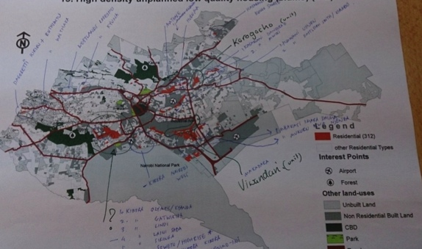
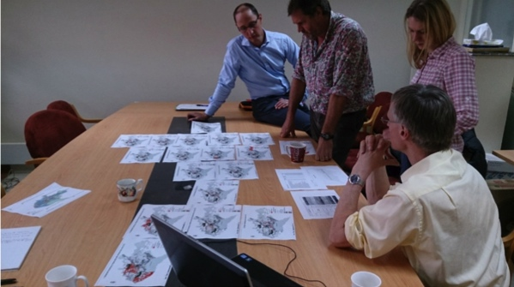
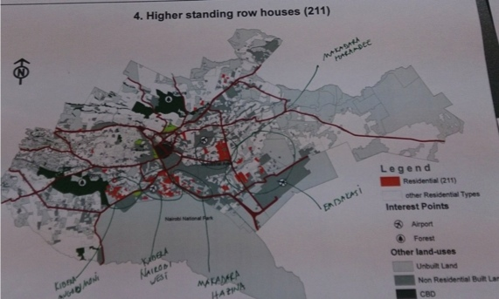
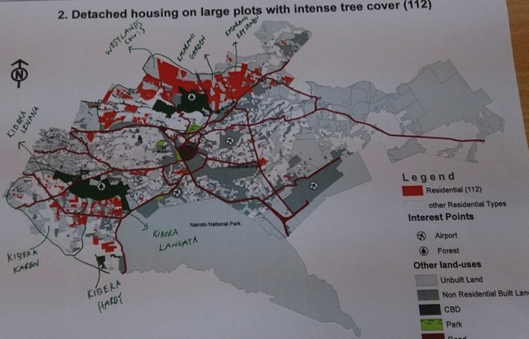

References

Dohoo, I., Martin, W., & Stryhn, H. (2003). Veterinary Epidemiologic Research. Charlottetown, Prince Edward Island: AVC Inc.
James, W.P., Mascie-Taylor, G.C., Norgan, N.G., Bistrian, B.R., Shetty, P.S., & Ferro-Luzzi, A. (1994). The value of arm circumference measurements in assessing chronic energy deficiency in Third World adults. European Journal of Clinical Nutrition, 48, pp. 883-894.
Ledant, M. (2011). Socio-Economical and Infrastrucural Mapping and Analysis of Nairobi: Technical Report. Nairobi: IFRA/UN-HABITAT.
Morris, S.S., Carletto, C., Hoddinott, J., & Christiaensen, L.J.M. (2000). Validity of rapid estimates of household wealth and income for health surveys in rural Africa. Journal of Epidemiology and Community Health, 54, pp. 381-387.
Ndeng’e, G., Opiyo, C., Mistiaen, J., & Kristjanson, P. (2003). Geographic dimensions of well-being in Kenya. Where are the poor? Volume 1. Nairobi: The Regal Press Kenya Ltd.
World Health Organization. (1995). Physical Status, the Use and Interpretation of Anthropometry. WHO Expert Committee on Physical Status. Geneva: WHO.

