Table 1: GC-MS analysis and mass spectral data from the fruits of Dialium guineense showing the molecular structure, molecular weight, percentage content, retention time, base peak and bio-activity
S.No |  | Compound name | Molecular weight (g/mol) | Retention time | Peak Area (%) | Structure | Bioactivity
 | 1 | 2,4-Dihydroxy-2,5-dimethyl-3(2H)-furanone | 144 | 3.985 | 1.46 |  | 11B-HSD-Inhibitor, 17-beta-hydroxysteroid dehydrogenase-Inhibitor
2 |  | 3,5-Dihydroxy-6-methyl-2,3-dihydro-4H-pyran-4-one | 144 | 6.403 | 1.51 |  | Catechol-O-Methyl-Transferase-Inhibitor, 5-HETE-Inhibitor, 5-HT-Inhibitor
3 |  | 5-Hydrxoymethylfurfural or 5-(hydroxymethyl)furan-2-carbaldehyde | 126 | 6.761 | 10.99 |  | Not Found
4 |  | 4-[(E)-(methoxyimino)methyl]phenol | 151 | 7.922 | 13.55 |  | Not found
5 |  | 2,5-dihydroxy-6-methyl-2,3-dihydro-4H-pyran-4-one | 144 | 9.023 | 1.43 |  | Anti-HIV-Integrase, Antidote (Heavy Metals)
6 |  | Lauric acid | 200 | 10.461 | 0.18 |  | Acidifier, Acidulant, Arachidonicacid-Inhibitor
7 |  | Ethyl 5-methylnonanoate | 200 | 11.537 | 2.30 |  | Not found
8 |  | Myristic acid, methyl ester | 242 | 12.908 | 2.39 |  | Inhibit the production of Uric Acid
9 |  | n-Tridecanoic acid methyl ester | 228 | 13.759 | 2.32 |  | Anaphylactic (antidote=Neostigmine), Antitumor (Nasopharynx)
10 |  | Methyl 14-methylpentadecanoate | 270 | 15.678 | 5.21 |  | Methyl-Guanidine-Inhibitor
11 |  | Palmitic acid, ethyl ester | 284 | 16.968 | 34.23 |  | Urine-Acidifier
12 |  | Undecanoic acid | 185 | 18.352 | 4.52 |  | Urinary-Acidulant
13 |  | Stearic acid, ethyl ester | 312 | 20.276 | 1.37 |  | Inhibit the production of Uric Acid
14 |  | cis-11-Hexadecenal | 238 | 21.658 | 1.57 |  | Not found
15 |  | 2-chloro-N-[(2-chlorophenyl)carbonyl]-N-(2-methylpropyl)benzamide | 349 | 22.201 | 1.72 |  | Not found
16 |  | Butyl5-oxo-1-(trifluoroacetyl)pyrrolidine-2-carboxylate | 281 | 23.558 | 1.24 |  | Not found
17 |  | Glutaric acid, decylpentafluorobenzyl ester | 452 | 26.567 | 14.02 |  | Arachidonic-Acid-Inhibitor
3.2 Virtual screening outputs
The results also showed that DG1 to 7, 11, 12 and 17 are integrase inhibitors, DG1, 2, 4, 5, 6, 9, 10 and 12 are cycloxygenase-1 inhibitors while DG1, 3 and 9 are xanthine oxidase inhibitors as shown in Table 2.
Table 2: Binding affinity of the screened compounds to the target proteins
Dialium guinense (DG) and standard inhibitor Compounds |  |  | Target proteins and binding affinity (kcal/mol)
ID | PubChem ID | ChemSpider ID | Integrase  (5OYM) | COX1  (6Y33) | XO  (2EIQ)
Ral | 54671008 | - | -7.5ª | - | -
Ibu | 3672 | - | - | -6.6ª | -
Caf | 2519 | - | - | - | -6.4ª
DG1 | -- | 469160 | -4.9ª | -6.1ª | -5.6ª
DG2 | - | 106997 | -4.8ª | -6.0ª | -6.0^{b}
DG3 | - | 207215 | -4.6ª | -5.1^{b} | -5.4ª
DG4 | - | 14583656 | -5.2ª | -6.0ª | -6.2ª
DG5 | - | 1600550 | 5.3ª | 5.2ª | -5.7^{b}
DG6 | - | 3756 | -4.5ª | -5.6ª | -5.8^{b}
DG7 | - | 487041 | -4.1ª | -4.4^{b} | -5.2^{b}
DG8 | - | 10539 | -4.4^{b} | -4.0^{b} | -6.0^{b}
DG9 | - | 14848 | -3.7^{b} | -4.8ª | -5.7ª
DG10 | - | 19937 | -4.5^{b} | 5.1ª | -5.6^{b}
DG11 | - | 960 | -3.9ª | -4.8^{b} | -5.7^{b}
DG12 | - | 7888 | -4.0ª | -5.2ª | -5.8^{b}
DG13 | - | 5091 | -3.9^{b} | -4.2^{b} | -6.3^{b}
DG14 | - | 4516647 | -4.1^{b} | -4.1^{b} | -5.8^{b}
DG15 | - | - | - | - | -
DG16 | - | - | - | - | -
DG17 | - | 723 | -4.3ª | -4.9^{b} | -5.1^{b}
ª compound that bind at the same site with standard inhibitor (best pose); ^{b} compounds that bind at a different site from the standard inhibitor.

Table 3: 3D Structures of the proteins and ligands (inhibitors)
1 | 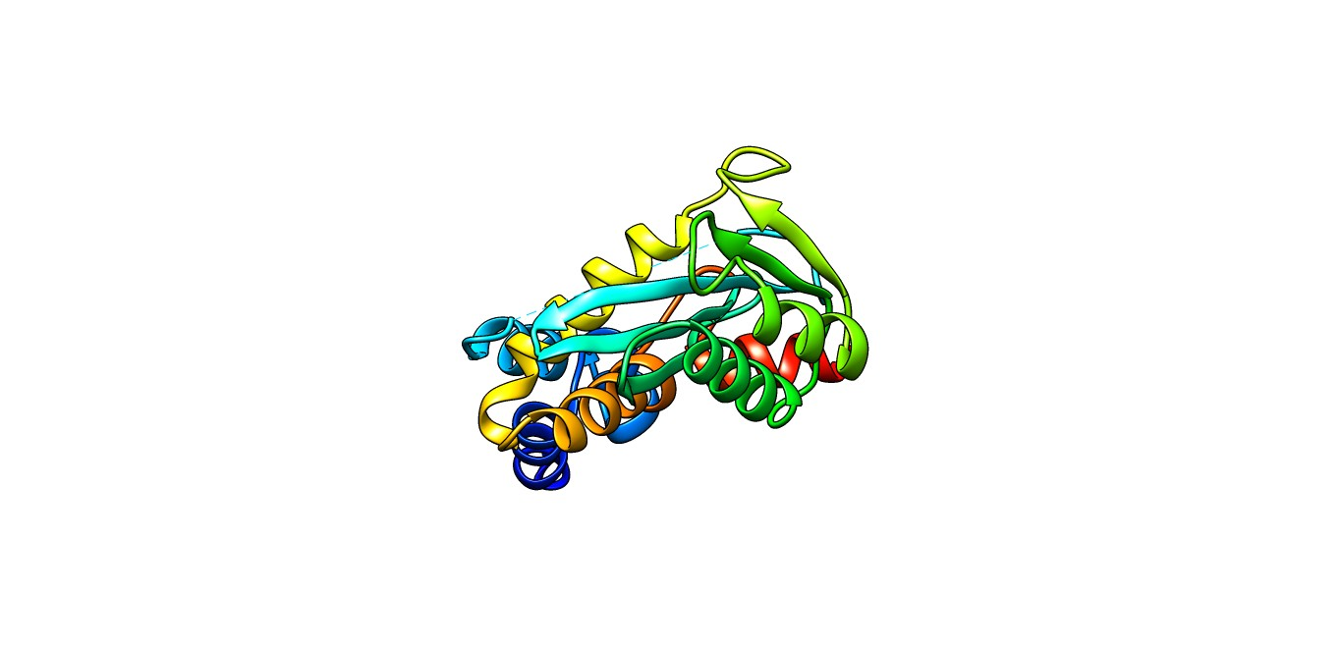Integrase | 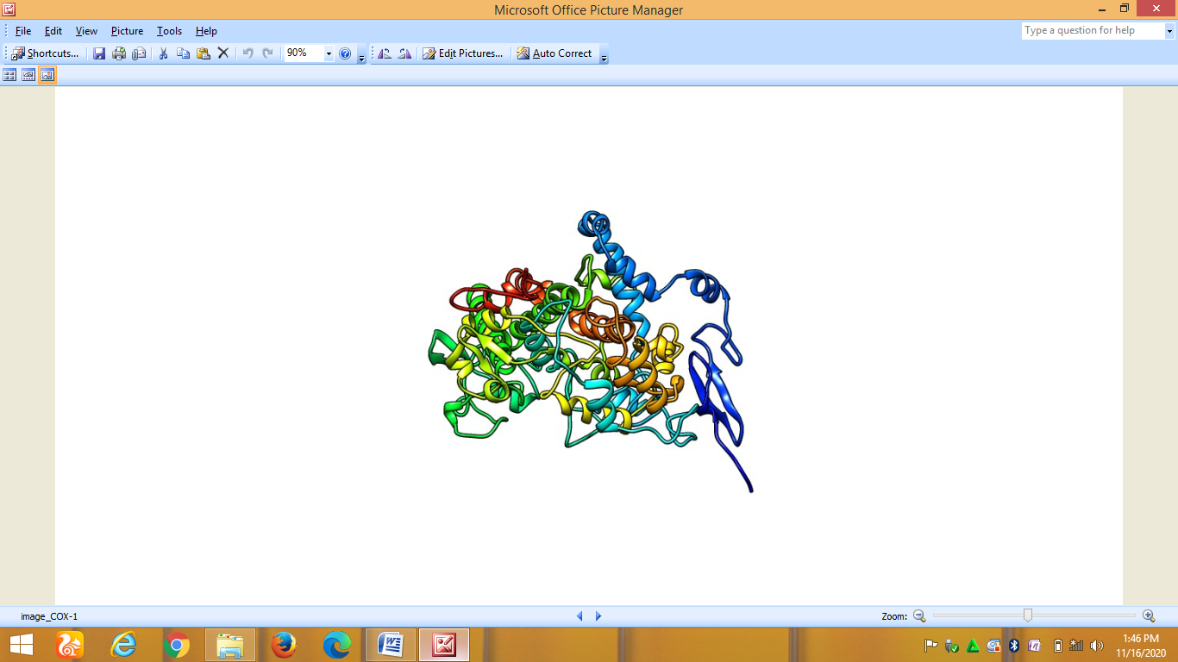  Cycloxigenase-1 | 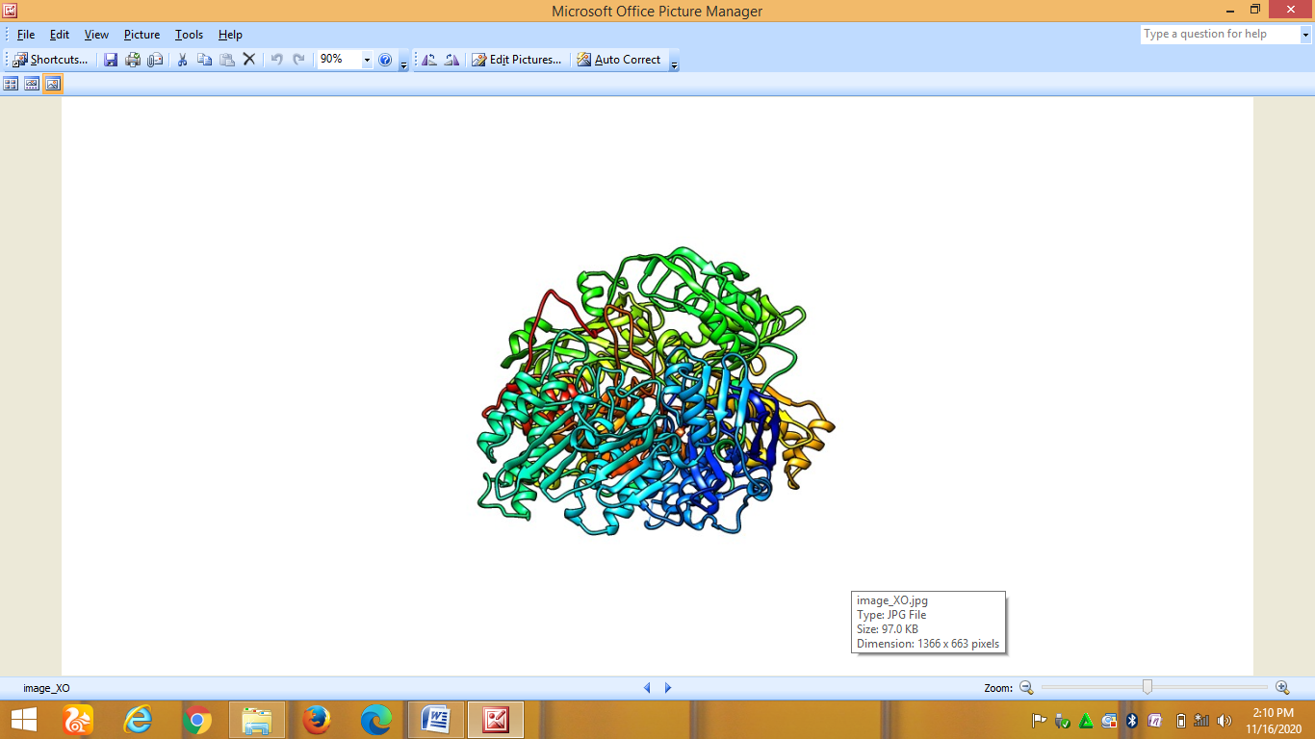  Xanthine oxidase
2 | 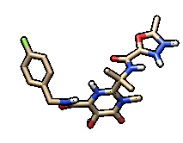Raltegavir | 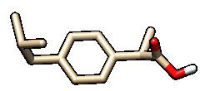Ibuprofen | 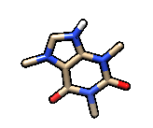Caffeine
3 | 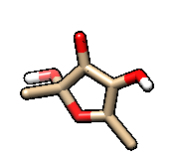DG1 | 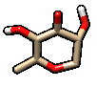DG2 | 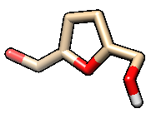DG3
3 | 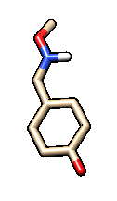DG4 | 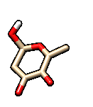DG5 | 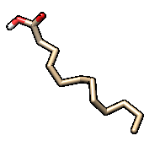DG6
3 | 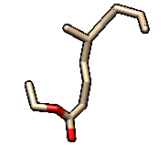DG7 | 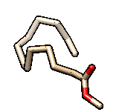DG9 | 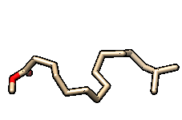DG10
3 | 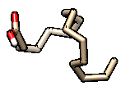DG11 | 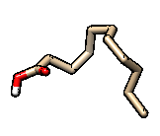DG12 | 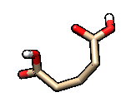DG17
¹Target protein; ²Standard inhibitors; ³Dialium guineense (DG) compounds

Table 4: Drug likeness of the lead compounds by SwissAdme
Compound  Name | Molecular  Weight | Hydrogen Bonds |  | Rotatable  bonds | LOGP  (iLogP_{o/w}) | TPSA | Role of Five (RO5) violation
Compound  Name | Molecular  Weight | Donor | Acceptor
DG1 | 144.14 | 2 | 4 | 0 | 1.24 | 66.76 | 0
DG2 | 144.13 | 2 | 4 | 0 | 1.19 | 66.76 | 0
DG3 | 130.14 | 1 | 3 | 2 | 0.84 | 46.53 | 0
DG4 | 151.16 | 1 | 3 | 2 | 1.86 | 41.82 | 0
DG5 | 144.13 | 2 | 4 | 0 | 1.05 | 66.76 | 0
DG6 | 198.34 | 0 | 1 | 10 | 3.56 | 17.07 | 0
DG7 | 214.34 | 0 | 2 | 10 | 3.78 | 26.3 | 0
DG9 | 228.37 | 0 | 2 | 12 | 4.01 | 26.3 | 0
DG10 | 242.40 | 0 | 2 | 12 | 4.13 | 26.3 | 0
DG11 | 270.45 | 0 | 2 | 15 | 4.67 | 26.3 | 1
DG12 | 186.29 | 1 | 2 | 9 | 2.74 | 37.3 | 0
DG17 | 422.52 | 0 | 6 | 17 | 5.72 | 9.23 | 1

Table 5: ADMET profile of the lead compounds by AdmetSAR
Compound  Name | Physiological and pharmacokinetic properties |  |  |  |  |  |  |  |  |  |  |  |  |  | Organ, endocrine, and genomic toxicity properties
Compound  Name | A | B | C | D | E | F | G | H | I | J | K | L | M | N | O | P | Q | R | S | T | U | V | W | X | Y
DG1 | + | - | + | + | - | + | - | - | - | - | - | - | - | + | - | - | + | - | - | - | - | - | - | - | -
DG2 | + | - | + | + | - | + | - | - | - | - | - | - | - | + | - | + | + | + | - | - | - | - | - | - | -
DG3 | + | - | + | + | - | + | - | - | - | - | - | - | - | + | - | - | - | - | - | - | - | - | - | - | -
DG4 | + | + | + | + | - | + | - | - | + | - | - | - | - | + | - | - | + | - | - | - | + | - | - | - | -
DG5 | + | - | + | + | - | + | - | - | - | - | - | - | - | + | - | - | + | - | - | - | - | - | - | - | -
DG6 | + | + | + | - | - | + | - | + | - | - | - | - | - | - | - | + | + | - | - | - | - | - | - | - | -
DG7 | + | + | + | - | - | + | - | - | - | - | + | - | - | - | - | + | + | - | - | - | - | - | - | - | -
DG9 | + | + | + | - | - | + | - | - | - | - | - | - | - | - | - | + | + | - | - | - | - | - | - | - | -
DG10 | + | + | + | - | - | + | - | - | - | - | + | - | - | - | - | + | + | - | - | - | - | - | - | - | -
DG11 | + | + | + | - | - | + | - | - | - | - | - | - | - | - | - | + | + | - | - | - | - | - | - | - | -
DG12 | + | + | + | - | - | + | - | - | + | - | + | - | - | - | - | + | + | - | - | - | - | - | - | - | +
DG17 | + | + | + | + | - | + | - | - | +- | + | - | + | - | - | - | - | + | - | - | + | + | + | - | - | +
(+)=active/yes/high; (-)=inactive/no/low; A= Human Intestinal Absorption; B= Caco-2; C= Blood Brain Barrier; D=Human oral bioavailability; E=OATP2B1 inhibitior; F= OATP1B1 inhibitior; G= P-glycoprotein inhibitior; H=P-glycoprotein substrate; I=CYP1A2 inhibition; J=CYP2C19 inhibition; K=CYP2C9 inhibition; L=CYP2D6 inhibition; M= CYP3A4 inhibition; N= UGT catalyzed; O= Carcinogenicity; P=Eye corrosion; Q=Eye irritation; R=Ames mutagenesis; S= Human either-a-go-go inhibition; T= Hepatotoxicity; U= Estrogen receptor binding; V= Thyroid receptor binding; W=Glucocorticoid receptor binding; X=Aromatase binding; Y=PPAR gamma.

