Table S1. The results of MSPA classes at edge width of 1, 2, 3and 4.
Value | GI Element | Edge width=1 |  | Edge width=2 |  | Edge width=3 |  | Edge width=4
Value | GI Element | Area | Proportion% | Area | Proportion% | Area | Proportion% | Area | Proportion%
Value | GI Element | (km²) | Proportion% | (km²) | Proportion% | (km²) | Proportion% | (km²) | Proportion%
1 | Core | 10196.86 | 90.14% | 9049.80 | 80.00% | 8217.22 | 72.64% | 7489.84 | 66.21%
2 | Islet | 5.66 | 0.05% | 30.54 | 0.27% | 61.09 | 0.54% | 96.15 | 0.85%
3 | Edge | 479.64 | 4.24% | 1150.46 | 10.17% | 1666.29 | 14.73% | 2063.35 | 18.24%
4 | Perforation | 588.24 | 5.20% | 841.63 | 7.44% | 910.64 | 8.05% | 932.13 | 8.24%
5 | Bridge | 3.39 | 0.03% | 70.14 | 0.62% | 207.01 | 1.83% | 419.68 | 3.71%
6 | Loop | 7.92 | 0.07% | 62.22 | 0.55% | 96.15 | 0.85% | 117.65 | 1.04%
7 | Branch | 31.67 | 0.28% | 106.34 | 0.94% | 154.98 | 1.37% | 192.31 | 1.70%
8 | Background | 3021.53 | -- | 3021.53 | -- | 3021.53 | -- | 3021.53 | --

Table S2. Indices of UGS patch importance evaluation
dPC  area/km² | area≥50 | 5≤area＜50 | 0.5≤area＜5 | 0≤area＜0.5
dPC≥5 | level-1 | level-2 | level-3 | level-4
0.5≤dPC ＜5 | level-2 | level-3 | level-4 | level-5
0.05≤dPC ＜0.5 | level-3 | level-4 | level-5 | level-6
0≤dPC＜0.05 | level-3 | level-4 | level-6 | level-7

Table S3. Sequence of the landscape connectivity index of the source patches
Rank | Patch No. | area/km² | dPC | Rank | Patch No. | area/km² | dPC
1 | 25 | 3172.867 | 57.4366 | 15 | 13 | 23.1212 | 1.509031
2 | 24 | 1333.835 | 39.92943 | 16 | 9 | 23.99895 | 1.019838
3 | 20 | 1645.701 | 30.51935 | 17 | 7 | 22.0206 | 0.790531
4 | 22 | 1006.299 | 16.40255 | 18 | 4 | 36.08797 | 0.757079
5 | 27 | 45.74007 | 10.09527 | 19 | 3 | 30.65679 | 0.741013
6 | 23 | 558.6716 | 8.783724 | 20 | 8 | 18.42899 | 0.711706
7 | 26 | 393.5631 | 6.820706 | 21 | 1 | 34.35682 | 0.673172
8 | 21 | 292.4433 | 6.342338 | 22 | 12 | 17.21587 | 0.670097
9 | 11 | 34.64924 | 4.909189 | 23 | 10 | 38.22536 | 0.663545
10 | 19 | 54.00128 | 4.155439 | 24 | 6 | 19.99722 | 0.656635
11 | 17 | 170.6809 | 3.853005 | 25 | 14 | 37.70804 | 0.652445
12 | 15 | 147.45 | 3.030117 | 26 | 2 | 32.35895 | 0.638599
13 | 16 | 92.75065 | 2.032342 | 27 | 5 | 29.11947 | 0.580739
14 | 18 | 71.13724 | 1.893679
Table S4. Value of ecological resistance
Resistance factor | Classification index | Resistance value | weight
Land use | Forest | 1.711 | 0.47
Land use | Cropland | 3.736 | 0.47
Land use | Waterbody | 4.732 | 0.47
Land use | Grassland | 4.825 | 0.47
Land use | Built-up area | 5.000 | 0.47
Land use | unused land | 4.996 | 0.47
Elevation/m | 341-747 | 1.00 | 0.08
Elevation/m | 747-1290 | 2.00 | 0.08
Elevation/m | 1290-2012 | 3.00 | 0.08
Elevation/m | 2012-2930 | 4.00 | 0.08
Elevation/m | 2930-5279 | 5.00 | 0.08
Slope/degree | <4.498 | 1.00 | 0.11
Slope/degree | 4.498-12.45081 | 2.00 | 0.11
Slope/degree | 12.45081-22.035217 | 3.00 | 0.11
Slope/degree | 22.035217-33.363277 | 4.00 | 0.11
Slope/degree | 33.363277-69.107056 | 5.00 | 0.11
Distance from main road/m | >2000 | 1.00 | 0.13
Distance from main road/m | 1000-2000 | 2.00 | 0.13
Distance from main road/m | 500-1000 | 3.00 | 0.13
Distance from main road/m | 100-500 | 4.00 | 0.13
Distance from main road/m | 0-100 | 5.00 | 0.13
Distance from main town/m | >3500 | 1.00 | 0.21
Distance from main town/m | 2000-3500 | 2.00 | 0.21
Distance from main town/m | 1000-2000 | 3.00 | 0.21
Distance from main town/m | 500-1000 | 4.00 | 0.21
Distance from main town/m | 0-500 | 5.00 | 0.21

Table S5. Interaction matrix based on gravity modeling
 | 1 | 2 | 3 | 4 | 5 | 6 | 7 | 8 | 9 | 10 | 11 | 12 | 13 | 14 | 15 | 16 | 17 | 18 | 19 | 20 | 21 | 22 | 23 | 24 | 25 | 26 | 27
1 | - | 738 | 563 | 151 | 166 | 143 | 171 | 119 | 152 | 76 | 110 | 99 | 88 | 76 | 681 | 104 | 125 | 110 | 83 | 2578 | 1171 | 87 | 75 | 88 | 250 | 68 | 103
2 |  | - | 42327 | 526 | 577 | 86 | 163 | 119 | 131 | 160 | 110 | 100 | 88 | 144 | 277 | 73 | 99 | 90 | 91 | 431 | 497 | 174 | 138 | 168 | 147 | 120 | 114
3 |  |  | - | 634 | 612 | 77 | 142 | 108 | 115 | 173 | 98 | 92 | 80 | 154 | 234 | 66 | 88 | 81 | 96 | 363 | 401 | 187 | 146 | 180 | 131 | 127 | 111
4 |  |  |  | - | 4558 | 49 | 126 | 129 | 97 | 630 | 136 | 148 | 136 | 465 | 108 | 54 | 71 | 72 | 229 | 144 | 166 | 585 | 357 | 559 | 83 | 308 | 224
5 |  |  |  |  | - | 56 | 158 | 165 | 118 | 420 | 158 | 172 | 148 | 378 | 133 | 60 | 82 | 83 | 195 | 153 | 218 | 394 | 261 | 457 | 95 | 258 | 236
6 |  |  |  |  |  | - | 283 | 193 | 406 | 54 | 202 | 176 | 175 | 88 | 552 | 2596 | 1297 | 1024 | 151 | 345 | 293 | 64 | 59 | 126 | 7331 | 82 | 184
7 |  |  |  |  |  |  | - | 6088 | 6505 | 125 | 2391 | 1628 | 1070 | 228 | 512 | 338 | 807 | 786 | 578 | 178 | 566 | 136 | 115 | 38 4 | 315 | 192 | 967
8 |  |  |  |  |  |  |  | - | 2321 | 150 | 10179 | 5144 | 2421 | 290 | 298 | 261 | 569 | 559 | 920 | 129 | 333 | 158 | 129 | 528 | 227 | 232 | 1881
9 |  |  |  |  |  |  |  |  | - | 111 | 1834 | 1275 | 916 | 205 | 448 | 532 | 1762 | 1553 | 508 | 174 | 463 | 125 | 107 | 338 | 409 | 175 | 817
10 |  |  |  |  |  |  |  |  |  | - | 191 | 209 | 215 | 2354 | 68 | 68 | 91 | 97 | 385 | 85 | 93 | 14011 | 2160 | 1189 | 78 | 1287 | 361
11 |  |  |  |  |  |  |  |  |  |  | - | 44671 | 10355 | 418 | 252 | 284 | 613 | 611 | 1925 | 123 | 279 | 208 | 166 | 825 | 248 | 321 | 4939
12 |  |  |  |  |  |  |  |  |  |  |  | - | 13478 | 483 | 220 | 243 | 493 | 488 | 2606 | 113 | 242 | 226 | 179 | 1010 | 220 | 360 | 9267
13 |  |  |  |  |  |  |  |  |  |  |  |  | - | 538 | 187 | 247 | 497 | 561 | 4661 | 102 | 205 | 235 | 188 | 1175 | 220 | 392 | 13128
14 |  |  |  |  |  |  |  |  |  |  |  |  |  | - | 100 | 113 | 162 | 175 | 1193 | 88 | 129 | 2067 | 1079 | 9864 | 123 | 6401 | 1034
15 |  |  |  |  |  |  |  |  |  |  |  |  |  |  | - | 296 | 363 | 291 | 160 | 713 | 3699 | 76 | 68 | 142 | 960 | 93 | 209
16 |  |  |  |  |  |  |  |  |  |  |  |  |  |  |  | - | 2583 | 2452 | 206 | 244 | 216 | 80 | 74 | 165 | 3557 | 105 | 253
17 |  |  |  |  |  |  |  |  |  |  |  |  |  |  |  |  | - | 17470 | 357 | 211 | 322 | 105 | 95 | 252 | 1071 | 145 | 463
18 |  |  |  |  |  |  |  |  |  |  |  |  |  |  |  |  |  | - | 395 | 189 | 264 | 112 | 101 | 274 | 981 | 155 | 516
19 |  |  |  |  |  |  |  |  |  |  |  |  |  |  |  |  |  |  | - | 99 | 173 | 407 | 308 | 3488 | 199 | 759 | 9646
20 |  |  |  |  |  |  |  |  |  |  |  |  |  |  |  |  |  |  |  | - | 676 | 100 | 90 | 101 | 651 | 82 | 121
21 |  |  |  |  |  |  |  |  |  |  |  |  |  |  |  |  |  |  |  |  | - | 102 | 88 | 164 | 499 | 111 | 228
22 |  |  |  |  |  |  |  |  |  |  |  |  |  |  |  |  |  |  |  |  |  | - | 6564 | 1126 | 93 | 2195 | 385
23 |  |  |  |  |  |  |  |  |  |  |  |  |  |  |  |  |  |  |  |  |  |  | - | 729 | 88 | 2400 | 298
24 |  |  |  |  |  |  |  |  |  |  |  |  |  |  |  |  |  |  |  |  |  |  |  | - | 173 | 3190 | 2697
25 |  |  |  |  |  |  |  |  |  |  |  |  |  |  |  |  |  |  |  |  |  |  |  |  | - | 118 | 237
26 |  |  |  |  |  |  |  |  |  |  |  |  |  |  |  |  |  |  |  |  |  |  |  |  |  | - | 691
27 |  |  |  |  |  |  |  |  |  |  |  |  |  |  |  |  |  |  |  |  |  |  |  |  |  |  | -

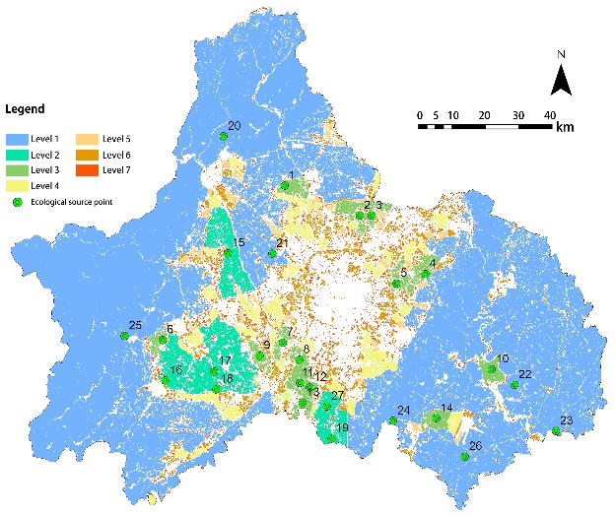
Figure S1. Grading of patches and distribution of ecological sources in Chengdu
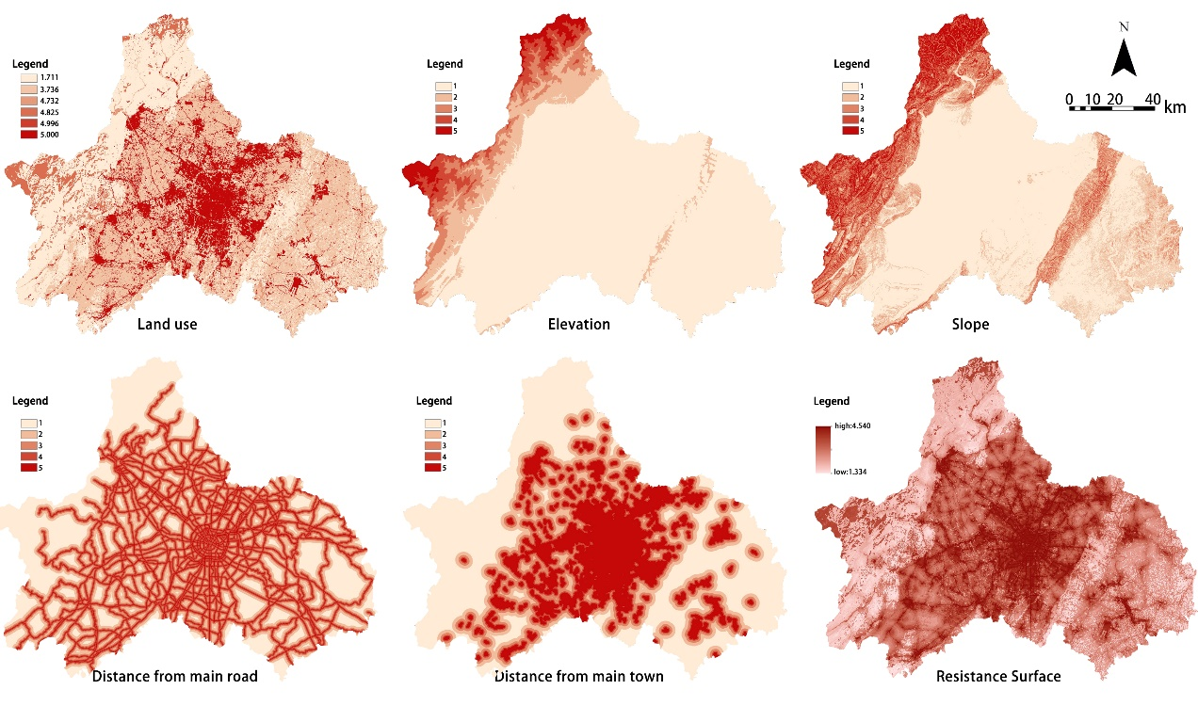
Figure S2. Ecological resistance surface of the study area
Horizontal:
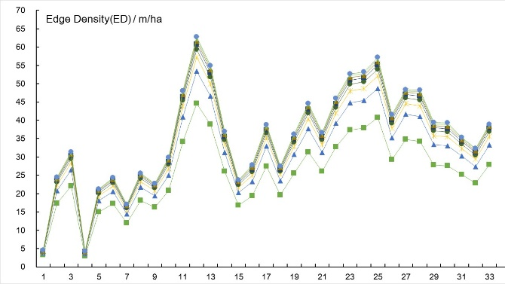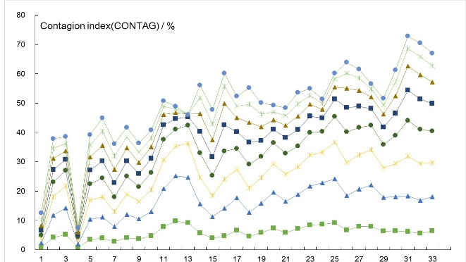
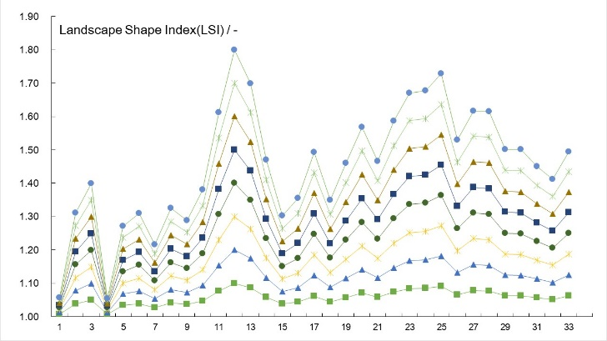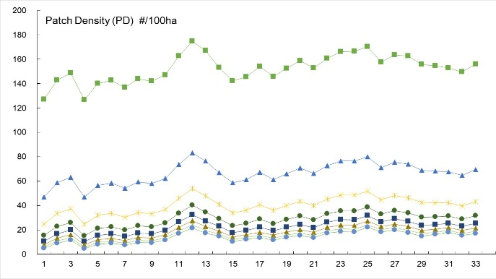
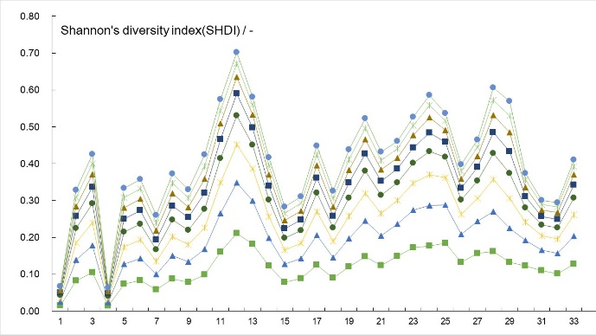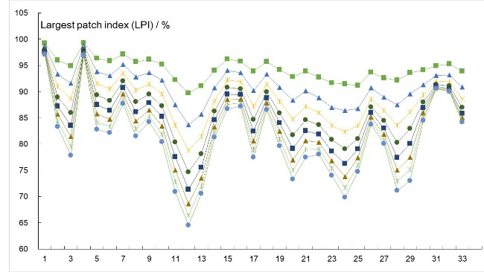
Longitudinal:
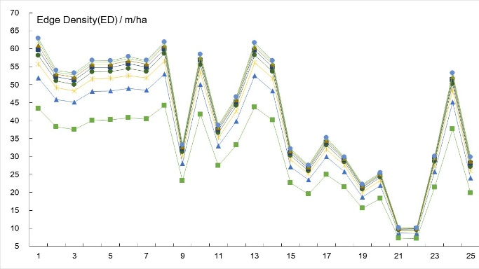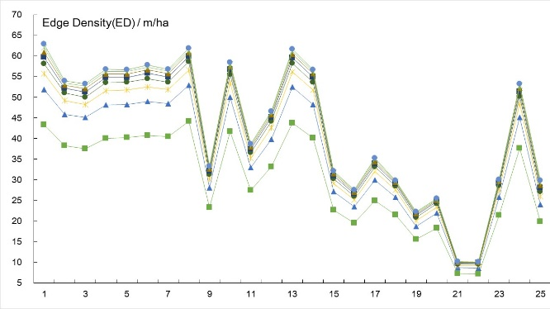
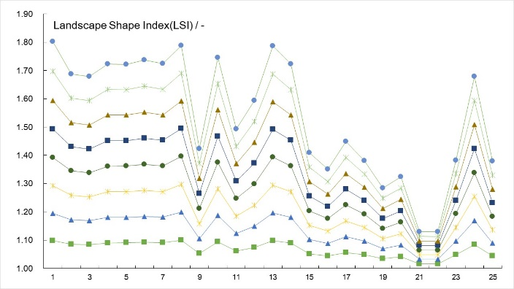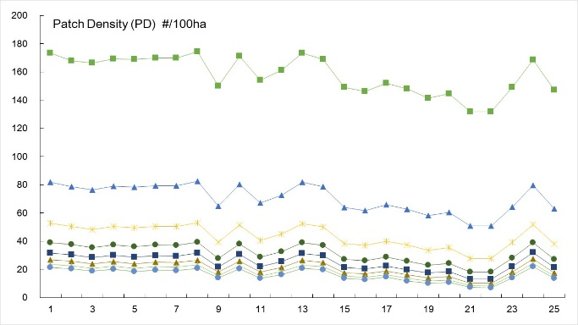
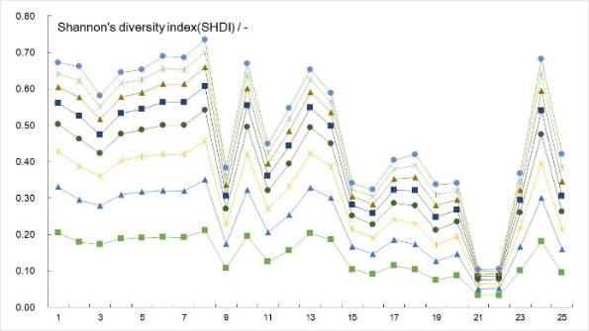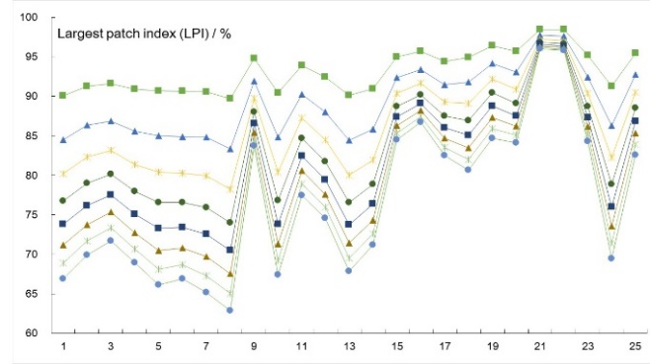
Figure S3. Study area gradient analysis
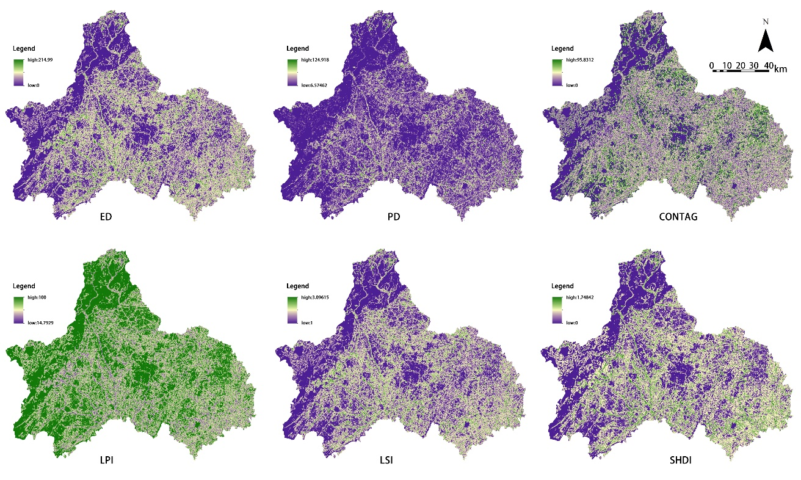
Figure S4. Landscape pattern index values at a radius width of 390

