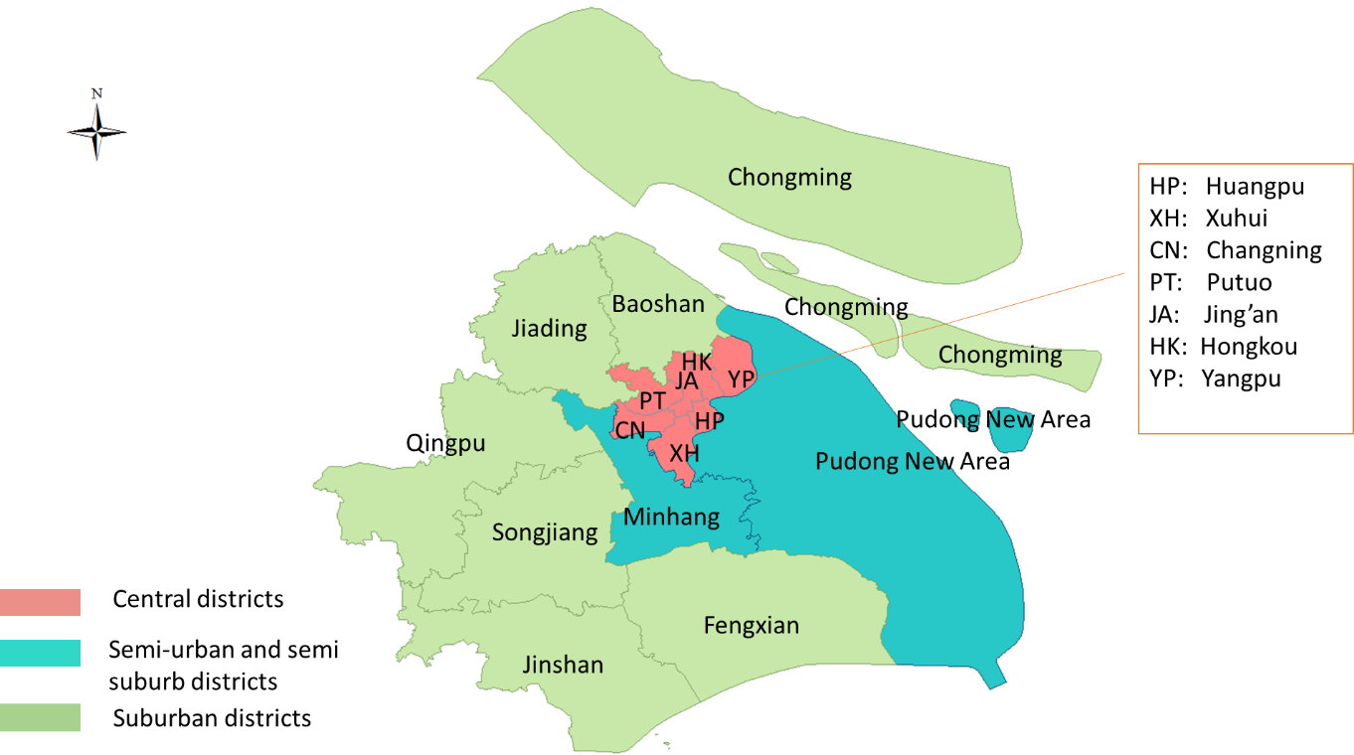
Fig S1. The Map of Administrative Divisions of Shanghai, China

- (b) (c)

(d) (e)
Fig.S2 Trends of The Theil Indexes For the Health Resources in Shanghai at regional level From 2010 to 2016. (a),(b),(c) ,(d) and (e) presents trends of the Theil Indexes for health institution, beds, technicians, doctors and nurses in Shanghai at regional level From 2010 to 2016,respectively.IPK: Number of institutions per 1000 people ;BPK: Number of beds per 1000 people; DPK: Number of doctors per 1000 people; TPK: Number of technicians per 1000 people; NPK: Number of nurses per 1000 people

