Tidal expiratory flow limitation detected with intra-breath oscillometry in obesity hypoventilation syndrome patients: effects of body position and positive airway pressure
Supplementary material

Table S1: Diagnostic criteria of study patients (n = 35). Data was collected at the time long-term respiratory support was initiated
Y = yes; N = no; md = missing data; NA = non applicable; M = male; F = female

 | Daytime hypercapnia  (pCO2>45 Hgmm) | HCO3>27mmol/l | Epworth sleepiness scale | Signs of right heart failure | Worsening hypercapnia during sleep (>10Hgmm) romlás) | Age (year) | Male / Femal | Cardial comorbidity | Weight (kg) | Height (cm) | BMI (kg/m2) | OHS staging
Patient_1 | Y | Y | 10 | Y | NA | 78 | M | Y | 99 | 175 | 32.327 | 4
Patient_2 | Y | Y | 4 | Y | NA | 57 | M | N | 125.0 | 162 | 47.63 | 3
Patient_3 | Y | Y | md | Y | NA | 47 | M | Y | 295.0 | 180 | 91.049 | 4
Patient_4 | Y | Y | 17 | Y | NA | 65 | M | N | 137.0 | 170 | 47.405 | 3
Patient_5 | Y | Y | 7 | N | NA | 63 | M | Y | 193.2 | 182 | 58.326 | 4
Patient_6 | N | N | 20 | Y | Y | 52 | M | N | 176.5 | 178 | 55.706 | 3
Patient_7 | Y | Y | 15 | Y | NA | 53 | M | N | 193 | 170 | 66.782 | 3
Patient_8 | Y | Y | 15 | Y | NA | 71 | M | Y | 152.5 | 173 | 50.954 | 4
Patient_9 | Y | Y | 10 | Y | NA | 46 | F | N | 106 | 152 | 45.88 | 3
Patient_10 | N | N | 15 | N | Y | 57 | M | N | 134.5 | 176 | 43.421 | 1
Patient_11 | Y | Y | 8 | Y | NA | 61 | F | N | 118 | 158 | 47.268 | 1
Patient_12 | Y | Y | 16 | Y | NA | 55 | M | Y | 142.2 | 172 | 48.067 | 4
Patient_13 | Y | Y | 10 | N | NA | 48 | M | Y | 161.4 | 178 | 50.941 | 4
Patient_14 | N | N | 8 | N | Y | 47 | M | N | 130 | 176 | 41.968 | 1
Patient_15 | Y | Y | 10 | N | NA | 67 | M | N | 125 | 170 | 43.253 | 3
Patient_16 | Y | N | 8 | Y | NA | 57 | F | N | 112.4 | 170 | 38.893 | 3
Patient_17 | Y | N | 0 | N | NA | 39 | F | N | 127.4 | 154 | 53.719 | 3
Patient_18 | Y | Y | 5 | N | NA | 51 | F | N | 165 | 175 | 53.878 | 3
Patient_19 | Y | Y | 8 | Y | NA | 52 | M | N | 135 | 170 | 46.713 | 3
Patient_20 | Y | Y | 22 | N | NA | 50 | F | N | 130 | 155 | 54.11 | 3
Patient_21 | Y | Y | 4 | N | NA | 48 | F | N | 128 | 170 | 44.291 | 3
Patient_22 | Y | Y | 24 | N | NA | 61 | F | N | 140 | 156 | 57.528 | 3
Patient_23 | Y | Y | 14 | Y | NA | 61 | M | N | 118 | 183 | 35.235 | 3
Patient_24 | Y | Y | 7 | Y | Y | 54 | M | N | 227 | 187 | 64.915 | 3
Patient_25 | Y | Y | 20 | N | NA | 39 | M | N | 139 | 176 | 44.873 | 3
Patient_26 | Y | Y | 19 | Y | NA | 57 | M | N | 139.4 | 172 | 47.12 | 3
Patient_27 | N | N | 10 | N | Y | 60 | M | N | 123 | 178 | 38.821 | 2
Patient_28 | Y | Y | 1 | Y | NA | 68 | F | Y | 91.5 | 167 | 32.809 | 4
Patient_29 | N | Y | 8 | N | Y | 59 | M | N | 116 | 170 | 40.138 | 3
Patient_30 | Y | Y | 2 | N | NA | 46 | M | N | 141.1 | 174 | 46.605 | 3
Patient_31 | Y | Y | 8 | Y | NA | 56 | M | Y | 186.2 | 185 | 54.405 | 4
Patient_32 | Y | Y | 13 | N | Y | 61 | F | Y | 147.2 | 155 | 61.27 | 4
Patient_33 | Y | Y | 10 | N | NA | 60 | F | Y | 119 | 164 | 44.244 | 4
Patient_34 | Y | Y | 4 | Y | NA | 66 | F | Y | 109.4 | 153 | 46.734 | 4
Patient_35 | Y | Y | 7 | Y | NA | 59 | M | Y | 135 | 165 | 49.587 | 4

Figure S1. Schematics of the oscillometry setup. Antibacterial/viral filter and mouthpiece assembly: PBF-100 (Piston Medical Inc., Budapest, Hungary). Pressure (P) and airflow (V’) sensors: Honeywell model 26PCAFA6D (Golden Valley, MN, USA). Breathing tube and non-invasive respiratory device (A40; Philips Respironics, Murrysville, PA, USA) were alternately connected to the setup via a T-tap for measurements for “no CPAP” and at CPAP≥5 H₂Ocm, respectively. The shunt tube allowed for equilibration of static pressures between the front and back chambers of the loudspeaker-in-box system.
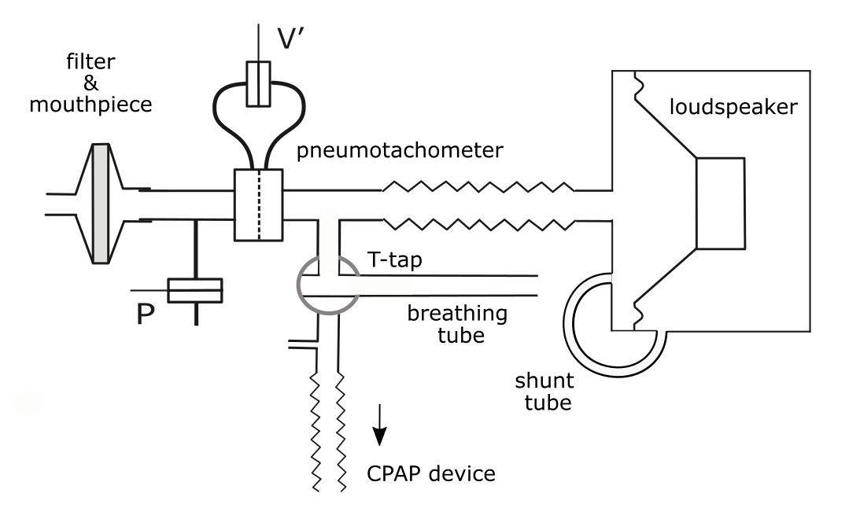

Table S2: Extended list of measured and calculated values of intra-breath oscillometry
Parameter | Unit | Definition
Vt | litre | Tidal volume
Frequency | min⁻¹ | Breathing frequency
Ti/Ttot |  | Inspiratory time divided by breathing cycle time
Te/Ttot |  | Expiratory time divided by breathing cycle time
Rmean | hPa·s·L⁻¹ | Mean respiratory resistance during the breathing cycle
RmeanE | hPa·s·L⁻¹ | Mean respiratory resistance during the expiration
RmeanI | hPa·s·L⁻¹ | Mean respiratory resistance during the inspiration
ReE | hPa·s·L⁻¹ | Respiratory resistance at the end of expiration
ReI | hPa·s·L⁻¹ | Respiratory resistance at the end of inspiration
ΔR | hPa·s·L⁻¹ | Difference between ReE and ReI
ARV | hPa·s | Area of the resistance vs volume diagram
ARV’ | hPa·s·L⁻¹ | Area of the resistance vs flow diagram
Xmean | hPa·s·L⁻¹ | Mean respiratory reactance during the breathing cycle
XmeanE | hPa·s·L⁻¹ | Mean respiratory reactance during the expiration
XmeanI | hPa·s·L⁻¹ | Mean respiratory reactance during the inspiration
EFL index (ΔXmean) | hPa·s·L⁻¹ | Difference between XmeanE and XmeanI
XeE | hPa·s·L⁻¹ | Respiratory reactance at the end of expiration
XeI | hPa·s·L⁻¹ | Respiratory reactance at the end of inspiration
ΔX | hPa·s·L⁻¹ | Difference between XeE and XeI
AXV | hPa·s | Area of the reactance vs volume diagram
AXV’ | hPa | Area of the reactance vs flow diagram

Table S3: Oscillometry values corresponding to different CPAP levels. Data are presented as mean±SD. *=p<0.05
Vt = tidal volume; Ti = time of the inspiration; Ttot = time of the breathing cycle; ReE = end expiratory resistance; ReI = end inspiratory resistance; ΔR = difference between ReE and ReI; ΔXmean = difference between the mean expiratory and mean inspiratory reactance; XeE = end expiratory reactance, XeI = end inspiratory reactance, ΔX = difference between XeE and XeI, AXV = Area of Xrs vs volume diagram; AXV’= Area of Xrs vs flow diagram;
Mean. SD | No CPAP  N = 33 |  | CPAP 5 hPa  N = 33 |  | CPAP 10 hPa N = 31 |  | CPAP 15 hPa N = 29 |  | CPAP 20 hPa N = 29 |  | Friedman  p-value | r
Vt  (liter) | 0.96 | ±0.25 | 1.10 | ±0.37 | 1.21 | ±0.40 | 1.24 | ±0.47 | 1.17 | ±0.44 | 0.0000* | 0.2045
Frequency  (1/min) | 16.70 | ±4.31 | 15.47 | ±4.05 | 15.31 | ±4.11 | 15.70 | ±3.99 | 16.68 | ±4.29 | 0.0045* | 0.1065
Ti/Ttot | 0.44 | ±0.04 | 0.43 | ±0.04 | 0.42 | ±0.04 | 0.41 | ±0.03 | 0.42 | ±0.05 | 0.0438* | 0.0558
ReE  (hPa*s*L⁻¹) | 5.65 | ±1.82 | 4.64 | ±1.38 | 4.35 | ±1.62 | 4.08 | ±1.59 | 3.43 | ±1.35 | 0.0000* | 0.4561
ReI  (hPa*s*L⁻¹) | 3.21 | ±0.92 | 2.83 | ±0.89 | 2.67 | ±0.93 | 2.60 | ±0.96 | 2.64 | ±1.15 | 0.0000* | 0.2860
ΔR  (hPa*s*L⁻¹) | 2.44 | ±1.45 | 1.81 | ±1.09 | 1.69 | ±1.18 | 1.47 | ±0.95 | 0.80 | ±0.80 | 0.0000* | 0.3467
ΔXmean  (hPa*s*L⁻¹) | -3.40 | ±2.15 | -2.32 | ±1.79 | -1.60 | ±1.51 | -0.81 | ±1.15 | -0.26 | ±0.56 | 0.0000* | 0.7906
XeE  (hPa*s*L⁻¹) | -4.25 | ±2.26 | -3.11 | ±2.32 | -2.06 | ±2.04 | -1.23 | ±1.57 | -0.42 | ±0.71 | 0.0000* | 0.9046
XeI  (hPa*s*L⁻¹) | -0.58 | ±0.54 | -0.41 | ±0.51 | -0.40 | ±0.51 | -0.36 | ±0.41 | -0.30 | ±0.45 | 0.0000* | 0.1971
ΔX  (hPa*s*L⁻¹) | -3.67 | ±2.04 | -2.69 | ±2.04 | -1.65 | ±1.76 | -0.87 | ±1.33 | -0.12 | ±0.43 | 0.0000* | 0.8672
AXV  (hPa) | 2.58 | ±1.42 | 1.98 | ±1.24 | 1.53 | ±1.18 | 0.84 | ±1.20 | 0.34 | ±0.70 | 0.0000* | 0.6063
AXV’ (hPa*s*L⁻¹) | -5.09 | ±2.92 | -3.95 | ±2.93 | -2.70 | ±2.57 | -1.50 | ±1.83 | -0.40 | ±0.65 | 0.0000* | 0.7966
ARV  (hPa) | -1.55 | ±1.30 | -1.82 | ±1.31 | -2.42 | ±1.17 | -2.38 | ±1.55 | -2.01 | ±1.55 | 0.00201* | 0.1242
ARV’  (hPa·s·L⁻¹) | 3.10 | ±1.89 | 2.78 | ±1.84 | 2.68 | ±2.85 | 2.53 | ±1.41 | 1.61 | ±1.51 | 0.00358* | 0.1117

Figure S2: Intra-breath changes of impedance values of the study patients during different CPAP levels. The two components of respiratory impedance (Zrs), resistance (Rrs) and reactance (Xrs) are marked with grey and red colours respectively. The Rrs and Xrs recordings of a single patient are mapped against tidal volume and tidal flow parameters. The arrows mark the direction of looping during a single breathing cycle.
Two types of expiratory interference of the glottis can be visible: one resembling a “trapeze-like” looping pattern in the Rrs vs volume diagram with continuously increased Rrs during expiration (ac), ad), ah), ai), al), aq), ar), at), au), av), aw), az), ba)), or another with a gradual end-expiratory increase in Rrs (ae), af), aj), am), bc), bf)).

Zrs=respiratory impedance, Rrs=respiratory resistance, Xrs= respiratory reactance
