Supplementary Results.
1. Changing the number of sequences and their length by the same factor approximately preserves ratios between numbers of motif sets of different sizes.
Given are the set of $N$ sequences with length $l$ and the motif width . The number of motif sets $M$ of size $x$ is:
$M\left(x|N\right)=\left(\begin{matrix}N \\ x\end{matrix}\right){\left(l-w\right)}^{x}$ (1s)
It is desirable to decrease the number of sequence and their length such that the following equality is satisfied:
$\frac{M(x_{i}|N,l)}{M(x_{j}|N,l)}=\frac{M(x_{i}|αN,βl)}{M(x_{j}|αN,βl)}$ (2s)
Suppose, $α$ is known. We need to find the value of $β$, such that eq.(2s) is satisfied. After simplifying eq.(2s):
$β=\frac{1}{l}\left[\left(l-w\right)\frac{αN-x_{i}+1}{N-x_{i}+1}+w\right]≈α$ (3s)

Supplementary
Supplementary Figures.
Fig. S1. The performance of the population size estimator.
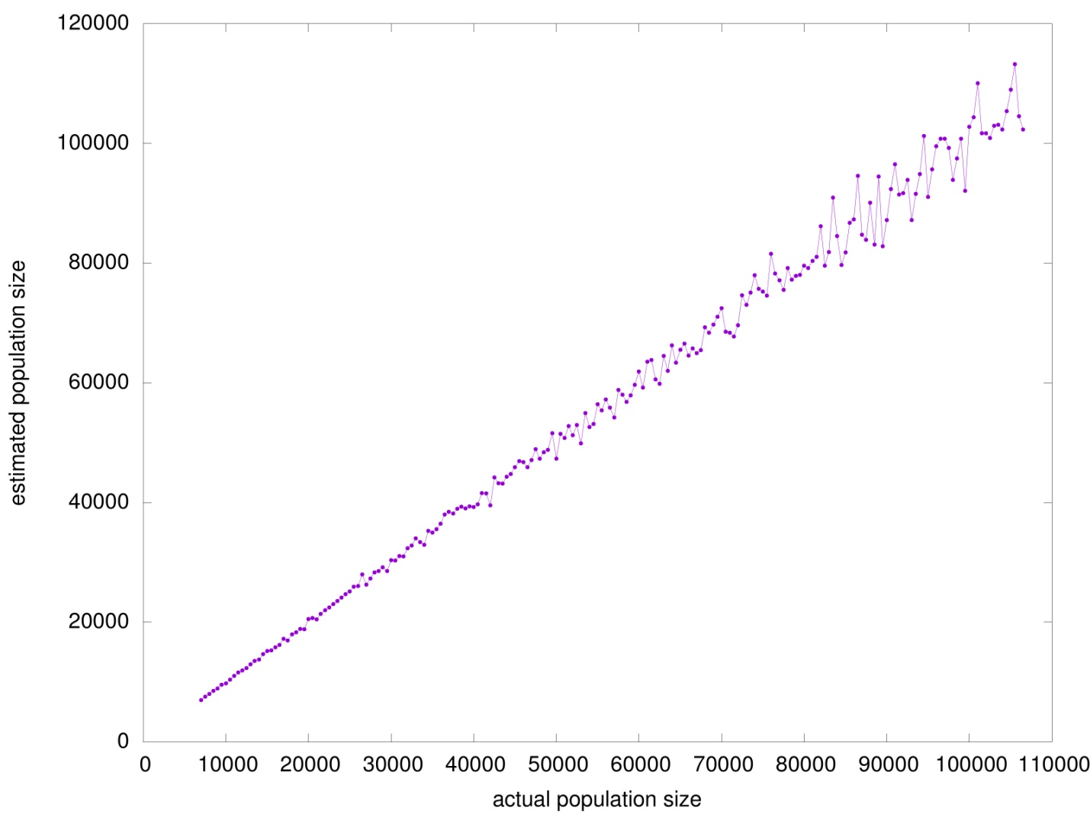

Fig.S2. Fractions of motif sets with size larger than $\frac{N}{2}$ ($N$ - number of sequences).
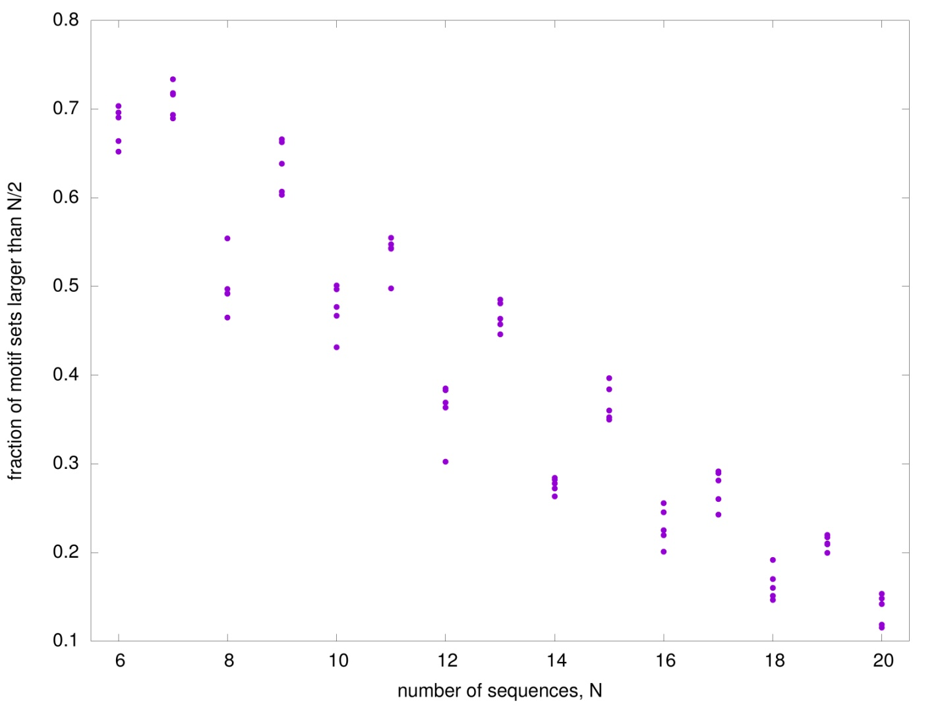

Fig. S3. Evaluation of the four lasso regression models. The value of the penalty coefficient ranged from 0.0 to 0.08 (step 0.001) for models#2 and 3, and from 0.0 to 0.05 (step 0.001) for models##0 and 1.
A) The relation between the coefficient of determination and degrees of freedom. B) The relation between the Kendal correlation coefficient and degrees of freedom.
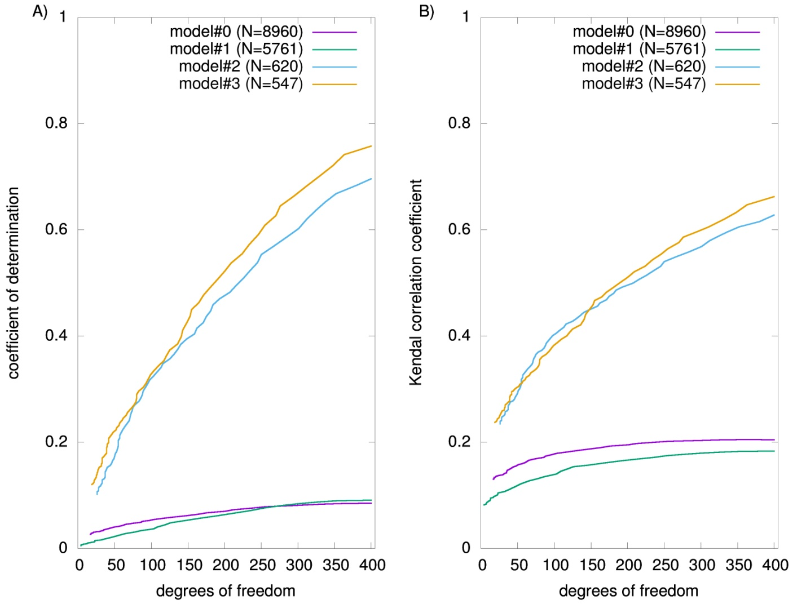

Fig. S4. Logos of 43 significant motifs identified by glmnet() function. Motifs are signed with values of their regression coefficients.
