Supplemental Information

Table S1
Primers used for cloning.
Plasmid and DNA | Sequence (5’→3’)
pYD1-ScafI | olpa F: GAGGATCCACAAACACCATTGAAATAA  olpa R: GCTCGAGGCTTTATCTGCCTCCGGAGCGGATG
pYD1-ScafI | sdba F: CATCCGCTCCGGAGGCAGATAAAGCCTCGAGC  sdba R: CTGCGGCCGCTTATGCAGGCGAAGGCGTC
pYD1-XynII | xynii F: AGCTTTGGATCCTTATATAGTTATAAGTCC  xynii R: TGGAGCCTGTGAAGTGCTGACGGTGATGGA
pYD1-XynII | doc-sdba F: TCCATCACCGTCAGCACTTCACAGGCTCCA  doc-sdba R: AGCTTTGTTTAAACTTACTGTGCGTCGTAA
pYD1-XylA | xyla F: GAGGATCCAAAAGACAAGCAAACCAAAGC  xyla R: CATTAAGCACAACAGGTTGCGGCGCAATCAAC
pYD1-XylA | doc-olpa F: GTTGATTGCGCCGCAACCTGTTGTGCTTAATG  doc-olpa R: AGCTTTGTTTAAACTTATATAGTTATAAGTCC
5’ Delta homologous arms | 5’-δ F: GCCGCGTGTTGGAATAGAAATCAACTATC
5’ Delta homologous arms | 5’-δ R: GAGGAAGCTGAAACGCAATATTTTAGATTCCTGACTTC
3’ Delta homologous arms | 3’-δ F: AATACTACTCAGTAATAAAAAATGATGATAATAATAT
3’ Delta homologous arms | 3’-δ R: CGGCCATGAGAAATGGGTGAATG
PGK | pgk F: GAGGAAGCTGAAACGCAATATTTTAGATTCCTGACTTC
PGK | pgk R1: CAACTTAATAGAAGGCATCGTTTTGTTTTATATTTGTTGTA  pgk R2: GGAAGGGTTAGCAGTCATCGTTTTGTTTTATATTTGTTGTA
XR | xr F: ACAACAAATATAAAACAAAACGATGCCTTCTATTAAG
XR | xr R: GTTATCAGATCAGCGGGTTTAAACTTAGACGAAGATAGGAATC
XDH | xdh F: TACAACAAATATAAAACAAAACGATGACTGCTAACCCTTCC
XDH | xdh R: GTTATCAGATCAGCGGGTTTAAACTTACTCAGGGCCGTCAATG
MATT | MATT F1: GATTCCTATCTTCGTCTAAGTTTAAACCCGCTGATCTGATAA  MATT F2: CATTGACGGCCCTGAGTAAGTTTAAACCCGCTGATCTGATA
MATT | MATT R: TATTATTATCATCATTTTTTATTACTGAGTAGTAT
gRNA1 | gRNA1-F: CCAAAACGCAAGGATTGATAATGTAATGTTTT
gRNA1 | gRNA1-R: CTCTAAAACATTACATTATCAATCCTTGCGTT

Table S2
Primers used for qPCR.
Target Gene | Sequence (5’→3’)
XYL1 | qX1-F: GAGGTGCTACCATCAAGCCATCTG
XYL1 | qX1-R: CGAACGAAGAGTAAGCGGTGACAG
XYL2 | qX2-F: CTTTGGTGCTGGTCCTGTTGGTC
XYL2 | qX2-R: CGGTCTTGGAGTTGAAGGTGTGAG
ALG9 | qALG9-F: GCCGTCTACGAGCAATTTTC
ALG9 | qALG9-R: ATCTGGCAGCAGGAAAGAAC

Figure S1. A schematic representation of plasmid construction.

Fig. S1A. pDi-g1 plasmid for δ-integration CRISPR-Cas9.

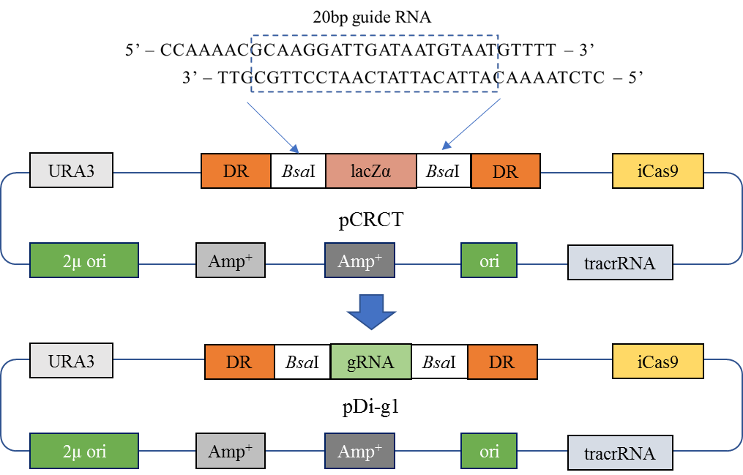

Fig. S1B. Surface displaying plasmid for anchoring scaffoldin.

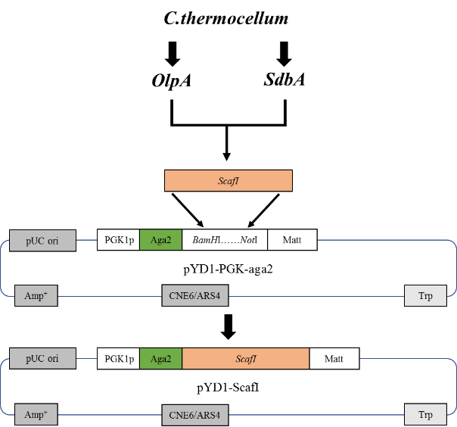

Fig. S1C. Secretion expression plasmids for two types of xylanases.

