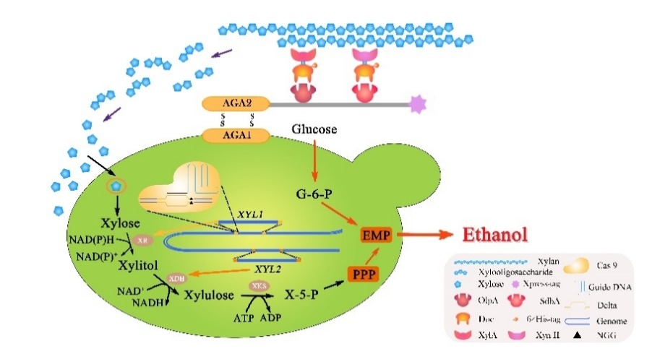

A mincellulosome attaching on the xylose-utilizing recombinant yeast strain is developed for synergistic catalysis and cellulosic ethanol co-fermentation from steam-exploded Pennisetum purpureum. Here, our elaborated organization presents an approach designed toward genetic engineering of S. cerevisiae, a widespread, industrially important microorganism, for improved lignocellulolytic potential and advanced capability of consolidated bioprocessing.

