Supplementary Material

Fig. S1 The relationship of S. obliquus biomass with cyanobacteria biomass. Solid points represent the 15 samples where S. obliquus was detected.

Fig. S2 The proportions of 22 fatty acids detected in our samples. Samples are ranked in ascending order according to Chl a concentration.

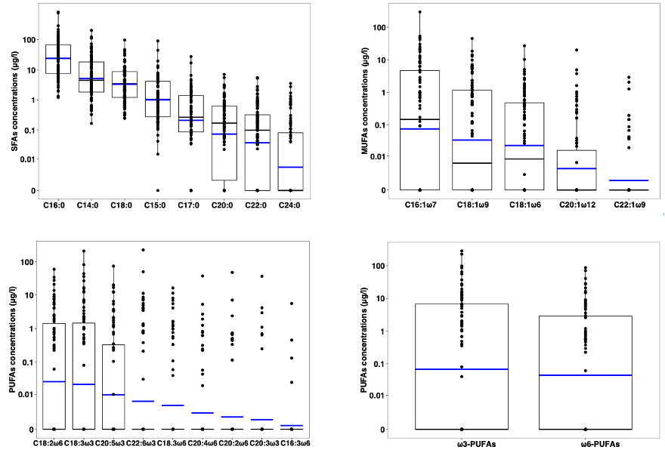
Fig.S3 Boxplot of the concentrations of fatty acids detected in our investigated waters. The boxes represent median values and inter-quantile ranges. The blue lines represent mean values. y-axis is on log10 scale.

Table S1 Morphological variables of the investigated lakes and reservoirs and the number of samples.
 | Sites | Mean depth  (m) | Surface area  (m²) | Volume  (10⁸ m³) | Number of samples
Lakes | Xihu | 2 | 6.2 | 0.15 | 3
 | Xiannvhu | 2 | 1.4 | 0.028 | 7
 | Luhu | 2 | 0.2 | 0.004 | 2
 | Zhongxinhu | 2 | 2.12 | 0.004 | 8
 | Liuhuahu | 2 | 0.3 | 0.006 | 3
Reservoirs | Qiyeshi | 4 | 1.5 | 0.06 | 9
 | Chishijing | 5 | 2 | 0.1 | 3
 | Shatian | 7 | 3 | 0.2 | 3
 | Hedi | 9 | 122 | 11.4 | 3
 | Shenzhen | 9 | 4.4 | 0.4 | 7
 | Dajingshan | 9 | 5 | 0.12 | 3
 | Dashahe | 16 | 16 | 2.4 | 3
 | Tangxi | 18 | 21 | 3.78 | 8
 | Gaozhou | 18 | 58.5 | 11 | 3
 | Feilaixia | 21 | 90 | 19 | 8
 | Liuxihe | 21 | 15 | 3.25 | 9
 | Xinfengjiang | 31 | 370 | 115 | 8
 | All | / | / | / | 90

Table S2 Average values and standard deviations (s.d.) of TN, TP and Chl a concentrations in the investigated lakes and reservoirs.

 | Sites | TN (mg/L)  Mean ± s.d. | TP (mg/L)  Mean ± s.d. | Chl a (mg/L)  Mean ± s.d.
Lakes | Xihu | 1.01 ± 0.08 | 0.090 ± 0.05 | 13.4 ± 5.5
 | Xiannvhu | 1.17 ± 0.79 | 0.067 ± 0.03 | 21.6 ± 15.7
 | Luhu | 2.17 ± 0.88 | 0.049 ± 0.03 | 24.2 ± 2.7
 | Zhongxinhu | 1.65 ± 1.62 | 0.073 ± 0.03 | 24.5 ± 20.7
 | Liuhuahu | 5.14 ± 1.21 | 0.256 ± 0.16 | 182 ± 50.6
Reservoirs | Qiyeshi | 1.35 ± 0.63 | 0.037 ± 0.02 | 18.5 ± 12.8
 | Chishijing | 0.93 ± 0.43 | 0.013±0.006 | 2.0 ± 0.5
 | Shatian | 0.98 ± 0.62 | 0.008±0.002 | 1.4 ± 0.1
 | Hedi | 0.89 ± 0.10 | 0.013±0.006 | 8.5 ± 8.1
 | Shenzhen | 2.83 ± 1.42 | 0.090 ± 0.05 | 10.3 ± 7.0
 | Dajingshan | 1.40 ± 0.99 | 0.036±0.006 | 12.7 ± 7.6
 | Dashahe | 0.58 ± 0.04 | 0.031 ± 0.02 | 6.9 ± 4.7
 | Tangxi | 1.26 ± 0.70 | 0.038 ± 0.02 | 10.4 ± 7.8
 | Gaozhou | 0.80 ± 0.12 | 0.020 ± 0.02 | 5.9 ± 4.9
 | Feilaixia | 0.94 ± 0.53 | 0.016 ± 0.02 | 2.2 ± 1.1
 | Liuxihe | 0.60 ± 0.61 | 0.014 ± 0.01 | 3.1 ± 5.6
 | Xinfengjiang | 0.50 ± 0.27 | 0.011 ± 0.01 | 0.9 ± 0.5

