Supplementary Information for
Pervasive hydrous carbonatitic liquids mediate transfer of carbon
from the slab to the subarc mantle
Wei Chen¹, Guoliang Zhang^{1,2,3*}, Shantanu Keshav ⁴, Yuan Li⁵

¹Center of Deep Sea Research Institute of Oceanology, Chinese Academy of Sciences, Qingdao 266071, China,
²Laboratory for Marine Geology, Qingdao National Laboratory for Marine Science and Technology, Qingdao 266000, China,
³Center for Ocean Mega-Science, Chinese Academy of Sciences, Qingdao 266071, China.
⁴ Thapar School of Liberal Arts and Sciences, Thapar Institute of Engineering and Technology
Patiala, Punjab, India
⁵State Key Laboratory of Isotope Geochemistry, Guangzhou Institute of Geochemistry, Chinese Academy of Sciences, 510640 Guangzhou, China.

Supplementary information includes:

Supplementary Figures 1-5

Supplementary Tables 1-11 (Files uploaded separately)
Supplementary References

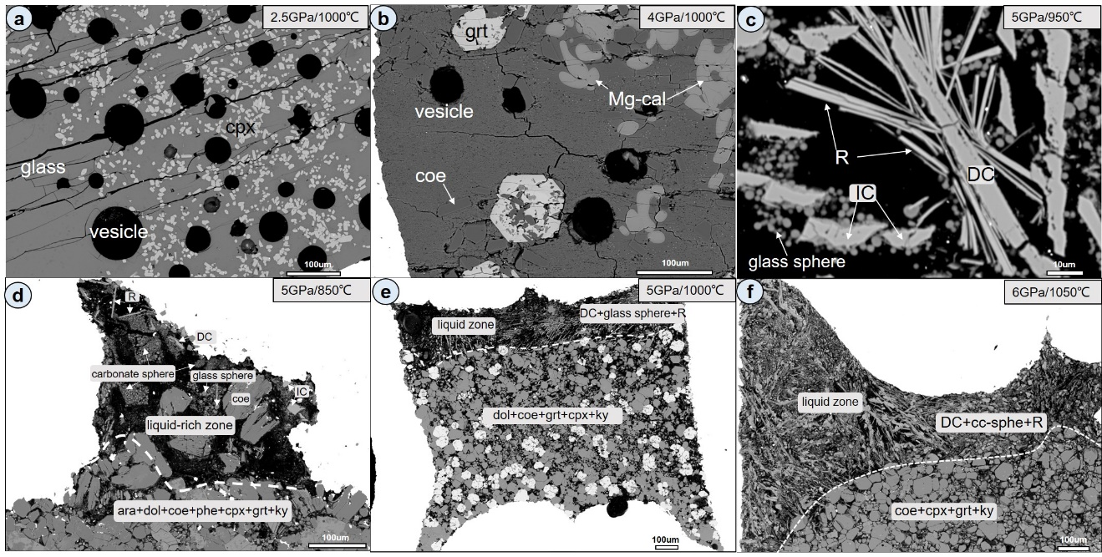
Supplementary Fig. 1. Backscatter electron images of quenched charges. (a) and (b) Large vesicles occur in the silicate glass, which indicate equilibrium presence of free CO₂-rich vapor under the run conditions. (c) Quenched carbonatitic liquid is composed of dendritic carbonate (DC), irregular carbonate (IC), Si-Al-K-Fe-rich acicular phase (R) and small glass spheres. (d)-(f) Quenched carbonatitc liquids are only collected in the upper most part of the capsule, and there is a distinct boundary between the liquid zone and residual crystalline phases. Abbreations as Figure 3.

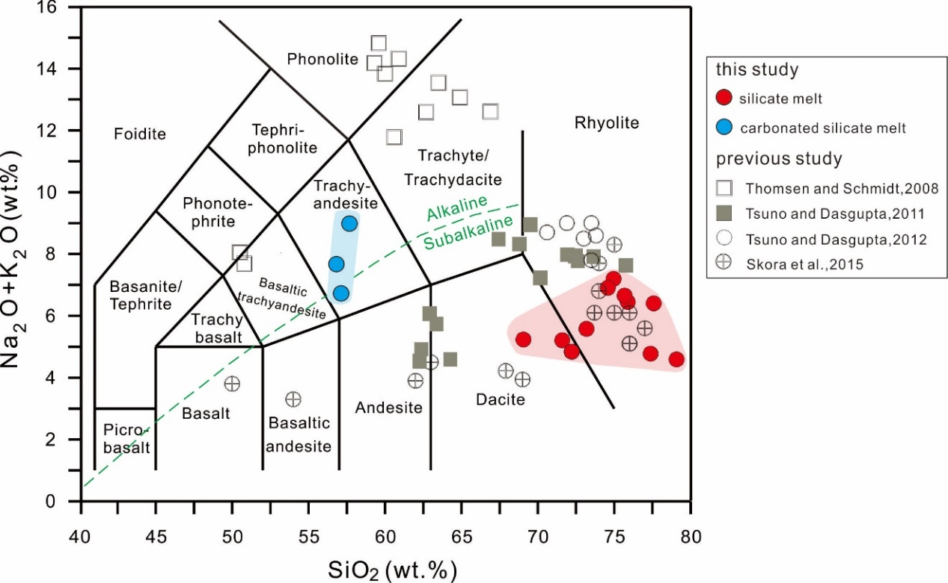
Supplementary Fig. 2. Total alkalis (Na₂O + K₂O) versus silica diagram with the relevant fields labeled based on the classification of Le Maitre (1984). Silicate melts and carbonated silicate melts are indicated by red and blue circles, respectively. Experimental melts from previous studies on melting of carbonated sediments are also shown for comparison.
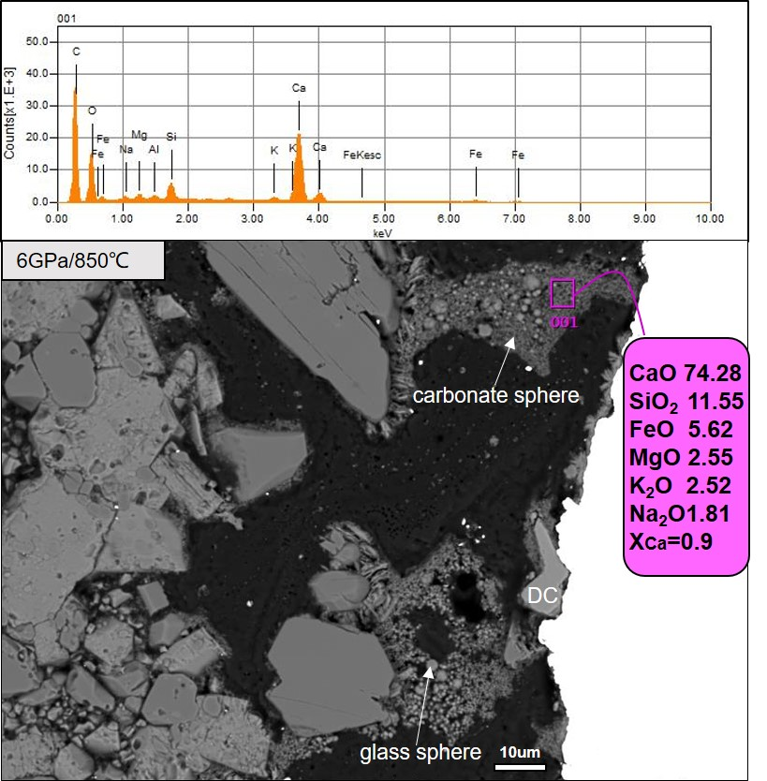
Supplementary Fig. 3. EDS analysis of the quenched carbonate spheres. The analyzed compositions (normalized to 100 wt.% on anhydrous basis) are extremely rich in CaO, and such amorphous spheres are inferred be quenched CaCO₃-rich carbonates. X_{Ca} = molar Ca/ Ca+ Mg+Fe. The sizes of glass spheres are much larger than those of carbonate sphere.

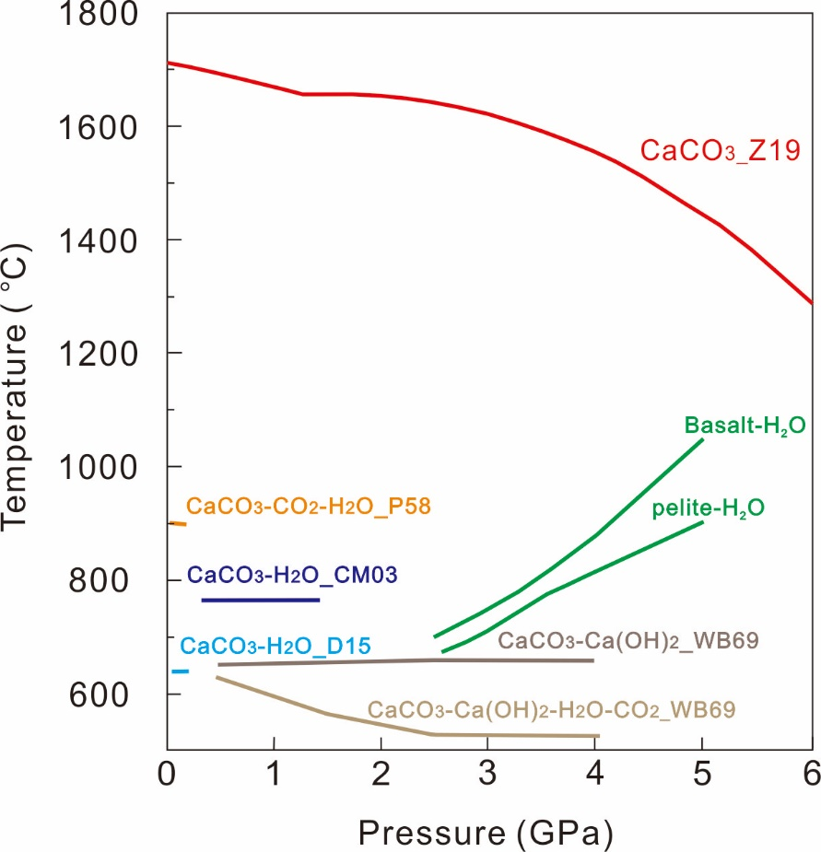
Supplementary Fig. 4. Comparison of the solidus for dry calcite, hydrous calcite, and hydrous, CO₂-free pelite and basalt. The solidus temperatures of the hydrous CaCO₃ are approximately 500-1000 ℃ lower than those of the dry calcite below 6 GPa. The solidus temperatures of calcite are nearly pressure independent or show a negative correlation with pressure, whereas the solidus of hydrous, CO₂-free sediments and basalt have a position Clapeyron slope. Data sources: P58 - Paterson (1958); WB69 - Wyllie and Boettcher (1969); IW75 - Irving and Wyllie (1975); CM03 - Caciagli and Manning (2003); D15 - Durand et al (2015); FM15 - Foustoukos and Mysen (2015); Z19 - Zhao et al. (2019); Pelite-H₂O – Nichols et al. (1994); Schmidt et al. (2004); Basalt-H₂O – Schmidt and Poli (1998); Kessel et al. (2005).
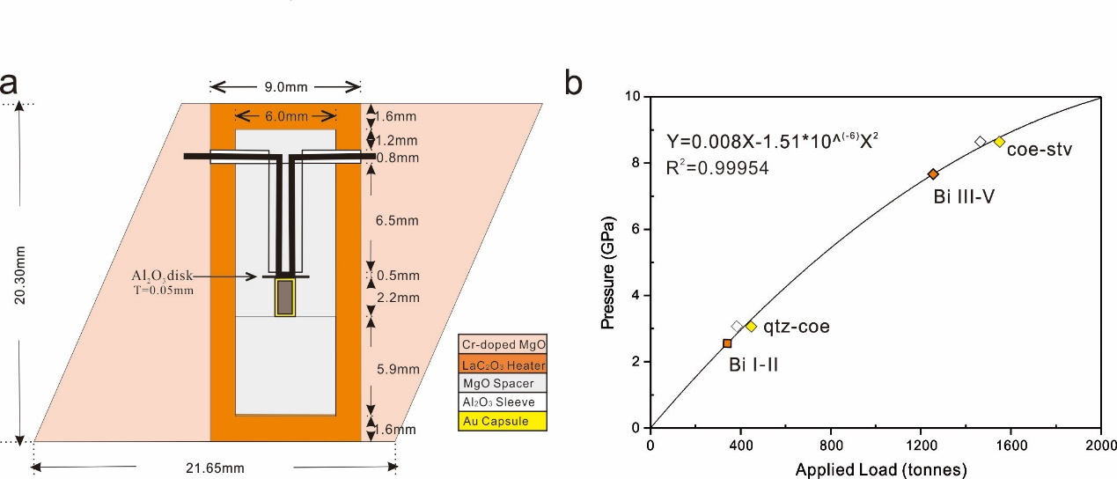
Supplementary Fig. 5. (a) Cross section of the octahedral pressure cell with the edge length of 25 mm as used in the present study; (b) pressure calibration curve which relating the oil pressure to the attained specimen pressure in GPa.

Supplementary References
Bose, K., & Ganguly, J. (1995). Quartz-coesite transition revisited: Reversed experimental determination at 500–1200 °C and retrieved thermochemical properties. American Mineralogist, 80, 231-238. https://doi.org/10.2138/am-1995-3-404
Caciagli, N. C., & Manning, C. E. (2003).The solubility of calcite in water at 6-16 kbar and 500-800 °C. Contributions to Mineralogy and Petrology, 146, 275-285. https://doi.org/10.1007/s00410-003-0501-y
Decker, D. L., Bassett, W. A., Merrill, L., Hall, H. T., & Barnett, J. D. (1972). High‐Pressure Calibration: A Critical Review. Journal of Physical and Chemical Reference Data 1, 773-836, https://doi.org/10.1063/1.3253105
Durand, C., Baumgartner, L. P., & Marquer, D. (2015). Low melting temperature for calcite at 1000 bars on the join CaCO3-H2O – some geological implications. Terra Nova, 27(5), 364-369, https://doi.org/10.1111/ter.12168
Foustoukos, D. I., & Mysen, B. O. (2015). The structure of water-saturated carbonate melts. American Mineralogist, 100, 35-46, https://doi.org 10.2138/am-2015-4856
Irving, A. J., & Wyllie, P. J. (1975). Subsolidus and melting relationships for calcite, magnesite and the join CaCO₃-MgCO₃ to 36 kb. Geochimica et Cosmochimica Acta, 39(1), 35-53, https://doi.org/10.1016/0016-7037(75)90183-0
Kessel, R., Schmidt, M.W., Ulmer, P., & Pettke, T.(2005). Trace element signature of subduction-zone fluids, melts and supercritical liquids at 120–180 km depth. Nature, 437, 724–727, https://doi.org/10.1038/nature03971
Le Maitre, R. W. (1984). A proposal by the IUGS Subcommission on the Systematics of Igneous Rocks for a chemical classification of volcanic rocks based on the total alkali silica (TAS) diagram, Australian Journal of Earth Sciences, 31(2), 243-255, https://doi.org/110.1080/08120098408729295
Mori, T., & Green, D. H. (1976). Subsolidus equilibria between pyroxenes in the CaO-MgO-SiO₂ system at high pressures and temperatures. American Mineralogist, 61(7-8), 616-625
Nichols, G.T., Wyllie, P.J., & Stern, C.R. (1994). Subduction zone-melting of pelagic sediments
constrained by melting experiments. Nature, 371, 785–788, https://doi.org/10.1038/371785a0
Ono, S., Kikegawa, T., Higo, Y., & Tange, Y. (2017). Precise determination of the phase boundary between coesite and stishovite in SiO₂. Physics of the Earth and Planetary Interiors, 264, 1-6, https://doi.org/10.1016/j.pepi.2017.01.003
Paterson, M. S. (1958). The melting of calcite in the presence of water and carbon dioxide. American Mineralogist, 43(5-6), 603-606.
Schmidt, M.W., Vielzeuf, D., & Auzanneau, E. (2004). Melting and dissolution of subducting
crust at high pressures: the key role of white mica. Earth and Planetary Science Letters, 228, 65–84, https://doi.org/10.1016/j.epsl.2004.09.020
Schmidt, M.W., & Poli, S. (1998). Experimentally based water budgets for dehydrating slabs
and consequences for arc magma generation. Earth and Planetary Science Letters, 163, 361–379, https://doi.org/10.1016/S0012-821X(98)00142-3
Wyllie, P. J., & Boettcher, A. L. (1969). Liquidus Phase Relationships in the System CaO-CO₂-H₂O to 40 Kilobars Pressure with Petrological Applications. American Journal of science, 267, 489-508.
Woolley, A.R., & Kempe, D.R.C. (1989). Carbonatites: nomenclature, average chemical compositions, and element distribution. In: Bell, K. (Ed.), Carbonatites. Genesis and Evolution, Unwin Hyman, London, 1–14.
Zhao, S., Schettino, E., Merlini, M., & Poli, S. (2019). The stability and melting of aragonite: An experimental and thermodynamic model for carbonated eclogites in the mantle. Lithos, 324-325, 105-114, https://doi.org/10.1016/j.lithos.2018.11.005

