Supplementary information
A touchless user interface based on a near-infrared sensitive transparent optical imager using printed Cu grid electrodes.
Takeshi Kamijo^{1,✉}, Albert J.J.M. van Breemen^{2, ✉}, Xiao Ma³, Santhosh Shanmugam^{2, 4}, Thijs Bel², Gerard Haas², Bart Peeters², Razvan Petre², Daniel Tordera^{2, 5}, Roy Verbeek², Hylke Akkerman², Luis Moreno Hagelsieb⁶, Florian de Roose⁶, Itai Lieberman⁶, René A. J. Janssen³, Eric A. Meulenkamp², Auke Jisk Kronemeijer², Gerwin H. Gelinck^{2, 3}

¹Asahi Kasei Corporation, PED project, Marketing & Innovation, 2-1 Samejima, Fuji, Shizuoka, 416-8501, Japan.
²TNO at Holst Centre, The Dutch Organization for Applied Scientific Research, High Tech Campus 31, Eindhoven 5656 AE, The Netherlands.
³Department of Applied Physics, Eindhoven University of Technology, 5600 MB Eindhoven, The Netherlands.
⁴Present address: Philips Engineering Solutions, High Tech Campus 4, 5656 AE Eindhoven, The Netherlands.
⁵Present address: Instituto de Ciencia Molecular (ICMol), Universidad de Valencia, Catedrático José Beltrán 2, 46980 Paterna, Spain
⁶imec, Kapeldreef 75, 3001 Leuven, Belgium

✉e-mail: kamijo.tb@om.asahi-kasei.co.jp; albert.vanbreemen@tno.nl

Keywords: printed Cu grid, transparent conductive electrodes, organic photodetector, touchless user interface, gesture recognition, optical imager

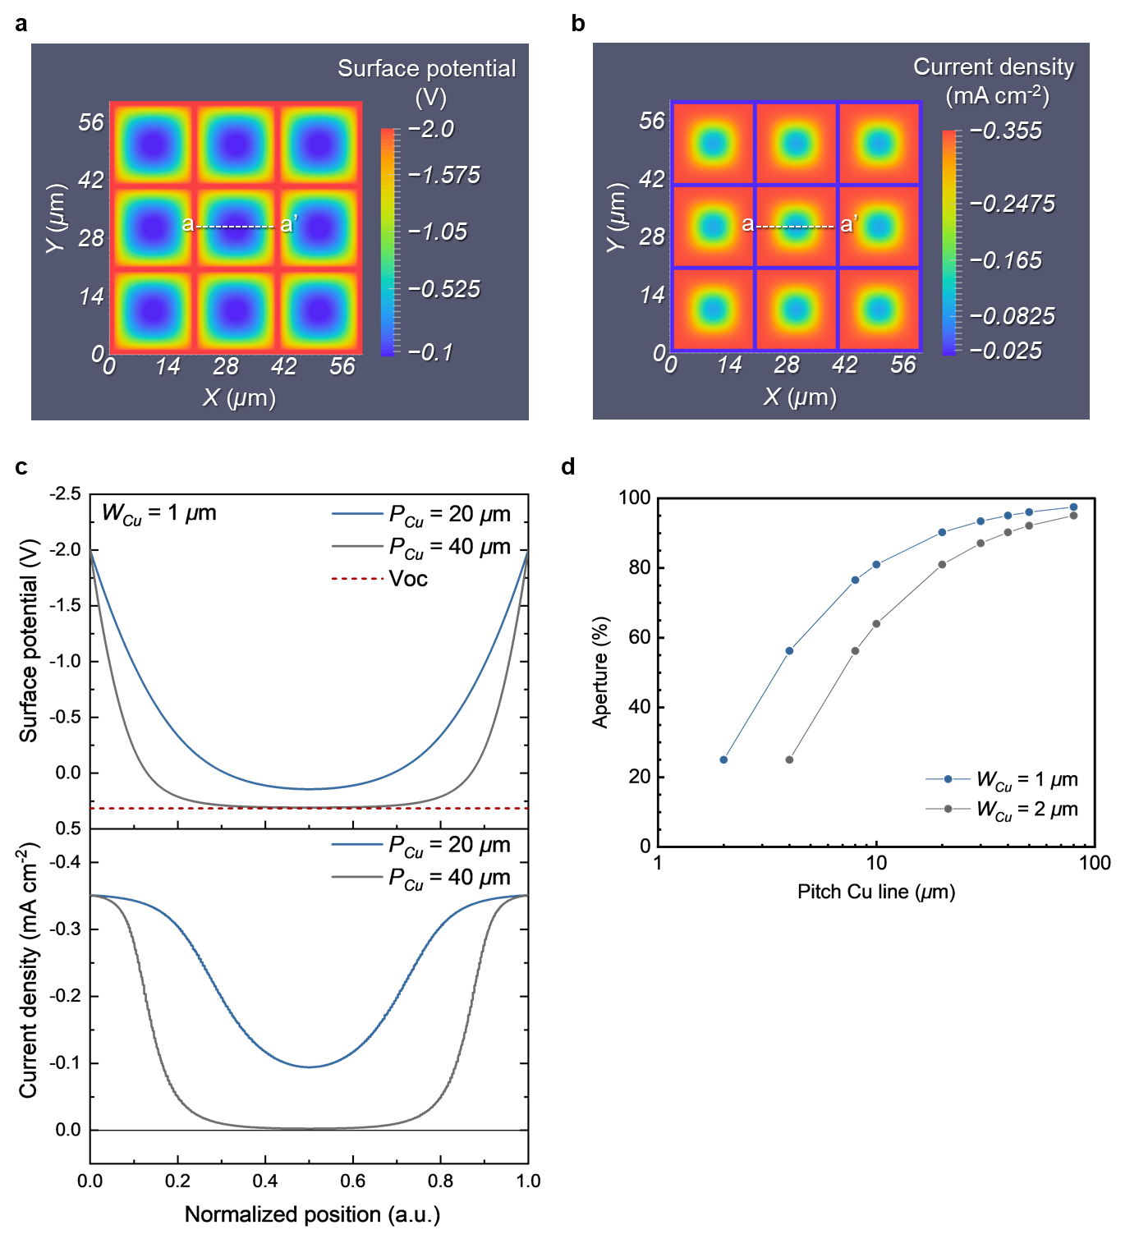
Supplementary Fig. 1 | EQE simulations for NIR sensitive OPDs with a printed Cu grid TCE. a, Two-dimensional plots of simulated surface potential and b, current density distributions on a-IGZO/Cu grid TCE (W_{Cu} = 1 µm, P_{Cu} = 20 µm) under 850-nm NIR light illumination with a light intensity of 1.05 mW cm⁻² at an applied voltage of −2 V. c, Cross-sectional simulated surface potential profiles (top graph) and current density profiles (bottom graph) at the P_{Cu} of 20 µm (blue) and 40 µm (grey) for the W_{Cu} of 1 µm along the a-a’ lines in the gap area in Supplementary Figs. 1a-b. The horizontal axis is normalized by the gaps for each pitch. An open circuit voltage (V_{OC} = ~0.3 V) of the studied system is shown as a red dotted line in the top graph. d, Calculated aperture of the printed Cu grid as a function of the P_{Cu} for the W_{Cu} of 1 µm (blue) and 2 µm (grey).

We conclude that EQE depending on the printed Cu grid design is determined by a trade-off between uniformizing a surface potential distribution in the gap area and decreasing shadowing effect of the printed Cu lines. Firstly, the decrease in EQE above a Cu line pitch of 20 μm, shown in Fig. 3a, is dominated by drops of the surface potential and the corresponding current density in the gap area. For the gap area, the surface potential distribution drastically decreases with increasing distance from the printed Cu lines due to ohmic losses attributed to that photocurrent flows laterally in a plane of high sheet resistance a-IGZO (35 × 10⁹ Ω □⁻¹), resulting in current density decreasing toward the center in the gap area (Supplementary Figs. 1a-b). In the studied system, when a pitch of the printed Cu grid is enlarged to 40 µm, there is a region where the surface potential in the gap area drops and is close to the open circuit voltage (V_{OC} = ~0.3 V), inducing decrease in the overall current density (Supplementary Fig. 1c).
Next, the decrease in EQE in a region where the pitch is less than 10 µm, shown in Fig. 3a is due to the shadowing effect. The surface potential on the printed Cu lines was almost equal to the applied voltage of –2 V as the printed Cu lines exhibit a very low sheet resistance (2.6 Ω □⁻¹), whereas the photocurrent density is an order of magnitude lower than that the one adjacent to the printed Cu lines in the gap area (Supplementary Figs. 1a-b). This is caused by the shadowing effect of the opaque printed Cu lines (VLT = ~10%, Supplementary Fig. 3a) that decreases the light intensity reaching the photoactive layer underneath those printed Cu lines (Supplementary Fig. 13a). The shadowing effect for the whole system can be roughly assessed based on the aperture of the printed Cu grid. The aperture decreases monotonically as the Cu line pitch decreases and the aperture at a given Cu line pitch increases with narrowing the Cu line width (Supplementary Fig. 1d). A 10% decrease in the aperture for the Cu line width of 2 µm compared to 1-µm line width at the Cu line pitch of 20 µm matches with the decrease in simulated EQE (Fig. 3a). This explains the decrease in EQE in the Cu line pitch below 10 µm, which is caused by the shadowing effect, that can be understood by the aperture and the VLT of the printed Cu grid.

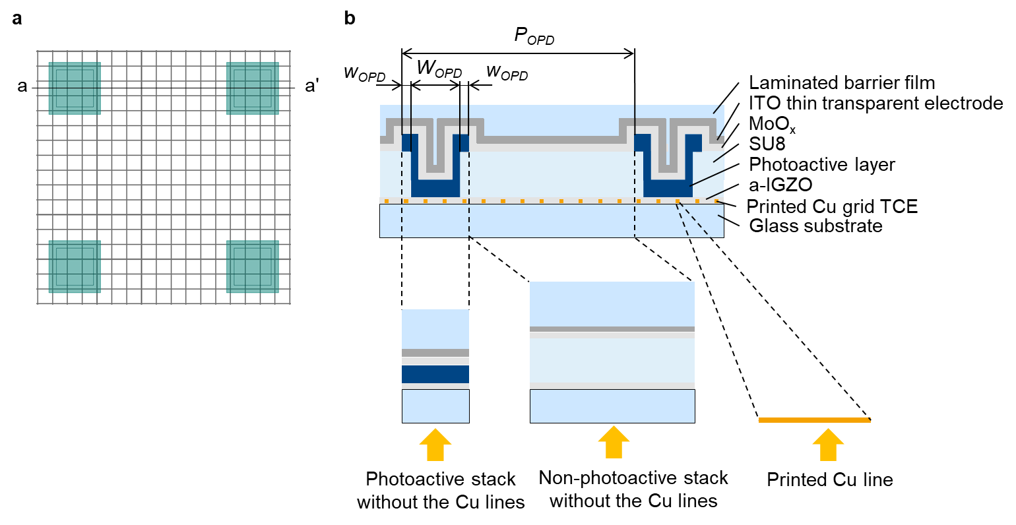
Supplementary Fig. 2 | Schematic drawing of an optical model for a parallel OPD subpixel array with a printed Cu grid TCE. a, An example of a parallel OPD subpixel array design. b, Cross sectional architecture of the parallel OPD subpixel array with a printed Cu grid TCE along a-a’ line shown in Supplementary Fig. 2a. Three simplified components for the optical transmittance prediction model: 1. a photoactive stack without the Cu lines (lower left), 2. a non-photoactive stack without the Cu lines (lower center), and 3. the printed Cu line (lower right). W_{OPD}, w_{OPD} and P_{OPD} represent an OPD subpixel width, an OPD subpixel overlap with the edge cover layer for alignment tolerance, and an OPD subpixel pitch, respectively.

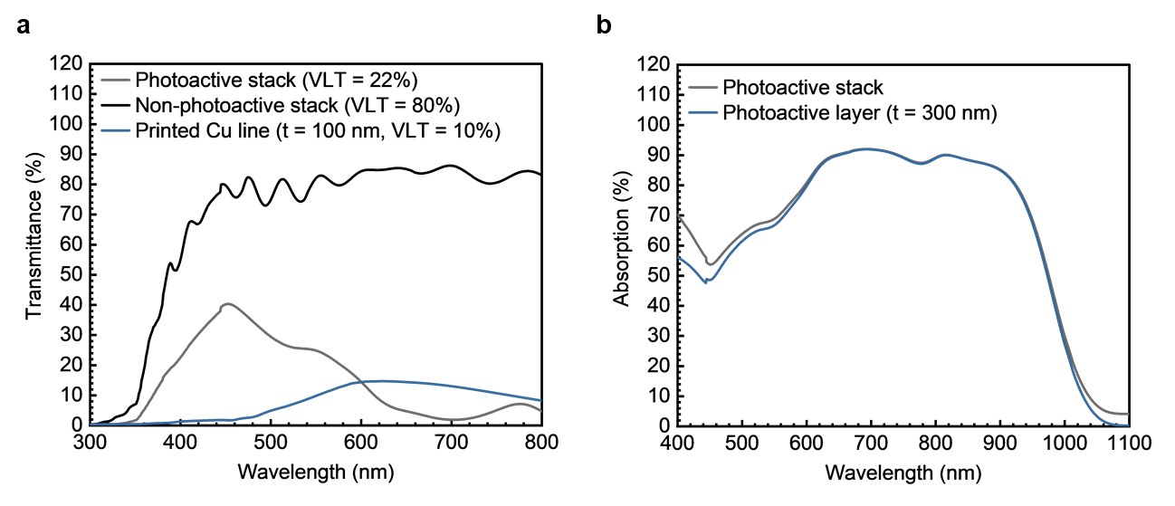
Supplementary Fig. 3 | Simulated optical transmittance of each simplified component. a, Simulated optical transmittance of a photoactive stack without the Cu lines (grey solid line), a non-photoactive stack without the Cu lines (black solid line), and the 100-nm thick printed Cu line (blue solid line). b, Simulated optical absorption of the 300-nm thick photoactive layer (blue solid line) in the photoactive stack without the Cu lines (grey solid line). The photoactive layer dominates optical absorption of the whole OPD stack in the visible-NIR wavelength region, leading to generate photoactivated charges. The other layers merely absorb in the visible-NIR wavelength region.

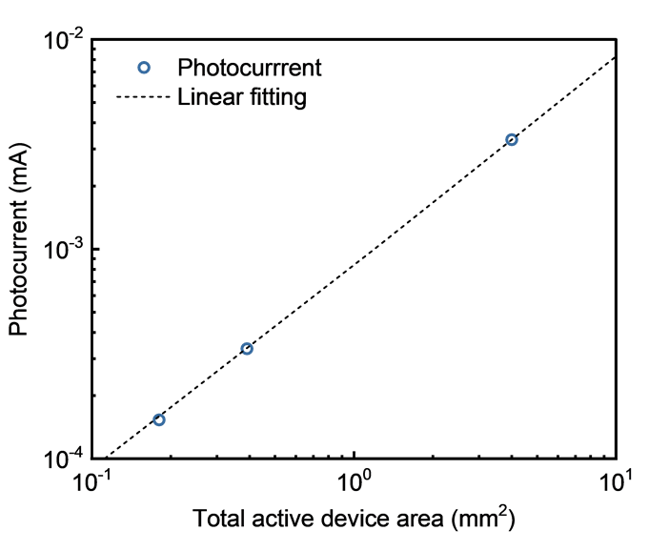
Supplementary Fig. 4 | Photocurrent as a function of total active device area for NIR sensitive OPDs with a printed Cu grid TCE. Blue open circles represent photocurrent with different electrically connected total active device areas: 0.181 mm² (patterned 17 × 17 parallel OPD subpixel array, a subpixel active area of 25 × 25 µm², a subpixel pitch of 120 µm), 0.391 mm² (patterned 25 × 25 parallel OPD subpixel array, a subpixel active area of 25 × 25 µm², a subpixel pitch of 80 µm), and 4 mm² (non-patterned OPD, an active area of 2 × 2 mm²), respectively. The printed Cu grid TCEs used in a series of the experiments consisted of a W_{Cu} of 1.1-1.2 µm, a P_{Cu} of 10 µm, and a thickness of 90-100 nm. The photocurrents were measured under illumination at a wavelength of 850 nm with a light intensity of ca. 0.28 mW cm⁻² at V = −2 V. Linear fitting curve of them is shown as a black dotted line. The photocurrent scaled linearly with increase in the total active device area.

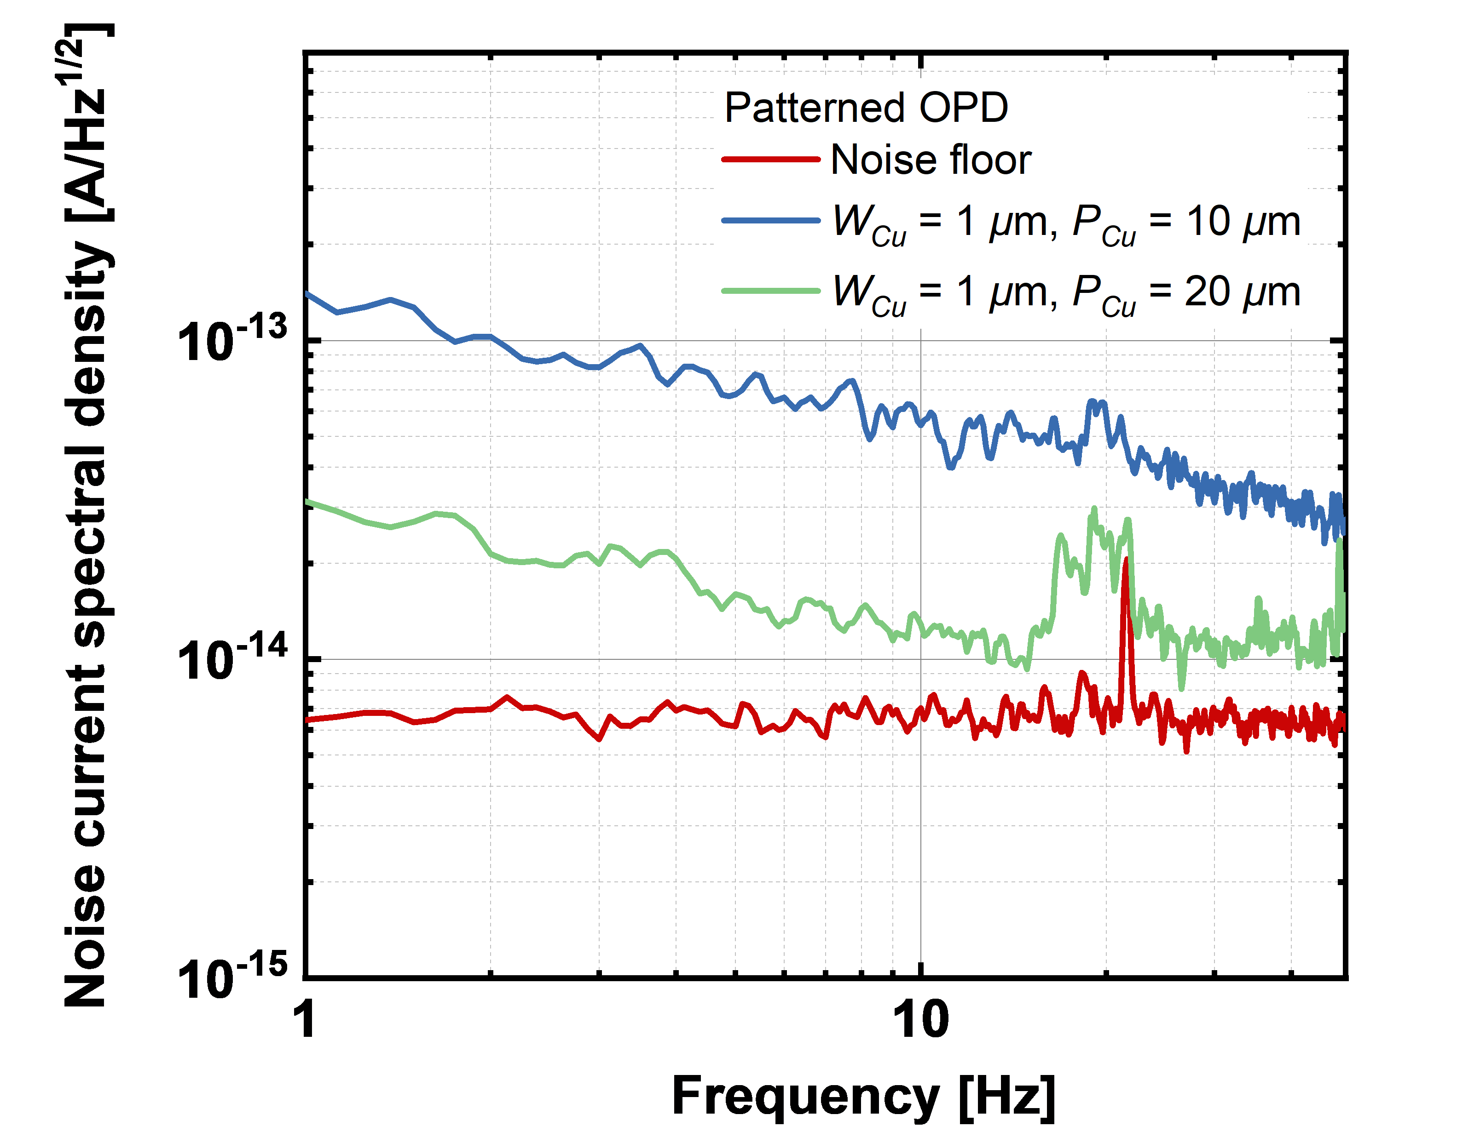
Supplementary Fig. 5 | Noise spectral density of discrete patterned NIR sensitive OPDs. Measurements for the noise spectral density of the discrete patterned NIR sensitive OPDs with the printed Cu grid TCF were performed at −2 V. Each current noise spectrum illustrated here is an average of 10 measurements. The red line represents the shot noise. The total active device area was 0.2025 mm².

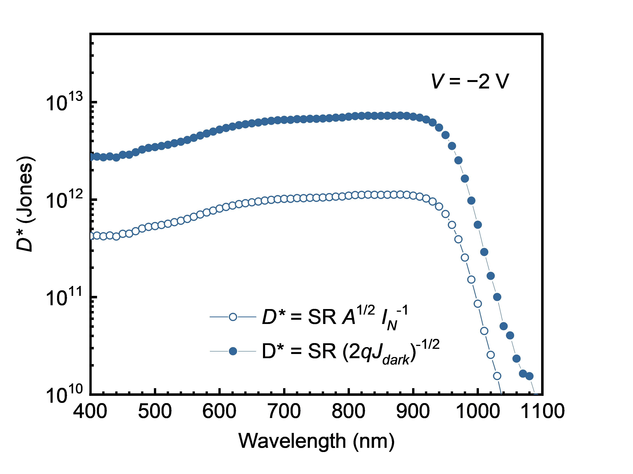
Supplementary Fig. 6 | Detectivity of a discrete patterned NIR sensitive OPD with a printed Cu grid TCE. Comparison of detectivity between calculated using D* = SR (2qJ_{dark})^{−1/2} (filled circles), the most used formula in literature, and the more accurate formula D* = SR A^{1/2} I_{N}⁻¹ (open circles) for the discrete patterned NIR sensitive OPD with the printed Cu grid TCE.

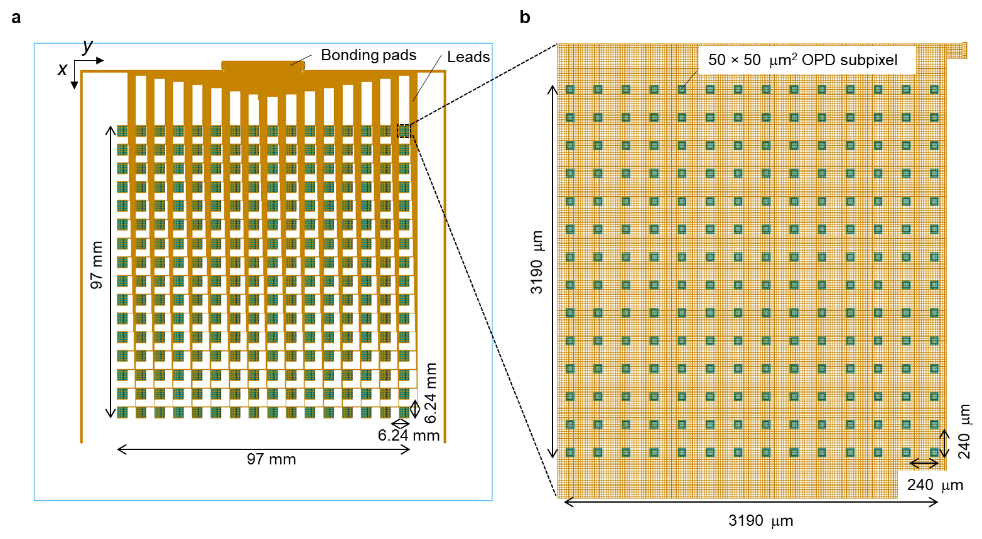
Supplementary Fig. 7 | Schematic design of visually transparent NIR sensitive OPD array. a, Schematic top view of the visually transparent NIR sensitive 16 × 16 OPD array. Blue enclosure represents outer edge of the glass substrate. Light brown lines represent the Cu grid lines. Greenish spots are OPD subpixels. 16 × 16 OPD main pixels are arranged in a square array with a pixel pitch of 6.24 mm along x and y coordinates (4.2 pixels per inch (ppi)) in the middle of substrate, leading to a total sensor area of 9.7 × 9.7 cm². b, Zoom-in view of the OPD main pixel. 14 × 14 parallel OPD subpixels are arranged in a square array with a subpixel pitch of 240 µm in both x and y coordinates in the single OPD main pixel. The active area of each OPD subpixel is 50 × 50 µm² and the 14 × 14 parallel OPD subpixels in the main pixel are electrically connected by the printed Cu grid TCE, resulting in the total photoactive area for each main pixel of 0.49 mm².

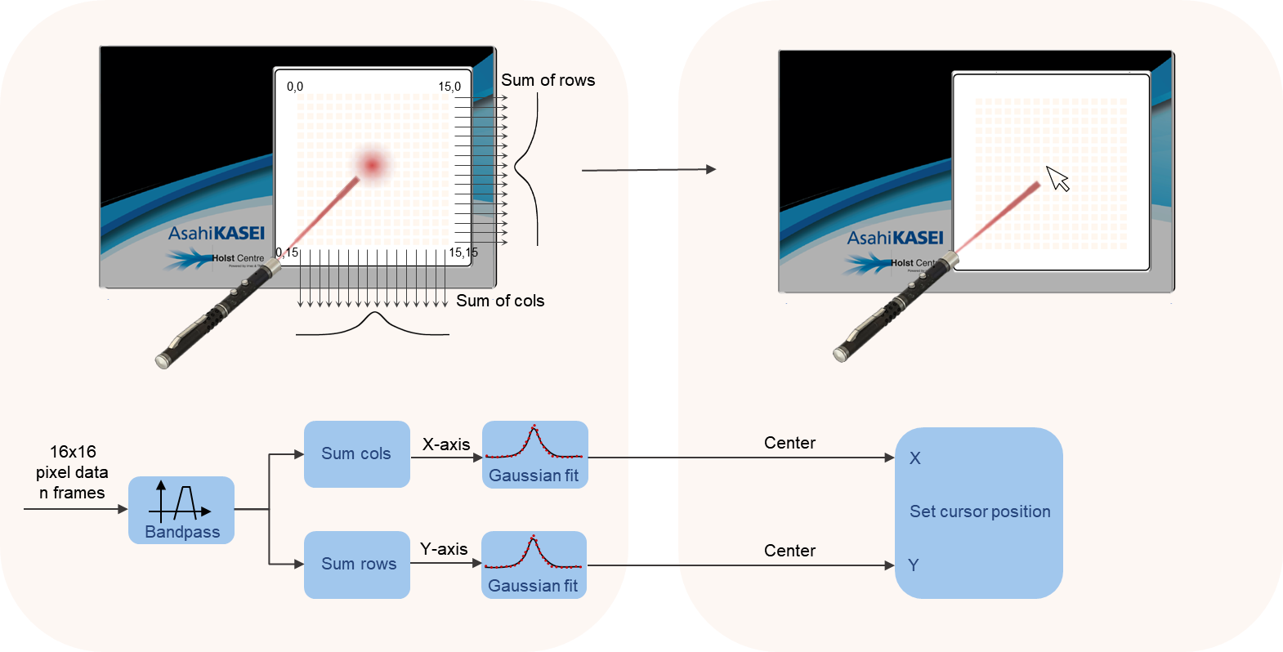
Supplementary Fig. 8 | Signal processing of touchless user interface. The photo-response signals from all pixels are bandpass-filtered to suppress background noise resulting from ambient and display light. A x-signal is determined by summation of all pixels’ signal within the same columns. A y-signal is determined by summation of all pixels’ signal within the same rows. The resulting x- and y-coordinates are computed by determining the center of a gaussian fit performed on the respective signals.
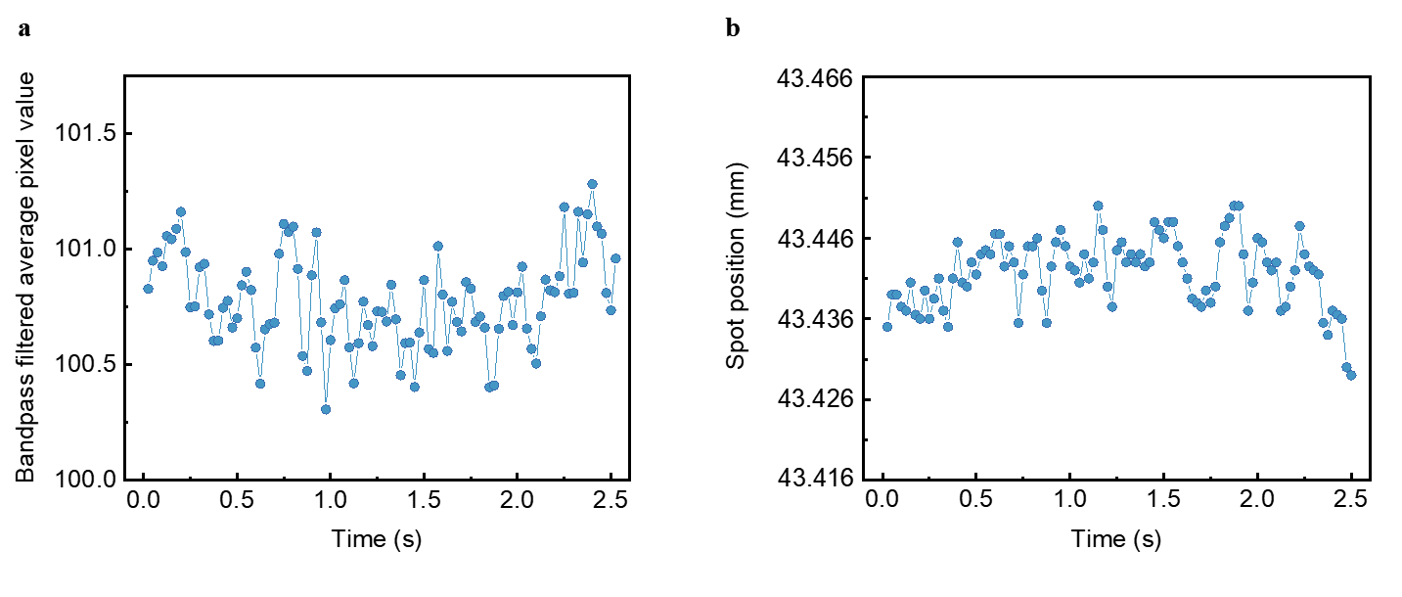
Supplementary Fig. 9 | Measurements to determine SNR and position accuracy. a, Bandpass filtered average pixel value vs. time. The bandpass filtered pixel values have been averaged and 1024 samples were saved. A subset of 100 pixel values representing 2.5 s, was used to determine the standard deviation on the amplitude which amounted to 0.2024. Hence, the resulting the signal-to-noise ratio (SNR) of the image sensor is 100/0.2024 = 494 or 20 log₁₀(494) = 54 dB. b, Spot position vs. time. The x position resulting from the gaussian fit is used to calculate the position in the software is plotted in time. The bandpass filtered pixel values have been averaged and 1024 samples were saved. A subset of 100 pixel values representing 2.5 s, was used to determine the peak to peak error on the amplitude which amounted to 19.8 µm. This translates to a position accuracy of less than a quarter of a pixel (20 µm) in the commercial 160 ppi laptop display used in this work.

Supplementary Fig. 10 | Video of touchless user interface using NIR penlight. A custom designed NIR emitting penlight together with the transparent image sensor in front of a laptop display is used as a touchless user interface for Google Earth.

Supplementary Fig. 11 | Video of touchless user interface using gesture recognition. Demonstration of a gesture-controlled ATM screen using the transparent image sensor in front of a laptop display.
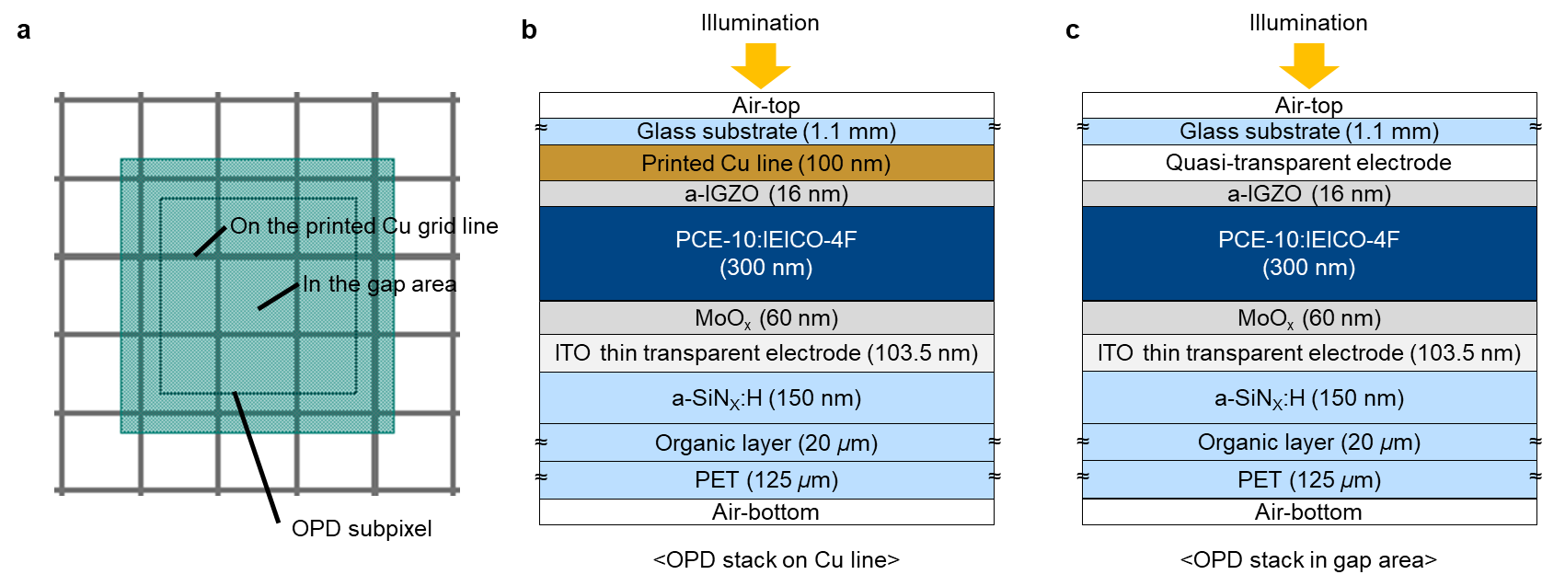
Supplementary Fig. 12 | Modeling OPD stacks for numerical electro-optical simulations. a, Schematic top view of the OPD subpixel with the printed Cu grid TCE. b, Model of OPD stack on the printed Cu line. c, Model of OPD stack in a gap area between the printed Cu lines. In Setfos, two counter electrodes on the outside of semiconductor layers are required to perform the numerical electro-optical simulations, whereas the OPD stack in the gap area does not have an electrode underneath a-IGZO. To overcome the contradiction, a quasi-transparent electrode that does not affect electro-optical performance was set for the simulations in the gap area.

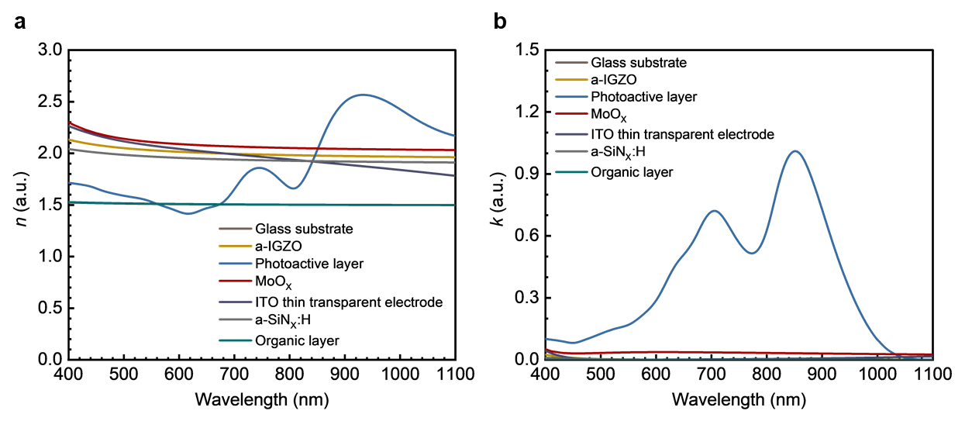
Supplementary Fig. 13 | Experimental n-k profiles as a function of wavelength. a, Refractive index (n) and b, extinction coefficient (k) of each layer in the OPD stack, except for the printed Cu grid and the PEN substrate of the optical transparent laminated barrier film, were determined by spectroscopic ellipsometry analysis. The photoactive layer with the same configuration and thickness as that in the NIR sensitive OPD fabrication was deposited on thermal growth SiO₂ (200 nm)/Si wafer for spectroscopic ellipsometry analysis. For the other layers, each layer with the same components and thickness as that in the NIR sensitive OPD fabrication were deposited on glass substrate (1.1 mm EAGLE XG®) and used to measure each n-k profile. The photoactive layer (blue solid line) has a large k value in in the red-NIR wavelength region, resulting in having a strong bluish color.

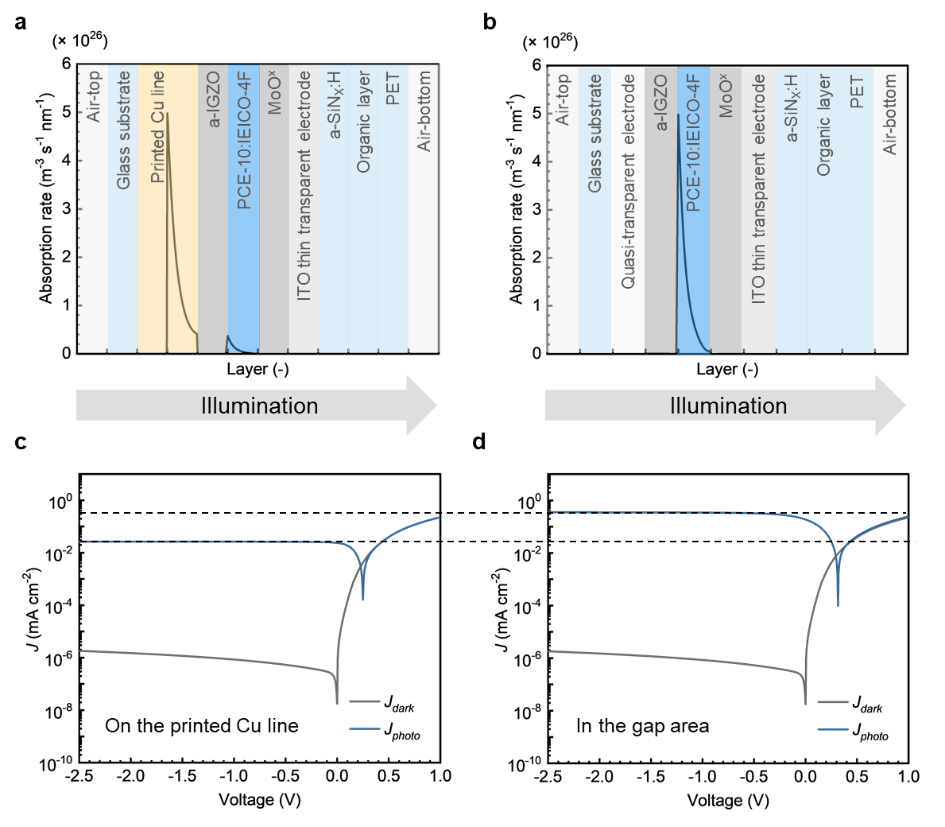
Supplementary Fig. 14 | Electro-optical simulations for OPD stacks. a, Absorption rate across the OPD stacks on the printed Cu line and b, in the gap area, at a wavelength of 850 nm with a light intensity of 1.05 mW cm⁻². The illuminated light passes through from left to right in the OPD stacks. c, Simulated J-V curves for the OPD stacks on the printed Cu line and d, in the gap area, in dark (J_{dark}) and under illumination (J_{photo}) of Supplementary Figs. 12b-c. Horizontal axes of the voltage are aligned to match with the experimental inverted OPD stack.

Supplementary Table 1 | Geometric values and characteristics of Cu grid TCEs
Discrete OPDs for electrical characteristics | Line width  (μm) | Pitch  (μm) | Thickness  (nm) | R_{s}  (Ω □⁻¹) | VLT  (%)
W_{Cu} = 1 μm, P_{Cu} = 10 μm | 1.0 | 10 | ~120 | 22 | 74
W_{Cu} = 1 μm, P_{Cu} = 20 μm | 1.0 | 20 | ~102 | 52 | 83
W_{Cu} = 2 μm, P_{Cu} = 20 μm | 1.9 | 20 | ~102 | 29 | 76
W_{Cu} = 2 μm, P_{Cu} = 40 μm | 1.9 | 40 | ~94 | 62 | 84
Discrete OPD for optical characteristics | Line width  (μm) | Pitch  (μm) | Thickness  (nm) | R_{s}  (Ω □⁻¹) | VLT  (%)
W_{Cu} = 1 μm, P_{Cu} = 10 μm | 1.2 | 10 | ~73 | 29 | 70
OPD array | Line width  (μm) | Pitch  (μm) | Thickness  (nm) | R_{s}  (Ω □⁻¹) | VLT  (%)
W_{Cu} = 1 μm, P_{Cu} = 20 μm | 1.2-1.4 | ~20 | 80-100 | 40-50 | 80-82

Supplementary Table 2 | Input parameters and boundary conditions of both electrodes for numerical drift-diffusion simulations.
Photoactive layer PCE-10:IEICO-4Fª  Parameter | Value | Unit | Remark
HOMO | −5.20 | eV | ref. 1
LUMO | −4.19 | eV | ref. 2
Dielectric constant | 3.95 | - | Modified value of ref. 3
Electron mobility | 1.48 × 10⁻⁴ | cm² V⁻¹ s⁻¹ | ref. 4
Hole mobility | 1.42 × 10⁻⁴ | cm² V⁻¹ s⁻¹ | ref. 4
Effective electron density of state | 1 × 10²⁷ | m⁻³ | Assumption
Effective hole density of state | 1 × 10²⁷ | m⁻³ | Assumption
Optical generation efficiency | 0.67 | - | As mentioned in the caption.
Langevin recombination efficiency | 1.0 | - | Assumption
a-IGZO^{b}  Parameter | Value | Unit | Remark
Valence band | −7.36 | eV | ref. 5
Conductive band | −4.16 | eV | ref. 5
Dielectric constant | 14.5 | - | Modified value of ref. 6
Electron mobility | 11.5 | cm² V⁻¹ s⁻¹ | ref. 7
Hole mobility | 0.1 | cm² V⁻¹ s⁻¹ | ref. 8
Effective electron density of state | 1 × 10²³ | m⁻³ | Assumption
Effective hole density of state | 1 × 10²³ | m⁻³ | Assumption
Printed Cu grid TCE  Parameter | Value | Unit | Remark
Work function | 4.65 | eV | ref. 9
MoO_{x}/ITO thin transparent electrode^{c}  Parameter | Value | Unit | Remark
Hole density | 1 × 10²² | m⁻³ | Assumption
ª Energy diagram of the photoactive layer consisting of PCE-10:IEICO-4F blend was considered HOMO of PCE-10 and LUMO of IEICO-4F in the numerical simulations, respectively. Optical generation efficiency of the photoactive layer was derived from the fitting simulated EQE spectra to experiment for an equivalent OPD with ITO bottom electrode in the same manner with ref.^{10,11}.
^{b} Mobility models for the photoactive layer and the a-IGZO were set to constant mobility. Charge injection between the printed Cu grid TCE and the a-IGZO was fitted to thermionic injection model due to the injection barrier of ~0.46 eV in the interface.
^{c} At an interface in between the MoO_{x}/ITO thin transparent electrode and the photoactive layer, ohmic injection model was chosen. An interface between organic semiconductors (OSCs) and MoO_{x}/ITO is known forming ohmic contact because HOMO of OSCs is pined to the gap states of MoO_{x} and it is close to Fermi level, passing charges through the gap states from OSCs to ITO¹²⁻¹⁴. We have implemented the ohmic injection as a Dirichlet boundary condition, where hole density in the MoO_{x}/ITO thin transparent electrode is fixed value in Supplementary Table 2 at the interface.

Supplementary Table 3 | Input parameters for 2D FEM electrodes.
 | Line width (m) | Pitch (m) | Thickness (m) | R_{S} (Ω □⁻¹)
Printed Cu grid TCE | 1 × 10⁻⁶ | 20 × 10⁻⁶ | 100 × 10⁻⁹ | 2.6 ª
a-IGZO | - | - | 16 × 10⁻⁹ | 35 × 10^{9 b}
ª Sheet resistance of the Cu grid lines was calculated from measured sheet resistance of the Cu grid TCE and corrected for a fill factor of the Cu grid TCE.
^{b} Sheet resistance of the a-IGZO was set in the gap area.

References
1. Lin, Y. et al. High-performance fullerene-free polymer solar cells with 6.31% efficiency. Energy Environ. Sci. 8, 610-616 (2015). https://doi.org/10.1039/C4EE03424D
2. Yao, H. et al. Design, Synthesis, and Photovoltaic Characterization of a Small Molecular Acceptor with an Ultra-Narrow Band Gap. Angew. Chem., Int. Ed. 56, 3045 (2017). https://doi.org/10.1002/anie.201610944
3. Duan, L. et al. Balance between Energy Transfer and Exciton Separation in Ternary Organic Solar Cells with Two Conjugated Polymer Donors . ACS Appl. Energy Mater. 3, 5792–5803 (2020). https://doi.org/10.1021/acsaem.0c00740
4. Song, X. et al. Controlling Blend Morphology for Ultrahigh Current Density in Nonfullerene Acceptor-Based Organic Solar Cells. ACS Energy Lett. 3, 669–676 (2018). https://doi.org/10.1021/acsenergylett.7b01266
5. Hays, D. C. et al. Energy band offsets of dielectrics on InGaZnO₄. Appl. Phys. Rev. 4, 021301 (2017). https://doi.org/10.1063/1.4980153
6. Chasin, A. et al. UHF IGZO Schottky diode. 2012 International Electron Devices Meeting 12.4.1-12.4.4 (2012). https://doi.org/10.1109/IEDM.2012.6479030
7. Steudel, S. et al. Power saving through state retention in IGZO-TFT AMOLED displays for wearable applications. Jnl. Soc. Info. Display 25, 222– 228 (2017). https://doi.org/10.1002/jsid.544
8. Fung, T.-C. et al. Two-dimensional numerical simulation of radio frequency sputter amorphous In–Ga–Zn–O thin-film transistors. J. Appl. Phys. 106, 084511 (2009). https://doi.org/10.1063/1.3234400
9. Tatewaki, H. Electronic structure of small copper clusters. I. J. Chem. Phys. 76, 5073 (1982). https://doi.org/10.1063/1.442856
10. Häusermann, R. et al. Coupled optoelectronic simulation of organic bulk-heterojunction solar cells: Parameter extraction and sensitivity analysis. J. Appl. Phys. 106, 104507 (2009). https://doi.org/10.1063/1.3259367
11. Gilot, J. et al. The use of ZnO as optical spacer in polymer solar cells: Theoretical and experimental study. Appl. Phys. Lett. 91, 113520 (2007). http://dx.doi.org/10.1063/1.2784961
12. Vasilopoulou, M. et al. Barrierless hole injection through sub-bandgap occupied states in organic light emitting diodes using substoichiometric MoO_{x} anode interfacial layer. Appl. Phys. Lett. 100, 013311 (2012). http://dx.doi.org/10.1063/1.3673283
13. Wang, C. et al. Role of molybdenum oxide for organic electronics: Surface analytical studies. J. Vac. Sci. Technol. B 32, 040801 (2014). http://dx.doi.org/10.1116/1.4886364
14. Kanai, K. et al. Electronic structure of anode interface with molybdenum oxide buffer layer. Org. Electron. 11, 188–194 (2010). https://doi.org/10.1016/j.orgel.2009.10.013

