Discovery, Synthesis and in silico approach of pyrrolo [3,4-c]pyrroles as SARS-CoV-2 M^{pro} inhibitors
Kailasam Saravana Mani^{a,b}*, S. Rajamanikandan^{c} and Balakrishnan Prabha^{a,b}
ªDepartment of Chemistry, Karpagam Academy of Higher Education, Coimbatore, Tamil Nadu, India.
^{b}Karpagam Cancer Research Centre, Karpagam Academy of Higher Education, Coimbatore, Tamil Nadu, India
^{c}Sree Balaji Medical College and Hospital, Chrompet, Chennai Tamil Nadu, India

Corresponding author: chemsaran.mani@gmail.com

Table of Contents

S.No. | Spectrum description | Page no.
1. | ¹H NMR and ¹³C NMR spectrum of compound 4a (Fig. S1 & S2) | 2
2. | ¹H NMR and ¹³C NMR spectrum of compound 4b (Fig. S3 & S4) | 3
3. | ¹H NMR and ¹³C NMR spectrum of compound 4c (Fig. S5 & S6) | 4
4. | ¹H NMR and ¹³C NMR spectrum of compound 5a (Fig. S7 & S8) | 5
5. | ¹H NMR and ¹³C NMR spectrum of compound 5b (Fig. S9 & S10) | 6

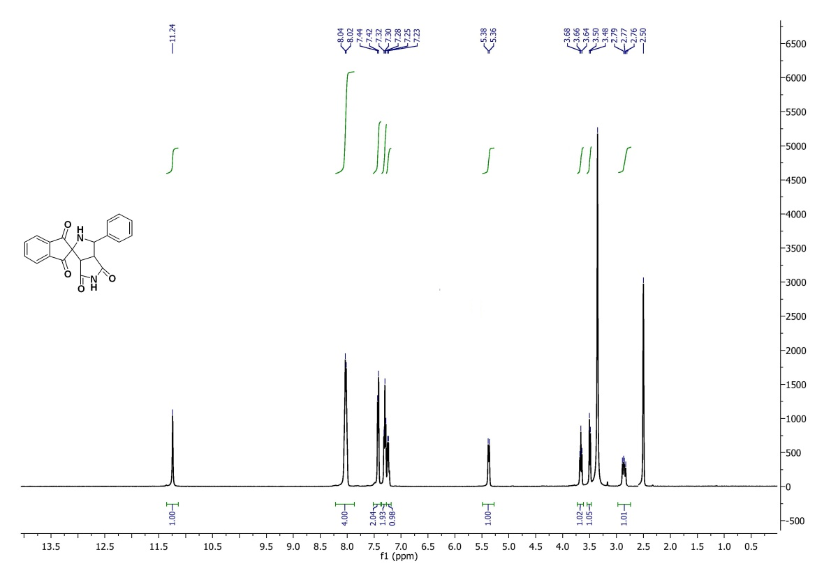
Fig.S1. ¹H NMR spectrum of compound 4a
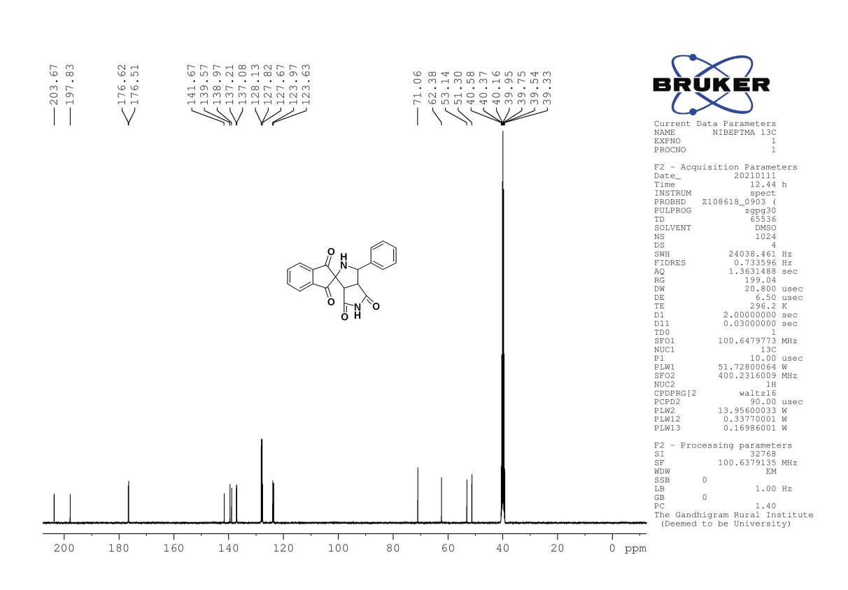
Fig.S2. ¹³C NMR spectrum of compound 4a
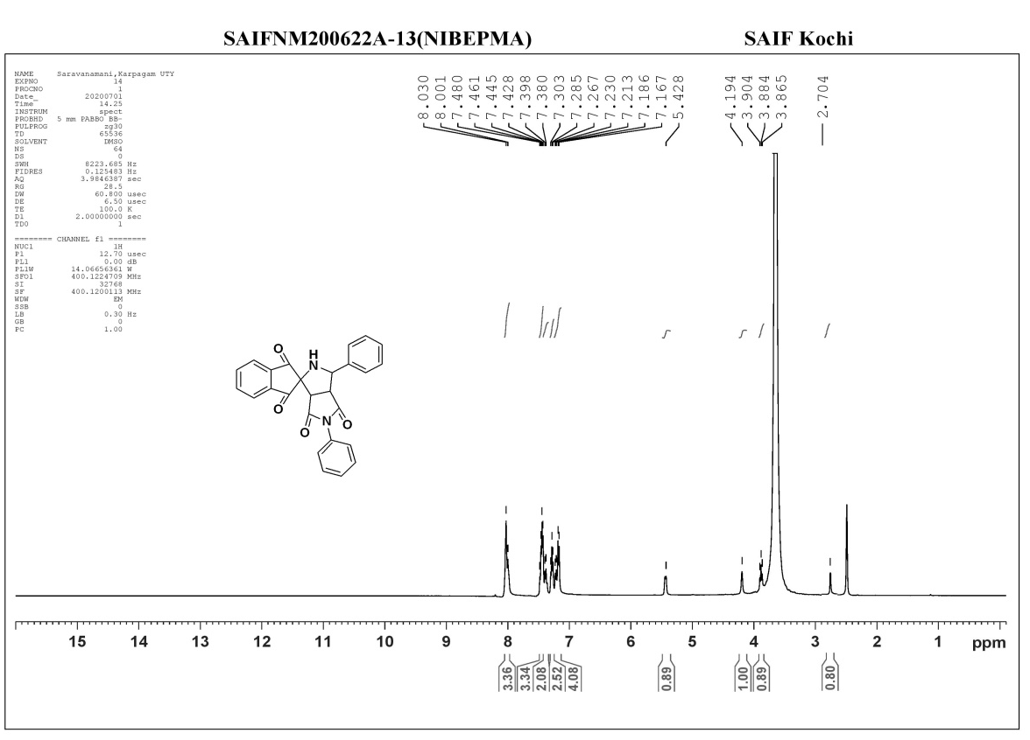
Fig.S3. ¹H NMR spectrum of compound 4b
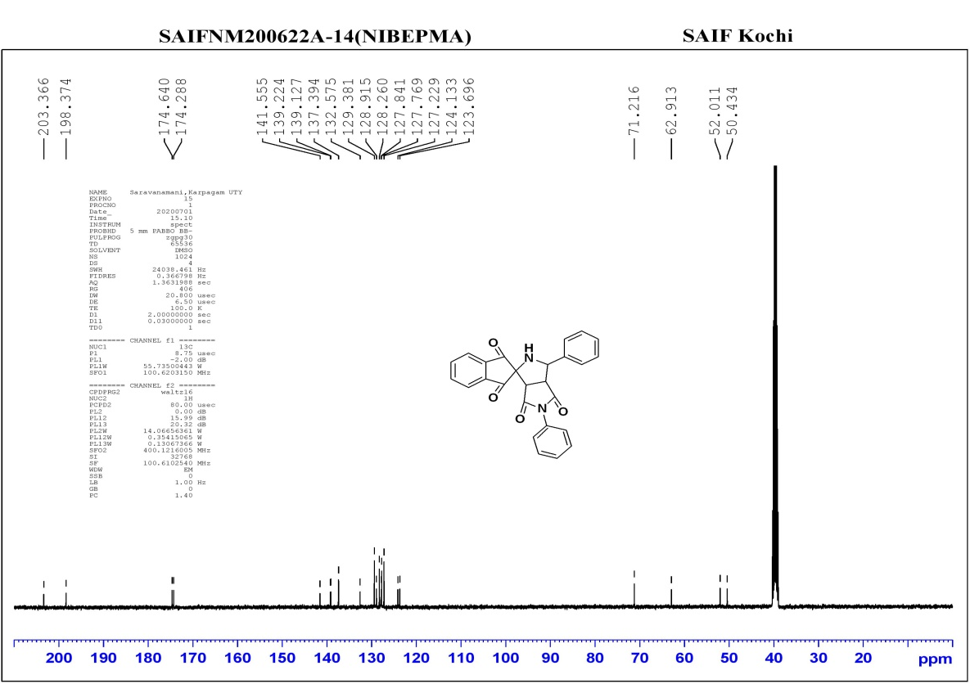
Fig.S4. ¹³C NMR spectrum of compound 4b
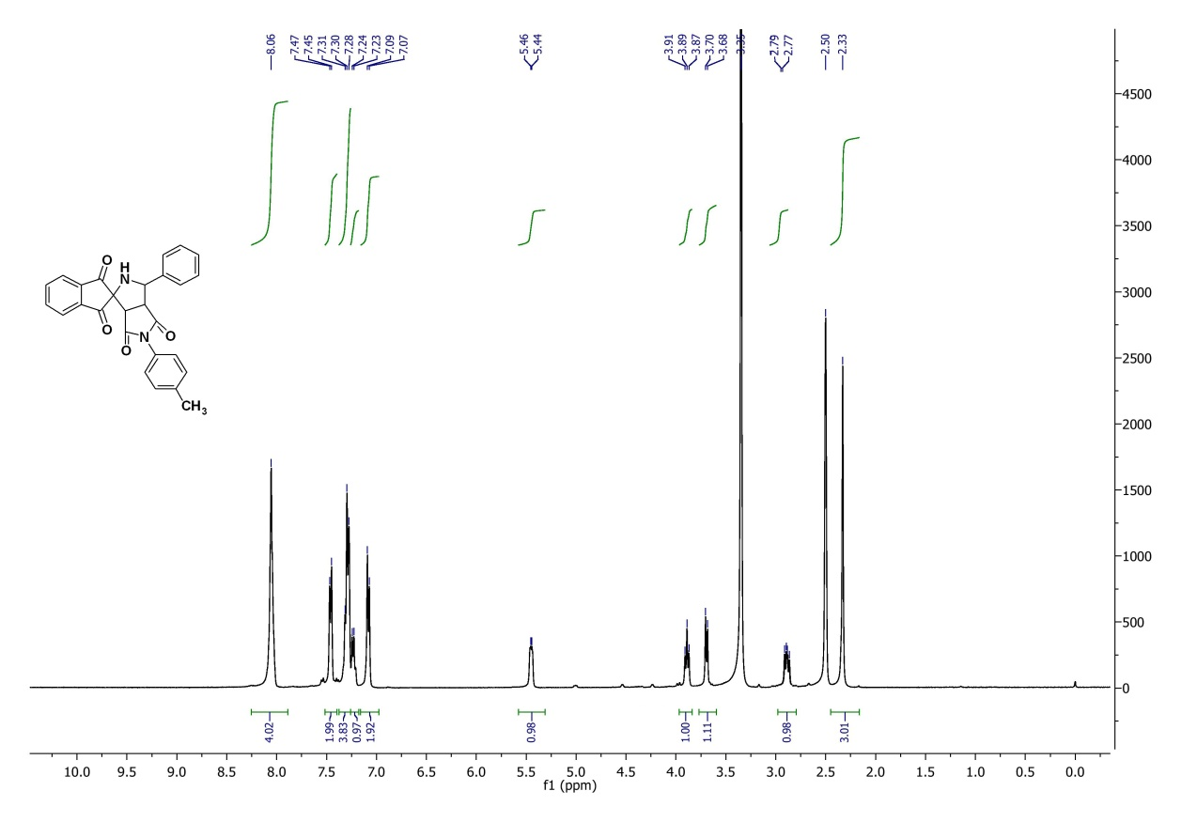
Fig.S5. ¹H NMR spectrum of compound 4c
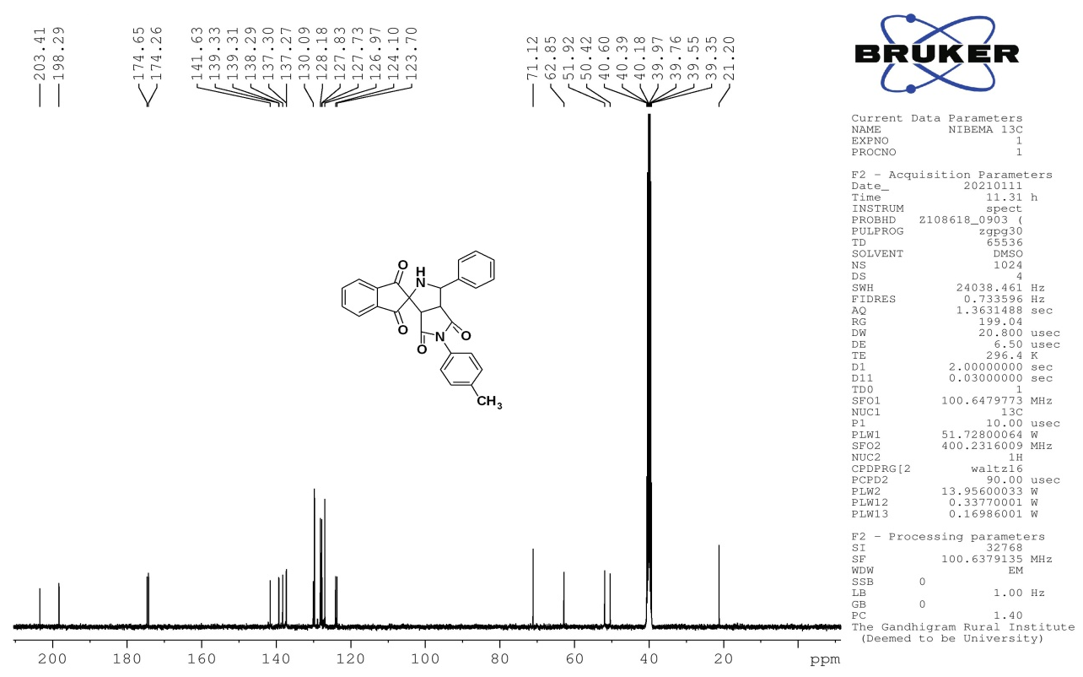
Fig.S6. ¹³C NMR spectrum of compound 4c
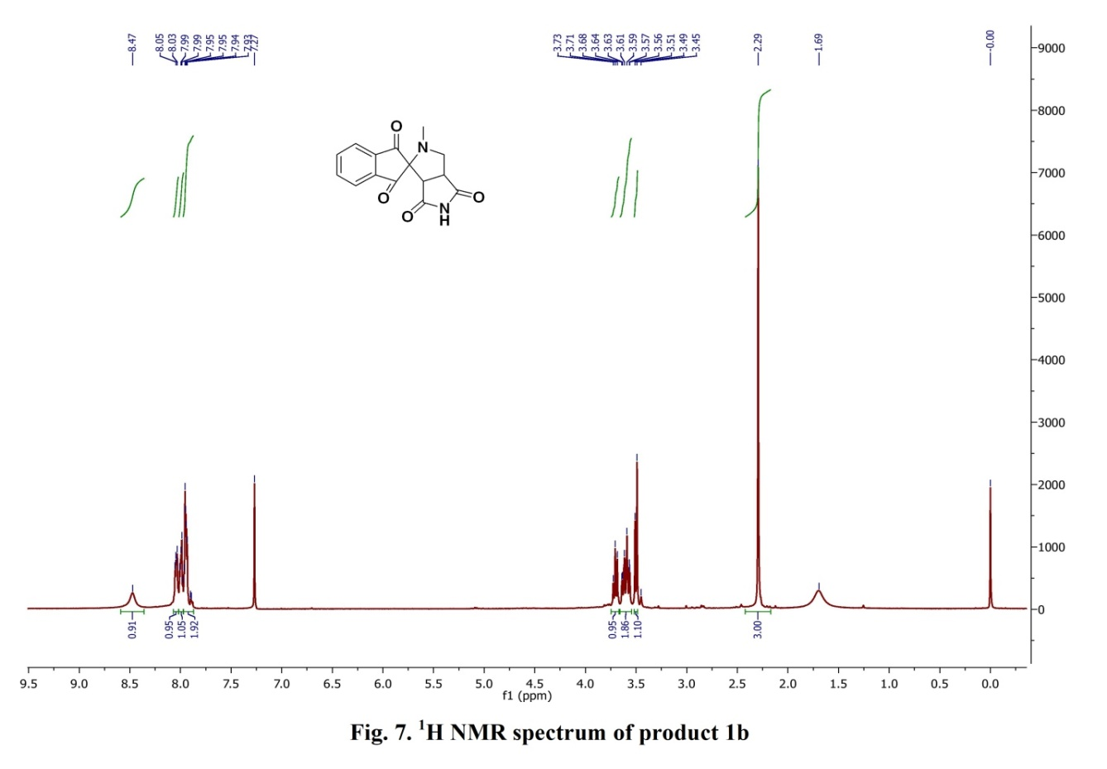
Fig.S7. ¹H NMR spectrum of compound 5a
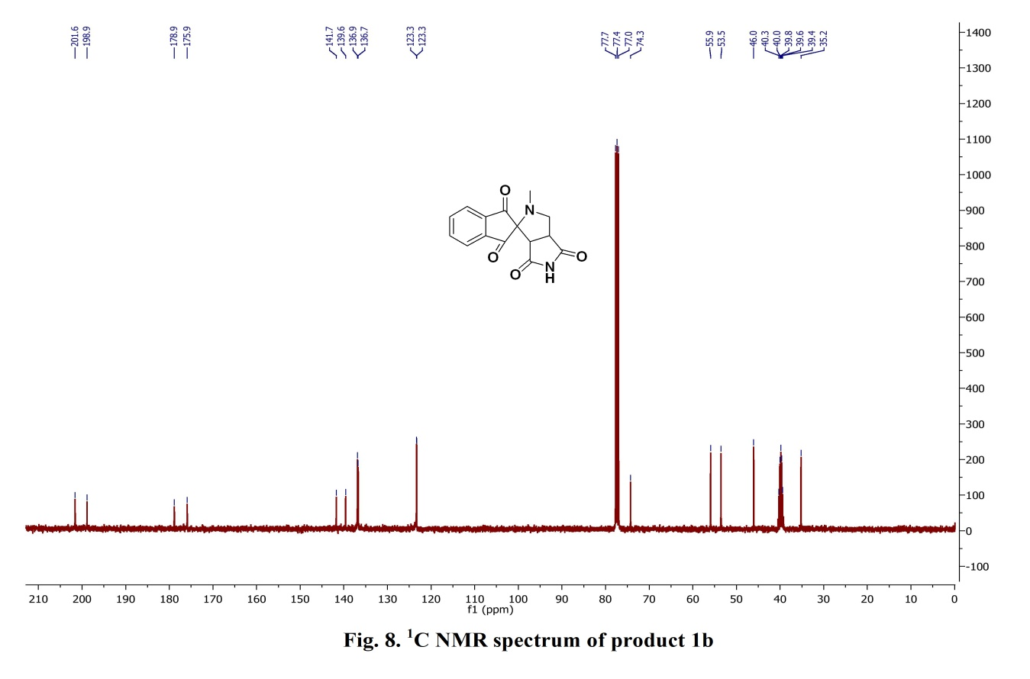
Fig.S8. ¹³C NMR spectrum of compound 5a
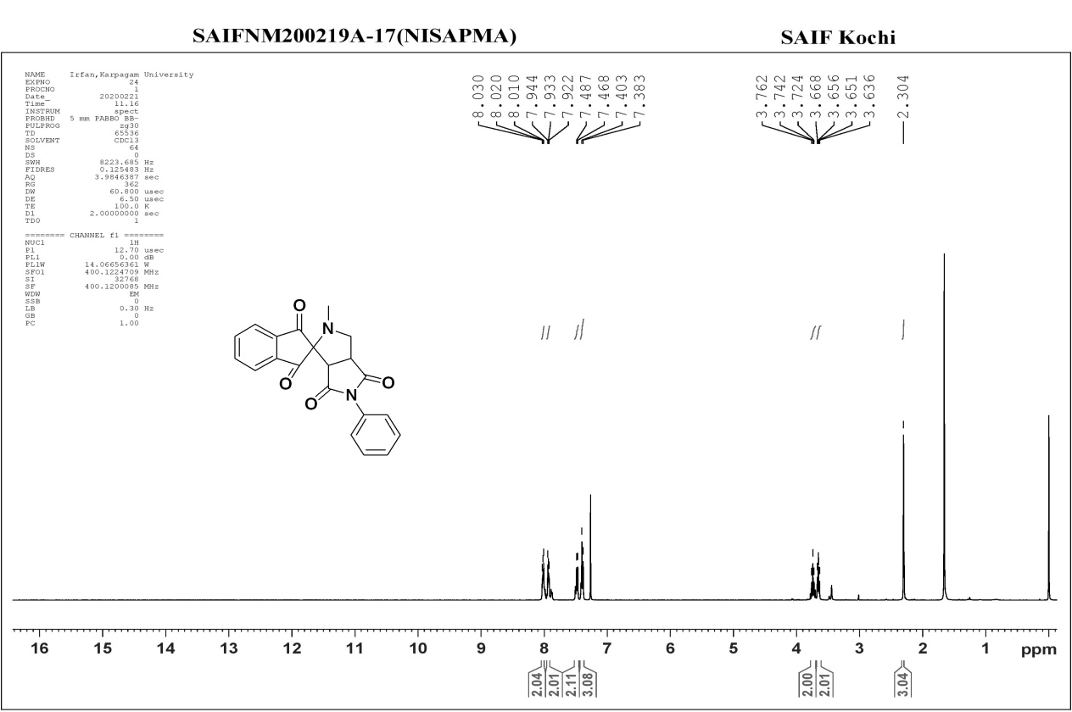
Fig.S9. ¹H NMR spectrum of compound 5b
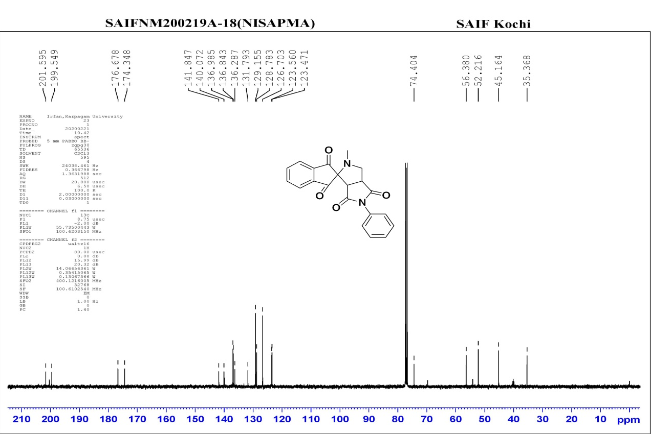
Fig.S10. ¹³C NMR spectrum of compound 5b

