Appendix 1. Mobility Data Processing Details

Appendix 1A: Mobility Data Source.

The data set used in this study is developed based on the network access logs over the period of January 2019–December 2020, provided by one of the largest mobile phone companies in the UK, accounting for a market share of 25%. The network access logs track the antennas that a mobile device is connected to. All access events of mobile devices to the cellular network, which occur whenever a device establishes or updates a channel with the network, are recorded. For example, when the device attaches to or detaches from the network, or the device is handed over between antennas. The mobile device typically connects to an antenna that is physically proximal to the mobile device for greater bandwidth and smaller last-mile latency.

In comparison to the data sources employed in prior studies of large-scale mobility, our data set is distinguished in terms of consistently capturing fine-grained mobility activity across space and time and representing the general population. Various data sources including Call Detail Records (CDRs), geo-social media, and public transportation logs have been used. For instance, CDRs log the antennas that mobile phones connect to in the same way, and prior works have used them to predict mobility, ¹ segregation, ² and socioeconomic status.³⁻⁵ An important drawback of CDRs is that they only record phone calls and SMS messages and, therefore, are inherently limited in their ability to accurately identify trip destinations and daily mobility due to the sparsity of records across different time spans. This issue is further compounded by the increasing usage of messaging apps instead of SMS, which are not recorded in CDRs. On the other hand, although geo-social media data (e.g., Foursquare) allow GPS-level spatial accuracy,⁶ the temporal sparsity described above for CDRs is similarly problematic here. In addition, social media sources are likely to be prone to a demographic bias as active users are not typically representative of the general population.⁷ Moreover, as individuals’ habits to use social media could have a significant temporal variation, the data may not represent routine mobility activities.⁸ Lastly, while public transportation logs have been used in a few studies,⁹ the data are restricted to the users of a particular mode of transportation.

Appendix 1B. Spatial Interpolation.

The mobile network log allows approximating the location of the user holding the device based on the coverage area of the antennas. We perform a Voronoi tesselation for antenna coverage estimation, which is commonly used in the literature using mobile phone–based big data, ¹⁰ and obtain a Voronoi polygon for every antenna.

Recall that our study analyses the visits from residential neighbourhoods (i.e., LSOAs) to destinations including the green spaces within London. A challenge here is the mismatch between the boundaries of the Voronoi antenna polygons and LSOAs/green spaces. We use the spatial interpolation to overcome this mismatch by making estimates from the Voronoi polygons to overlapping residential LSOAs and green spaces.
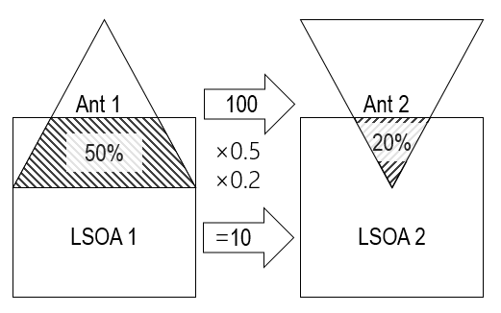

The above figure presents the key idea of the interpolation with a simplified example. Assume 100 trips between Antenna polygon 1 to Antenna polygon 2. Considering the overlaps (i.e., 50% of Antenna polygon 1 with LSOA 1, and 20% of Antenna polygon 2 with LSOA 2), the 100 travels are interpolated to 10 travels between LSOA 1 to LSOA 2. The estimation is completed by aggregating all the flows between the antenna polygons that overlap with LSOA 1 and 2 in the same way.

Appendix 1C. Home detection.

The residential neighbourhoods of all device users are estimated and we use them as the origin of the mobility flows. Methods for identifying residences from mobility traces commonly aim to identify routine activities during the evening and/or weekends.¹¹ Likewise, a method for home antenna detection is developed based on this intuition. For each day over a month, devices that remain in the same antenna's polygon during the evening (midnight–8 a.m.) for a substantial number of days are identified. The method first selects the set of antennas to which a device connects during the evening each day. Finally, the method classifies the home antenna of a device as the one with the maximum connection time for at least 14 days during the month, and the devices that do not have a home antenna that satisfies these criteria are excluded from the data sample.

Reference:
- Zhang, Y. User mobility from the view of cellular data networks. in IEEE INFOCOM 2014-IEEE Conference on Computer Communications 1348–1356 (IEEE, 2014).
- Dannemann, T., Sotomayor-Gómez, B. & Samaniego, H. The time geography of segregation during working hours. Royal Society open science 5, 180749 (2018).
- Silm, S. & Ahas, R. The temporal variation of ethnic segregation in a city: Evidence from a mobile phone use dataset. Social Science Research 47, 30–43 (2014).
- Pappalardo, L., Pedreschi, D., Smoreda, Z. & Giannotti, F. Using big data to study the link between human mobility and socio-economic development. in 2015 IEEE International Conference on Big Data (Big Data) 871–878 (IEEE, 2015).
- Smith-Clarke, C., Mashhadi, A. & Capra, L. Poverty on the cheap: Estimating poverty maps using aggregated mobile communication networks. in Proceedings of the SIGCHI conference on human factors in computing systems 511–520 (2014).
- Wang, Q., Phillips, N. E., Small, M. L. & Sampson, R. J. Urban mobility and neighborhood isolation in America’s 50 largest cities. Proceedings of the National Academy of Sciences 115, 7735–7740 (2018).
- Jiang, Y., Li, Z. & Ye, X. Understanding demographic and socioeconomic biases of geotagged Twitter users at the county level. Cartography and geographic information science 46, 228–242 (2019).
- Lindqvist, J., Cranshaw, J., Wiese, J., Hong, J. & Zimmerman, J. I’m the mayor of my house: examining why people use foursquare-a social-driven location sharing application. in Proceedings of the SIGCHI conference on human factors in computing systems 2409–2418 (2011).
- Lathia, N., Quercia, D. & Crowcroft, J. The hidden image of the city: sensing community well-being from urban mobility. in International conference on pervasive computing 91–98 (Springer, 2012).
- Park, S., Serra, J., Martinez, E. F. & Oliver, N. Mobinsight: A framework using semantic neighborhood features for localized interpretations of urban mobility. ACM Transactions on Interactive Intelligent Systems (TiiS) 8, 1–25 (2018).
- Kung, K. S., Greco, K., Sobolevsky, S. & Ratti, C. Exploring universal patterns in human home-work commuting from mobile phone data. PloS one 9, e96180 (2014).

Appendix 2. Propensity Score Matching Process for the UK Household Longitudinal Survey Sample

Appendix 2A: Summary statistics before matching

Variables | Individuals living within 800m from the nearest green space (Treatment) |  | Individuals living farther from the nearest green space (Comparison) |  | Diff (Treatment – Comparison)
 | Mean | Std. Dev | Mean | Std. Dev | Diff | T (z) | Sig.
Total Score of General Health Questionnaire-12 | 12·289 | 5·945 | 12·255 | 5·921 | 0·034 | 0·861
Total Score of Batty et al· (2017) | 2·380 | 3·354 | 2·326 | 3·342 | 0·054 | 2·408 | **
Wave falling in the lockdowns | 0·517 | 0·5 | 0·515 | 0·500 | 0·002 | 0·656
Demographic characteristics
Age | 53·894 | 16·814 | 54·295 | 16·316 | -0·401 | -3·635 | ***
%male | 0·409 | 0·492 | 0·418 | 0·493 | -0·009 | -2·770 | ***
%White | 0·857 | 0·350 | 0·903 | 0·296 | -0·046 | -21·777 | ***
%Black | 0·030 | 0·170 | 0·024 | 0·153 | 0·006 | 5·595 | ***
Number of household members | 1·634 | 1·284 | 1·680 | 1·27 | -0·046 | -5·433 | ***
Number of children | 0·381 | 0·788 | 0·417 | 0·796 | -0·036 | -6·678 | ***
%couple | 0·685 | 0·465 | 0·708 | 0·455 | -0·023 | -7·656 | ***
Economic characteristics
Household monthly earning | 4,025·395 | 14,688·38 | 3,150·657 | 11,908·63 | 874·738 | 10·208 | ***
Individual monthly earning | 1,712·841 | 6,878·399 | 1,411·296 | 5,403·278 | 301·545 | 7·657 | ***
%having financial difficulties | 0·046 | 0·209 | 0·043 | 0·203 | 0·003 | 2·122 | **
Health status
%feeling lonely often | 0·364 | 0·481 | 0·363 | 0·481 | 0·001 | 0·159
%having long-term health issues | 0·402 | 0·490 | 0·413 | 0·492 | -0·011 | -3·324 | ***
%COVID-19 infection | 0·008 | 0·086 | 0·008 | 0·089 | 0·000 | -0·809
Number of days doing moderate activities | 2·600 | 2·603 | 2·551 | 2·590 | 0·049 | 2·823 | **
%moderate/heavy drinker | 0·439 | 0·496 | 0·422 | 0·494 | 0·017 | 5·097 | ***
%smoker | 0·072 | 0·259 | 0·081 | 0·273 | -0·009 | -4·972 | ***
Number of individuals | 5,724 |  | 13,296
Number of individual*survey waves | 31,843 |  | 74,186
Notes: Appendix 2A reports summary statistics of the unmatched sample of 19,020 distinct survey respondents or 106,029 individual*waves.
*** indicates significance at the 1% level, ** indicates significance at the 5% level, and * indicates significance at the 10% level.

Appendix 2B: Application of Propensity Score Matching

In Appendix 2B, we would like to demonstrate that the distributions of propensity scores are very homogeneous after matching. Therefore, we have a panel of reasonably balanced treatment and comparison respondents, which allows us to claim that any observed treatment effect on mental well-being is not biased by observed differences between treatment and comparison groups in individual attributes.

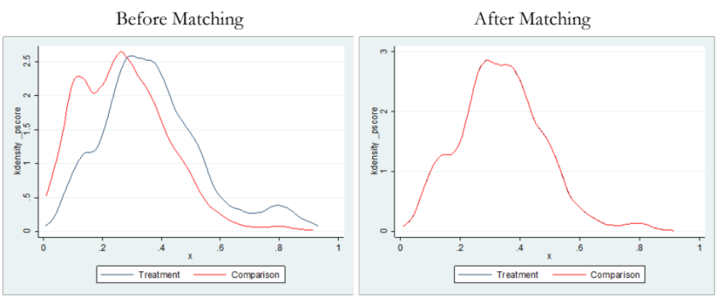
Notes: To estimate the propensity score based on the first wave of the survey, we use the logit model, in which the dependent variable is the nearest park (1 for living within 800m and 0 for otherwise) and the independent variables include age, gender, race, family composition, earnings, and health status as well as the city of their residence. These are the variables that could potentially affect mental well-being. We also apply longitudinal sampling weights for this model. Then, we use one-to-one matching with no replacement closest in the propensity score within a 0.003 caliper width to improve covariate balance and reduce bias. During the matching process, we lost some respondents in our treatment groups who were left unmatched because no one in the comparison group had a propensity score within a 0.003 caliper width of these individuals’ scores.

Appendix 2C: Quality of propensity score matching (PSM) sample
 |  | Treatment: living within 800m from the nearest park | Comparison: living farther from the nearest park | Difference | %reduction | Difference in means as proportion standard deviation | Cochran’s rule of thumb
Age | Unmatched | 53·894 | 54·295 | -0·401 | 3·567 | 0·056 | y
 | Matched | 52·159 | 53·121 | -0·962 | 3·567 | 0·056 | y
%male | Unmatched | 0·409 | 0·418 | -0·009 | -20·73 | 0·014 | y
 | Matched | 0·429 | 0·422 | 0·007 | -20·73 | 0·014 | y
%White | Unmatched | 0·857 | 0·903 | -0·046 | 0·582 | 0·14 | y
 | Matched | 0·84 | 0·888 | -0·048 | 0·582 | 0·14 | y
%Black | Unmatched | 0·03 | 0·024 | 0·006 | -1818 | 0·046 | y
 | Matched | 0·028 | 0·021 | 0·007 | -1818 | 0·046 | y
No. hh members | Unmatched | 1·634 | 1·68 | -0·046 | -160·7 | 0·029 | y
 | Matched | 1·948 | 1·908 | 0·04 | -160·7 | 0·029 | y
No. children | Unmatched | 0·381 | 0·417 | -0·036 | -186·1 | 0·056 | y
 | Matched | 0·449 | 0·403 | 0·046 | -186·1 | 0·056 | y
%partner | Unmatched | 0·685 | 0·708 | -0·023 | 89·5 | 0·006 | y
 | Matched | 0·712 | 0·715 | -0·003 | 89·5 | 0·006 | y
HH earning | Unmatched | 4025·395 | 3150·657 | 874·738 | 5·401 | 0·04 | y
 | Matched | 3782·9 | 3313·1 | 469·8 | 5·401 | 0·04 | y
Ind earning | Unmatched | 1712·841 | 1411·296 | 301·545 | -106·4 | 0·055 | y
 | Matched | 1454 | 1206·9 | 247·1 | -106·4 | 0·055 | y
%fin difficulty | Unmatched | 0·046 | 0·043 | 0·003 | -18·36 | 0·053 | y
 | Matched | 0·048 | 0·06 | -0·012 | -18·36 | 0·053 | y
% lonely | Unmatched | 0·364 | 0·363 | 0·001 | 20·1 | 0·005 | y
 | Matched | 0·348 | 0·345 | 0·003 | 20·1 | 0·005 | y
%health issues | Unmatched | 0·402 | 0·413 | -0·011 | -16·02 | 0·057 | y
 | Matched | 0·49 | 0·518 | -0·028 | -16·02 | 0·057 | y
%COVID-19 | Unmatched | 0·008 | 0·008 | 0 | 51·55 | 0·011 | y
 | Matched | 0·001 | 0·002 | -0·001 | 51·55 | 0·011 | y
No. activity | Unmatched | 2·6 | 2·551 | 0·049 | 99·05 | 0 | y
 | Matched | 2·517 | 2·517 | 0 | 99·05 | 0 | y
%drinker | Unmatched | 0·439 | 0·422 | 0·017 | -8·797 | 0·039 | y
 | Matched | 0·473 | 0·492 | -0·019 | -8·797 | 0·039 | y
%smoker | Unmatched | 0·072 | 0·081 | -0·009 | -19·2 | 0·008 | y
 | Matched | 0·076 | 0·078 | -0·002 | -19·2 | 0·008 | y
Notes: Appendix 2C compares the statistics of the unmatched sample of 106,029 individual*waves and the matched sample of 31,259 individual*waves (15,529 treatment and 15,730 comparison groups) or 4,992 distinct individuals. The column “% reduction” shows the percentage reduction in the mean difference between treatment and comparison groups. “Cochran’s rule of thumb” reports whether the mean difference of a variable with the matched sample is less than a quarter of a standard deviation of the respective variable (“y” indicates that the mean difference is smaller than this threshold, suggesting that good balance is achieved after matching).

Appendix 2D. UK Household Longitudinal Survey User Guide

For the study user guide, please see the following link:
https://doc.ukdataservice.ac.uk/doc/8644/mrdoc/pdf/8644_ukhls_covid19_user_guide_v10.0.pdf

For more study details, please see the following link:
https://beta.ukdataservice.ac.uk/datacatalogue/studies/study?id=8644#!/details

Appendix 3. Robustness Test for Table 2 with the Travel Frequency Measure (rather than number of travellers)
 | (1) | (2) | (3) | (4)
Dependent Variable | Proportion of Park Trips | Proportion of Park Trips | Proportion of Park Trips (post-COVID-19 periods) | Proportion of Park Trips (post-COVID-19 periods)
LSOAs located within 800 meters from the nearest park | 0·0226*** | 0·0202*** | 0·0233*** | 0·0229***
LSOAs located within 800 meters from the nearest park | (0·0036) | (0·0035) | (0·0040) | (0·0039)
After COVID-19 outbreak | -0·0005 | -0·0028***
After COVID-19 outbreak | (0·0007) | (0·0006)
Lockdown |  |  | -0·0000 | -0·0007**
Lockdown |  |  | (0·0001) | (0·0003)
LSOAs within 800 meters from the nearest park & After COVID-19 |  | 0·0053***
 |  | (0·0012)
LSOAs within 800 meters from the nearest park & lockdown |  |  |  | 0·0017**
LSOAs within 800 meters from the nearest park & lockdown |  |  |  | (0·0007)
Observations | 463,261 | 463,261 | 212,411 | 212,411
R-squared | 0·1429 | 0·1434 | 0·1503 | 0·1503
Demographic characteristics | Yes | Yes | Yes | Yes
Socioeconomic characteristics | Yes | Yes | Yes | Yes
Local authority fixed effects | Yes | Yes | Yes | Yes
Month fixed effects | Yes | Yes | Yes | Yes
Notes: *** indicates significance at the 1% level, ** indicates significance at the 5% level, and * indicates significance at the 10% level.

Appendix 4. Boxplot of Mental Distress Level by Different Waves for Treatment vs. Comparison Groups

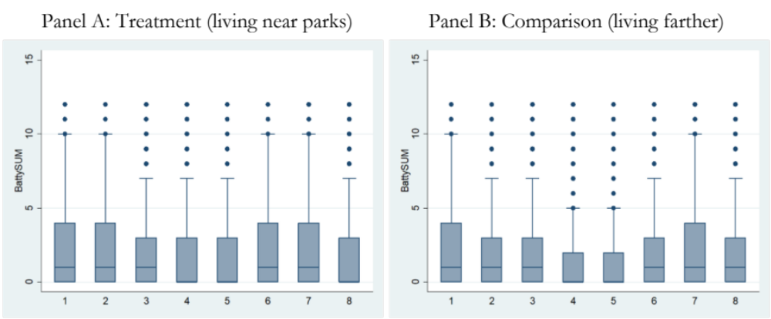
Notes: Note than Wave 1, 2, 6, 7, 8 fall into the lockdown periods in the UK.

