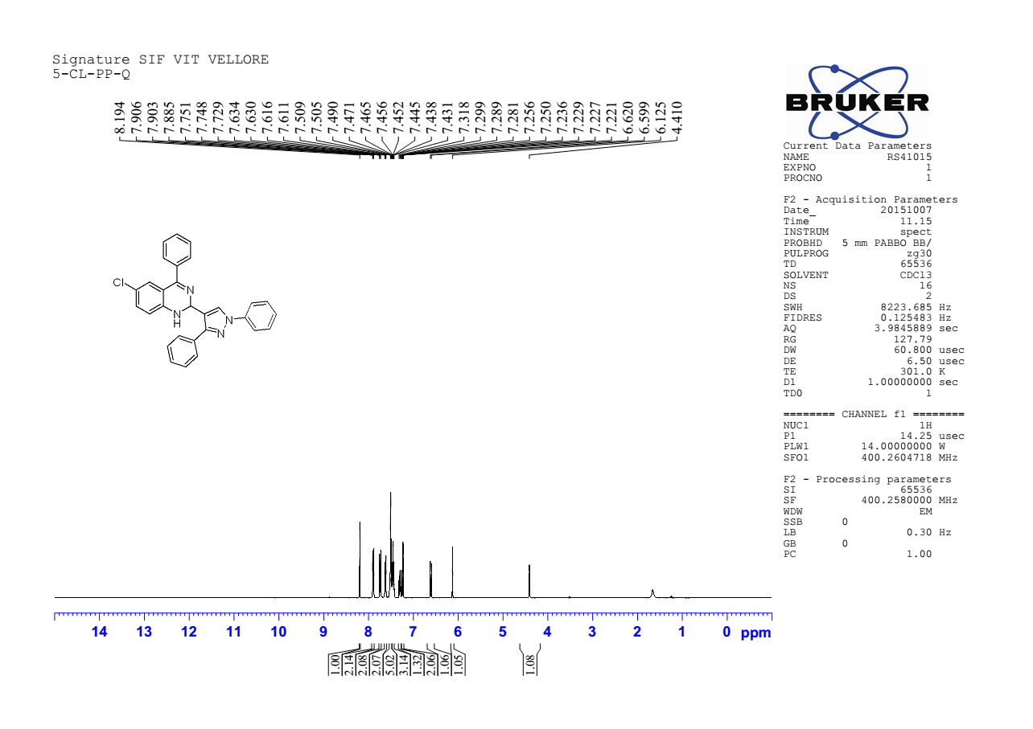

¹H NMR spectra of 6-Chloro-2(1,3-diphenyl-1H-pyrazol-4-yl)-4-phenyl-1,2-dihydroquinazoline 4a

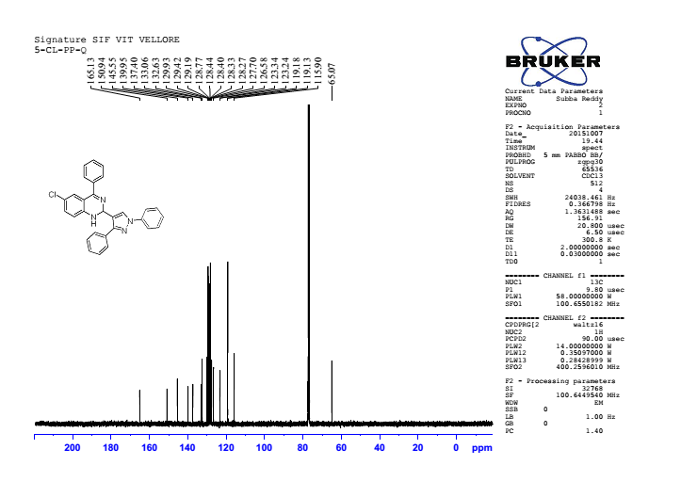

¹³C NMR spectra of 6-Chloro-2(1,3-diphenyl-1H-pyrazol-4-yl)-4-phenyl-1,2-dihydroquinazoline 4a

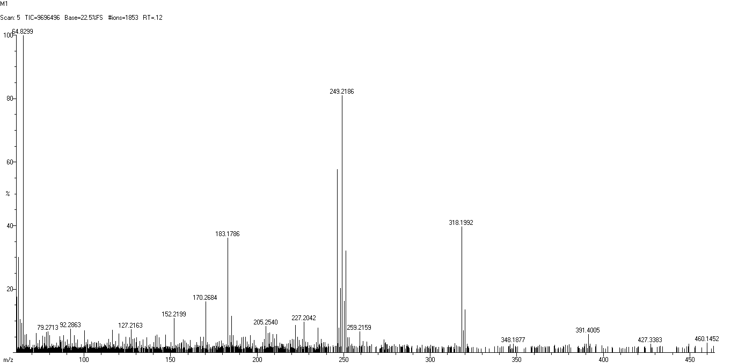

HRMS spectra of 6-Chloro-2(1,3-diphenyl-1H-pyrazol-4-yl)-4-phenyl-1,2-dihydroquinazoline 4a

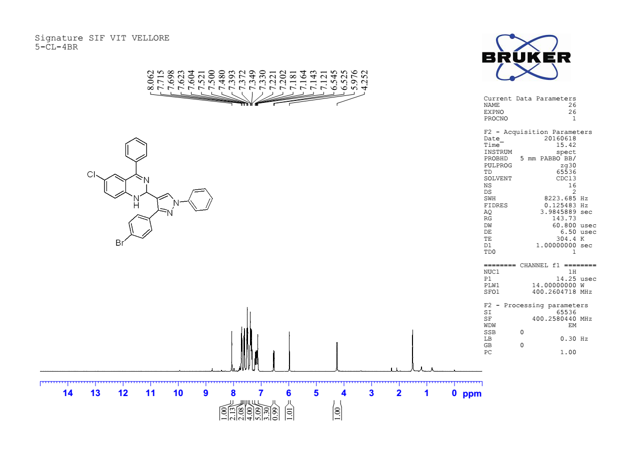

¹H NMR spectra of 2-(3-(4-bromophenyl)-1-phenyl-1H-pyrazol-4-yl)-6-chloro-4-phenyl-1,2-dihydroquinazoline 4b

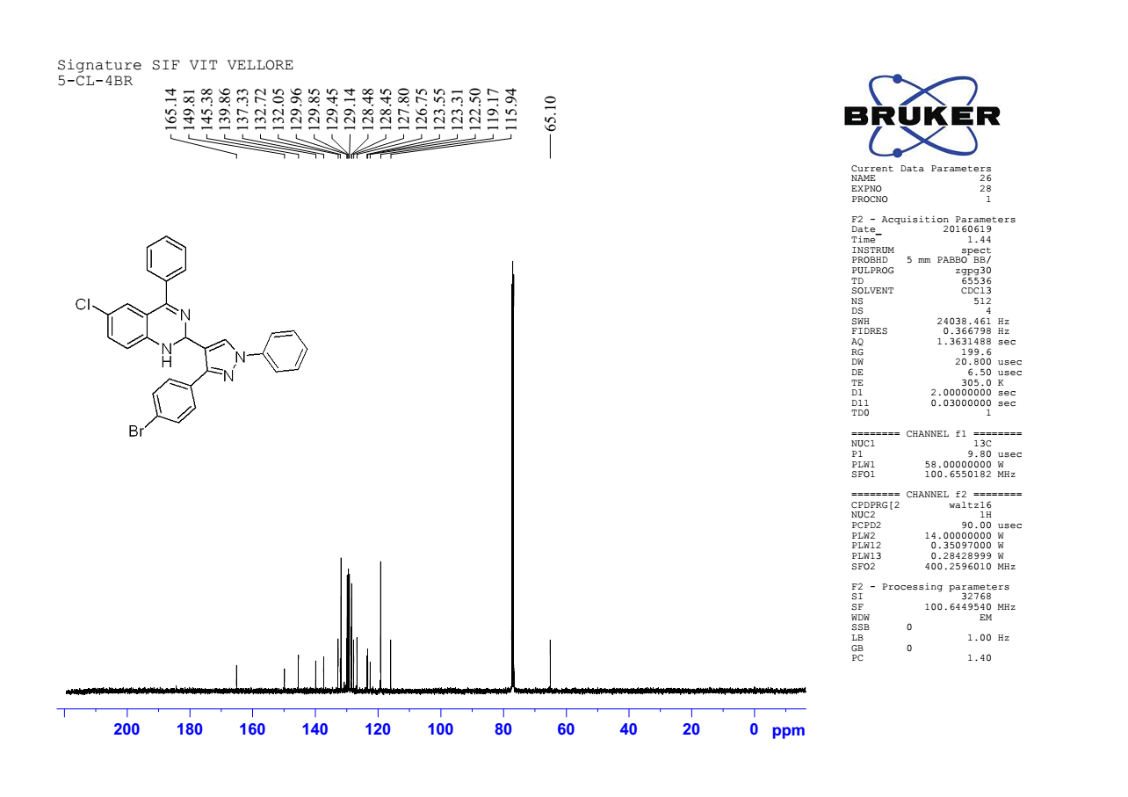

¹³ C NMR spectra of 2-(3-(4-bromophenyl)-1-phenyl-1H-pyrazol-4-yl)-6-chloro-4-phenyl-1,2-dihydroquinazoline 4b

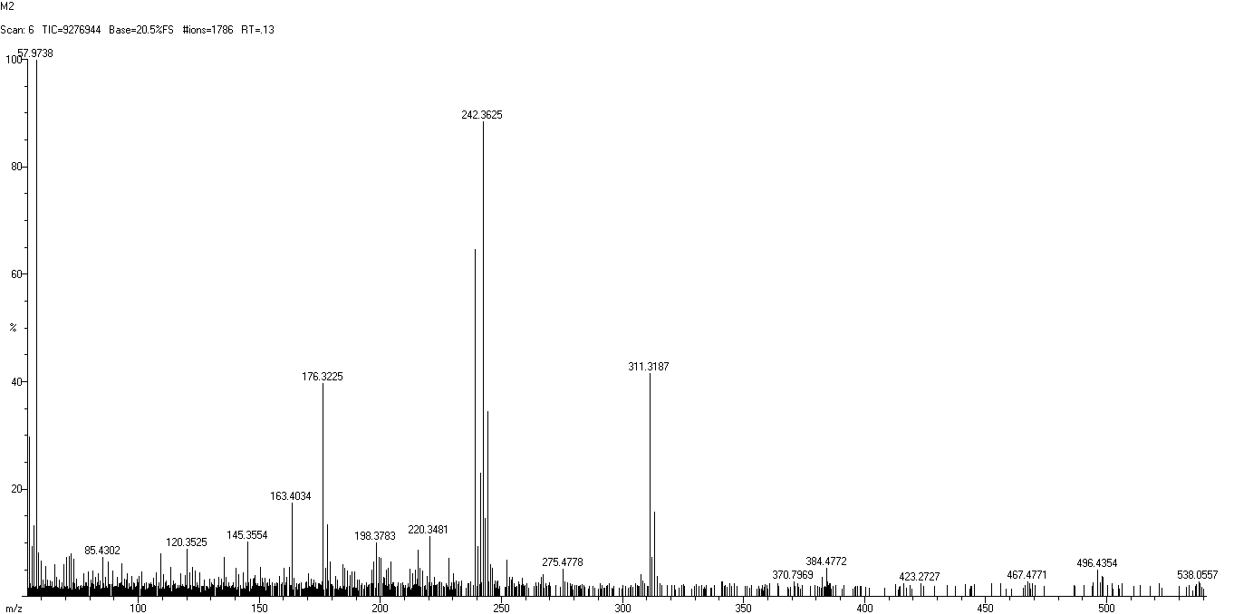

HRMS spectra of 2-(3-(4-bromophenyl)-1-phenyl-1H-pyrazol-4-yl)-6-chloro-4-phenyl-1,2-dihydroquinazoline 4b

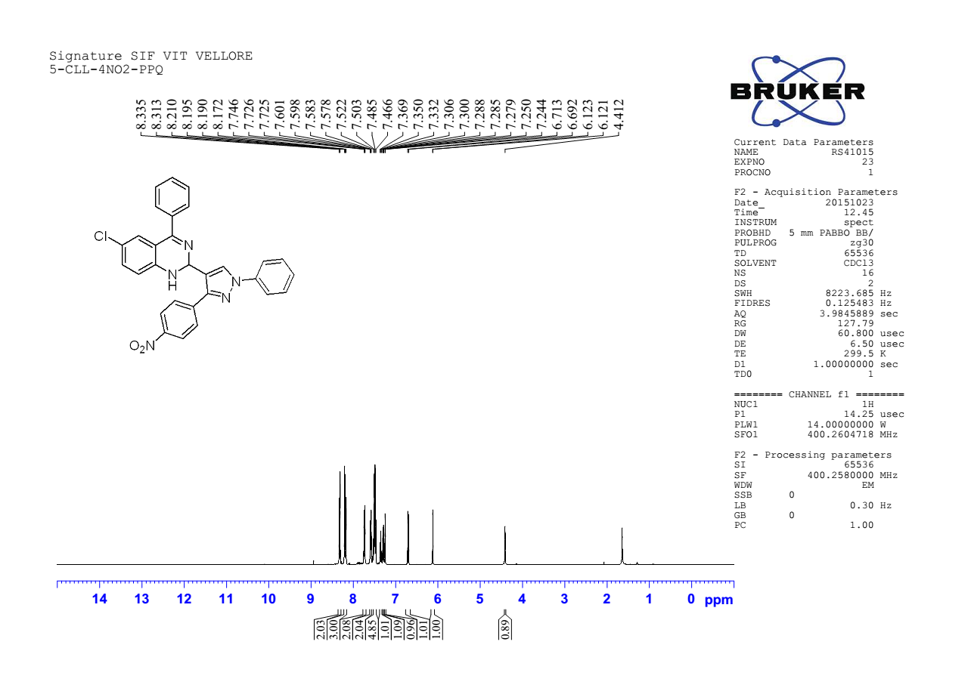

¹H NMR spectra of 6-Chloro2-(3-(4-nitrophenyl)-1-phenyl-1H-pyrazol-4-yl)-4-phenyl-1,2-dihydroquinazoline 4c

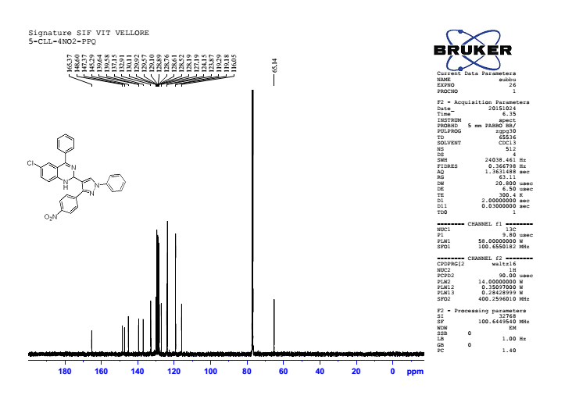

¹³C NMR spectra of 6-Chloro2-(3-(4-nitrophenyl)-1-phenyl-1H-pyrazol-4-yl)-4-phenyl-1,2-dihydroquinazoline 4c

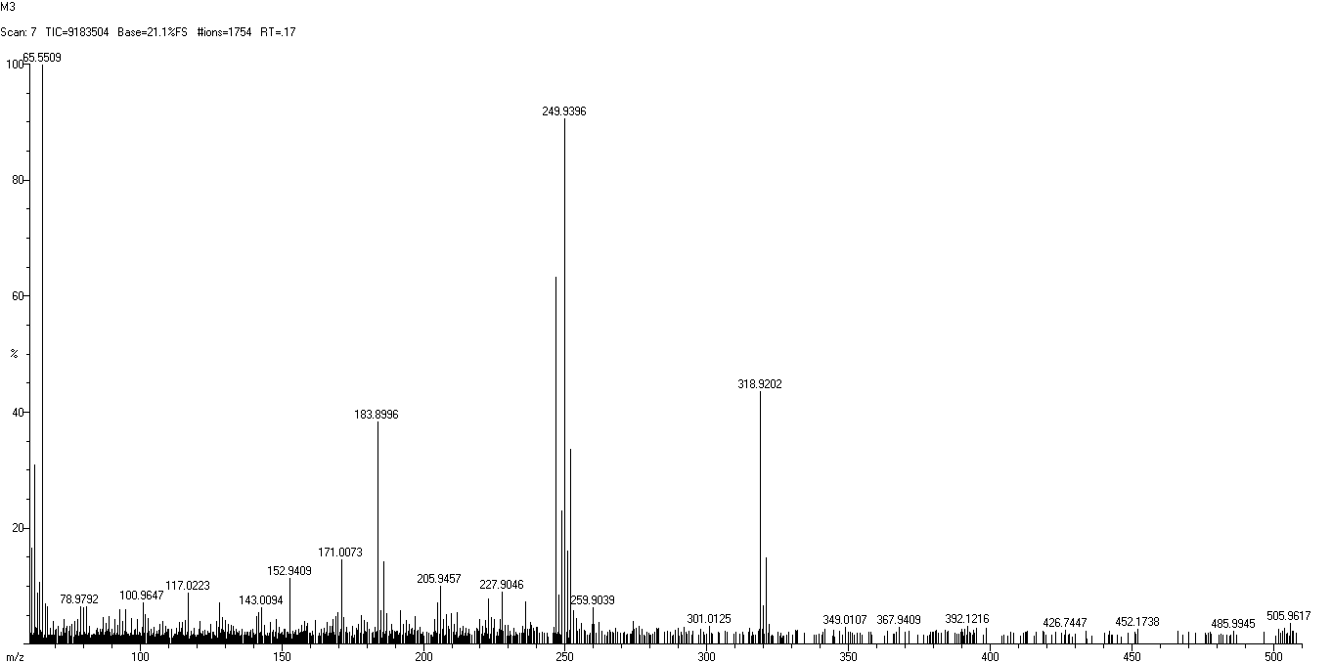

HRMS spectra of 6-Chloro2-(3-(4-nitrophenyl)-1-phenyl-1H-pyrazol-4-yl)-4-phenyl-1,2-dihydroquinazoline 4c

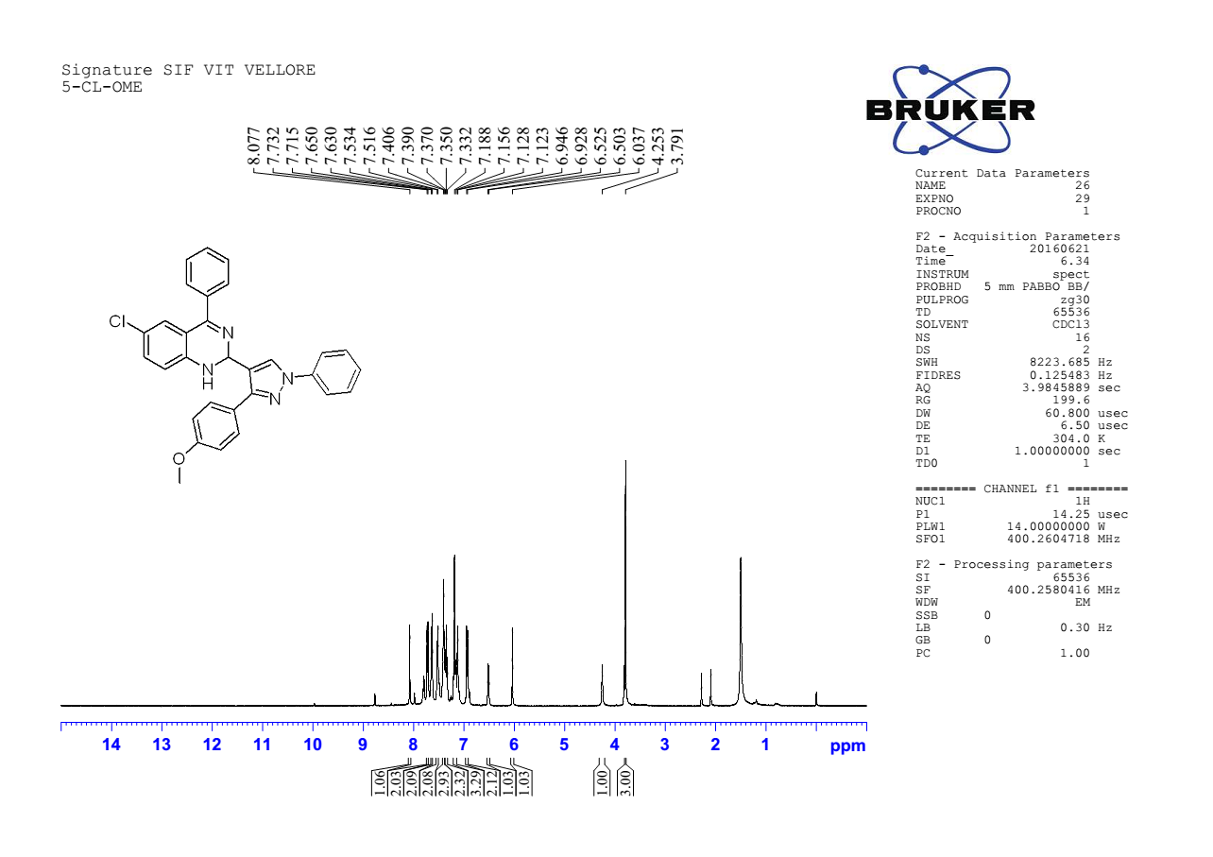

¹H NMR spectra of 6-chloro2-(3-(4-methoxyphenyl)-1-phenyl-1H-pyrazol-4-yl)-4-phenyl-1,2-dihydroquinazoline 4d

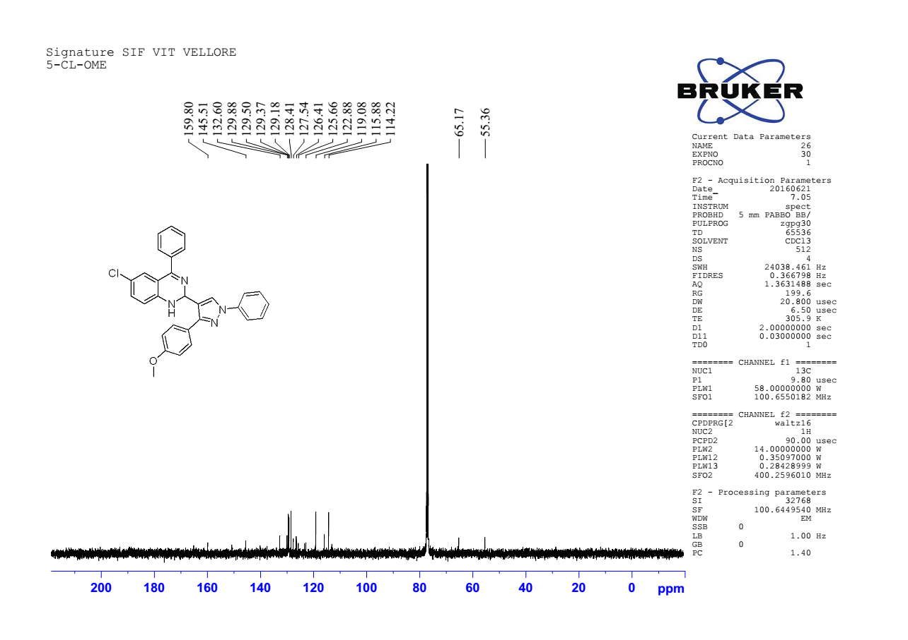

¹³ CNMRspectra of 6-chloro2-(3-(4-methoxyphenyl)-1-phenyl-1H-pyrazol-4-yl)-4-phenyl-1,2-dihydroquinazoline 4d

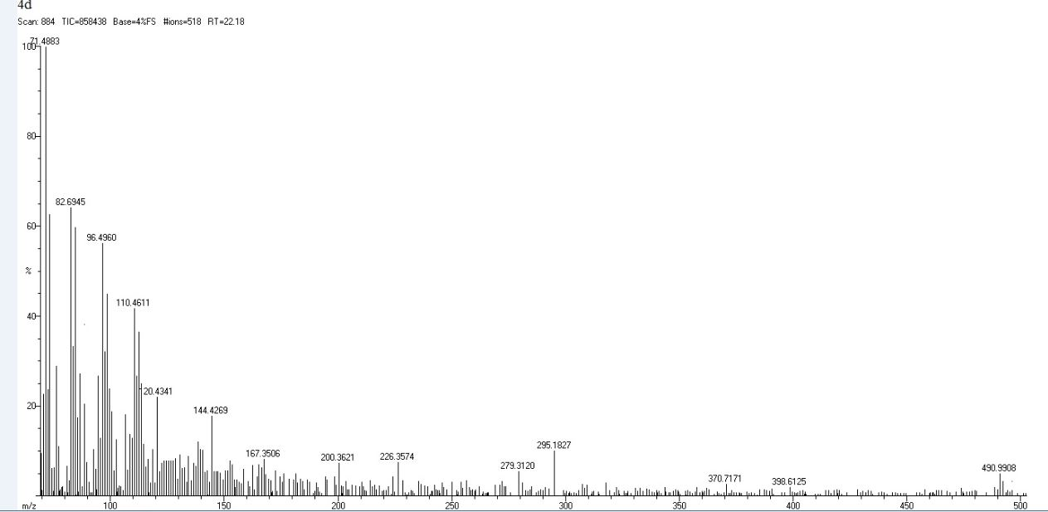

HRMS spectra of 6-chloro2-(3-(4-methoxyphenyl)-1-phenyl-1H-pyrazol-4-yl)-4-phenyl-1,2-dihydroquinazoline 4d

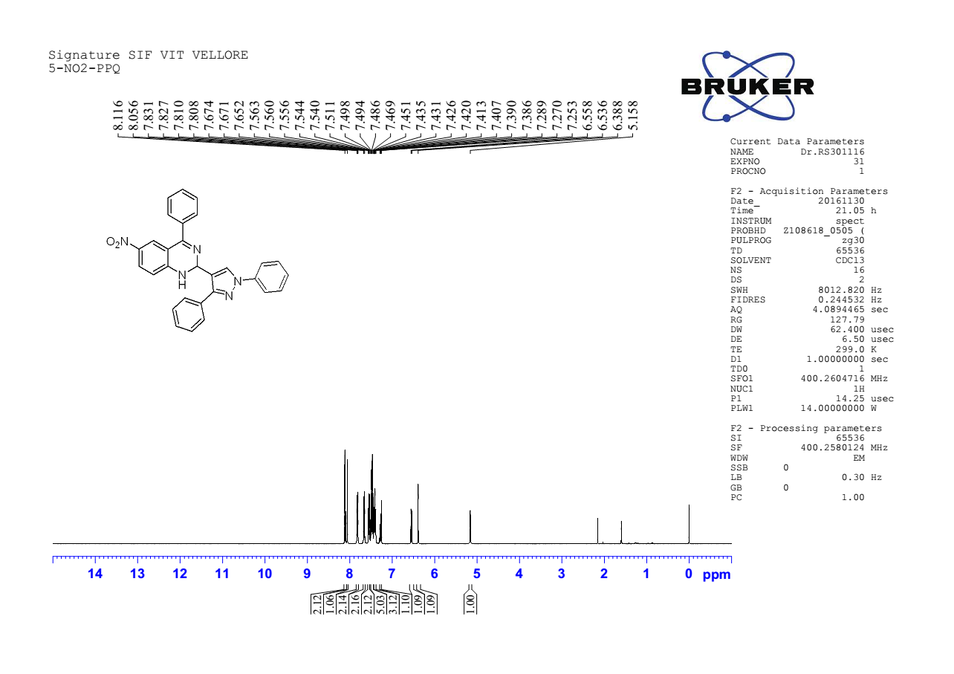

¹ H NMR spectra of 2-(1,3-diphenyl-1H-pyrazol-4-yl)-6-nitro-4-phenyl-1,2-dihydroquinazoline 4e

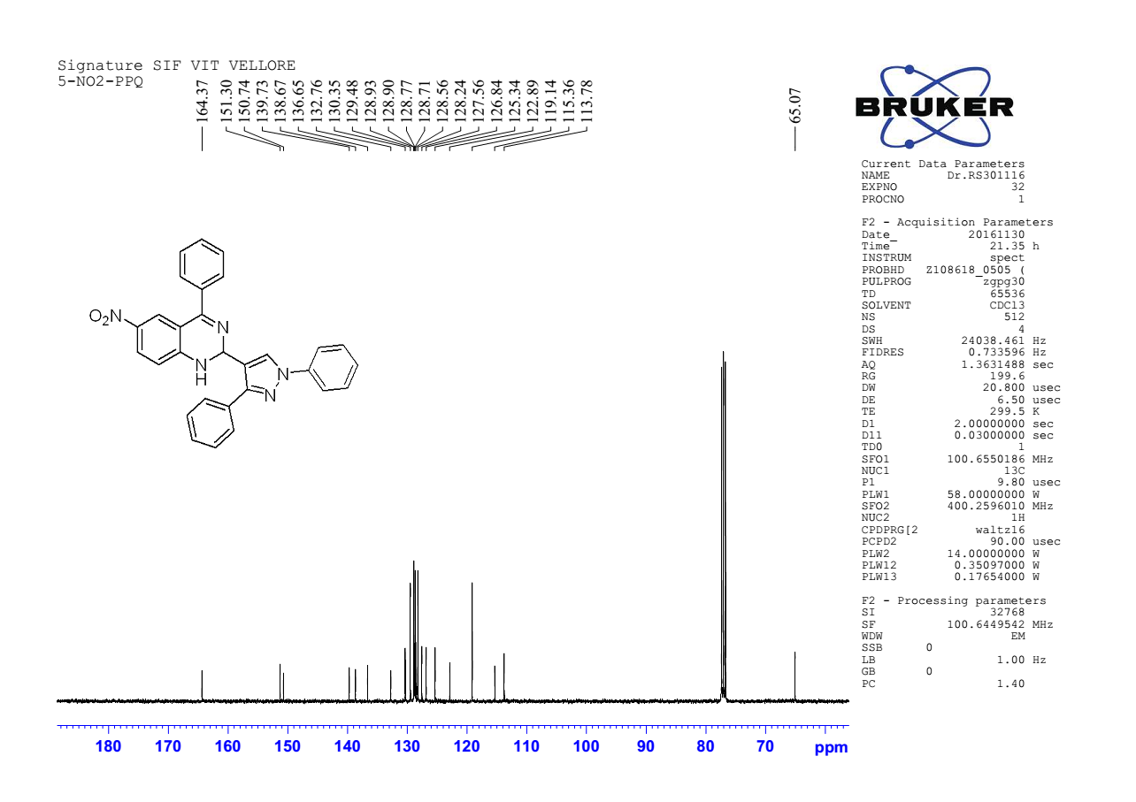

¹³ C NMR spectra of 2-(1,3-diphenyl-1H-pyrazol-4-yl)-6-nitro-4-phenyl-1,2-dihydroquinazoline 4e

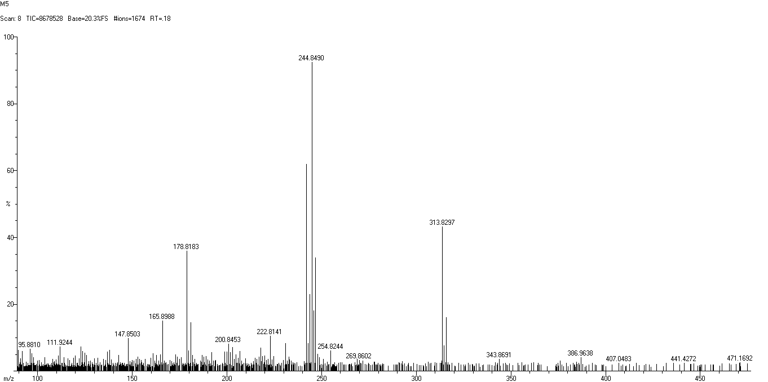

HRMS spectra of 2-(1,3-diphenyl-1H-pyrazol-4-yl)-6-nitro-4-phenyl-1,2-dihydroquinazoline 4e

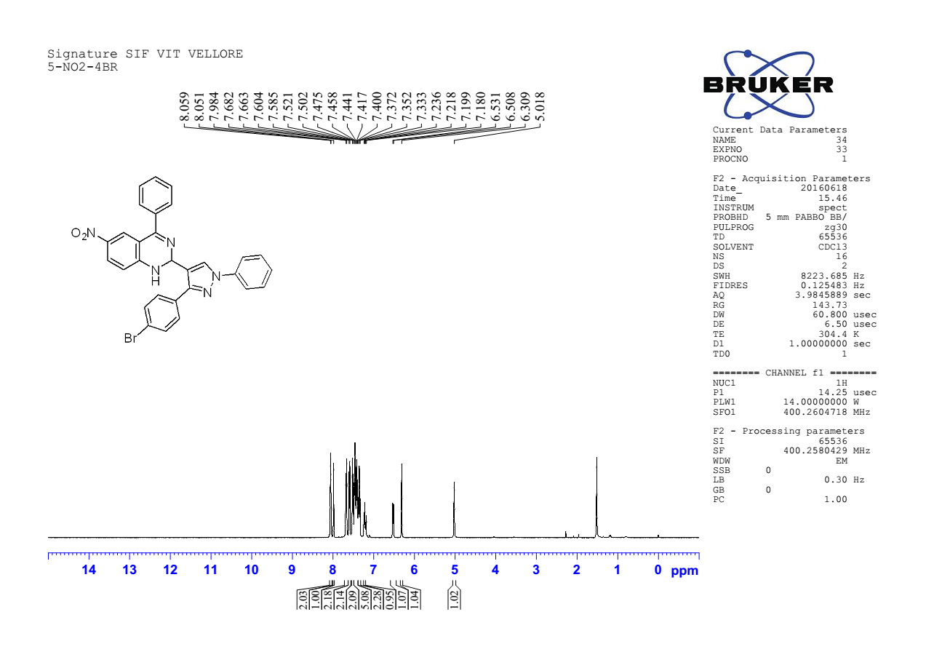

¹ H NMR spectra of 2-(3-(4-bromophenyl)-1-phenyl-1H-pyrazol-4-yl)-6-nitro-4-phenyl-1,2-dihydroquinazoline 4f

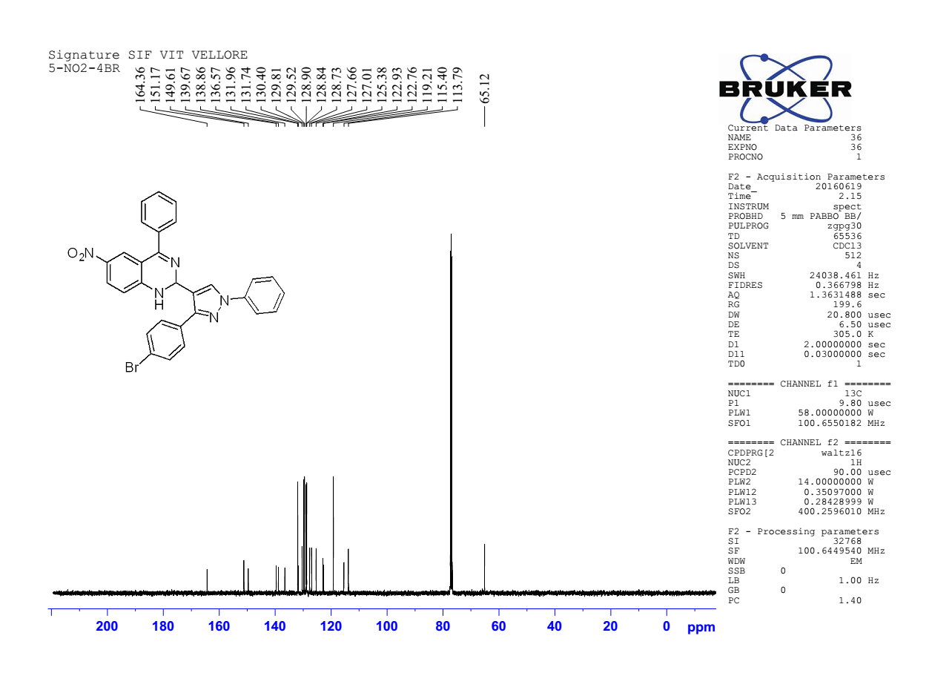

¹³C NMR spectra of 2-(3-(4-bromophenyl)-1-phenyl-1H-pyrazol-4-yl)-6-nitro-4-phenyl-1,2-dihydroquinazoline 4f

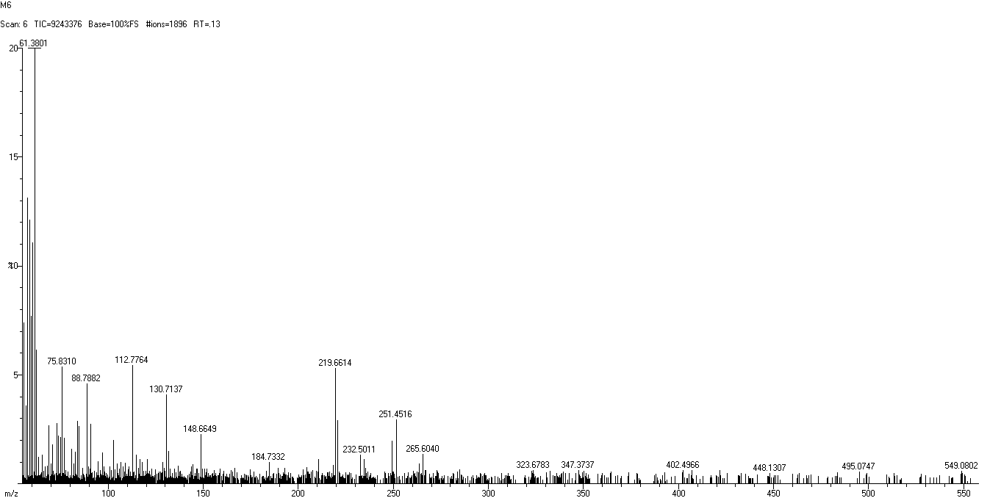

HRMS spectra of 2-(3-(4-bromophenyl)-1-phenyl-1H-pyrazol-4-yl)-6-nitro-4-phenyl-1,2-dihydroquinazoline 4f

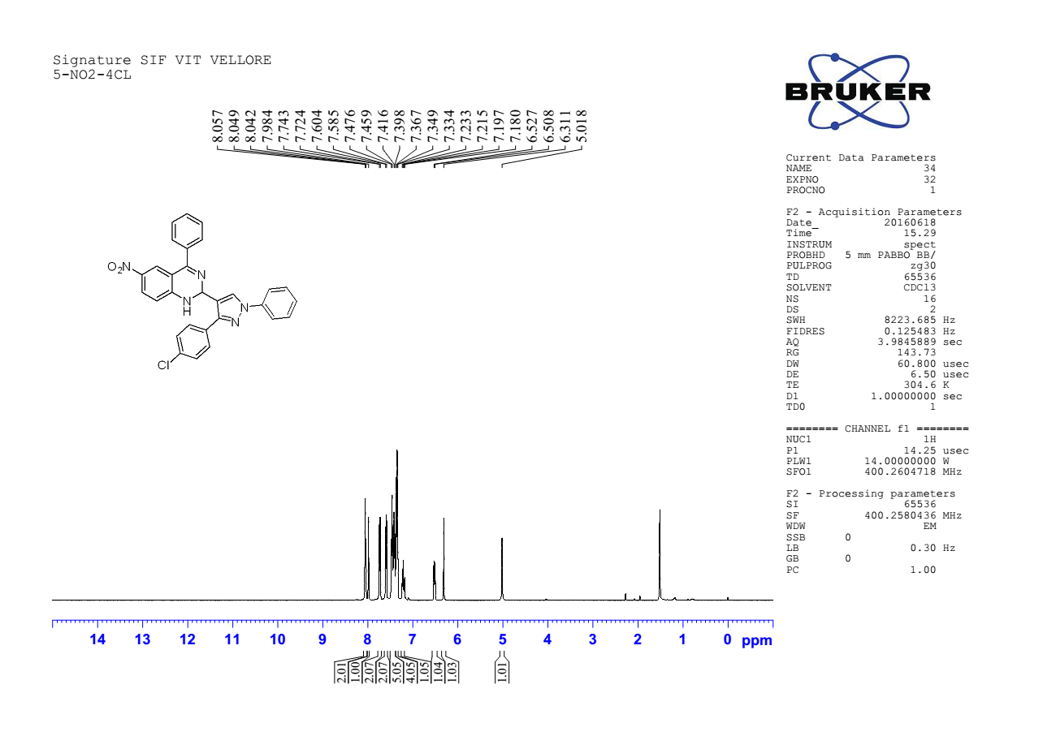

¹H NMR spectra of 2-(3-(4-chlorophenyl)-1-phenyl-1H-pyrazol-4-yl)-6-nitro-4-phenyl-1,2-dihydroquinazoline 4g

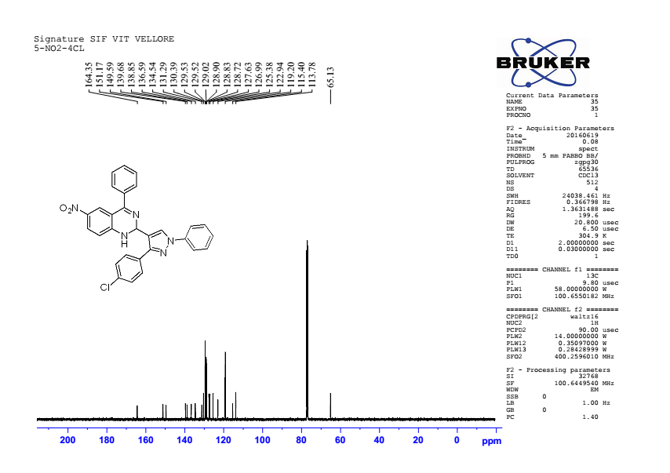

¹³C NMR spectra of 2-(3-(4-chlorophenyl)-1-phenyl-1H-pyrazol-4-yl)-6-nitro-4-phenyl-1,2-dihydroquinazoline 4g

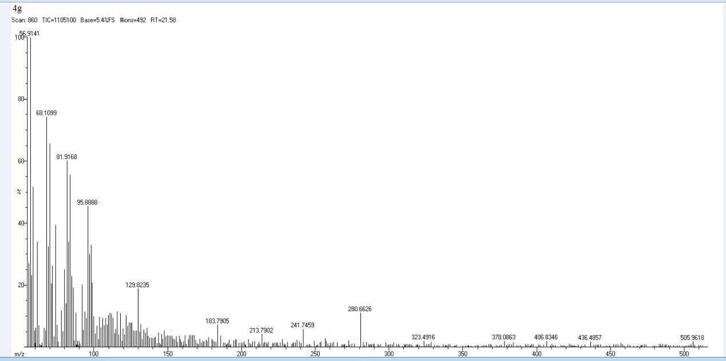

HRMS Spectra of 2-(3-(4-chlorophenyl)-1-phenyl-1H-pyrazol-4-yl)-6-nitro-4-phenyl-1,2-dihydroquinazoline 4g

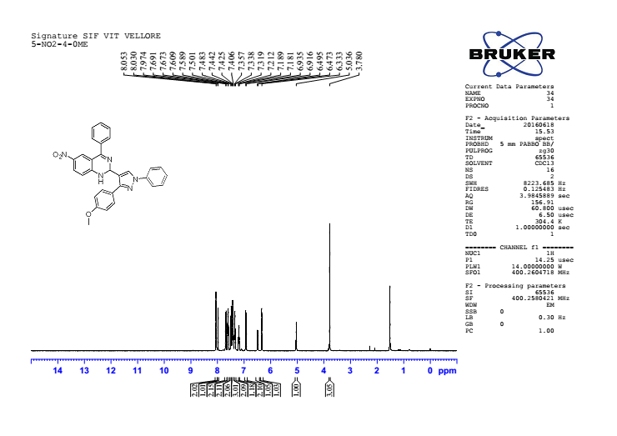

¹H NMR spectra of 2-(3-(4-methoxyphenyl)-1-phenyl-1H-pyrazol-4-yl)-6-nitro-4-phenyl-1,2-dihydroquinazoline 4h

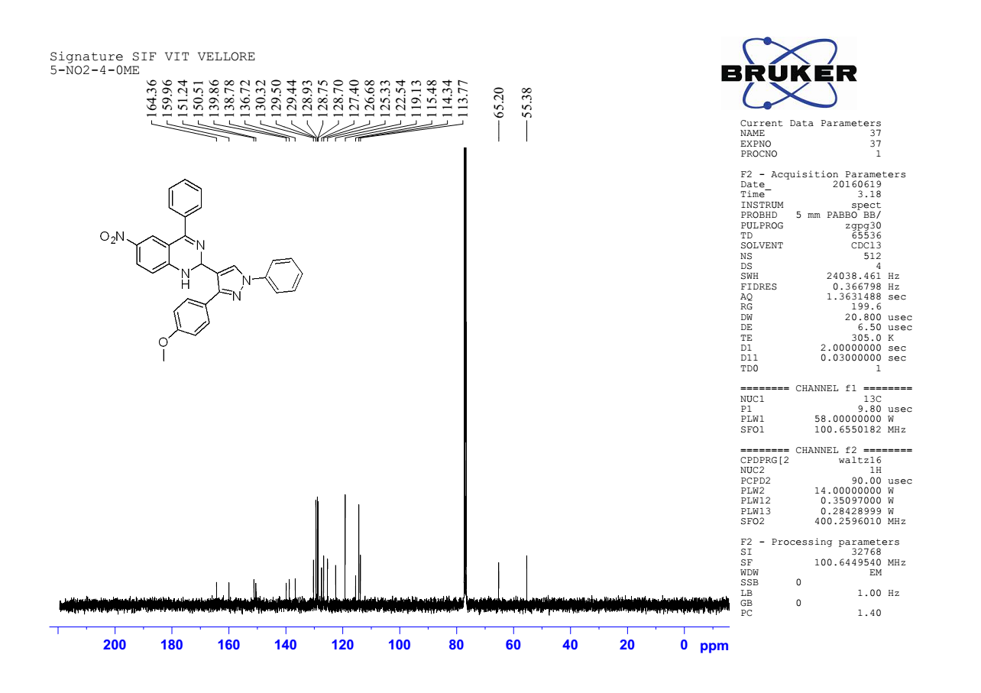

¹³C NMR spectra of 2-(3-(4-methoxyphenyl)-1-phenyl-1H-pyrazol-4-yl)-6-nitro-4-phenyl-1,2-dihydroquinazoline 4h

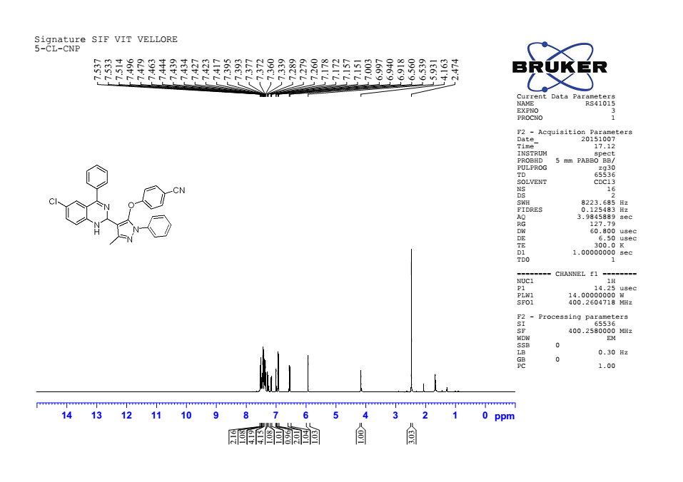

¹H NMR spectra of 4-((4-(6-chloro-4-phenyl-1,2-dihydroquinazolin-2-yl)-3-methyl-1-phenyl-1H-pyrazol-5-yl)oxy)benzonitrile 4i

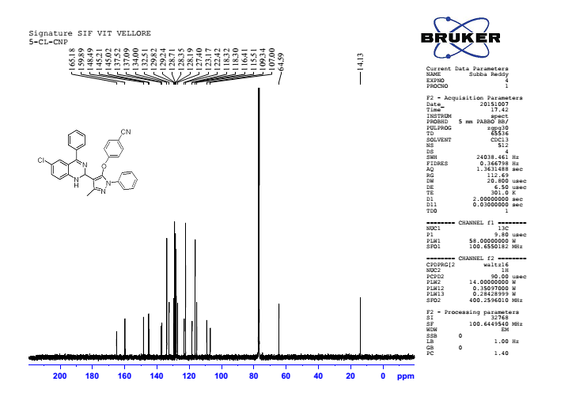

¹³ C NMR spectra of 4-((4-(6-chloro-4-phenyl-1,2-dihydroquinazolin-2-yl)-3-methyl-1-phenyl-1H-pyrazol-5-yl)oxy)benzonitrile 4i

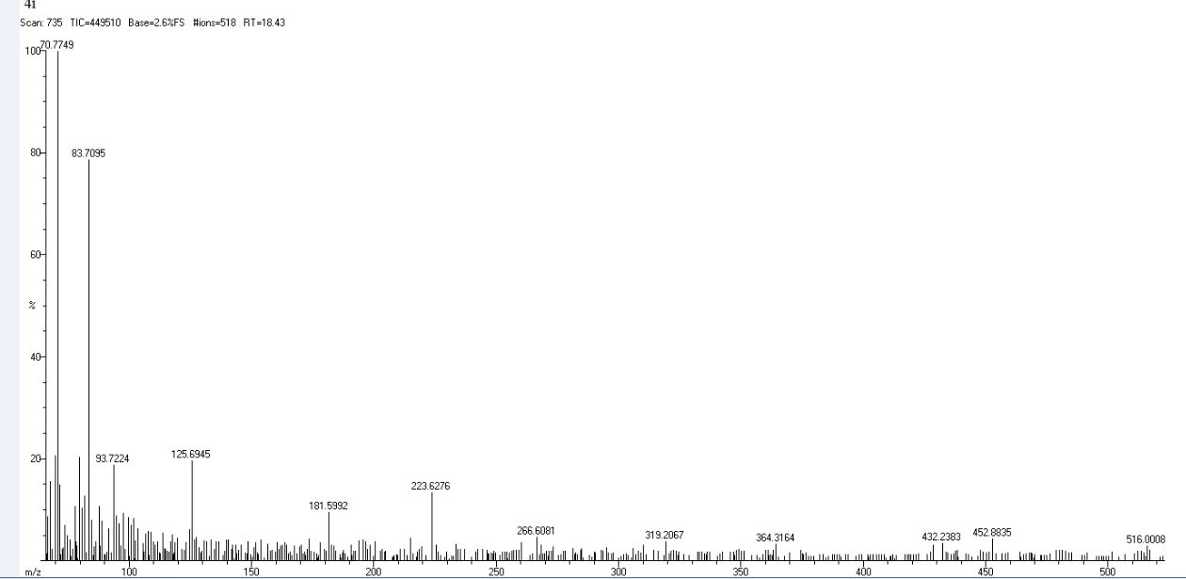

HRMS spectra of 4-((4-(6-chloro-4-phenyl-1,2-dihydroquinazolin-2-yl)-3-methyl-1-phenyl-1H-pyrazol-5-yl)oxy)benzonitrile 4i

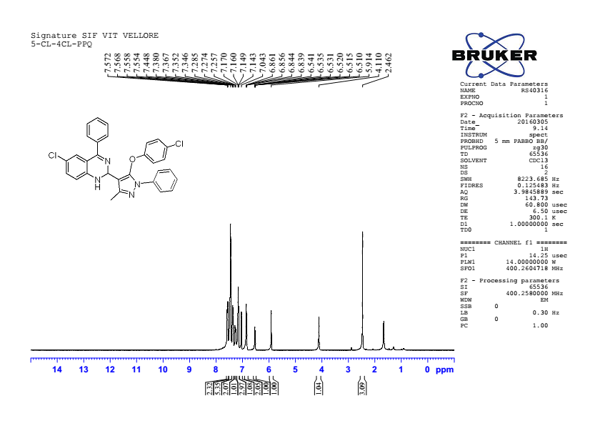

¹HNMR spectraof6-chloro-2-(5-(4-chlorophenoxy)-3-methyl-1-phenyl-1H-pyrazol-4-yl)-4-phenyl-1,2-dihydroquinazoline 4j

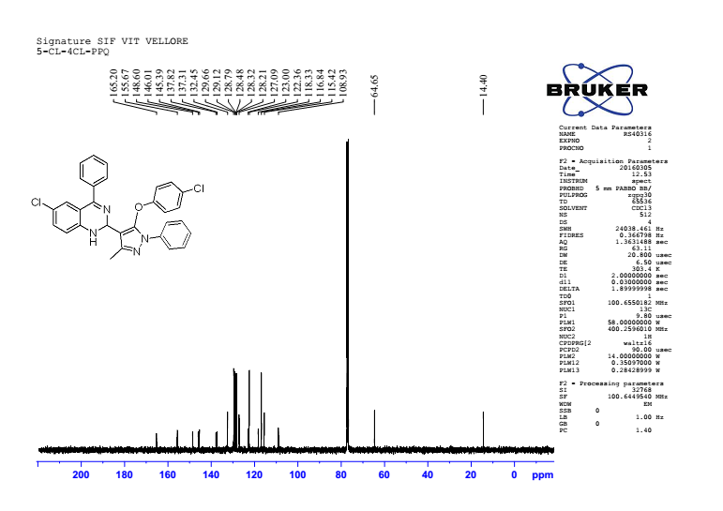

¹³C NMR spectra of 6-chloro-2-(5-(4-chlorophenoxy)-3-methyl-1-phenyl-1H-pyrazol-4-yl)-4-phenyl-1,2-dihydroquinazoline 4j

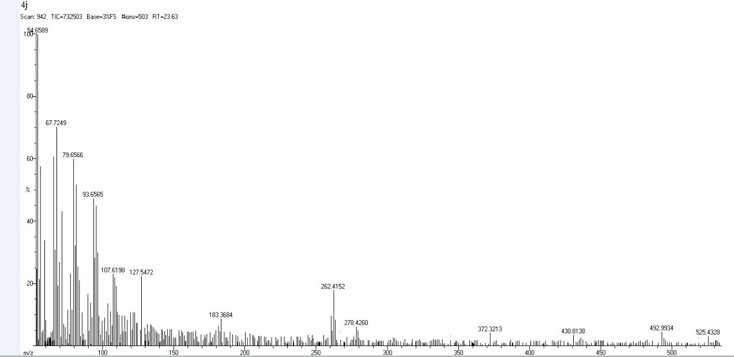

HRMS spectra of 6-chloro-2-(5-(4-chlorophenoxy)-3-methyl-1-phenyl-1H-pyrazol-4-yl)-4-phenyl-1,2-dihydroquinazoline 4j

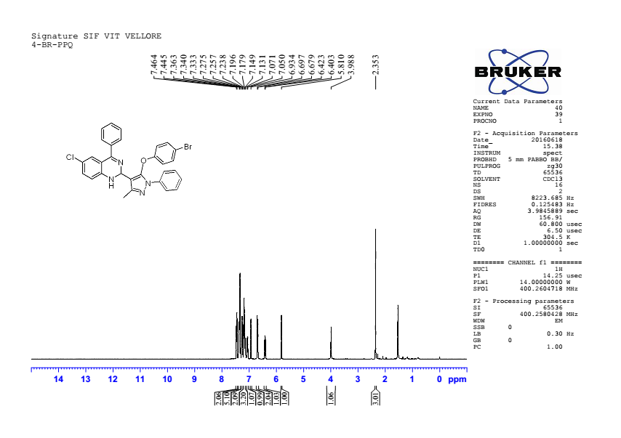

¹HNMR spectra of 2-(5-(4-bromophenoxy)-3-methyl-1-phenyl-1H-pyrazol-4-yl)-6-chloro-4-phenyl-1,2-dihydroquinazoline 4k

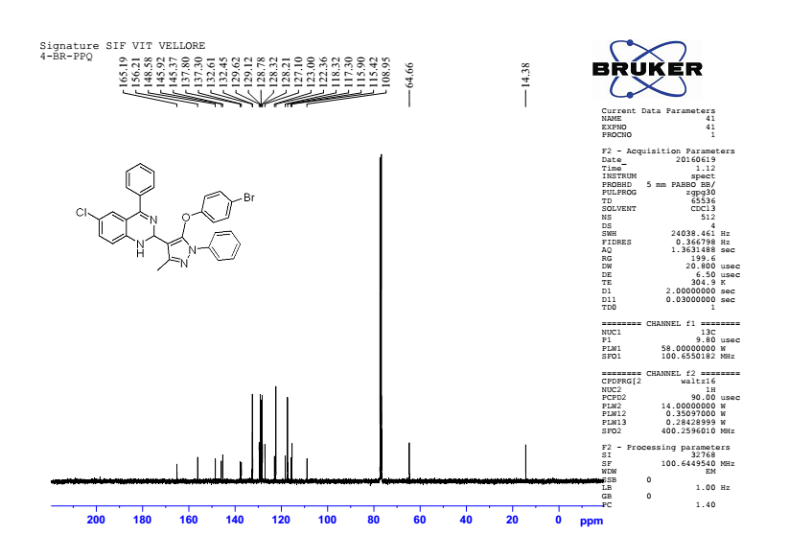

¹³CNMRspectra of 2-(5-(4-bromophenoxy)-3-methyl-1-phenyl-1H-pyrazol-4-yl)-6-chloro-4-phenyl-1,2-dihydroquinazoline 4k

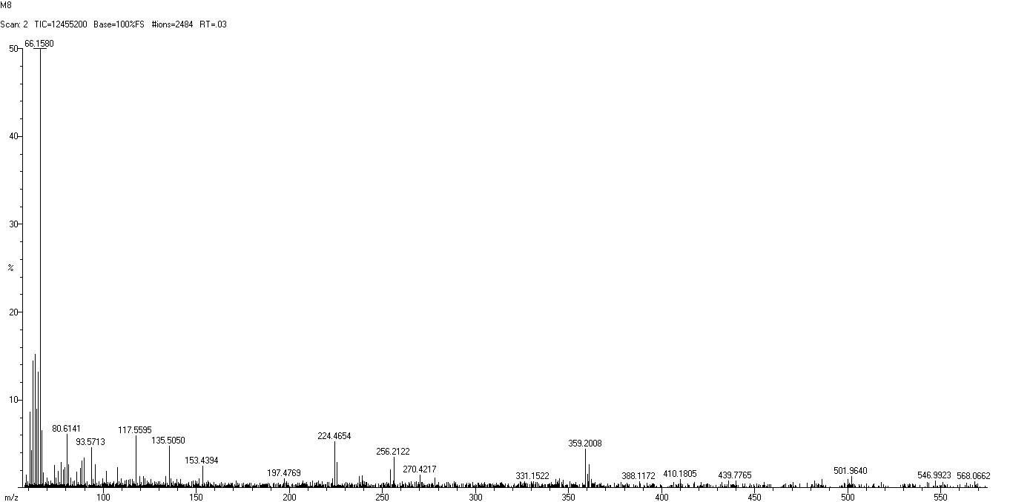

HRMS spectra of 2-(5-(4-bromophenoxy)-3-methyl-1-phenyl-1H-pyrazol-4-yl)-6-chloro-4-phenyl-1,2-dihydroquinazoline 4k

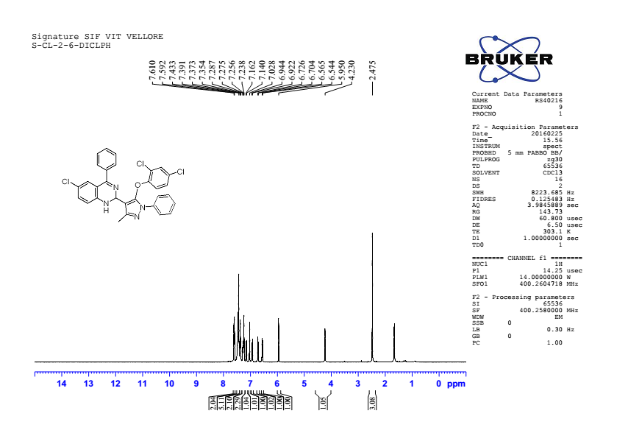

¹H NMR spectra of 6-chloro-2-(5-(2,4-dichlorophenoxy)-3-methyl-1-phenyl-1H-pyrazol-4-yl)-1,2-dihydroquinazoline 4l

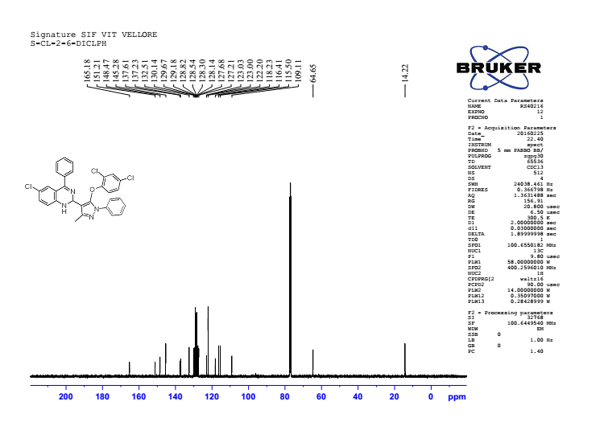

¹³ C NMR spectra of 6-chloro-2-(5-(2,4-dichlorophenoxy)-3-methyl-1-phenyl-1H-pyrazol-4-yl)-1,2-dihydroquinazoline 4l

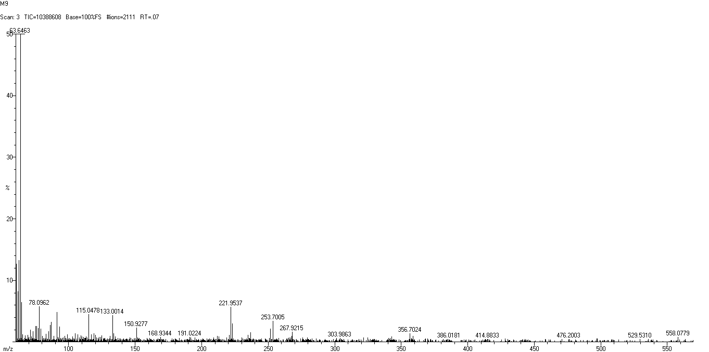

HRMS spectra of 6-chloro-2-(5-(2,4-dichlorophenoxy)-3-methyl-1-phenyl-1H-pyrazol-4-yl)-1,2-dihydroquinazoline 4l

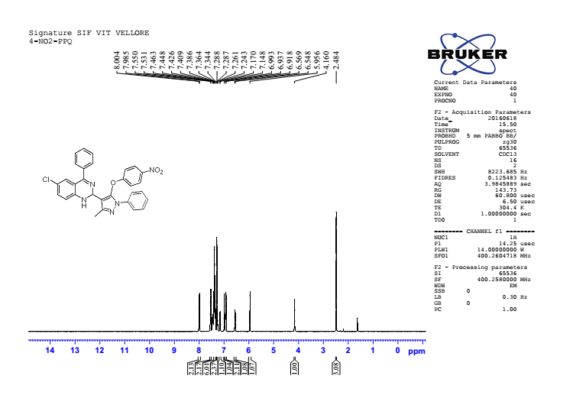

¹H NMR spectra of 6-chloro-2-(3-methyl-5-(4-nitrophenoxy)-1-phenyl-1H-pyrazol-4-yl)-4-phenyl-1,2-dihydroquinazoline 4m

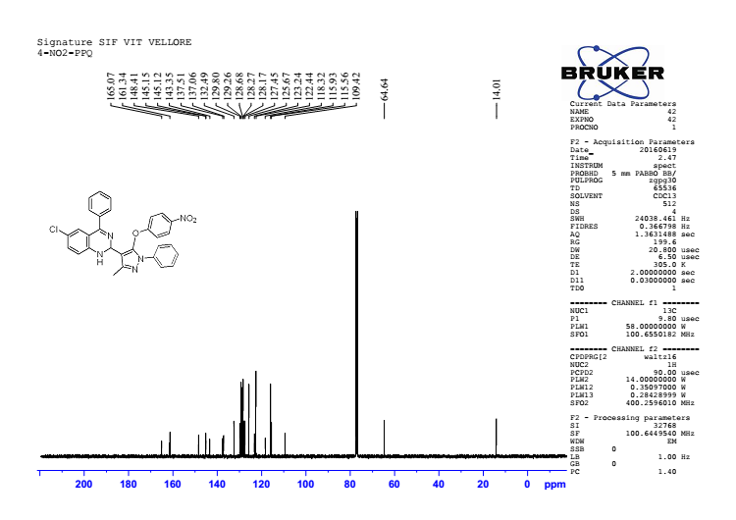

¹³C NMR spectra of 6-chloro-2-(3-methyl-5-(4-nitrophenoxy)-1-phenyl-1H-pyrazol-4-yl)-4-phenyl-1,2-dihydroquinazoline 4m

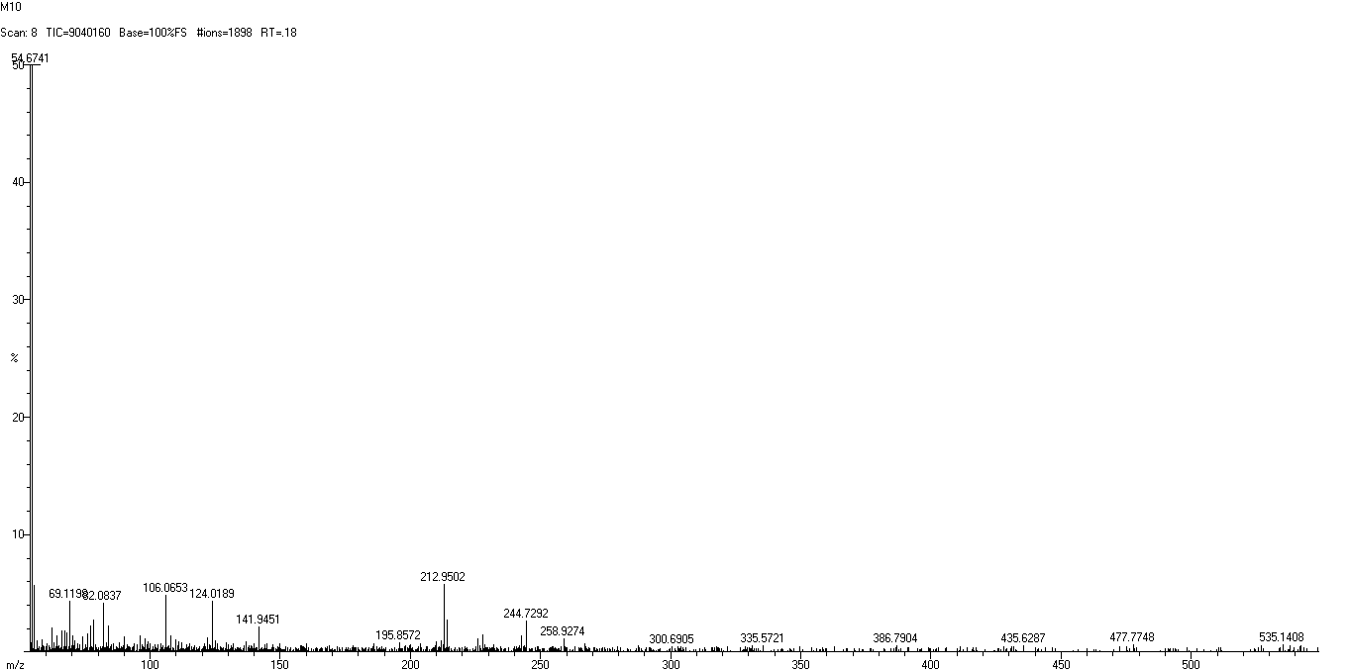

HRMS spectra of 6-chloro-2-(3-methyl-5-(4-nitrophenoxy)-1-phenyl-1H-pyrazol-4-yl)-4-phenyl-1,2-dihydroquinazoline 4m

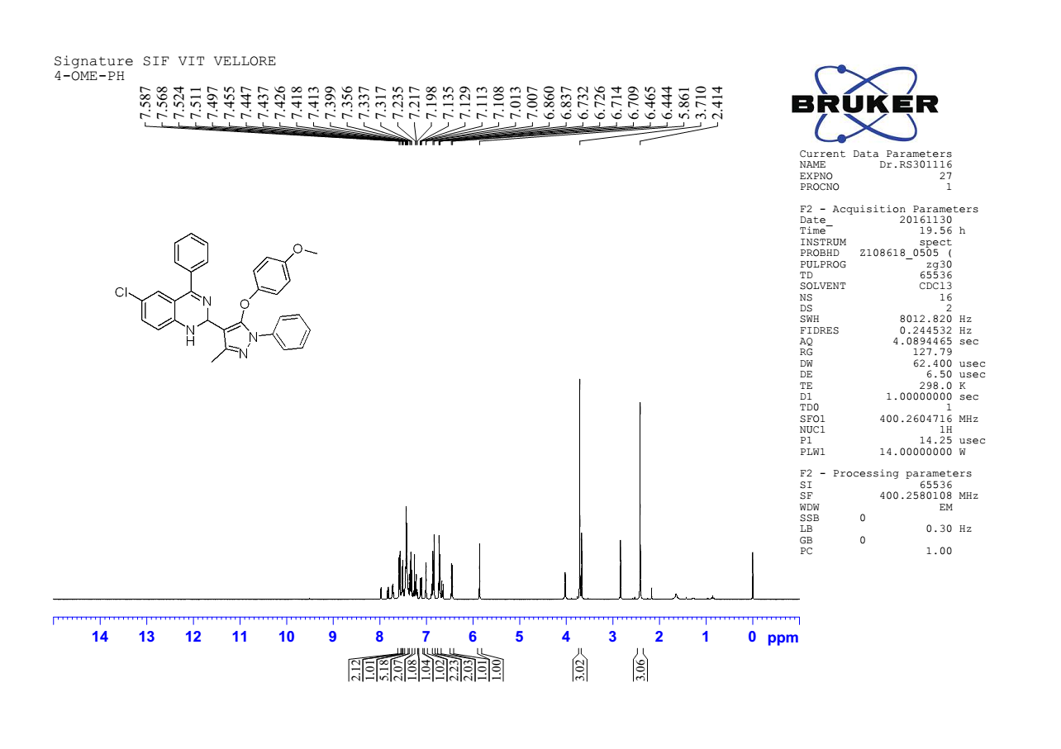

¹H NMR spectra of 6-chloro-2-(5-(4-methoxyphenoxy)-3-methyl-1-phenyl-1H-pyrazol-4-yl)-4-phenyl-1,2-dihydroquinazoline 4n

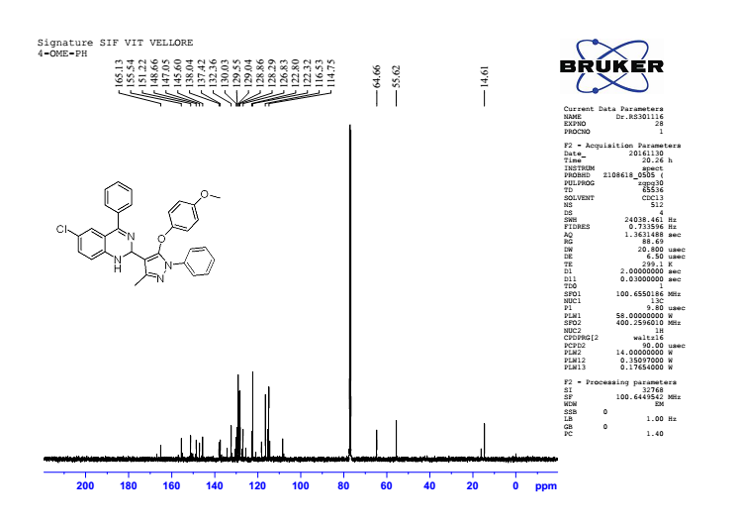

¹³ C NMR spectra of 6-chloro-2-(5-(4-methoxyphenoxy)-3-methyl-1-phenyl-1H-pyrazol-4-yl)-4-phenyl-1,2-dihydroquinazoline 4n

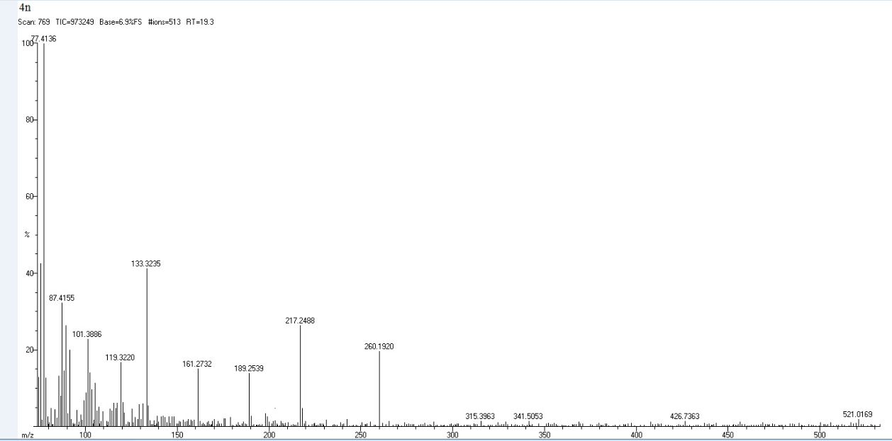

HRMS spectra of 6-chloro-2-(5-(4-methoxyphenoxy)-3-methyl-1-phenyl-1H-pyrazol-4-yl)-4-phenyl-1,2-dihydroquinazoline 4n

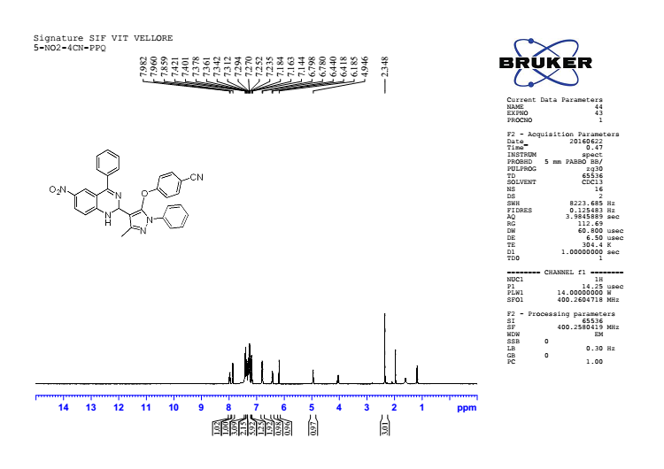

¹H NMR spectra of 4-((3-methyl-4-(6-nitro-4-phenyl-1,2-dihydroquinazolin-2-yl)-1-phenyl-1H-pyrazol-5-yl)oxy)benzonitrile 4o

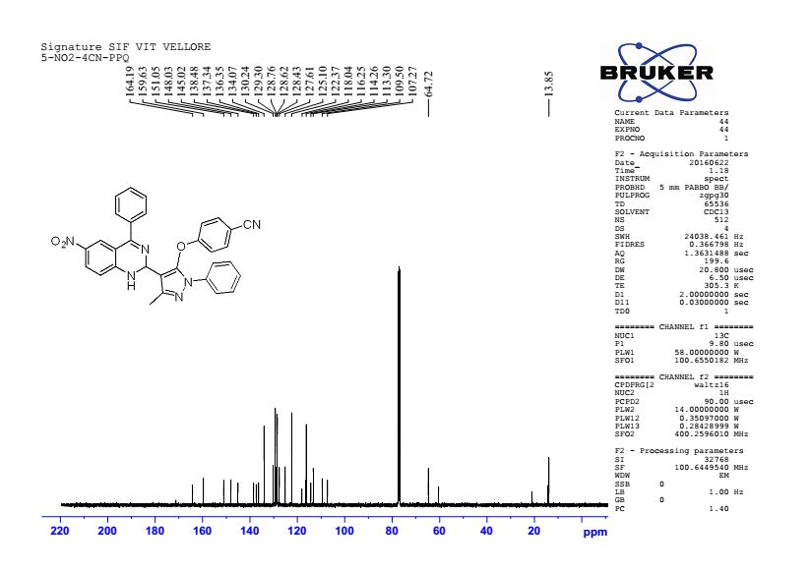

¹³ C NMR spectra of 4-((3-methyl-4-(6-nitro-4-phenyl-1,2-dihydroquinazolin-2-yl)-1-phenyl-1H-pyrazol-5-yl)oxy)benzonitrile 4o

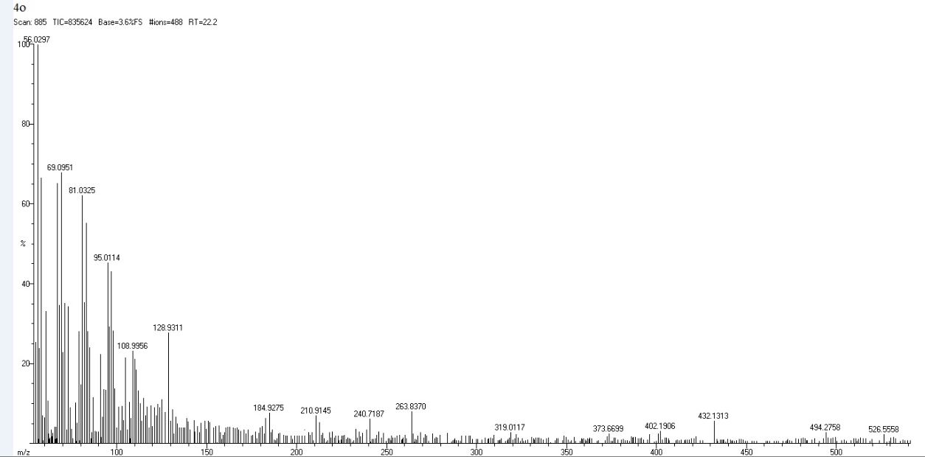
HRMS spectra of 4-((3-methyl-4-(6-nitro-4-phenyl-1,2-dihydroquinazolin-2-yl)-1-phenyl-1H-pyrazol-5-yl)oxy)benzonitrile 4o

