Supplementary Table 1. Baseline of clinicopathological characteristics of cohorts
 | Primary cohort | Validation cohort
Factors | No (%) | No (%)
All patients | 360 (100) | 126 (100)
Gender
Female | 140 (38.9) | 50 (39.7)
Male | 220 (61.1) | 76 (60.3)
Age
≤60 | 185 (51.4) | 68 (54.0)
＞60 | 175 (48.6) | 58 (46.0)
Preoperative serum CEA（ng/ml)
≤5 | 194 (53.9) | 66 (52.4)
＞5 | 166 (46.1) | 60 (47.6)
Primary tumor location
Right-sided colon | 216 (60.0) | 65 (51.6)
Left-sided colon | 144 (40.0) | 61 (48.4)
Primary tumor size（cm）
≤4 | 200 (55.6) | 53 (42.1)
＞4 | 160 (44.4) | 73 (57.9)
Histology
Non-mucinous | 314 (87.2) | 103 (81.7)
Mucinous | 46 (12.8) | 23 (18.3)
Primary Differentiation
Well/moderately | 259 (71.9) | 93 (73.8)
Poorly/undifferentiated | 101 (28.1) | 33 (26.2)
T stage
T1 | 14 (3.9) | 6 (4.8)
T2 | 135 (37.5) | 47 (37.3)
T3 | 123 (34.2) | 48 (38.1)
T4 | 88 (24.4) | 25 (19.8)
N stage
N0 | 179 (49.8) | 64 (50.8)
N1 | 120 (33.3) | 47 (37.3)
N2 | 61 (16.9) | 15 (11.9)
M stage
M0 | 263 (73.1) | 82 (65.1)
M1 | 97 (26.9) | 44 (34.9)
TNM stage
I | 55 (15.3) | 20 (15.9)
II | 99 (27.5) | 25 (19.8)
III | 109 (30.3) | 35 (27.8)
IV | 97 (26.9) | 44 (34.9)
Nerve invasion
No | 331 (91.9) | 118 (93.7)
Yes | 29 (8.1) | 8 (6.3)
Vascular invasion
No | 311 (86.4) | 110 (87.3)
Yes | 49 (13.6) | 16 (12.7)
Lymph nodes examined
＜12 | 29 (8.1) | 9 (7.1)
≥12 | 331 (91.9) | 117 (92.9)
MMR status
pMMR | 321 (89.2) | 110 (87.3)
dMMR | 39 (10.8) | 16 (12.7)
CEA, carcinoembryonic antigen; MMR, mismatch repair.

Supplementary Table 2. Cox regression analysis for OS of validation cohort
 | Univariate |  | Multivariate
 | HR（95% CI） | P | HR（95% CI） | P
Gender
Female | 1 (reference)
Male | 0.73 (0.40-1.33) | 0.299
Age
≤60 | 1 (reference)
＞60 | 0.77 (0.42-1.43) | 0.412
Preoperative serum CEA（ng/ml)
≤5 | 1 (reference)
＞5 | 1.65 (0.90-3.03) | 0.106
Primary tumor location
Right-sided colon | 1 (reference)
Left-sided colon | 0.92 (0.50-1.69) | 0.800
Primary tumor size（cm）
≤4 | 1 (reference)
＞4 | 0.77 (0.42-1.41) | 0.400
Histology
Non-mucinous | 1 (reference)
Mucinous | 0.84 (0.46-1.55) | 0.581
Primary Differentiation
Well/moderately | 1 (reference) |  | 1 (reference)
Poorly/undifferentiated | 1.77 (0.94-3.34) | 0.076 | 1.59 (0.83-3.03) | 0.163
T stage
T1-2 | 1 (reference)
T3-4 | 0.64 (0.35-1.17) | 0.144
N stage
N0 | 1 (reference) |  | 1 (reference)
N1-2 | 2.13 (1.14-3.98) | 0.018 | 1.59 (0.82-3.05) | 0.168
M stage
M0 | 1 (reference) |  | 1 (reference)
M1 | 1.72 (1.12-2.64) | 0.013 | 1.61 (1.04-2.49) | 0.033
TNM stage
I | 1 (reference)
II | 2.27 (0.60-8.56) | 0.226
III | 2.46 (0.69-8.83) | 0.167
IV | 4.30 (1.28-14.50) | 0.019
Nerve invasion
No | 1 (reference)
Yes | 1.47 (0.46-4.77) | 0.518
Vascular invasion
No | 1 (reference)
Yes | 1.77 (0.82-3.83) | 0.145
Lymph nodes examined
＜12 | 1 (reference)
≥12 | 0.65 (0.23-1.82) | 0.414
MMR status
pMMR | 1 (reference)
dMMR | 1.50 (0.67-3.38) | 0.326
The density of CXCR6+TAMs
Low | 1 (reference) |  | 1 (reference)
High | 2.61 (1.33-5.11) | 0.005 | 2.07 (1.03-4.17) | 0.041
CEA, carcinoembryonic antigen; MMR, mismatch repair.

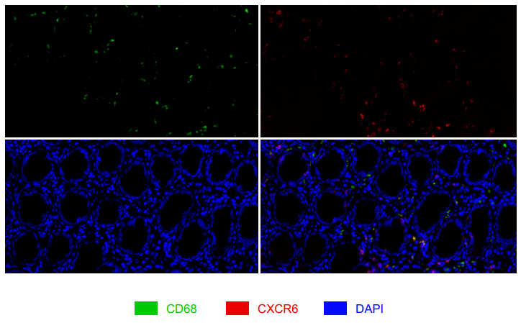
Figure S1.Representative images of CXCR6+ TAMs in peritumor specimens.

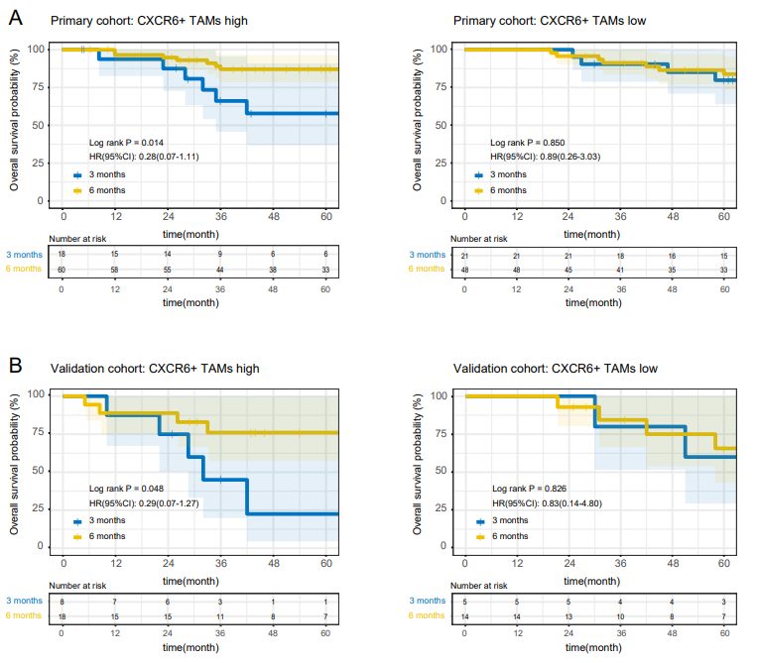

Figure S2. High CXCR6+ TAMs infiltration is associated with better response to 6-month adjuvant chemotherapy in high-risk II stage and III stage CC patients. (A) Overall survival curves of patients with high and low CXCR6+ TAMs from primary cohort. (B) Overall survival curves of patients with high and low CXCR6+ TAMs from validation cohort.

