Table 1. Top ten compounds information of SSR network.
Symbol | Compound | Molecule structure | DC | BC | CC | Source
B1 | Quercetin | 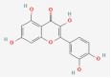 | 296 | 66045.287 | 0.509481669 | Epimedium,  Coptis chinensis
A1 | Luteolin | 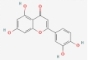 | 224 | 22754.447 | 0.418483904 | Codonopsis pilosula, Epimedium,  Salvia miltiorrhiza,  Folium perillae
C1 | β-sitosterol | 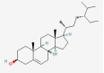 | 156 | 15277.625 | 0.402597403 | Angelica sinensis,  Rheum palmatum,  Folium perillae,  Peach kernel
E1 | Stigmasterol | 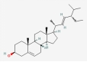 | 62 | 6966.866 | 0.394711068 | Codonopsis pilosula,  Angelica sinensis
YYH8 | Kaempferol | 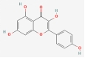 | 62 | 7826.428 | 0.420229406 | Epimedium
DS6 | 7-Methoxy-2-methyl isoflavone | 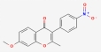 | 44 | 2955.041 | 0.402597403 | Codonopsis pilosula
DanS57 | Tanshinone iia | 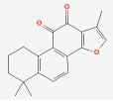 | 41 | 6645.125 | 0.388621022 | Salvia miltiorrhiza
DanS53 | Salviolone | 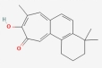 | 39 | 3495.749 | 0.390125847 | Salvia miltiorrhiza
YYH11 | C-Homoerythrinan,1,6-didehydro-3,15,16-trimethoxy-,(3.beta.)- | 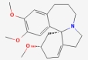 | 39 | 4005.660 | 0.387872955 | Epimedium
DanS34 | Dihydrotanshinlactone | 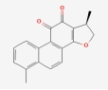 | 37 | 1226.602 | 0.388621022 | Salvia miltiorrhiza
Note: DC, Degree Centrality; BC, Betweenness Centrality; CC, Closeness Centrality

