Supplementary Materials

Theoretical Study on the Atomic Cluster Level of Gallium Doped in Magnesium Minerals: Gas-Phase GaMg_{n}⁻ (n=2-12) DFT Investigation
Yu-Jin Li ^{1,2}, Yu-Jie Hao ^{1,2}, Ke Jiang ³, Lu Zeng ⁴* and Feng-Yue Sun ^{1, 2}*
¹College of Earth Sciences, Jilin University, Changchun 130000, China
²Key Laboratory of Mineral Resources Evaluation in Northeast Asia, Ministry of Natural Resources of China, Changchun 130000, China
³Union Resources & Engineering co., LTD, Kunming 650000, China
⁴College of Materials Science and Engineering, Chongqing University, Chongqing 400044, China
*Corresponding author:
Email: Lu Zeng, zool@foxmail.com
Email: Feng-Yue Sun, 28004036@qq.com

Table of Contents | PaGas
Table S1. Structural coordinates in the ground state of GaMg_{n}⁻ (n=2-12) clusters. | 2–9
Table S2. NCP on Mg atoms in the ground state of GaMg_{n}⁻ (n=2-12) clusters. | 4–9
Table S3. NEC on Mg atoms in the ground state of GaMg_{n}⁻ (n=2-12) clusters. | 5–9
Figure S1. The HOMO, LUMO energies, and their MOs in the ground state of GaMg_{n}⁻ (n=2-12) clusters. | 6–9
Figure S2. ELF analysis on the ground state isomers of GaMg_{n}⁻ (n=2-7, 9-12) clusters. | 8–9
Figure S3. NTO analysis on the ground state isomer GaMg₈⁻ cluster for S0→S12, S0→S19 and S0→S26 excitation. | 9–9

Table S1. Structural coordinates in the ground state of GaMg_{n}⁻ (n=2-12) clusters.
GaMg₂⁻ | X | Y | Z | GaMg₈⁻ | X | Y | Z
Ga-1 | 0.000000 | 0.000000 | 1.011300 | Ga-1 | 0.000000 | 0.000000 | 2.006500
Mg-2 | 0.000000 | 1.573500 | -1.306300 | Mg-2 | 1.769100 | 1.538900 | 0.559900
Mg-3 | 0.000000 | -1.573500 | -1.306300 | Mg-3 | 0.000000 | -2.555100 | -1.670900
GaMg₃⁻ | X | Y | Z | Mg-4 | -1.673600 | 0.000000 | -2.040600
Ga-1 | 0.000000 | 0.000000 | 1.132100 | Mg-5 | -1.769100 | -1.538900 | 0.559900
Mg-2 | 0.000000 | 1.797500 | -0.974800 | Mg-6 | -1.769100 | 1.538900 | 0.559900
Mg-3 | -1.556700 | -0.898800 | -0.974800 | Mg-7 | 1.673600 | 0.000000 | -2.040600
Mg-4 | 1.556700 | -0.898800 | -0.974800 | Mg-8 | 0.000000 | 2.555100 | -1.670900
GaMg₄⁻ | X | Y | Z | Mg-9 | 1.769100 | -1.538900 | 0.559900
Ga-1 | 0.000000 | 0.000000 | 0.468700 | GaMg₉⁻ | X | Y | Z
Mg-2 | 0.000000 | 1.776800 | -1.675000 | Ga-1 | -0.809200 | 1.363300 | 0.000000
Mg-3 | -1.538800 | -0.888400 | -1.675000 | Mg-2 | -1.379400 | -0.685300 | 1.750700
Mg-4 | 1.538800 | -0.888400 | -1.675000 | Mg-3 | 1.259500 | 0.880600 | -1.752800
Mg-5 | 0.000000 | 0.000000 | 3.814100 | Mg-4 | 1.259500 | 0.880600 | 1.752800
GaMg₅⁻ | X | Y | Z | Mg-5 | -1.379400 | -0.685300 | -1.750700
Ga-1 | -0.129200 | 0.174500 | 0.000000 | Mg-6 | 1.259500 | -2.124300 | 1.677100
Mg-2 | -0.436500 | 2.814400 | 1.557900 | Mg-7 | -2.343800 | 3.973600 | 0.000000
Mg-3 | -0.436500 | -2.236200 | -1.540800 | Mg-8 | 1.259500 | -2.124300 | -1.677100
Mg-4 | -0.436500 | -2.236200 | 1.540800 | Mg-9 | 3.280600 | -0.510600 | 0.000000
Mg-5 | -0.436500 | 2.814400 | -1.557900 | Mg-10 | -1.125500 | -3.126600 | 0.000000
Mg-6 | 2.079800 | -1.607300 | 0.000000 | GaMg₁₀⁻ | X | Y | Z
GaMg₆⁻ | X | Y | Z | Ga-1 | -0.585500 | -0.975600 | -0.264600
Ga-1 | 0.544000 | -1.579200 | 0.000000 | Mg-2 | -4.649500 | 1.284000 | 0.201000
Mg-2 | -0.278300 | 2.745200 | 1.564500 | Mg-3 | 0.373600 | 0.426400 | 2.526100
Mg-3 | -0.278300 | -0.190800 | -2.240300 | Mg-4 | 1.865600 | -1.558800 | -1.409300
Mg-4 | -0.278300 | -0.190800 | 2.240300 | Mg-5 | -3.424100 | -1.550500 | -0.643500
Mg-5 | 1.806900 | 1.060200 | 0.000000 | Mg-6 | 3.125900 | 1.165200 | -1.618300
Mg-6 | -2.099200 | -2.089400 | 0.000000 | Mg-7 | 3.076500 | -0.028000 | 1.220500
Mg-7 | -0.278300 | 2.745200 | -1.564500 | Mg-8 | 1.136100 | -2.318000 | 1.448800
GaMg₇⁻ | X | Y | Z | Mg-9 | -1.510700 | 1.649200 | 0.471000
Ga-1 | 0.647100 | 1.733500 | 0.000000 | Mg-10 | 1.354000 | 2.467000 | 0.534700
Mg-2 | -1.373900 | -1.817600 | 1.606000 | Mg-11 | 0.165200 | 0.983700 | -2.047600
Mg-3 | -1.373900 | 1.225200 | -1.771200
Mg-4 | -1.373900 | -1.817600 | -1.606000
Mg-5 | 1.379700 | -0.277600 | 1.820800
Mg-6 | -1.373900 | 1.225200 | 1.771200
Mg-7 | 1.379700 | -0.277600 | -1.820800
Mg-8 | 1.064500 | -2.738300 | 0.000000
GaMg₁₁⁻ | X | Y | Z | GaMg₁₂⁻ | X | Y | Z
Ga-1 | -1.519200 | -0.073400 | 0.000000 | Ga-1 | -0.195300 | -0.334600 | -1.167400
Mg-2 | 0.004100 | 0.547200 | 2.220800 | Mg-2 | -1.967300 | 2.166500 | 2.032600
Mg-3 | 0.004100 | 0.547200 | -2.220800 | Mg-3 | -2.690500 | -0.202000 | -2.347200
Mg-4 | 1.891200 | -1.644600 | -1.550700 | Mg-4 | 2.678400 | -0.042800 | -1.557400
Mg-5 | -1.227600 | -2.332700 | -1.600500 | Mg-5 | 0.663800 | 0.978000 | 1.224500
Mg-6 | 0.792400 | 3.675900 | -1.561700 | Mg-6 | -1.648000 | -0.864800 | 2.401000
Mg-7 | 1.891200 | -1.644600 | 1.550700 | Mg-7 | 3.890100 | 0.476700 | 1.205200
Mg-8 | -1.227600 | -2.332700 | 1.600500 | Mg-8 | 2.921500 | 2.992400 | -0.531300
Mg-9 | 0.792400 | 3.675900 | 1.561700 | Mg-9 | 3.611800 | -2.568300 | 0.295400
Mg-10 | 0.667500 | -4.005500 | 0.000000 | Mg-10 | -3.770500 | 0.304100 | 0.460900
Mg-11 | -1.764400 | 2.776500 | 0.000000 | Mg-11 | -1.360900 | 2.169900 | -0.877200
Mg-12 | 2.101300 | 0.926900 | 0.000000 | Mg-12 | -2.360400 | -2.350200 | -0.127800
 |  |  |  | Mg-13 | 0.536500 | -2.195200 | 0.837200

Table S2. NCP on Mg atoms in the ground state of GaMg_{n}⁻ (n=2-12) clusters.

Table S3. NEC on Mg atoms in the ground state of GaMg_{n}⁻ (n=2-12) clusters.

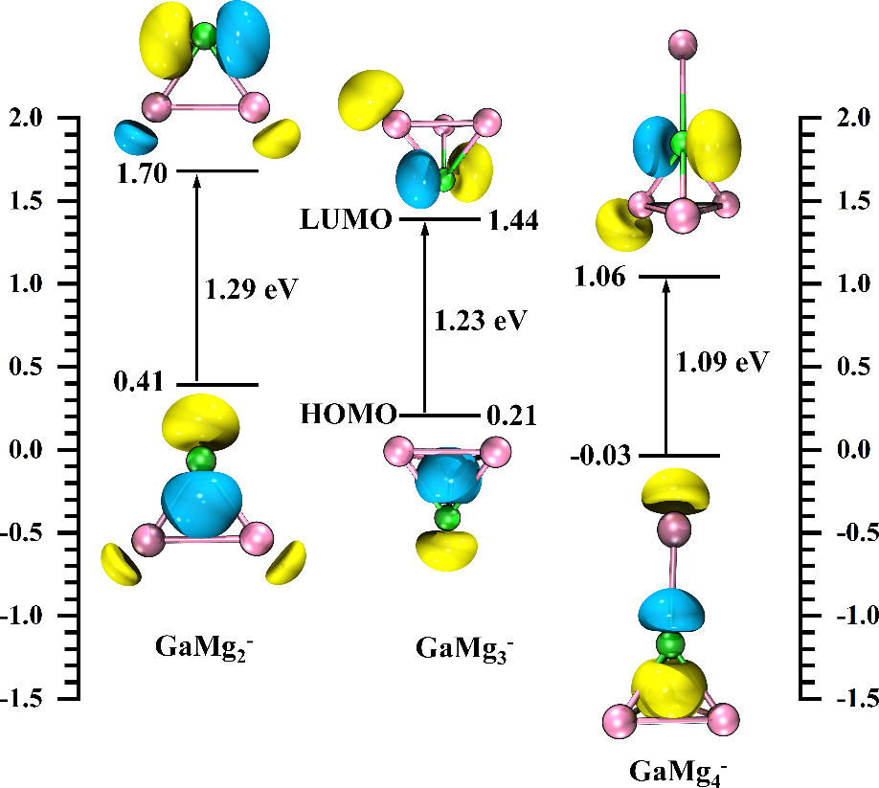
Figure S1-1. The HOMO, LUMO energies, and their MOs in the ground state of GaMg_{n}⁻ (n=2-4) clusters.
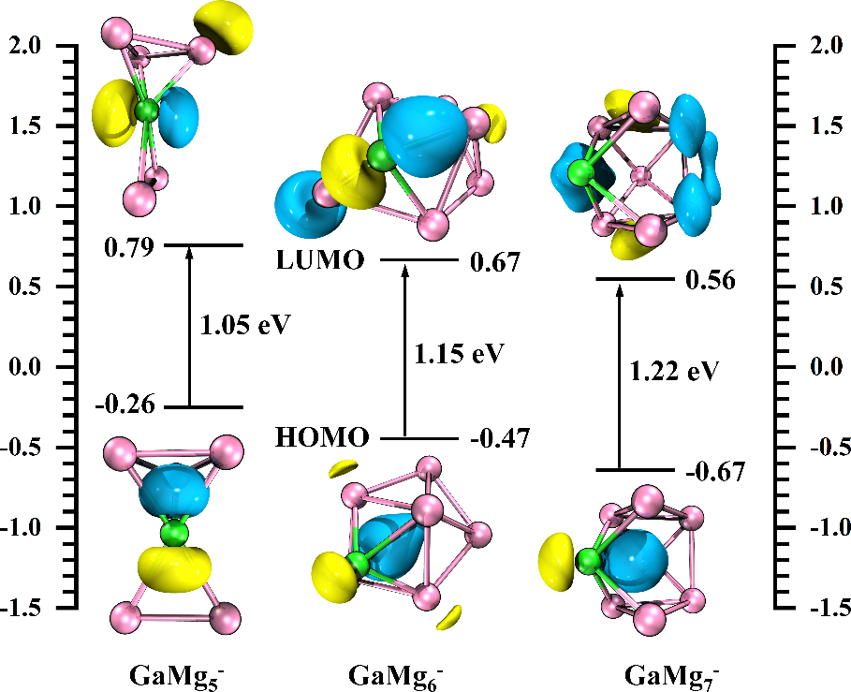
Figure S1-2. The HOMO, LUMO energies, and their MOs in the ground state of GaMg_{n}⁻ (n=5-7) clusters.
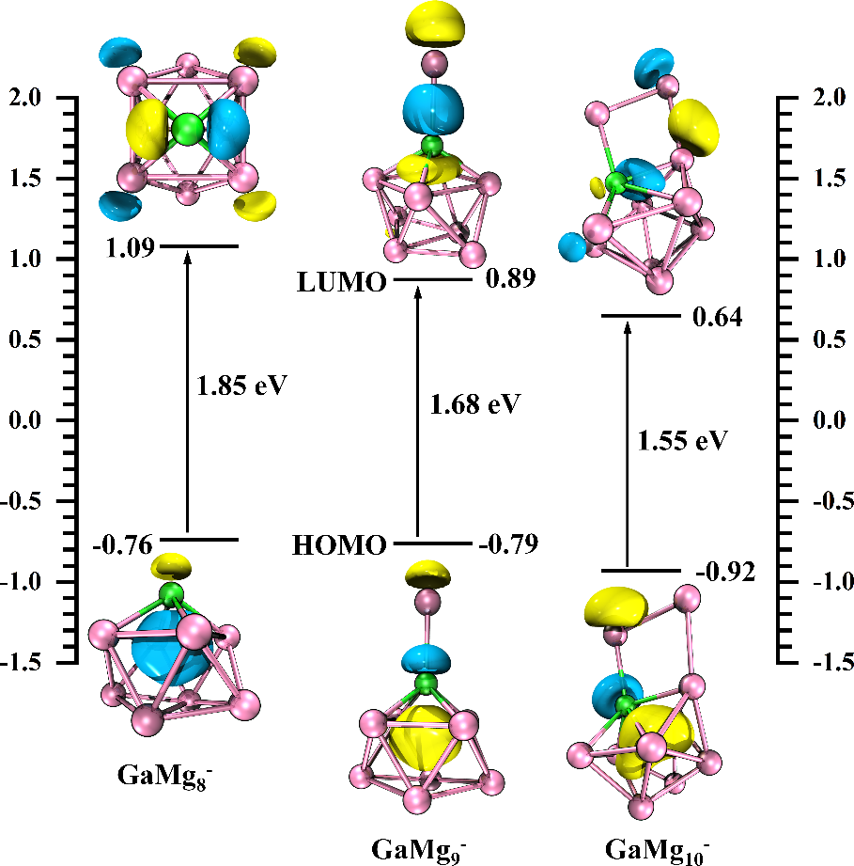
Figure S1-3. The HOMO, LUMO energies, and their MOs in the ground state of GaMg_{n}⁻ (n=8-10) clusters.

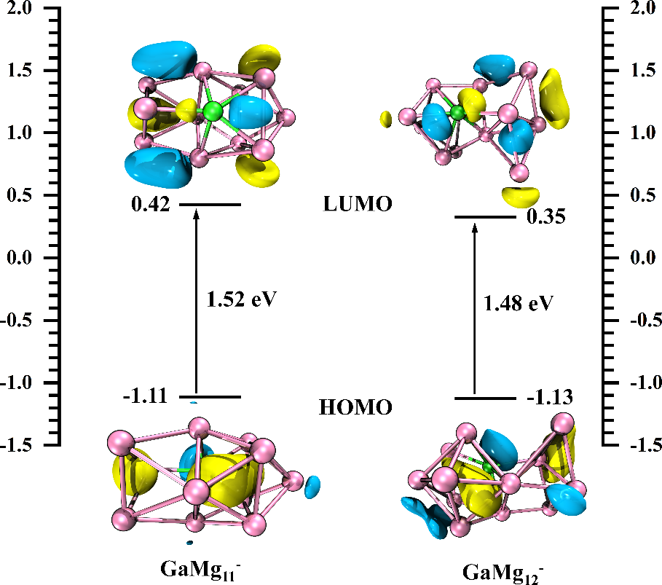
Figure S1-4. The HOMO, LUMO energies, and their MOs in the ground state of GaMg_{n}⁻ (n=11-12) clusters.
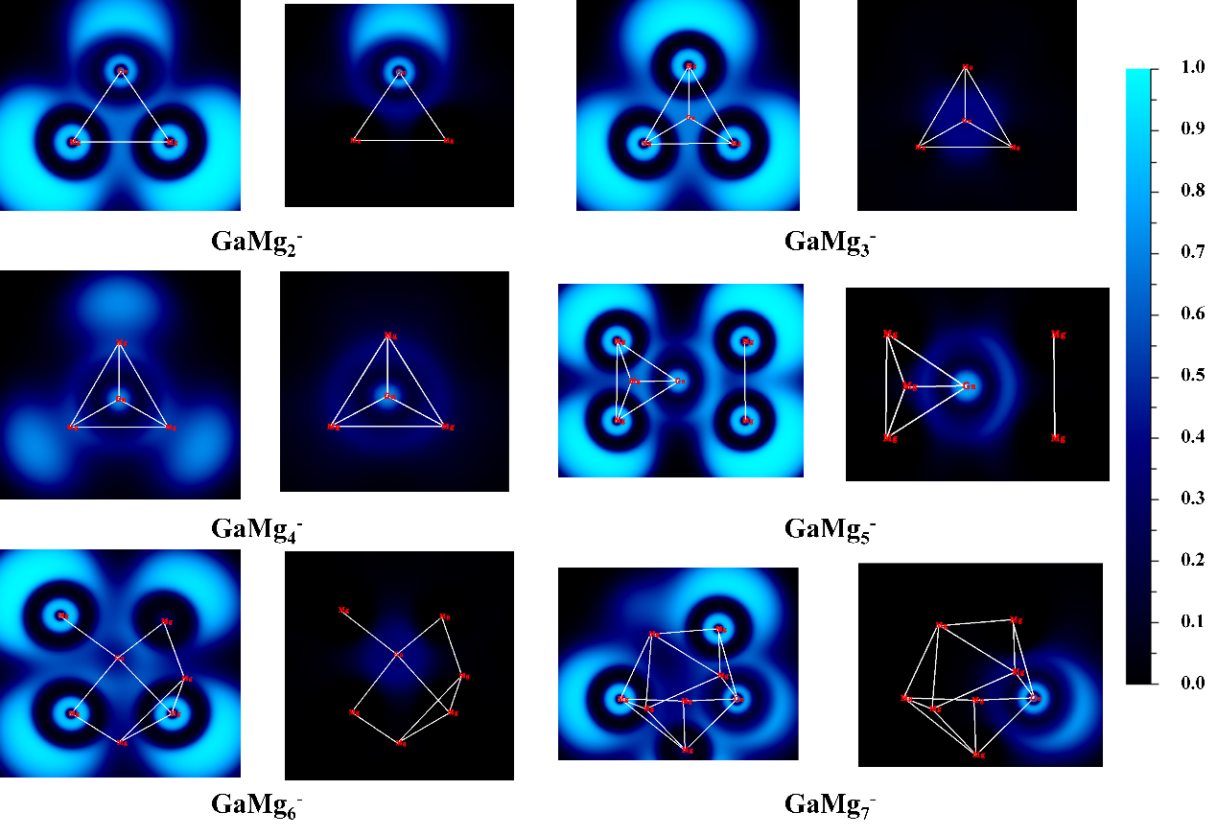
Figure S2-1. ELF analysis on the ground state isomers of GaMg_{n}⁻ (n=2-7) clusters.
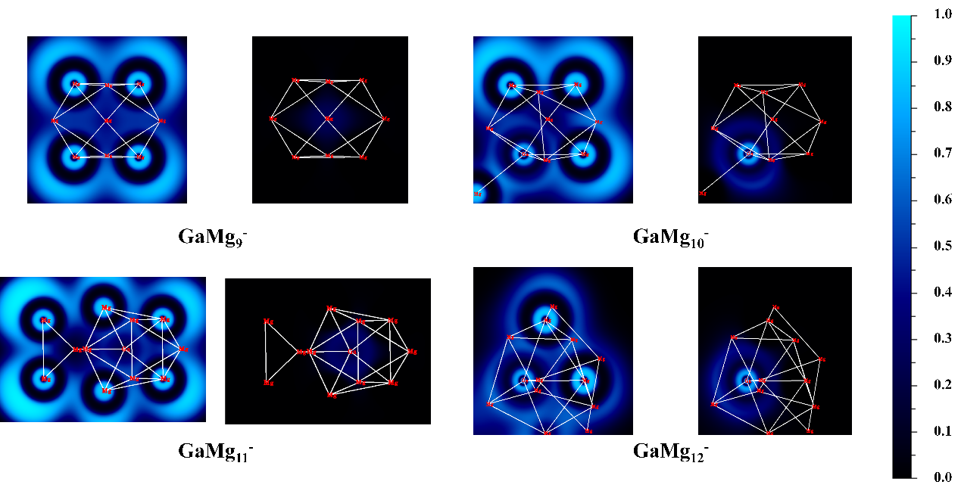
Figure S2-2. ELF analysis on the ground state isomers of GaMg_{n}⁻ (n=9-12) clusters.

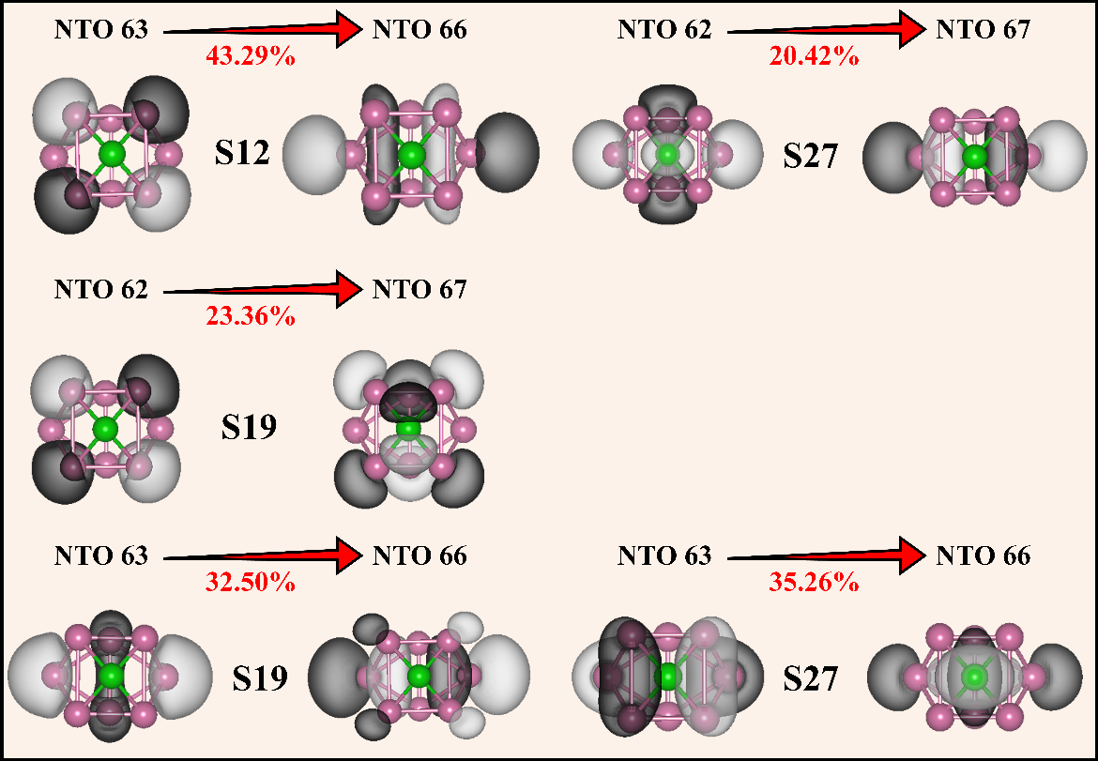
Figure S3. NTO analysis on the ground state isomer of GaMg₈⁻ cluster for S0→S12, S0→S19 and S0→S26 excitation.

