Supplementary information for
Bacterial composition analysis of colorectal tissue is affected by the degree of mucus adhesion
Yosuke Tajima, MD, PhD, Shujiro Okuda, PhD, Tsunekazu Hanai, MD, PhD, Junichiro Hiro, MD, PhD, Koji Masumori, MD, PhD, Yoshikazu Koide, MD, PhD, Tadahiro Kamiya, MD, PhD, Yeongcheol Cheong, MD, PhD, Gaku Inaguma, MD, Yoshifumi Shimada, MD, PhD, Toshifumi Wakai, MD, PhD, Shingo Akimoto, PhD, Hiroshi Matsuoka, MD, PhD, Ichiro Uyama, MD, PhD, Koichi Suda, MD, PhD

Contents
Supplementary Figure S1. The relative abundance of bacteria in feces, mucus, and tissues after washing at the phylum level.

Supplementary Figure S2. The relative abundance of bacteria in feces, mucus, and tissues after washing at the genus level.

Supplementary Figure S3. Principal coordinate analysis comparing the abundance of the mucus covering the mucosa and the mucosa itself.

Supplementary Figure S4. Principal coordinate analysis comparing the abundance of the mucus covering cancer tissue and the cancer tissue itself.

Supplementary Table S1. Relative abundance in the mucus covering the mucosa and the mucosa itself after washing at the phylum level.

Supplementary Table S2. Relative abundance in the mucus covering cancer tissue and the
cancer tissue itself after washing at the phylum level.

Supplementary Table S3. Relative abundance in the mucus covering the mucosa and the mucus covering cancer tissue at the phylum level.

Supplementary Table S4. Relative abundance in the mucosa after washing and cancer tissue after washing at the phylum level.

Supplementary Table S5. Clinicopathological characteristics of 18 patients.

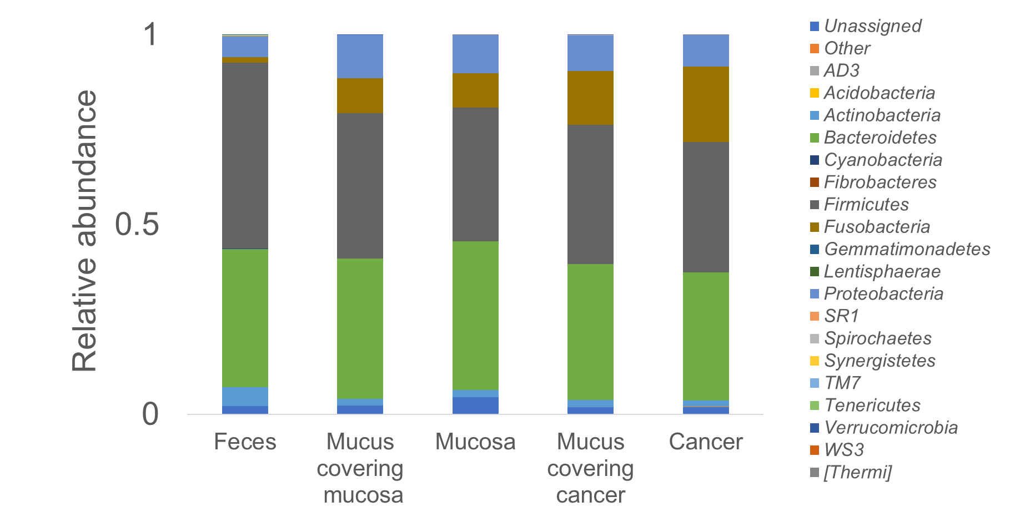
Supplementary Figure S1. The relative abundance of bacteria in feces, mucus, and tissues after washing at the phylum level.

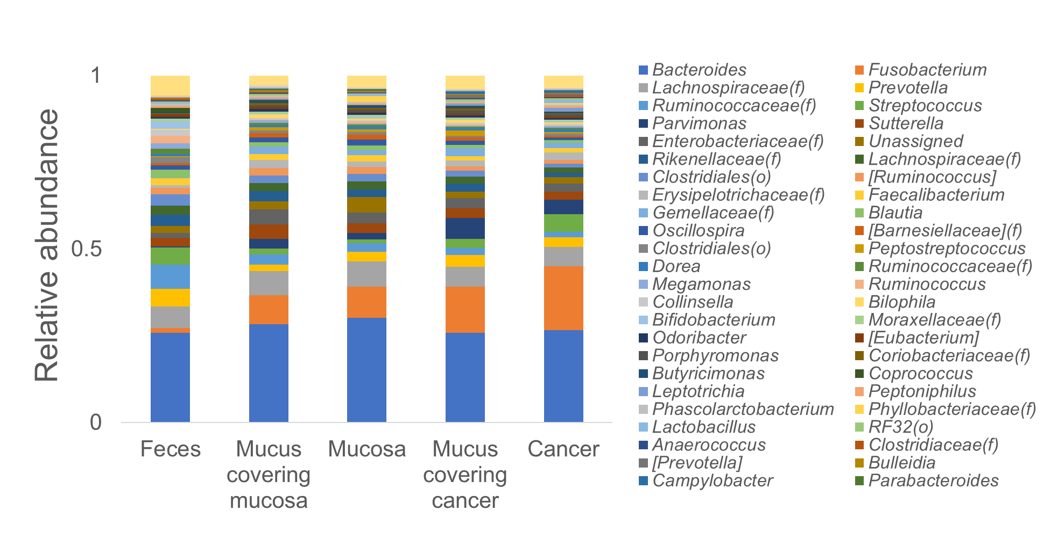
Supplementary Figure S2. The relative abundance of bacteria in feces, mucus, and tissues after washing at the genus level.

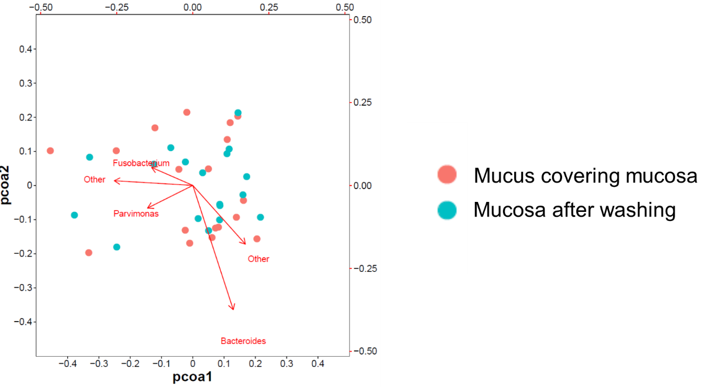Supplementary Figure S3. Principal coordinate analysis comparing the abundance of the mucus covering the mucosa and the mucosa itself.

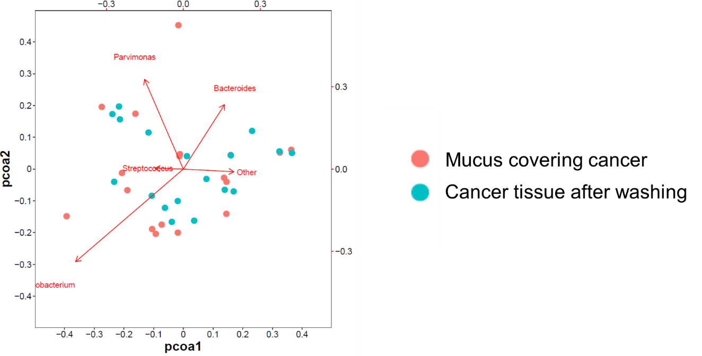 Supplementary Figure S4. Principal coordinate analysis comparing the abundance of the mucus covering cancer and the cancer tissue itself.

Supplementary Table S1. Relative abundance in the mucus covering the mucosa and the mucosa itself after washing at the phylum level.
Phylum | Relative abundance, median (Q1–Q3) |  |  |  |  | P-value | P-value  adjusted
Phylum | Mucus covering mucosa |  |  | Mucosa |  | P-value | P-value  adjusted
Actinobacteria | 0.016 | (0.011–0.024) |  | 0.011 | (0.007–0.023) | 0.133 | 0.333
Bacteroidetes | 0.371 | (0.339–0.400) |  | 0.391 | (0.314–0.470) | 0.267 | 0.333
Firmicutes | 0.387 | (0.307–0.466) |  | 0.370 | (0.250–0.412) | 0.248 | 0.413
Fusobacteria | 0.079 | (0.004–0.121) |  | 0.078 | (0.016–0.115) | 0.983 | 0.983
Proteobacteria | 0.103 | (0.061–0.152) |  | 0.095 | (0.047–0.152) | 0.048 | 0.240
Q1, first quartile; Q3, third quartile.

Supplementary Table S2. Relative abundance in the mucus covering cancer tissue and the cancer tissue itself after washing at the phylum level.
Phylum | Relative abundance, median (Q1–Q3) |  |  |  |  | P-value | P-value  adjusted
Phylum | Mucus covering cancer |  |  | Cancer tissue |  | P-value | P-value  adjusted
Actinobacteria | 0.014 | (0.010–0.023) |  | 0.014 | (0.004–0.024) | 0.327 | 0.545
Bacteroidetes | 0.361 | (0.296–0.418) |  | 0.244 | (0.128–0.353) | 0.239 | 1.195
Firmicutes | 0.363 | (0.302–0.439) |  | 0.334 | (0.260–0.460) | 0.679 | 0.679
Fusobacteria | 0.140 | (0.075–0.214) |  | 0.191 | (0.059–0.261) | 0.306 | 0.765
Proteobacteria | 0.076 | (0.064–0.127) |  | 0.062 | (0.037–0.113) | 0.557 | 0.696
Q1, first quartile; Q3, third quartile.

Supplementary Table S3. Relative abundance in the mucus covering the mucosa and the mucus covering cancer tissue at the phylum level.
Phylum | Relative abundance, median (Q1–Q3) |  |  |  |  | P-value | P-value  adjusted
Phylum | Mucus covering mucosa |  |  | Mucus covering cancer |  | P-value | P-value  adjusted
Actinobacteria | 0.016 | (0.011–0.024) |  | 0.014 | (0.010–0.023) | 0.983 | 0.983
Bacteroidetes | 0.371 | (0.339–0.400) |  | 0.361 | (0.296–0.418) | 0.557 | 0.696
Firmicutes | 0.387 | (0.307–0.466) |  | 0.363 | (0.302–0.439) | 0.112 | 0.183
Fusobacteria | 0.079 | (0.004–0.121) |  | 0.14 | (0.075–0.214) | 0.008 | 0.040
Proteobacteria | 0.103 | (0.061–0.152) |  | 0.076 | (0.064–0.127) | 0.018 | 0.045
Q1, first quartile; Q3, third quartile.

Supplementary Table S4. Relative abundance in the mucosa after washing and cancer tissue after washing at the phylum level.
Phylum | Relative abundance, median (Q1–Q3) |  |  |  |  | P-value | P-value  adjusted
Phylum | Mucosa |  |  | Cancer tissue |  | P-value | P-value  adjusted
Actinobacteria | 0.011 | (0.007–0.023) |  | 0.014 | (0.004–0.024) | 0.500 | 0.625
Bacteroidetes | 0.391 | (0.314–0.470) |  | 0.244 | (0.128–0.353) | 0.006 | 0.030
Firmicutes | 0.370 | (0.250–0.412) |  | 0.334 | (0.260–0.460) | 0.528 | 0.528
Fusobacteria | 0.078 | (0.016–0.115) |  | 0.191 | (0.059–0.261) | 0.022 | 0.055
Proteobacteria | 0.095 | (0.047–0.152) |  | 0.062 | (0.037–0.113) | 0.327 | 0.545
Q1, first quartile; Q3, third quartile.

Supplementary Table S5. Clinicopathological characteristics of 18 patients.
Gender
Male | 12
Female | 6
Age (years)
<65 | 5
≥65 | 13
Tumor location
Right-side colon | 9
Left-side colon | 5
Rectum | 4
Tumor size (mm)
<50 | 6
≥50 | 12
Histopathological grading
G1, G2 | 16
G3 | 2
Tumor stage
T1, T2 | 3
T3, T4 | 15
Lymphatic invasion
Absence | 1
Presence | 17
Venous invasion
Absence | 1
Presence | 17
Nodal involvement
N0 | 7
N1, N2 | 11
Distant metastasis
M0 | 14
M1 | 4

