Supplemental Information
Supplemental Table S1：List of putative off-target sites homologous to sgRNA. PAM sequences are labeled in blue. Base substitutions are shown in red.
Mouse-mybpc3-sgRNA | GGAGCCTGCAATGACCGCGT AGG
OTS1 | GGAGCCTGGAATGACAGCTT TGG
OTS2 | AGAGCCTGCACTGGCCGCGT TGG
OTS3 | GGAGCCTGTAATGACCCAGT GGG
OTS4 | GGAGCCTGCTATGTCCCCGT GGG
OTS5 | TGAGCCTGCAATGATCACGT GGG
Pig-mybpc3-sgRNA | CTCCCGGGTCAGCTCCACCC CGT
OTS1 | ATCCCAGCACAGCTCCACCC TGG
OTS2 | CTCCCGAGCTAGCACCACCC GGG
OTS3 | CCCACTGGCCAGCTCCACCC TGG
OTS4 | CATTCGGGACAGCTCCACCC TGG
OTS5 | TTCCCGCAGCAGCTCCACCC CGG
OTS6 | CCCGCAGGCCAGCTCCACCC TGG

Supplemental Table S2：List of primers for PCR amplification of off-target sites.
Primers | Sequences (5' to 3') | Amplicon (bp)
Mouse-MYBPC3- sgRNA-OTS1 | AACGTGCTCATGCCTCTCAG | 624
Mouse-MYBPC3- sgRNA-OTS1 | GCAGACAGAATGCACACTGG | 624
Mouse-MYBPC3- sgRNA-OTS2 | AATCCCAGAACGAAGGCCTG | 783
Mouse-MYBPC3- sgRNA-OTS2 | GCAAAGAGGACACTGAGGCT | 783
Mouse-MYBPC3 - sgRNA-OTS3 | CTCAACCTGTGGGTCGAGAC | 686
Mouse-MYBPC3 - sgRNA-OTS3 | CAGCAGGACCCATGGAAAGT | 686
Mouse-MYBPC3 - sgRNA-OTS4 | GTTGGCTCCCTTGCTTCTCT | 754
Mouse-MYBPC3 - sgRNA-OTS4 | CATGGAGAGATCCGAGCCAC | 754
Mouse-MYBPC3 - sgRNA-OTS5 | CCCTGTTCACGGCATCTCAT | 713
Mouse-MYBPC3 - sgRNA-OTS5 | CCGCCGCCATCAGTATAACT | 713
Pig-MYBPC3- sgRNA-OTS1 | GTCCCAGGGAAGAAACCAGG | 863
Pig-MYBPC3- sgRNA-OTS1 | TTGTCCAGTGTGGCTTGGTT | 863
Pig-MYBPC3- sgRNA-OTS2 | GGTTACAGACACGGCTTGGA | 936
Pig-MYBPC3- sgRNA-OTS2 | GGAGGCACCAAGGAAGTTGA | 936
Pig-MYBPC3- sgRNA-OTS3 | CAGAGATCCTCCATCACCGC | 811
Pig-MYBPC3- sgRNA-OTS3 | AGCTCTGAGTCACCTCCCTT | 811
Pig-MYBPC3- sgRNA-OTS4 | GCCCTCTCTCATAGCCACAC | 698
Pig-MYBPC3- sgRNA-OTS4 | GGTCGTGGAAACAGGCTACA | 698
Pig-MYBPC3- sgRNA-OTS5 | AGTGAGGATGCAGCGTTTGA | 923
Pig-MYBPC3- sgRNA-OTS5 | AACCTATCCCTGCCCTTTGC | 923
Pig-MYBPC3- sgRNA-OTS6 | CTGGCCTCTCTGAGCATCTG | 840
Pig-MYBPC3- sgRNA-OTS6 | TCCACACAGCTCTGGAAACC | 840

Supplemental Table S3：List of the primers used in RT-PCR.
Primers | Sequences (5' to 3') | Amplicon (bp)
Mouse-MYBPC3-RT | GAACACTACCGACGCACTCA | 176
Mouse-MYBPC3-RT | AGGGCCTTGTATTTGGGTGG | 176
Mouse-HIF-1α-RT | CCAGCCTAACAGTCCCAGTG | 240
Mouse-HIF-1α-RT | GGAGGGCTTGGAGAATTGCT | 240
Mouse-TGF-β1-RT | ACTGGAGTTGTACGGCAGTG | 123
Mouse-TGF-β1-RT | GGGGCTGATCCCGTTGATTT | 123
Mouse-GCK-RT | AGGTAGAGCAGATCCTGGCA | 143
Mouse-GCK-RT | CACGTAGGTGGATGAGAGCTC | 143
Mouse-PFKM-RT | TTGGAGCTGATGGAAGGCAG | 297
Mouse-PFKM-RT | ATCGCGAATGGTGAAGGGTT | 297
Mouse-LDHA-RT | GGAGCAGTGGAAGGAGGTTC | 293
Mouse-LDHA-RT | TGTCTGCGCTCTTCTTCAGG | 293
Mouse-COL1A1-RT | CCCAGTGGCGGTTATGACTT | 117
Mouse-COL1A1-RT | CTCAAGGTCACGGTCACGAA | 117
Mouse-α-SMA-RT | CCCAATGGTGAGACGTGGAA | 198
Mouse-α-SMA-RT | CTTGGGTCCCTCGACTCCTA | 198
Mouse-ACTB-RT | TCGAGACCTTCAACACCCCA | 101
Mouse-ACTB-RT | GTCTCCGGAGTCCATCACG | 101
Pig-MYBPC3-RT | CTGTGGTGCCAATCGCTCTT | 177
Pig-MYBPC3-RT | GGACGTCCAGACGTAGCTTG | 177
Pig-HIF-1α-RT | TACTCATCCGTGCGACCATG | 257
Pig-HIF-1α-RT | CCAAGCACGTCATAGGTGGT | 257
Pig-TGF-β1-RT | GGCCAGATTCTGTCCAAGCT | 209
Pig-TGF-β1-RT | ATTTGGTTGCCGCTTTCCAC | 209
Pig-GCK-RT | CCGACTTCCTGGACAAGCAT | 181
Pig-GCK-RT | CGTTTGATGGCATCTCGCAG | 181
Pig-PFKM-RT | AGGGCCTTGTGATCATTGGG | 202
Pig-PFKM-RT | TGCTTAATGCGGTCACAGGT | 202
Pig-LDHA-RT | GTCATGGGTGGATCCTTGGG | 141
Pig-LDHA-RT | TGTGAACCGCTTTCCAGTGT | 141
Pig-COL1A1-RT | CCTGGACGCCATCAAAGTCT | 125
Pig-COL1A1-RT | AGACGTGCCTCTTGTCCTTG | 125
Pig-α-SMA-RT | AAGATCAGGACAGGCTTGCC | 226
Pig-α-SMA-RT | GCATTAGCTGGGGTGACTGT | 226
Pig-GAPDH-RT | ATCCTGGGCTACACTGAGGA | 130
Pig-GAPDH-RT | TGTCGTACCAGGAAATGAGCT | 130

Antibodies | Host | Dilutions | Supplier
Anti-MYBPC3 Antibody (E-7) | Mouse | 1:1000 | Santa Cruz Biotechnology
MYL (F-5) | Mouse | 1:1000 | Santa Cruz Biotechnology
Anti-VIM Antibody | Mouse | 1:1000 | BOSTER
Rabbit Anti-Troponin T/TNNT2 | Rabbit | 1:1000 | BOSTER
Anti-TGF beta 1 Antibody | Rabbit | 1:1000 | BOSTER
Anti-COL1A1 Antibody | Rabbit | 1:1000 | BOSTER
a-SMA Antibody (monoclonal,1A4) | Mouse | 1:1000 | BOSTER
Anti-GCK Antibody | Rabbit | 1:1000 | BOSTER
PFKM Polyclonal antibody | Rabbit | 1:1000 | Proteintech
Anti-LDHA Antibody | Rabbit | 1:1000 | BOSTER
Anti-HIF1A Antibody  Phospho-NF-κB p65 (Ser536) (93H1)  NF-κB p65 (D14E12) | Rabbit | 1:1000 | BOSTER
 | Rabbit | 1:1000 | Cell Signaling Technology
 | Rabbit | 1:1000 | Cell Signaling Technology
β-Actin Mouse Monoclonal Antibody | Mouse | 1:1000 | Beyotime
HRP-labeled Goat Anti-Mouse IgG(H+L) | Goat | 1:1000 | Beyotime
HRP-labeled Goat Anti-Rabbit IgG(H+L) | Goat | 1:1000 | Beyotime
Alexa Fluor 488 Goat anti-Mouse -IgG(L+H) | Goat | 1:500 | Proteintech
Supplemental Table S4：List of the primary and secondary antibodies used in this study.

Supplemental Figure S1. Sequence analysis of pig MYBPC3 gene and design of CBEs-targeting strategy. (a) The flowchart to generate MYBPC3-R495Q mutant pigs. (b) Sanger sequencing traces of PCR amplicons from WT and electrotransfected PFFs. The target base is labeled with a red arrow. (c) Gene targeting analysis by T-cloning and Sanger sequencing in all piglets. (d) Analysis of off-target activities at the top predicted off-target sites. (e) The H&E-stained images of WT and R495Q^{+/-} pig heart sections. (f-i) Serum levels of CCL2, IL-1β, IL-6 and TNF-α in WT and R495Q^{+/-} pigs (n=3). ***P<0.001, ****P<0.0001. (j) Lactic acid measurements in heart tissues of WT and R495Q^{+/-} pigs (n=3). ****P<0.0001.

Supplemental Figure S2. The design of CRISPR-targeting strategy in fibroblasts. (a) Schematic showing the targeting strategy to generate MYBPC3-KO NIH3T3 fibroblasts. (b) Sanger sequencing traces showing the CRISPR/Cas9-engineered indels in mouse Mybpc3 gene. PAM is highlighted in blue. (c) The off-target activity analysis. (d, e) Quantitative RT-PCR and Western blot analysis of Mybpc3 expression in WT and MYBPC3-KO NIH3T3 cells (n=3). ***P<0.001, ****P<0.0001.

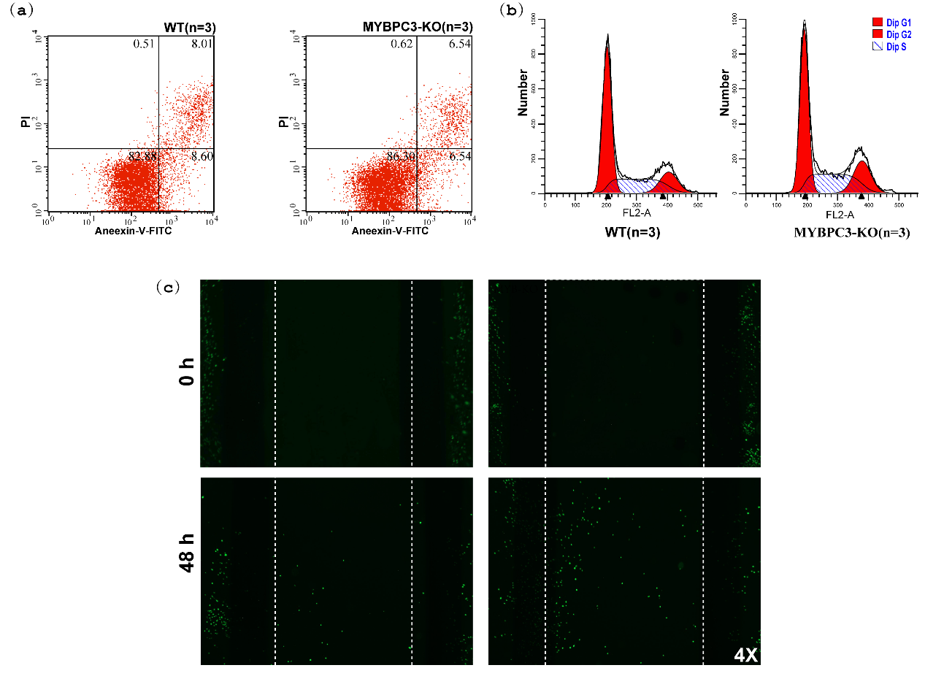
Supplemental Figure S3. The impact of MYBPC3 disruption on apoptosis, cell cycle and migration of NIH3T3 fibroblasts. (a-b) Analysis of apoptosis (a) and cell cycle (b) in WT and MYBPC3-KO NIH3T3 fibroblasts by fluorescence-activated cell sorting (FACS). (c) Cell migration analysis in WT and MYBPC3-KO fibroblasts by the wound scratch assay.

Supplemental Figure S4. Activated NF-κB signaling pathway in MYBPC3-KO fibroblasts. Measurements of CCL2, IL-1β, IL-6 and TNF-α in cell lysates of WT and MYBPC3-KO NIH3T3 fibroblasts with or without PDTC treatment (n=3). **P<0.01, ****P<0.0001.

Supplemental Figure S5. Concentration-dependent cell toxicity of 2-DG, SB-431542, Oltipraz and PDTC. The cell toxicity of 2-DG, SB-431542, Oltipraz and PDTC was analyzed by CCK8 assays (n=3). ***P<0.001, ****P<0.0001.

Supplemental Figure S6 related to Figure 1B. Uncropped immunoblots of MYBPC3, TGF-β1, COL1A1 and α-SMA with β-actin obtained from heart tissue lysate. All experiments were performed three times.

Supplemental Figure S7 related to Figure 2B. Uncropped immunoblots of MYBPC3, MYL3, TNNT2 with β-actin obtained from fibroblasts cell lysate. All experiments were performed three times.

Supplemental Figure S8 related to Figure 3B. Uncropped immunoblots of COL1A1, α-SMA and TGF-β1 with β-actin obtained from NIH-3T3 cell lysate. All experiments were performed three times.

Supplemental Figure S9 related to Figure 4G. Uncropped immunoblots of TGF-β1, GCK, PFKM, LDHA, COL1A1, α-SMA and with β-actin obtained from NIH-3T3 cell lysate. All experiments were performed three times.

Supplemental Figure S10 related to Figure 5A. Uncropped immunoblots of TGF-β1, HIF-1α, GCK, LDHA, COL1A1, α-SMA and with β-actin obtained from NIH-3T3 cell lysate. All experiments were performed three times.
Supplemental Figure S11 related to Figure 5B. Uncropped immunoblots of TGF-β1, HIF-1α, GCK, LDHA, COL1A1, α-SMA and with β-actin obtained from NIH-3T3 cell lysate. All experiments were performed three times.
Supplemental Figure S12 related to Figure 6A. Uncropped immunoblots of P-p65 and p65 with β-actin obtained from NIH-3T3 cell lysate. All experiments were performed three times.
Supplemental Figure S13 related to Figure 6G. Uncropped immunoblots of P-p65, p65, TGF-β1 and HIF-1α with β-actin obtained from NIH-3T3 cell lysate. All experiments were performed three times.

Supplemental Figure S14 related to Supplementary Figure 2e. Uncropped immunoblots of MYBPC3 with β-actin obtained from NIH-3T3 cell lysate. All experiments were performed three times.

