Extended Data Figures
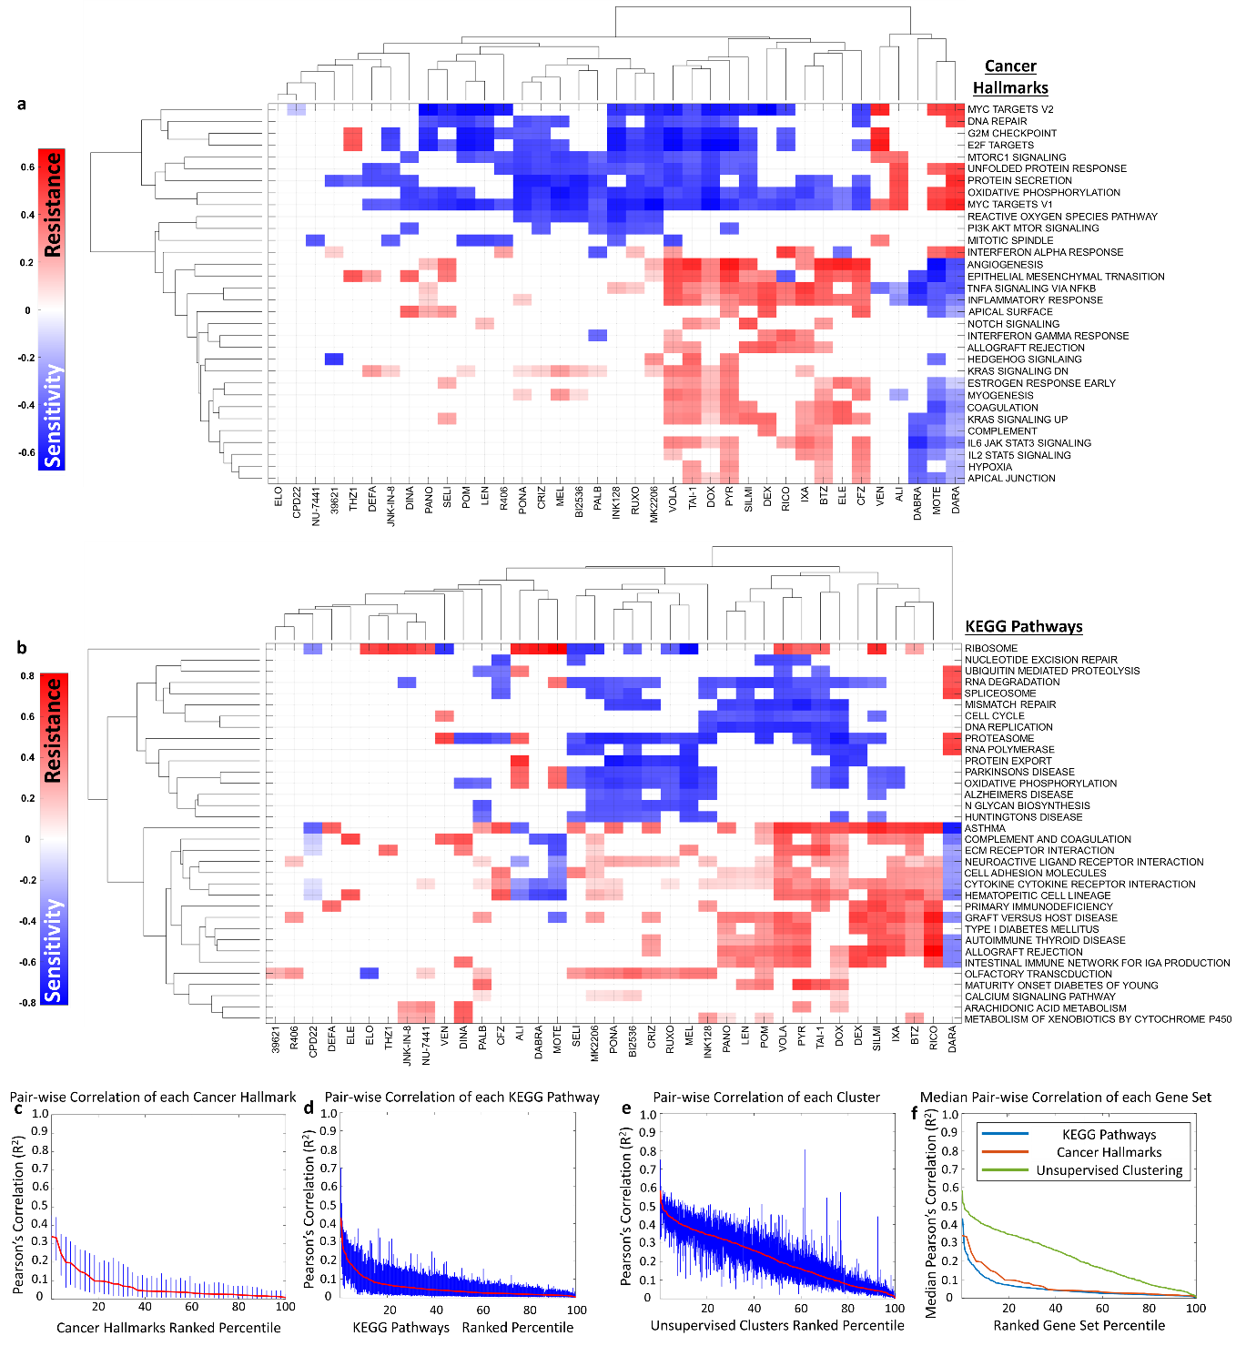
Extended Data Fig. 1 | Gene set enrichment analysis (GSEA) identified cancer hallmarks and KEGG pathways enriched for sensitivity and resistance. a, A clustergram of normalized enrichment scores (NES) computed using cancer hallmarks as supervised gene sets where NES represent the enrichment of a cancer hallmark by overexpression of genes implicated in resistance (red) or under-expression of genes implicated in sensitivity (blue) using GSEA. b, A clustergram that uses KEGG Pathways as the supervised gene sets to carry out GSEA. c - e, All pairwise correlations (R²) of z-normalized gene expression of any two genes within each cancer hallmark, KEGG pathway, and co-expressing gene cluster are plotted with the ranked percentile of each gene set on x-axis and their respective R² values on the y-axis, where the red line indicates the median correlation within each gene set and the blue bars signify the interquartile range of R². f, A plot showing median pairwise correlations within each gene set as a function of ranked (by median correlation) percentile of gene sets for each of cancer hallmarks (red), KEGG pathways (blue), unsupervised clusters (green).
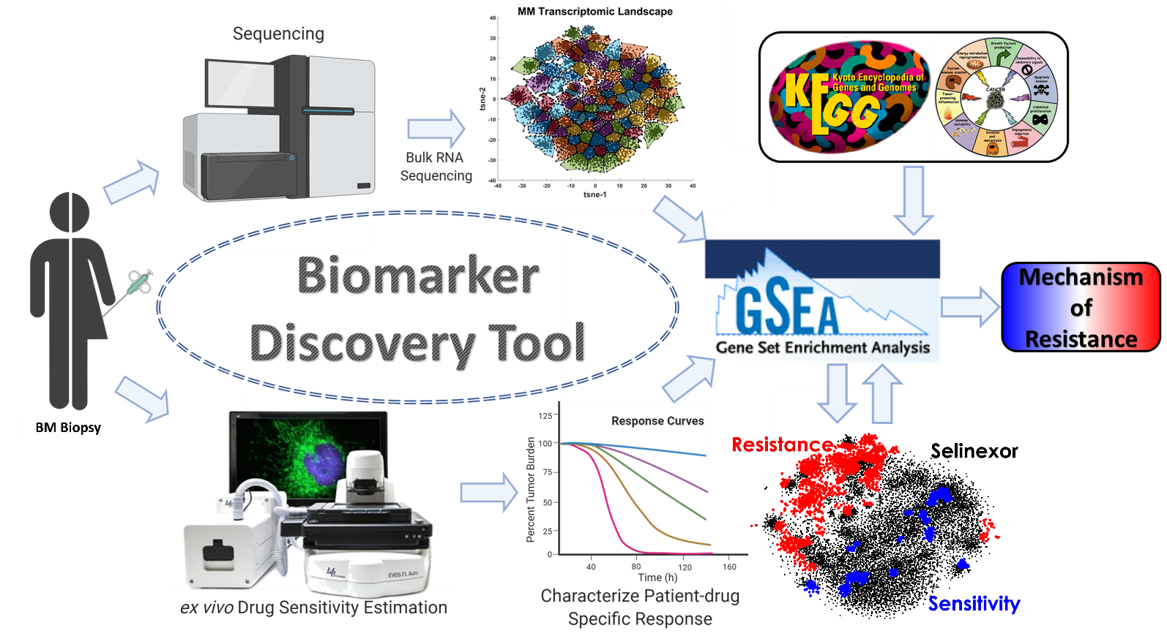
Extended Data Fig. 2 | Overview of the Biomarker Discovery Tool. The computational pipeline begins with a BM biopsy from an MM patient, where the specimen is sorted for CD138⁺ cells. One of these aliquots is sent to bulk RNA sequencing and the other is sent for ex vivo drug sensitivity characterization using the EMMA framework. Bulk RNA sequencing data from 844 MM patients is used to construct an MM transcriptomic map, where z-normalized gene expression of 16,738 genes is subjected to dimensionality reduction using tSNE to reduce the patient-space from 844 to two-dimensions. The genes on the 2D transcriptomic map are subjected fuzzy C-means clustering to identify clusters of co-expressing genes. Each gene cluster is passed through GSEA, along with ex vivo drug sensitivity data as a phenotypic variable to determine if the cluster is enriched for resistance (shown in red), or sensitivity (shown in blue) for bortezomib, for example. The genes from gene clusters enriched for resistance (or sensitivity) are concatenated into a long list of genes that are again passed through GSEA to identify KEGG pathways and Cancer Hallmarks that are enriched for each of these conditions. These enriched pathways/mechanisms are the output of the computational pipeline implicating mechanisms involved in resistance to a certain therapy.

Extended Data Tables
Extended Data Table 1. Examples of cytogenetic abnormalities and mutations implicated in resistance and sensitivity to various drugs
Description | t(11;14) MM patients are sensitive to Venetoclax^{1,2} | MCL1 locus is present in 1q21 and amplification of 1q21 leads to overexpression of MCL1, which in turn leads to resistance to Venetoclax³ | BHLHE41 is a HIF-presenting factor and promotes proteasomal degradation of HIFs⁴. | CSK1B overexpression causes drug resistance by upregulating MEK and Stat3⁵. | Reduced EP300 expression leads to doxorubicin resistance in bladder cancer^{6,7}.
Study Type | Clinical/ Pre-clinical | Pre-clinical | Pre-clinical | Pre-clinical | Pre-clinical
Disease | MM | MM | TNBC | MM | Bladder Cancer
Abnormality | t(11;14) | Amp/dup1q21 | BHLHE41 | Amp/dup1q21 | EP300
Drug | VEN | VEN | BTZ | TRAM | DOX
Extended Data Table 2. Examples of transcription factors implicated in resistance and sensitivity to various drugs
Description | PLK1 is a key cell cycle regulator that promotes cell proliferation, which is regulated by FOXM1 and phosphorylates FOXM1 as part of a positive feedback loop^{8,9}. | Silencing FOXM1 increased MTOR protein levels in gastric cancer cells¹⁰ and overexpression of FOXM1 decreased MTOR signaling activity through phosphorylation in castration resistant prostate cancer cells¹¹. | Panobinostat decreased FOXM1 expression and induced cell cycle arrest in gastric cancer¹² | Higher FOXM1 expression leads to activation of wnt/β-catenin pathway, which justifies the association with antihelminitic pyrvinium that blocks wnt/β-catenin^{13,14}. | Activation of PI3K-AKT signaling pathway regulates FOXM1 expression, so inhibiting AKT signaling reduces FOXM1 expression and leads to cell cycle arrest^{15,16}. | FOXM1 knockdown decreased BCL2 mRNA and protein levels, and suppressed BCL2L1 expression leading to increased cellular dependency on BCL2, and sensitivity to VEN^{17,18} | CDK7 inhibitor resistance is associated with TGF-b/activin signaling and FOXM1 is found to be a critical driver of TGF-b-induced endothelial to mesenchymal transition^{19,20} | RELA is an NFκB subunit and NFκB activity is associated with proteasome inhibitor resistance in MM. The mechanism is likely regulated through cIAP2 gene^{21,22}. | BACH1 is exported from the nucleus by XPO1, and it recruits PRC2 to promote H3K27me3 modification^{23,24} | Increased levels of FOXM1 diminishes the sensitivity of MM cells to MEL and DOX²⁵. | High FOXM1 expression could be associated with development of resistance to lenalidomide and cross resistance to pomalidomide in RRMM²⁶. | EwS-specific oncogenic transcription factor EWSR1-FLI1 hijacks PRC1.PLK1 is a major upstream interacting partner of PRC1. PLK1 inhibition that can repress even chemo resistant EwS cells by triggering mitotic catastrophe²⁷. | Hyper-activation of the Aurora kinase A (AKA)-FOXM1 axis contribute to evade death in Imatinib(IM)-resistant BCR-ABL1+ cells. IM-resistant patients displaying over-expression and hyper-activation of AKA may thus benefit from ponatinib treatment²⁸.
Phenotype | Sensitive | Sensitive | Sensitive | Sensitive | Sensitive | Resistance | Resistance | Resistance | Resistance | Resistance | Resistance | Sensitivity | Sensitivity
Disease | Oesophaegal Adenocarcinoma | Gastric & Prostate Cancers | Gastric Cancer & Glioma | MM and Glioma | Colorectal Cancer | AML | Breast Cancer | MM | Pan-cancer | MM | MM | Ewing Sarcoma | CML
Transcription Factor | FOXM1 | FOXM1 | FOXM1 | FOXM1 | FOXM1 | FOXM1 | FOXM1 | RELA | BACH1 | FOXM1 | FOXM1 | FLI1 | FOXM1
Drug | VOLA | INK128 | PANO | PYR | MK2206 | VEN | THZ1 | BTZ, CFZ, IXA | SELI | DOX, MEL | LEN, POM | BI2536 | PONA
Extended Data Table 3. Comparison of Selinexor response between patients treated with an anti-CD38 monoclonal antibody in an immediate prior line versus those who didn’t in STOMP and XPORT-MM-028 clinical trials.
STOMP Study of Selinexor and Combinations in MM |  | Best overall Response |  |  | PFS
STOMP Study of Selinexor and Combinations in MM | Patients | VGPR or Better  n (%) | ORR  n (%) | CBR  n (%) | Events | Median  (95% CI)
Anti-CD38 mAb In Immediate Prior Line | 28 | 9 (32.1) | 17 (60.7) | 19 (67.9) | 8 | 15.0 (8.7, NE)
Anti-CD38 mAb Not in Immediate Prior Line | 16 | 2 (12.5) | 10 (62.5) | 14 (87.5) | 8 | 8.9 (4.9, NE)
Patients with MM treated with either XPd or XKd (ongoing clinical trial, most recent update on 14th July 2021)
XPORT-028 Selinexor and Bortezomib Plus Low-dose Dexamethasone in Triple Class refractory MM |  | Best overall Response |  |  | PFS
 | Patients | VGPR or Better  n (%) | ORR  n (%) | CBR  n (%) | Events | Median  (95% CI)
Anti-CD38 mAb In Immediate Prior Line | 15 | 0 | 7 (46.7) | 9 (60.0) | 1 | NE (7.0, NE)
Anti-CD38 mAb Not in Immediate Prior Line | 12 | 1 (8.3) | 1 (8.3) | 5 (41.7) | 6 | 3.5 (3.4, NE)
Patients with MM treated with XVd (ongoing clinical trial, most recent update on 1st June 2021)

Extended Data Table 4. Organotypic high-throughput ex vivo drug sensitivity screening data
Category | Parameter | Description
Assay | Type of assay | Organotypic high-throughput ex vivo drug sensitivity screening using brightfield microscopy
Assay | Target | Patient-derived primary multiple myeloma cells
Assay | Primary measurement | Cell viability (percent live cells) measured by the persistent membrane motion of live MM cells non-destructively estimated by digital image analysis of brightfield images taken once every 30 minutes for upto 6 days.
Assay | Key reagents | None
Assay | Assay protocol | https://www.jove.com/t/53070/an-organotypic-high-throughput-system-for-characterization-drug
Assay | Additional comments | None
Library | Library size | 37 agents
Library | Library composition | Standard-of-care and experimental agents used to treat multiple myeloma and other cancers in humans, which includes proteasome inhibitors, immunomodulatory drugs, monoclonal antibodies, DNA damaging agents, and kinase inhibitors. A complete list of drug class description is provided in Extended Data Table 5.
Library | Source | SelleckChem library of compounds
Library | Additional comments | None
Screen | Format | Each patient specimen is treated with 31 drugs at five concentrations each in two replicates in a 384-well plate
Screen | Concentration(s) tested | Five serially diluted concentrations at a ratio of 1:3 starting from the maximum concentration. A complete list of maximum concentrations for each agent is provided in Extended Data Table 5.
Screen | Plate controls | Internal positive and negative controls are included on each plate. MM1.S (MM human cell line) cells are used in lieu of patient-derived primary MM cells as positive control for each agent. Untreated patient-derived cells are seeded in 10 wells with DMSO as negative control.
Screen | Reagent/ compound dispensing system | Biotek Precision
Screen | Detection instrument and software | EVOS Auto FL 2.0
Screen | Assay validation/QC | In 90 patients, we have tested the panel of agents at same concentrations in two different plates. We correlated the area under the curve (AUC) between the technical replicates, which yielded a Pearson’s correlation of 0.905 and linear regression coefficient of 0.901; regardless of the agent. Quality control is done by visually inspecting time lapse videos of live imaging in each well, followed by comparing the estimates measured in two replicates for each drug and concentration to ensure that the replicates yield similar measurements. Finally, for each drug the dose-response curves are assessed to ensure a dose-dependent response consistent with literature and historical studies.
Screen | Correction factors | As part of the aforementioned QC process, if certain wells were identified to have technical and experimental artifacts such as debris, excessive condensation, and inadvertent displacement of the plate these wells would be excluded from AUC estimations after confirming the cause.
Screen | Normalization | Response to each agent is measured as the total area occupied by live MM cells across time. Viability estimates at each time point of a given well are normalized by the estimate at t=0 for all wells. Further, wells treated with drugs are normalized by the untreated control response.
Screen | Additional comments | None
Post-HTS analysis | Hit criteria | Not applicable. The organotypic high-throughput ex vivo drug sensitivity screening assay employed here is used to estimate patient-drug specific sensitivities using patient-derived MM cells co-cultured in an ex vivo reconstruction of the tumor microenvironment as described in the methods section. Unlike HTS assays with small molecules, which have a high percentage of false positives (hence the need for post-HTS analysis), all the compounds tested in this study have predicted mechanisms of action (targets) and are expected to have an effect (cell death) in the cells tested. Our objective thus is not to seek new hits (targets) but to identify the molecular characteristics that associate with resistance or sensitivity to these known compounds. The accuracy of estimation of this assay is discussed in the literature²⁹⁻³⁸.
Post-HTS analysis | Hit rate
Post-HTS analysis | Additional assay(s)
Post-HTS analysis | Confirmation of hit purity and structure
Post-HTS analysis | Additional comments

Extended Data Table 5. Appendix of therapeutic agents used in the ex vivo assay. All drugs were tested in five concentrations in three-fold serial dilution.

References:
1 Touzeau, C. et al. The Bcl-2 specific BH3 mimetic ABT-199: a promising targeted therapy for t(11;14) multiple myeloma. Leukemia 28, 210-212, doi:10.1038/leu.2013.216 (2014).
2 Kumar, S. K. et al. Safety and Efficacy of Venetoclax (ABT-199/GDC-0199) Monotherapy for Relapsed/Refractory Multiple Myeloma: Phase 1 Preliminary Results. Blood 126, 4219, doi:https://doi.org/10.1182/blood.V126.23.4219.4219 (2015).
3 Slomp, A. et al. Multiple myeloma with 1q21 amplification is highly sensitive to MCL-1 targeting. Blood Advances 3, 4202-4214, doi:10.1182/bloodadvances.2019000702 (2019).
4 Montagner, M. et al. SHARP1 suppresses breast cancer metastasis by promoting degradation of hypoxia-inducible factors. Nature 487, 380-384, doi:10.1038/nature11207 (2012).
5 Shi, L. et al. Over-expression of CKS1B activates both MEK/ERK and JAK/STAT3 signaling pathways and promotes myeloma cell drug-resistance. Oncotarget 1 (2010).
6 Takeuchi, A. et al. p300 mediates cellular resistance to doxorubicin in bladder cancer. Mol Med Rep 5, 173-176, doi:10.3892/mmr.2011.593 (2012).
7 Zhou, Y. et al. The miR-106b∼25 cluster promotes bypass of doxorubicin-induced senescence and increase in motility and invasion by targeting the E-cadherin transcriptional activator EP300. Cell Death & Differentiation 21, 462-474, doi:10.1038/cdd.2013.167 (2014).
8 Dibb, M. et al. The FOXM1-PLK1 axis is commonly upregulated in oesophageal adenocarcinoma. British Journal of Cancer 107, 1766-1775, doi:10.1038/bjc.2012.424 (2012).
9 Fu, Z. et al. Plk1-dependent phosphorylation of FoxM1 regulates a transcriptional programme required for mitotic progression. Nature Cell Biology 10, 1076-1082, doi:10.1038/ncb1767 (2008).
10 Yu, W. et al. Silencing forkhead box M1 promotes apoptosis and autophagy through SIRT7/mTOR/IGF2 pathway in gastric cancer cells. Journal of Cellular Biochemistry 119, 9090-9098, doi:https://doi.org/10.1002/jcb.27168 (2018).
11 Lin, J.-Z. et al. FOXM1 contributes to docetaxel resistance in castration-resistant prostate cancer by inducing AMPK/mTOR-mediated autophagy. Cancer Lett 469, 481-489, doi:10.1016/j.canlet.2019.11.014 (2020).
12 Lee, N.-R. et al. Inactivation of the Akt/FOXM1 Signaling Pathway by Panobinostat Suppresses the Proliferation and Metastasis of Gastric Cancer Cells. International Journal of Molecular Sciences 22, 5955 (2021).
13 Zhang, N. et al. FoxM1 Promotes β-Catenin Nuclear Localization and Controls Wnt Target-Gene Expression and Glioma Tumorigenesis. Cancer Cell 20, 427-442, doi:https://doi.org/10.1016/j.ccr.2011.08.016 (2011).
14 Xu, F. et al. Anthelmintic pyrvinium pamoate blocks Wnt/β-catenin and induces apoptosis in multiple myeloma cells. Oncology letters 15, 5871-5878, doi:10.3892/ol.2018.8006 (2018).
15 Gomes, A. R., Zhao, F. & Lam, E. W. F. Role and regulation of the forkhead transcription factors FOXO3a and FOXM1 in carcinogenesis and drug resistance. Chin J Cancer 32, 365-370, doi:10.5732/cjc.012.10277 (2013).
16 Zhang, C. et al. Gli1 promotes colorectal cancer metastasis in a Foxm1-dependent manner by activating EMT and PI3K-AKT signaling. Oncotarget 7 (2016).
17 Halasi, M. & Gartel, A. L. Suppression of FOXM1 Sensitizes Human Cancer Cells to Cell Death Induced by DNA-Damage. PLOS ONE 7, e31761, doi:10.1371/journal.pone.0031761 (2012).
18 Chesnokov, M. S. et al. FOXM1-AKT Positive Regulation Loop Provides Venetoclax Resistance in AML. Frontiers in Oncology 11, doi:10.3389/fonc.2021.696532 (2021).
19 Webb, B. M. et al. TGF-&#x3b2;/activin signaling promotes CDK7 inhibitor resistance in triple-negative breast cancer cells through upregulation of multidrug transporters. Journal of Biological Chemistry 297, doi:10.1016/j.jbc.2021.101162 (2021).
20 Song, S. et al. Foxm1 is a critical driver of TGF-β-induced EndMT in endothelial cells through Smad2/3 and binds to the Snail promoter. Journal of Cellular Physiology 234, 9052-9064, doi:https://doi.org/10.1002/jcp.27583 (2019).
21 Markovina, S. et al. Bortezomib-Resistant Nuclear Factor-κB Activity in Multiple Myeloma Cells. Molecular Cancer Research 6, 1356-1364, doi:10.1158/1541-7786.Mcr-08-0108 (2008).
22 Duvefelt, C. F. et al. Increased resistance to proteasome inhibitors in multiple myeloma mediated by cIAP2 - implications for a combinatorial treatment. Oncotarget 6 (2015).
23 Cai, Y. et al. Crm1-Dependent Nuclear Export of Bach1 is Involved in the Protective Effect of Hyperoside on Oxidative Damage in Hepatocytes and CCl4-induced Acute Liver Injury. J Inflamm Res 14, 551-565, doi:10.2147/JIR.S279249 (2021).
24 Igarashi, K., Nishizawa, H., Saiki, Y. & Matsumoto, M. The transcription factor BACH1 at the crossroads of cancer biology: From epithelial–mesenchymal transition to ferroptosis. Journal of Biological Chemistry 297, 101032, doi:https://doi.org/10.1016/j.jbc.2021.101032 (2021).
25 Gu, C. et al. Upregulation of FOXM1 leads to diminished drug sensitivity in myeloma. BMC Cancer 18, 1152, doi:10.1186/s12885-018-5015-0 (2018).
26 Amatangelo, M. et al. FOXM1 Is Associated with Development of Therapeutic Resistance in Multiple Myeloma. Blood 130, 1261-1261, doi:10.1182/blood.V130.Suppl_1.1261.1261 (2017).
27 Li, J. et al. Therapeutic targeting of the PLK1-PRC1-axis triggers cell death in genomically silent childhood cancer. Nature Communications 12, 5356, doi:10.1038/s41467-021-25553-z (2021).
28 Mancini, M. et al. Hyper-activation of Aurora kinase a-polo-like kinase 1-FOXM1 axis promotes chronic myeloid leukemia resistance to tyrosine kinase inhibitors. Journal of Experimental & Clinical Cancer Research 38, 216, doi:10.1186/s13046-019-1197-9 (2019).
29 Khin, Z. P. et al. A Preclinical Assay for Chemosensitivity in Multiple Myeloma. Cancer Research 74, 56-67, doi:10.1158/0008-5472.CAN-13-2397 (2014).
30 Mostofa, A. G. M. et al. Plasma cell dependence on histone/protein deacetylase 11 reveals a therapeutic target in multiple myeloma. JCI Insight 6, doi:10.1172/jci.insight.151713 (2021).
31 Ren, Y. et al. PLK1 stabilizes a MYC-dependent kinase network in aggressive B cell lymphomas. The Journal of Clinical Investigation 128, 5517-5530, doi:10.1172/JCI122533 (2018).
32 Renatino-Canevarolo, R. et al. Dynamic Epigenetic Landscapes Define Multiple Myeloma Progression and Drug Resistance. Blood 136, 32-33, doi:https://doi.org/10.1182/blood-2020-142872 (2020).
33 Silva, A. et al. An Ex Vivo Platform for the Prediction of Clinical Response in Multiple Myeloma. Cancer Research 77, 3336-3351, doi:10.1158/0008-5472.CAN-17-0502 (2017).
34 Sudalagunta, P. et al. Rationale for Selinexor Treatment in Daratumumab-Refractory MM Patients Identified By Paired Ex Vivo Drug Sensitivity and RNA-Seq. Blood 138 (Supplement 1), 893 (2021).
35 Sudalagunta, P. et al. A pharmacodynamic model of clinical synergy in multiple myeloma. EBioMedicine 54, 102716, doi:10.1016/j.ebiom.2020.102716 (2020).
36 Sudalagunta, P. R. et al. Rationale for Selinexor Treatment in Daratumumab-Refractory MM Patients Identified By Paired Ex Vivo Drug Sensitivity and RNA-Seq. Blood 138 (Supplement 1), 893 (2021).
37 Zhao, X. et al. <em>BCL2</em> Amplicon Loss and Transcriptional Remodeling Drives ABT-199 Resistance in B Cell Lymphoma Models. Cancer Cell 35, 752-766.e759, doi:10.1016/j.ccell.2019.04.005 (2019).
38 Zhou, L. et al. IAP and HDAC inhibitors interact synergistically in myeloma cells through noncanonical NF-κB– and caspase-8–dependent mechanisms. Blood Advances 5, 3776-3788, doi:10.1182/bloodadvances.2020003597 (2021).

