Supplemental Information Figure 1. ³¹P-MRS spectra of two representative participants
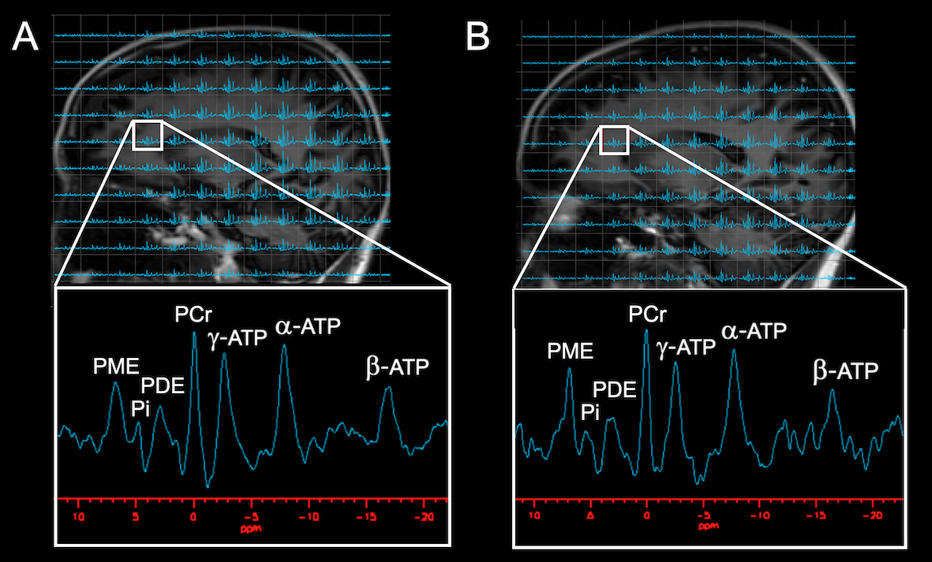
Seven well-resolved resonance peaks were identified, including the HEP molecules phosphocreatine (PCr), adenosine triphosphate (α-ATP, β-ATP and γ-ATP), and inorganic phosphate (Pi); and phospholipid metabolites phosphomonoesters (PME) and phosphodiesters (PDE). P_{i} and the phospholipids are located to the left of PCr. Resonant peaks from the three phosphate groups of ATP (γ-, α-, and β-ATP from left to right) are located to the right of PCr.
A spectrum from the frontal lobe is shown in (A) a 55 year-old post-menopausal woman exhibiting decreased PCr/ATP and (B) a pre-menopausal woman exhibiting increased PCr/ATP.

