EXTENDED FIGURES

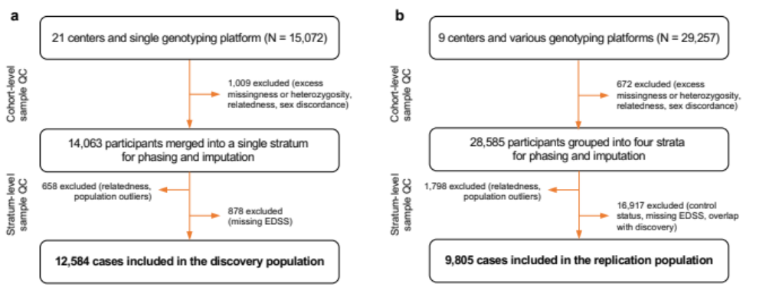

Extended Data Fig. 1 | Flowchart of study participants. Each chart details the number of participants submitted to quality control and total number of cases included in the analysis for the discovery (a) and replication (b) populations. Note that the replication population included MS cases and controls genotyped as part of the same effort. To maximize subsequent phasing and imputation accuracy, all individuals were included in the quality control process. MS cases without measures of disability and controls were excluded prior to analysis, resulting in the final sample count.
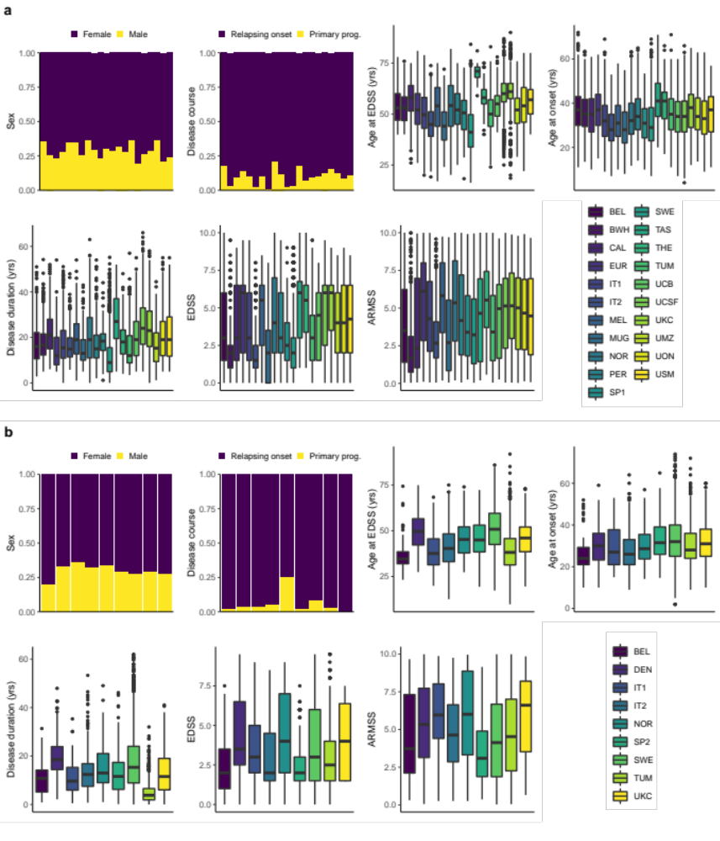

Extended Data Fig. 2 | Demographic characteristics by population and center. a, Discovery population. b, Replication population. Bars represent the proportion of patients in each category. Centers are ordered as in the box plot legend (bottom right subpanel). Box plots show the median, first and third quartiles, with whiskers indicating 1.5 times the interquartile range; outliers are shown as dots. The countries corresponding to the abbreviations in the box plot legend are shown in Supplementary Table 1. ARMSS, age-related multiple sclerosis severity; EDSS, expanded disability status scale; Primary prog., primary progressive; yrs, years.
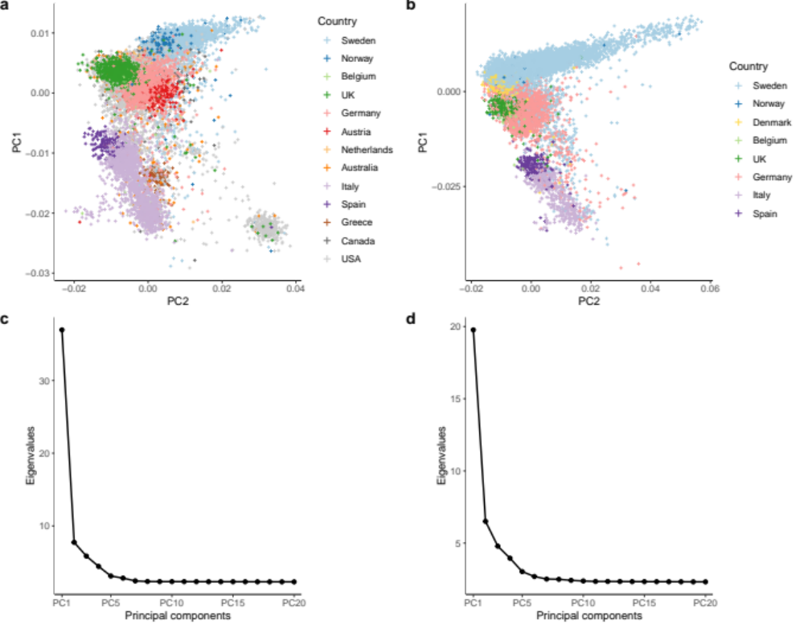

Extended Data Fig. 3 | Principal component analysis of the discovery and replication populations. MS cases were recruited from 13 countries for the discovery (a) and 8 for the replication (b). After removing population outliers, all remaining cases were of European ancestry. The first two principal components respectively captured the north to south and east to west gradients of European genetic structure. US and Canadian participants overlapped with those from other countries. Based on self-reported ancestry, East European and Ashkenazi Jewish individuals constituted the majority of the predominantly US subcluster located at the bottom right of the discovery population (a). The scree plots for our principal component analysis in the discovery (c) and replication (d) populations confirm that the first few principal components capture most of the variance attributable to the minimal population structure remaining after quality control.
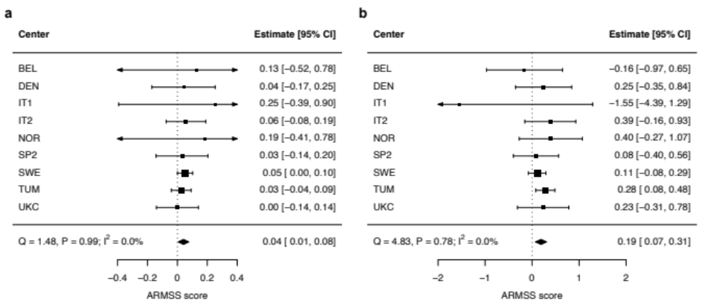

Extended Data Fig. 4 | Replication of MS severity variants by center. a, Genome-wide significant lead variant rs10191329. b, Suggestive lead variant rs149097173. Forest plots show successful replication of the two variants with minimal heterogeneity between centers as indicated by the Cochran’s Q and I² statistics. ARMSS scores are rank-based inverse-normal transformed. ARMSS, age-related multiple sclerosis severity; CI, confidence interval.
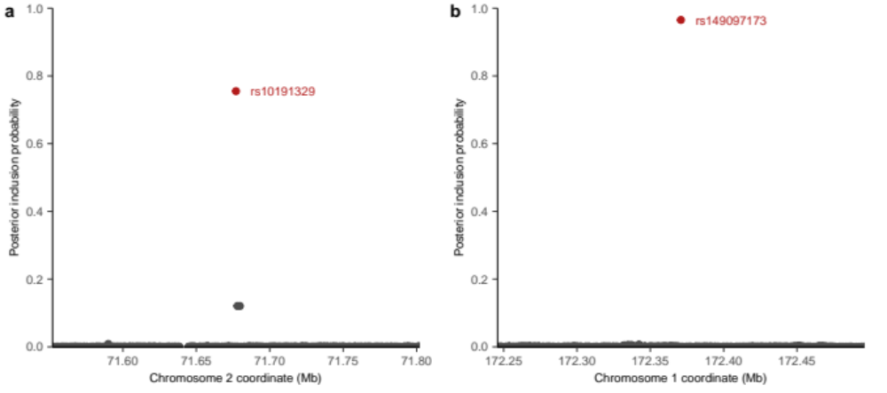

Extended Data Fig. 5 | Fine mapping of the MS severity loci. a, Statistical fine-mapping at the
DYSF–ZNF638 locus identified the rs10191329 as the most likely causal variant with a high PIP. b, Statistical fine-mapping at the suggestive DNM3-PIGC locus found rs149097173 as the most likely causal variant. MS, multiple sclerosis; PIP, posterior inclusion probability.
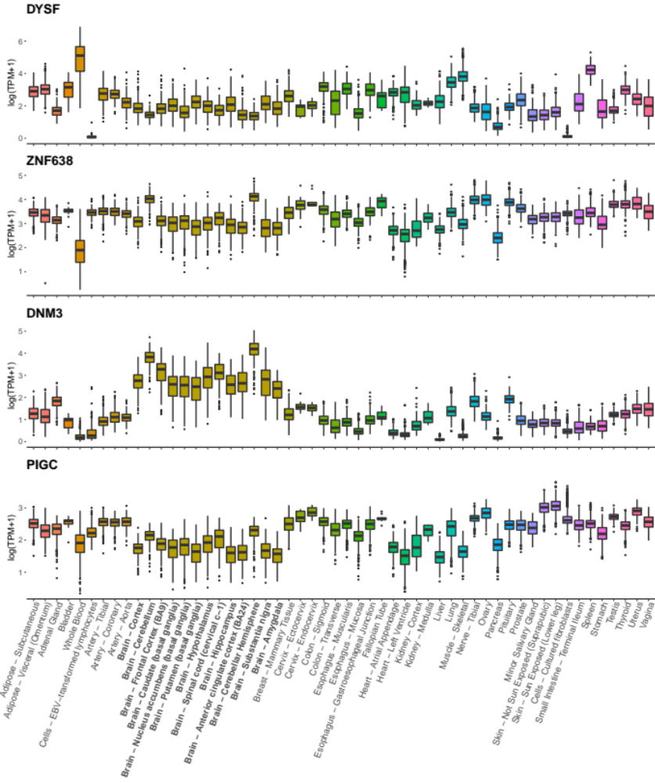

Extended Data Fig. 6 | Tissue expression for nominated MS severity genes. Gene expression profiles were obtained from GTEx⁹⁴ (version 8). Transcripts were collapsed to the gene level and expressed in natural log transformed transcript per million (TPM) units. DYSF, ZNF638, DNM3 and PIGC are expressed in the brain. Bold x-axis labels identify CNS tissues. Colors represent tissue types as defined in GTEx.
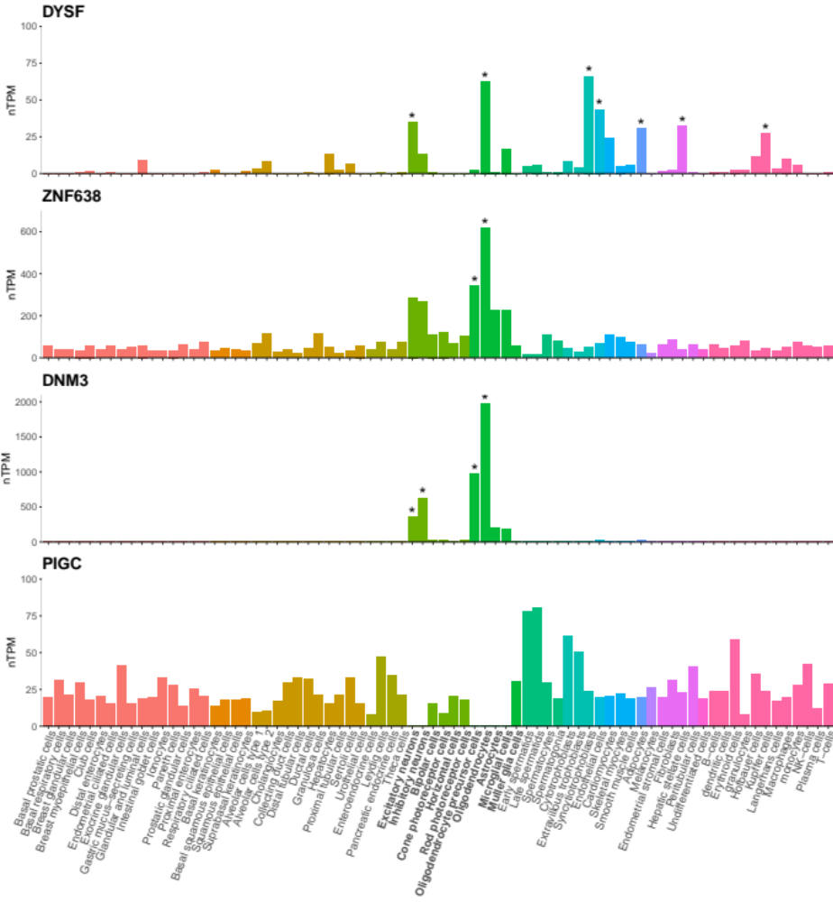

Extended Data Fig. 7 | Cell type expression profiles for nominated MS severity genes. Single cell RNA sequencing data from 25 human tissues and peripheral blood mononuclear cells were obtained from the Human Protein Atlas⁹⁷. Transcript expression levels were summarized per gene and reported as average normalized transcripts per million (nTPM) in 76 cell types. Asterisks mark cell type specificity for the gene, defined as at least fourfold higher expression in a cell type compared to the mean of others. We note that three of the genes show specificity for oligodendrocyte lineage cells. PIGC expression in brain neuronal and glial cells, missing here, is demonstrated in Extended Data Fig. 8. Colors represent cell type categories; bold x-axis labels identify neuronal and glial cell categories.
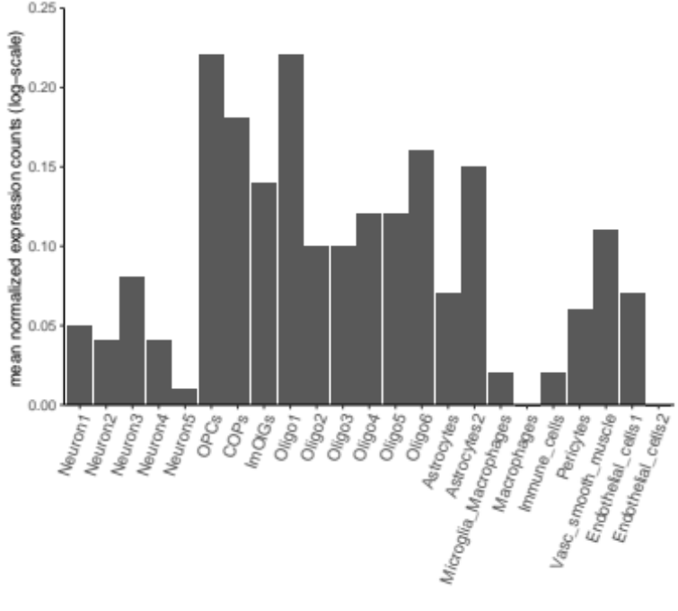

Extended Data Fig. 8 | Cell type expression for PIGC in brain white matter tissue. Single nuclear RNA expression from 4 progressive MS patients and 5 non neurological controls⁷⁴ confirms PIGC expression in neuronal and glial cells including oligodendrocyte lineage cells. COPs, committed oligodendrocyte precursors; ImOLGs, immune oligodendroglia; Oligo, oligodendrocyte; OPCs, oligodendrocyte precursor cells; Vasc, vascular.
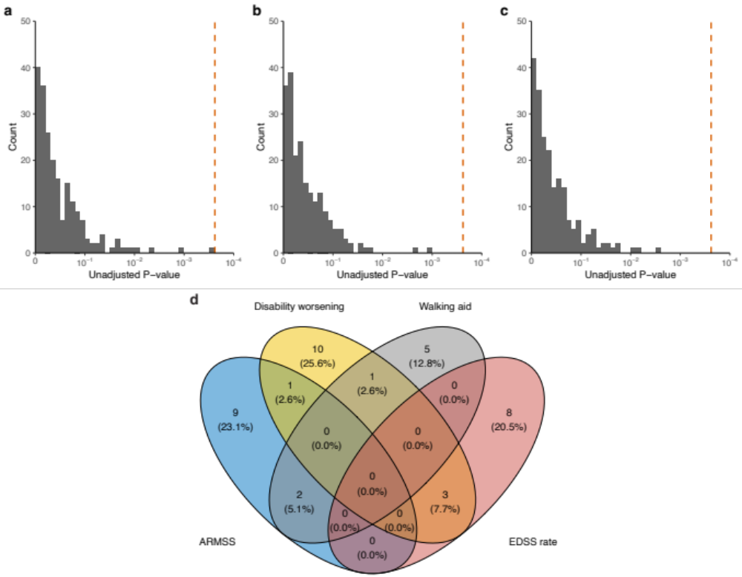

Extended Data Fig. 9 | Association of individual MS susceptibility variants (n = 209) with longitudinal disability outcomes. Distribution of P values from adjusted Cox proportional hazards analyses of (a) time to 24-week confirmed disability worsening and (b) time to require a walking aid. c, Distribution of P values from adjusted linear mixed model analysis of EDSS change across all study visits. The dashed orange line represents the Bonferroni-corrected significance threshold adjusted for the number of susceptibility variants. d, Venn diagram of nominal associations (P_{unadjusted} < 0.05) between individual MS susceptibility variants and all disability outcomes considered; no variant showed consistent association across three or more outcomes. The labels in this panel correspond to the following outcomes: ARMSS, association with ARMSS scores following rank-based inverse normal transformation; Disability worsening, time to 24-week confirmed disability worsening; Walking aid, time to require a walking aid (EDSS 6.0); EDSS rate, rate of EDSS change across all study visits.
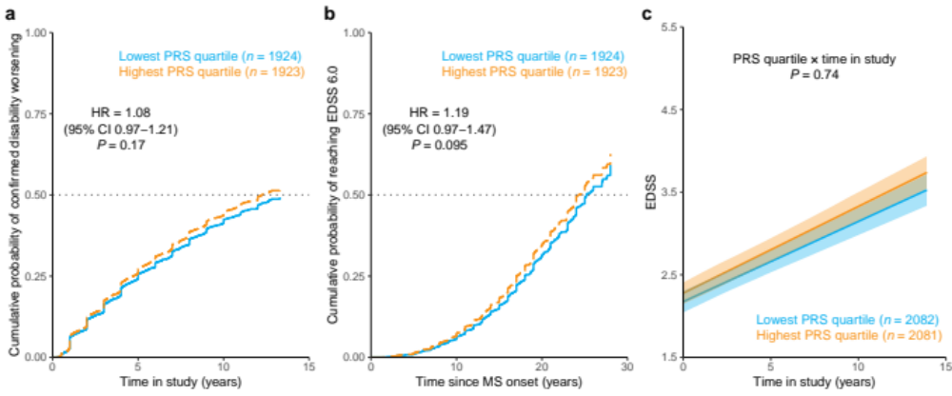

Extended Data Fig. 10 | MS susceptibility PRS and longitudinal disability outcomes. a, Covariate-adjusted cumulative incidence of 24-week confirmed disability worsening comparing individuals in the highest versus those in the lowest quartile of MS susceptibility PRS. b, Covariate-adjusted cumulative incidence of requiring a walking aid for the same groups of individuals. c, Adjusted mean EDSS scores over time by PRS quartile predicted from linear mixed model analysis. Across all analysis, the MS susceptibility PRS had no influence on longitudinal outcomes.

