Supplementary Information

a. b.
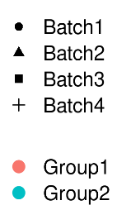
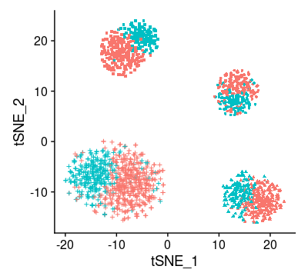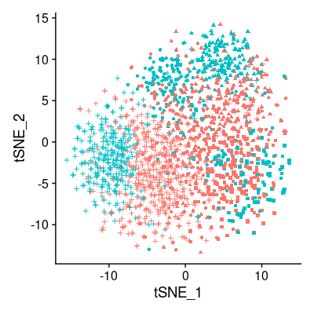
d.

c.

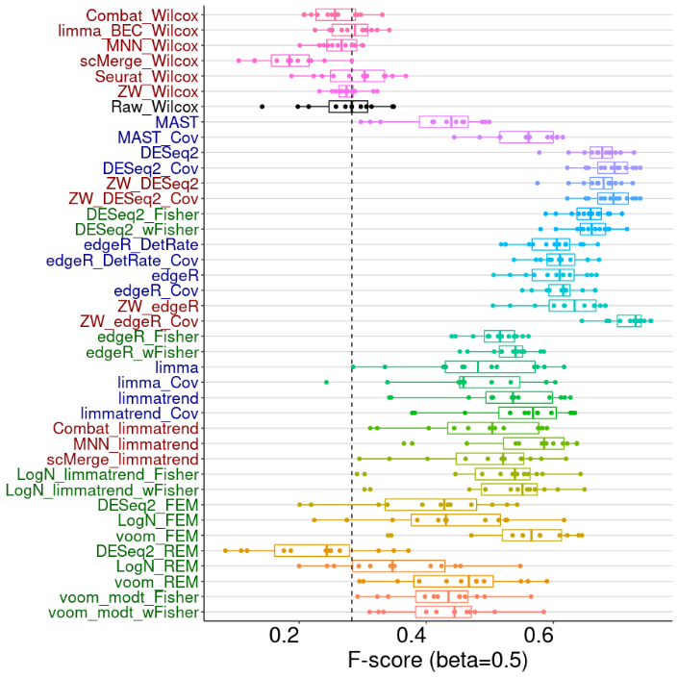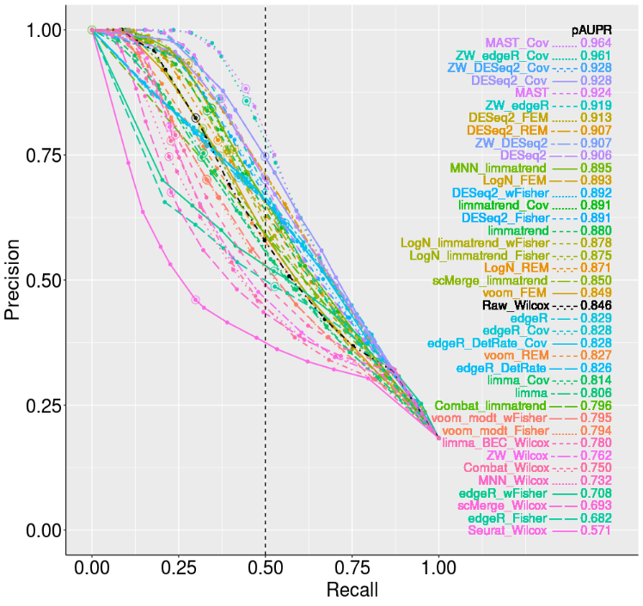
f.
e.
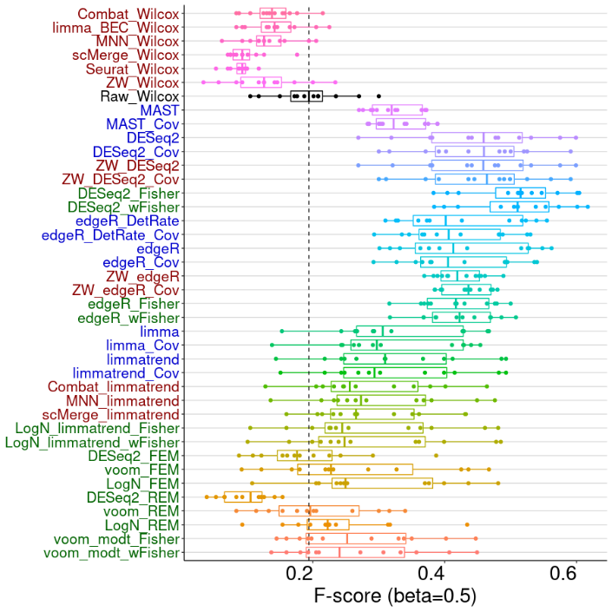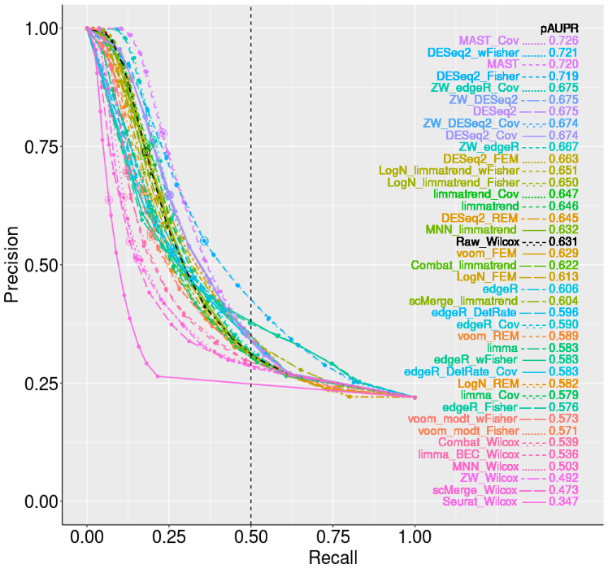
Figure S1. Data distributions, F-score and pAUPR results for four-batch simulations. a. Simple four-batch data with large batch effects. b. Four-batch with large heterogeneity in the test samples. c. The $F_{0.5}$-scores and d. precision-recall analysis results of integrative methods for simple four-batch data. The pAUPR values (recall < 0.5) are represented in the legends. e. The $F_{0.5}$-scores and f. precision-recall analysis results for four-batch data with incomplete association where the batches do not share exactly the same set of DE genes.

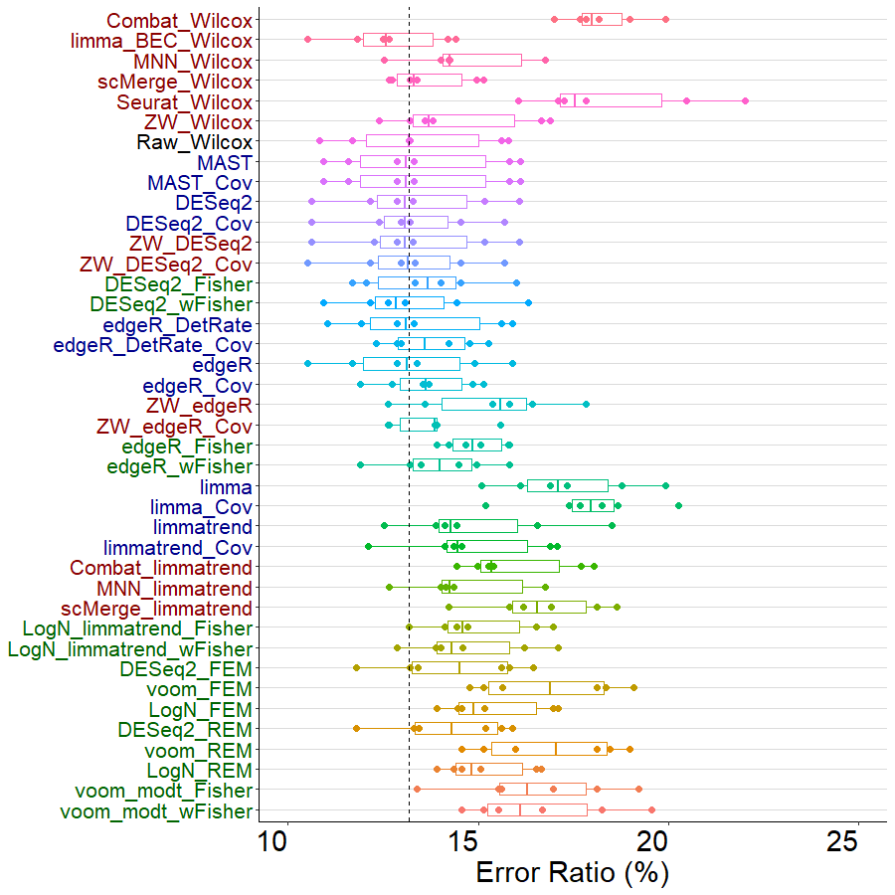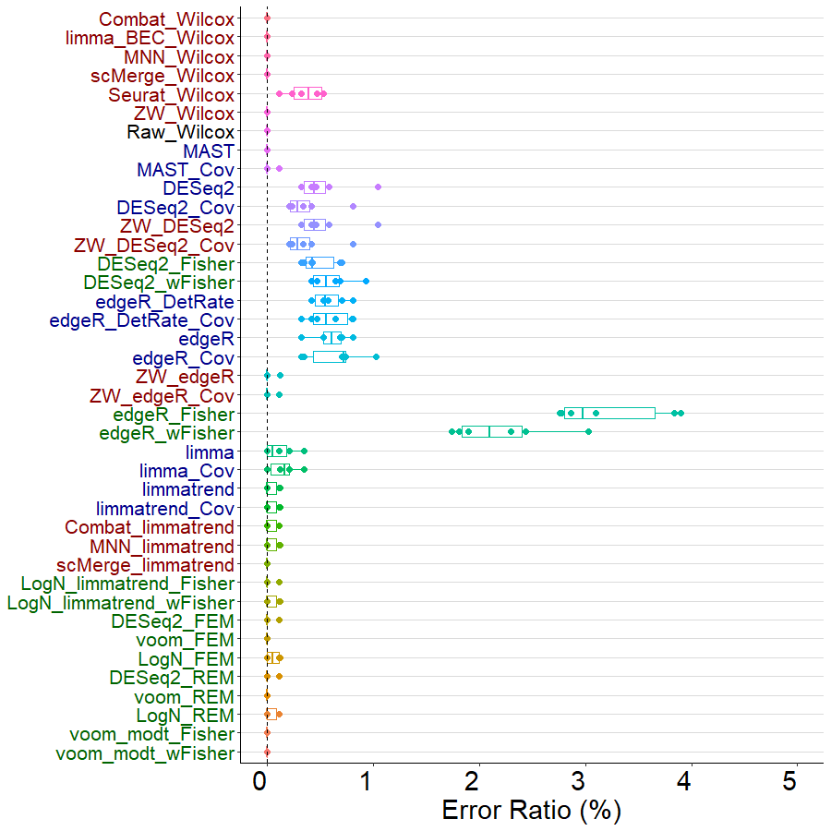
b
d
c
a

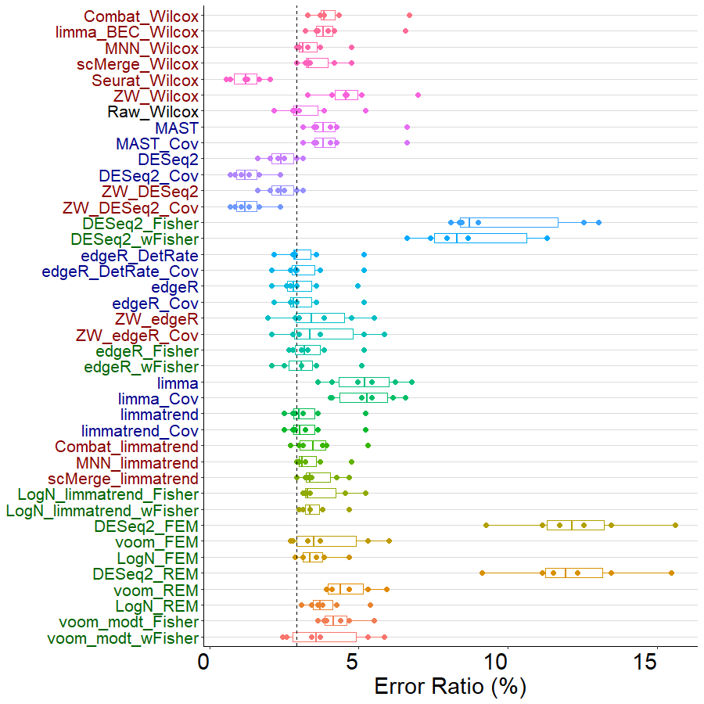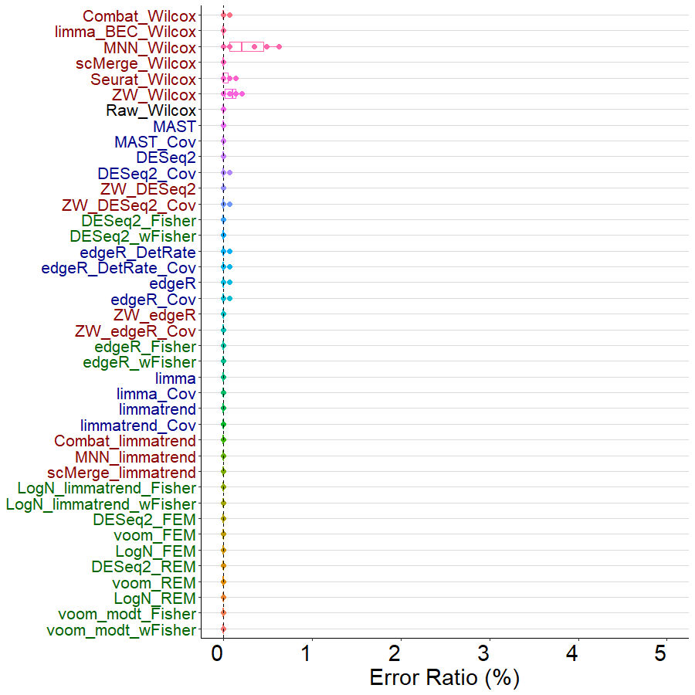

Figure S2. Ratios of DE genes that altered their signs. Total error ratios for a model-based simulation data (four batches) and b error ratios for model-based simulation data among the significant genes. Total error ratios for c pancreas data and d error ratios of pancreas data among the significant genes.

a.
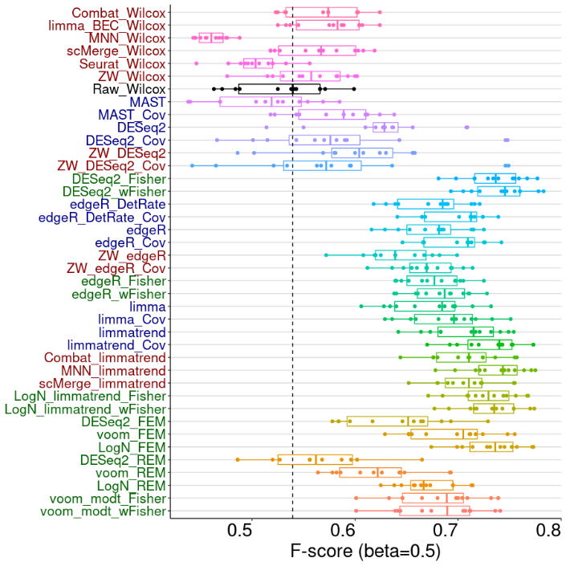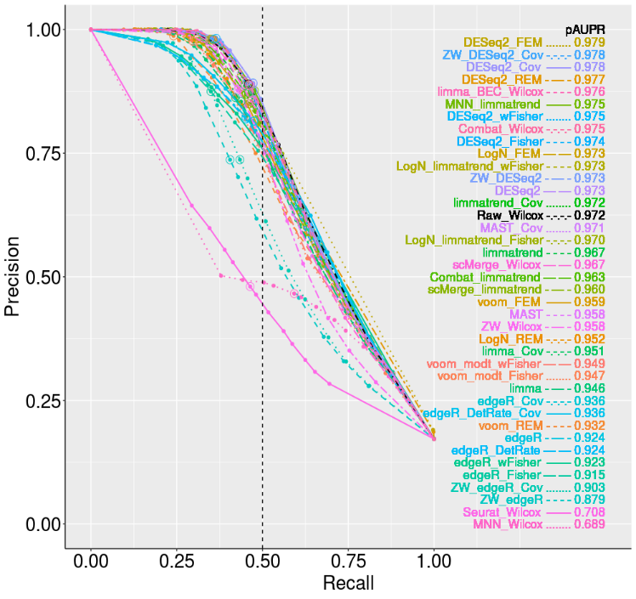
b.

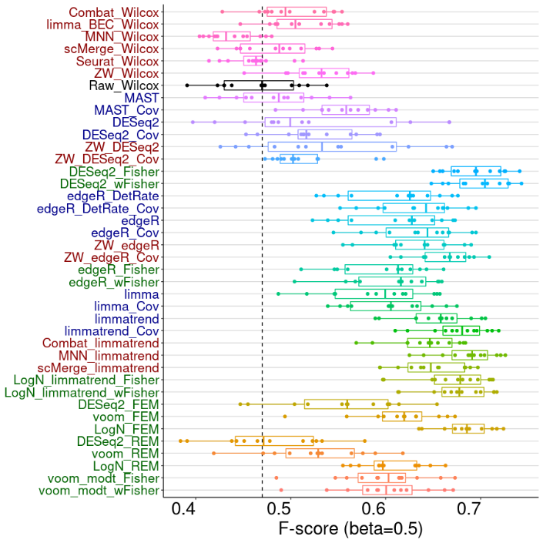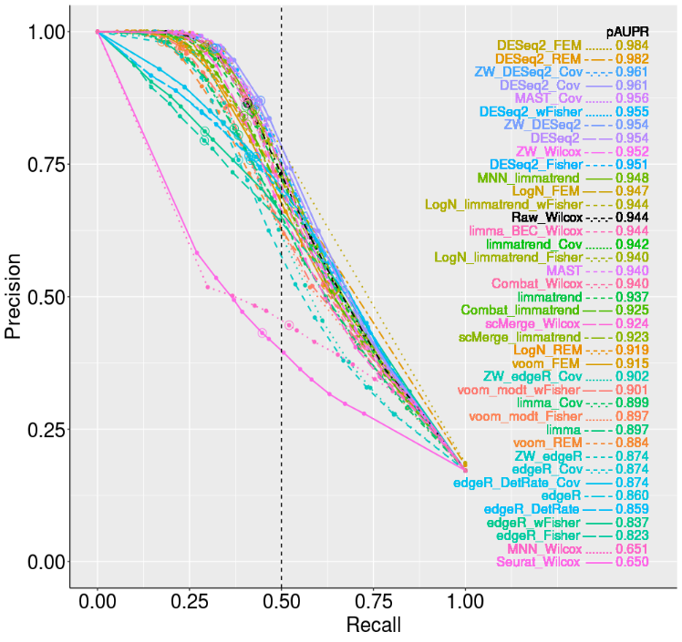
Figure S3. The $F_{0.5}$-scores (left) and precision-recall analysis results (right) for simulated data. Results for zero rates a. 60% and b. 40%. The pAUPR values (recall < 0.5) are sorted in descending order in the legends.

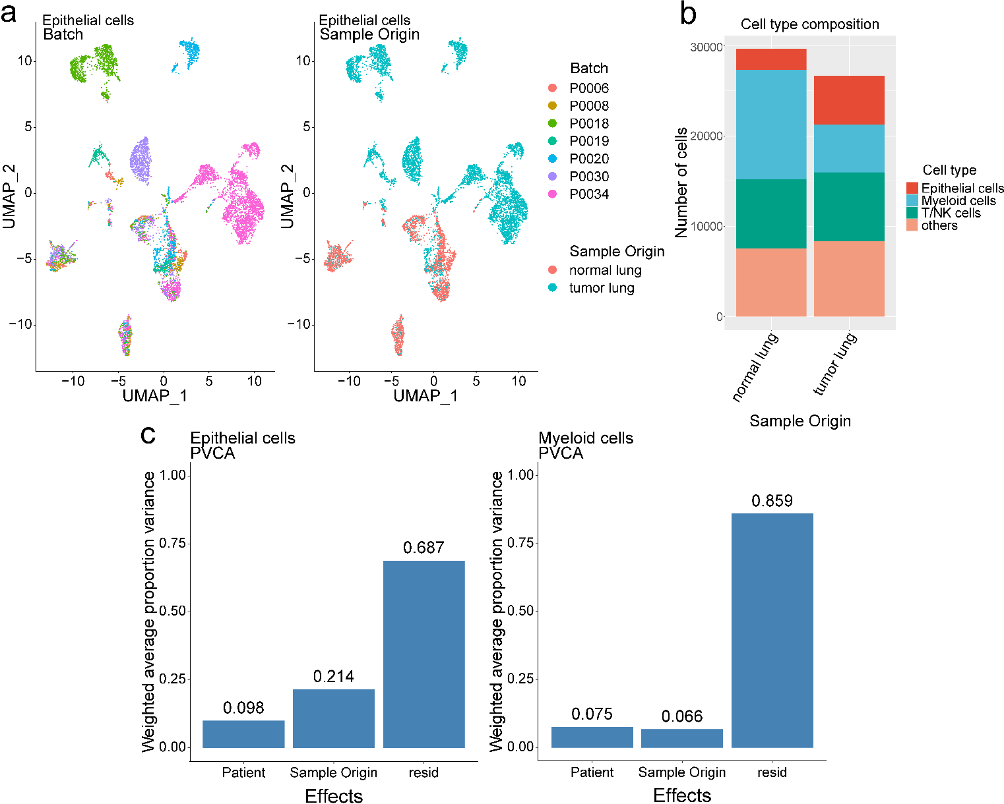
Figure S4. Distribution and batch effects of LUAD scRNA-seq data. a UMAP visualization of epithelial cell data for seven patients. b Composition of the three largest cell types in normal and tumor lung samples. c PVCA results for epithelial and myeloid cells. “Patient” represents batch effects factor between patients.

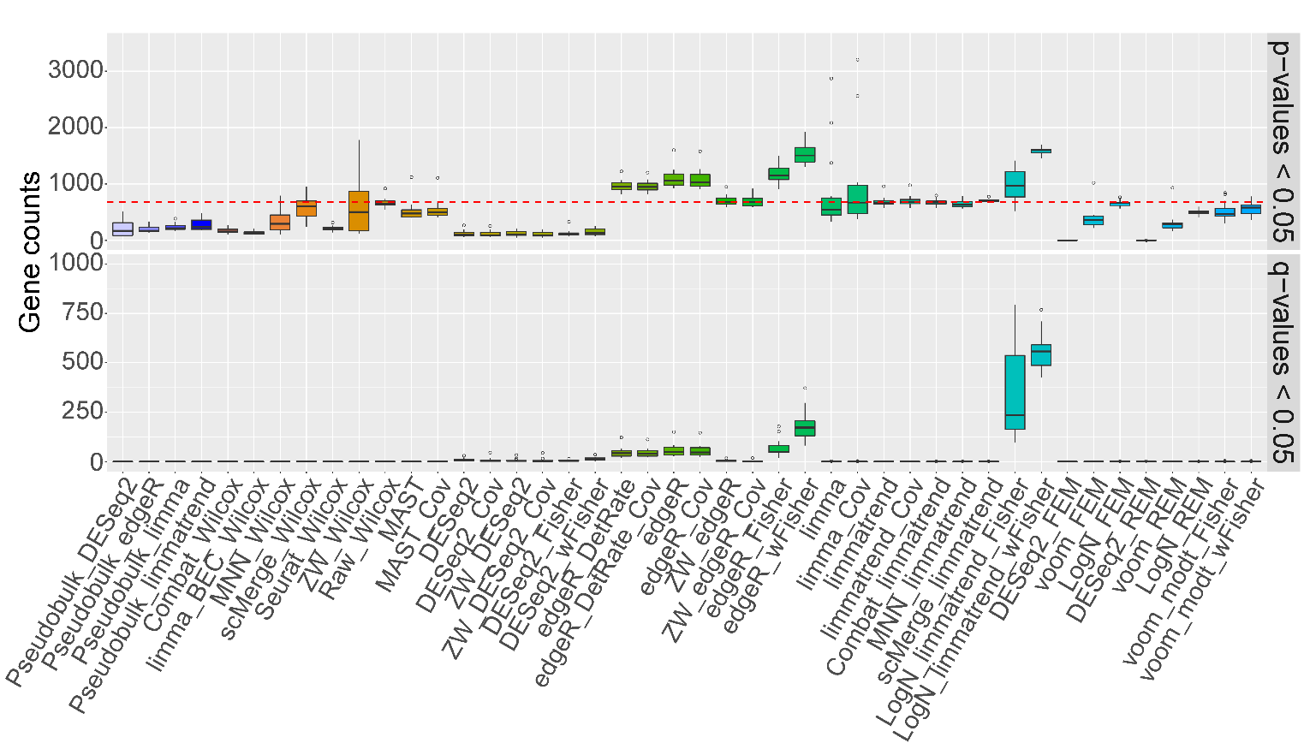
Figure S5. Comparison of false positive controls (above, p-value < 0.05) and false discovery controls (below, q-value < 0.05) between integrative DE and pseudobulk analysis methods using the seven batches of normal lung epithelial cells (gene filtering: zero rate < 0.99). The red-dashed line indicates the five percent of all genes tested.

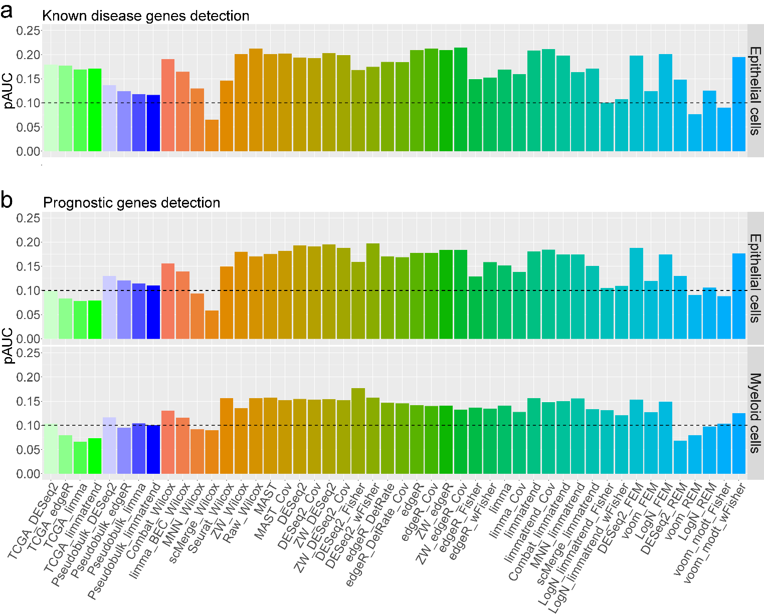
Figure S6. pAUC for standard positive genes detected by DE analysis of scRNA-seq, TCGA LUAD, and pseudobulk data (up to top 20% DE genes). a pAUC of cumulative disease scores (gda) from epithelial cell data analysis. b pAUC of cumulative counts of prognostic genes from epithelial and myeloid cell data analyses. Black-dashed lines represent the expected numbers of standard positive genes for random gene ranks.

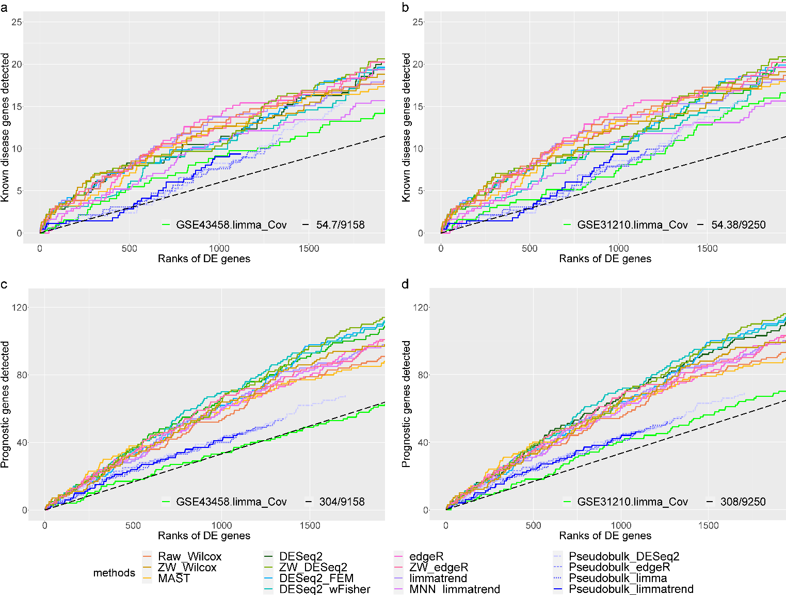
Figure S7. Cumulative scores of standard positive genes obtained from analyses of LUAD epithelial cells and two microarray datasets. Cumulative scores of 11 scRNA-seq DE methods, four pseudobulk analysis methods, and one bulk sample data analysis method (limma) are compared for (a, b) known disease genes and (c, d) prognostic genes. (a, c) GSE43458 and (b, d) GSE31210 LUAD microarray datasets are analyzed. Black-dashed slopes represent the expected cumulative scores for random gene ranks.
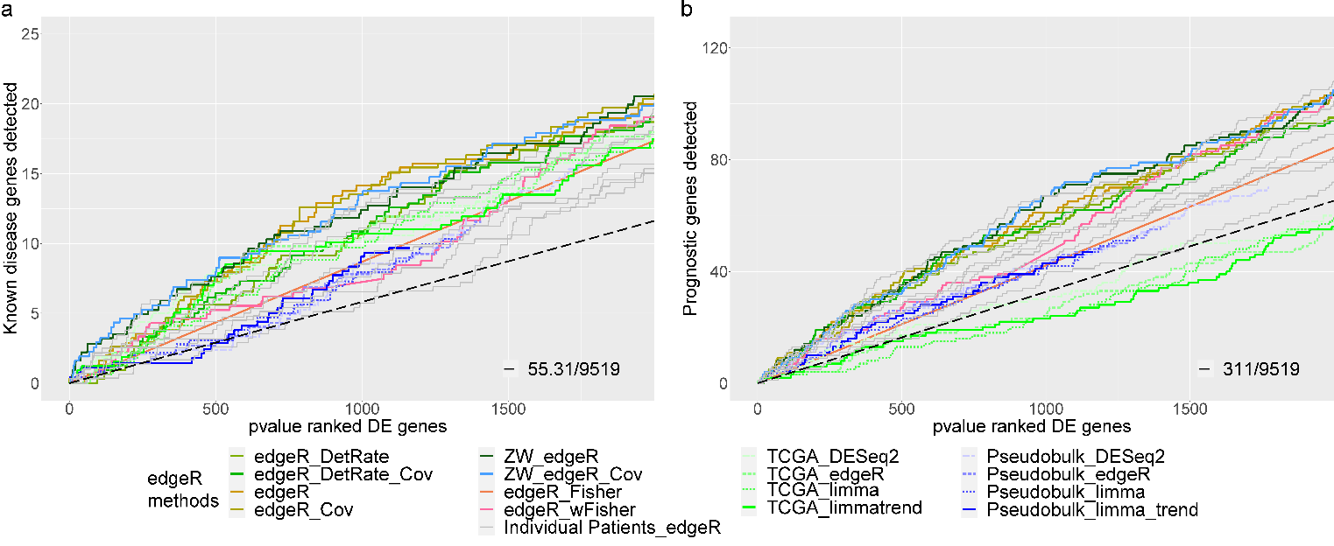
Figure S8. Cumulative scores of standard positive genes obtained using data from individual LUAD patients. Comparison of cumulative scores for a known disease genes and b prognostic genes between eight edgeR-based methods, four bulk/pseudobulk analysis methods, and edgeR analyses of data from seven individual patients. Black-dashed lines represent the expected cumulative scores for random gene ranks.

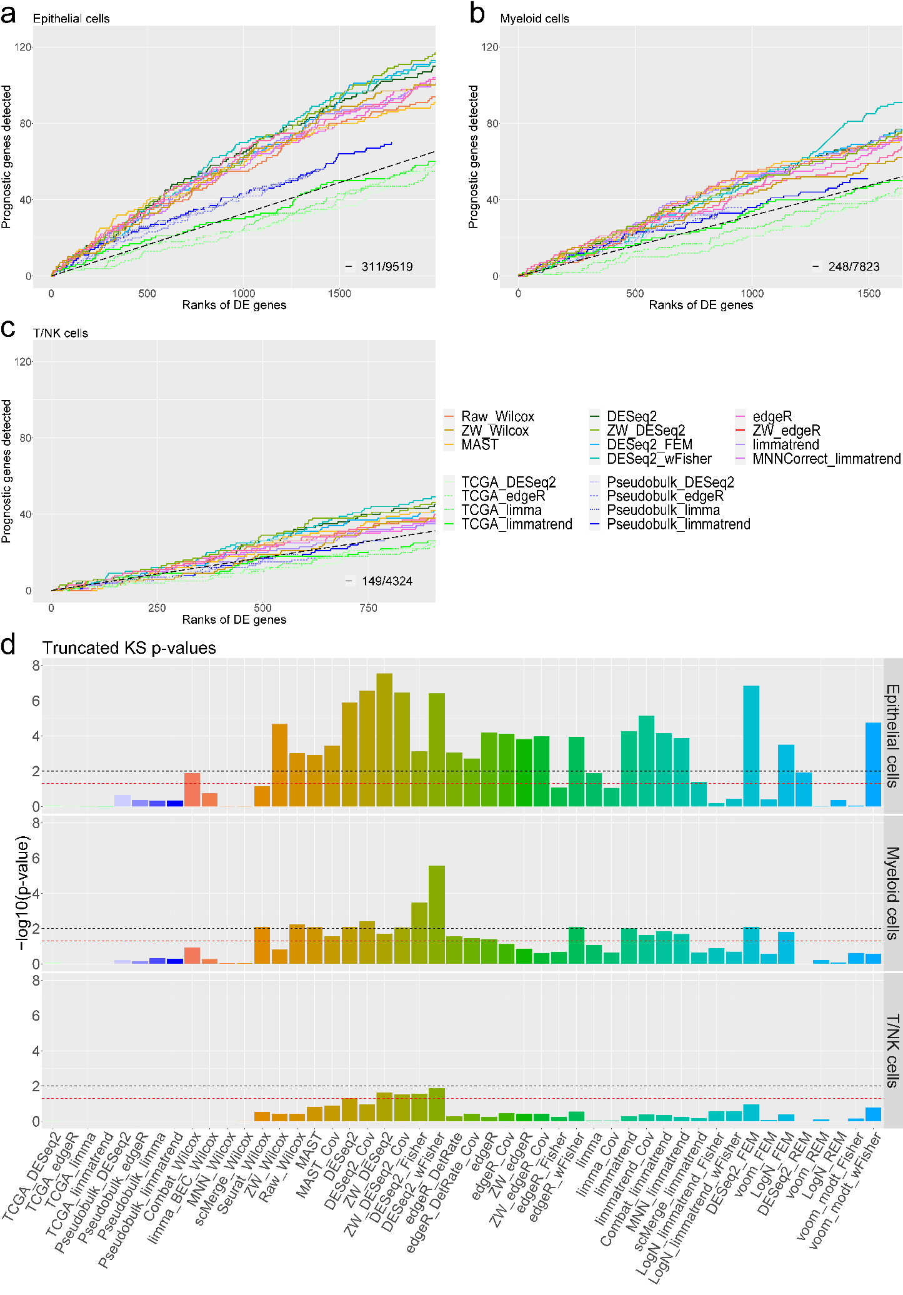
Figure S9. Detection of prognostic genes is compared between DE analyses of scRNA-seq, TCGA LUAD RNA sequencing, and pseudobulk data. Cumulative gda_scores up to top 20% DE genes are shown for three cell types: a epithelial cells, b myeloid cells and c T/NK cells. X-axis represents the gene ranks in each DE analysis (up to top 20%). Y-axis represents the cumulative score of of known disease genes captured within top-k gene ranks by each DE method. The black-dashed slopes represent the expected cumulative scores of prognostic genes for random gene ranks. 15 and 4 methods are selected for analysis of scRNA-seq and bulk/pseudobulk data, respectively. d p-values for the scRNA-seq DE methods and the bulk/pseudobulk analysis methods (truncated KS test) are shown for the three cell types. Black and red dashes represent the two significance cutoffs p-values < 0.01 and < 0.05, respectively.

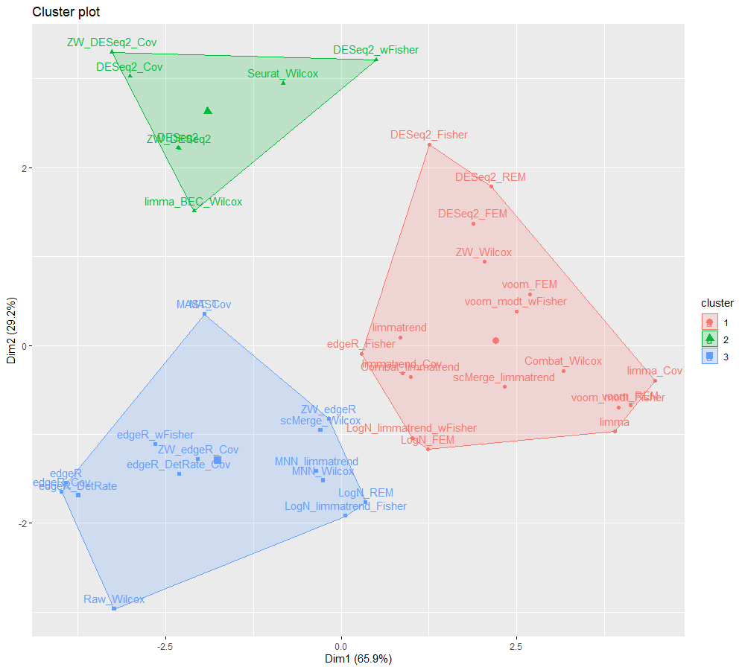
Figure S10. The similarity of sign preservation between integrative methods. Performance on the uncorrected (raw) data is used as an anchor for other methods to compare. We used K-means algorithm to cluster the error ratios of a method for simulation datasets into three groups. Blue, green, and red clusters represent the groups of methods with low, medium, and high error ratios, respectively.

Known disease genes (gda_score $≥$0.5) exclusively detected by epithelial cell analyses
EGFR gene encodes a cell membrane receptor tyrosine kinase. It is involved in multiple signaling transduction cascades, known to play an important role in development of tumor malignancy through cell cycle progression, apoptosis inhibition, induction of angiogenesis through several downstream pathways including RAS/RAF/MAPK pathway.¹ KRAS is well known member of RAS gene family as an oncogene involved in RAS/RAF/MAPK signaling pathway. In general, KRAS is activated in response to signaling from upstream Receptor Tyrosine Kinases including EGFR.² CTNNB1 is a key regulator of Wnt signaling pathway and maintains cell-cell adhesion.³ Increased CTNNB1 expression can promote tumor invasion and metastasis by loss of epithelial structural integrity.⁴ Lastly, ERBB2 encodes another receptor tyrosine kinase and belong to same Erbb family where EGFR is included. Increased expression of ERBB2 is known to trigger multiple signaling pathways such as RAS/RAF/MAPK signaling pathway, which plays an important role in regulating cell proliferation, migration, and differentiation.¹

Implementation of benchmark methods
Here is a brief description of how each benchmark method was implemented. The corresponding codes are available at Github: https://github.com/noobCoding/Benchmarking-integration-of-scRNAseq-differential-analysis.
- Combat ¹ (sva package ver. 3.38.0): The count data were log-normalized. The normalized data and batch information were fed to Combat function. Most of default options were used such as: ref.batch=NULL indicating Combat will decide the reference batch for the adjustment, par.prior=TRUE indicating parametric adjustments will be used; mean.only=FALSE indicating Combat will correct all values in batches with scale adjustment.
- MNNCorrect ² (batchelor package ver. 1.6.3): MNNCorrect uses the first batch as the coordinating system to integrate other batches so the selection of first batch is a critical step. However, MNNCorrect also provides the option auto.merge to search for the optimal order for merging batches to increase the stability of the correction. By detecting the batches with the maximum matching mutual nearest neighbors (MNNs), mnnCorrect can firstly merge more similar batches (having more MNNs). We applied auto.merge=TRUE with other default parameters including the cosine normalization for input datasets.
- scMerge ³ (ver. 1.6.0): Since scMerge requires a list of highly variable genes (HVGs) as an input, we identified the HVGs of the log-normalized data. Besides, scMerge asks for a set of ‘negative control genes’ ³ (e.g., stably expressed genes-SEGs) for its processing. Although scMerge provides the pre-calculated lists of SEGs for human (h-scSEG) and mouse (m-scSEG), we cannot use them directly; because Splatter simulated data contains artificial genes that will not match to any SEGs used in scMerge. Therefore, we used the built-in function SEGIndex to compute the stably expressed values for all artificial genes in the simulations. After a number of trials, we found that threshold=0.5 is reasonable for all our simulated data. Since the cell categories are available in each simulation, we also use that information for the parameter cell_type of the function scMerge to maximize the performance.
- limma ⁴ (ver. 3.46.0): Because of the wide range of applications of limma, we determined to examine the capabilities of limma in various ways: the effectiveness of batch effect correction (limma_bec) and the performance of several combinations or approaches using limma such as: limma with voom transformation, limma with/without using covariates and limmatrend combined with a BEC method such as Combat, MNNCorrect or scMerge. For limma_bec, the function removeBatchEffect was applied on the log-transformed data. By setting parameter trend of the function eBayes as TRUE, we were able to check the performance of limma with trending parameters: limmatrend. By alternating the design matrix of the estimating function lmFit, we were able to test limma with/without covariates ⁴. For in-cooperating with Combat, MNNCorrect, and scMerge batch corrected data can be easily used as direct input for limmatrend algorithm while edgeR and DESeq2 require the raw count data as input.
- Seurat ⁵ (ver. 4.0.2): We normalized each batch using function SCTransform. Then, we selected 1000 features (genes) for the functions: SelectIntegrationFeatures and PrepSCTIntegration. A set of 50 anchors between batches was then identified via the built-in function FindIntegrationAnchors. Finally, IntegrateData function finished the integration.
- Wilcoxson’s ranksum test ⁶ : This test is used to compare distributions of two sample groups based on the ranks rather than the expression values. This test was implemented using FindMarkers function in Seurat package with the following parameters: logfc.threshold=0, min.cells.feature=0, min.cells.group=0, min.pct=0, only.pos=FALSE to obtain the full list of ranked genes (whether significant or not).
- MAST ⁷ (ver. 1.16.0): log-normalized data was fed into the estimating function zlm of MAST package via the wrapper from Seurat. We used the default settings for all datasets except manipulating the formula design to include or exclude the batch covariates information. We also fixed the parameter logfc.threshold to 0 to maximize the range searching for all markers.
- DESeq2 ⁸ (ver. 1.30.1): We added 1 pseudo count to all data entries to prevent the situation that each gene includes at least one 0, which leads to an unsolvable problem for the function. Or, alternately, using the raw count with sfType=’poscount’ can also do the trick. However, we found that the first option usually gives the better performance in tests. Counts matrix, the information of cells, and the contrasting design formula are then fed as input for the function DESeqDataSetFromMatrix to create a so-called DESeq2 object. DESeq2 will take care of the processing and the obtained object will be passed to the function lfcShrink for estimating the shrinkage of effect size (log fold-changes – LFC), which is used for ranking of genes. As suggested by the authors, we specified to use the apeglm method for effect size shrinkage ⁹, which improves the performance more frequently. By customizing the design formula, we can test the method with/without the batch covariates information.
- edgeR ¹⁰ (ver. 3.32.1): We loaded counts data to DGEList object along with the corresponding group information as meta data. The edgeR’s built-in normalization was applied via function calcNormFactors with the trimmed mean of M-values (TMM) method by default. After that, we estimated the dispersion parameter for the negative binomial model by feeding the normalized data and the modeled design to the function glmQLFit. We used the function glmQLFTest to find deferentially expressed genes. Beside testing the batch covariates variant, we also investigate the edgeR variant including the edgeR_DetRate ¹¹ version, which uses the fraction of detected genes per cell as another covariates.
- ZINB-WaVE ¹² (ver. 1.12.0): We used the function SingleCellExperiment to create an object from the zero-variance-gene filtered counts data and the corresponding meta information. The zinbwave function is applied to obtain the low-dimensional representation of the data from the perspective of ZINB-WaVE. For DE analysis of genes, ZINB-WaVE output should be incorporated with edgeR or DESeq2
(https://bioconductor.org/packages/release/bioc/vignettes/zinbwave/inst/doc/intro.html#differential-expression). There are two ways for DE analysis using ZINB-WaVE output
- To obtain the batch-effect-corrected data, the parameter normalizedValues should be set as “TRUE” to let the function return the corrected data.
- To use the observation weights, the parameter observationalWeights of the function zinbwave is required to be “TRUE”. The function glmWeightedF is then used to estimate the shrinkage of the log fold-changes for gene ranking if edgeR is used. For DESeq2, we first need the function DESeqDataSet to create an object from the output of the function zinbwave. Next, the functions DESeq and lfcShrink are used in that order on the output to obtain the ranking of DE genes. The observation weights are used transparently in this case. We also found that the performance of DESeq2 trends to improve when adding the pseudo count of one to the ‘counts’ field of the output zinbwave before creating the object with the function DESeqDataSet.
- Pseudobulk ¹³ DE approach: Read counts for each feature/gene are aggregated across the cells of a given group within each batch. Each collapsed sample will be treated like a single bulk sample for that group. Any DE method can be applied to the pseudo-bulk data identify DE genes.
Meta-analysis (FEM/REM)¹⁴ : FEM and REM combine effect size of each gene from multiple batches. Both approaches are implemented by MetaDE R package¹⁵ (ver.1.0.5) as get.FEM and get.REM functions. Variance and effect size values for each gene and batch are used as input for get.FEM and get.REM functions, obtained by get.ES function. We applied get.ES function to voom transformed and log-normalized count data. DESeq2 with lfcShrink function and apeglm method is also incorporated with FEM and REM and provide input values.
Meta-analysis (Fisher/wFisher)^{16,17} : Fisher and wFisher methods combine p-values of each gene from multiple batches. We used get.fisher function from MetaDE R package for running Fisher. Since get.fisher function combine p-values without considering direction of gene expression, Fisher with right tailed p-values and left tailed p-values are compared to establish signs with two tailed results. For wFisher, we used wFisher function from metapro R package. wFisher takes direction of each gene as sign to eff.sign parameter. For each gene, number of cells with expression in each batch are combined and used as weight parameter for wFisher function. P-values from four different DE methods are used as input of Fisher and wFisher. While DESeq2 and edgeR are applied to raw count data, limmatrend and moderate t test implemented by MetaDE R package are applied to log-normalized and voom transformed count, respectively.

Table S1. Top 20% DE genes obtained from analysis of epithelial cell data using three integrative DE methods and from analysis of TCGA LUAD data using four bulk RNA-seq DE methods. Gene names, “standard positive” LUAD genes, adjusted p-values, and logFC values for each gene are shown. Genes are sorted by corresponding adjusted p-values from each method.

Table S2. Standard positive pathways detected from GSEA of DE analysis results for 16 pathway categories for lung adenocarcinoma. Significant standard positive pathways (FDR < 0.25) detected within the top 50 pathways were counted for each category.

Table S3. GSEA results for three integrative DE methods applied to epithelial cell data and those for DE analysis of TCGA data. LogFC was used as test statistic for GSEA, averaged logFC values were used for GSEA of summarized bulk sample analysis results. Pathways, corresponding standard positive categories, adjusted p-values, and enrichment scores from each method are described. Pathways are sorted by adjusted p-values from each DE method.

Reference

1 Johnson, W. E., Li, C. & Rabinovic, A. Adjusting batch effects in microarray expression data using empirical Bayes methods. Biostatistics 8, 118-127, doi:10.1093/biostatistics/kxj037 (2006).
2 Haghverdi, L., Lun, A. T. L., Morgan, M. D. & Marioni, J. C. Batch effects in single-cell RNA-sequencing data are corrected by matching mutual nearest neighbors. Nat Biotechnol 36, 421-427, doi:10.1038/nbt.4091 (2018).
3 Lin, Y. et al. scMerge leverages factor analysis, stable expression, and pseudoreplication to merge multiple single-cell RNA-seq datasets. PNAS 116, 9775-9784, doi:10.1073/pnas.1820006116 (2019).
4 Ritchie, M. E. et al. limma powers differential expression analyses for RNA-sequencing and microarray studies. Nucleic Acids Res 43, e47, doi:10.1093/nar/gkv007 (2015).
5 Stuart, T. et al. Comprehensive Integration of Single-Cell Data. Cell 177, 1888-1902.e1821, doi:10.1016/j.cell.2019.05.031 (2019).
6 Wilcoxon, F. Individual comparisons by ranking methods. Biom Bull 1, 80–83 (1945).
7 Finak, G. et al. MAST: a flexible statistical framework for assessing transcriptional changes and characterizing heterogeneity in single-cell RNA sequencing data. Genome Biol 16, 278, doi:10.1186/s13059-015-0844-5 (2015).
8 Love, M. I., Huber, W. & Anders, S. Moderated estimation of fold change and dispersion for RNA-seq data with DESeq2. Genome Biol 15, 550, doi:10.1186/s13059-014-0550-8 (2014).
9 Zhu, A., Ibrahim, J. G. & Love, M. I. Heavy-tailed prior distributions for sequence count data: removing the noise and preserving large differences. Bioinformatics 35, 2084-2092, doi:10.1093/bioinformatics/bty895 (2018).
10 Robinson, M. D., McCarthy, D. J. & Smyth, G. K. edgeR: a Bioconductor package for differential expression analysis of digital gene expression data. Bioinformatics 26, 139-140, doi:10.1093/bioinformatics/btp616 (2010).
11 Soneson, C. & Robinson, M. D. Bias, robustness and scalability in single-cell differential expression analysis. Nat Methods 15, 255-261, doi:10.1038/nmeth.4612 (2018).
12 Risso, D., Perraudeau, F., Gribkova, S., Dudoit, S. & Vert, J.-P. A general and flexible method for signal extraction from single-cell RNA-seq data. Nat Commun 9, 284, doi:10.1038/s41467-017-02554-5 (2018).
13 Squair, J. W. et al. Confronting false discoveries in single-cell differential expression. Nat Commun 12, 5692, doi:10.1038/s41467-021-25960-2 (2021).
14 Choi, J. K., Yu, U., Kim, S. & Yoo, O. J. Combining multiple microarray studies and modeling interstudy variation. Bioinformatics 19 Suppl 1, i84-90, doi:10.1093/bioinformatics/btg1010 (2003).
15 Wang, X. et al. An R package suite for microarray meta-analysis in quality control, differentially expressed gene analysis and pathway enrichment detection. Bioinformatics 28, 2534-2536, doi:10.1093/bioinformatics/bts485 (2012).
16 Fisher, R. A. Statistical Methods for Research Workers. 4th edn, (Oliver and Boyd, 1932).
17 Yoon, S., Baik, B., Park, T. & Nam, D. Powerful p-value combination methods to detect incomplete association. Sci Rep 11, 6980, doi:10.1038/s41598-021-86465-y (2021).

