Supplementary information to:
Silva ANF, Silva CR, Santos REC, Arce CCM, Araújo APA & Cristaldo PF*. The dilemma between colony growth and survival: an experiment on food resource selection with a nasute termite
* corresponding author: paulo.cristaldo@ufrpe.br

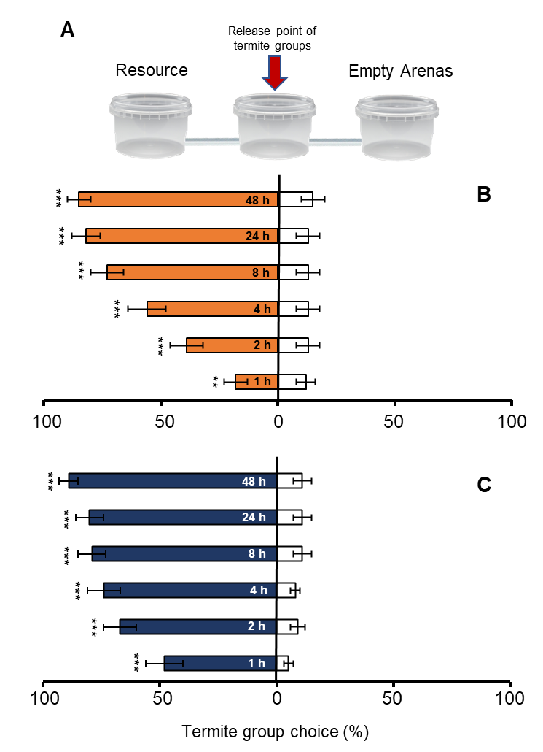
Fig. S1. Temporal dynamic of foraging by Nasutitermes corniger groups in binary choice experiments (A) with arenas containing sugarcane baits [low (B) and high (C) resource quantity] versus empty arenas. Asterisks indicate significant differences between treatments (**P <0.01; *** P <0.001).

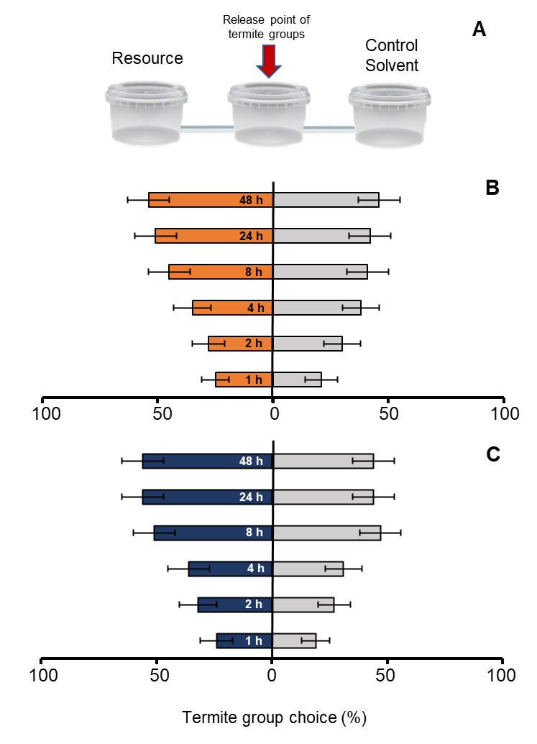
Fig. S2. Temporal dynamic of foraging by Nasutitermes corniger groups in binary choice experiments (A) with arenas containing sugarcane baits (B) low (LR) and (C) high (HR) resource quantity) versus low and high bait with solvent (control), respectively. Asterisks indicate significant differences between treatments (**P <0.01; *** P <0.001).

