Supplementary Table 1 Characteristics of the included studies in the mata-analysis
Study | Country | Breed | Age, d | N | Probiotic | Duration, d | Feed
Abu-Tarboush et al. (1996) | Saudi Arabia | Holstein | 3.5 | 16 | Lactobacillus acidophilus, Lactobacillus plantarum | 84 | Pasteurized whole milk and milk replacer, starter
Agazzi et al. (2014) | Italy | Holstein | 2 | 22 | L. animalis, L. paracasei, B. coagulans | 26 | Milk replacer, concentrate
Al-Saiady (2010) | Arabia | Holstein | 3 | 16 | L. acidophilus, L. plantarum |  | Whole pasteurized milk and milk replacer, starter
B. Wang et al. (2018) | China | Holstein | 28 | 10 | Candida tropicalis | 28 | Milk replacer, starter
Bayatkouhsar et al. (2013) | Iran | Holstein | 4 | 16 | L. acidophilus, L. rhamnosus, L. casei, L. delbrueckii | 86 | Whole milk, starter
Cruywagenet al. (1996) | South Africa | Holstein | 2 | 40 | Lactobacillus acidophilus | 42 | Milk replacer, starter
El-Diastyet al. (2021) | Egypt | Holstein |  | 20 | Pediococcus | 42 | Milk, starter
Kim et al. (2020) | Korea | Holstein | 7 | 18 | Saccharomyces cerevisiae | 42 | Whole milk, starter, mixed grass hay
Foditsch et al. (2015) | USA | Holstein | 5 | 287 | Faecalibacterium prausnitzii | 14 | Acidified milk, starter
Fomenky et al. (2017) | Canada | Holstein | 4.5 | 24 | Lactobacillus acidophilus, Saccharomyces cerevisiae boulardii | 89 | Milk replacer, starter, hay
Frizzo et al. (2010) | Argentina | Holstein | 10 | 16 | L. casei, L. salivarius, P. acidilactici | 35 | Milk replacer, concentrate pellet
Frizzo et al. (2008) | Argentina | Holstein | 10 | 24 | L. casei, L. salivarius, P. acidilactici | 35 | Milk replacer, concentrate pellet
Abe et al. (1995) | Japan | Holstein | 1 | 19 | L. acidophilus, B.thermophilum, E.faecium | 56 | Milk replacer
Gorgulu et al. (2003) | Turkey | Holstein | 3 | 22 | Lactobacillus plantarum, L. bulgaricus, L. acidophilus, L. mamnsus, Bifidobacterium bifidum, Streptococcus thermophilus, Enterococcus faecium, Aspergillus oryza, and Candida pintolopessi | 60 | Whole milk, starter, alfalfa
H. Wang et al. (2021) | China | Holstein | 1 | 32 | Lactobacillus plantarum, Pediococcus acidilactici, Pediococcus pentosaceus, Bacillus subtilis | 90 | Milk replacer, starter pellets
He et al. (2017) | Canada | Holstein | 1 | 42 | Saccharomyces cerevisiae var boulardii | 56 | Milk replacer, starter
Higginbotham et al. (1993) | USA | Holstein | 9 | 50 | L. acidophilus and Streptococcus faecium | 36 | Milk replacer, starter
Hill et al. (2009) | USA | Holstein | 2 | 76 | Saccharomyces cerevisiae | 63 | Whole milk, starter
Pinos et al. (2008) | USA | Holstein | 2 | 16 | Saccharomyces boulardii | 56 | Whole milk, starter
Jatkauskas et al. (2010) | Lithuania | Black-and-White | 6 | 20 | Enterococcus faecium | 56 | Fresh milk and skimmed milk, meal feed, hay, and grass silage
Jennyet al. (1991) | USA | Holstein | 2 | 56 | Bacillus subtilis, L. acidophilus, L. lactis, B. subtilis | 42 | Milk replacer, starter
Jiang et al. (2020) | China | Holstein | 3 | 24 | Lactobacillus plantarum | 56 | Milk, starter
Karamzadeh et al. (2020) | Iran | Holstein | 1 | 60 | Enterococcus faecium, Pediococcus acidilactici, Streptococcus thermophilus, Lactobacillus bulgaricus, Lactobacillus acidophilus, Lactobacillus rhamnosus, Bifidobacterium bifidum | 28 | Milk, starter
Kawakami et al. (2010) | Japan | Holstein | 6 | 8 | Lactic acid bacteria, S. cerevisiae | 28 | Milk replacer
Kekana et al. (2020) | South Africa | Holstein | 4 | 16 | L. bavaricus, L. casei, L. rhamnosus, L. coryniformis, L. curvatus, L. sake, S. species, Leuconostoc | 42 | Whole milk, starter
Khaziakhmetov et al. (2020) | Russia | Holstein | 8.5 | 20 | “Stimix Testim” probiotic: E. coli, L. acidophilus, Saccharomyces cerevisiae, Bacillus subtilis, Azotobacter vinelandii, and Azotobacter chroococcum. | 90 | Whole milk, starter, green fodder
Laborde (2008) | America | Holstein | 1 | 24 | Bacillus lichenformis, Bacillus subtilis | 56 | Milk replacer,starter
Le et al. (2017) | Australia | Holstein-Friesians | 28 | 24 | Bacillus amyloliquefaciens |  | Whole milk, starter pellets
Zábranský et al. (2021) | Czech | Holstein | 1 | 80 | Lactobacillus sporogenes, Enterococcus faecalis， Bifidobacterium bifidum | 56 | Milk replacer, starter, alfalfa hay
Kong et al. (2019) | China | Holstein | 28 | 24 | Candida tropicalis | 53 | Milk replacer, starter
Morrison et al. (2010) | UK | Holstein–Friesian | 5 | 40 | Streptococcus faecium | 84 | Milk replacer, starter
Gorka et al. (2021) | Poland | Holstein | 10 | 32 | Bacillus licheniformis, Bacillus subtilis | 50 | Milk replacer, starter
Zhang et al. (2016) | China | Holstein | 7 | 16 | L. plantarum, B. subtilis | 75 | Milk replacer, starter and alfalfa
Zhang et al. (2017) | China | Holstein | 8 | 8 | Lactobacillus plantarum | 84 | Milk replacer, starter and alfalfa
Roodposhti et al. (2012) | Iran | Holstein | 3 | 32 | Protexin | 56 | Whole milk, starter
Rychen et al. (2018) | Europe | Holstein | 18 | 80 | Bacillus subtilis | 56 | Milk replacer, starter
Salazar et al. (2019) | Brazil | Holstein | 6 | 20 | Enterococcus faecium | 54 | Whole milk, starter
Saremi et al. (2003) | Iran | Holstein | 1 | 12 | Saccharomyces cerevisiae | 90 | Milk, starter, alfalfa
Seifzadeh et al. (2017) | Iran | Holstein | 5 | 10 | L. plantarum, L. bulgaricus, L. acidophilus, L. rhamnosus, B. bifidum, S. thermophilus, E. faecium, A. oryzae, C. pintolopesii | 60 | Whole milk, alfalfa hay
Stefańska et al. (2021) | Poland | Holstein-Friesian | 3 | 22 | multi-strain Lactobacillus probiotic | 53 | Milk replacer, starter
Strzetelski et al. (1998) | Poland | Black-and-White | 7 | 20 | L. acidophilus, L. casei, L. plantarium, S. faecium | 74 | Milk replacer, concentrate
Sun et al. (2010) | China | Holstein | 7 | 12 | Bacillus subtilis natto |  | Fresh cow milk, starter
Takemura et al. (2020) | Japan | Holstein | 20 | 24 | Saccharomyces cerevisiae | 50 | Whole milk, starter
Terré et al. (2015) | Spain | Holstein | 9 | 120 | Saccharomyces cerevisiae | 56 | Milk replacer, concentrate
Villot et al., (2019) | Canada | Holstein | 6 | 84 | Saccharomyces cerevisiae boulardii | 49 | Milk replacer, starter
Wu et al., (2021) | Chinese | Holstein | 3 | 20 | L. acidophilus, B. subtilis, S. cerevisiae， | 56 | Milk, starter concentrates
Yao et al. (2020) | China | Holstein | 1 | 20 | Bacillus megaterium | 28 | Cow milk, starter, alfalfa
Guo et al. (2021) | China | Holstein | 2 | 20 | Bifidobacterium animalis, Lactobacillus casei, Streptococcus faecalis, Bacillus cerevisiae | 30 | Milk replacer, pelleted starter
Zhang et al. (2019) | China | Holstein | 12 | 24 | Lactobacillus rhamnosus GG | 42 | Milk replacer, starter, alfalfa hay

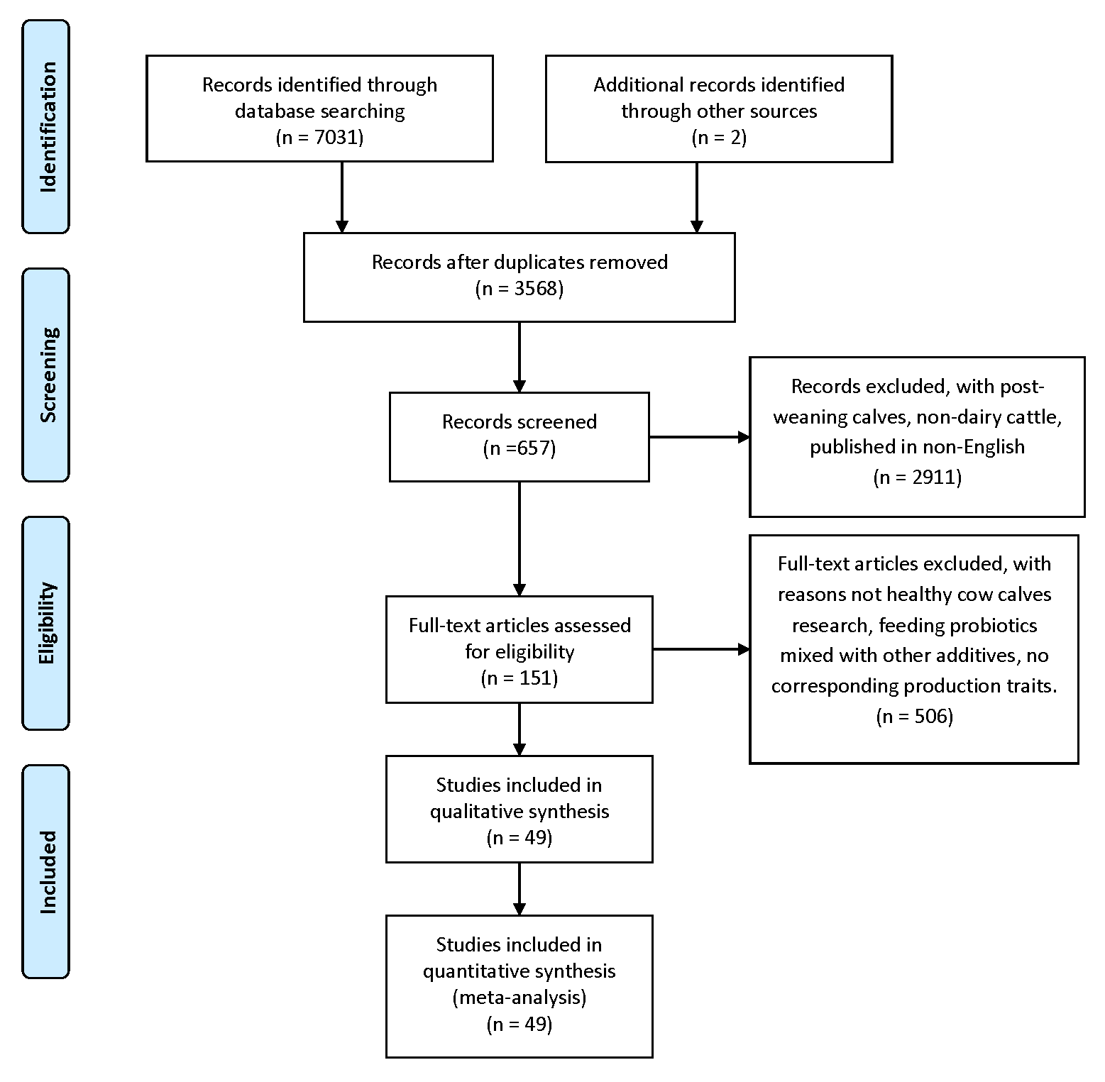
Supplementary Figure 1 The flowchart of the search strategy and selection of eligible studies for meta-analysis of the effects of probiotics on pre-weaning dairy calves.

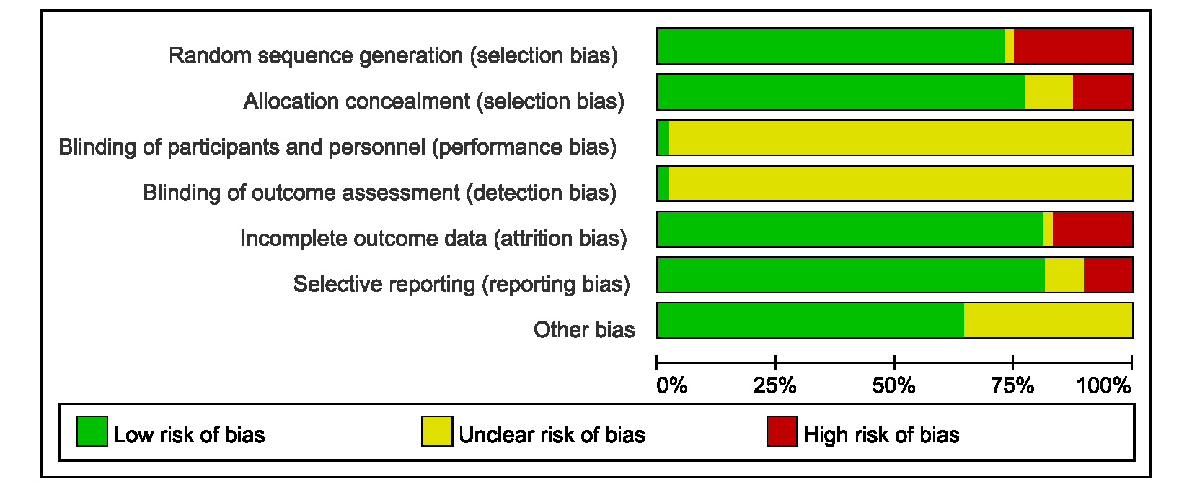
Supplementary Figure 2. Risk of bias graph depicting review authors’ judgements about each risk of bias item presented as percentages across all included studies.

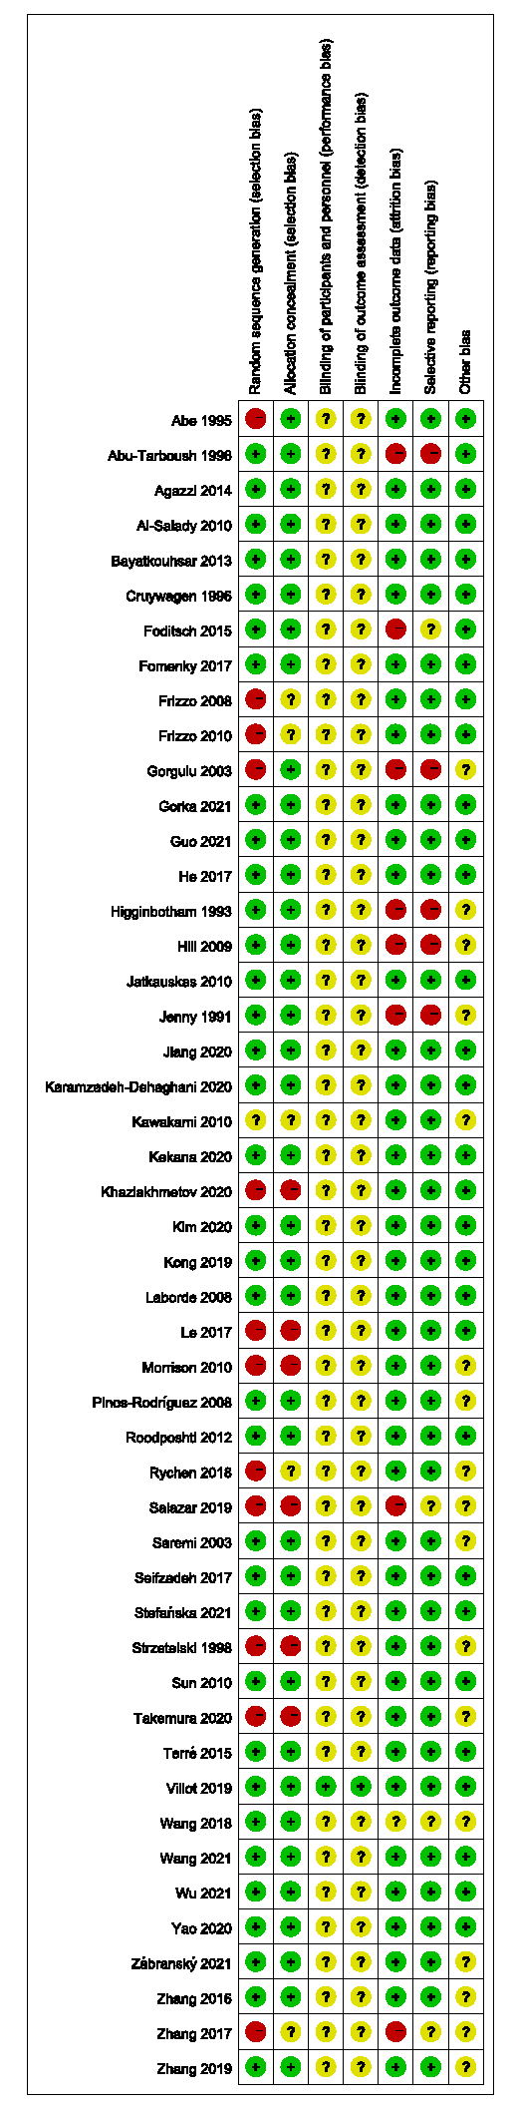
Supplementary Figure 3. Risk of bias summary depicting authors’ judgements about each risk of bias item for each included study.

