Supporting Information

Triple Cation perovskites: Exploring the optimal process parameters of slot-die coated n-i-p perovskite solar cells

Janardan Dagar^{1a}, Rahim Munir^{1a}, Jinzhao Li^{1a}, Marion Flatken^{1b},
Florian Mathies^{1a}, Oliver Maus^{1a}, Daniel M. Többens³, Eva Unger^{1a, 2}*

¹Helmholtz-Zentrum Berlin, HySPRINT Innovation Lab, Kekuléstrasse 5, 12489 Berlin, Germany.
ªYoung Investigator Group Hybrid Materials Formation and Scaling Kekuléstrasse 5, 12489 Berlin, Germany.
^{b}Young Investigator Group Active Materials and interfaces for stable perovskite solar cells Kekuléstrasse 5, 12489 Berlin, Germany.
²Department of Chemistry & NanoLund, Lund University, Naturvetarvägen 14, 22362 Lund, Sweden.
³Helmholtz-Zentrum Berlin für Materialien und Energie (HZB), Department Structure and Dynamics of Energy Materials, Albert-Einstein-Str. 15, 12489 Berlin Germany.

^{1a}These authors contributed equally: Janardan Dagar, Rahim Munir, Jinzhao Li

Corresponding Author

*eva.unger@helmholtz-berlin.de

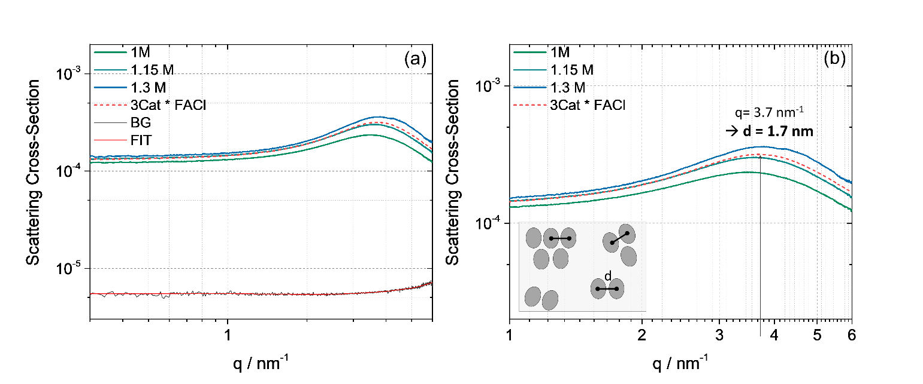

Figure S1. Small angle scattering curves. (a) Comparison of the measured scattering curve of FACl treated Cs-MAFA precursor (1.2 M) to a concentration series of plain Cs-MAFA precursor solution (1 M, 1.15 M, 1.3 M). As background (BG) the solvent mixture of DMF:DMSO (v/v ratio of 4:1) has been partially subtracted. (b) Maximum in the scattering curve as a consequence of a dominant structure factor in the regarded specimen.

Small angle X-ray scattering was used as a further characterization technique to analyze the perovskite precursor solution. To derive a better understanding of the structural behavior in the precursor the FACl treated Cs-FAMA ink is being compared to different concentrations of Cs-FAMA precursor solution (from 1 M to 1.3 M). The scattering curve of the FACl treated precursor fits well to the curves derived from a concentration series of the Cs-FAMA precursor. Hence, no significant difference between the considered systems can be observed in terms of the shape of the scattering curve. Still, all scattering curves show a dominant structure factor which becomes evident in the formation of a maximum in the scattering curves (see the black line in Figure S10 (b)). The structure factor is part of the equation for the measured scattering cross section of the regarded sample and describes the inter-particle interference. Using the extended Braggs law the d-spacing between the center of mass of the interacting particles can be calculated.
${\text{2π}}/{\text{q}}\text{=d}$
As a consequence the mean d-spacing between the center of mass of the observed particles in the FACl treated Cs-FAMA precursor is 1.7 nm. In the case of Cs-FAMA the concentration series gives the trend to shift the maximum to lower q-values with lower concentration. Due to the reciprocal relationship, the mean d-spacing between the centers of masses of the interacting particles is increasing. Connecting it with the similarity to the FACl treated Cs-FAMA, this trend could also be assumed for the latter composition. The decreasing d-spacing goes along with a less pronounced structure factor. As the structure factor is an indication about the “pre-organization” in solution, it can be observed, that at higher concentration already more particles are taking part in the formation of a somehow pseudo-crystalline cluster in the precursor whereas at lower concentration the particles are not as densely packed as a well as there are less particles taking part in the cluster formation.

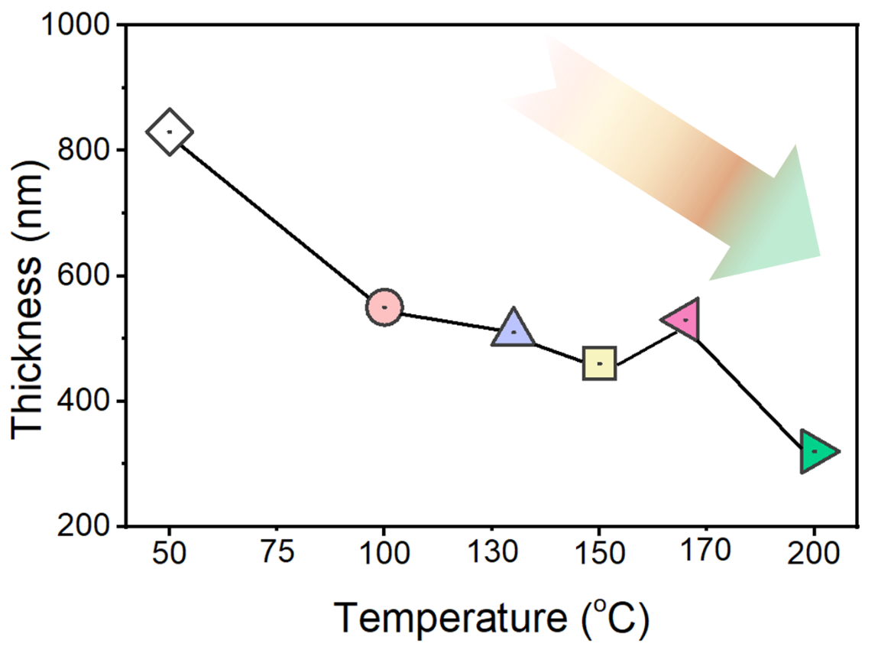

Figure S2. Thickness vs temperature curve of triple cation perovskite solar cell coated vias slot die coating measured simulated AM 1.5G illumination.

Table S1: concentrations, additives, coating speed, die head, pump rate, coating temperature and PV parameters slot die coated perovskite solar cells.

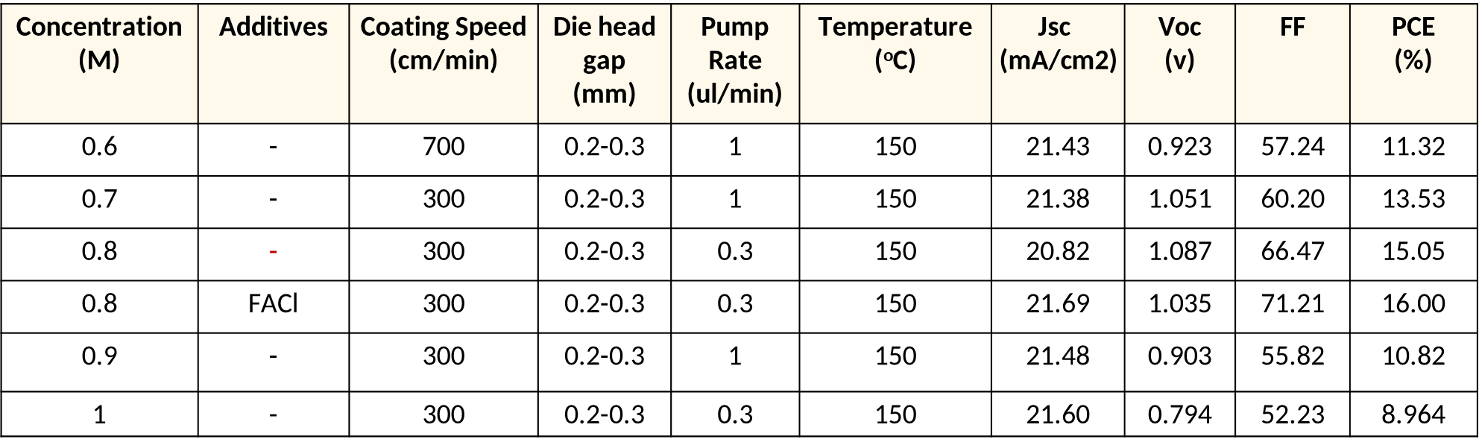

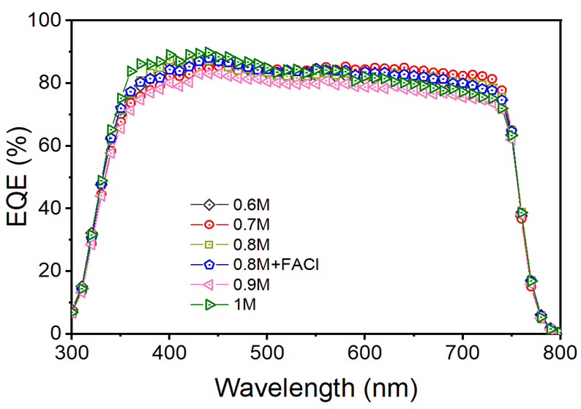

Figure S3. EQE spectra of different concentrations of perovskite solar cell along with the FACl additive.

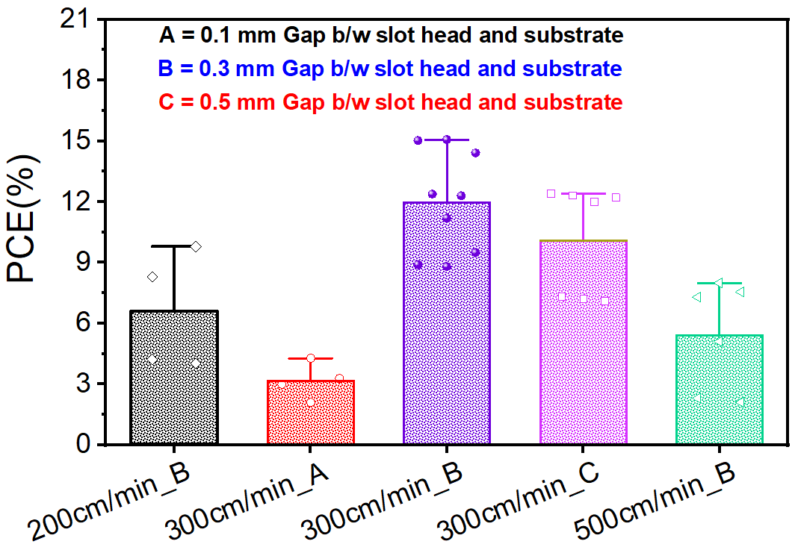

Figure S4. Different processing conditions during the slot die coating of perovskite layer affecting the performance of the Perovskite solar cells.

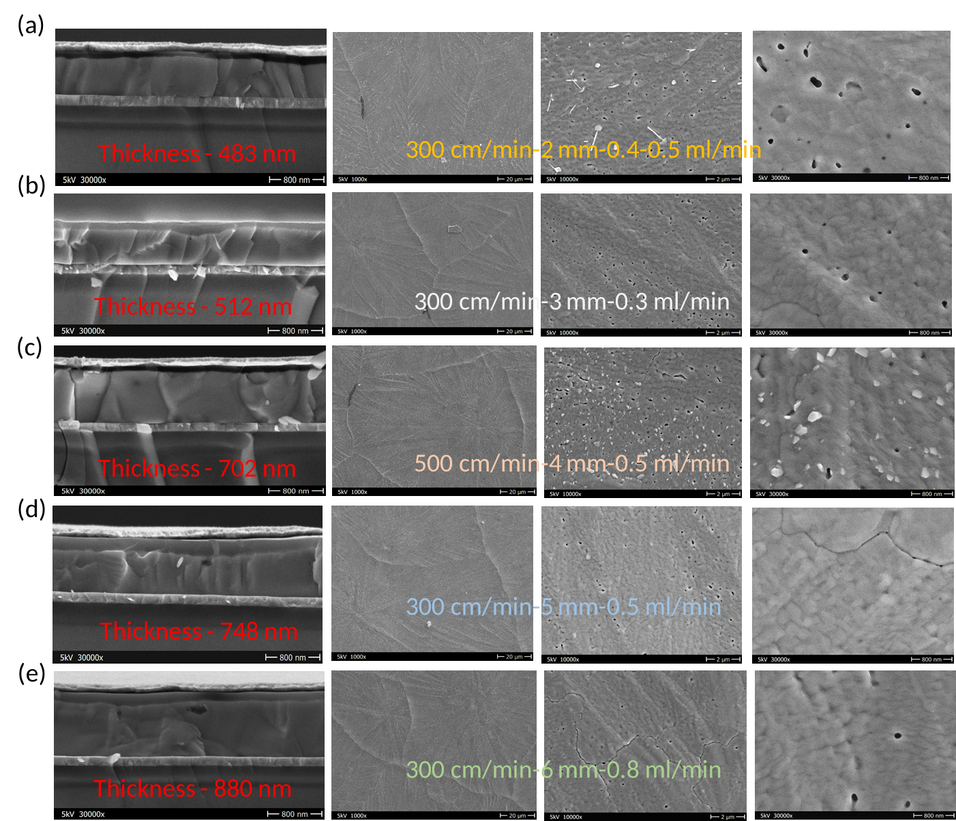

Figure S5. Cross section scanning electron microscopy images showing different thickness obtained using different chuck speeds, contact gaps and flow rates of 0.8M concentration perovskite solar cells.

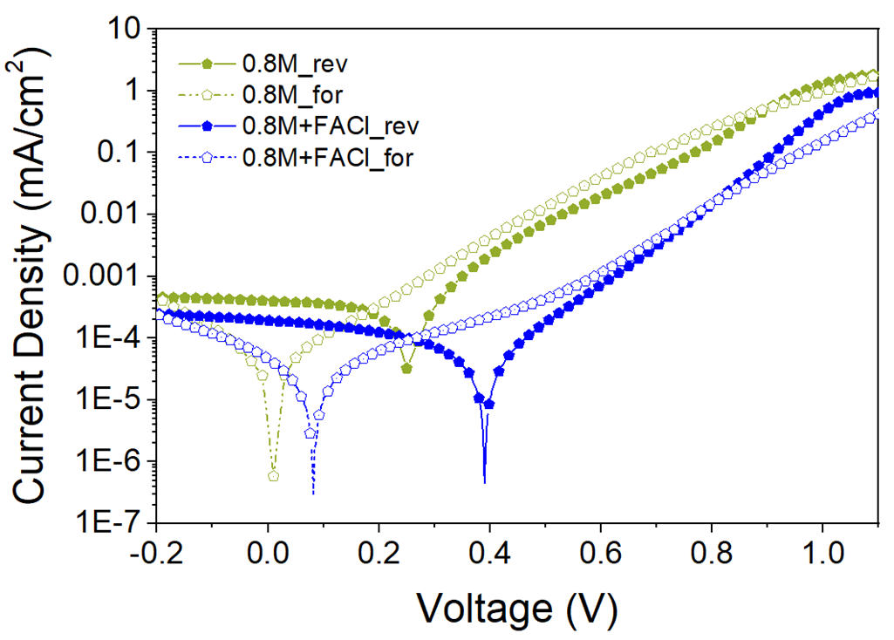

Figure S6. Dark current density-voltage curves of 0.8M concentration perovskite solar cell with and without FACl additive.

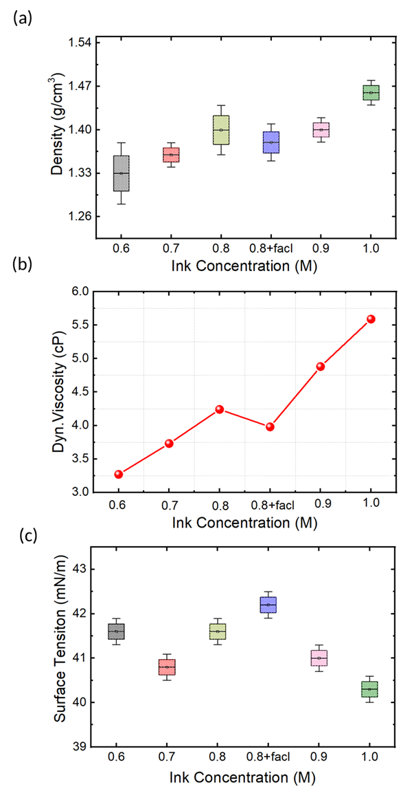

Figure S7. Density, Dynamic viscosity and surface tension of different perovskite ink concentration

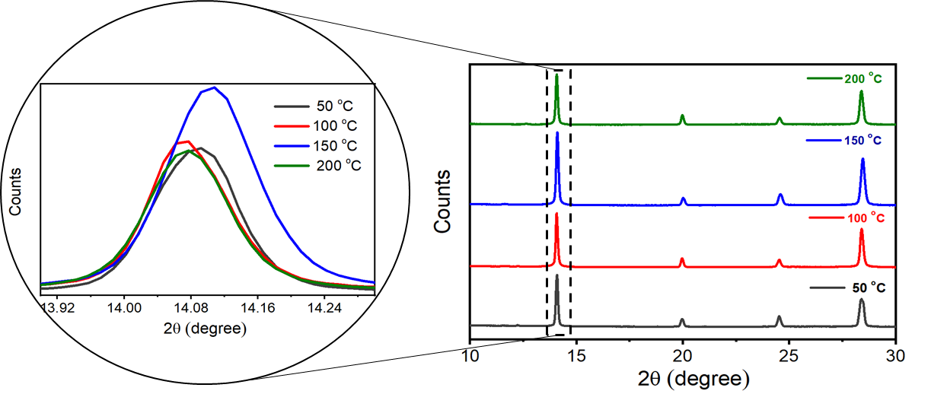

Figure S8. GIWAXS measurements of different temperature based perovskite films.

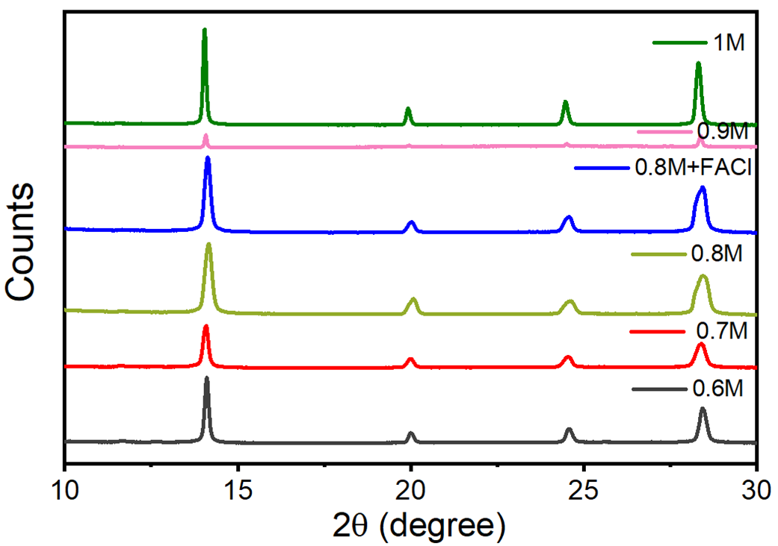

Figure S9. GIWAXS measurements of different temperature based perovskite films.

References

[1] M. Krumrey, G. Ulm, Nucl. Instruments Methods Phys. Res. Sect. A Accel. Spectrometers, Detect. Assoc. Equip. 2001, 467, 1175–1178.

