- Title:
Bacterial assembly as part of immune system in Paulownia responses to witches’ broom caused by phytoplasmas
- Journal name：
Plant and soil
- Authors:
Xuanzhen Liª, Jing Huangª, Xiaoqiao Zhai^{b}, Zhenli Zhaoª, Yanshuo Pan^{c}, Guoqiang Fanª
- Affiliation:
ªCollege of Forestry, Henan Agricultural University, Zhengzhou, 450002, China
^{b}Henan Academy of Forestry, Zhengzhou, 450002, China
^{c}Institute of Environment and Sustainable Development in Agriculture, Chinese Academy of Agricultural Sciences, Beijing, 100081, China
- Corresponding author:
Guoqiang Fan, Tel.: 0086-371-63558070; E-mail: zlxx64@henau.edu.cn

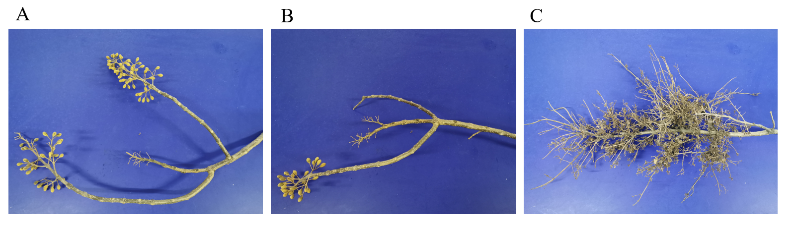
Fig. S1 The appearance of symptomatic and asymptomatic branches (A: HB samples; B: ASB samples; C: SB samples)

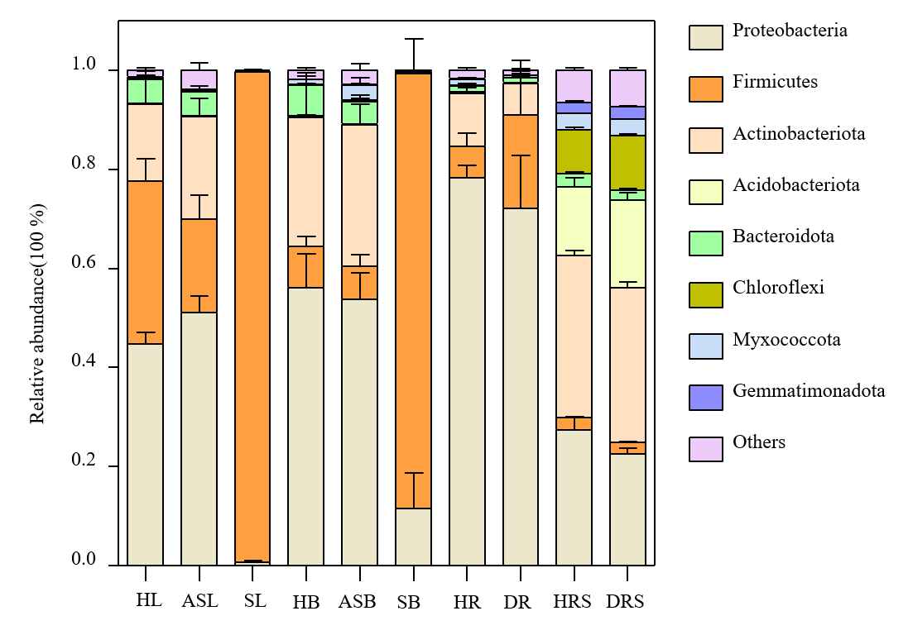
Fig. S2 Comosition of bacterial conmmunity in the phylum level in the different of compartments of Paulownia plant

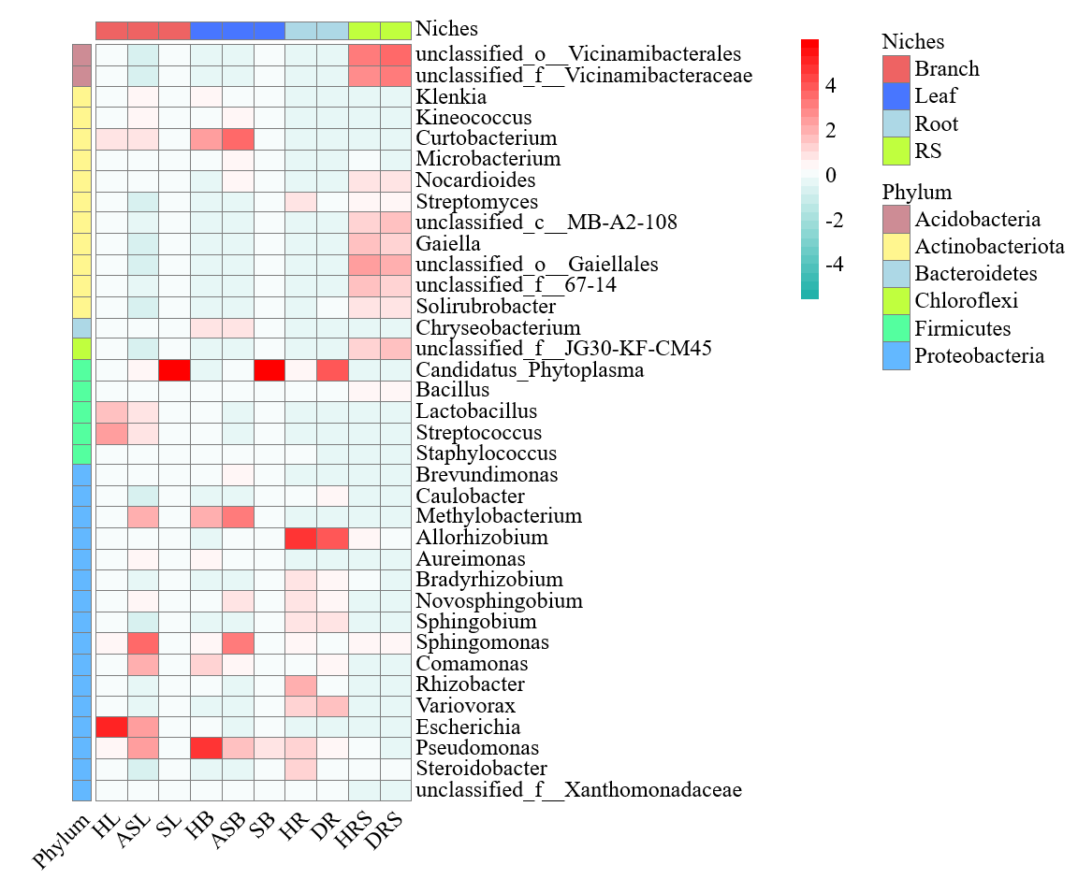Fig. S3 Comosition of bacterial conmmunity in the genus level in the different of compartments of Paulownia plant

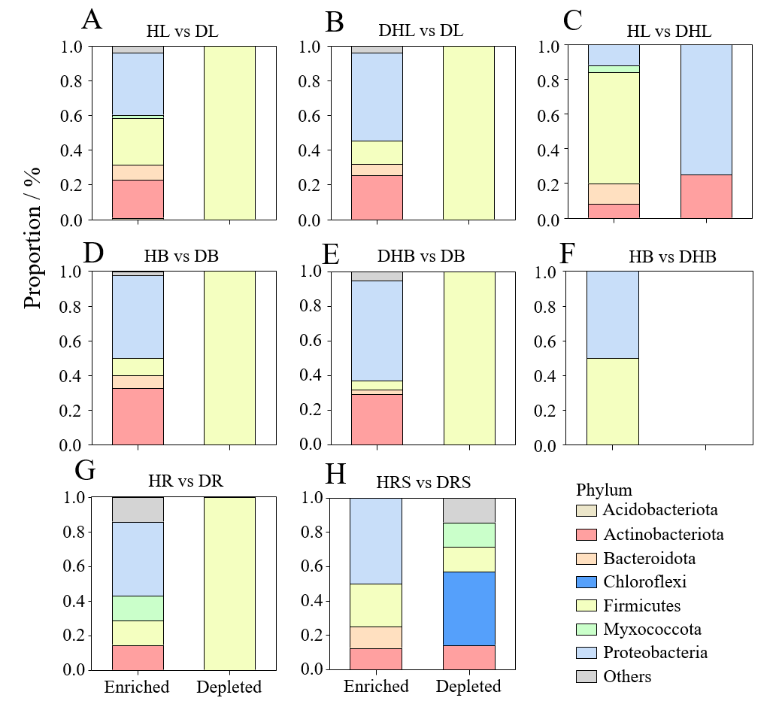
Fig. S4 The volcano plot illustrating the enrichment and depletion patterns of the crop-associated bacterial microbiomes beteween different compartment

