Supplementary Materials
Optimization for improved cellulase production of Penicillium funiculosum NCIM 1228 in submerged fermentation
Sambhaji B. Chavan^{1,2,3}, Ashvini M. Shete³, Mahesh S. Dharne^{1,2}
Author affiliation:
¹National Collection of Industrial Microorganisms (NCIM), Biochemical Sciences Division,
CSIR-National Chemical Laboratory, Pune-411008, India
² Academy of Scientific and Innovative Research (AcSIR), Ghaziabad - 201002, India
³ Praj Matrix - R & D Center (division of Praj Industries Limited),Pune- 412115
Correspondence to: M.S. Dharne, National Collection of Industrial Microorganisms (NCIM), Biochemical Sciences Division, CSIR-National Chemical Laboratory (NCL), Pune 411008, India. E-mail addresses: ms.dharne@ncl.res.in

Supplementary Fig. S1: Effect of media components Urea, CaCl₂, MgSO₄, Peptone, Avicel, Wheat bran, CSL, Lactose and KH₂PO₄ on the mean cellulase enzyme production (FPU U/mL) depicted by the main effect plot based on PBD.
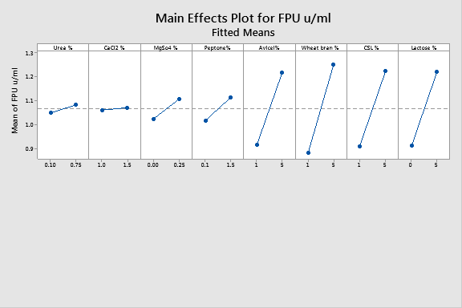
Supplementary Fig. S2: PBD-based normal plot of standardized effect of media components
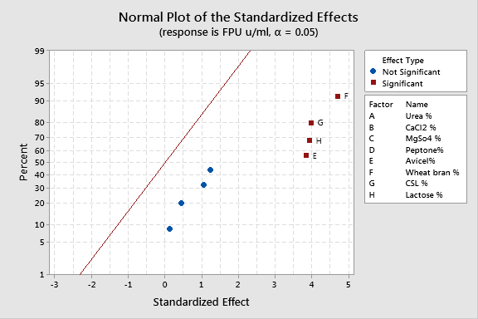

Supplementary Fig. S3: Residual plots of media components for cellulase production PFU (U/mL). (a) Normal Probability Plot. (b) Versus Fits. (c) Histogram. (d) Versus Order based on PBD.
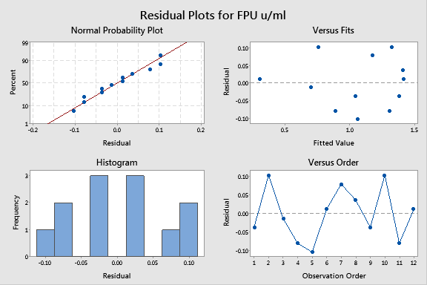
Supplementary Fig. S4: Normal Plot of Standardized Effect of media components based on BBD
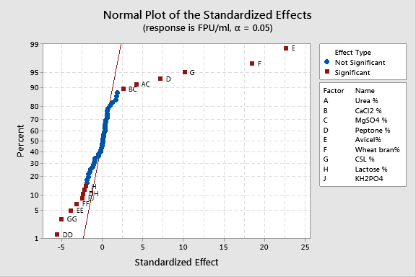

Supplementary Fig. S5: Standardized effects of process factors on cellulase enzyme production are plotted in a normal plot.
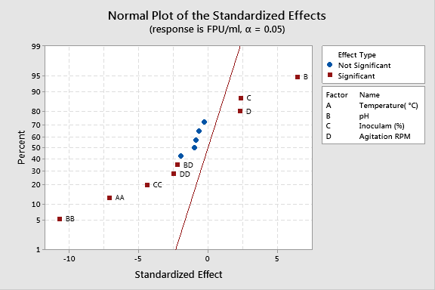
Supplementary Fig. S6: Pareto chart for the effect of process parameter based on BBD.
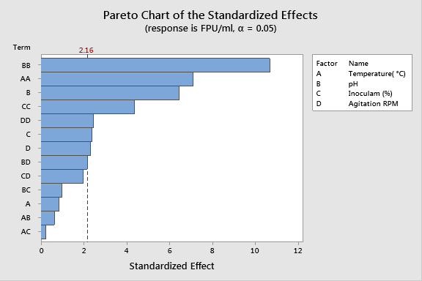

Supplementary Fig. S7: Contour plots for cellulase production : (a) Interaction between pH and Temperature; (b) Interaction between Inoculum and Temperature; (c) Interaction between Agitation and Temperature; (d) Interaction between Inoculum and pH; (e) Interaction between Agitation and pH; (f) Interaction between Agitation and Inoculum.
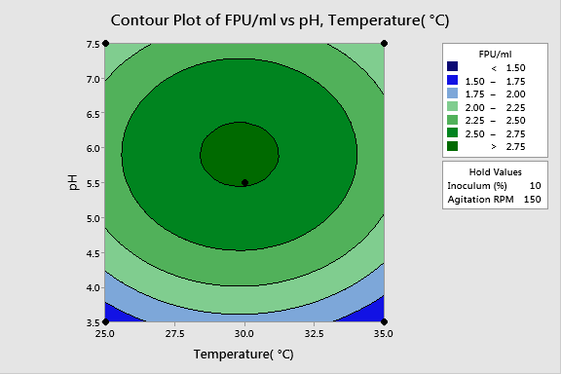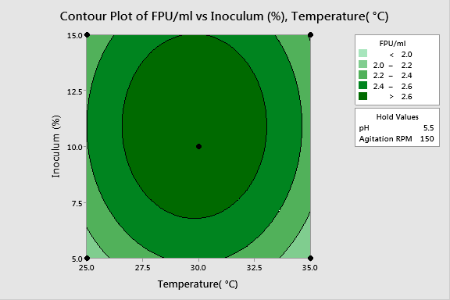
(a) (b)
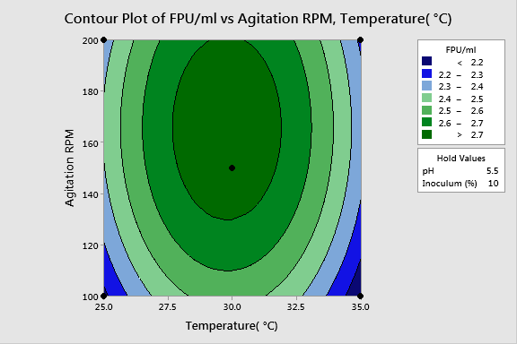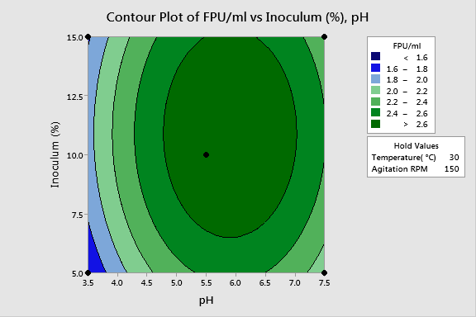
(c) (d)
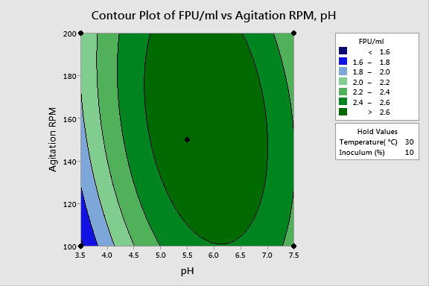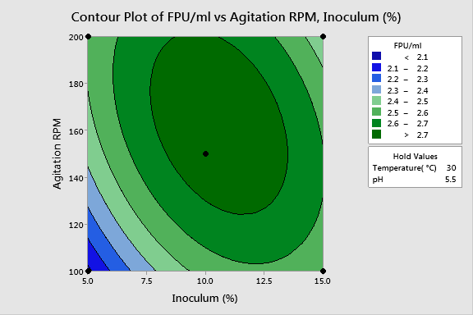
(e) (f)

