Sea Surface Temperature Predictability at the interface between oceanographic modelling and machine learning
Supplementary Material
Fabio Boschetti^{1*}, Ming Feng^{1,2}, Jason R. Hartog³, Alistair J. Hobday³, Xuebin, Zhang³

¹CSIRO Oceans and Atmosphere, Perth, Western Australia, Australia
²Centre for Southern Hemisphere Oceans Research, Hobart, Tasmania, Australia
³CSIRO Oceans and Atmosphere, Hobart, 7000, Tasmania, Australia

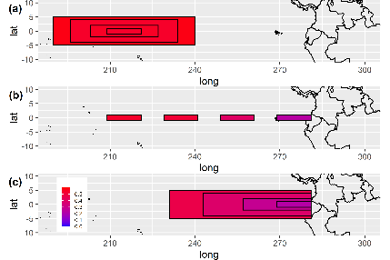 | 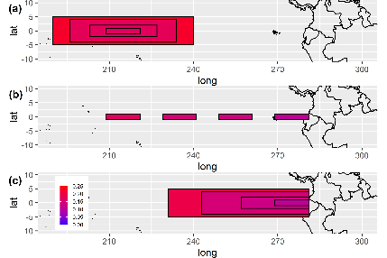 | 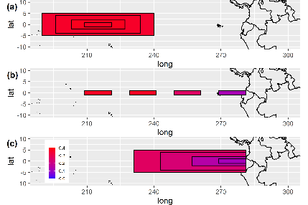
Figure 1. SWF cumulative prediction skill (first column), persistence cumulative prediction skill (second column) and predictability gain (third column) over different regions in the equatorial Pacific Ocean. (a) Nino3.4 region and 3 regions of decreasing size cantered in the same geographical location. (b) The smallest region is shifted eastward towards the South American continent, thus closer to land. (c) Four regions of the same size as in (a), with the rightmost edge bordering the South American continent. Panels in a column share the same colormaps. Each colormap go from low (low) to red (high).

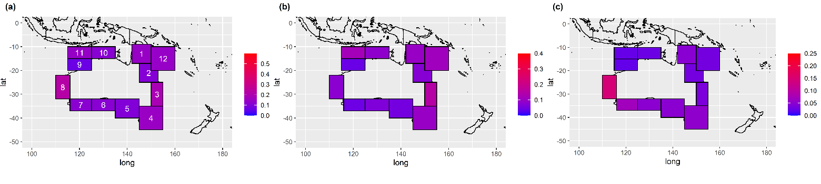
Figure 2. SWF cumulative prediction skill (a), persistence cumulative prediction skill (b) and predictability gain (c) over 12 coastal regions surrounding the Australian continent. Each column uses the same colormap as in the column in Figure 1 to ease visual comparison.

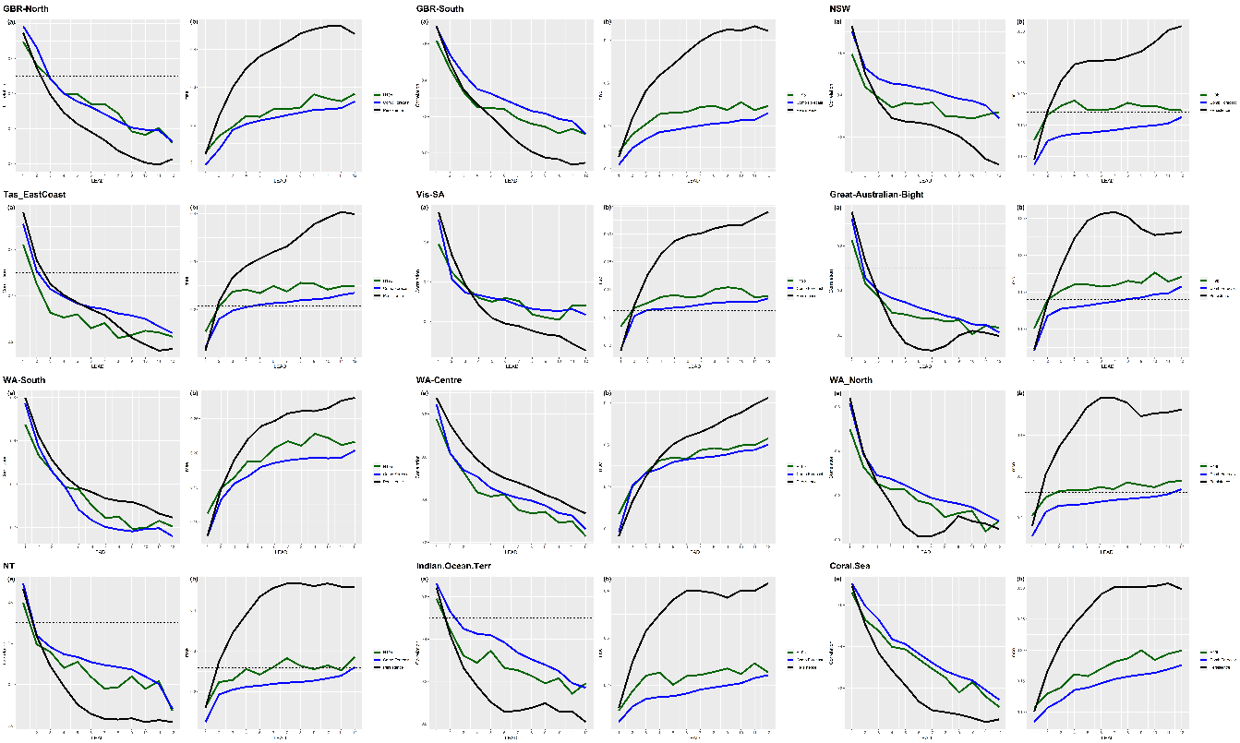
Figure 3. correlation (left panel) and all-season mean squared error (right panel) as functions of lead time, for all the 12 coastal regions around the Australian continent. Persistence skill (black lines), SWF skill (blue lines), and the skill of a ML forecast carried out with a single lead (green lines). With the exception of WA-Centre for leads <4 months, the SWF forecast outperforms both persistence and single lead forecast for all leads.

Figure 4. GODAS re-analysis data (black line) and SWF hindcasts (blue line) for all the 12 coastal regions around the Australian continent. 1-month lead time

Figure 5. GODAS re-analysis data (black line) and SWF hindcasts (blue line) for all the 12 coastal regions around the Australian continent. 3-month lead time

