In-silico investigations on the anticancer activity of selected 2-aryloxazoline derivatives that inhibit fatty acid synthase (FASN)
Moly Rani,ª Ashutosh Nath *^{a,b} and Ajoy Kumer ^{c}

ªDepartment of Chemistry, Bangladesh University of Engineering and Technology (BUET), Dhaka-1000, Bangladesh
^{b}Department of Chemistry, University of Massachusetts Boston, MA 02125, USA
^{c}Department of Chemistry, European University of Bangladesh (EUB), Dhaka-1216, Bangladesh
Corresponding author email: ashutosh.nath001@umb.edu

Table of contents Page

Table S1: Optimize Structure of selected compounds. ................................................................................ S2
Table S2: Selected FDA approved drugs structure ...................................................................................... S4
Table S3: HOMO-LUMO Energy calculation of selected compounds ...................................................... S6
Table S4: Calculation of pIC₅₀ .................................................................................................................... S8
Figure S1: Molecular docking complex of best three compound with protein 3tjm ................................. S9
Figure S2: Molecular docking complex of Hit 1 to 9 with receptor protein 3TJM, 3ERT, 2J6M and 4OAR ... S10
Table S5: Chemical reactivity of selected nine compounds ....................................................................... S15
Table S6: Bonding analysis of compounds 1–9 with various pharmacological targets involved
in cell proliferation ...................................................................................................................... S16

Table S1: Optimize Structure of selected compounds.
Hit | 2D Structure |  | 3D Structure
1 |  |  | 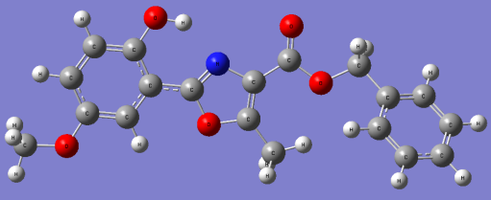
1 | (4R,5R)-Benzyl 2-(2-hydroxy-5-methoxyphenyl)-5-methyl-4,5-dihydrooxazole-4-carboxylate
2 |  | 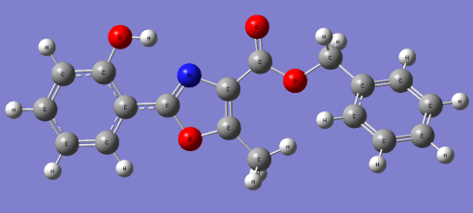
2 | (4R,5R)-Benzyl-2-(2-hydroxyphenyl)-5-methyl-4,5-dihydrooxazole-4-carboxylate
3 |  | 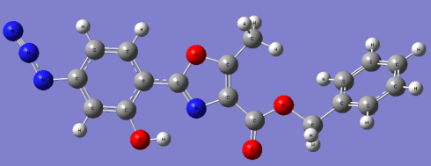
3 | (4R,5R)-Benzyl-2-(4-azido-2-hydroxyphenyl)-5-methyl-4,5-dihydrooxazole-4-carboxylate
4 |  | 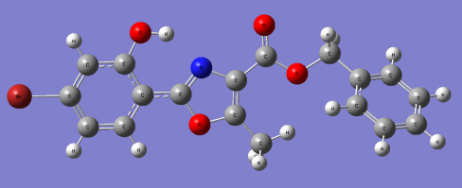
4 | (4R,5R)-Benzyl-2-(4-bromo-2-hydroxyphenyl)-5-methyl-4,5-dihydrooxazole-4-carboxylate
5 |  | 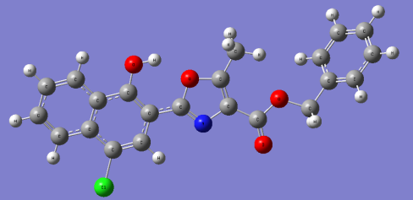
5 | (4S,5S)-benzyl-2-(4-chloro-1-hydroxynaphthalen-2-yl)-5-methyl-4,5 dihydrooxazole-4-carboxylate
6 |  | 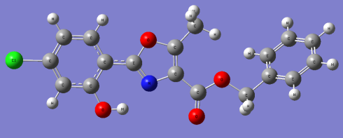
6 | (4R,5R)-Benzyl-2-(4-chloro-2-hydroxyphenyl)-5-methyl-4,5-dihydrooxazole-4-carboxylate
7 |  | 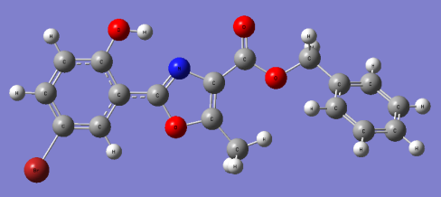
7 | (4R,5R)-Benzyl-2-(5-bromo-2-hydroxyphenyl)-5-methyl-4,5-dihydrooxazole-4-carboxylate
8 |  | 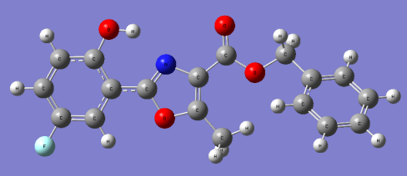
8 | (4R,5R)-Benzyl 2-(5-fluoro-2-hydroxyphenyl)-5-methyl-4,5-dihydrooxazole-4-carboxilate
9 |  | 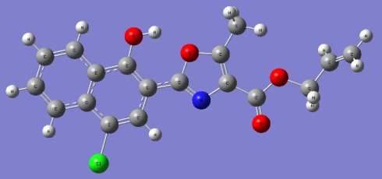
9 | (4R,5S)-allyl-2-(4-chloro-1-hydroxynaphthalen-2-yl)-5-methyl-4,5-dihydroo xazole-4-carboxylate

Table S2: Selected FDA approved drugs structure:
SL | 2D Structure | 3D Structure
1 | 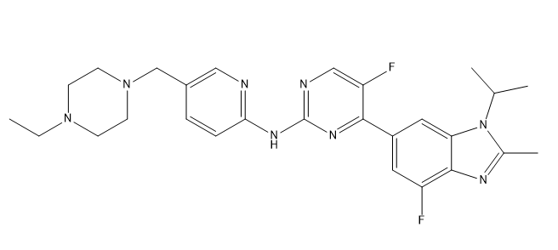 | 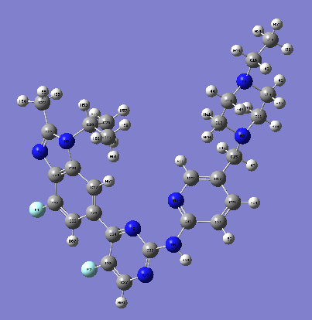
1 | Commercial Name: Abemaciclib  IUPAC Name: N-[5-[(4-ethylpiperazin-1-yl)methyl]pyridin-2-yl]-5-fluoro-4-(7-fluoro-2-methyl-3-propan-2-ylbenzimidazol-5-yl)pyrimidin-2-amine
2 | 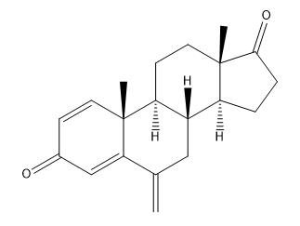 | 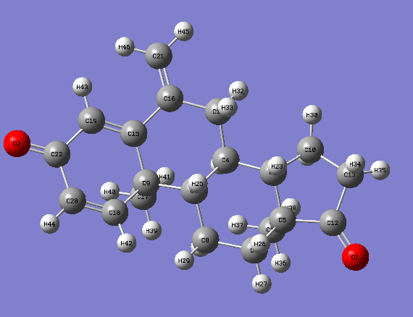
2 | Commercial Name: Exemestane  IUPAC Name: (8R,9S,10R,13S,14S)-10,13-dimethyl-6-methylidene-7,8,9,11,12,14,15,16-octahydrocyclopenta[a]phenanthrene-3,17-dione
3 | 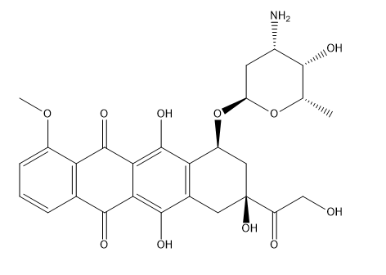 | 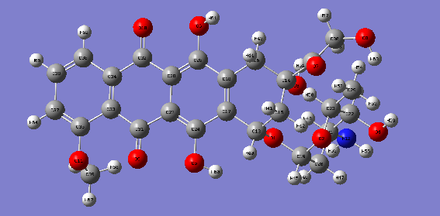
3 | Commercial Name: Doxorubicin  IUPAC Name: (7S,9S)-7-[(2R,4S,5S,6S)-4-amino-5-hydroxy-6-methyloxan-2-yl]oxy-6,9,11-trihydroxy-9-(2-hydroxyacetyl)-4-methoxy-8,10-dihydro-7H-tetracene-5,12-dione
4 | 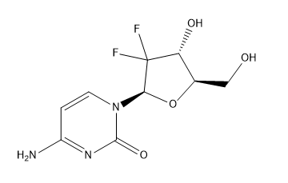 | 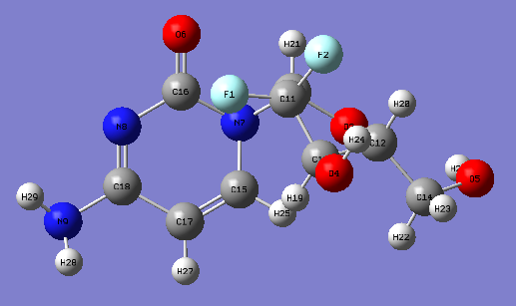
4 | Commercial Name: Gemcitabine  IUPAC Name: 4-amino-1-[(2R,4R,5R)-3,3-difluoro-4-hydroxy-5-(hydroxymethyl)oxolan-2-yl]pyrimidin-2-one
5 | 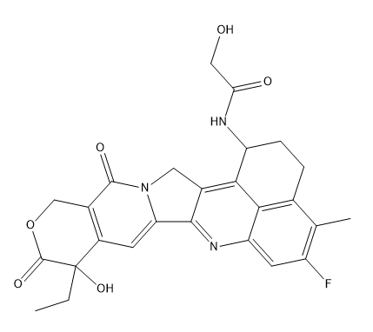 | 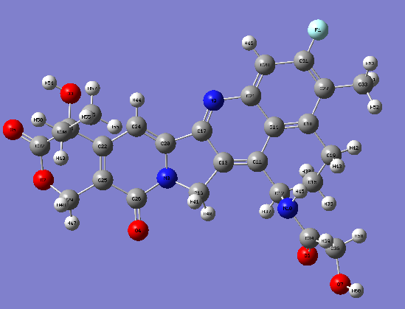
5 | Commercial Name: Trastuzumab Deruxtecan  IUPAC Name: N-(10-ethyl-18-fluoro-10-hydroxy-19-methyl-5,9-dioxo-8-oxa-4,15-diazahexacyclo[14.7.1.0^{2,14}.0^{4,13}.0^{6,11}.0^{20,24}]tetracosa-1,6(11),12,14,16,18,20(24)-heptaen-23-yl)-2-hydroxyacetamide
6 | 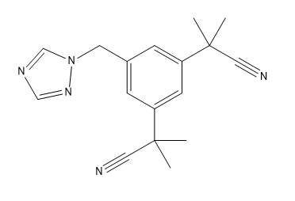 | 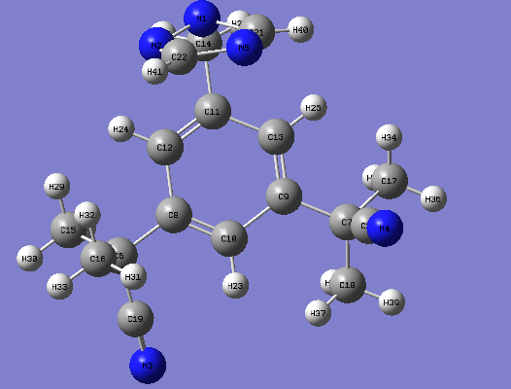
6 | Commercial Name: Anastrozole  IUPAC Name: 2-[3-(2-cyanopropan-2-yl)-5-(1,2,4-triazol-1-ylmethyl) phenyl]-2-methylpropanenitrile
7 | 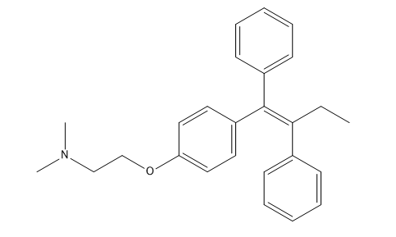 | 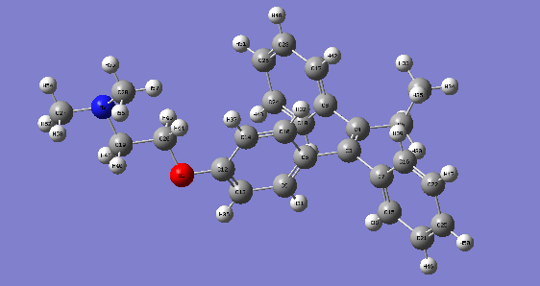
7 | Commercial Name: Tamoxifen  IUPAC Name: 2-[4-[(Z)-1,2-diphenylbut-1-enyl]phenoxy]-N,N-dimethylethanamine

Table S3: HOMO-LUMO Energy calculation of selected compounds.
Compound | HOMO & LUMO | $∆E$ =  (E_{HOMO} - E_{LUMO}) Hartree
1 | 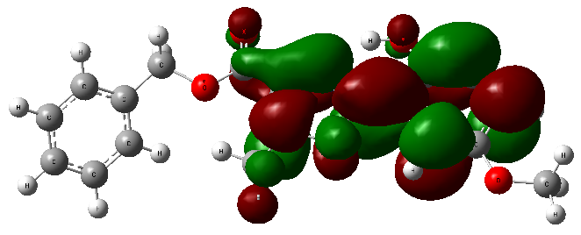 LUMO  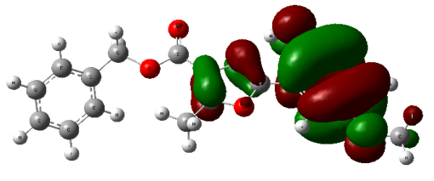HOMO | (- 0.29293 - 0.08703)  = -0.37896
2 | 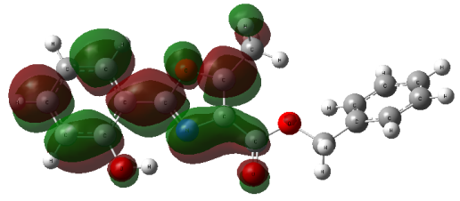LUMO  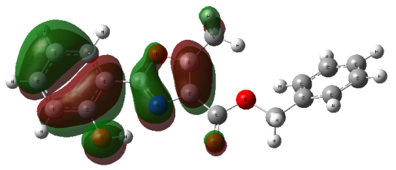HOMO | (-0.30878 - 0.08898)  = -0.39776
3 | 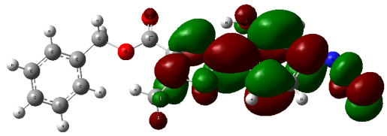LUMO  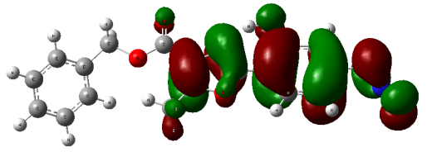HOMO | (-0.30213 - 0.07718)  = -0.037931
4 | 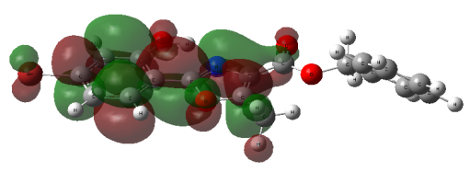LUMO  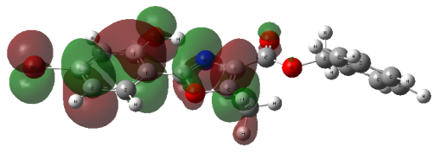HOMO | (-0.31621 - 0.07868)  = -0.39489
5 | 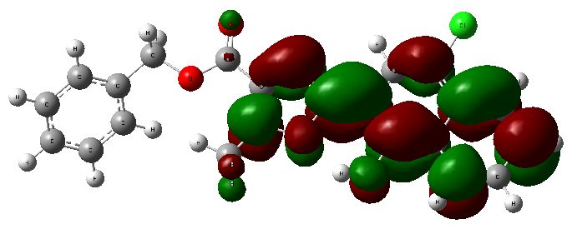LUMO  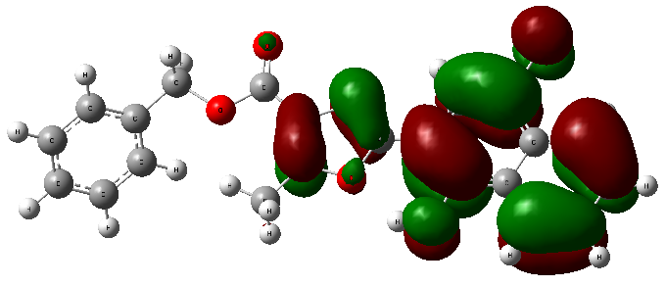HOMO | (-0.29538 - 0.06892)  = -0.3643
6 | 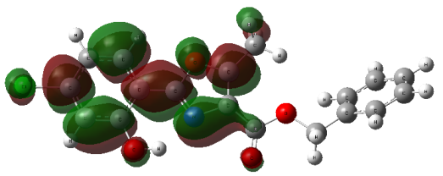LUMO  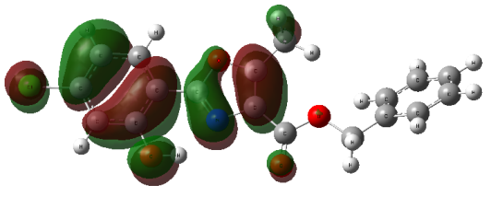HOMO | (-0.032214 - 0.07567)  = -0.107884
7 | 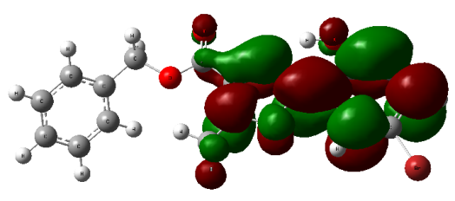LUMO  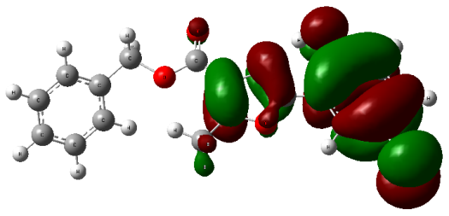HOMO | (-0.31223 - 0.07886)  = -0.39109
8 | 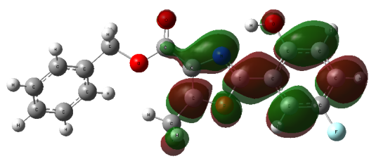LUMO  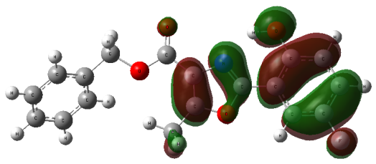HOMO | (-0.31475 - 0.7683)  = -1.08305
9 | 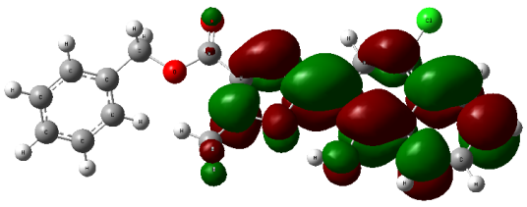LUMO  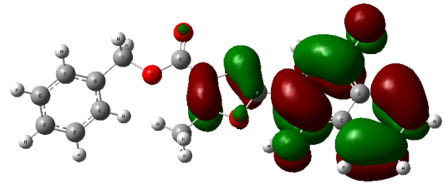HOMO | (-0.29538 - 0.06892)  = -0.3643

Table S4: Calculation of pIC₅₀
Here, pIC₅₀
(Activity) = -2.768483965 + 0.133928895 × (Chiv5) + 1.59986423 × (bcutml) + (-0.02309681) × (MRVSA 9) + (-0.002946101) × (MRVSA6) + (0.00671218) × (PEOEVSAS) + (-0.15963415) × (GATSV4) + (0.207949 857 × J) × + (0.082568569) × (Diameter)
 | Hit | Chiv5 | bcutm1 | MRVSA9 | MRVSA6 | PEOEVSA5 | GATSV4 | J | Diameter | pIC50
 | 1 | 1.615 | 3.922 | 11.867 | 59.658 | 36.398 | 1.006 | 1.525 | 13 | 4.74686
 | 2 | 1.476 | 3.9 | 11.867 | 65.724 | 42.465 | 1.24 | 1.469 | 13 | 4.66690
 | 3 | 1.574 | 3.924 | 17.554 | 70.101 | 41.512 | 1.216 | 1.457 | 16 | 4.81682
 | 4 | 1.747 | 6.842 | 27.797 | 64.131 | 46.262 | 1.276 | 1.473 | 14 | 9.14989
 | 5 | 2.302 | 4.106 | 34.24 | 76.813 | 66.198 | 1.18 | 1.322 | 15 | 4.86113
 | 6 | 1.613 | 3.975 | 23.468 | 64.68 | 41.933 | 1.305 | 1.473 | 14 | 4.60982
 | 7 | 1.851 | 6.842 | 27.797 | 64.131 | 46.262 | 1.059 | 1.487 | 13 | 9.11881
 | 8 | 1.511 | 3.912 | 11.867 | 65.475 | 30.332 | 1.191 | 1.487 | 13 | 4.62164
 | 9 | 1.91 | 4.106 | 34.24 | 53.573 | 48.521 | 0.978 | 1.636 | 13 | 4.69085

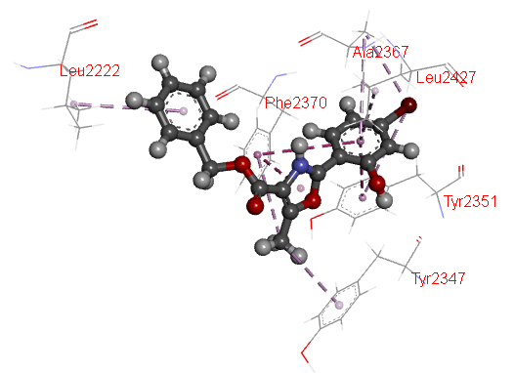 | 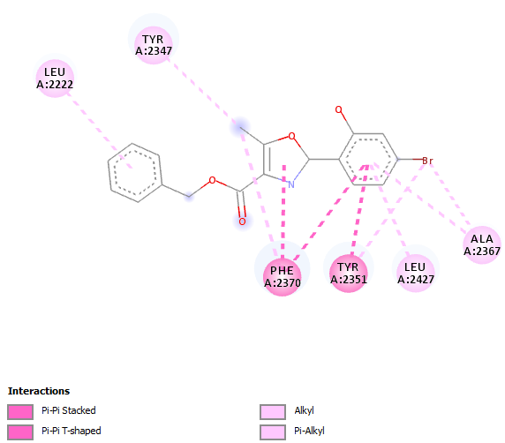
Hit 4 + 3tjm
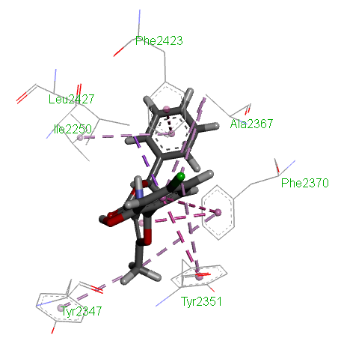 | 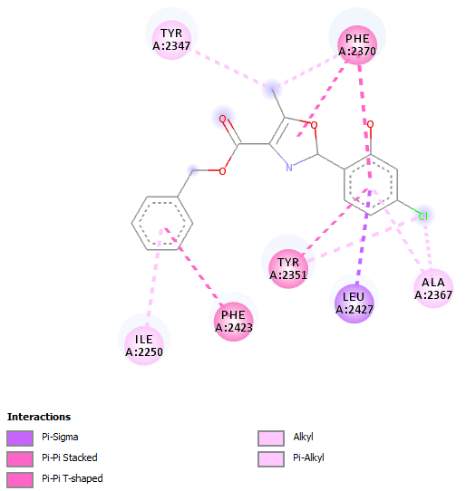
Hit 6 + 3tjm
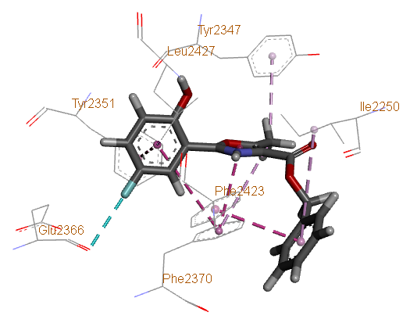 | 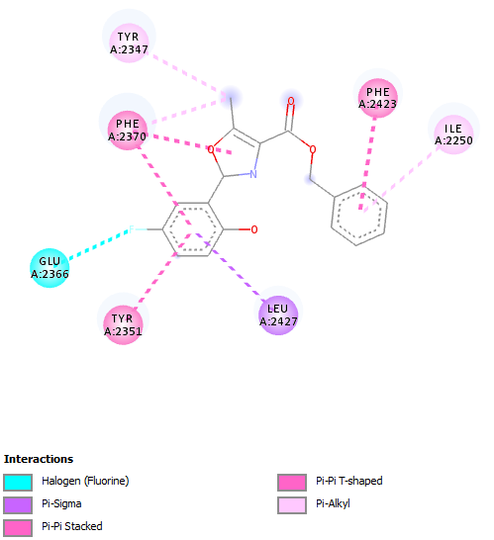
Hit- 8 + 3tjm
Figure S1: Molecular docking complex of best three compound with protein 3tjm

Figure S2: Molecular docking complex of Hit-1 to 9 with receptor protein 3TJM, 3ERT, 2J6M and 4OAR
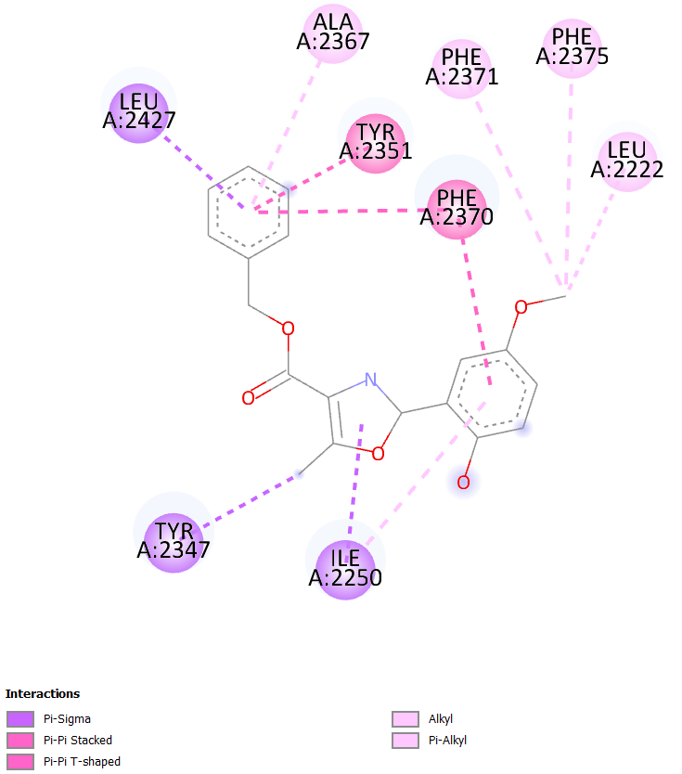  Hit 1 + 3tjm | 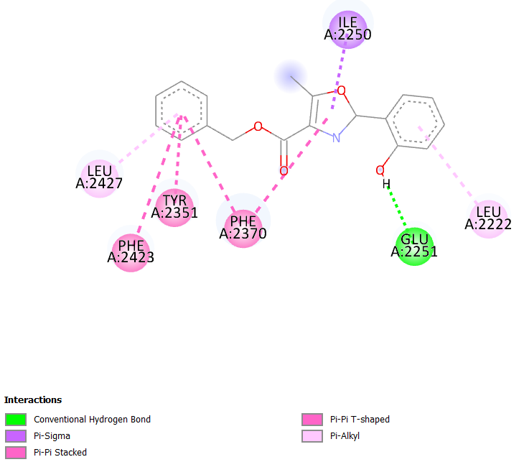  Hit 2 + 3tjm
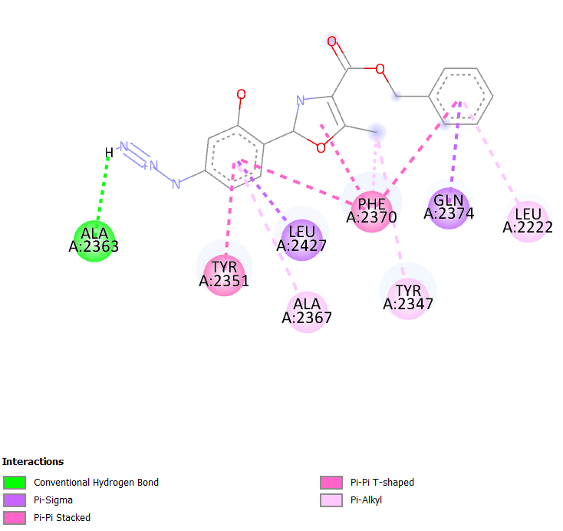  Hit 3 + 3tjm | 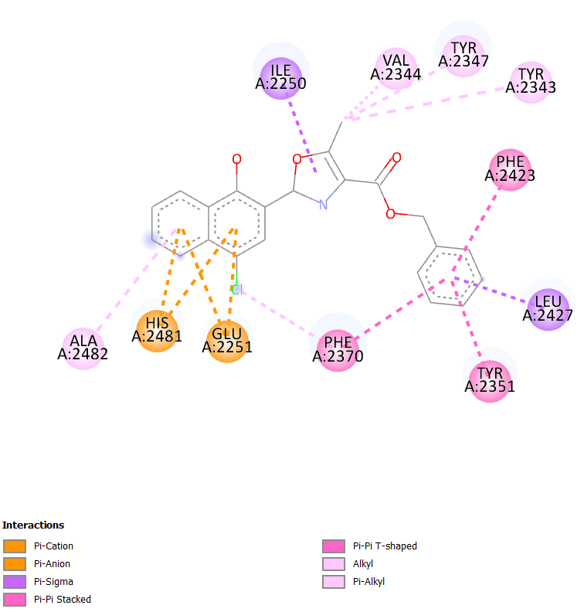  Hit 5 + 3tjm
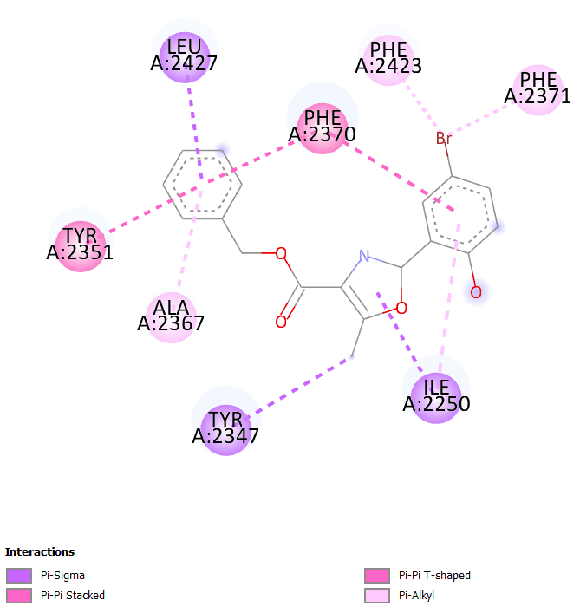  Hit 7 + 3tjm | 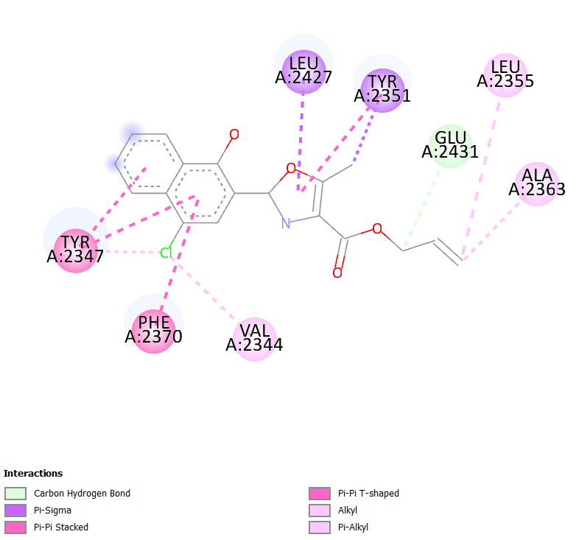  Hit 9 + 3tjm
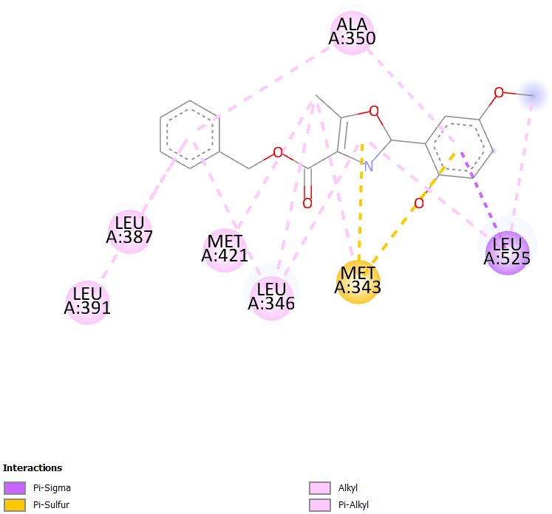  Hit 1 + 3ert | 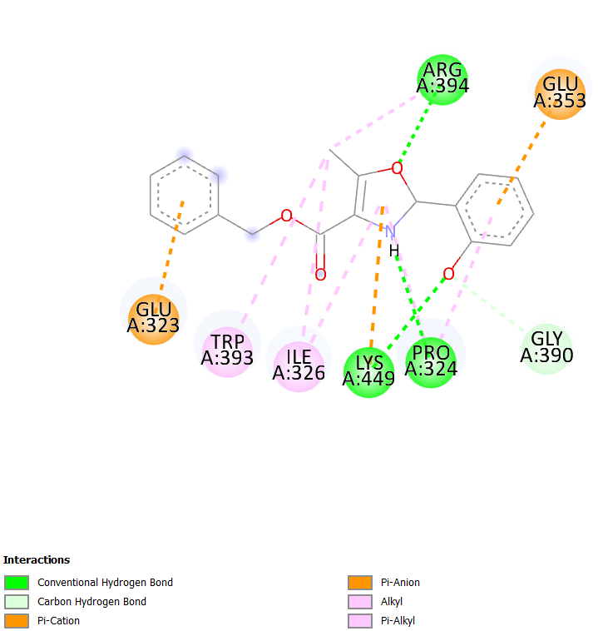  Hit 2 + 3ert
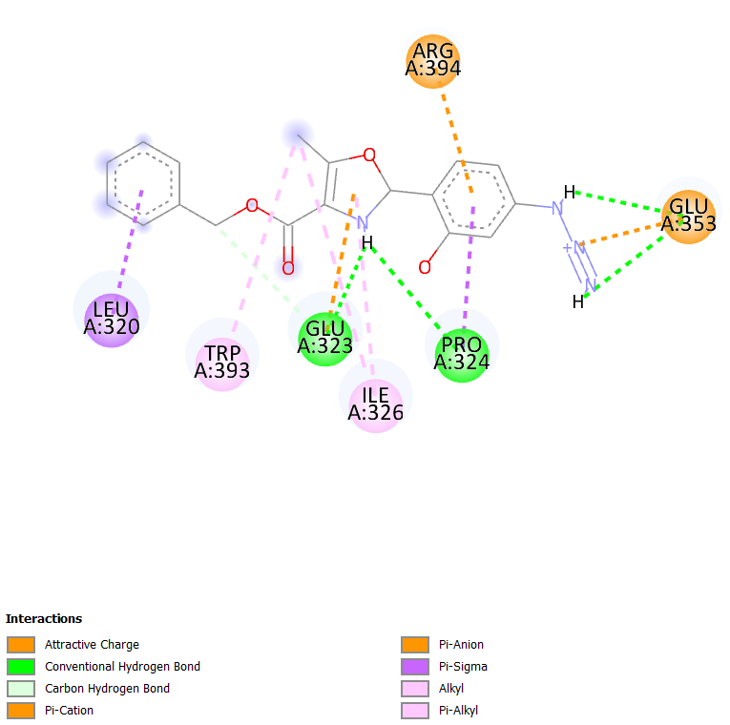  Hit 3 + 3ert | 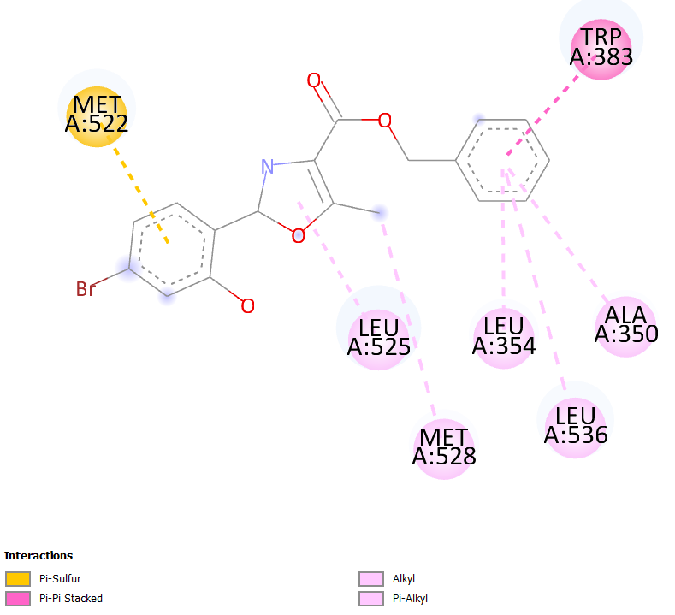  Hit 4 + 3ert
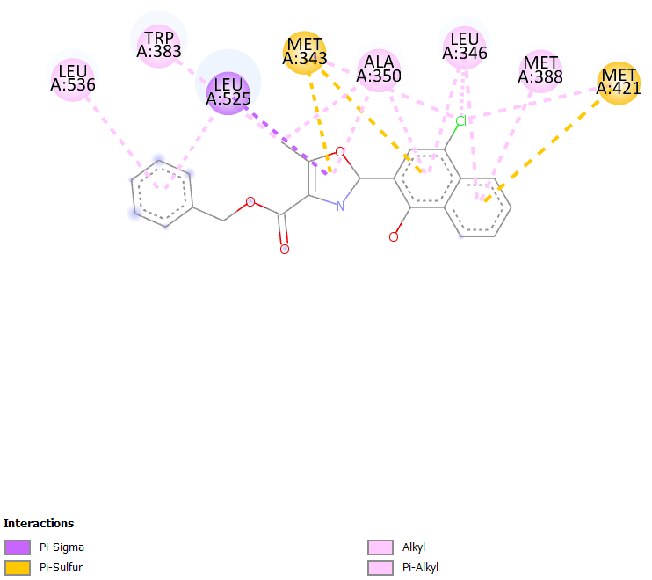  Hit 5 + 3ert | 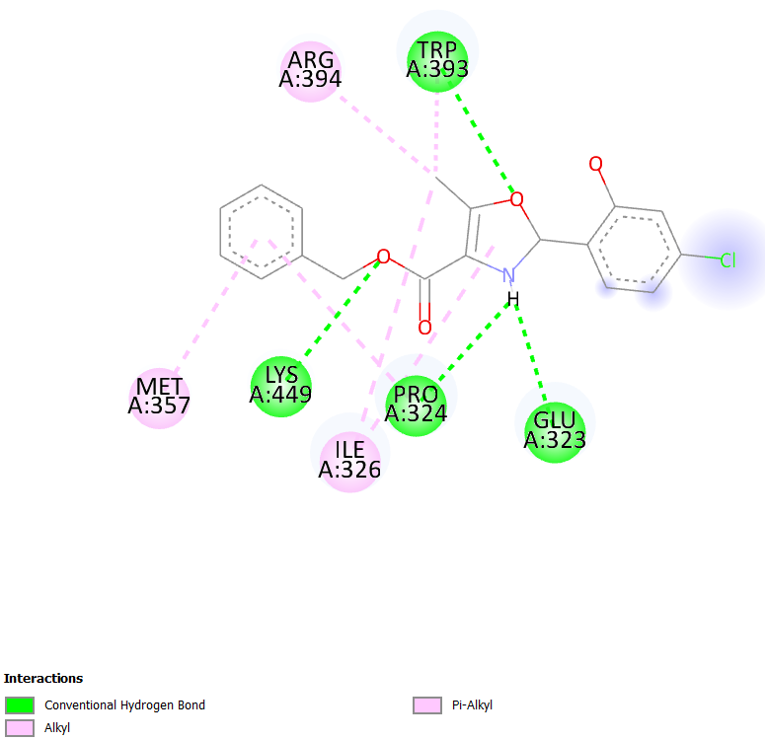  Hit 6 + 3ert
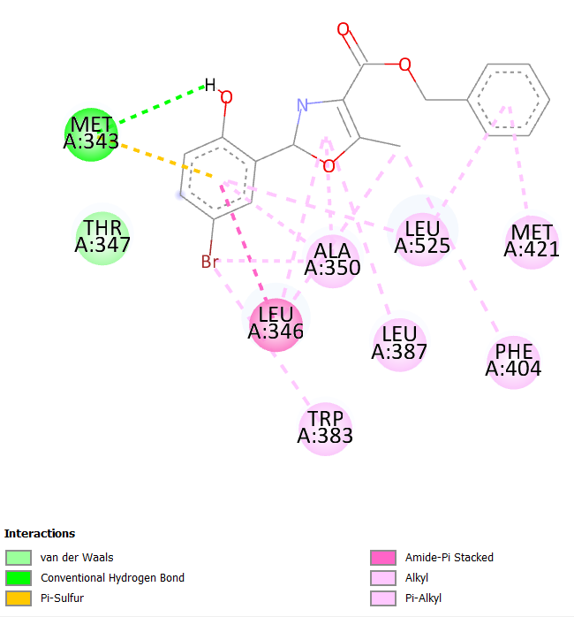  Hit 7 + 3ert | 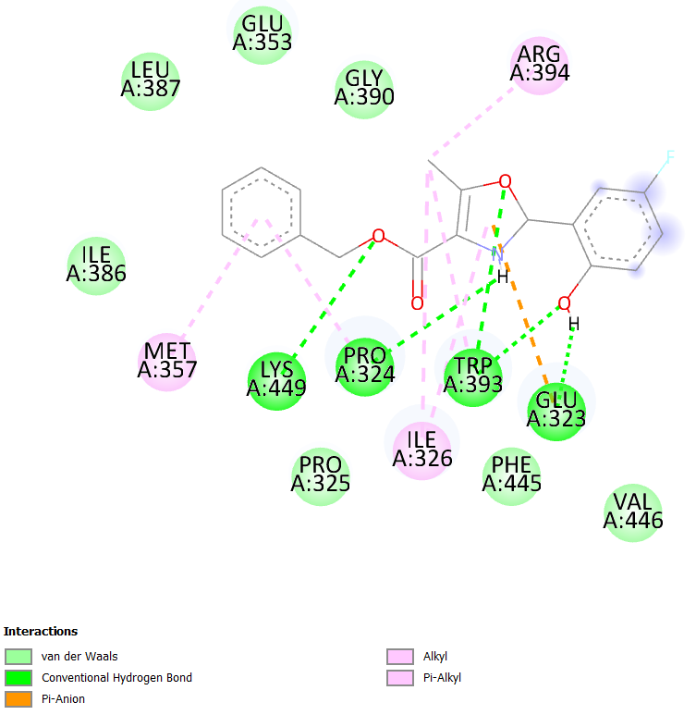  Hit 8 + 3ert
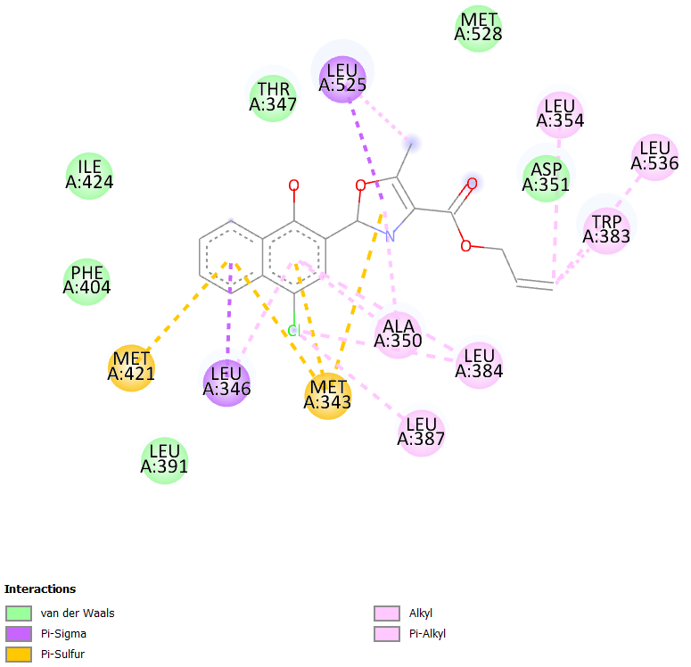  Hit 9 + 3ert | 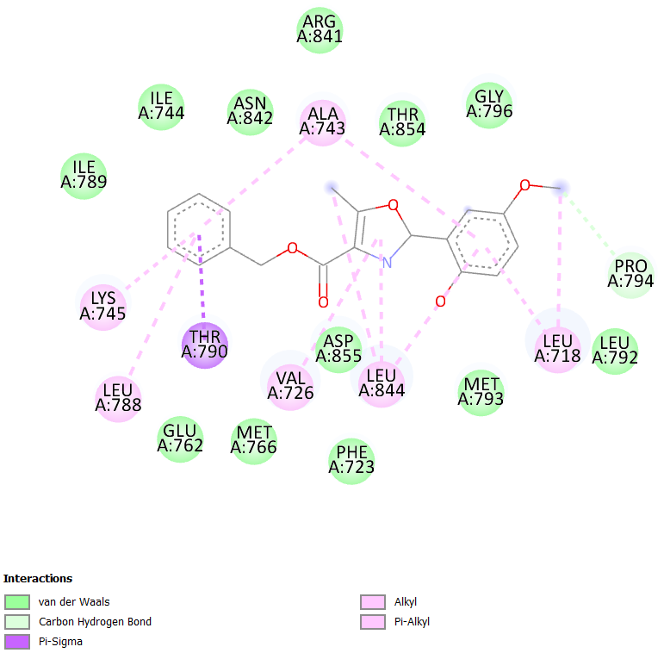  Hit 1 + 2j6m
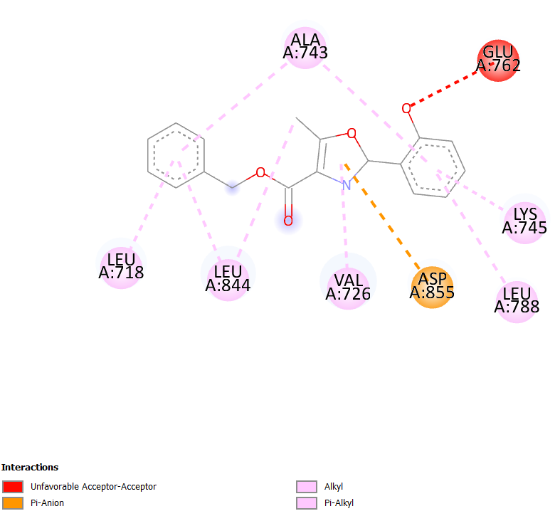  Hit 2 + 2j6m | 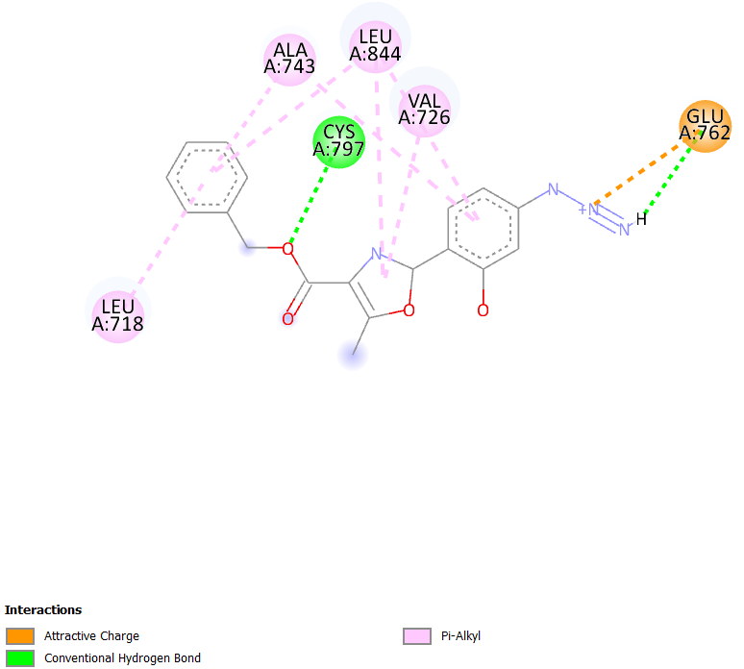  Hit 3 + 2j6m
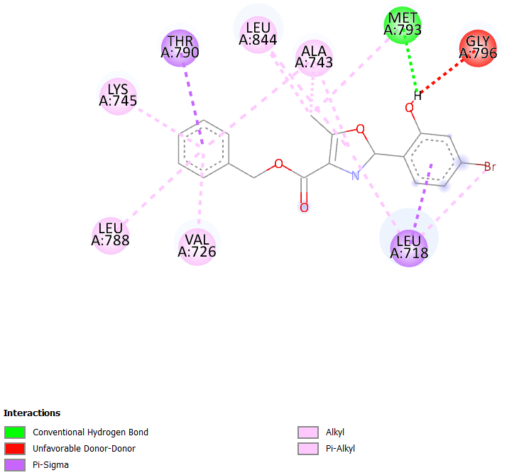  Hit 4 + 2j6m | 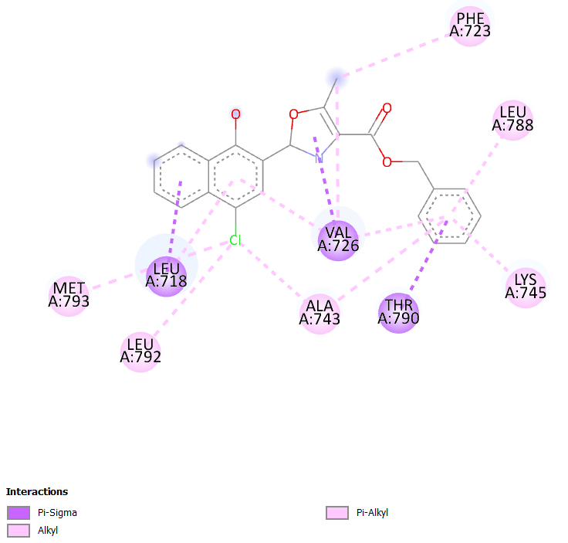  Hit 5 + 2j6m
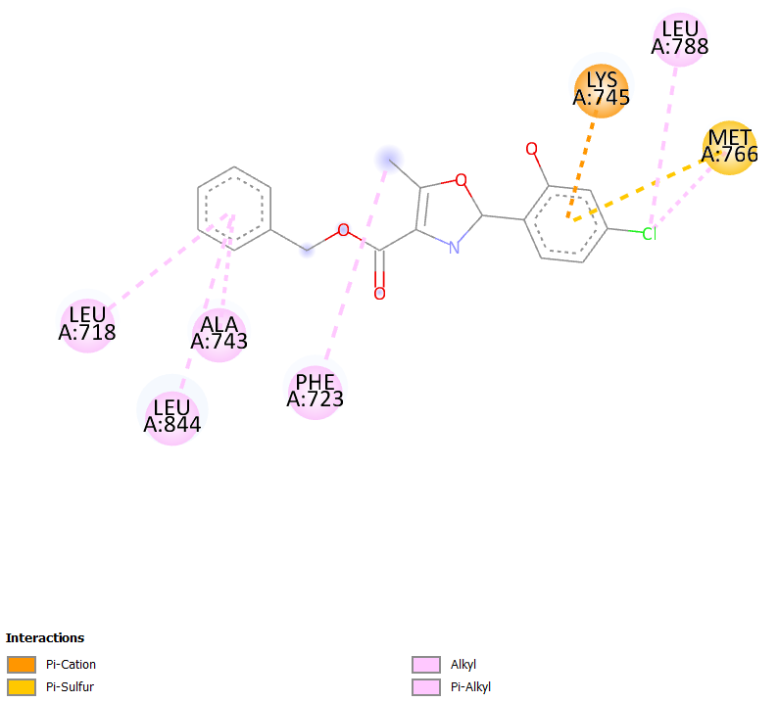  Hit 6 + 2j6m | 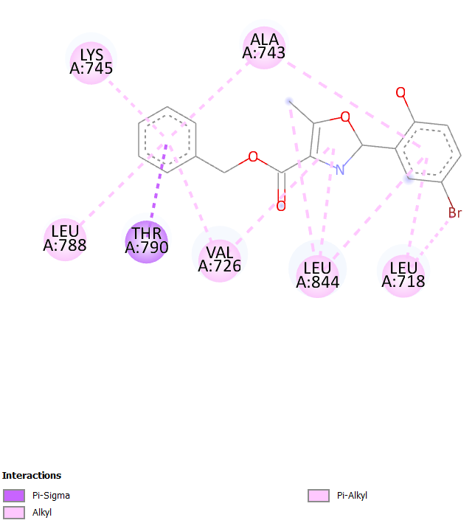  Hit 7 + 2j6m
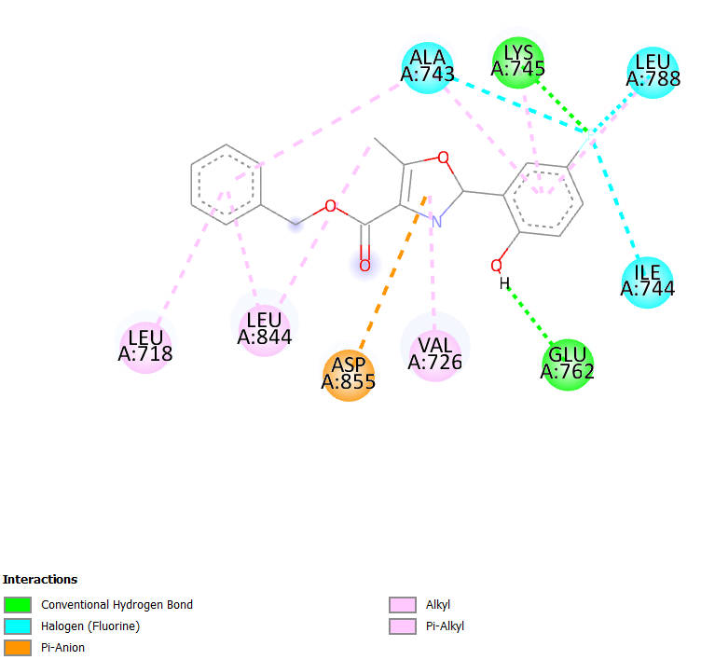  Hit 8 + 2j6m | 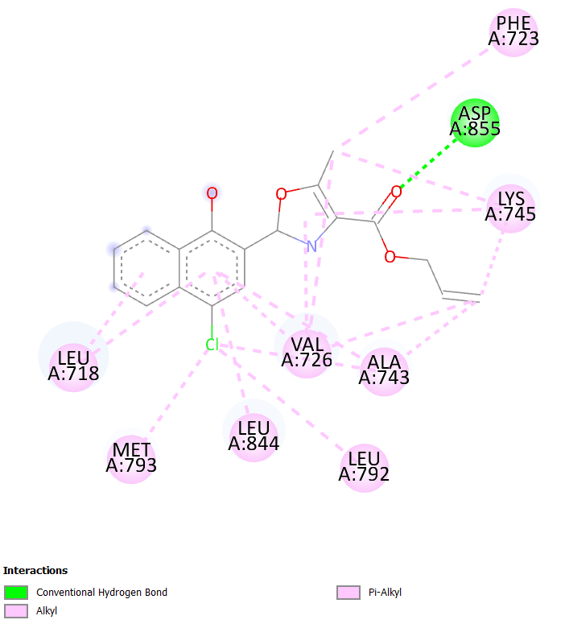  Hit 9 + 2j6m
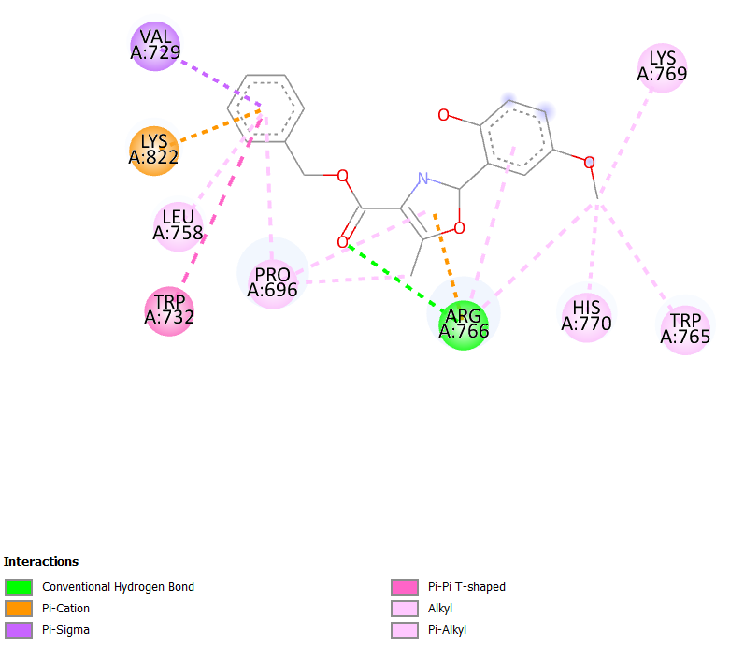  Hit 1 + 4OAR | 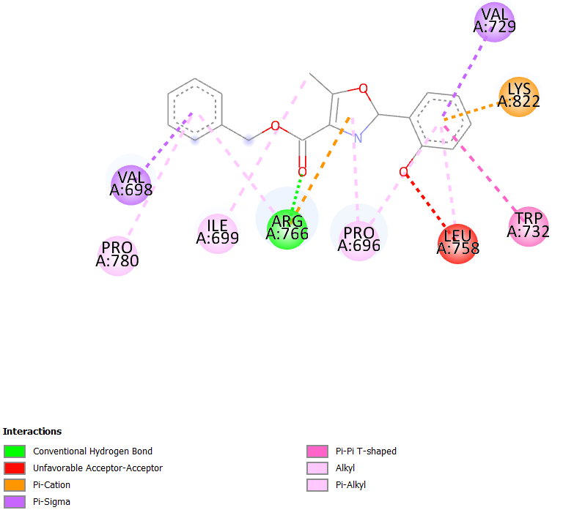  Hit 2 + 4OAR
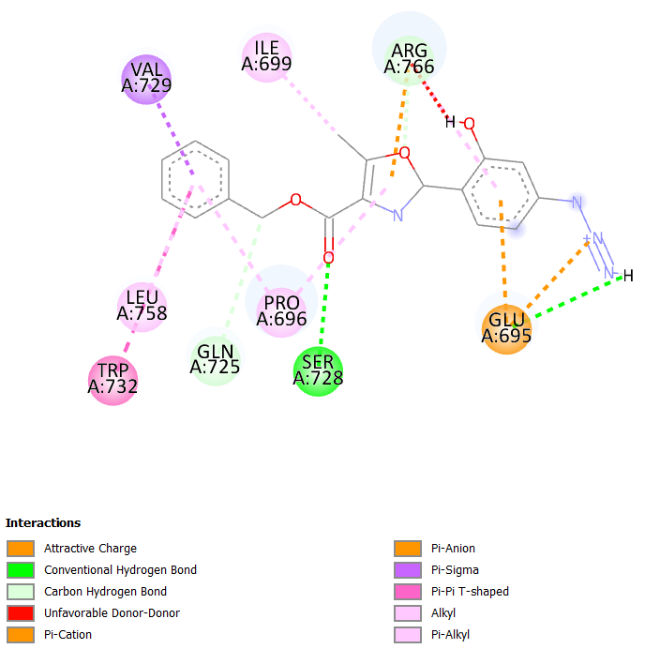  Hit 3 + 4OAR | 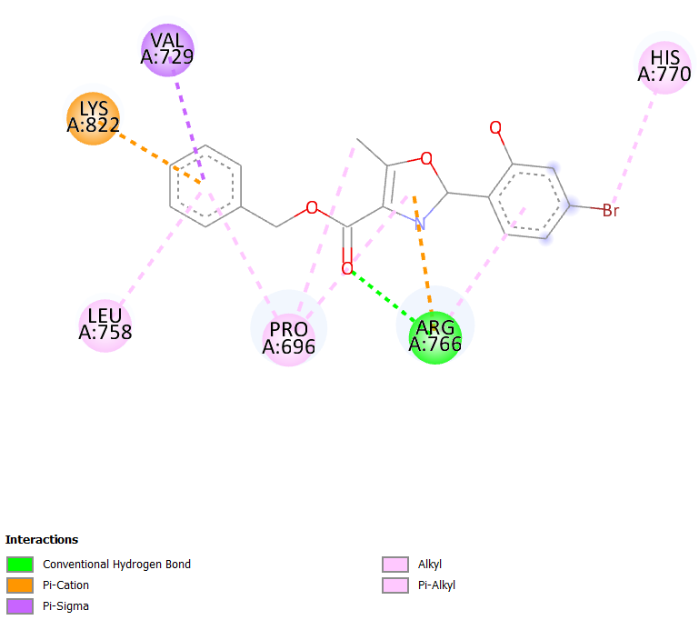  Hit 4 + 4OAR
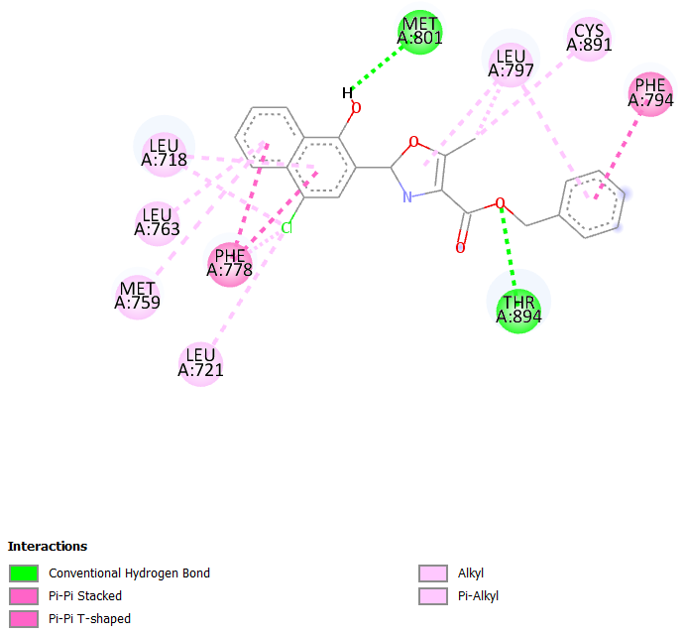  Hit 5 + 4OAR | 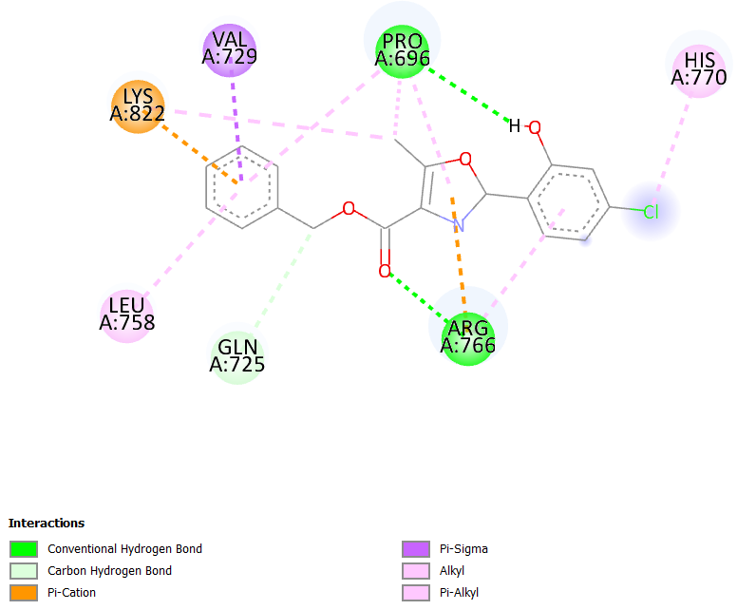  Hit 6 + 4OAR
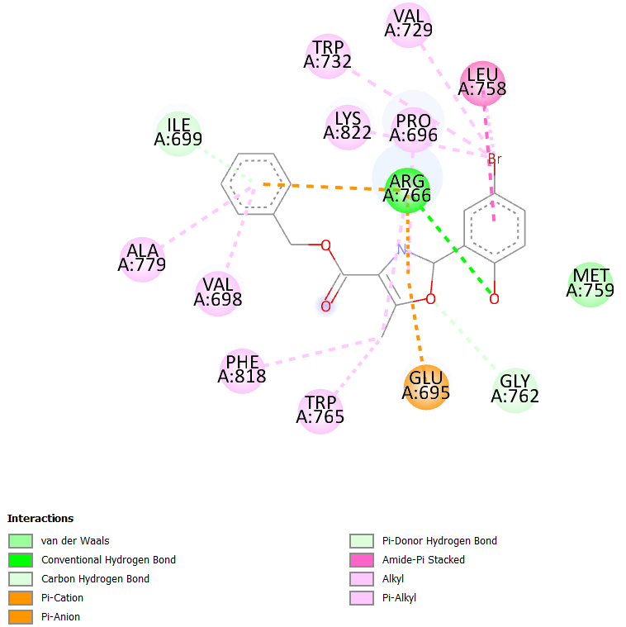  Hit 7 + 4OAR | 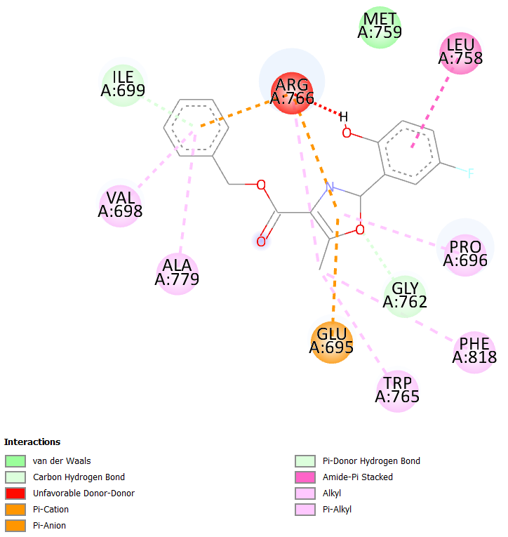  Hit 8 + 4OAR
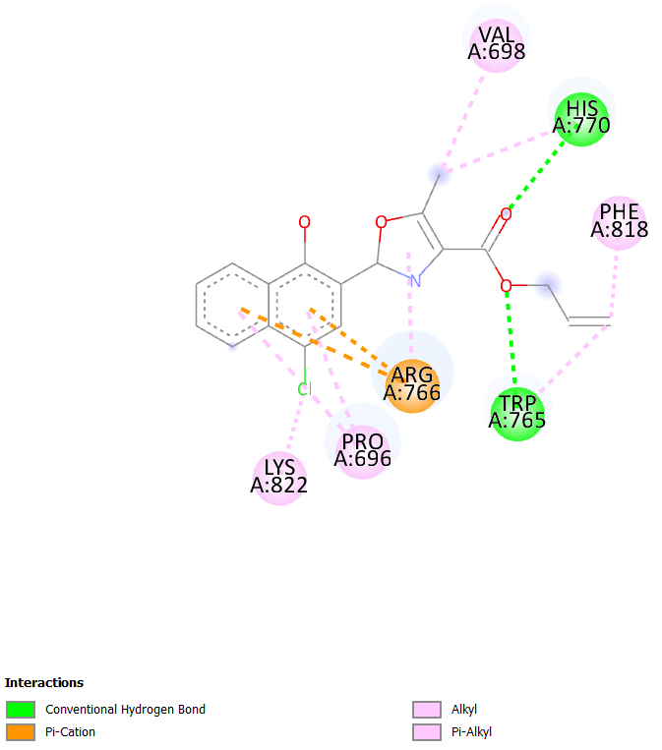
Hit 9 + 4OAR

Table S5: Chemical reactivity of selected nine compounds.
SL | Homo, eV | Lumo,  eV | I= -homo | A = -lumo | Egap=lomo-homo | μ = - (I+A)/2 | η=(𝐼 −𝐴)/2 | χ = (I+A)/2 | ω = μ2/2η | s = 1/η
01 | -7.971 | 2.368 | 7.971 | -2.368 | -10.339 | -2.802 | 5.170 | 2.802 | 0.759 | 0.193
02 | -8.402 | 2.421 | 8.402 | -2.421 | -10.823 | -2.991 | 5.412 | 2.991 | 0.826 | 0.185
03 | -8.221 | 2.100 | 8.221 | -2.100 | -10.321 | -3.061 | 5.161 | 3.061 | 0.908 | 0.194
04 | -8.604 | 2.14 | 8.604 | -2.140 | -10.744 | -3.232 | 5.372 | 3.232 | 0.972 | 0.186
05 | -8.037 | 1.875 | 8.037 | -1.875 | -9.912 | -3.081 | 4.956 | 3.081 | 0.958 | 0.202
06 | -8.765 | 2.059 | 8.765 | -2.059 | -10.824 | -3.353 | 5.412 | 3.353 | 1.039 | 0.185
07 | -8.496 | 2.145 | 8.496 | -2.145 | -10.641 | -3.176 | 5.321 | 3.176 | 0.948 | 0.188
08 | -8.564 | 2.09 | 8.564 | -2.090 | -10.654 | -3.237 | 5.327 | 3.237 | 0.983 | 0.188
09 | -8.037 | 1.875 | 8.037 | -1.875 | -9.912 | -3.081 | 4.956 | 3.081 | 0.958 | 0.202

Table S6: Bonding analysis of compounds 1–9 with various pharmacological targets involved in cell proliferation
Compound 1 + 3TJM
Interaction residue | Distance |  |  | Bond category | Bond type
GLU2251 | 4.59879 |  |  | Electrostatic | Pi-Anion
TYR2351 | 3.95133 |  |  | Hydrophobic | Pi-Pi Stacked
PHE2370 | 5.42608 |  |  | Hydrophobic | Pi-Pi T-shaped
HIS2481 | 5.31163 |  |  | Hydrophobic | Pi-Pi T-shaped
ALA2367 | 5.13236 |  |  | Hydrophobic | Pi-Alkyl
LEU2427 | 4.82689 |  |  | Hydrophobic | Pi-Alkyl
ILE2250 | 5.49877 |  |  | Hydrophobic | Pi-Alkyl
ILE2250 | 5.4359 |  |  | Hydrophobic | Pi-Alkyl
TYR2343 | 4.97827 |  |  | Hydrophobic | Pi-Alkyl
TYR2347 | 4.89402 |  |  | Hydrophobic | Pi-Alkyl
TYR2347 | 4.13385 |  |  | Hydrophobic | Pi-Alkyl
TYR2351 | 5.15215 |  |  | Hydrophobic | Pi-Alkyl
PHE2370 | 4.36425 |  |  | Hydrophobic | Pi-Alkyl
HIS2481 | 4.75032 |  |  | Hydrophobic | Pi-Alkyl
Compound 2 + 3TJM
PHE2423 | 4.14114 | Hydrophobic |  |  |  | Pi-Pi Stacked
TYR2351 | 4.05308 | Hydrophobic |  |  |  | Pi-Pi Stacked
PHE2370 | 3.99027 | Hydrophobic |  |  |  | Pi-Pi Stacked
PHE2370 | 5.20283 | Hydrophobic |  |  |  | Pi-Pi T-shaped
ILE2250 | 4.98498 | Hydrophobic |  |  |  | Pi-Alkyl
LEU2427 | 4.61416 | Hydrophobic |  |  |  | Pi-Alkyl
TYR2347 | 4.37681 | Hydrophobic |  |  |  | Pi-Alkyl
PHE2370 | 5.08747 | Hydrophobic |  |  |  | Pi-Alkyl
Compound 3 + 3TJM
ALA2363 | 3.04176 |  | Hydrogen Bond |  |  | Conventional Hydrogen Bond
PHE2423 | 4.12614 |  | Hydrophobic |  |  | Pi-Pi Stacked
TYR2351 | 4.09504 |  | Hydrophobic |  |  | Pi-Pi Stacked
PHE2370 | 3.95397 |  | Hydrophobic |  |  | Pi-Pi Stacked
PHE2370 | 5.17334 |  | Hydrophobic |  |  | Pi-Pi T-shaped
ILE2250 | 4.96971 |  | Hydrophobic |  |  | Pi-Alkyl
ALA2367 | 5.14435 |  | Hydrophobic |  |  | Pi-Alkyl
LEU2427 | 4.66088 |  | Hydrophobic |  |  | Pi-Alkyl
TYR2347 | 4.36343 |  | Hydrophobic |  |  | Pi-Alkyl
PHE2370 | 4.99246 |  | Hydrophobic |  |  | Pi-Alkyl
Compound 4 + 3TJM

LEU2427 | 3.73275 | Hydrophobic | Pi-Sigma
PHE2423 | 4.14815 | Hydrophobic | Pi-Pi Stacked
TYR2351 | 4.15031 | Hydrophobic | Pi-Pi Stacked
PHE2370 | 3.96076 | Hydrophobic | Pi-Pi Stacked
PHE2370 | 5.18832 | Hydrophobic | Pi-Pi T-shaped
ILE2250 | 4.98972 | Hydrophobic | Pi-Alkyl
ALA2367 | 5.23648 | Hydrophobic | Pi-Alkyl
TYR2347 | 4.44386 | Hydrophobic | Pi-Alkyl
PHE2370 | 4.95974 | Hydrophobic | Pi-Alkyl
Compound 5 + 3TJM

SER2308 | 2.50469 | Hydrogen Bond | Conventional Hydrogen Bond
GLU2251 | 4.2816 | Electrostatic | Pi-Anion
GLU2251 | 4.24895 | Electrostatic | Pi-Anion
ILE2250 | 3.73674 | Hydrophobic | Pi-Sigma
TYR2351 | 3.90557 | Hydrophobic | Pi-Pi Stacked
PHE2370 | 4.95567 | Hydrophobic | Pi-Pi T-shaped
PHE2423 | 5.97671 | Hydrophobic | Pi-Pi T-shaped
HIS2481 | 5.50036 | Hydrophobic | Pi-Pi T-shaped
HIS2481 | 5.32146 | Hydrophobic | Pi-Pi T-shaped
VAL2344 | 3.98033 | Hydrophobic | Alkyl
LEU2427 | 4.82037 | Hydrophobic | Pi-Alkyl
ALA2482 | 4.85258 | Hydrophobic | Pi-Alkyl
TYR2343 | 5.08915 | Hydrophobic | Pi-Alkyl
TYR2347 | 4.26904 | Hydrophobic | Pi-Alkyl
Compound 6 + 3TJM
LEU2427 | 3.7732 | Hydrophobic | Pi-Sigma
PHE2370 | 3.96869 | Hydrophobic | Pi-Pi Stacked
PHE2423 | 4.15955 | Hydrophobic | Pi-Pi Stacked
TYR2351 | 4.10974 | Hydrophobic | Pi-Pi Stacked
PHE2370 | 5.1842 | Hydrophobic | Pi-Pi T-shaped
ALA2367 | 4.2443 | Hydrophobic | Alkyl
ILE2250 | 5.01624 | Hydrophobic | Pi-Alkyl
ALA2367 | 5.26412 | Hydrophobic | Pi-Alkyl
TYR2347 | 4.40474 | Hydrophobic | Pi-Alkyl
TYR2351 | 5.1958 | Hydrophobic | Pi-Alkyl
PHE2370 | 4.99653 | Hydrophobic | Pi-Alkyl
Compound 7+ 3TJM

ILE2250 | 3.9246 | Hydrophobic | Pi-Sigma
LEU2427 | 3.95122 | Hydrophobic | Pi-Sigma
TYR2351 | 3.95533 | Hydrophobic | Pi-Pi Stacked
PHE2370 | 5.41184 | Hydrophobic | Pi-Pi T-shaped
PHE2370 | 5.01569 | Hydrophobic | Pi-Pi T-shaped
ALA2367 | 5.1748 | Hydrophobic | Pi-Alkyl
ILE2250 | 5.37256 | Hydrophobic | Pi-Alkyl
TYR2347 | 3.62709 | Hydrophobic | Pi-Alkyl
Compound 8+ 3TJM

ALA2367 | 2.40197 |  | Hydrogen Bond;Halogen |  |  | Carbon Hydrogen Bond;Halogen (Fluorine)
GLU2366 | 3.0617 |  | Halogen |  |  | Halogen (Fluorine)
PHE2423 | 4.14267 |  | Hydrophobic |  |  | Pi-Pi Stacked
TYR2351 | 3.98359 |  | Hydrophobic |  |  | Pi-Pi Stacked
PHE2370 | 4.02845 |  | Hydrophobic |  |  | Pi-Pi Stacked
PHE2370 | 5.20254 |  | Hydrophobic |  |  | Pi-Pi T-shaped
ILE2250 | 4.99999 |  | Hydrophobic |  |  | Pi-Alkyl
LEU2427 | 4.66734 |  | Hydrophobic |  |  | Pi-Alkyl
TYR2347 | 4.38178 |  | Hydrophobic |  |  | Pi-Alkyl
PHE2370 | 5.13808 |  | Hydrophobic |  |  | Pi-Alkyl
Compound 9 + 3TJM
ALA2363 | 3.49899 | Hydrogen Bond |  |  |  | Carbon Hydrogen Bond
THR2348 | 2.83526 | Hydrogen Bond |  |  |  | Carbon Hydrogen Bond
TYR2351 | 3.1331 | Hydrogen Bond |  |  |  | Pi-Donor Hydrogen Bond
TYR2351 | 3.81228 | Hydrophobic |  |  |  | Pi-Sigma
TYR2347 | 4.25441 | Hydrophobic |  |  |  | Pi-Pi Stacked
TYR2347 | 4.97961 | Hydrophobic |  |  |  | Pi-Pi Stacked
TYR2351 | 5.9015 | Hydrophobic |  |  |  | Pi-Pi Stacked
TYR2351 | 4.32425 | Hydrophobic |  |  |  | Pi-Pi Stacked
PHE2370 | 5.43852 | Hydrophobic |  |  |  | Pi-Pi T-shaped
PHE2370 | 5.76068 | Hydrophobic |  |  |  | Pi-Pi T-shaped
LEU2427 | 4.27054 | Hydrophobic |  |  |  | Alkyl
ARG2428 | 4.04768 | Hydrophobic |  |  |  | Alkyl
VAL2344 | 3.21523 | Hydrophobic |  |  |  | Alkyl
LEU2427 | 5.46311 | Hydrophobic |  |  |  | Pi-Alkyl
LEU2427 | 4.3217 | Hydrophobic |  |  |  | Pi-Alkyl
TYR2347 | 4.57285 | Hydrophobic |  |  |  | Pi-Alkyl
TYR2424 | 4.64213 | Hydrophobic |  |  |  | Pi-Alkyl
Compound 1+ 3ERT
MET522 | 2.44068 |  |  | Hydrogen Bond |  | Conventional Hydrogen Bond
MET522 | 3.06996 |  |  | Hydrogen Bond |  | Carbon Hydrogen Bond
MET522 | 5.73628 |  |  | Other |  | Pi-Sulfur
TRP383 | 3.81825 |  |  | Hydrophobic |  | Pi-Pi Stacked
TRP383 | 5.03002 |  |  | Hydrophobic |  | Pi-Pi Stacked
TYR526 | 4.92927 |  |  | Hydrophobic |  | Pi-Pi T-shaped
LYS529 | 3.82851 |  |  | Hydrophobic |  | Alkyl
ALA350 | 4.99621 |  |  | Hydrophobic |  | Pi-Alkyl
LEU354 | 4.98747 |  |  | Hydrophobic |  | Pi-Alkyl
LEU536 | 5.41613 |  |  | Hydrophobic |  | Pi-Alkyl
MET522 | 4.86578 |  |  | Hydrophobic |  | Pi-Alkyl
LYS529 | 5.09593 |  |  | Hydrophobic |  | Pi-Alkyl
TYR526 | 5.38777 |  |  | Hydrophobic |  | Pi-Alkyl
Compound 2 + 3ERT
PRO324 | 2.42159 |  |  | Hydrogen Bond |  | Conventional Hydrogen Bond
ARG394 | 3.31376 |  |  | Hydrogen Bond |  | Conventional Hydrogen Bond
GLY390 | 3.69368 |  |  | Hydrogen Bond |  | Carbon Hydrogen Bond
LYS449 | 4.8662 |  |  | Electrostatic |  | Pi-Cation
GLU323 | 3.49447 |  |  | Electrostatic |  | Pi-Anion
GLU353 | 3.69293 |  |  | Electrostatic |  | Pi-Anion
ILE326 | 4.60032 |  |  | Hydrophobic |  | Alkyl
ARG394 | 3.71698 |  |  | Hydrophobic |  | Alkyl
PRO324 | 4.08642 |  |  | Hydrophobic |  | Pi-Alkyl
PRO324 | 4.88375 |  |  | Hydrophobic |  | Pi-Alkyl
ILE326 | 4.89382 |  |  | Hydrophobic |  | Pi-Alkyl
TRP393 | 4.74503 |  |  | Hydrophobic |  | Pi-Alkyl
Compound 3 + 3ERT
MET343 | 2.5245 |  |  | Hydrogen Bond |  | Conventional Hydrogen Bond
THR347 | 3.07116 |  |  | Hydrogen Bond |  | Conventional Hydrogen Bond
LEU525 | 3.72664 |  |  | Hydrophobic |  | Pi-Sigma
LEU525 | 3.57214 |  |  | Hydrophobic |  | Pi-Sigma
TRP383 | 3.73376 |  |  | Hydrophobic |  | Pi-Pi Stacked
TRP383 | 4.8242 |  |  | Hydrophobic |  | Pi-Pi Stacked
MET528 | 5.46458 |  |  | Hydrophobic |  | Alkyl
ALA350 | 5.084 |  |  | Hydrophobic |  | Pi-Alkyl
LEU354 | 4.56797 |  |  | Hydrophobic |  | Pi-Alkyl
LEU536 | 5.25607 |  |  | Hydrophobic |  | Pi-Alkyl
ALA350 | 3.63742 |  |  | Hydrophobic |  | Pi-Alkyl
LEU525 | 5.40364 |  |  | Hydrophobic |  | Pi-Alkyl
Compound 4 + 3ERT
GLU323 | 2.77758 |  |  | Hydrogen Bond |  | Conventional Hydrogen Bond
PRO324 | 2.62334 |  |  | Hydrogen Bond |  | Conventional Hydrogen Bond
GLU323 | 2.7478 |  |  | Hydrogen Bond |  | Conventional Hydrogen Bond
TRP393 | 3.09125 |  |  | Hydrogen Bond |  | Conventional Hydrogen Bond
MET357 | 5.78534 |  |  | Other |  | Pi-Sulfur
ILE326 | 4.72554 |  |  | Hydrophobic |  | Alkyl
ARG394 | 3.85206 |  |  | Hydrophobic |  | Alkyl
PRO324 | 4.19963 |  |  | Hydrophobic |  | Pi-Alkyl
ILE326 | 4.86345 |  |  | Hydrophobic |  | Pi-Alkyl
TRP393 | 4.66842 |  |  | Hydrophobic |  | Pi-Alkyl
Compound 5 + 3ERT
THR347 | 2.91342 |  |  |  | Hydrogen Bond | Conventional Hydrogen Bond
LEU525 | 3.77855 |  |  |  | Hydrophobic | Pi-Sigma
MET343 | 5.36068 |  |  |  | Other | Pi-Sulfur
MET343 | 5.32382 |  |  |  | Other | Pi-Sulfur
MET421 | 5.69942 |  |  |  | Other | Pi-Sulfur
ALA350 | 3.77438 |  |  |  | Hydrophobic | Alkyl
MET343 | 4.83321 |  |  |  | Hydrophobic | Alkyl
LEU346 | 4.57916 |  |  |  | Hydrophobic | Alkyl
MET421 | 4.20839 |  |  |  | Hydrophobic | Alkyl
LEU525 | 5.17659 |  |  |  | Hydrophobic | Pi-Alkyl
LEU536 | 5.28476 |  |  |  | Hydrophobic | Pi-Alkyl
LEU346 | 5.14434 |  |  |  | Hydrophobic | Pi-Alkyl
LEU346 | 4.86686 |  |  |  | Hydrophobic | Pi-Alkyl
ALA350 | 5.35462 |  |  |  | Hydrophobic | Pi-Alkyl
MET388 | 5.37424 |  |  |  | Hydrophobic | Pi-Alkyl
ALA350 | 4.10467 |  |  |  | Hydrophobic | Pi-Alkyl
ATRP383 | 4.50924 |  |  |  | Hydrophobic | Pi-Alkyl
Compound 6 + 3ERT
THR347 | 2.96589 |  |  |  | Hydrogen Bond | Conventional Hydrogen Bond
THR347 | 4.01971 |  |  |  | Hydrogen Bond | Pi-Donor Hydrogen Bond
THR347 | 3.57208 |  |  |  | Hydrophobic | Pi-Sigma
LEU525 | 3.8353 |  |  |  | Hydrophobic | Pi-Sigma
LEU525 | 3.84932 |  |  |  | Hydrophobic | Pi-Sigma
MET343 | 4.94724 |  |  |  | Other | Pi-Sulfur
LEU346 THR347 | 4.68626 |  |  |  | Hydrophobic | Amide-Pi Stacked
ALA350 | 3.619 |  |  |  | Hydrophobic | Alkyl
LEU384 | 4.5371 |  |  |  | Hydrophobic | Alkyl
LEU387 | 4.84759 |  |  |  | Hydrophobic | Alkyl
LEU346 | 4.40204 |  |  |  | Hydrophobic | Pi-Alkyl
LEU349 | 5.4186 |  |  |  | Hydrophobic | Pi-Alkyl
ALA350 | 5.22782 |  |  |  | Hydrophobic | Pi-Alkyl
LEU391 | 5.33959 |  |  |  | Hydrophobic | Pi-Alkyl
LEU525 | 5.26743 |  |  |  | Hydrophobic | Pi-Alkyl
ALA350 | 4.13603 |  |  |  | Hydrophobic | Pi-Alkyl
TRP383 | 4.84954 |  |  |  | Hydrophobic | Pi-Alkyl
Compound 7 + 3ERT
THR347 | 2.4322 |  |  |  | Hydrogen Bond | Conventional Hydrogen Bond
ASP351 | 2.17551 |  |  |  | Hydrogen Bond | Conventional Hydrogen Bond
MET343 | 5.17443 |  |  |  | Other | Pi-Sulfur
ALA350 | 3.61157 |  |  |  | Hydrophobic | Alkyl
LEU384 | 4.52269 |  |  |  | Hydrophobic | Alkyl
LEU387 | 4.66913 |  |  |  | Hydrophobic | Alkyl
LEU346 | 4.40156 |  |  |  | Hydrophobic | Pi-Alkyl
LEU349 | 5.43228 |  |  |  | Hydrophobic | Pi-Alkyl
ALA350 | 5.23757 |  |  |  | Hydrophobic | Pi-Alkyl
LEU391 | 5.33151 |  |  |  | Hydrophobic | Pi-Alkyl
LEU525 | 5.02706 |  |  |  | Hydrophobic | Pi-Alkyl
ALA350 | 4.07673 |  |  |  | Hydrophobic | Pi-Alkyl
LEU525 | 4.32373 |  |  |  | Hydrophobic | Pi-Alkyl
TRP383 | 4.93304 |  |  |  | Hydrophobic | Pi-Alkyl
Compound 8 + 3ERT
PRO324 | 2.47711 |  |  |  | Hydrogen Bond | Conventional Hydrogen Bond
ARG394 | 2.66425 |  |  |  | Hydrogen Bond | Conventional Hydrogen Bond
LYS449 | 2.48039 |  |  |  | Hydrogen Bond | Conventional Hydrogen Bond
LYS449 | 2.94217 |  |  |  | Hydrogen Bond | Conventional Hydrogen Bond
GLU353 | 2.76749 |  |  |  | Hydrogen Bond;Halogen | Carbon Hydrogen Bond;Halogen (Fluorine)
GLU353 | 3.22479 |  |  |  | Halogen | Halogen (Fluorine)
GLU353 | 3.58791 |  |  |  | Halogen | Halogen (Fluorine)
LYS449 | 4.83298 |  |  |  | Electrostatic | Pi-Cation
GLU323 | 3.53387 |  |  |  | Electrostatic | Pi-Anion
GLU353 | 3.77604 |  |  |  | Electrostatic | Pi-Anion
ILE326 | 4.68778 |  |  |  | Hydrophobic | Alkyl
ARG394 | 3.68737 |  |  |  | Hydrophobic | Alkyl
PRO324 | 4.06 |  |  |  | Hydrophobic | Pi-Alkyl
PRO324 | 4.94759 |  |  |  | Hydrophobic | Pi-Alkyl
ILE326 | 4.93267 |  |  |  | Hydrophobic | Pi-Alkyl
TRP393 | 4.62045 |  |  |  | Hydrophobic | Pi-Alkyl
Compound 9 + 3ERT
ARG503 | 3.23707 |  |  |  | Hydrogen Bond | Conventional Hydrogen Bond
ALA493 | 3.36508 |  |  |  | Hydrophobic | Pi-Sigma
LEU495 | 3.72168 |  |  |  | Hydrophobic | Pi-Sigma
LEU489 ;MET490 | 4.47802 |  |  |  | Hydrophobic | Amide-Pi Stacked
LEU495 | 4.14544 |  |  |  | Hydrophobic | Alkyl
LEU495 | 4.20969 |  |  |  | Hydrophobic | Alkyl
LEU489 | 4.93313 |  |  |  | Hydrophobic | Pi-Alkyl
ALA493 | 4.22382 |  |  |  | Hydrophobic | Pi-Alkyl
ALA493 | 5.04077 |  |  |  | Hydrophobic | Pi-Alkyl

Compound 1+ 4OAR
PRO696 | 2.41301 | Hydrogen Bond | Conventional Hydrogen Bond
SER728 | 3.15665 | Hydrogen Bond | Conventional Hydrogen Bond
ARG766 | 3.32711 | Hydrogen Bond | Conventional Hydrogen Bond
GLN725 | 2.89275 | Hydrogen Bond | Carbon Hydrogen Bond
ARG766 | 3.40651 | Hydrogen Bond | Carbon Hydrogen Bond
ARG766 | 3.40365 | Electrostatic | Pi-Cation
GLU695 | 4.55885 | Electrostatic | Pi-Anion
VAL729 | 3.41671 | Hydrophobic | Pi-Sigma
ILE699 | 3.93233 | Hydrophobic | Alkyl
PRO696 | 4.92787 | Hydrophobic | Pi-Alkyl
LEU758 | 5.20797 | Hydrophobic | Pi-Alkyl
ARG766 | 4.96521 | Hydrophobic | Pi-Alkyl
PRO696 | 4.91977 | Hydrophobic | Pi-Alkyl
PHE818 | 5.08136 | Hydrophobic | Pi-Alkyl
 |  | Compound 2+ 4OAR
PRO696 | 2.77776 | Hydrogen Bond | Carbon Hydrogen Bond
ARG766 | 3.95698 | Electrostatic | Pi-Cation
LYS822 | 3.39364 | Hydrogen Bond;Electrostatic | Pi-Cation;Pi-Donor Hydrogen Bond
VAL698 | 3.57071 | Hydrophobic | Pi-Sigma
VAL729 | 3.94091 | Hydrophobic | Pi-Sigma
TRP732 | 4.89555 | Hydrophobic | Pi-Pi T-shaped
TRP732 | 5.16282 | Hydrophobic | Pi-Pi T-shaped
ILE699 | 4.4098 | Hydrophobic | Alkyl
ARG766 | 4.81717 | Hydrophobic | Pi-Alkyl
PRO780 | 5.32121 | Hydrophobic | Pi-Alkyl
PRO696 | 5.20679 | Hydrophobic | Pi-Alkyl
LEU758 | 4.70316 | Hydrophobic | Pi-Alkyl
LYS822 | 5.34113 | Hydrophobic | Pi-Alkyl
PRO696 | 3.96969 | Hydrophobic | Pi-Alkyl
 |  | Compound 3+ 4OAR
GLU695 | 3.32392 | Electrostatic | Attractive Charge
GLU695 | 2.341 | Hydrogen Bond | Conventional Hydrogen Bond
ARG766 | 3.24989 | Hydrogen Bond | Conventional Hydrogen Bond
GLN725 | 2.84991 | Hydrogen Bond | Carbon Hydrogen Bond
ARG766 | 3.43798 | Hydrogen Bond | Carbon Hydrogen Bond
ARG766 | 3.25217 | Electrostatic | Pi-Cation
GLU695 | 3.78441 | Electrostatic | Pi-Anion
VAL729 | 3.39195 | Hydrophobic | Pi-Sigma
ILE699 | 4.13521 | Hydrophobic | Alkyl
PRO696 | 4.93335 | Hydrophobic | Pi-Alkyl
LEU758 | 5.22486 | Hydrophobic | Pi-Alkyl
ARG766 | 5.19585 | Hydrophobic | Pi-Alkyl
PRO696 | 4.8285 | Hydrophobic | Pi-Alkyl
 |  | Compound 4+ 4OAR
ARG766 | 2.94549 | Hydrogen Bond | Conventional Hydrogen Bond
ARG766 | 3.61331 | Electrostatic | Pi-Cation
LYS822 | 4.11053 | Hydrogen Bond;Electrostatic | Pi-Cation;Pi-Donor Hydrogen Bond
VAL729 | 3.41302 | Hydrophobic | Pi-Sigma
PRO696 | 4.53679 | Hydrophobic | Alkyl
LYS822 | 5.43788 | Hydrophobic | Alkyl
PRO696 | 4.93559 | Hydrophobic | Pi-Alkyl
LEU758 | 5.1748 | Hydrophobic | Pi-Alkyl
ARG766 | 5.15082 | Hydrophobic | Pi-Alkyl
PRO696 | 4.31304 | Hydrophobic | Pi-Alkyl
 |  | Compound 5+ 4OAR
GLU695 | 2.57524 | Hydrogen Bond | Conventional Hydrogen Bond
ARG766 | 2.90531 | Hydrogen Bond | Conventional Hydrogen Bond
TRP765 | 3.67648 | Hydrogen Bond | Carbon Hydrogen Bond
ARG766 | 3.64034 | Electrostatic | Pi-Cation
LYS822 | 4.09853 | Hydrogen Bond;Electrostatic | Pi-Cation;Pi-Donor Hydrogen Bond
VAL729 | 3.40757 | Hydrophobic | Pi-Sigma
TRP732 | 5.33382 | Hydrophobic | Pi-Pi T-shaped
PRO696 | 4.31699 | Hydrophobic | Alkyl
LYS822 | 5.46793 | Hydrophobic | Alkyl
VAL698 | 4.22743 | Hydrophobic | Alkyl
PRO696 | 4.98465 | Hydrophobic | Pi-Alkyl
LEU758 | 5.12294 | Hydrophobic | Pi-Alkyl
ARG766 | 4.74456 | Hydrophobic | Pi-Alkyl
PRO696 | 4.39674 | Hydrophobic | Pi-Alkyl
HIS770 | 4.57695 | Hydrophobic | Pi-Alkyl
 |  | Compound 6+ 4OAR
ARG766 | 3.02087 | Hydrogen Bond | Conventional Hydrogen Bond
GLN725 | 3.08106 | Hydrogen Bond | Carbon Hydrogen Bond
ARG766 | 3.57045 | Electrostatic | Pi-Cation
LYS822 | 4.09289 | Hydrogen Bond;Electrostatic | Pi-Cation;Pi-Donor Hydrogen Bond
VAL729 | 3.40444 | Hydrophobic | Pi-Sigma
PRO696 | 4.63506 | Hydrophobic | Alkyl
LYS822 | 5.39858 | Hydrophobic | Alkyl
PRO696 | 4.95379 | Hydrophobic | Pi-Alkyl
LEU758 | 5.14419 | Hydrophobic | Pi-Alkyl
ARG766 | 5.16724 | Hydrophobic | Pi-Alkyl
PRO696 | 4.31043 | Hydrophobic | Pi-Alkyl
HIS770 | 5.01152 | Hydrophobic | Pi-Alkyl
 |  | Compound 7+ 4OAR
ARG766 | 2.97257 | Hydrogen Bond | Conventional Hydrogen Bond
ARG766 | 3.59645 | Electrostatic | Pi-Cation
VAL729 | 3.41141 | Hydrophobic | Pi-Sigma
PRO696 | 4.46724 | Hydrophobic | Alkyl
LYS822 | 5.46897 | Hydrophobic | Alkyl
PRO696 | 4.91089 | Hydrophobic | Pi-Alkyl
LEU758 | 5.21047 | Hydrophobic | Pi-Alkyl
ARG766 | 5.08284 | Hydrophobic | Pi-Alkyl
PRO696 | 4.30993 | Hydrophobic | Pi-Alkyl
 |  | Compound 8+ 4OAR
ARG766 | 2.86077 | Hydrogen Bond | Conventional Hydrogen Bond
GLY762 | 3.24181 | Hydrogen Bond | Carbon Hydrogen Bond
ARG766 | 4.01682 | Electrostatic | Pi-Cation
ARG766 | 3.5137 | Electrostatic | Pi-Cation
GLU695 | 4.23522 | Electrostatic | Pi-Anion
ILE699 | 3.50614 | Hydrogen Bond | Pi-Donor Hydrogen Bond
LEU758 ;MET759 | 4.10355 | Hydrophobic | Amide-Pi Stacked
ARG766 | 4.87471 | Hydrophobic | Alkyl
VAL698 | 5.11707 | Hydrophobic | Pi-Alkyl
ILE699 | 4.79814 | Hydrophobic | Pi-Alkyl
ALA779 | 5.36174 | Hydrophobic | Pi-Alkyl
PRO696 | 4.8861 | Hydrophobic | Pi-Alkyl
TRP765 | 4.28396 | Hydrophobic | Pi-Alkyl
PHE818 | 4.50244 | Hydrophobic | Pi-Alkyl
 |  | Compound 9+ 4OAR
ARG766 | 3.43196 | Electrostatic | Pi-Cation
ARG766 | 4.3291 | Electrostatic | Pi-Cation
VAL698 | 4.66598 | Hydrophobic | Alkyl
LYS822 | 4.94372 | Hydrophobic | Alkyl
PRO696 | 4.25634 | Hydrophobic | Pi-Alkyl
PRO696 | 4.10818 | Hydrophobic | Pi-Alkyl
ARG766 | 4.29699 | Hydrophobic | Pi-Alkyl
TRP765 | 4.37504 | Hydrophobic | Pi-Alkyl
HIS770 | 4.7943 | Hydrophobic | Pi-Alkyl
PHE818 | 5.36428 | Hydrophobic | Pi-Alkyl

Compound 1 + 2J6M

GLU758 | 2.66016 | Hydrogen Bond | Carbon Hydrogen Bond
ALA755 | 3.6206 | Hydrophobic | Pi-Sigma
PHE723 | 3.71429 | Hydrophobic | Pi-Pi Stacked
LEU747 | 3.85649 | Hydrophobic | Alkyl
ILE759 | 3.92959 | Hydrophobic | Alkyl
ALA755 | 4.10379 | Hydrophobic | Alkyl
LEU747 | 4.60254 | Hydrophobic | Pi-Alkyl
ALA755 | 4.79577 | Hydrophobic | Pi-Alkyl
Compound 2 + 2J6M

MET793 | 1.90399 | Hydrogen Bond | Conventional Hydrogen Bond
LEU718 | 3.96592 | Hydrophobic | Pi-Sigma
LEU718 | 3.96463 | Hydrophobic | Pi-Sigma
THR790 | 3.91127 | Hydrophobic | Pi-Sigma
ALA743 | 3.67377 | Hydrophobic | Alkyl
MET793 | 4.76739 | Hydrophobic | Alkyl
LEU844 | 4.57865 | Hydrophobic | Alkyl
VAL726 | 5.38664 | Hydrophobic | Pi-Alkyl
ALA743 | 4.72865 | Hydrophobic | Pi-Alkyl
LYS745 | 3.8688 | Hydrophobic | Pi-Alkyl
LEU788 | 5.39872 | Hydrophobic | Pi-Alkyl
LEU718 | 5.48112 | Hydrophobic | Pi-Alkyl
ALA743 | 4.83551 | Hydrophobic | Pi-Alkyl
LEU844 | 4.96118 | Hydrophobic | Pi-Alkyl
Compound 3 + 2J6M

GLU762 | 3.4733 | Electrostatic | Attractive Charge
GLU762 | 2.68366 | Hydrogen Bond | Conventional Hydrogen Bond
ASP855 | 2.68999 | Hydrogen Bond | Conventional Hydrogen Bond
CYS797 | 3.23819 | Hydrogen Bond | Conventional Hydrogen Bond
VAL726 | 4.43709 | Hydrophobic | Alkyl
LEU718 | 5.35759 | Hydrophobic | Pi-Alkyl
ALA743 | 4.91051 | Hydrophobic | Pi-Alkyl
LEU844 | 5.02222 | Hydrophobic | Pi-Alkyl
VAL726 | 5.39415 | Hydrophobic | Pi-Alkyl
ALA743 | 5.28288 | Hydrophobic | Pi-Alkyl
VAL726 | 4.8004 | Hydrophobic | Pi-Alkyl
Compound 4 + 2J6M

MET793 | 2.2198 | Hydrogen Bond | Conventional Hydrogen Bond
LEU718 | 3.90528 | Hydrophobic | Pi-Sigma
THR790 | 3.87518 | Hydrophobic | Pi-Sigma
ALA743 | 3.62771 | Hydrophobic | Alkyl
MET793 | 4.73561 | Hydrophobic | Alkyl
LEU844 | 4.5822 | Hydrophobic | Alkyl
VAL726 | 5.46126 | Hydrophobic | Pi-Alkyl
ALA743 | 4.7563 | Hydrophobic | Pi-Alkyl
LYS745 | 3.87763 | Hydrophobic | Pi-Alkyl
LEU788 | 5.31688 | Hydrophobic | Pi-Alkyl
ALA743 | 4.80601 | Hydrophobic | Pi-Alkyl
LEU844 | 4.75636 | Hydrophobic | Pi-Alkyl
Compound 5 + 2J6M

LEU718 | 3.84574 | Hydrophobic | Pi-Sigma
VAL726 | 3.80074 | Hydrophobic | Pi-Sigma
THR790 | 3.94469 | Hydrophobic | Pi-Sigma
VAL726 | 4.92636 | Hydrophobic | Alkyl
ALA743 | 4.12845 | Hydrophobic | Alkyl
LEU792 | 4.38699 | Hydrophobic | Alkyl
VAL726 | 5.42692 | Hydrophobic | Pi-Alkyl
ALA743 | 4.79562 | Hydrophobic | Pi-Alkyl
LYS745 | 3.798 | Hydrophobic | Pi-Alkyl
LEU788 | 5.27635 | Hydrophobic | Pi-Alkyl
LEU718 | 4.51639 | Hydrophobic | Pi-Alkyl
VAL726 | 5.46299 | Hydrophobic | Pi-Alkyl
PHE723 | 4.80836 | Hydrophobic | Pi-Alkyl
Compound 6 + 2J6M

ASP855 | 2.74532 | Hydrogen Bond | Conventional Hydrogen Bond
THR854 | 2.39437 | Hydrogen Bond | Conventional Hydrogen Bond
ASP855 | 2.60717 | Hydrogen Bond | Conventional Hydrogen Bond
LYS745 | 4.87312 | Electrostatic | Pi-Cation
MET766 | 5.48122 | Other | Pi-Sulfur
MET766 | 4.82989 | Hydrophobic | Alkyl
LEU788 | 4.00229 | Hydrophobic | Alkyl
LEU718 | 5.44482 | Hydrophobic | Pi-Alkyl
ALA743 | 4.71376 | Hydrophobic | Pi-Alkyl
LEU844 | 5.00082 | Hydrophobic | Pi-Alkyl
LYS745 | 4.42251 | Hydrophobic | Pi-Alkyl
PHE723 | 5.28397 | Hydrophobic | Pi-Alkyl
Compound 7 + 2J6M

THR790 | 3.88908 | Hydrophobic | Pi-Sigma
LEU844 | 4.88504 | Hydrophobic | Alkyl
ALA743 | 4.81525 | Hydrophobic | Pi-Alkyl
LYS745 | 3.86238 | Hydrophobic | Pi-Alkyl
LEU788 | 5.25483 | Hydrophobic | Pi-Alkyl
LEU718 | 5.09943 | Hydrophobic | Pi-Alkyl
ALA743 | 4.71107 | Hydrophobic | Pi-Alkyl
LEU844 | 5.31105 | Hydrophobic | Pi-Alkyl
VAL726 | 4.94199 | Hydrophobic | Pi-Alkyl
LEU844 | 4.99533 | Hydrophobic | Pi-Alkyl
Compound 8 + 2J6M

LYS745 | 3.28422 | Hydrogen Bond;Halogen | Conventional Hydrogen Bond;Halogen (Fluorine)
ALA743 | 2.98951 | Halogen | Halogen (Fluorine)
LEU788 | 3.03517 | Halogen | Halogen (Fluorine)
ASP855 | 4.77797 | Electrostatic | Pi-Anion
LEU844 | 4.38958 | Hydrophobic | Alkyl
LEU718 | 5.43409 | Hydrophobic | Pi-Alkyl
ALA743 | 4.76402 | Hydrophobic | Pi-Alkyl
LEU844 | 5.00526 | Hydrophobic | Pi-Alkyl
ALA743 | 5.25961 | Hydrophobic | Pi-Alkyl
LYS745 | 4.00243 | Hydrophobic | Pi-Alkyl
LEU788 | 5.30909 | Hydrophobic | Pi-Alkyl
VAL726 | 4.61807 | Hydrophobic | Pi-Alkyl
Compound 9 + 2J6M
MET793 | 2.41902 | Hydrogen Bond | Conventional Hydrogen Bond
LYS745 | 3.80341 | Hydrophobic | Alkyl
MET766 | 5.39732 | Hydrophobic | Alkyl
LEU788 | 4.16851 | Hydrophobic | Alkyl
ALA743 | 3.72222 | Hydrophobic | Alkyl
MET793 | 5.02107 | Hydrophobic | Alkyl
LEU844 | 4.96872 | Hydrophobic | Alkyl
LEU718 | 5.48483 | Hydrophobic | Alkyl
LEU718 | 4.44622 | Hydrophobic | Pi-Alkyl
LEU718 | 3.72344 | Hydrophobic | Pi-Alkyl
VAL726 | 5.48266 | Hydrophobic | Pi-Alkyl
VAL726 | 5.36988 | Hydrophobic | Pi-Alkyl
ALA743 | 3.99362 | Hydrophobic | Pi-Alkyl
LEU844 | 4.64503 | Hydrophobic | Pi-Alkyl

Protein interaction:
Interaction with PDB Id 3ERT
Hit 4 formed four conventional hydrogen bonds with the active site residues GLU323, PRO324, and TRP393, while Hit 6 formed a stable conventional hydrogen bond, π -donor hydrogen bond, π -sigma, and π -alkyl with the active site residues THR347, LEU346, ALA350, and TRP383. Hit 8 has four conventional hydrogen bonds, π -donor hydrogen bond, π -sigma bond, and π -alkyl bond with the active site residues THR347, LEU346, ALA350, and TRP383, in that order.
Interaction with PDB Id 4OAR
Hit 4 demonstrated one conventional hydrogen bond, π –cation, and π –alkyl bonds with the active site residue ARG766, whereas Hits 6 and 8 demonstrated stable conventional hydrogen bond, carbon hydrogen bond, π –cation, and π –alkyl bonds with the active site residues ARG766, GLN725, and GLY762 respectively.

Interaction with PDB Id 2J6M

Hits 4, 6, and 8 revealed one, three, and one conventional hydrogen bonds with the active site residues MET793, ASP855, and THR854 respectively. These Hits also formed π –sigma, π –alkyl bonds with the active site residues ALA743, LYS745, and LEU844.

