Supporting Information

Discovery and structural characterization of chicoric acid as a SARS-CoV-2 nucleocapsid protein ligand and RNA binding disruptor

Gustavo Fernando Mercaldi^{1a}, Eduardo Henrique Salviano Bezerra^{1a}, Fernanda Aparecida Heleno Batista^{1a}, Celisa Caldana Costa Tonoli¹, Adriana Santos Soprano¹, Jacqueline Farinha Shimizu¹, Alice Nagai¹, Jaqueline Cristina da Silva¹, Helder Veras Ribeiro Filho¹, Jéssica do Nascimento Faria¹, Marcos Guilherme da Cunha¹, Ana Carolina Mattos Zeri², Andrey Ziem Nascimento², José Luiz Proenca-Modena^{3,4}, Marcio Chaim Bajgelman¹, Silvana Aparecida Rocco¹, Paulo Sérgio Lopes de Oliveira¹, Artur Torres Cordeiro¹, Marjorie Bruder¹, Rafael Elias Marques¹, Mauricio Luis Sforça¹, Kleber Gomes Franchini¹, Celso Eduardo Benedetti¹, Ana Carolina Migliorini Figueira^{1*}, Daniela Barretto Barbosa Trivella^{1*}

¹Brazilian Biosciences National Laboratory (LNBio), Brazilian Centre for Research in Energy and Materials (CNPEM), 13083-100, Campinas, SP, Brazil
²Brazilian Synchrotron Light Source (LNLS), Brazilian Centre for Research in Energy and Materials (CNPEM), 13083-100, Campinas, SP, Brazil
³Laboratory of Emerging Viruses (LEVE), Department of Genetics, Evolution, Microbiology and Immunology, Institute of Biology, University of Campinas (UNICAMP), Campinas, SP, Brazil
⁴Hub of Global Health (HGH), University of Campinas (UNICAMP), Campinas, Brazil
ª authors contributed equally to this work
*Corresponding authors:

Daniela B. B. Trivella
phone: +55 19 3517-5055
E-mail: daniela.trivella@lnbio.cnpem.br

Ana Carolina M. Figueira
phone: +55 19 3512-1100
E-mail: ana.figueira@lnbio.cnpem.br
TABLES

Table S1. X-ray data collection and refinement statistics.

Parameter/ structure | Apo CTD | CTD Chicoric acid

Data colection
Source | Manacá, Sirius | Manacá, Sirius
Wavelength (Å) | 1.32 | 0.97
Resolution range (Å) | 41.3 - 1.85 (1.916 - 1.85) | 43.98 - 1.73 (1.79 - 1.73)
Space group | P 2₁ 2₁ 2₁ | P 2₁ 2₁ 2₁
a b c (Å) – α β γ (º) | 43.61 119.75 128.56 - 90 90 90 | 43.66 120.65 128.50 - 90 90 90
Total reflections | 116966 (11518) | 756128 (70666)
Unique reflections | 58499 (5761) | 71415 (6959)
Multiplicity | 2.0 (2.0) | 10.6 (10.2)
Completeness (%) | 99.93 (99.97) | 99.86 (98.86)
Mean I/sigma(I) | 9.33 (2.66) | 9.46 (1.28)
Wilson B-factor | 16.21 | 18.25
R-merge | 0.053 (0.245) | 0.403 (2.741)
R-meas | 0.075 (0.347) | 0.423 (2.885)
R-pim | 0.053 (0.245) | 0.127 (0.891)
CC_{1/2} | 0.997 (0.887) | 0.995 (0.509)
Reflections in refinement | 58463 (5759) | 71415 (6959)
Reflections for R-free | 2914 (345) | 3571 (348)

Refinement
R_{work} (%) | 0.172 (0.199) | 0.174 (0.315)
R_{free} (%) | 0.203 (0.240) | 0.215 (0.324)
CC(work) | 0.963 (0.933) | 0.964 (0.716)
CC(free) | 0.947 (0.901) | 0.941 (0.638)
RMS bonds(Å) | 0.006 | 0.014
RMS angles(º) | 1.40 | 1.83

Ramachandran statistics
Favored (%) | 98.29 | 98.44
Allowed (%) | 1.71 | 1.56
Outliers (%) | 0.00 | 0.00
Rotamer outliers (%) | 0.00 | 3.39
Clashscore | 7.80 | 5.29
Average B-factor (Å²) | 20.25 | 22.08
macromolecules | 17.96 | 20.31
ligands | 23.80 | 50.57
solvent | 31.81 | 31.82
Statistics for the highest-resolution shell are shown in parentheses.

FIGURES

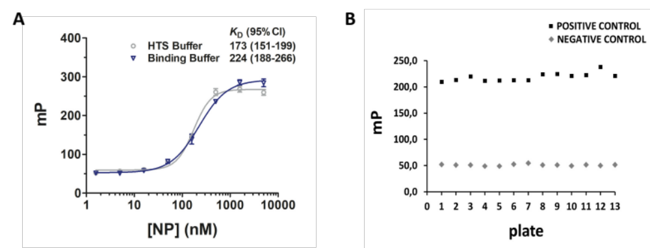
Figure S1. Validation of a screening assay for the SARS-CoV-2 N protein. A) FP assays showing that the binding affinity of the RNA1 probe for the N protein is not affected by 2% DMSO and 0.01% triton X-100, two additives absent in the binding buffer (50 mM Sodium Phosphate, 0.1 M NaCl, pH7.6) but present in the buffer used in the HTS trials. B) Scatter plot showing the mP values for positive and negative controls obtained for each HTS assay plate. The mean and standard deviation values for positive and negative controls were 220.2 ± 5.1 and 51.1 ± 3.2, respectively.

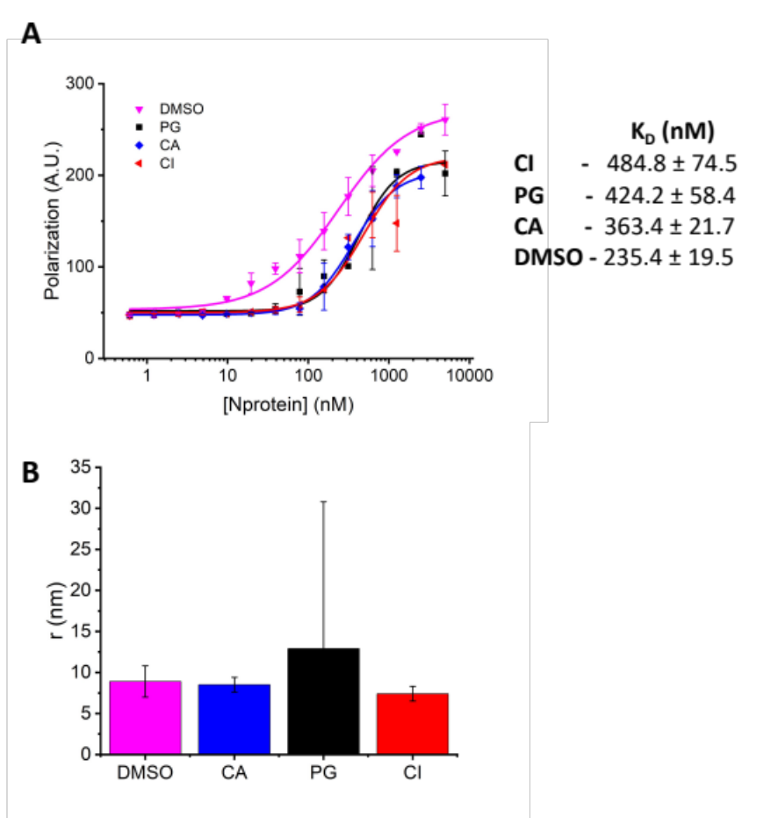
Figure S2. The binding affinity of RNA1 to the N protein is reduced in the presence of CI, PG and CA and the phenolic acids CI and CA are not protein aggregators. A) FP assay showing that when the N protein in the presence of CI, CA or PNG, is titrated against RNA1, its binding affinity for RNA1 is reduced, as indicated by the corresponding KD values. Error bars represent standard deviation of the means of three independent experiments. B) DLS measurements of N protein samples incubated with two-fold molar excess of each compound (CI, CA or PN at 20 µM final concentration), showing that the phenolic acids CI and CA do not significantly change the Rh or the oligomeric state of the N protein. PN, on the other hand, appears to cause N protein aggregation, as indicated by the variation in the Rh values obtained. Plotted values are the means of three independent measurements with error bars denoting standard deviations.

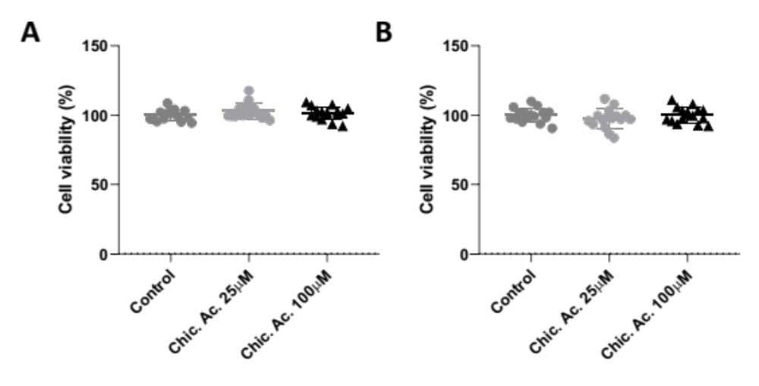
Figure S3. Cell viability assays in the presence of CA. Calu-3 and Vero CCL81 cells were treated with CA at 25 µM or 100 µM for 48 h. Cell viability was evaluated using the MTT assay. DMSO at 0.2% final concentration was used as vehicle control. Results are expressed as individual values (n=16) and error bars represent mean +/- standard deviation.

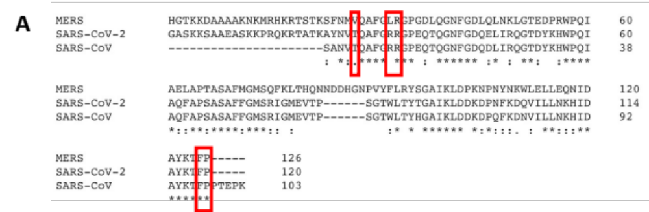

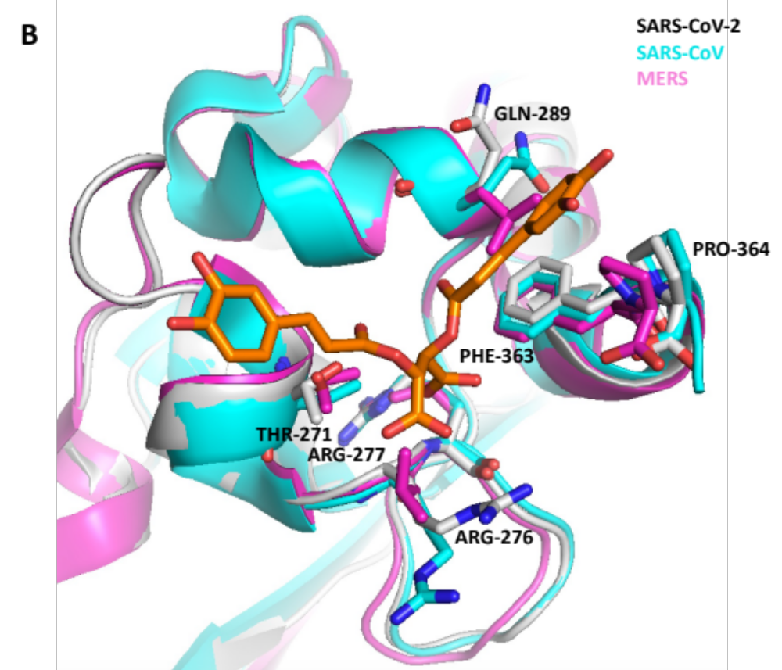

Figure S4. Sequence and structural alignment of SARS-CoV-2, SARS-CoV and MERS N proteins CTDs show conservation of the CA-binding site among these pathogenic human coronaviruses. A) Multiple sequence alignment with CLUSTAL O (1.2.4). B) Superposition of the N protein CTDs crystal structures for SARS-CoV-2 (PDB ID 7UXZ, grey), SARS-CoV (PDB entry 2GIB, cyan) and MERS (PDB entry 6G13, magenta). The residues involved in CA binding are shown as sticks and labelled.
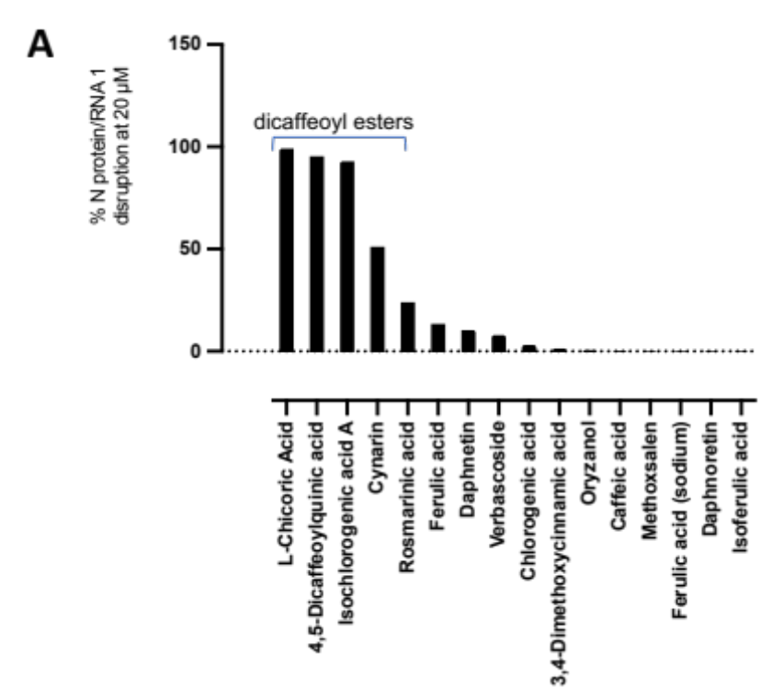
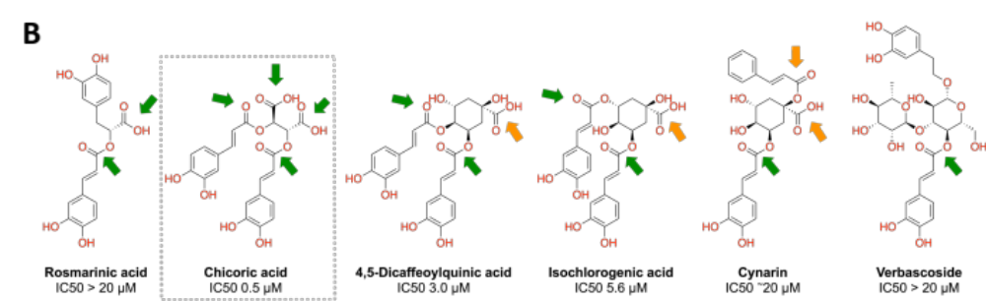
Figure S5. Initial structure-activity relationship (SAR) analysis of 16 compounds containing caffeoyl substructures assessed in our screening efforts against SARS-CoV-2 N protein suggests that both dicaffeoyl carbonyls and symmetric carboxylates are key pharmacophores for the CA-N protein biding site. A) Sixteen compounds assessed in our screening efforts and containing caffeoyl substructures, those bearing two caffeoyl esters clearly stand out with over 50% N protein-RNA1 disruption at 20 µM. B) In CA, the most potent derivative (IC50 = 0.5 µM), the dicaffeoyl units are bound to tartaric acid, whose carboxylate moieties’ contribution for protein binding have been established. The other three dicaffeoyl derivatives are in fact isomers of dicaffeoylquinic acid, being 4,5-dicaffeoylquinic acid, 3,5-dicaffeoylquinic acid (isochlorogenic acid A) and 1,5-dicaffeoylquinic acid (cynarin). Assuming that they bind to the same site as CA, one can see that the caffeoyl esters could occupy similar positions, especially for 4,5-dicaffeoylquinic acid and isochlorogenic acid A. Their single carboxylate moiety at C1 would be further way in comparison to CA, but still able to engage in ionic interactions with positively charged residues, but clearly, this modification causes a ~10-fold loss in IC50 values. Looking at cynarin or 1,5-dicaffeoylquinic acid, one could propose that in order to accommodate the caffeoyl esters similarly to its congeners and CA, the carboxylate moiety would be moved from the arginine-rich region, yielding a much weaker binding affinity. Or one could suggest that in order to achieve ionic interactions between the carboxylate and arginine residues, the caffeoyl ester moieties would lose contact with the protein, likewise yielding low binding affinity. This observation can be extended to the other caffeoyl derivatives, such as rosmarinic acid and verbascoside which showed low N protein/RNA1 disruption, and which only contain one or two of the 4 key elements found in CA. Indeed, the two carboxylate and two caffeoyl ester moieties are important for binding to the N protein and to induce conformational changes that affect its RNA binding function.

