Fig. S1. Endometrial lavage samples and patients of this study. Sample identifiers were derived from Table S1.

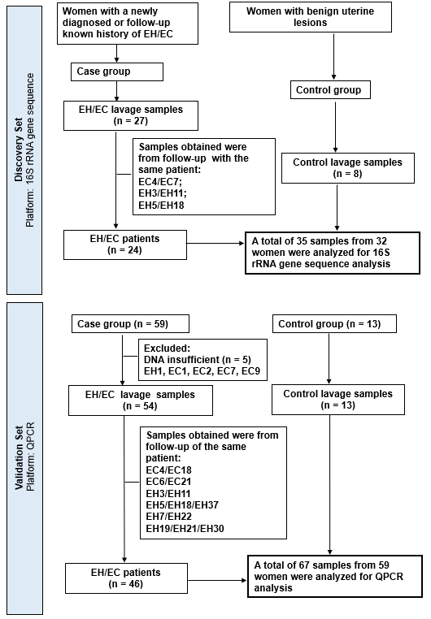
Table S1. Characteristics of the uterine lavage samples analyzed in the study

Sample ID | Age | Pathology findings | EC stage | Analysis by 16S sequencing | Analysis by QPCR
B1 | 51 | benign | - | O | O
B2 | 31 | benign | - | O | O
B3 | 41 | benign | - | O | O
B4 | 47 | benign | - | O | O
B5 | 70 | benign | - | O | O
B6 | 43 | benign | - | O | O
B7 | 33 | benign | - | O | O
B8 | 41 | benign | - | O | O
B9 | 46 | benign | - | - | O
B10 | 46 | benign | - | - | O
B11 | 44 | benign | - | - | O
B12 | 48 | benign | - | - | O
B13 | 41 | benign | - | - | O
EC1 | 66 | metastatic lobular carcinoma | NA | O | -
EC2 | 34 | progesterone effect, history of EC | IA | O | -
EC3 | 50 | EC | IA | O | O
EC4 | 35 | progesterone effect, history of EC | IA | O | O
EC5 | 57 | EC | IA | O | O
EC6 | 31 | progesterone effect, history of EC | IA | O | O
EC7 | 35 | progesterone effect, history of EC | IA | O | -
EC8 | 56 | ductal carcinoma, metastatic | NA | O | O
EC9 | 29 | EH, history of EC | IA | O | -
EC10 | 44 | EC | IIIA | - | O
EC11 | 29 | EC | IA | - | O
EC12 | 51 | EC | II | - | O
EC13 | 28 | EC | IA | - | O
EC14 | 39 | progesterone effect, history of EC | IA | - | O
EC15 | 41 | EC | IA | - | O
EC16 | 40 | EC | II | - | O
EC17 | 32 | EC | IA | - | O
EC18 | 35 | negative, history of EC | IA | - | O
EC19 | 29 | progesterone effect, history of EC | IA | - | O
EC20 | 41 | progesterone effect, history of EC | IA | - | O
EC21 | 31 | negative, history of EC | IA | - | O
EC22 | 35 | EH, history of EC | IA | - | O
EH1 | 46 | EH | - | O | -
EH2 | 45 | EH | - | O | O
EH3 | 38 | EH | - | O | O
EH4 | 49 | EH | - | O | O
EH5 | 22 | progesterone effect, history of EH | - | O | O
EH6 | 56 | EH | - | O | O
EH7 | 40 | EH | - | O | O
EH8 | 52 | EH | - | O | O
EH9 | 46 | EH | - | O | O
EH10 | 48 | EH | - | O | O
EH11 | 38 | history of EH | - | O | O
EH12 | 49 | EH | - | O | O
EH13 | 60 | EH | - | O | O
EH14 | 34 | EH | - | O | O
EH15 | 43 | EH | - | O | O
EH16 | 33 | EH | - | O | O
EH17 | 48 | EH | - | O | O
EH18 | 22 | progesterone effect, history of EH | - | O | O
EH19 | 31 | progesterone effect, history of EH | - | - | O
EH20 | 51 | EH | - | - | O
EH21 | 31 | progesterone effect, history of EH | - | - | O
EH22 | 40 | EH | - | - | O
EH23 | 49 | EH | - | - | O
EH24 | 38 | history of EH | - | - | O
EH25 | 53 | history of EH | - | - | O
EH26 | 34 | EH | - | - | O
EH27 | 51 | EH | - | - | O
EH28 | 42 | EH | - | - | O
EH29 | 44 | EH | - | - | O
EH30 | 31 | progesterone effect, history of EH | - | - | O
EH31 | 47 | EH | - | - | O
EH32 | 27 | progesterone effect, history of EH | - | - | O
EH33 | 46 | EH | - | - | O
EH34 | 43 | progesterone effect, history of EH | - | - | O
EH35 | 39 | EH | - | - | O
EH36 | 44 | history of EH | - | - | O
EH37 | 22 | progesterone effect, history of EH | - | - | O
O: were analyzed by16S rRNA sequence or QPCR

Samples obtained were from the same patient:
EC4/EC7/EC18;
EC6/EC21;
EC9/EC19;
EH3/EH11;
EH5/EH18/EH37;
EH7/EH22;
EH19/EH21/EH30
EH comprised both simple hyperplasia and atypical hyperplasia.
Abbreviations: EC, endometrial cancer; EH, endometrial hyperplasia; NA, not applicable.

