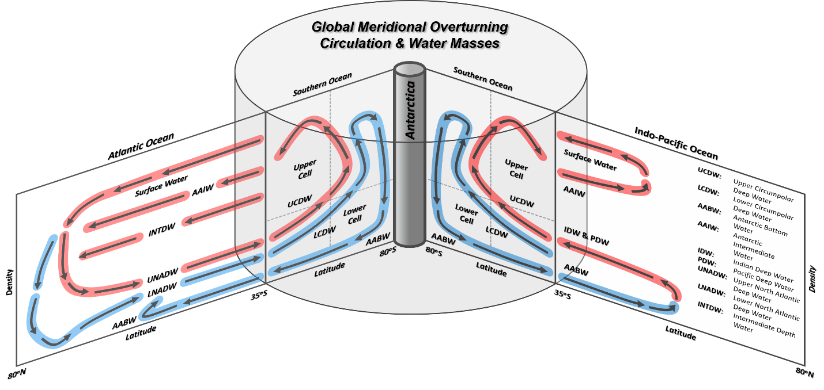
Figure S1. A schematic of the GMOC in the Southern Ocean (south of 35°S), the Indo-Pacific Ocean and the Atlantic Ocean (north of 35°S) and the water masses referenced in this study³⁴⁻³⁶. Arrows with red shade indicate the transports contributing to the upper overturning cell, while those with blue shade indicate the transports contributing to the lower overturning cell. The vertical axis is density.

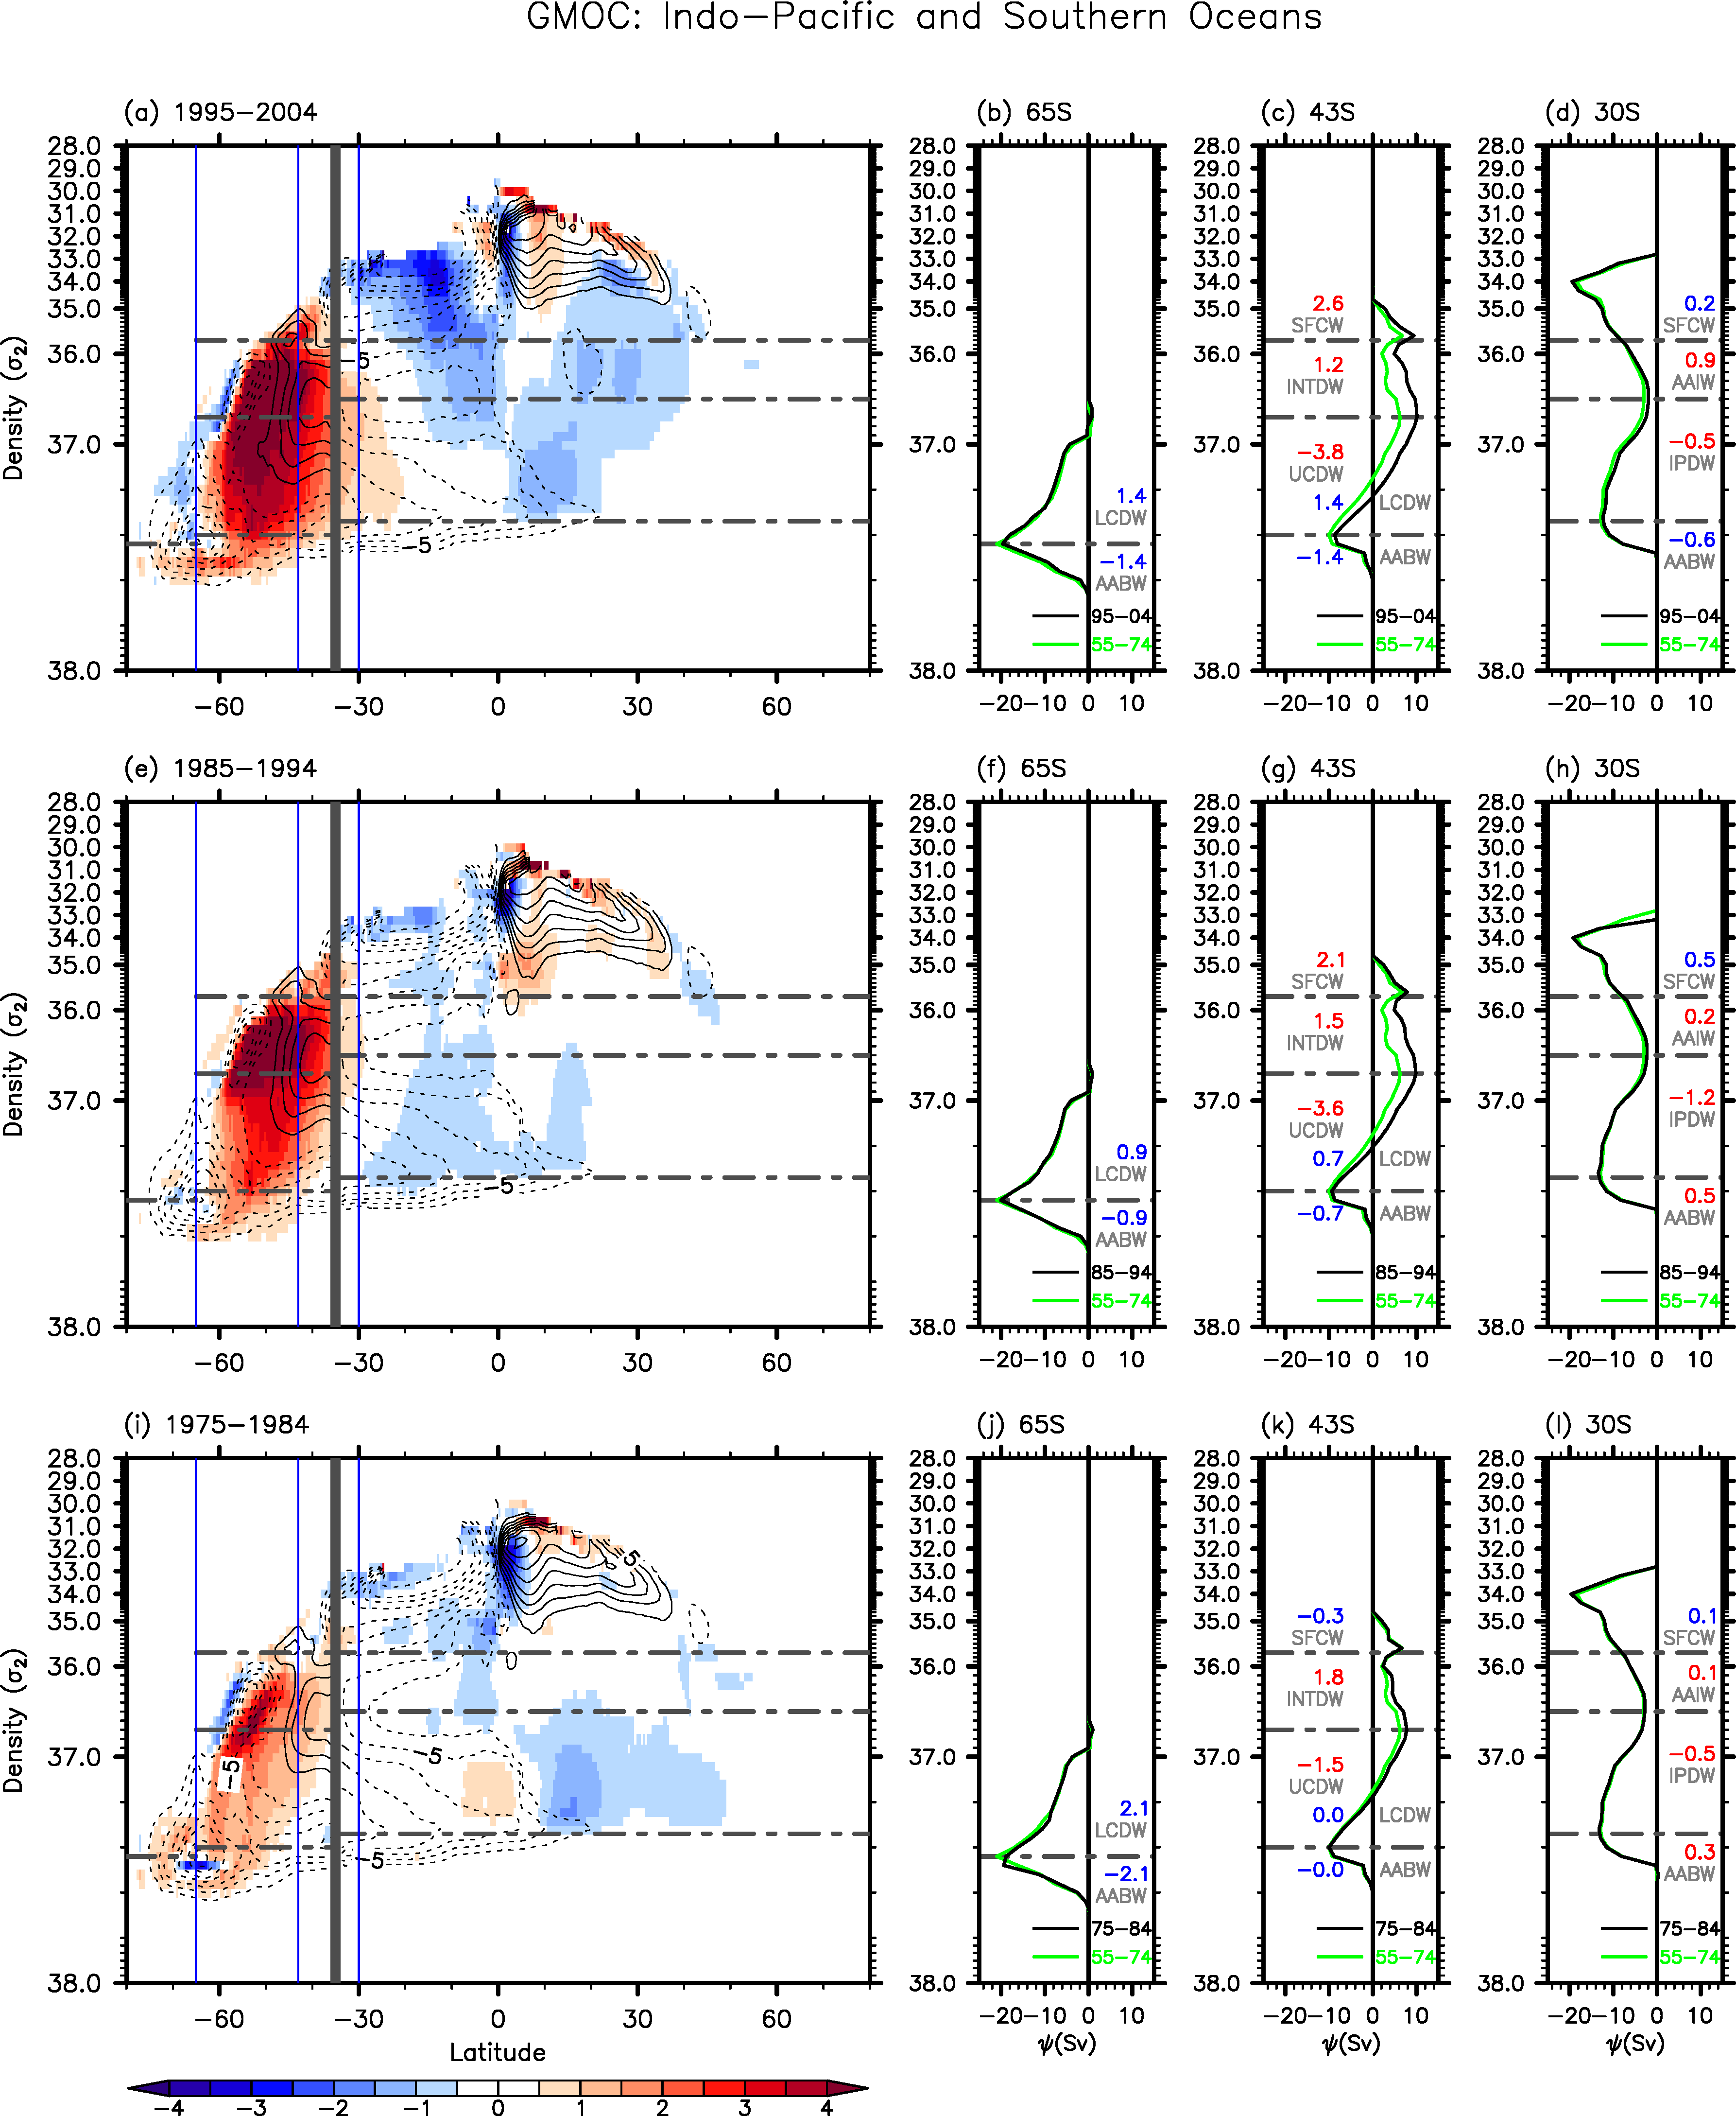
Figure S2. The GMOC (contours) in the Southern Ocean (south of 35°S) and the Indo-Pacific Ocean (north of 35°S) and its changes (shades) during (a) 1995-2004, (e) 1985-1994, and (i) 1975-1984 in reference to the base period of 1955-1974. The GMOC at (b,f,j) 65°S and (c,g,k) 43°S in the Southern Ocean, and at (d,h,l) 30°S in the Indo-Pacific Ocean during (b,c,d) 1995-2004, (f,g,h) 1985-1994, and (j,k,l) 1975-1984 (black lines) in reference to those during 1955-1974 (green lines). The vertical axis is potential density in reference to 2,000 m (σ₂ units). The differences in GMOC transport values for SFCW, AAIW, INTDW, UCDW, LCDW, IPDW, and AABW are shown at (b,f,i) 65°S, (c,g,k) 43°S, and (d,h,l) 30°S. Red color is for the increased transport values, and blue color for the decreased transport values. Volume transports are in Sv units.
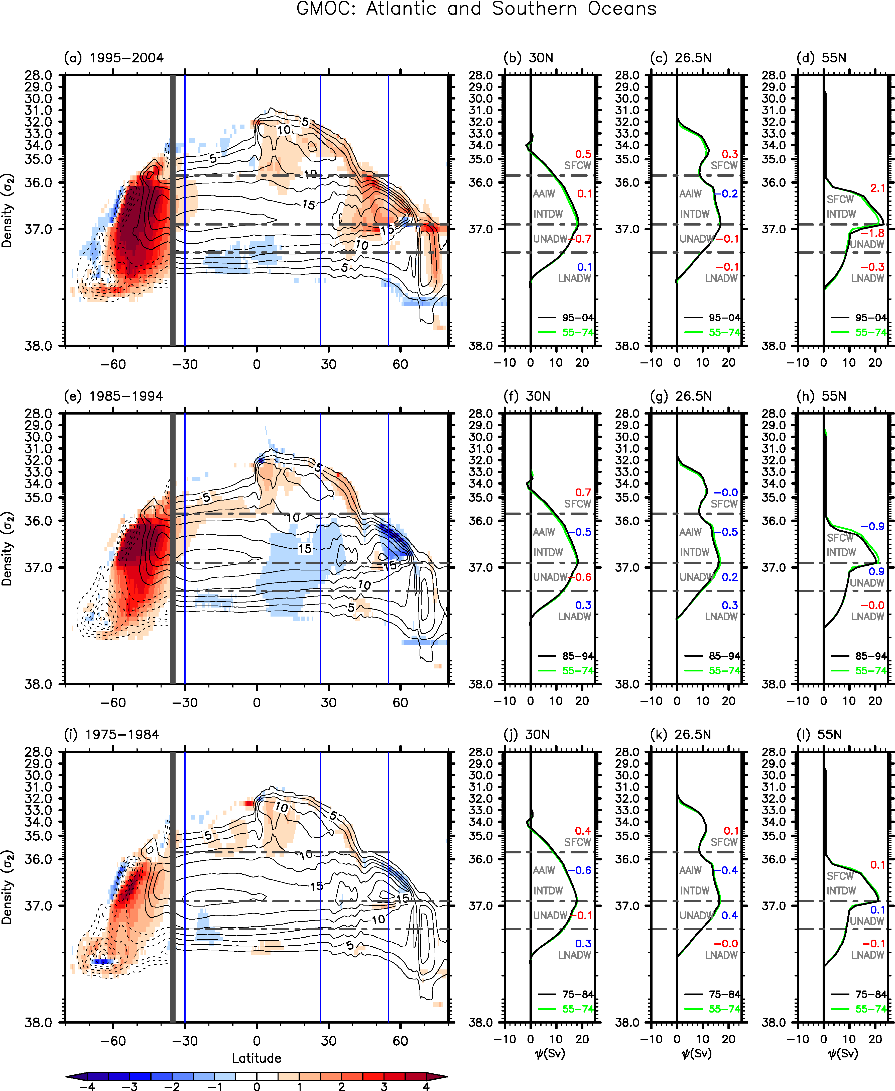
Figure S3. The GMOC (contours) in the Southern Ocean (south of 35°S) and the Atlantic Ocean (north of 35°S) and its changes (shades) during (a) 1995-2004, (e) 1985-1994, and (i) 1975-1984 in reference to the base period of 1955-1974. The AMOC at (b,f,j) 30°S, (c,g,k) 26.5°N, and (d,h,l) 55°N during (b,c,d) 1995-2004, (f,g,h) 1985-1994, and (j,k,l) 1975-1984 (black lines) in reference to those during 1955-1974 (green lines). The vertical axis is potential density in reference to 2,000 m (σ₂ units). The differences in AMOC transport values for SFCW, AAIW, INTDW, UNADW and LNADW are shown at (b,f,j) 30°S, (c,g,j) 26.5°N, and (d,h,l) 55°N. Red color is for the increased transport values, and blue color for the decreased transport values. Volume transports are in Sv units.

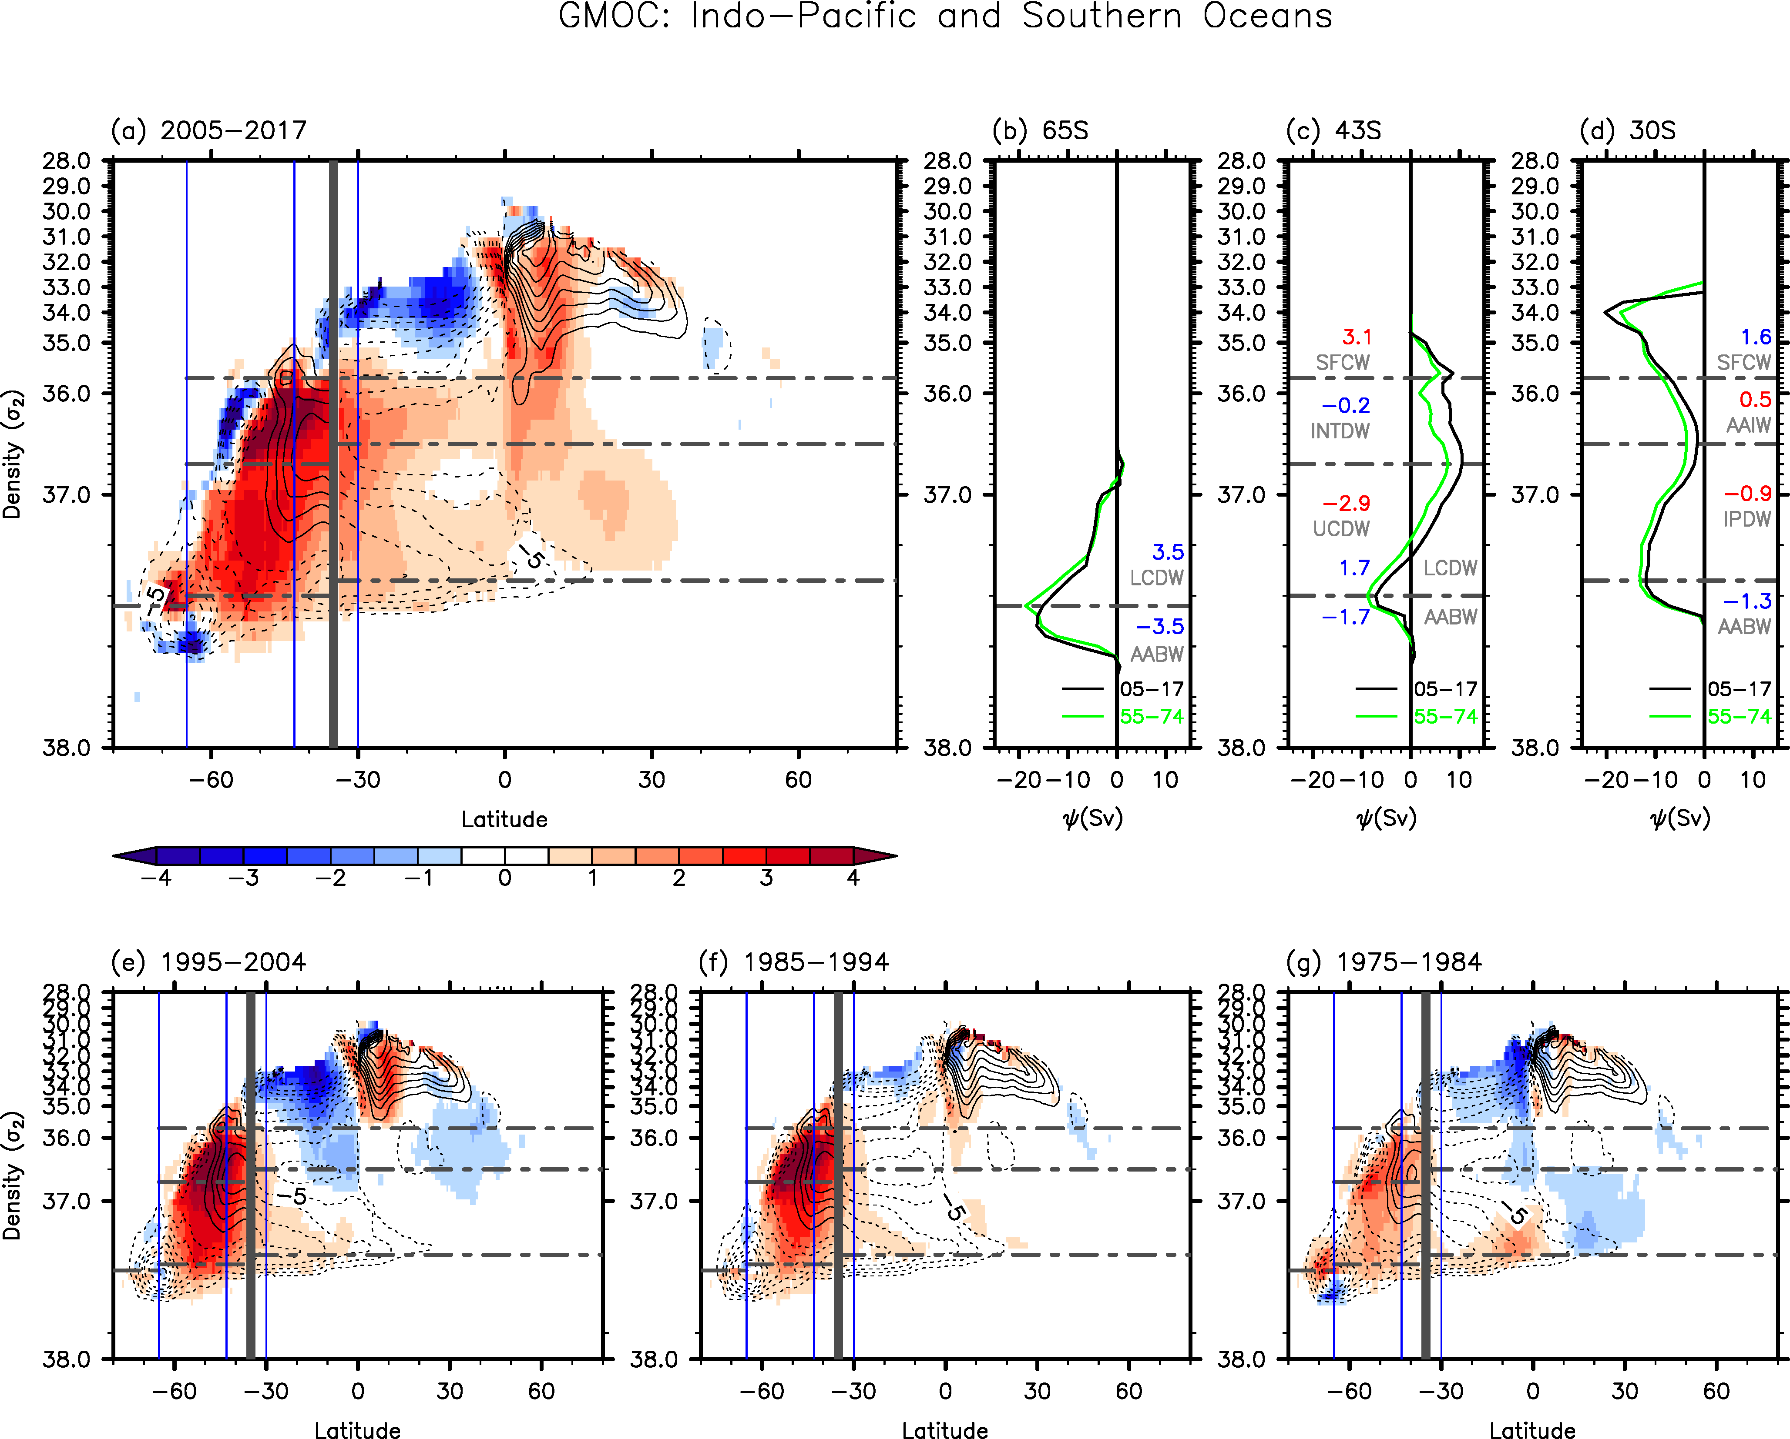
Figure S4. Same as Figure 1 except that EN4 data is used instead of WOA18.

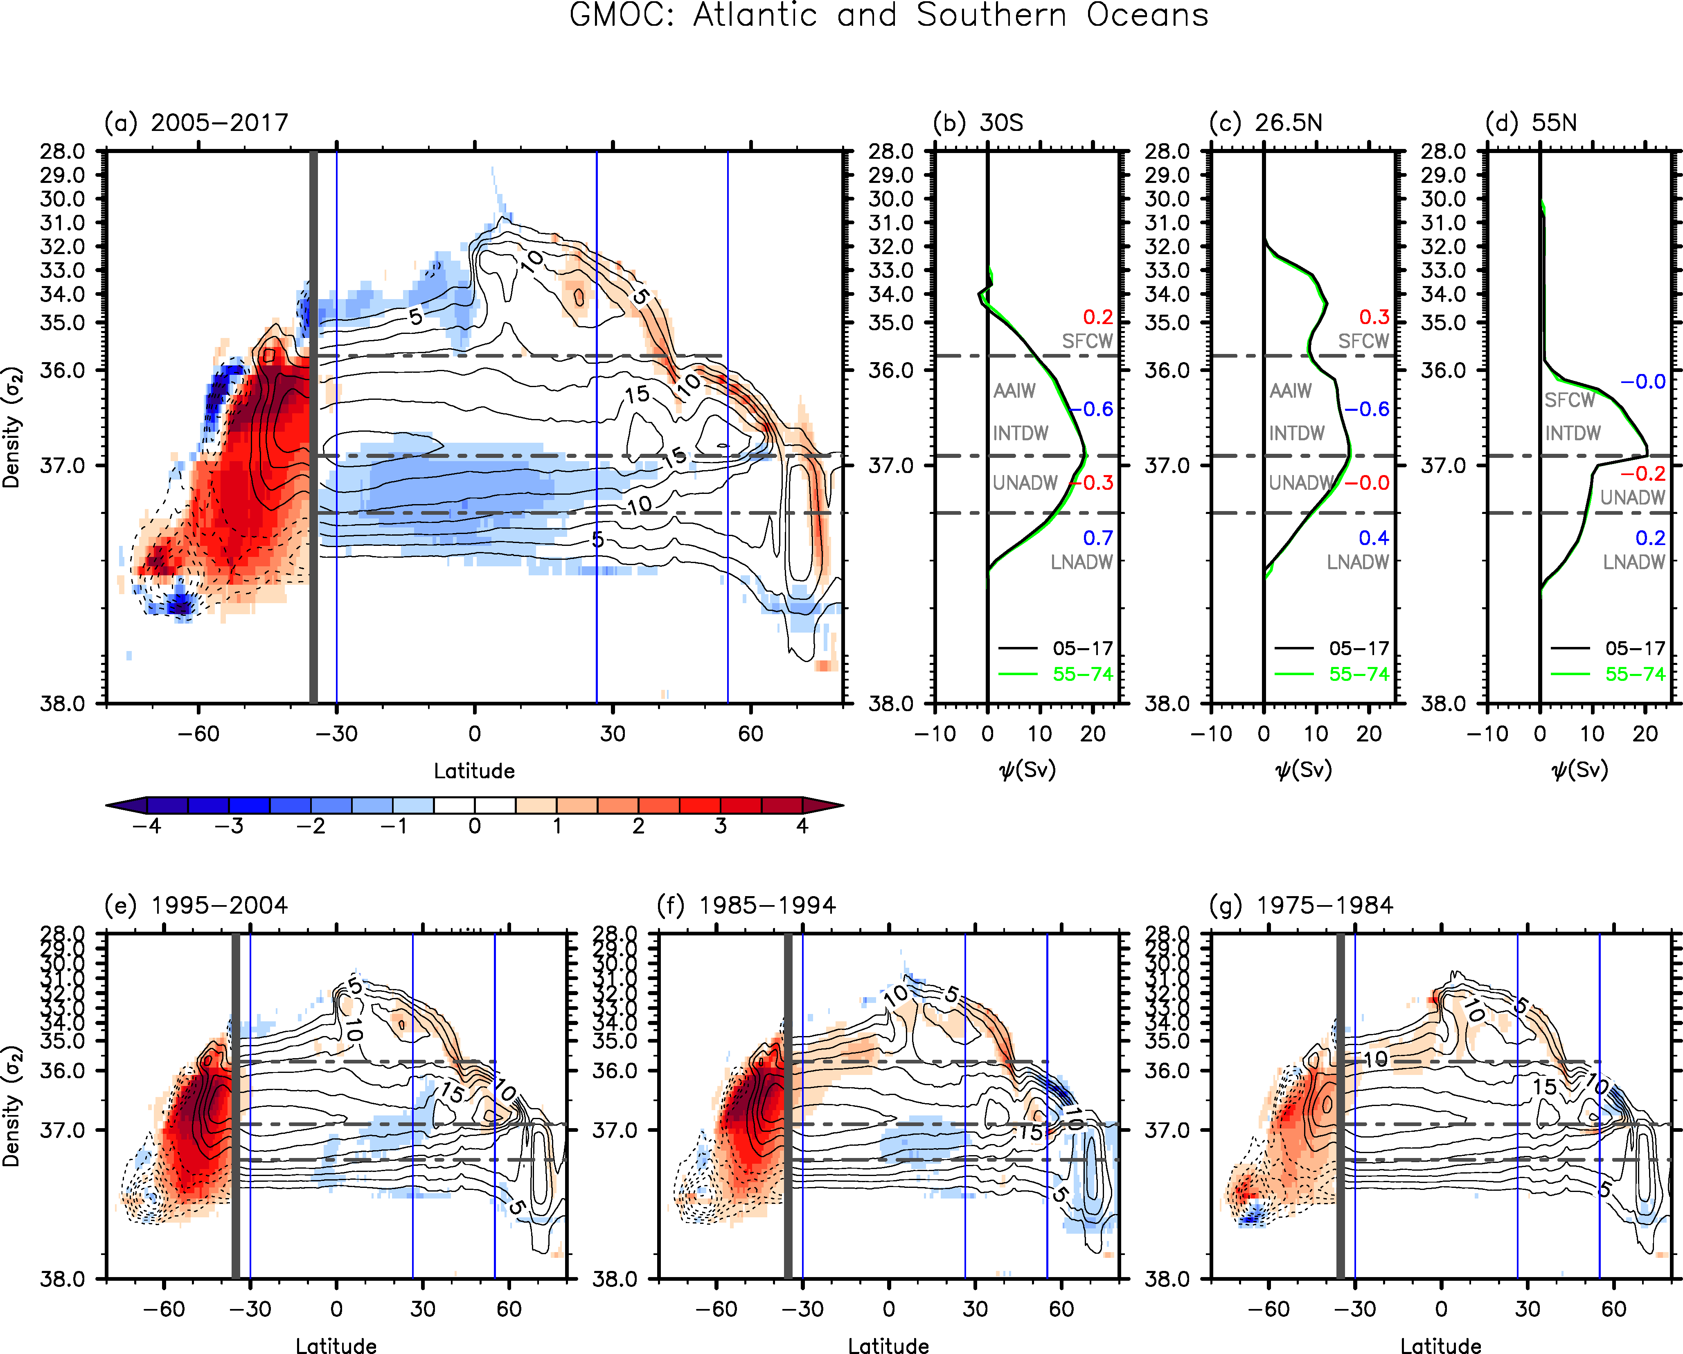
Figure S5. Same as Figure 2 except that EN4 data is used instead of WOA18.

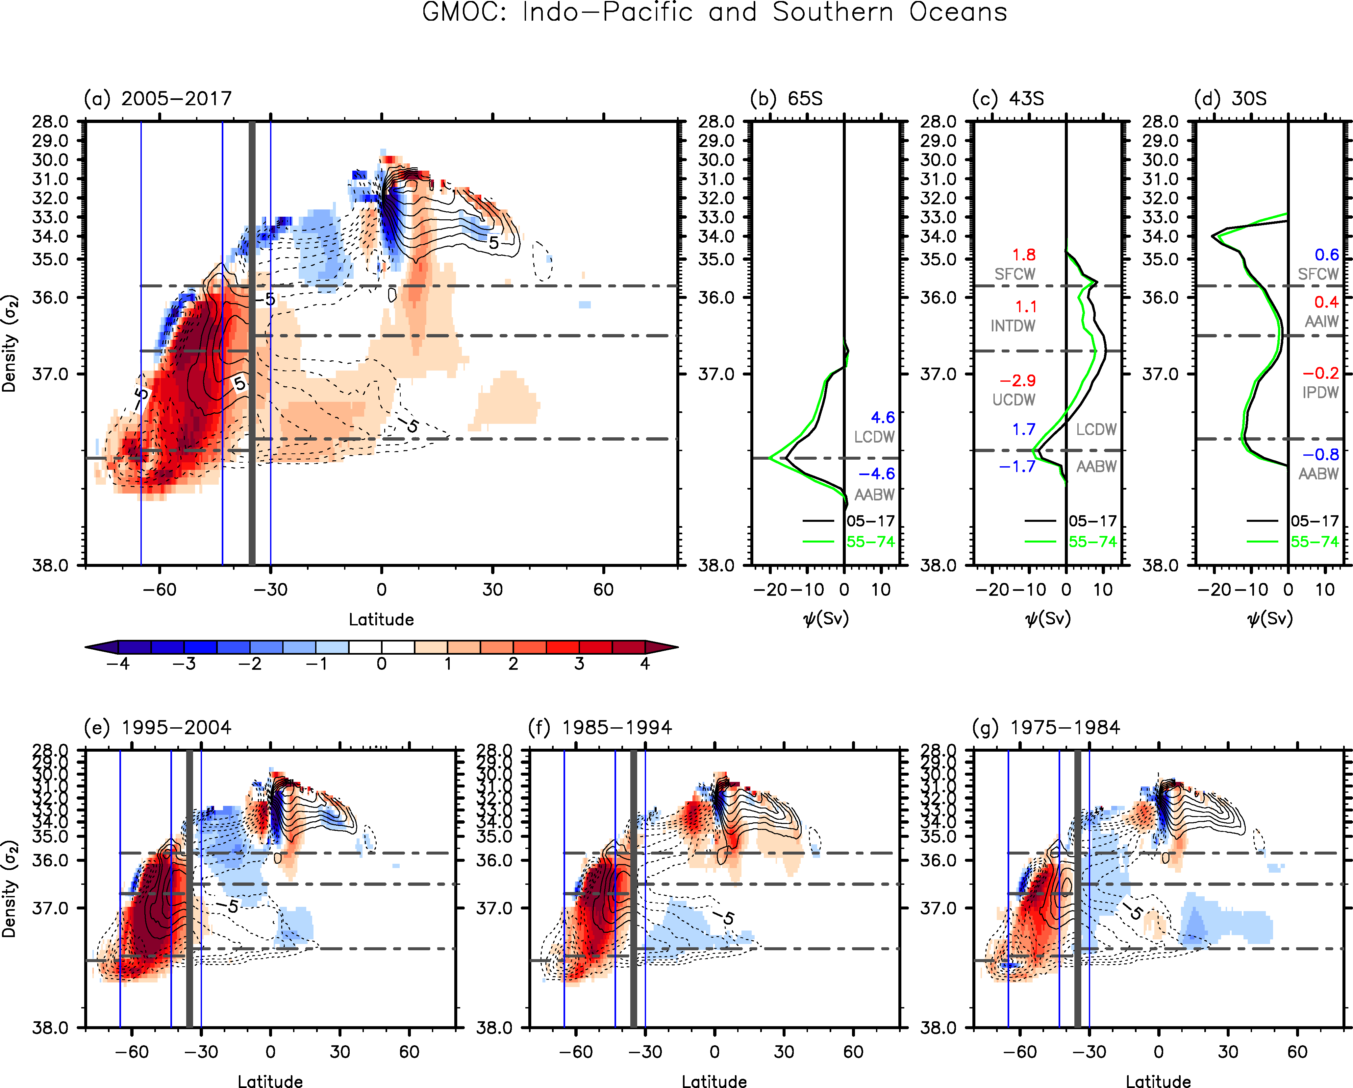
Figure S6. Same as Figure 1 except that JRA55 surface forcing fields are used instead of ERA5 surface forcing fields.

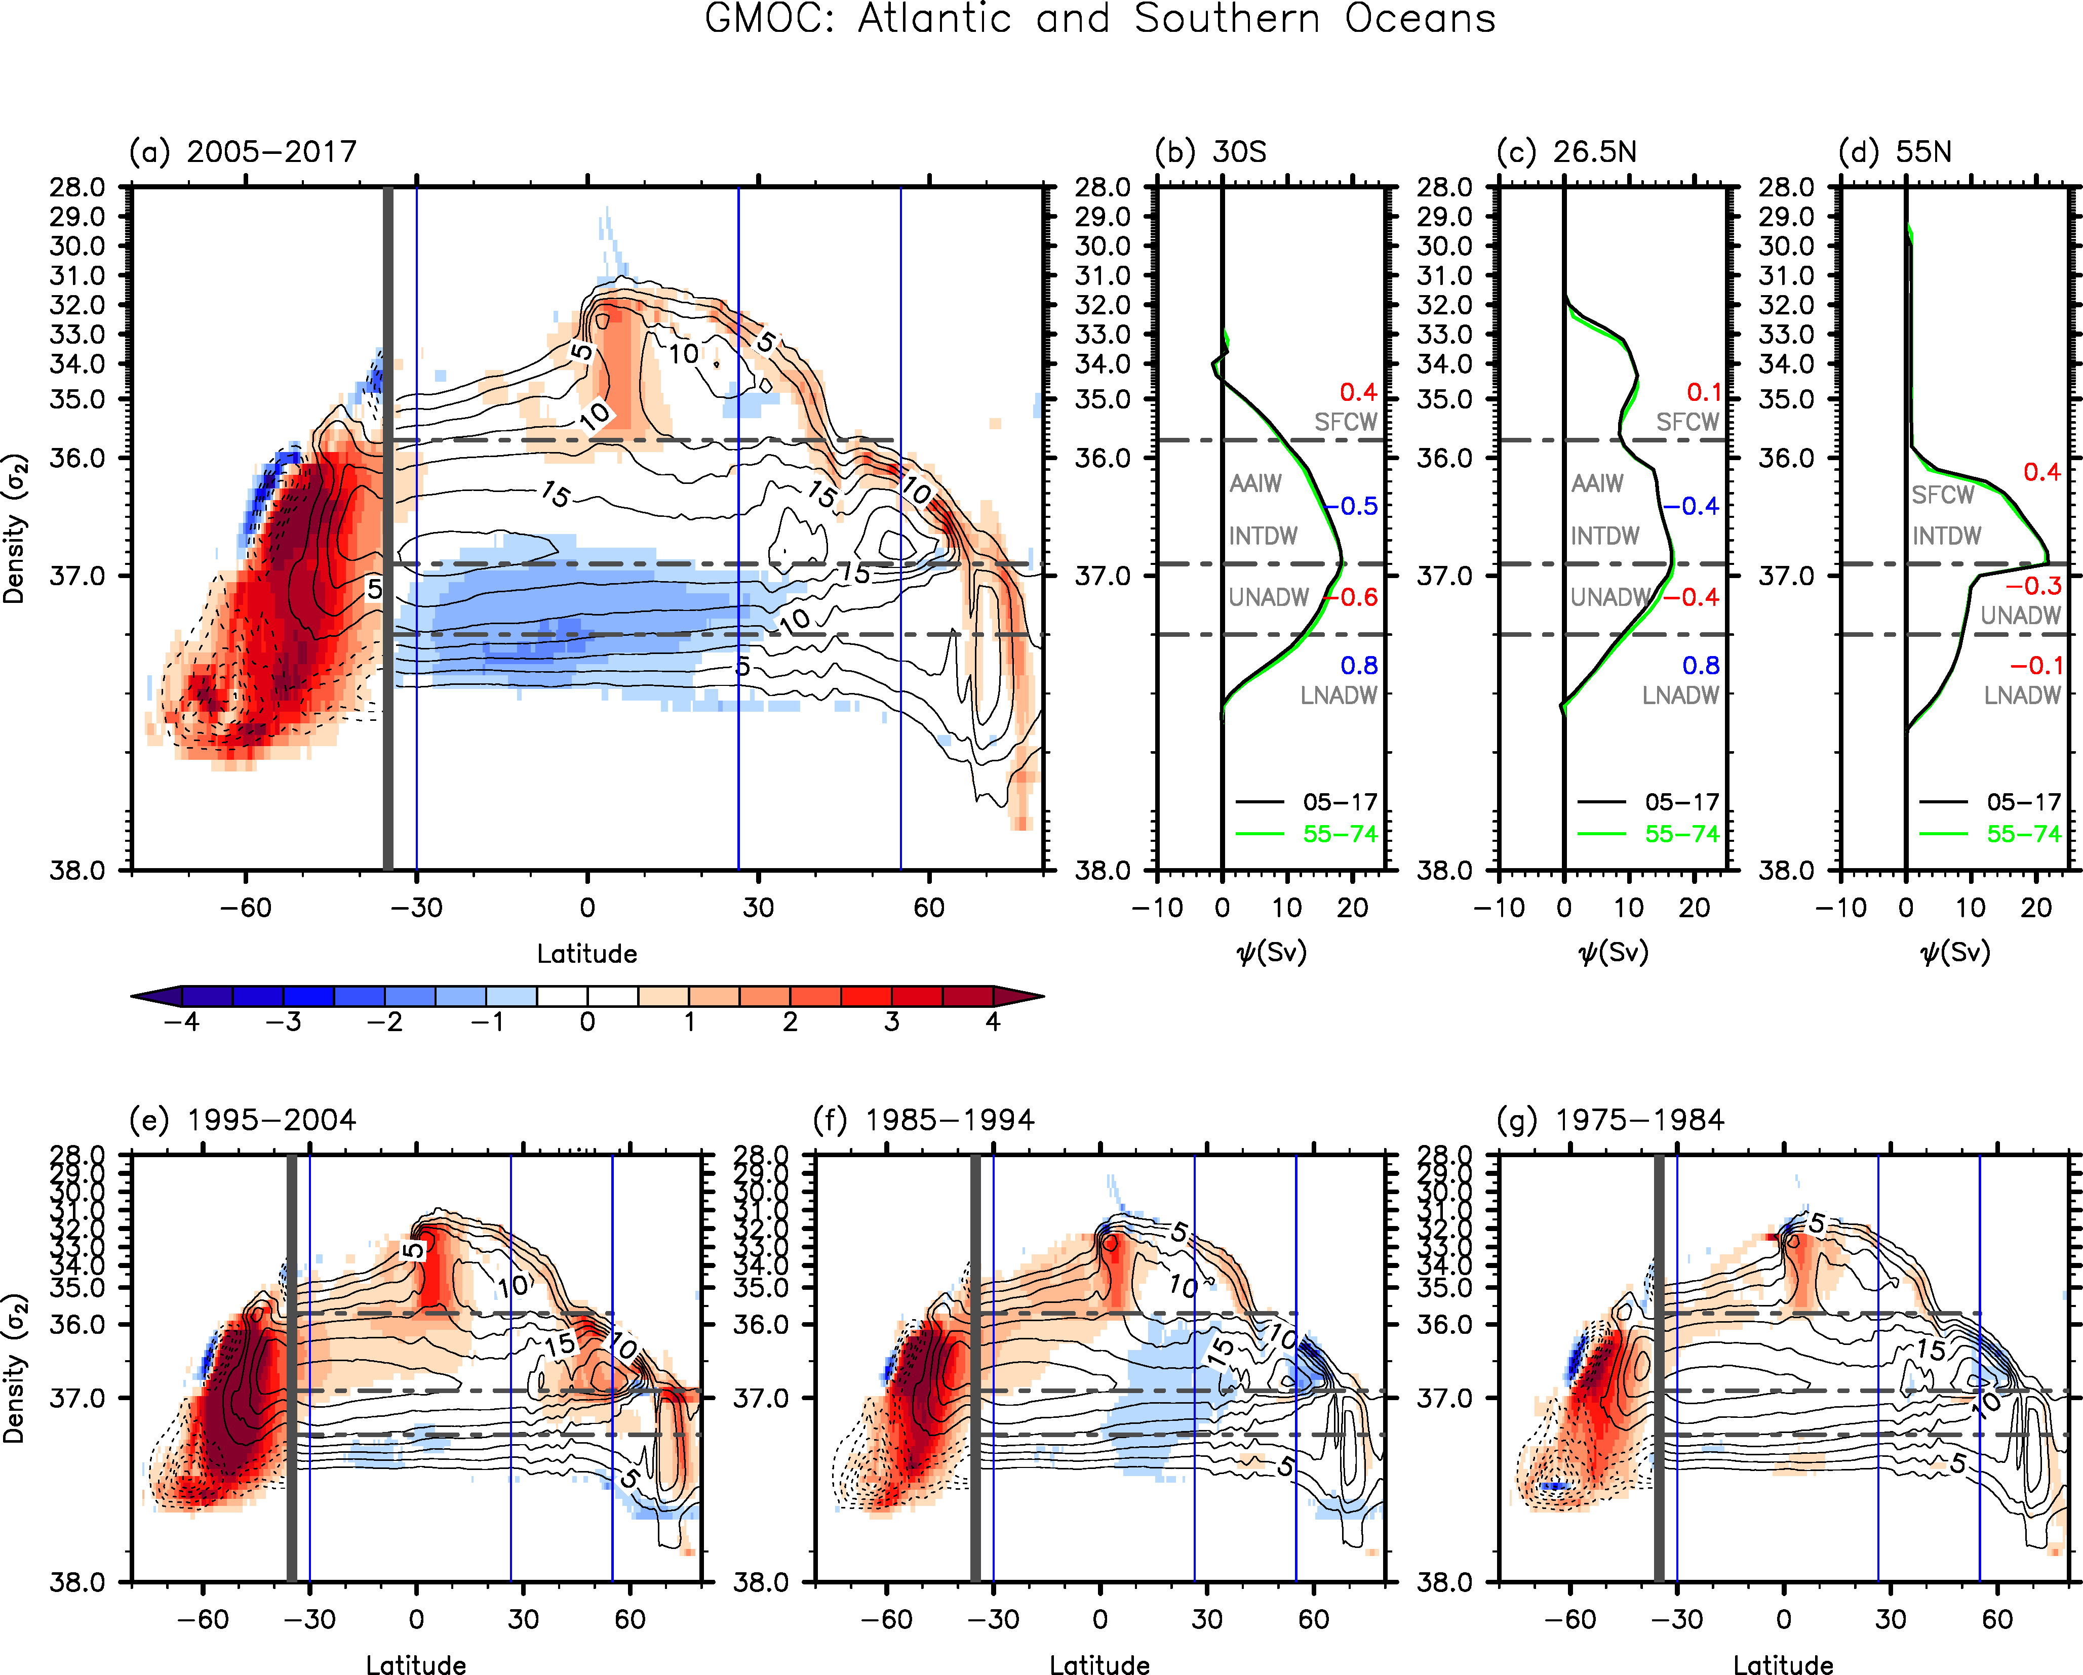
Figure S7. Same as Figure 2 except that JRA55 surface forcing fields are used instead of ERA5 surface forcing fields.

Table S1. The differences in overturning transport values between 2005-2017 and 1955-1974 for SFCW, AAIW, INTDW, UCDW, LCDW, and AABW at the core latitudes of the lower and upper overturning cells in the Southern Ocean (i.e., 65°S and 43°S) and at 30°S in the Indo-Pacific Ocean, derived from the three different sets of data-constrained ocean model simulations. The mean and standard deviation values derived from the three sets of simulations are also indicated. Red color is for the increased transport values, and blue color for the decreased transport values. Bold values indicate that the mean is larger than the stand deviation. Volume transports are in Sv units.
Hydrography Data | WOA18 |  | EN4 |  | WOA18 |  | Average
Surface Forcing | ERA5 |  | ERA5 |  | JRA55
65°S (Southern Ocean)
LCDW | 3.3 |  | 3.5 |  | 4.6 |  | 3.8±0.5
AABW | -3.3 |  | -3.5 |  | -4.6 |  | -3.8±0.5
43°S (Southern Ocean)
SFCW | 3.0 |  | 3.1 |  | 1.8 |  | 2.6±0.6
INTDW | 0.5 |  | -0.2 |  | 1.1 |  | 0.5±0.3
UCDW | -3.5 |  | -2.9 |  | -2.9 |  | -3.1±0.3
LCDW | 1.4 |  | 1.7 |  | 1.7 |  | 1.6±0.1
AABW | -1.4 |  | -1.7 |  | -1.7 |  | -1.6±0.1
30°S (Indo-Pacific Ocean)
SFCW | 1.0 |  | 1.6 |  | 0.6 |  | 1.1±0.4
AAIW | 0.4 |  | 0.5 |  | 0.4 |  | 0.4±0.0
IPDW | -0.5 |  | -0.9 |  | -0.2 |  | -0.5±0.2
AABW | -0.9 |  | -1.3 |  | -0.8 |  | -1.0±0.2

Table S2. The differences in overturning transport values between 2005-2017 and 1955-1974 for SFCW, AAIW, INTDW, UNADW and LNADW at 30°S, 26.5°N and 55°N in the Atlantic Ocean, derived from the three different sets of data-constrained ocean model simulations. The mean and standard deviation values derived from the three sets of simulations are also indicated. Red color is for the increased transport values, and blue color for the decreased transport values. Bold values indicate that the mean is larger than the stand deviation. Volume transports are in Sv units.
Hydrography Data | WOA18 |  | EN4 |  | WOA18 |  | Average
Surface Forcing | ERA5 |  | ERA5 |  | JRA55
30°S (Atlantic Ocean)
SFCW | 0.1 |  | 0.2 |  | 0.4 |  | 0.2±0.1
INTDW | -0.6 |  | -0.6 |  | -0.5 |  | -0.6±0.0
UNADW | -0.5 |  | -0.3 |  | -0.6 |  | -0.5±0.1
LNADW | 1.1 |  | 0.7 |  | 0.8 |  | 0.9±0.2
25.6°N (Atlantic Ocean)
SFCW | 0.2 |  | 0.3 |  | 0.1 |  | 0.2±0.1
INTDW | -0.7 |  | -0.6 |  | -0.4 |  | -0.6±0.1
UNADW | -0.3 |  | 0.0 |  | -0.4 |  | -0.2±0.2
LNADW | 0.8 |  | 0.4 |  | 0.8 |  | 0.7±0.2
55°N (Atlantic Ocean)
SFCW | 0.5 |  | 0.0 |  | 0.4 |  | 0.3±0.2
UNADW | -0.5 |  | -0.2 |  | -0.3 |  | -0.3±0.1
LNADW | 0.0 |  | 0.2 |  | -0.1 |  | 0.1±0.1

