Influence of thinning intensity and frequency on the provision of ecosystem services in Mediterranean mountain pine forests under climate change scenarios

APPENDICES

Appendix A – Material and methods

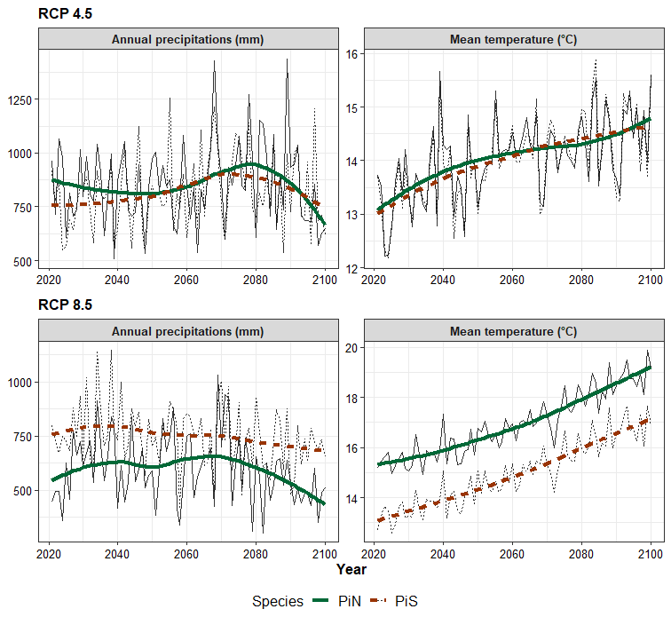
Figure A.1. Predicted changes in precipitations and temperature between 2021 – 2100 in the study area under RCP 4.5 and RCP 8.5

Table A.1. Dasometric characteristics of the initial stands
 | Pinus sylvestris | Pinus nigra
Age | 20 | 20
N (trees/ha) | 2,500 | 2,100
Mean DBH (cm) | 10.7 | 9.6
Basal area (m²/ha) | 46.2 | 40.4
Dg (cm) | 15.3 | 15.7

Table A.2. Details of each thinning regime, including the frequency, intensity, and years of application
Nr. crt | Frequency (every __ years) | The ages when the thinning was applied (years) | Intensity (%)
1 | No intervention regime
2 | 10 | 20, 30, 40, 50 | 15
3 | 10 | 20, 30, 40, 50 | 25
4 | 10 | 20, 30, 40, 50 | 35
5 | 15 | 20, 35, 50, 65 | 15
6 | 15 | 20, 35, 50, 65 | 25
7 | 15 | 20, 35, 50, 65 | 35
8 | 20 | 20, 40, 60 | 15
9 | 20 | 20, 40, 60 | 25
10 | 20 | 20, 40, 60 | 35
11 | 25 | 20, 45, 70 | 15
12 | 25 | 20, 45, 70 | 25
13 | 25 | 20, 45, 70 | 35

Each thinning regime was applied for each species (Pinus sylvestris and Pinus nigra) and two climate scenarios RCP 4.5 and RCP 8.5. Therefore, 52 thinning regimes were considered for this study. In addition, these 52 regimes, were simulated 5 times in order to include the stochasticity of processes, thus, in the end, the study included 260 simulations (13 regimes x 2 species x 2 RCP x 5 repetitions).

Appendix B – Calculations of ecosystem services

- Model for mushroom production

Source: Bonet et al. (2010)
(Eq. B.1)
$$\ln{{(y}_{ij})= β_{0}+ β_{1} × \ln\left(G_{ij}\right)+ β_{2}× \sqrt{G_{ij }}+ β_{3} × \ln\left({Ele}_{i}\right)+ β_{4} × \ln{({Slo}_{i}+1)} × \cos\left({Asp}_{i}\right)+ u_{i}+ u_{j}+ ε_{ij}}$$
Where:
y_{ij} is the mushroom production of plot i in year j $[kg∙{ha}^{-1}∙{year}^{-1}]$
G is the basal area on the stand [$m^{2}∙{ha}^{-1}]$
Asp is the aspect (rad)
Slo is slope
Ele is the elevation (m above sea level)

u_{i} is the random plot factor:

$\hat{u_{i}}= β_{0}+ β_{1} × {planted}_{i}+ β_{2} × {Slo}_{i}^{1.5}+ β_{3} ×{sylvestris}_{i}+ ε_{i}$ (Eq. B.2)

where:
‘planted’’ is a dummy variable that is equal to 1 for planted Pinus sylvestris stands and otherwise zero
‘‘sylvestris’’ is a dummy variable equal to 1 for Pinus sylvestris dominated stands and is zero for P. nigra

u_{j} is the random year factor:

${\hat{u}}_{j}= β_{0}+ β_{1} × \ln{({AutumnRain}_{j}) + ε_{j}}$ (Eq. B3)
where:
‘‘AutumnRain’’ is the total autumn rainfall (mm) during August, September, October, and November in year j
$ε_{ij}$ is the residual

Table B.1. Parameters in the equations B1, B2, B3
Parameter | Eq. 1 | Eq. 2 | Eq. 3
$$β_{0}$$ | -23.960 | 0.101 | -16.833
$$β_{1}$$ | 4.590 | -0.473 | 3.151
$$β_{2}$$ | -2.375 | -0.004
$$β_{3}$$ | 3.441 | 0.863
$$β_{4}$$ | 0.445

- Model for volume estimation

Source: AllometrApp of the Catalan Forestry Lab
(Eq. B4)
$$VOB = a + b × {(DBH × 10)}^{2} × H_{t}$$
where:
VOB = Over bark volume [m³]
DBH is the diameter at breast height (cm)
H_{t} is the height (m)

Table B.2. Parameters in equation B4
Parameter | Pinus sylvestris | Pinus nigra
a | 30.83 | 14.46
b | 0.000321 | 0.0003435

- Model for the estimation of the amount of carbon stored in trees
Step 1: Estimate the total biomass in (tones/ha) separately for above ground and below-ground biomass (BGBM). Above-ground biomass (AGBM) includes bark (BBM), wood (WBM), and crown (CBM).
Source: AllometrApp of the Catalan Forestry Lab
(Eq. B5)
General equation for biomass: $BM = a + {DBH}^{b}$
Above-ground biomass: $AGBM = BBM + WBM + CBM$ [kg] (Eq. B6)
Table 3. Parameters in the equations B5 andB 6
Species | Parameter | BBM | WBM | CBM | BGBM
Pinus sylvestris | a | 0.006 | 0.028 | 0.062 | 0.011
Pinus sylvestris | b | 2.472 | 2.544 | 2.031 | 2.628
Pinus nigra | a | 0.005 | 0.017 | 0.035 | 0.024
Pinus nigra | b | 2.627 | 2.714 | 2.195 | 2.388

Step 2: Total biomass: $TBM = AGBM + BGBM$ [kg] (Eq. B7)
Step 3: TBM converted to carbon using the conversion coefficient of 0.509 (Montero et al., 2005). Then the amount of carbon was converted from kg to tones.
References:
Bonet, J. A., Palahí, M., Colinas, C., Pukkala, T., Fischer, C. R., Miina, J., & Martínez de Aragón, J. (2010). Modelling the production and species richness of wild mushrooms in pine forests of the Central Pyrenees in northeastern Spain. Canadian Journal of Forest Research, 40(2), 347–356. https://doi.org/10.1139/X09-198
Montero, G., Ruiz-Peinado, R., Muñoz, M., 2005. Producción de biomasa y fijación de CO2 por los bosques españoles, Monografías INIA: Serie Forestal. Instituto Nacional de Investigación y Técnica Agraria y Alimentaria, Madrid.
https://laboratoriforestal.creaf.uab.cat/allometrapp
Appendix C - Results
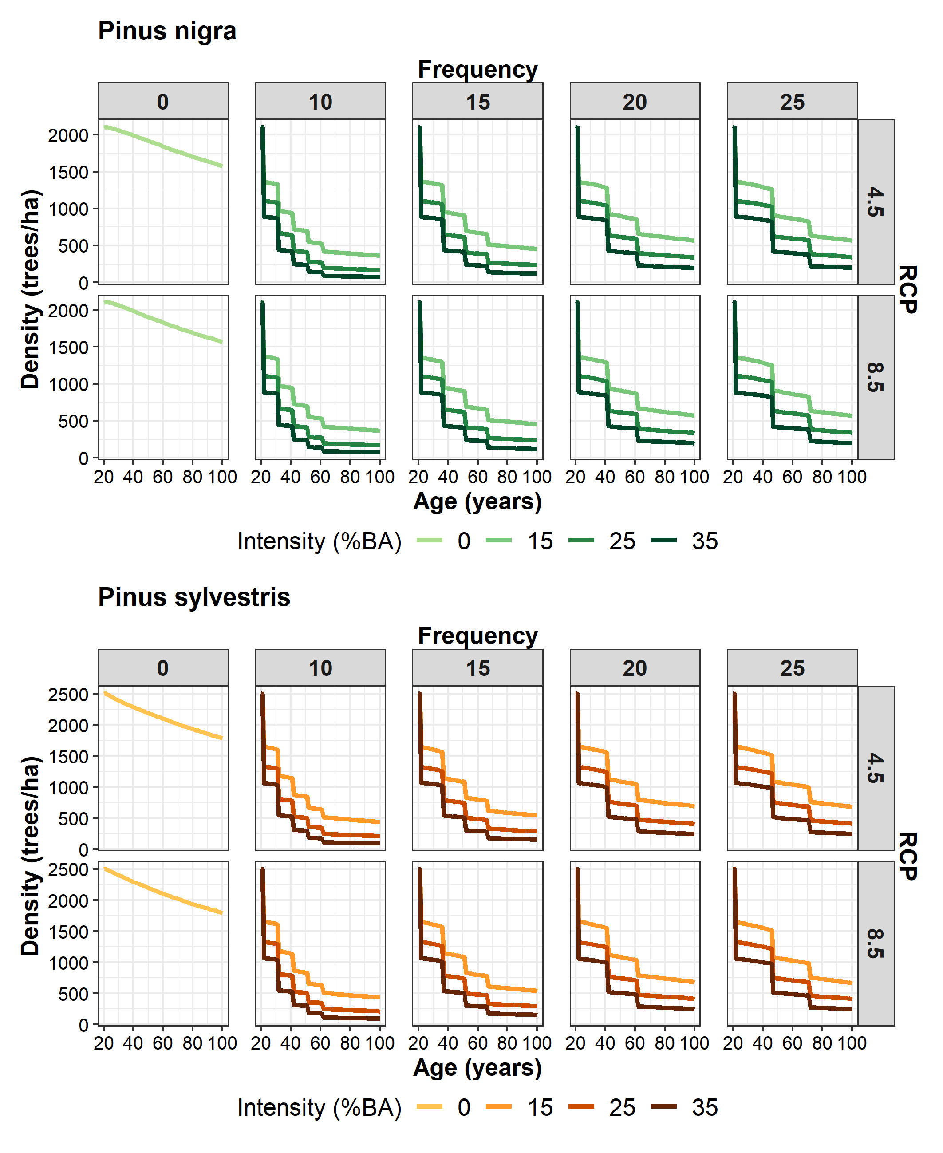
Figure C.1. The effect of thinning frequency (10, 15, 20, 25 years) and intensity (15, 25, 35%) on the dynamics of stem density during a rotation period under two climate change scenarios (RCP 4.5 and RCP 8.5) in a Pinus nigra and Pinus sylvestris stand

Table C.1. P-values of ANOVA test assessing the effects of thinning frequency, intensity, climatic scenario and species on the provision of services (confidence level of 95%)
 | Frequency | Intensity | RCP | Species | Frequency:Intensity
Mushrooms | < 2e-16 | < 2e-16 | < 2e-16 | < 2e-16 | < 2e-16
Wood | < 2e-16 | < 2e-16 | < 2e-16 | < 2e-16 | < 2e-16
Carbon | < 2e-16 | < 2e-16 | < 2e-16 | < 2e-16 | < 2e-16
Blue water | < 2e-16 | < 2e-16 | < 2e-16 | < 2e-16 | < 2e-16
Large dead trees | < 2e-16 | 1.05e-12 | < 2e-16 | < 2e-16 | < 2e-16

Table C2. Effect size, expressed as Eta squared partial, of thinning frequency, intensity, climatic scenario and species on the provision of services (confidence level of 95%)
Ecosystem services | Frequency | Intensity | RCP | Species
Mushrooms | 0.996 | 0.998 | 0.993 | 0.999
Timber | 0.926 | 0.964 | 0.974 | 0.997
Carbon | 0.997 | 0.998 | 0.963 | 0.999
Blue water | 0.9979 | 0.998 | 0.963 | 0.999
Biodiversity | 0.062 | 0.232 | 0.572 | 0.875

Table C3. Pearson’s correlation coefficient between overall projections of ecosystem services provision in Pinus nigra stands
 | RCP 4.5 |  |  |  | RCP 8.5
 | Carbon | Mushrooms | Blue water | Biodiversity | Carbon | Mushrooms | Blue water | Biodiversity
Timber | 0.97 | 0.93 | -0.92 | -0.12 | 0.94 | 0.89 | -0.87 | -0.72
Carbon | - | 0.96 | -0.96 | -0.13 | - | 0.97 | -0.96 | -0.68
Mushrooms | - | - | -0.99 | -0.25 | - | - | -0.99 | -0.68
Blue water | - | - | - | 0.29 | - | - | - | 0.64

Table C4. Pearson’s correlation coefficient between overall projections of ecosystem services provision in Pinus sylvestris stands
 | RCP 4.5 |  |  |  | RCP 8.5
 | Carbon | Mushrooms | Blue water | Biodiversity | Carbon | Mushrooms | Blue wate | Biodiversity
Timber | 0.95 | 0.80 | -0.88 | 0.48 | 0.92 | 0.75 | -0.84 | 0.31
Carbon | - | 0.92 | -0.95 | 0.41 | - | 0.93 | -0.94 | 0.16
Mushrooms | - | - | -0.96 | 0.13 | - | - | -0.94 | -0.07
Blue water | - | - | - | -0.32 | - | - | - | -0.15

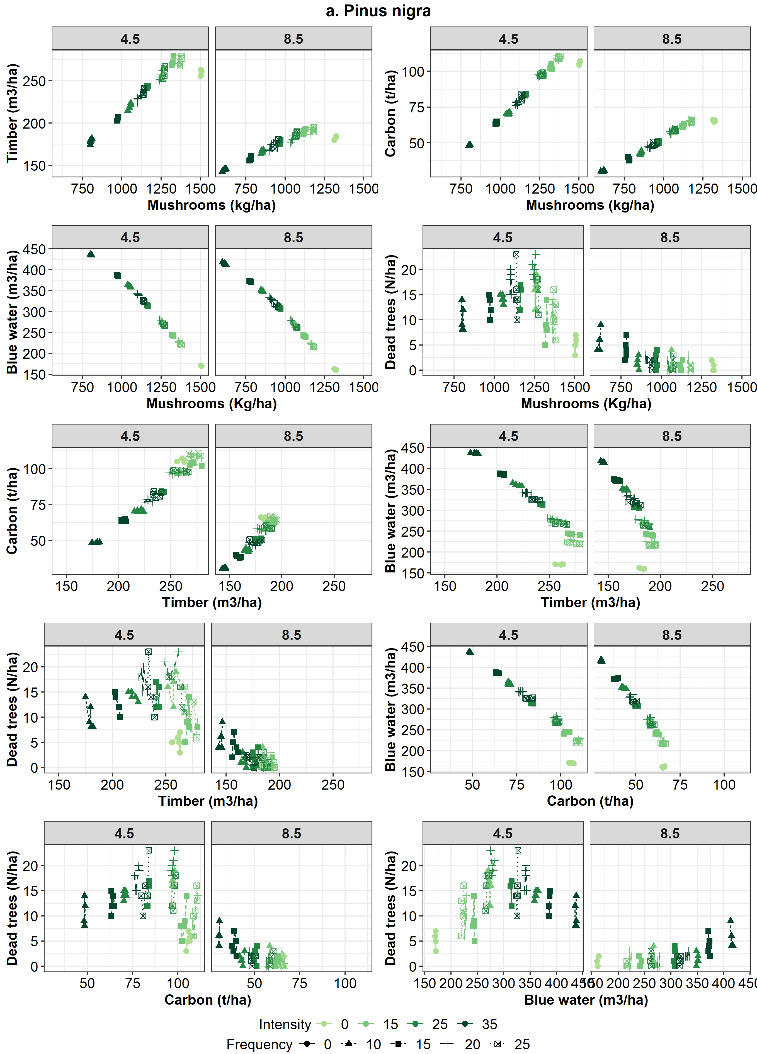
Figure C2. Correlation charts between pairs of ecosystem services in Pinus nigra stands

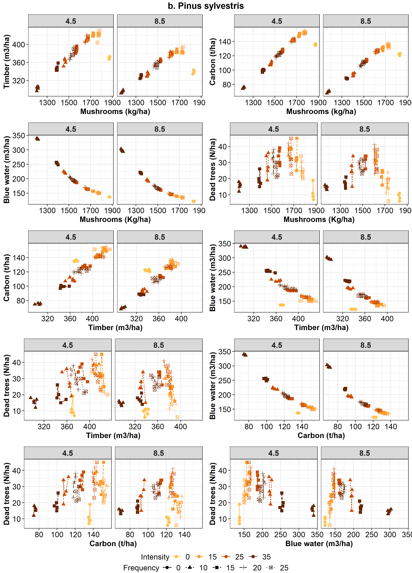
Figure C3. Correlation charts between pairs of ecosystem services in Pinus sylvestris stands

