Supplemental Tables
Table S1: EPIC-HR Swab collection site by treatment and visit.
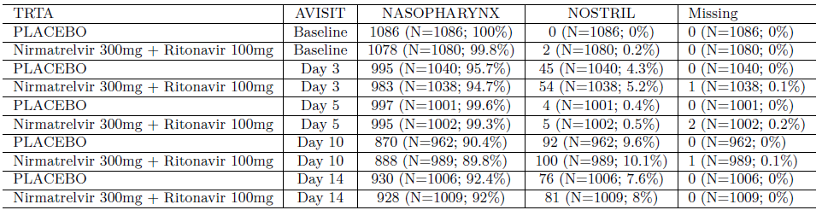

Table S2: Present/Persistent VLR collection site by treatment and visit.
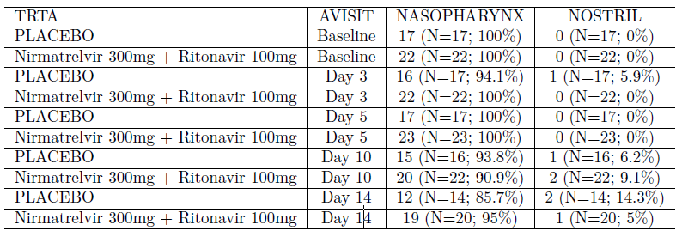

Table S3: Transient VLR collection site by treatment and visit.
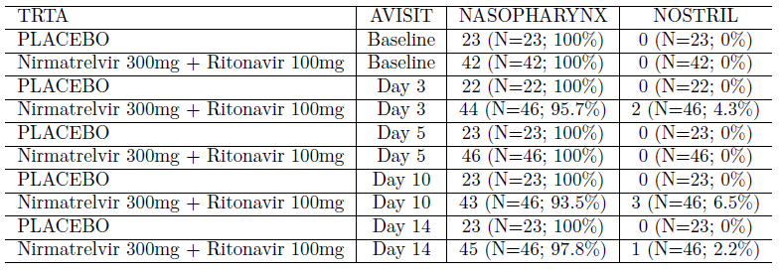
Table S4: Mpro residues within 5 Angstroms of nirmatrelvir. List of 23 residues of the SARS-CoV-2 Mpro, including key nirmatrelvir contact residues, which are within 5 Angstrom, irrespective of whether they interact or contact nirmatrelvir.
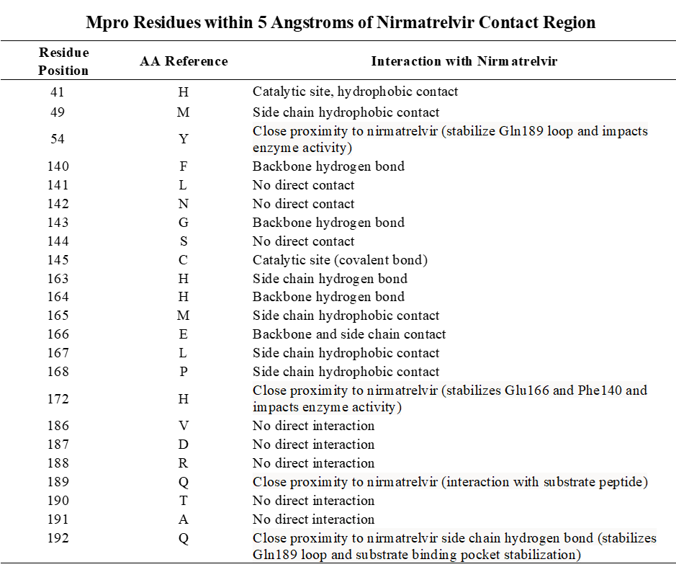

Table S5: Mpro cleavage region (including cleavage region not within Mpro gene). Lists the cleavage region or the amino acid regions in the ORF1ab polyprotein that surround the cleavage targets of Mpro. Mutations were monitored within 5 amino acids upstream and downstream of the cleavage site.

Cleavage Site (CS) | Amino Acid Position (AAPOS) | NSP Reference (NSPREF)
CS-1: nsp4:Mpro | 3259-3268 | SAVLQ↓SGFRK
CS-2 – Mpro-nsp6 | 3565-3574 | GVTFQ↓SAVKR
CS-3 – nsp6-nsp7 | 3855-3864 | VATVQ↓SKMSD
CS-4 – nsp7-nsp8 | 3938-3947 | RATLQ↓AIASE
CS-5 – nsp8-nsp9 | 4136-4145 | AVKLQ↓NNELS
CS-6 – nsp9-nsp10 | 4249-4258 | TVRLQ↓AGNAT
CS-7 – nsp10-nsp11 | 4388-4397 | EPMLQ↓SADAQ
CS-8 – RdRp - helicase | 5320-5329 | HTVLQ↓AVGAC
CS-9 – helicase-3’-to5’ exonuclease | 5921-5930 | VATLQ↓AENVT
CS-10 - 3’-to5’ exonuclease-endoRNAse | 6448-6457 | FTRLQ↓SLENV
CS-11 – EndoRNAse- 2’-O-ribose methyltransferase | 6794-6803 | YPKLQ↓SSQAW
M^{pro} cleavage region within the ORF1ab (open reading frame 1ab) polyprotein. Arrow denotes cleavage location and NSP are listed in order of corresponding NSP position. CS-1-11 denotes cleavage site regions. NSP, non-structural proteins.

Table S6: Present and/or persistent VLR by country.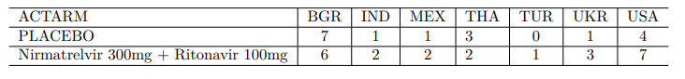

Table S7: Transient VLR by country.

Table S8: Distribution of EPIC-HR with viral load data by country.
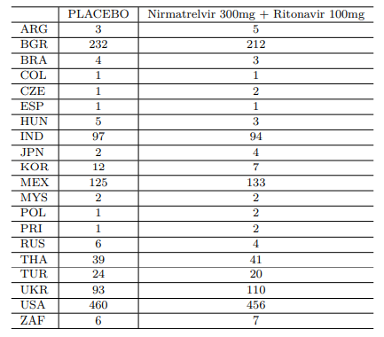

Supplemental Figures

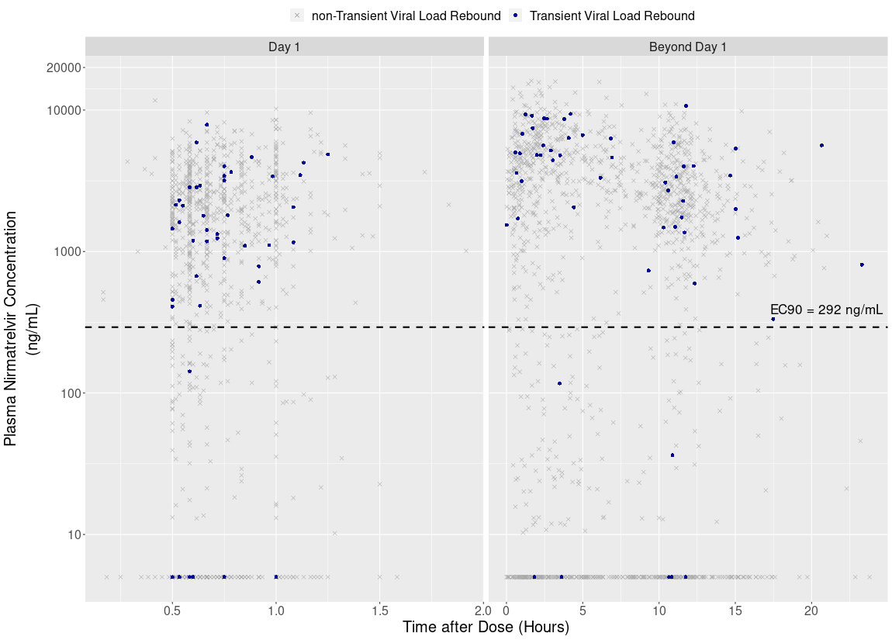

Figure S1. Nirmatrelvir exposure in transient VLR. Nirmatrelvir exposures in transient VLR (n=46) did not differ from overall EPIC-HR population exposures. Observed nirmatrelvir plasma concentrations in transient VLR (solid circles) vs EPIC-HR study population concentrations (gray x).

