Supplemental Materials
Gene Expression and Early Radiation Response of Two Distinct Neuroblastoma Cell Lines
Carissa Ritner ^{1,*}, Jelena Popović ², Aushra Abouzeid³, Ya Li⁴, Tatjana Paunesku⁵, Rao Papineni⁶, and Gayle Woloschak ^{7,}*
¹ Department of Radiation Oncology, Northwestern University, Chicago IL USA; ritner@u.northwestern.edu
² Department of Radiation Oncology, Northwestern University, Chicago IL USA; jelena.popovic@northwestern.edu
³ Department of Radiation Oncology, Northwestern University, Chicago IL USA; aushra.abouzeid@northwestern.edu
⁴ Department of Radiation Oncology, Northwestern University, Chicago IL USA; yali2022@u.northwestern.edu
⁵ Department of Radiation Oncology, Northwestern University, Chicago IL USA; tpaunesku@northwestern.edu
⁶ PACT & Health LLC/NCI, Branford CT USA; docpapineni@gmail.com
⁷ Department of Radiation Oncology, Northwestern University, Chicago IL USA; g-woloschak@northwestern.edu
* Correspondence: ritner@u.northwestern.edu (C.R.); g-woloschak@northwestern.edu (G.W.)
Simple Summary: Neuroblastoma is a common pediatric cancer that spreads systemically, making therapy difficult. Tumors are frequently resistant to radiation therapy, a last line of defense in patients with aggressive disease. In this study, we found that there are distinct gene expression patterns dependent on neuroblastoma subtype; however, both neuroblastoma types examined showed only subtle gene expression differences early following radiation exposure. This indicates that while neuroblastoma tumors are diverse in phenotype and gene expression, they have similarly stable gene expression and resistance during early response to stressors such as radiation.
Abstract: External beam radiation is infrequently used for treatment of pediatric cancer such as neuroblastoma, typically reserved for palliative care in patients with aggressive metastatic disease who fail to respond to alternative treatments. Understanding effects of radiation on neuroblastoma cells could improve efficacy of this final means of therapy to decrease tumor burden and stabilize the disease. In this study, clonogenic assays were used to establish radiation responses for SK-N-AS and SK-N-DZ cell lines; cells were then irradiated at doses that cause 90% cell killing based on clonogenic assay and their RNA isolated and subjected to microarray analysis. In addition, cells were transfected with pre-miRNA constructs that led to overexpression of microRNAs miR-34a and miR-1228. Statistically significant differences were detected for expression of several thousands of genes when the two cell lines were compared with each other. In comparison, radiation led only to minor gene expression differences of less than two-fold at the 1h post-irradiation timepoint in both cell lines. Overexpression of miR-34a and miR-1228 in either cell line did not change this outcome. Therefore, neuroblastoma cell lines SK-N-AS and SK-N-DZ are phenotypically diverse and gene expression differences between them are extensive. At the same time, the regulation of gene expression in both of these cell lines is in a stable equilibrium at early timepoints after exposure to ionizing radiation.
Keywords: neuroblastoma; external beam radiation; radiotherapy; microRNAs.

Table S1: Characterization of NBL cell lines utilized
NBL cell line | MYCN status | P53 status | Cell type | Radiation  sensitivity
SK-N-AS | Single copy | Dysfunctional | Epithelial | Resistant
SK-N-DZ | Amplified | Wild type | Neuronal | Sensitive

Table S2: PCR primers for qPCR
Gene | Primer Sequence | NCBI Reference Sequence
NFκB inhibitor β |  | NM_001369699.1
  NFKBIB F: 5’ CACTCGGCAGTGCCATGCTC 3’
  NFKBIB R: 5’ TCCTCCTGACTCACGCCCTC 3’
DnaJ heat shock protein family (Hsp40) member B2 (DNAJB2) |  | NM_006736.6
  DNAJB2 F: 5’ GCCTCATGCCCCTTGGACAG 3’
  DNAJB2 F: 5’ GCCTGGATCTTGGTGCTGGG 3’
DENN domain containing 4A |  | NM_001144823
  DENN4A F: 5’ GACACTGAATAAGTGTCCAC 3’
  DENN4A R: 5’ GATCGTATGCCATCTTGTACTC 3’
GAPDH | GAPDH F: 5′-GGACCTGACCTGCCGTCTAG-3′  GAPDH R: 5′-CCACCACCCTGTTGCTGTAG-3′ | NM_002046.7

Tables S3-S6: Excel spreadsheets attached
Table S3: Gene expression in non-transected SK-N-AS cells vs. SK-N-DZ cells for genes either suppressed or induced by radiation. “AS vs DZ w/o IR”, “DZ vs AS w/o IR”, “AS vs DZ IR”, “DZ vs AS IR”. ENSEMBL designations for differentially expressed genes were used in g-profiler to generate Figure S4.
Table S4: Gene expression in control transfected SK-N-AS cells vs. SK-N-DZ cells for genes either suppressed or induced by radiation. “AS vs DZ w/o IR”, “DZ vs AS w/o IR”, “AS vs DZ IR”, “DZ vs AS IR”. ENSEMBL designations for differentially expressed genes were used in g-profiler to generate Figure S5.
Table S5: Gene expression in SK-N-AS cells vs. SK-N-DZ cells transfected with pre-miR-34a and either suppressed or induced by radiation. “AS vs DZ w/o IR”, “DZ vs AS w/o IR”, “AS vs DZ IR”, “DZ vs AS IR”. ENSEMBL designations for differentially expressed genes were used in g-profiler to generate Figure S6.
Table S6: Gene expression in SK-N-AS cells vs. SK-N-DZ cells transfected with pre-miR-1228 and either suppressed or induced by radiation. “AS vs DZ w/o IR”, “DZ vs AS w/o IR”, “AS vs DZ IR”, “DZ vs AS IR”. ENSEMBL designations for differentially expressed genes were used in g-profiler to generate Figure S7.
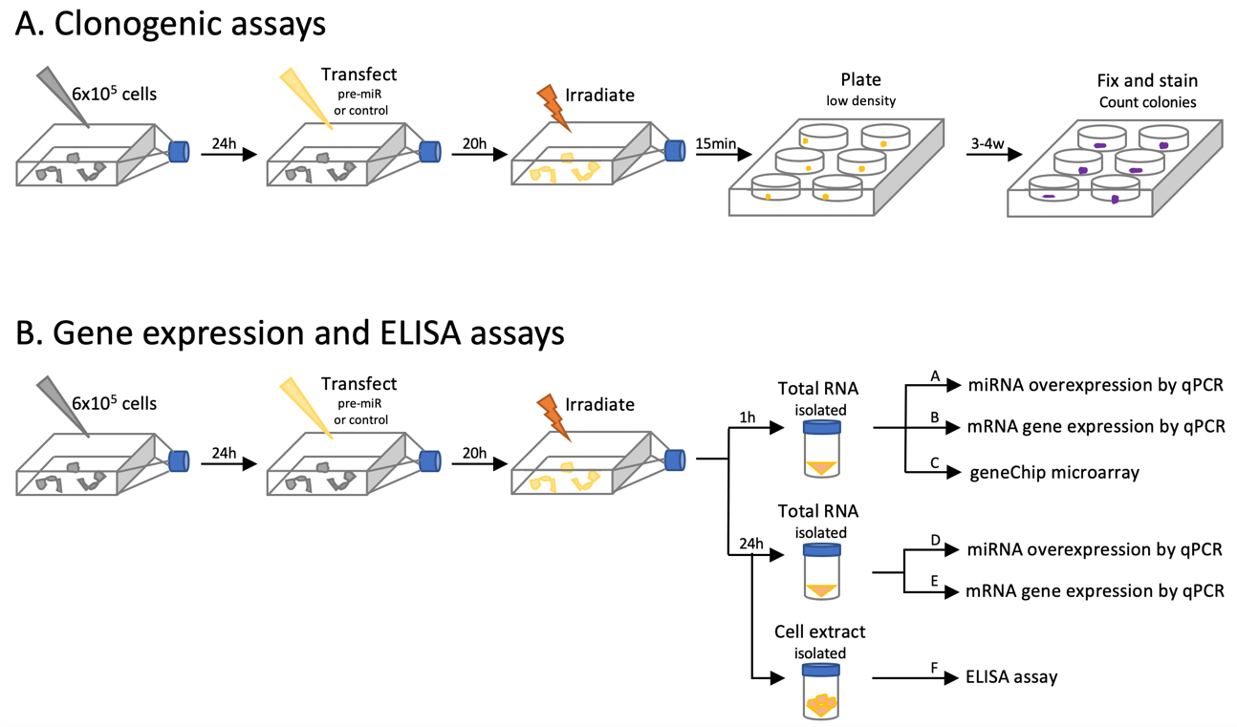
Figure S1: Schematic of experimental design. Clonogenic assays (A) are done using cells irradiated 24h after transfection with control or miRNA construct, replated at low density 15min after irradiation, and cultured for 3-4 weeks. Gene expression and ELISA assays (B) are conducted with cells transfected 24h after plating and irradiated 20h later. RNA for microarray analysis was collected for analysis at 1h after irradiation; RNA and proteins were collected for qPCR and ELISA analyses at 24h after irradiation.

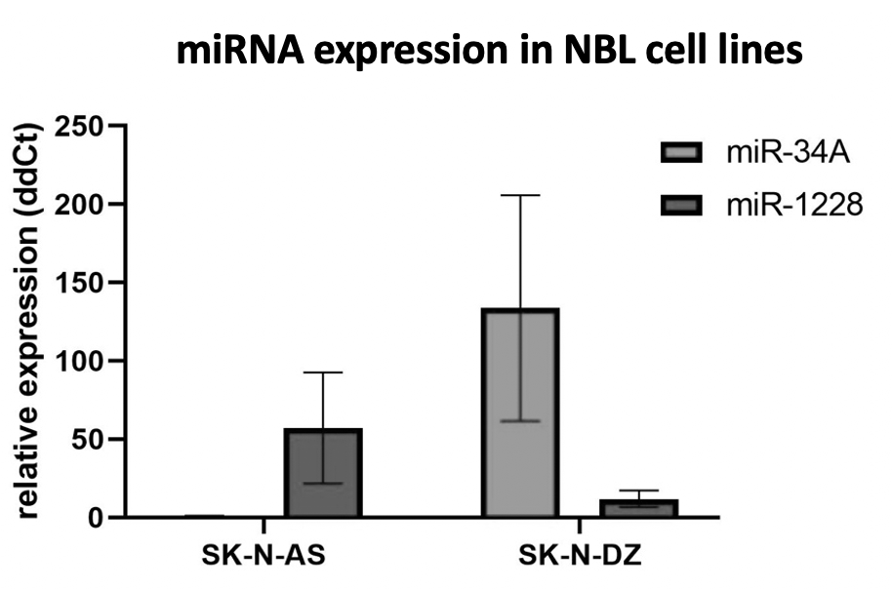
Figure S2: Comparison of native expression for miR-34a and miR-1228 in neuroblastoma cell lines SK-N-AS and SK-N-DZ demonstrates reverse expression pattern. Relative expression of miR-34a (blue) and miR-1228 (red) is shown in SK-N-AS cells and SK-N-DZ cells, with U6 snRNA used as an endogenous control. Expression of miR-34a in SK-N-AS was used as calibrator and is presented as an expression value of 1; error bars show standard deviation.

Figure S3. Relative quantification of overexpression of miR-34a and miR-1228 in neuroblastoma cell lines SK-N-AS and SK-N-DZ used in miRNA overexpression experiments shown in Figure S1. Results are presented as fold change over native expression of the same miRNA in unirradiated cells transfected with control miR set as 1. Error bars show standard deviation.

Figure S4. Different pathways in irradiated non-transfected neuroblastoma cell lines. ENSEMBL designations for differentially expressed genes in non-transfected SK-N-AS cells vs. SK-N-DZ cells suppressed or induced by radiation provided in Table S3 “AS vs DZ w/o IR”, “DZ vs AS w/o IR”, “AS vs DZ IR”, “DZ vs AS IR” were used for g-profiler analyses with parameters explained in the methods section. Significant GO Molecular Function (GO MF) and Biological Processes (GO BP) pathways and probable expression of miRs (MIRNA) (p better than 0.05 as determined by g-profiler) are indicated by colored rectangles in appropriate columns.
Figure S5. Different pathways in irradiated neuroblastoma cell lines transfected with control miR. ENSEMBL designations for differentially expressed genes in control-transfected SK-N-AS cells vs. SK-N-DZ cells suppressed or induced by radiation provided in Table S4 “AS vs DZ w/o IR”, “DZ vs AS w/o IR”, “AS vs DZ IR”, “DZ vs AS IR” were used for g-profiler analyses with parameters explained in the methods section. Significant GO MF and GO BP and probable expression of miRs (p better than 0.05 as determined by g-profiler) are indicated by colored rectangles in appropriate columns.

Figure S6. Different pathways in irradiated neuroblastoma cell lines transfected with pre-miR-34a. ENSEMBL designations for differentially expressed genes in SK-N-AS cells vs. SK-N-DZ cells transfected by pre miR-34a suppressed or induced by radiation provided in Table S5 “AS vs DZ w/o IR”, “DZ vs AS w/o IR”, “AS vs DZ IR”, “DZ vs AS IR” were used for g-profiler analyses with parameters explained in the methods section. Significant GO MF and GO BP (p better than 0.05 as determined by g-profiler) are indicated by colored rectangles in appropriate columns. No significant pathways indicating miRNA expression were noted in g-profiler analyses of these cells.

Figure S7. Different pathways in irradiated neuroblastoma cell lines transfected with pre-miR-1228. ENSEMBL designations for differentially expressed genes in SK-N-AS cells vs. SK-N-DZ cells transfected by pre miR-1228 suppressed or induced by radiation provided in Table S6 “AS vs DZ w/o IR”, “DZ vs AS w/o IR”, “AS vs DZ IR”, “DZ vs AS IR” were used for g-profiler analyses with parameters explained in the methods section. Significant GO MF and probable expression of miRs (p better than 0.05 as determined by g-profiler) are indicated by colored rectangles in appropriate columns. GO BP list was too extensive to be included in this figure.

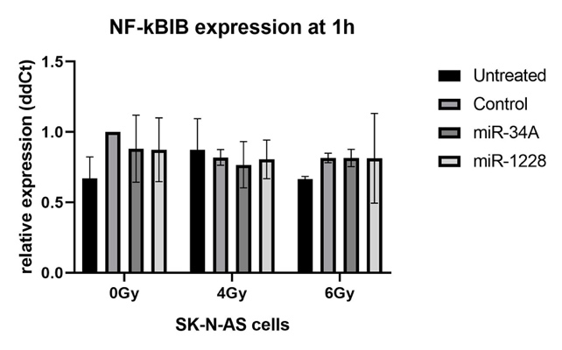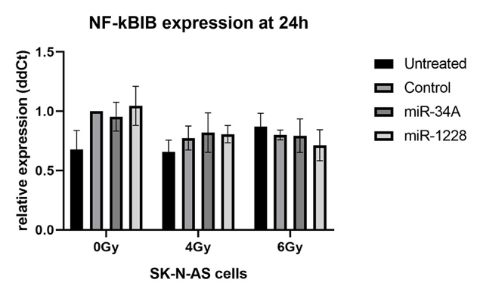
Figure S8. Expression of NF-kBIB mRNA in native or transfected SK-N-AS cells at 1h or 24h after exposure to sham, 4Gy or 6Gy of X-ray radiation. Error bars show standard deviation.

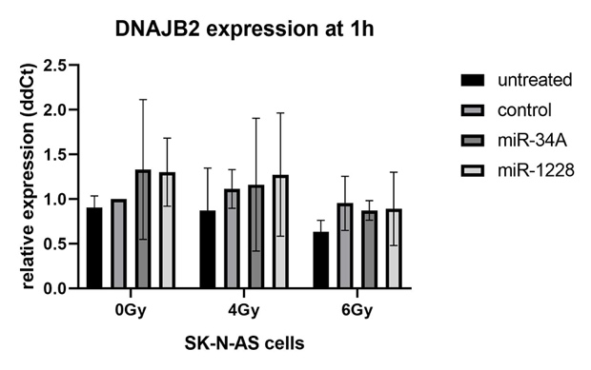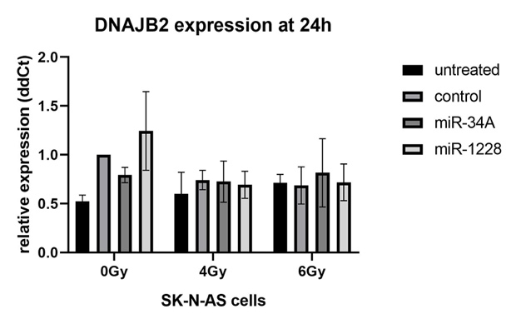

Figure S9. Expression of DNAJ gene in SK-N-AS cells at 1h or 24h after exposure to sham, 4Gy or 6Gy of X-rays.

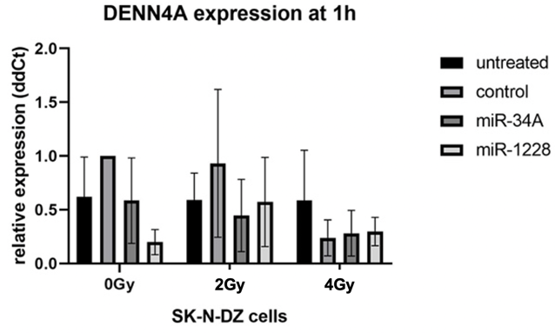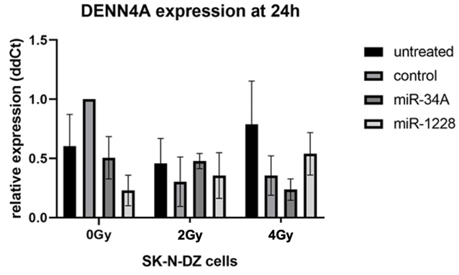
Figure S10. Expression of DENN4A gene in SK-N-DZ cells at 1h or 24h after exposure to sham, 2Gy or 4Gy of X-rays.

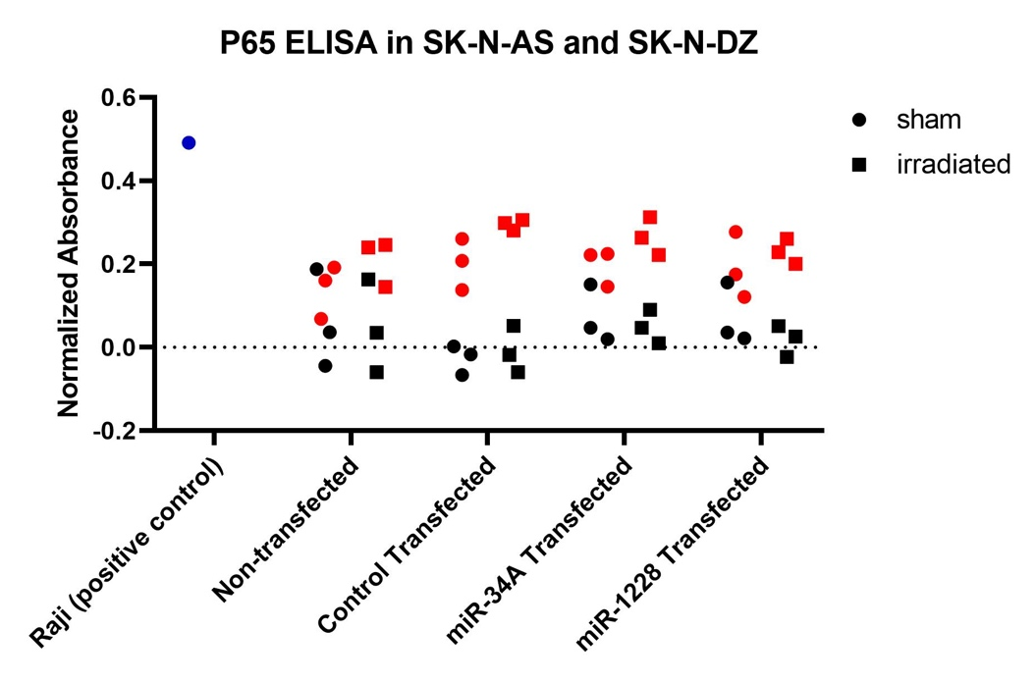
Figure S11. Relative expression of protein p65 NFkB subunit in cell nuclei of neuroblastoma cell lines SK-N-AS and SK-N-DZ shows no statistically significant differences between the cell lines or in response to radiation. Samples include positive control Raji cell line nuclear extract (blue), SK-N-AS (red), and SK-N-DZ (black). Sham-irradiated cells depicted as circles, irradiated as squares (6Gy exposure for SK-N-AS, 4Gy for SK-N-DZ).
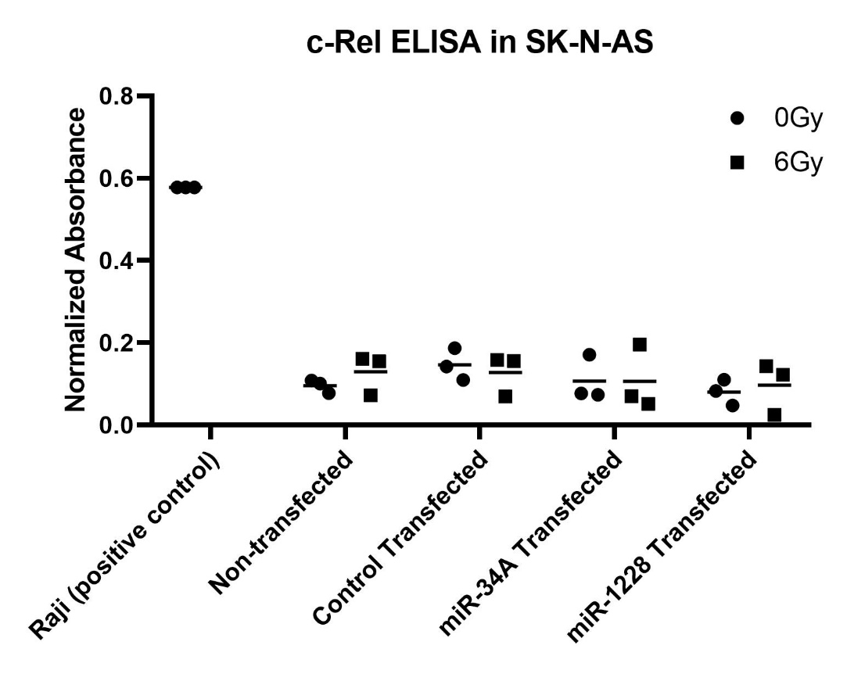
Figure S12. Relative expression of c-Rel NF-kB subunit in cell nuclei of neuroblastoma cell line SK-N-AS shows no statistically significant differences between transfection conditions or in response to radiation.

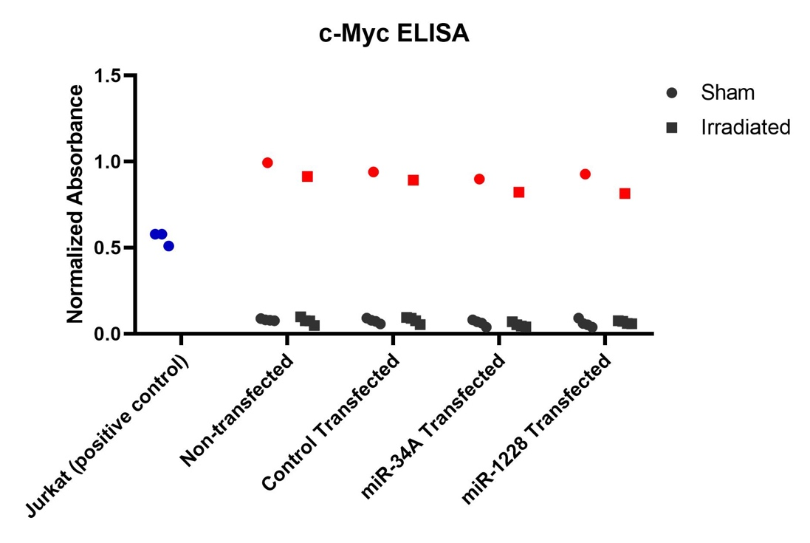
Figure S13. Relative expression of c-Myc protein in cell nuclei of neuroblastoma cell lines SK-N-AS and SK-N-DZ shows no statistically significant differences between in response to radiation. Samples include positive control Jurkat cell line nuclear extract (blue), SK-N-AS (red), and SK-N-DZ (black). Sham-irradiated cells depicted as circles, radiated as squares (6Gy SK-N-AS, 4Gy for SK-N-DZ).

