Gene Expression and Radiation Response of Two Distinct Neuroblastoma Cell Lines
Carissa Ritner ^{1,*}, Jelena Popovic ², Aushra Abouzeid³, Ya Li⁴, Tatjana Paunesku⁵, Rao Papineni⁶, and Gale Woloschak ^{7,}*
¹ Department of Radiation Oncology, Northwestern University, Chicago IL USA; ritner@u.northwestern.edu
² Department of Radiation Oncology, Northwestern University, Chicago IL USA; jelena.popovic@northwestern.edu
³ Department of Radiation Oncology, Northwestern University, Chicago IL USA; aushra.abouzeid@northwestern.edu
⁴ Department of Radiation Oncology, Northwestern University, Chicago IL USA; yali2022@u.northwestern.edu
⁵ Department of Radiation Oncology, Northwestern University, Chicago IL USA; tpaunesku@northwestern.edu
⁶ PACT & Health LLC/NCI, Branford CT USA; docpapineni@gmail.com
⁷ Department of Radiation Oncology, Northwestern University, Chicago IL USA; g-woloschak@northwestern.edu
* Correspondence: ritner@u.northwestern.edu (C.R.); g-woloschak@northwestern.edu (G.W.)

Abstract
Background: External beam radiation is infrequently used for treatment of pediatric cancer such as neuroblastoma, typically reserved for palliative care in patients with aggressive metastatic disease who fail to respond to alternative treatments. Understanding effects of radiation on neuroblastoma cells could improve efficacy of this final means of therapy to decrease tumor burden and stabilize the disease.
Methods: In this study, clonogenic assays were used to establish radiation responses for SK-N-AS and SK-N-DZ cell lines; cells were then irradiated at doses that cause 90% cell killing based on clonogenic assay and their RNA isolated and subjected to microarray analysis. In addition, cells were transfected with pre-miRNA constructs that led to overexpression of microRNAs miR-34a and miR-1228 in combination with radiation exposure to determine possible miRNA regulation of radiation response.
Results: Statistically significant differences were detected for expression of several thousands of genes when the two cell lines were compared with each other. In contrast, radiation led only to minor gene expression differences of less than two-fold between irradiated and non-irradiated cultures in both cell lines. Overexpression of miR-34a and miR-1228 in either cell line did not change this outcome.
Conclusion: Neuroblastoma cell lines SK-N-AS and SK-N-DZ are phenotypically diverse and gene expression differences between them are extensive. However, the regulation of gene expression in both of these cell lines is in a stable equilibrium even when exposed to stressors such as radiation.

Keywords: neuroblastoma; external beam radiation; radiotherapy; microRNAs.

Table S1: Real time PCR primers
Gene | Primer Sequence | NCBI Reference Sequence
NFκB inhibitor β |  | NM_001369699.1
  NFKBIB F: 5’ CACTCGGCAGTGCCATGCTC 3’
  NFKBIB R: 5’ TCCTCCTGACTCACGCCCTC 3’
DnaJ heat shock protein family (Hsp40) member B2 (DNAJB2) |  | NM_006736.6
  DNAJB2 F: 5’ GCCTCATGCCCCTTGGACAG 3’
  DNAJB2 F: 5’ GCCTGGATCTTGGTGCTGGG 3’
DENN domain containing 4A |  | NM_001144823
  DENN4A F: 5’ GACACTGAATAAGTGTCCAC 3’
  DENN4A R: 5’ GATCGTATGCCATCTTGTACTC 3’
GAPDH | GAPDH F: 5′-GGACCTGACCTGCCGTCTAG-3′  GAPDH R: 5′-CCACCACCCTGTTGCTGTAG-3′ | NM_002046.7

Table S1. Gene identification and reference sequences with associated primer sequences used for real-time PCR

Tables S2-S7: Excel spreadsheets (separate)
Table S2: Gene expression in SK-N-AS cells vs SK-N-DZ cells without radiation
S2. Gene expression array reveals 387 genes differentially expressed in SK-N-AS cells vs SK-N-DZ cells only when not irradiated
Table S3: Gene expression in SK-N-AS cells vs SK-N-DZ cells regardless of radiation
S3. Gene expression array reveals 3177 genes differentially expressed in SK-N-AS cells compared to SK-N-DZ cells regardless of radiation exposure
Table S4: Gene expression in SK-N-AS cells vs SK-N-DZ cells with radiation
S4. Gene expression array reveals 400 genes differentially expressed in SK-N-AS cells vs SK-N-DZ cells only when irradiated
Table S5: Stable gene expression pathways in SK-N-AS cells according to gProfiler
S5. List of pathways activated by gene expression patterns in SK-N-AS cells when compared to SK-N-DZ cells, regardless of irradiation
Table S6: Radiation induced pathways in SK-N-AS cells according to gProfiler
S6. List of pathways activated by gene expression patterns in SK-N-AS cells when compared to SK-N-DZ cells, following irradiation
Table S7: Radiation induced pathways in SK-N-DZ cells according to gProfiler
S7. List of pathways activated by gene expression patterns in SK-N-DZ cells, following irradiation

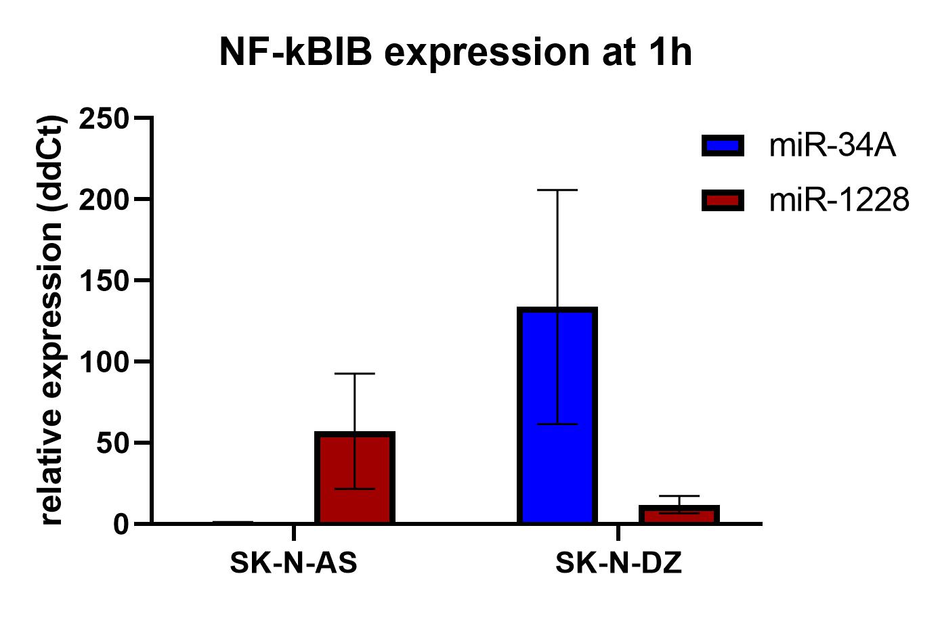
Figure S1: Comparison of miR-34a and miR-1228 expression in neuroblastoma cell lines demonstrates reverse expression of miR-34A and miR-1228 between cell lines. Relative expression of miR-34a (blue) and miR-1228 (red) is shown in SK-N-AS cells and SK-N-DZ cells. Error bars show standard deviation. Expression of miR-34a in SK-N-AS was used as calibrator and is presented as an expression value of 1.

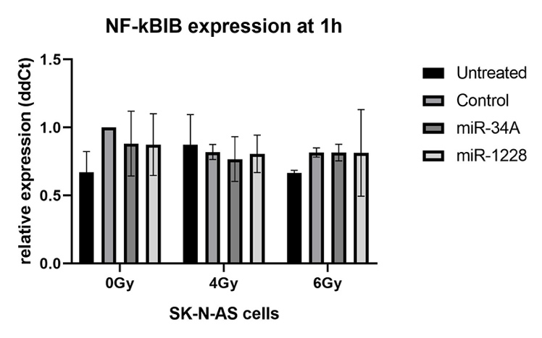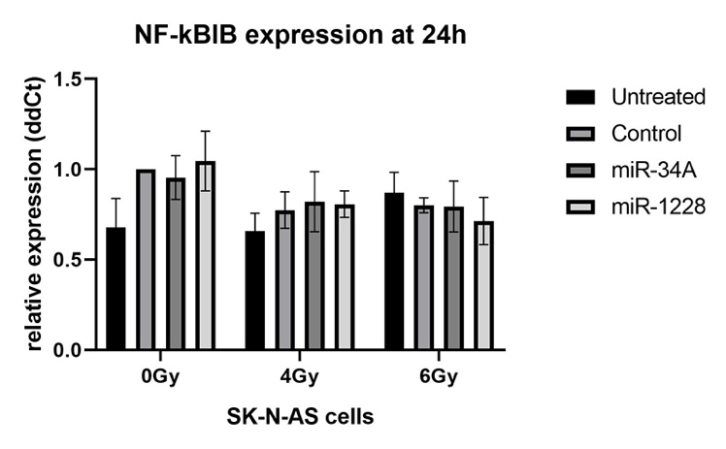
Figure S2. Expression of NF-kBIB gene in SK-N-AS cells at 1h or 24h after exposure to sham, 4Gy or 6Gy of X-ray radiation. Error bars = standard deviation.

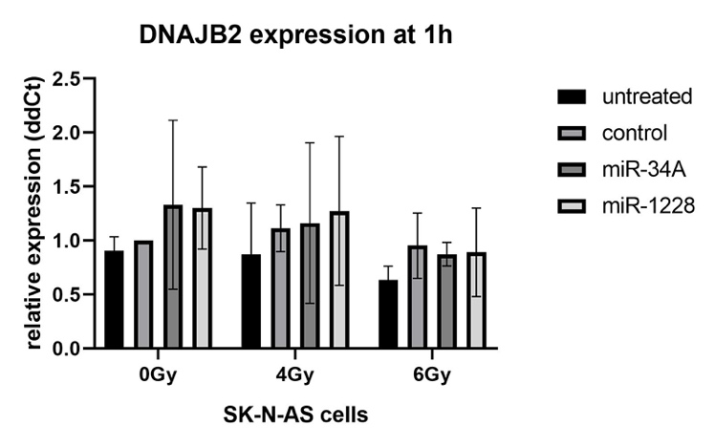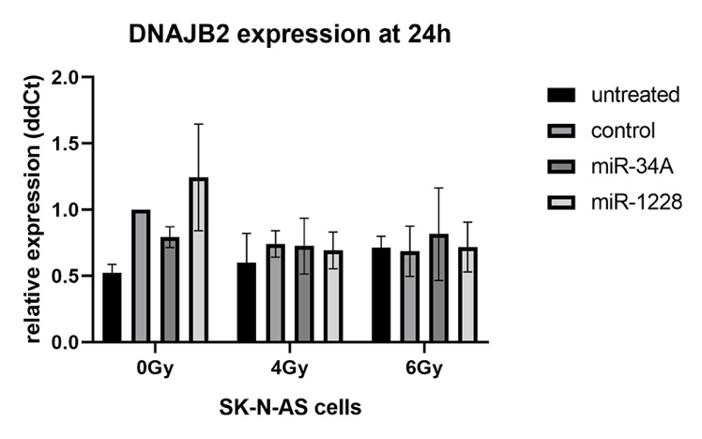
Figure S3. Expression of DNAJ gene in SK-N-AS cells at 1h or 24h after exposure to sham, 4Gy or 6Gy of X-rays.

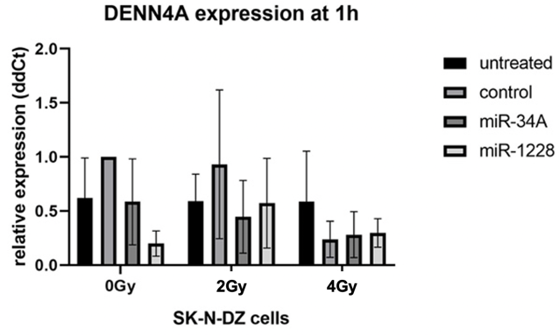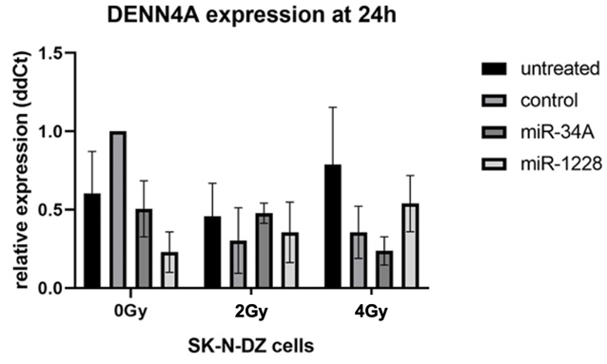
Figure S4. Expression of DENN4A gene in SK-N-DZ cells at 1h or 24h after exposure to sham, 2Gy or 4Gy of X-rays.

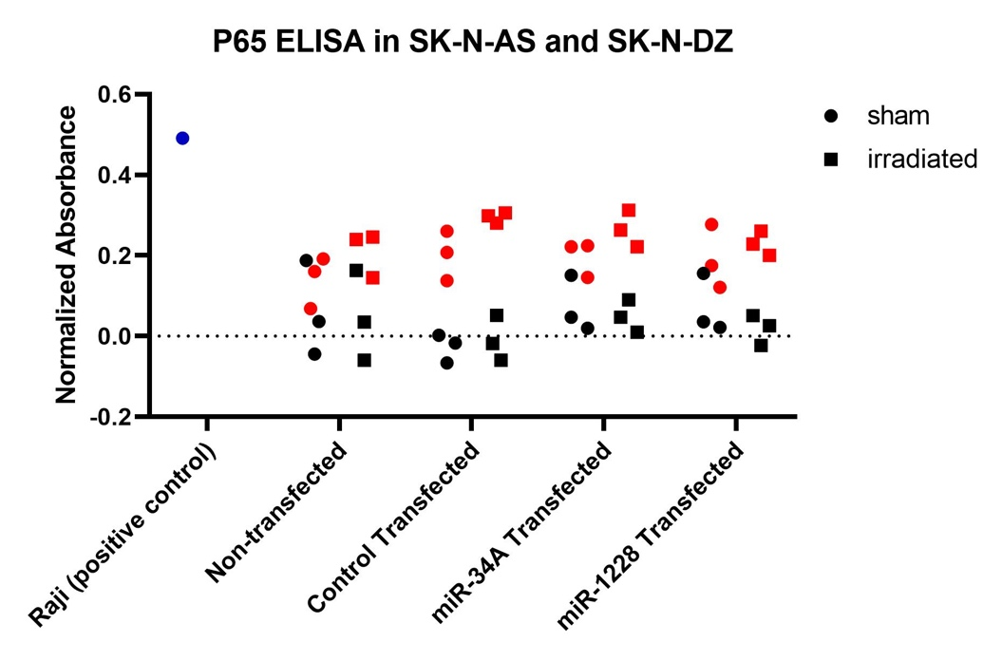
Figure S5. Relative expression of p65 NF-kB subunit in cell nuclei of neuroblastoma cell lines SK-N-AS and SK-N-DZ shows no statistically significant differences between the cell lines or in response to radiation. Samples include positive control Raji cell line nuclear extract (blue), SK-N-AS (red), and SK-N-DZ (black). Sham-irradiated cells depicted as circles, irradiated as squares (6Gy exposure for SK-N-AS, 4Gy for SK-N-DZ).
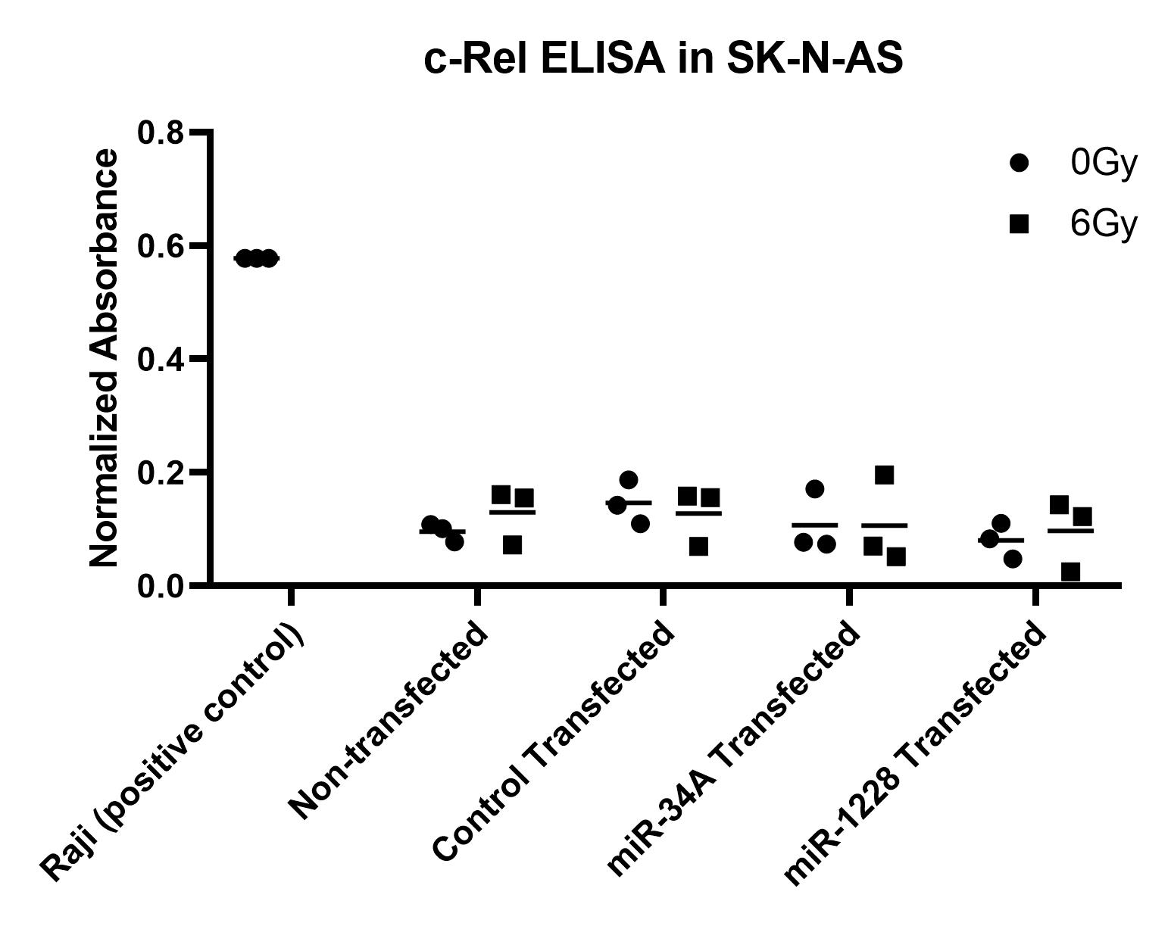
Figure S6. Relative expression of c-Rel NF-kB subunit in cell nuclei of neuroblastoma cell line SK-N-AS shows no statistically significant differences between transfection conditions or in response to radiation.

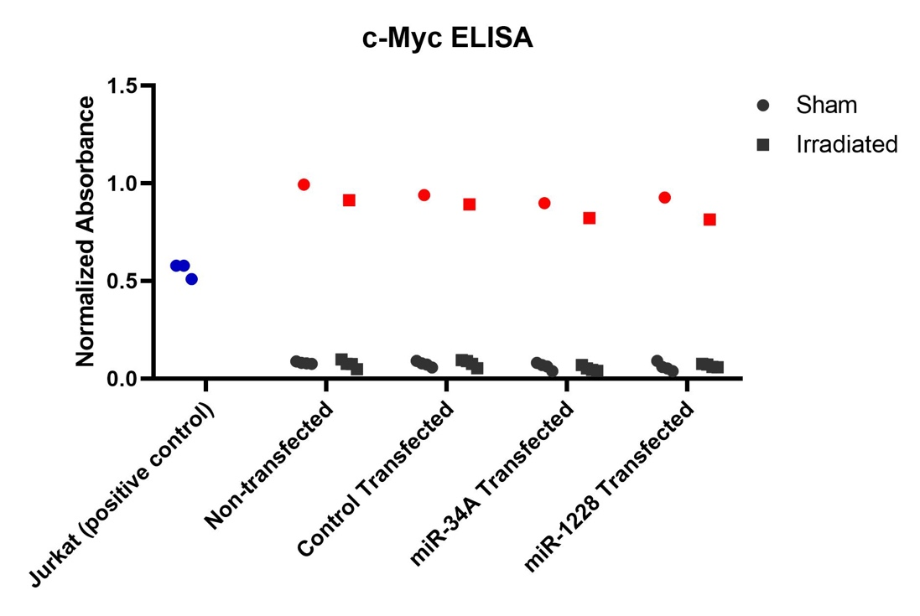
Figure S7. Relative expression of c-Myc protein in cell nuclei of neuroblastoma cell lines SK-N-AS and SK-N-DZ shows no statistically significant differences between in response to radiation. Samples include positive control Jurkat cell line nuclear extract (blue), SK-N-AS (red), and SK-N-DZ (black). Sham-irradiated cells depicted as circles, radiated as squares (6Gy SK-N-AS, 4Gy for SK-N-DZ).

