Title: Trophic ontogeny of a generalist predator is conserved across space

Authors: Christopher D. Stallings^{1,*}, James A. Nelson², Ernst B. Peebles¹, Gregory Ellis^{1,3}, Ethan A. Goddard¹, Nathaniel K. Jue⁴, Alejandra Mickle^{5,6}, Orian E. Tzadik¹, and Christopher C. Koenig⁷

Authors’ affiliations:
¹ College of Marine Science, University of South Florida, St. Petersburg, FL, USA
² Department of Biology, University of Louisiana Lafayette, Lafayette, LA, USA
³ Johns Hopkins All Children’s Hospital, St Petersburg, FL, USA
⁴ Department of Biology and Chemistry, California State University, Monterey Bay, Seaside, CA,
USA
⁵ Department of Biology, Florida State University, Tallahassee, FL, USA
⁶ NOAA Fisheries, Office of Habitat Conservation-Restoration Center, Silver Spring, MD, USA
⁷ Coastal and Marine Laboratory, Florida State University, St. Teresa, FL, USA

*Corresponding author’s contact information:
email: stallings@usf.edu
telephone: +1-727-553-3371
fax: +1-727-553-1189

Supporting Information

Trophic ontogeny of a generalist predator is conserved across space

Table S1 Summary of juvenile gag sampled across seven seagrass systems in the eastern Gulf of Mexico, including sample sizes and range (min-max) of sizes collected.

Seagrass system | No. samples | TL_{min} (cm) | TL_{max} (cm)
St. Andrew Bay (SAB) | 113 | 11.0 | 34.4
St. Joseph Bay (SJB) | 130 | 11.9 | 27.2
Turkey Point Shoal (TPS) | 142 | 11.1 | 32.1
Big Bend Region (BBR) | 171 | 12.4 | 24.4
Tampa Bay (TAM) | 71 | 13.0 | 25.5
Sarasota Bay (SAR) | 121 | 12.0 | 35.4
Pine Island Sound (PIS) | 152 | 9.6 | 28.0
Overall | 900 | 11.0 | 35.4

Table S2 Table of prey observed in the diets of juvenile gag at the family level and corresponding functional groups and prey types. Functional group and prey type are the same for invertebrates since they were all benthic-associated species. For fishes, functional group is separated by water column association while prey type reduces their resolution to a single fish group.

Class | Family | Functional group/prey type
Malacostraca | Alpheidae | Decapod - small
Malacostraca | Euphausiidae* | Decapod - small
Malacostraca | Hippolytidae | Decapod - small
Malacostraca | Palaemonidae | Decapod - small
Malacostraca | Processidae | Decapod - small
Malacostraca | Penaeidae | Decapod - large
Malacostraca | Polychaete† | Decapod - large
Malacostraca | Portunidae | Decapod - large
Malacostraca | Xanthidae | Decapod - large
Malacostraca | UIDdecapod | Decapod - unidentified
Actinopterygii | Batrachoididae | Fish - demersal
Actinopterygii | Blenniidae | Fish - demersal
Actinopterygii | Gobiidae | Fish - demersal
Actinopterygii | Haemulidae | Fish - midwater
Actinopterygii | Lutjanidae | Fish - midwater
Actinopterygii | Monacanthidae | Fish - midwater
Actinopterygii | Ostraciidae | Fish - midwater
Actinopterygii | Sciaenidae | Fish - midwater
Actinopterygii | Serranidae | Fish - midwater
Actinopterygii | Sparidae | Fish - midwater
Actinopterygii | Syngnathidae | Fish - midwater
Actinopterygii | Atherinopsidae | Fish - topwater
Actinopterygii | Engraulidae | Fish - topwater
Actinopterygii | UIDfish | Fish - unidentified
*euphausiids are not decapods, but can be considered functionally similar as small decapod prey
†polychaetes are not in the Class Malacostraca, but for simplicity we considered them functionally similar as large decapod prey

Table S3 Summary of the relative importance of prey functional groups observed across local populations by percent occurrence (%O), percent number (%N), and percent mass (%M). Across-population mean values are provided for each prey group by each metric. Note the substantial heterogeneity of each prey across sites (columns). Subscript acronyms are SM (small), LG (large), unidentified (UI), bottom (BT), midwater (MW), and topwater (TW).
 |  | Decapod_{SM} | Decapod_{LG} | Decapod_{UI} | Fish_{BT} | Fish_{MW} | Fish_{TW} | Fish_{UI}
%O | SAB | 1.52 | 36.36 | 6.06 | 3.03 | 28.79 | 4.55 | 19.70
%O | SJB | 20.65 | 27.17 | 6.52 | 6.52 | 11.96 | 0.00 | 27.17
%O | TPS | 8.82 | 25.49 | 4.90 | 5.88 | 35.29 | 0.00 | 19.61
%O | BBR | 18.80 | 29.06 | 8.55 | 1.71 | 27.35 | 1.71 | 12.82
%O | TAM | 32.08 | 9.43 | 5.66 | 3.77 | 18.87 | 11.32 | 18.87
%O | SAR | 19.35 | 27.96 | 6.45 | 4.30 | 16.13 | 8.60 | 17.20
%O | PIS | 22.58 | 30.65 | 9.68 | 5.65 | 16.94 | 4.03 | 10.48
 | %O mean | 17.69 | 26.59 | 6.83 | 4.41 | 22.19 | 4.32 | 17.98
%N | SAB | 1.20 | 44.58 | 4.82 | 3.61 | 25.30 | 3.61 | 16.87
%N | SJB | 49.37 | 20.25 | 3.80 | 3.80 | 6.96 | 0.00 | 15.82
%N | TPS | 9.68 | 33.87 | 4.03 | 5.65 | 29.84 | 0.00 | 16.94
%N | BBR | 24.84 | 31.85 | 6.37 | 1.27 | 24.20 | 1.91 | 9.55
%N | TAM | 68.79 | 7.09 | 2.13 | 1.42 | 7.09 | 6.38 | 7.09
%N | SAR | 24.05 | 20.89 | 12.03 | 3.16 | 11.39 | 16.46 | 12.03
%N | PIS | 51.35 | 20.46 | 6.56 | 4.25 | 9.65 | 2.32 | 5.41
 | %N mean | 32.76 | 25.57 | 5.68 | 3.31 | 16.35 | 4.38 | 11.96
%M | SAB | 0.01 | 28.65 | 1.19 | 0.28 | 45.31 | 12.30 | 12.25
%M | SJB | 7.52 | 31.18 | 0.35 | 9.47 | 31.66 | 0.00 | 19.83
%M | TPS | 0.33 | 15.23 | 0.20 | 3.96 | 72.15 | 0.00 | 8.14
%M | BBR | 4.55 | 39.26 | 2.98 | 6.27 | 38.67 | 3.46 | 4.81
%M | TAM | 6.98 | 8.63 | 0.64 | 2.28 | 38.79 | 29.64 | 13.05
%M | SAR | 1.11 | 14.90 | 0.27 | 4.71 | 33.73 | 36.02 | 9.26
%M | PIS | 7.26 | 37.83 | 2.46 | 2.11 | 38.38 | 7.52 | 4.45
 | %M mean | 3.96 | 25.10 | 1.15 | 4.15 | 42.67 | 12.70 | 10.26

Fig. S1 Proportion of observed prey mass by family in the diet of juvenile gag across the seven local populations. Prey families and unidentified groups of fish and decapods accounting for 95% of the observations are individually identified and are presented in descending order of mass from zero on the figure (i.e., Penaeidae had the greatest contribution to mass across populations). Fourteen additional families/taxa accounted for a combined representation of 5%, are listed as “Other,” and included (in descending order of representation) Sciaenidae, Gerreidae, Lutjanidae, Serranidae, Alpheidae, Ostraciidae, Atherinopsidae, Engraulidae, polycheate, Processidae, Fundulidae, Euphasiidae, Blenniidae, and Xanthidae.

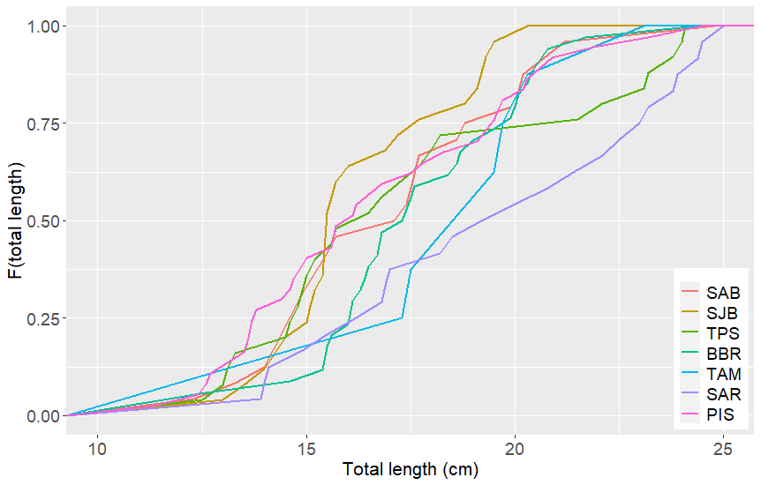
15.5 – 19.2 cm
20.3 – 25.0 cm

Fig. S2 Empirical cumulative distribution functions (ECDF) displaying the cumulative probability (F) of the total length of gags observed to have small decapods in their stomachs across the seven local populations. The range of gag sizes (min to max) observed to account for 0.50 (bottom box) and 1.0 (top box) the cumulative proportion of prey are provided to demonstrate variability across populations.

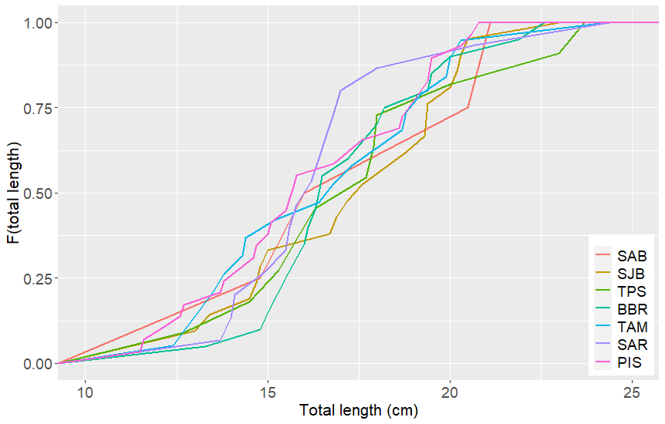
15.6 – 17.4 cm
20.8 – 24.4 cm

Fig. S3 Empirical cumulative distribution functions (ECDF) displaying the cumulative probability (F) of the total length of gags observed to have large decapods in their stomachs across the seven local populations. The range of gag sizes (min to max) observed to account for 0.50 (bottom box) and 1.0 (top box) the cumulative proportion of prey are provided to demonstrate variability across populations.

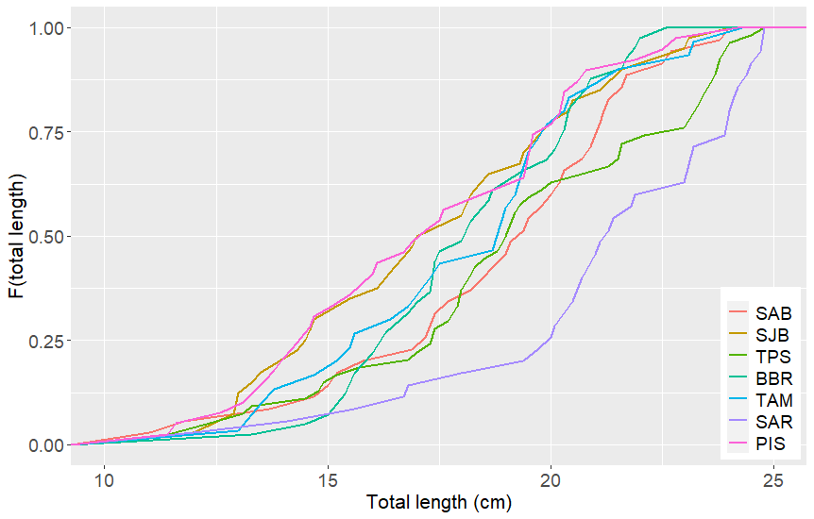
17.0 – 21.2 cm
22.6 – 24.8 cm

Fig. S4 Empirical cumulative distribution functions (ECDF) displaying the cumulative probability (F) of the total length of gags observed to have fish in their stomachs across the seven local populations. The range of gag sizes (min to max) observed to account for 0.50 (bottom box) and 1.0 (top box) the cumulative proportion of prey are provided to demonstrate variability across populations.

Fig. S5 Empirical cumulative distribution functions (ECDF) displaying the cumulative probability (F) of the total length of gags observed to have each of the three main prey groups in their stomachs among the seven local populations. (Figure caption placed above since the graphs are presented over the next four pages)
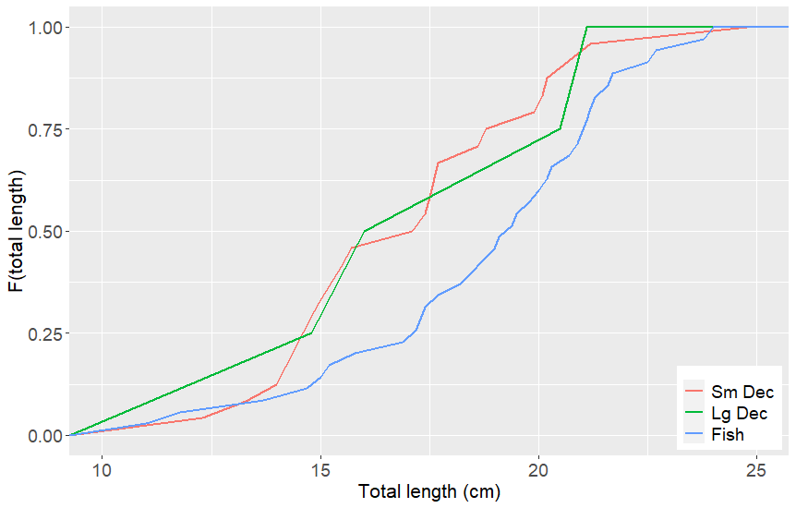
St. Andrew Bay (SAB)
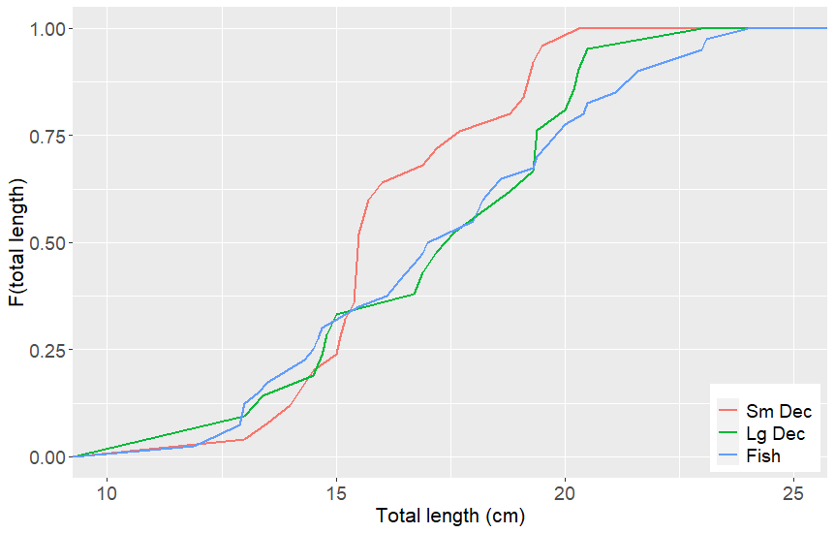
St. Joe Bay (SJB)

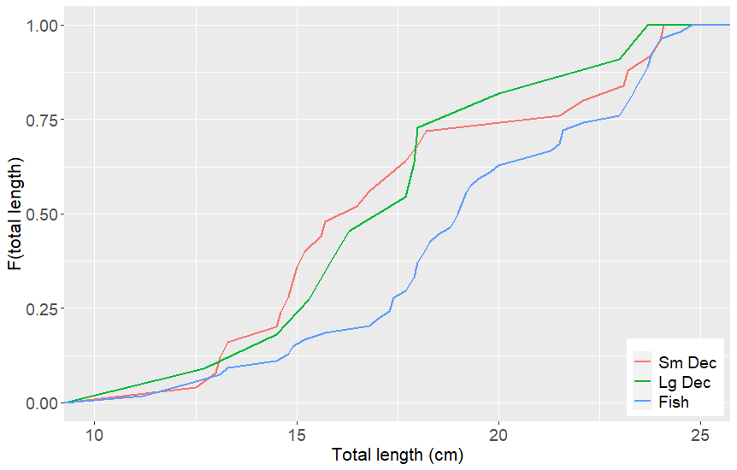
Turkey Point Shoal (TPS)
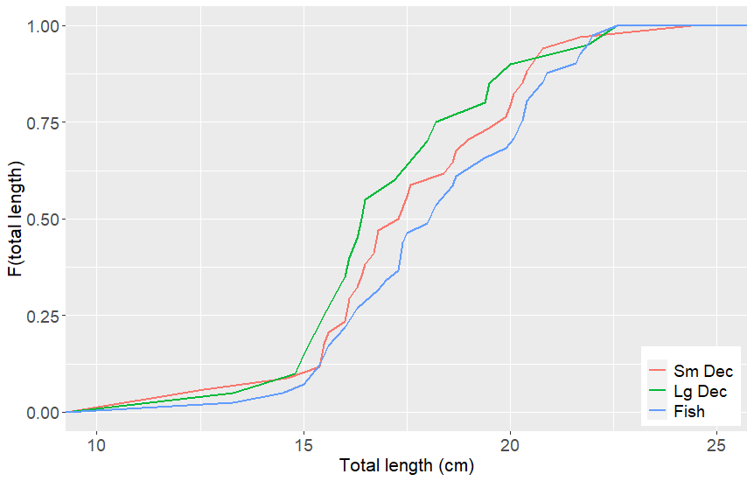
Big Bend Region (BBR)
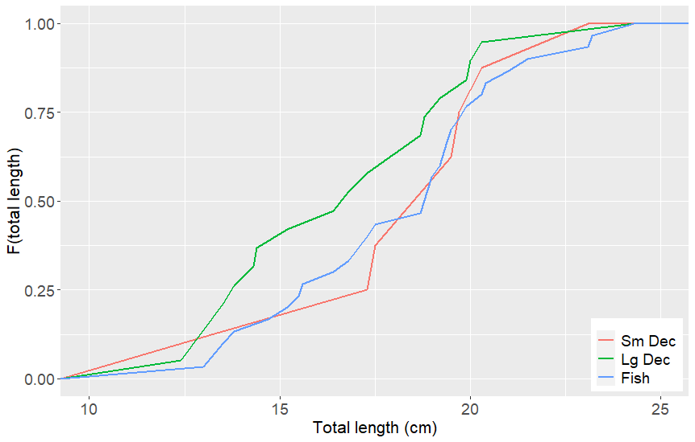
Tampa Bay (TAM)

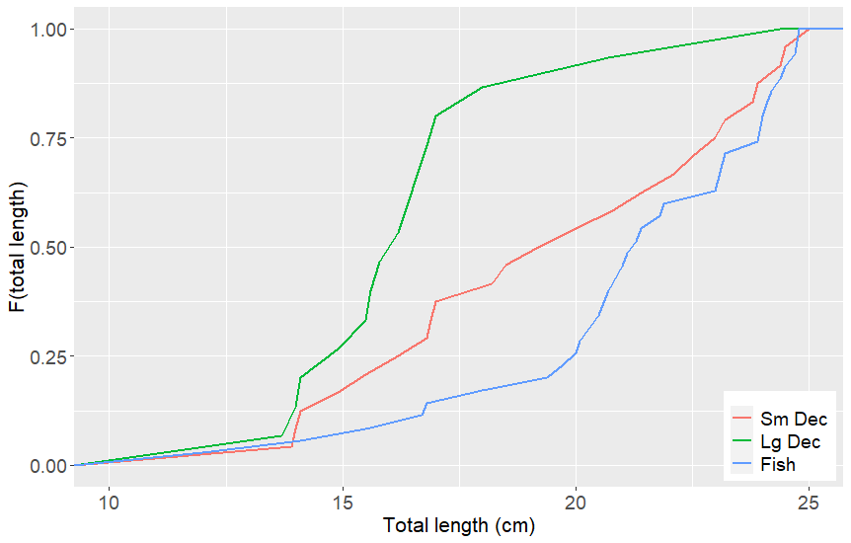
Sarasota Bay (SAR)
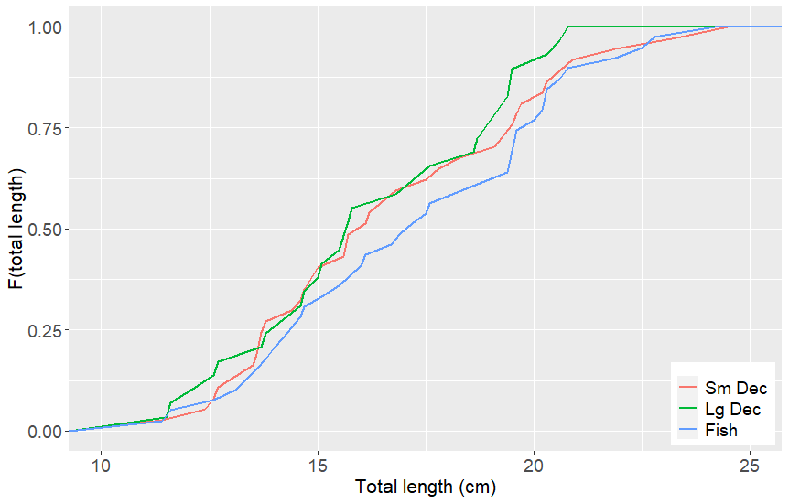
Pine Island Sound (PIS)

(b)
(a)
Fig. S6 Fitted (trendlines) and observed (points) values of (a) δ¹⁵N_{Glu-Phe} and (b) δ¹⁵N_{Asp-Phe} against total length of juvenile gag across local populations (n = 12 per location). The legend lists the local populations by latitude (top is north) and their complete names are provided in Fig. 2.

