– Supporting Information –
CMOS Beyond Silicon: Vertical GeSn Nanowire MOSFETs

- Material growth and characterization
Ge and GeSn/Ge heterostructures are grown by reduced pressure chemical vapor deposition (RP-CVD) in an industrial reactor. Germane, GeH₄, is used as precursor gas for the Ge-epitaxy and, digermane, Ge₂H₆, and tin-tetrachloride SnCl₄ precursors for GeSn epitaxy. The stoichiometry extracted from Rutherford backscattering spectrometry (RBS) is used as an input parameter in the XRD to determine the lattice strain in both Ge and GeSn layers.

The cross-sectional TEM image in Fig. S1(a) shows the 60 nm GeSn layer on a Ge virtual substrate. The high-resolution (HR) TEM image (Fig.S1b) show the high crystalline quality of the Ge_{0.92}Sn_{0.08} layer. The reciprocal space mapping (RSM) (Fig.S1c) show that the peaks of GeSn and Ge lie along the same in-plane lattice vector, confirming the GeSn layer is fully strained. The doping p⁺-p⁻- p⁺ layer stack, needed for p-FET is confirmed by the ECV measurement (Fig.S1d).
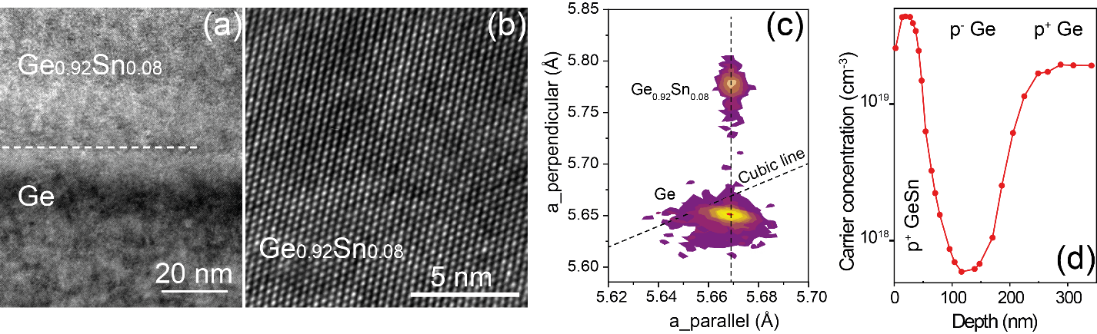
Fig. S1: (a) Cross-sectional TEM image of Ge/Ge_{0.95}Sn_{0.05}/Ge epi-stacks. HR-TEM images of Ge/Ge_{0.95}Sn_{0.05} interface (b), and Ge_{0.95}Sn_{0.05}/Ge interface (c), highlighting the good crystallinity of GeSn and Ge layers, and defect-free interfaces.
The as-grown Ge/Ge_{0.95}Sn_{0.05} /Ge heterostructure for n-FETs is shown by the cross-sectional TEM image (Fig. S2a). Both the top Ge layer and the GeSn layer are ~100 nm thick. The good crystalline quality of the pseudomorphic growth of Ge and GeSn layers without the defect-free interfaces is highlighted by the HR-TEM images and it is supported by RSM data (Fig. S2b)
The activated Phosphorus atoms distribution measured with by Electrochemical-CV (ECV, Fig. S2c), shows doping concentrations of ~7×10¹⁹ and ~2.5×10¹⁹ cm⁻³ in the top and bottom Ge layers, respectively. The higher n- doping in the top layer is caused by the different growth parameter considering the thermal budget constraints of GeSn alloy. The device channel region is slightly n-type doped due to the memory effect during the growth. From this doping scheme, the devices indeed work in the accumulation-mode, which is desired for Ge(Sn)-based n-MOSFETs.

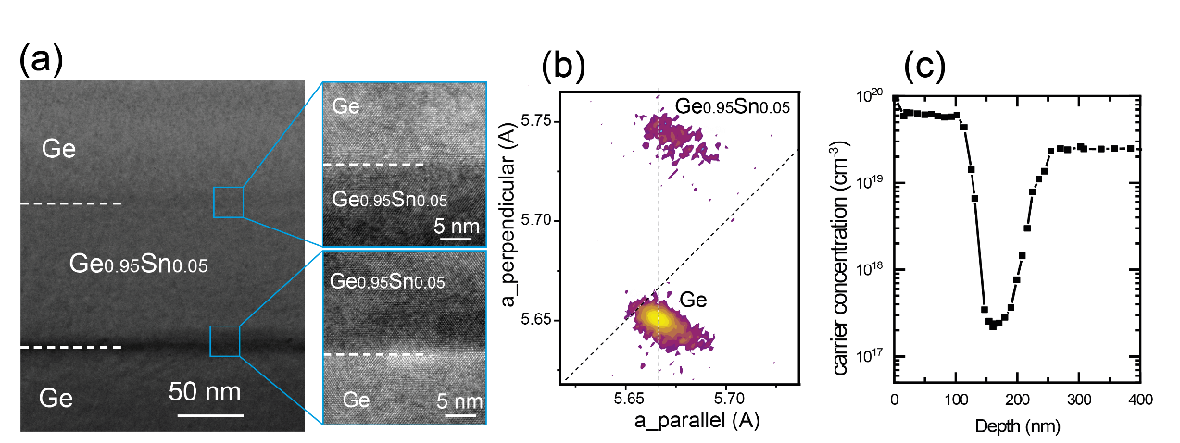
Fig. S2: (a) RSM of as-grown Ge/Ge_{0.95}Sn_{0.05}/Ge layers. The GeSn layer has the same in-plane lattice vector as the top and bottom Ge layers, showing the pseudomorphic growth. (b) TOF-SIMS analysis of P, Sn, and Ge elements along the epi-stacks. The in-situ P doping is clearly shown in the top and bottom Ge layers.
- Band structures
The band edges for strained Ge_{0.92}Sn_{0.08} and Ge in “bulk form” (as-grown case) are given in the Table S1 below. The "effective bandgaps" taken as spacing between the lowest conduction band state and the highest valance band state for as-grown Ge_{0.92}Sn_{0.08} are E_{gap-Γ}=0.604 eV, and E_{gap-L}=0.538 eV. The band alignment of the GeSn/Ge heterostructure is given in Figure S3. For the relaxed case, cubic GeSn is a direct bandgap alloy with the bandgaps E_{gap-Γ} = 0.551 eV, and E_{gap-L}=0.570 eV.

Table S1. Calculated band energies for as grown strained GeSn and Ge layers.
Sn content (at.%) | Ev_{HH} (eV) | Ev_{LH} (eV) | E_{Γ}(eV) | E_{L}(eV) | Biaxial strain (%)
0 | 0.000 | 0.000 | 0.664 | 0.804 | 0
0 | -0.017 | -0.001 | 0.779 | 0.651 | 0.16
0.080 | 0.058 | 0.058 | 0.609 | 0.628 | 0
0.080 | 0.121 | 0.029 | 0.725 | 0.659 | -1.06
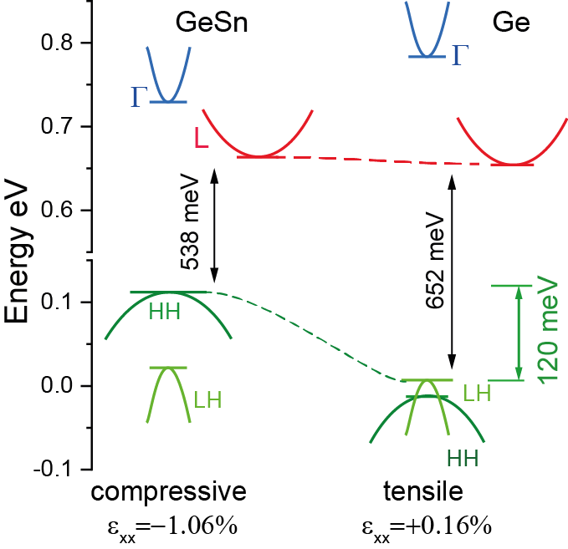
Fig. S3. Electronic bands alignment for the as-grown GeSn/Ge heterostructure.
The quantised states of electrons and holes in a quantum wire were calculated within the effective-mass approximation. Mixing of bands near Γ point was neglected. The heavy-hole, light-hole, and the Γ and L conduction bands were described by appropriate effective masses. In the presence of strain these masses are different in different directions. We have used the approximation that the in-plane mass (m||) is the same in any direction in the wire cross section, but is different from the mass in the axial, z-direction (m_{z}). The values of m|| and m_{z} are very different for both heavy and light holes, and also slightly depend on strain, while they are very similar for electrons, as given in Table S2 for Ge_{0.92}Sn_{0.08}, calculated by the k.p method. The potential (band edge energy V(z)) for the particular carrier type, depends on the material composition and local strain (calculated from the strain value and deformation potentials), as given in Table S3 for Ge_{0.92}Sn_{0.08.} But is here approximately taken to be constant across the wire cross-section, and becomes infinite at the wire surface. It may only depend on z in heterostructure wires. Within these approximations the Hamiltonian / Schrödinger equation in cylindrical coordinate system (with r the radial coordinate, z the axial, and φ the azimuthal angle) is
$-\frac{ℏ^{2}}{2m_{0}}\left[\frac{1}{m_{∥}}\frac{1}{r}\frac{∂}{∂r}\left(r\frac{∂}{∂r}\right)+\frac{1}{r^{2}}\frac{∂^{2}}{∂ϕ^{2}}+\frac{∂}{∂z}\frac{1}{m_{z}}\frac{∂}{∂z}\right]Ψ+V\left(z\right)Ψ=EΨ$ (S1)
The wave function can then be factorised as
$Ψ=R\left(r\right)Z\left(z\right)Φ(ϕ)$ (S2)
with Φ=e^{imφ} (m is the azimuthal quantum number) the radial component of energy is given by
$E_{l,m}=\frac{ℏ^{2}}{2m_{0}}{\left(\frac{q_{l,m}}{r_{0}}\right)}^{2}$ (S3)
where q_{l,m} is l-th root of m-th order Bessel function J_{m}(q)=0, r₀ is the wire radius, and l the radial quantum number. The axial component of energy is found by solving the 1D Schrödinger equation by finite-difference method. For single-composition wire of length L the axial component of energy would simply be $E_{n}=\left(\frac{ℏ^{2}}{2m_{0}m_{z}}\right){\left(\frac{nπ}{L}\right)}^{2}$, where n is the axial quantum number.

Table S2. Calculated effective masses in Ge_{0.92}Sn_{0.08} with biaxial compressive strain.
ε_{xx} | m_{HHz} | m_{HH||} | m_{LHz} | m_{LH||} | m_{Γz} | m_{Γ||} | m_{Lz} | m_{L||}
0.000 | 0.222 | 0.029 | 0.020 | 0.050 | 0.032 | 0.032 | 0.117 | 0.293
-0.002 | 0.222 | 0.029 | 0.022 | 0.052 | 0.034 | 0.032 | 0.117 | 0.293
-0.004 | 0.222 | 0.028 | 0.024 | 0.052 | 0.036 | 0.032 | 0.117 | 0.293
-0.006 | 0.222 | 0.027 | 0.026 | 0.050 | 0.038 | 0.033 | 0.117 | 0.293

Table S3. Calculated band edges in Ge_{0.92}Sn_{0.08} layer with biaxial compressive strain (reference zero is the v.b. top in unstrained Ge).
ε_{xx} | E_{HH} (eV) | E_{LH} (eV) | E_{Γ} (eV) | E_{L} (eV)
0.000 | 0.058 | 0.058 | 0.609 | 0.628
-0.002 | 0.071 | 0.052 | 0.632 | 0.635
-0.004 | 0.085 | 0.047 | 0.656 | 0.642
-0.006 | 0.098 | 0.043 | 0.679 | 0.650

- Device fabrication
The fabrication process of vertical Ge/Ge_{0.95}Sn_{0.05}/Ge NW n-VFETs is detailed in Figure S4.
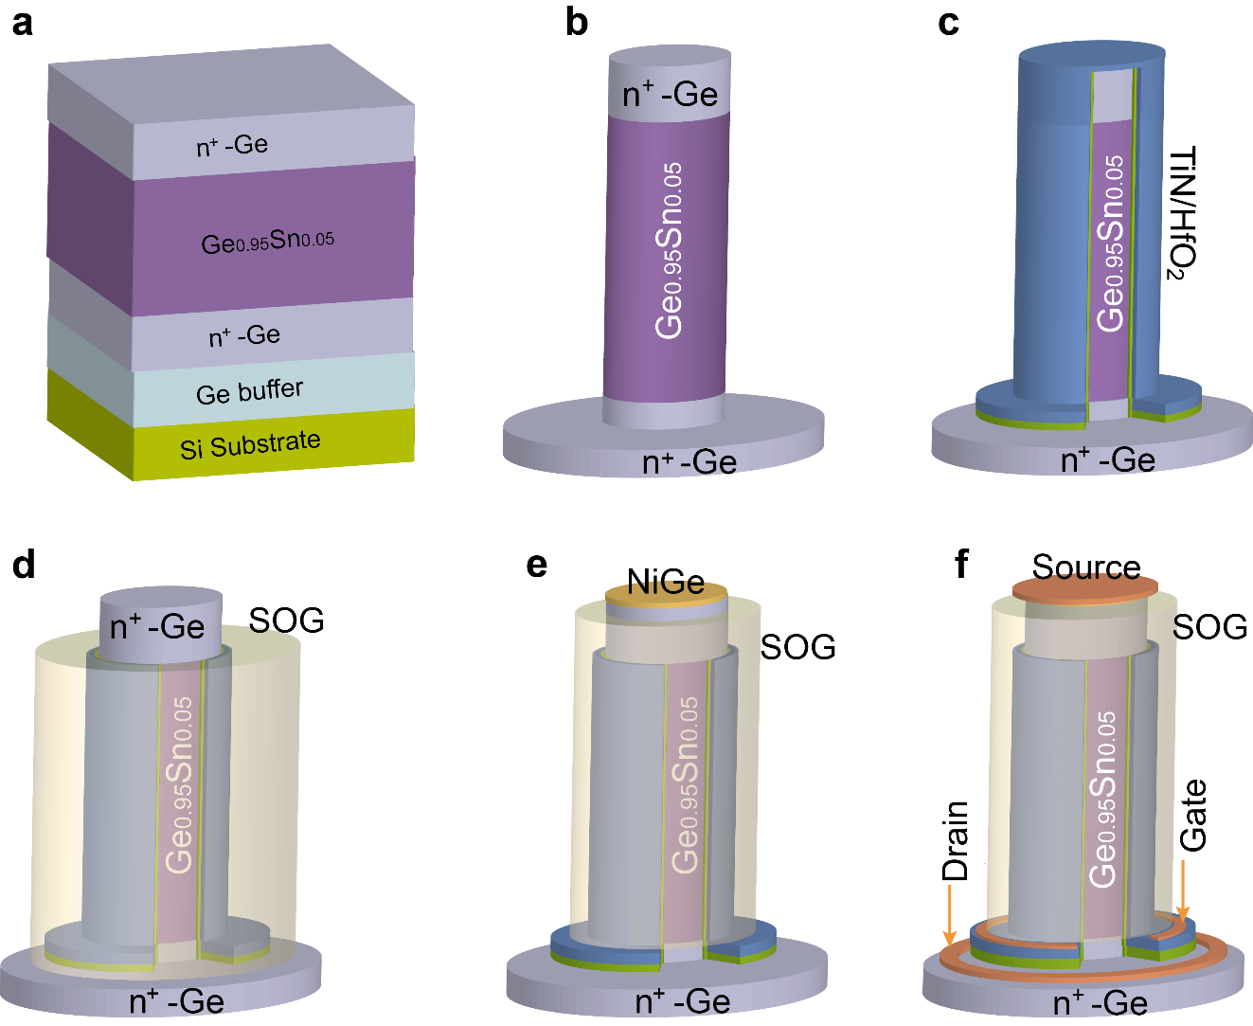
Figure S4: Schematic of vertical Ge/GeSn/Ge NW n-MOSFET fabrication process. (a) layer stack grown by CVD, (b) Vertical Ge/GeSn/Ge NW fabrication by top-down process; (c) TiN/HfO₂ gate stack deposition and patterning; (d) SOG planarization and etch back following by gate stack removal from the top of the NW; (e) NiGe formation after SOG planarization to isolate the gate to the top of the NW; (f) metallization of the S/D and gate.

The vertical NWs are formed using e-beam lithography and RIE etching. Digital etching consisting of multiple cycles of self-limiting O₂ plasma oxidation and diluted HCl stripping is applied to shrink the NW diameters. Subsequently high–κ dielectric deposition starts with an ultra-thin 1 nm ALD Al₂O₃ followed by a post-oxidation process treatment in O₂ plasma. The oxidation passivates the GeSn dangling bonds, forming an ultra-thin GeSnO_{x} interfacial layer (IL), and saturates oxygen vacancies in the Al₂O₃ layer. The gate stack is completed by 5 nm ALD HfO₂ and 40 nm TiN deposited conformal around the vertical NWs. Planarization is performed by spin-coated spin-on-glass (SOG) and cured at 350 ºC followed by isotropic back-etching with CHF₃. The exposed top gate stack is removed by an optimized Cl₂/SF₆ etching recipe. Subsequently, a second SOG spin-coating and planarization are performed to isolate the gate stack and top contact. NiGeSn is then formed by annealing of a 5 nm thick Ni layer at 300°C. Via openings through the SOG layer are formed and finally Ti/Al contact metallization is conducted to finish the device fabrication. For comparison, Ge control devices with n⁺-n⁻-n⁺ doping scheme are also fabricated at the same experimental conditions except the post-oxidation passivation.
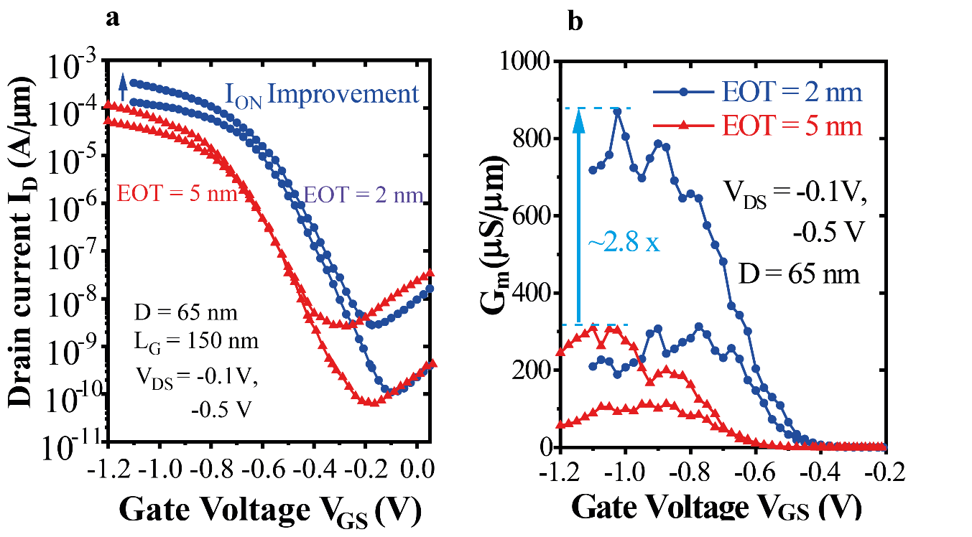
Figure S5. Comparison of electrical characteristics between GeSn/Ge and Ge GAA pFETs with a NW diameter of 65 nm. (a) Transfer characteristics, showing a subthreshold swing SS of 68mV/dec for Ge and 84mV/dec for GeSn/Ge NW devices at V_{DS}=-0.1V, (b) Transfer characteristics in logarithmic scale of I_{D} and linear I_{D} (inset) for the 65 nm diameter devices under normalized V_{GS}-V´_{TH}, showing the on-current increase. (c) Transfer characteristics for p-FETs with a NW diameter of 45 nm further demonstrate the current improvement by using GeSn as source.

- Device performance improvement by EOT scaling
Few generations of devices were fabricated with two gate oxide thicknesses used 9 nm Al₂O₃ for an equivalent oxide thickness (EOT) of ~5 nm and 5 nm HfO₂ (EOT~2 nm) as the gate oxide for GeSn/Ge p-VFETs, respectively to demonstrate the EOT scaling on the device performance improvement. The transfer characteristics for vertical GAA GeSn/Ge NW p-VFETs with EOT of ~5 nm and 2 nm for 65 nm diameter NWs are compared in Figure S5 (a). The shift of V_{TH} for GeSn/Ge device could be caused by different D_{it} and other process variations. Higher on-currents for EOT=~2 nm are clearly demonstrated in the transfer characteristics. The comparison of the transconductance shows an increasing factor of 2.8 of the peak G_{m} for the EOT=~2 nm p-VFET (Fig. S5b).

- Mobility comparison: The Y-function
In the linear region with a small drain voltage V_{DS,} the drain current for a MOSFET device is described in the first order as:
$I_{D}=\frac{W}{L}µ_{eff}Q_{i}V_{DS}$ (1)
Where W and L are the gate width (here, the NW perimeter) and channel length, µ_{eff} is the effective mobility, Q_{i} the charge in the channel. In the first order approximation µ_{eff} can be expressed as ¹²:
$μ_{eff}≈\frac{μ_{0}}{1+θ(V_{GS}-V_{TH})}$ (2)
Where θ is the gate-field mobility reduction factor. The Y- function can be simplified as ¹:
$Y=\frac{I_{D}}{\sqrt{g_{m}}}=\sqrt{\frac{W}{L}C_{ox}μ_{0}V_{DS}}×\left(V_{GS}-V_{TH}\right)$ (3)
Where $g_{m}={∂I_{D}}/{∂V_{GS}}$ is the transconductance of the transistor at a constant V_{DS}. From the Y-V_{GS} linear dependence one can estimate the intrinsic mobility µ₀ of the transistor. For NW transistor we cannot measure the C_{ox} because of the small structure and the unknown dielectric constant of the interfacial layer. We thus estimate the mobility ratio between the GeSn channel and Ge channel n-VFETs from the corresponding Y-V_{GS} line slopes, suggesting that C_{ox} is the same for both devices.

- Full GeSn n-VFET
In order to reduce the off-current induced by GIDL in the low bandgap GeSn drain material as shown in Fig.6b we can use a lower Sn content (<5%) layer at source/drain while use high Sn content layer (>8%) in the channel to improve further the electron mobility (Fig.S6). For lower Sn content source/drain layers it is also much easier to obtain much higher n-type doping concentration to lower further the series resistance.
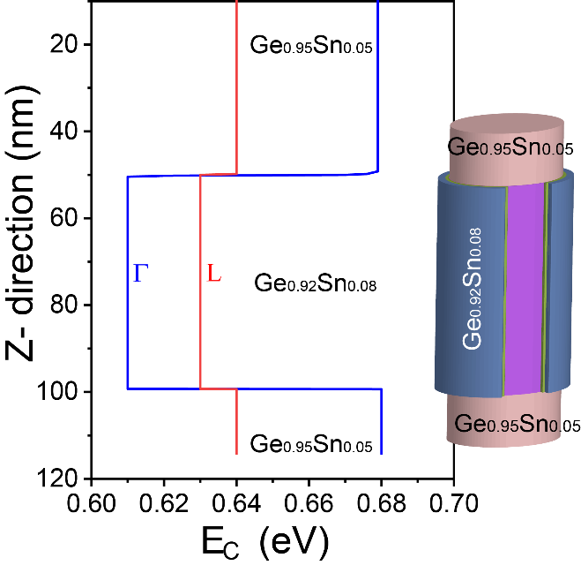
Figure S6. Conduction band energy alignment for proposed all GeSn n-VFET with direct band channel and highly doped and lower Sn content GeSn alloy as the source/drain.

- Cryogenic all GeSn n-VFET
CMOS circuits working at cryogenic temperatures from 100 mK to a few 10 K are required for the control and readout of the qubit information in quantum computing system. In order to reduce the power consumption and the heating dissipation the subthreshold swing SS of a MOSFET should be very small (<5 mV/dec @4 K). However, the interface states and defects cause a band tail in the band, leading to an inflection phenomenon³ as illustrated in Fig.S7. As a result, SS does not follow the Boltzmann limit and saturates at temperatures T<50 K. The inverse slope S_{inf} above V_{th} becomes much larger, inhibiting the applied voltage V_{DD} scaling.

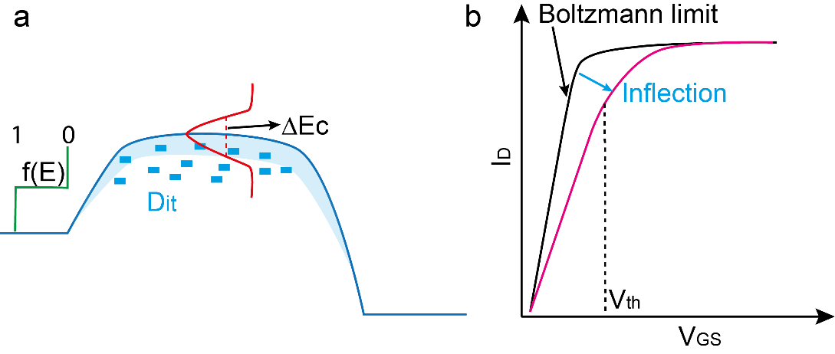
Figure S7. Band tail effects and the inflection phenomenon in the I_{D}-V_{GS} transfer characteristics. (a) Schematic illustrating the band tail of the conduction band caused by D_{it} and defects. (b) The band-tail effects result in inflection in the I_{D}-V_{GS} characteristics, increasing the SS and the inverse slope above V_{th}.

Figure S8a shows the I_{D}-V_{GS} transfer characteristics of the full GeSn n-VFET measured at 120 K and 60 K. The decrease of on-currents at lower temperature is caused by high series resistance at source/drain due to relatively low doping and incomplete ionization at low temperature. The SS-I_{D} characteristics at 12 K show a relative constant SS at I_{D} <10⁻² µA/µm and then a sharp increase, following the trend of the ideal curve. We suggest that interface state energies in this low bandgap Ge_{0.922}Sn_{0.078} material are mainly located close to the valence band ⁴, thus suppressed the inflection phenomenon. Moreover, the electron mobility of the direct bandgap GeSn channel is mcuher higher at low temperatures. All these facts provide a great potential for quantum computing application.

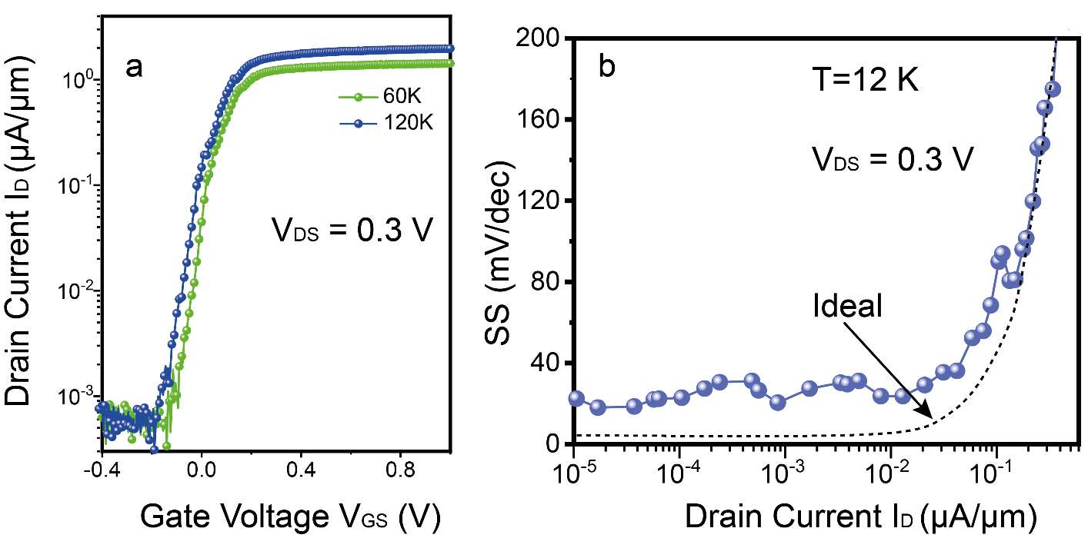
Figure S8 Low temperature characteristics of the full Ge_{0.922}Sn_{0.078} n-VFET . (a) I_{D}-V_{GS} transfer characteristics the device measured at 120 K and 60 K respectively. (b) SS∼I_{D} characteristics for the GeSn n-VFET measured at 12 K, demonstrating suppressed inflection.

References
1. Ghibaudo, G. New method for the extraction of MOSFET parameters. Electron. Lett. 24, 543–545 (1988).
2. Henry, J. B., Rafhay, Q., Cros, A. & Ghibaudo, G. New Y-function based MOSFET parameter extraction method from weak to strong inversion range. Solid. State. Electron. 123, 84–88 (2016).
3. Beckers, A., Jazaeri, F. & Enz, C. Inflection Phenomenon in Cryogenic MOSFET Behavior. IEEE Trans. Electron Devices 67, 1357–1360 (2020).
4. Baert, B., Schmeits, M. & Nguyen, N. D. Study of the energy distribution of the interface trap density in a GeSn MOS structure by numerical simulation of the electrical characteristics. Appl. Surf. Sci. 291, 25–30 (2014).

