Supplementary Information
for
The transcription factor HIF2α partakes in the differentiation block of acute myeloid leukemia

Daniela Magliulo¹, Carolina Caserta², Serena Belluschi^{3,4}, Cristina Fracassi¹, Kety Giannetti², Raffaella Pini⁵, Ettore Zapparoli⁵, Stefano Beretta², Martina Uggè¹, Matilde Simoni¹, Eleonora Draghi⁶, Nadia Coltella², Cristina Tresoldi⁷, Marco J. Morelli⁵, Raffaella Di Micco², Bernhard Gentner², Luca Vago⁶ and Rosa Bernardi^{1*}.
¹Division of Experimental Oncology, ²San Raffaele Telethon Institute for Gene Therapy (SR-TIGET), IRCCS San Raffaele Scientific Institute, Milan, Italy. ³Vita Salute San Raffaele University School of Medicine, Milan, Italy. ⁴Present address: Mogrify, 25 Cambridge Science Park Milton Road, Milton, Cambridge, UK. ⁵Center for Omics Sciences, ⁶Unit of Immunogenetics, Leukemia Genomics and Immunobiology, ⁷Unit of Hematology and Bone Marrow Transplantation, IRCCS San Raffaele Scientific Institute, Milan, Italy.

*Correspondence
Rosa Bernardi, PhD
IRCSS San Raffaele Scientific Institute
Via Olgettina 60, 20132, Milan, Italy
E-mail: bernardi.rosa@hsr.it
Phone: +390226435606
Fax: +390226435602

Contents
Supplementary Figures
- Supplementary Fig. 1 Silencing of HIF1α and HIF2α in AML cell lines.
- Supplementary Fig. 2 HIF1α and HIF2α expression in AML patients and cell lines.
- Supplementary Fig. 3 Colony formation and differentiation analysis upon HIF1α and HIF2α silencing with an independent set of shRNAs.
- Supplementary Fig. 4 Global changes in gene expression upon HIF1α or HIF2α silencing in AML cells.
- Supplementary Fig. 5 ATAC sequencing profiles and H3K4me3 deposition at regulatory regions of ITGB2, CD53 and IFI16 genes.
- Supplementary Fig. 6 Silencing of HIFα factors in PDX-derived AML cells.
- Supplementary Fig. 7 Treatment of NB4, Molm13, and THP1 cells with the specific HIF2α inhibitor PT2385.
- Supplementary Fig. 8 Combination of HIF2α inhibition and ATRA increases AML differentiation in NB4, Molm13, and THP1 cells.
- Supplementary Fig. 9 Gene sets negatively regulated upon HIF2α inhibition and ATRA treatment.
Supplementary Tables
- Supplementary Table 1. List of 118 genes commonly upregulated in shHIF2α HL60 and Kasumi1 cells.
- Supplementary Table 2. List of 73 genes commonly downregulated in shHIF2α HL60 and Kasumi1 cells.
- Supplementary Table 3. Probes for qPCR.
- Supplementary Table 4. Sets of primers for ChIP experiments.
Supplementary References
Supplementary Figures
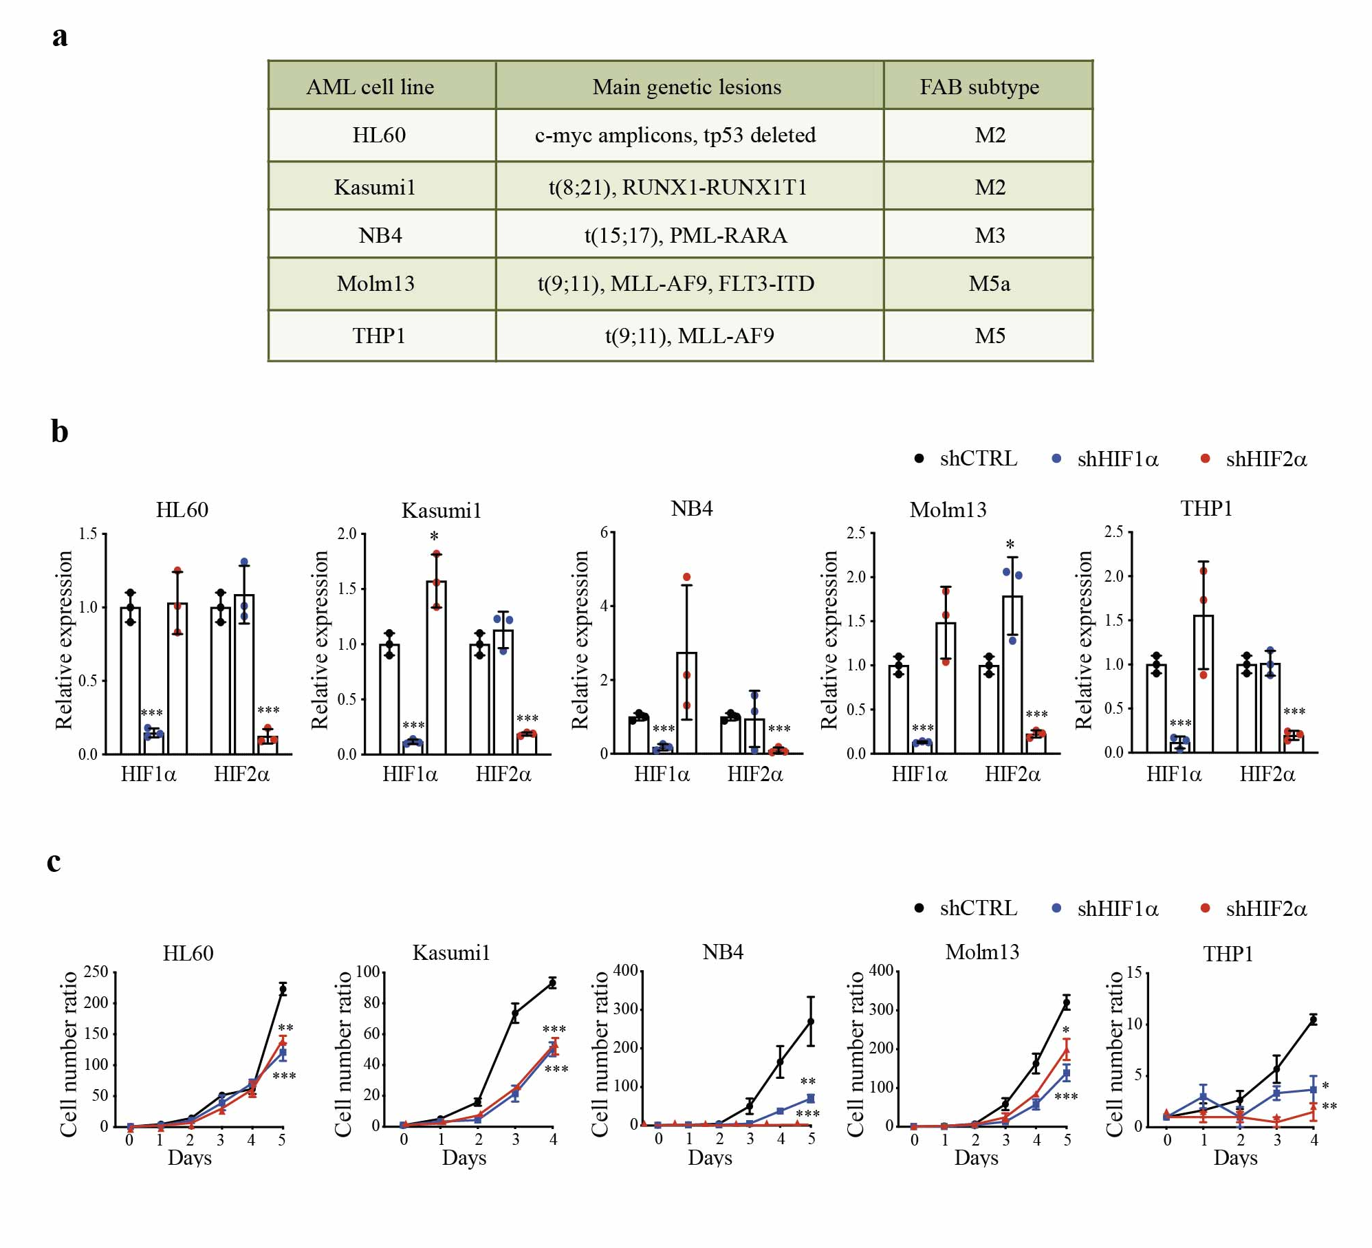
Supplementary Fig. 1 Silencing of HIF1α and HIF2α in AML cell lines. a Main mutations and chromosomal rearrangements, and FAB (French-American-British) morphological subtype of the 5 AML cell lines utilized in this work. b mRNA expression of HIF1α and HIF2α in the indicated AML cells stably expressing shRNAs against HIF1α (shHIF1α) or HIF2α (shHIF2α). Data are expressed as fold change in HIFα-silenced cells compared to cells with a control shRNA (shCTRL). c Cell proliferation of the indicated AML cell lines carrying shHIF1α, shHIF2α, or shCTRL. Values represent cell numbers normalized over day 0. All data represent the mean ± SD of 3 biological replicates. Statistical significance was determined by two-sided Student’s t-test.
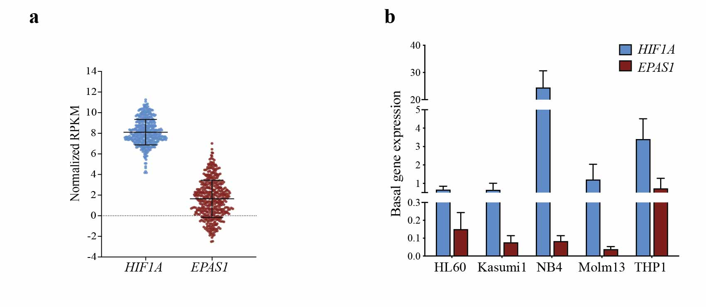
Supplementary Fig. 2 HIF1α and HIF2α expression in AML patients and cell lines. a mRNA expression of HIF1A and EPAS1 (encoding HIF1α and HIF2α respectively) in 451 AML patients from the Oregon Health & Science University (OSHU) dataset¹. Data are expressed as normalized RPKM (Reads Per Kilobase Million), and were obtained from the cBioportal database². b Analysis of HIF1A and EPAS1 expression in the human AML cell lines utilized in this study.

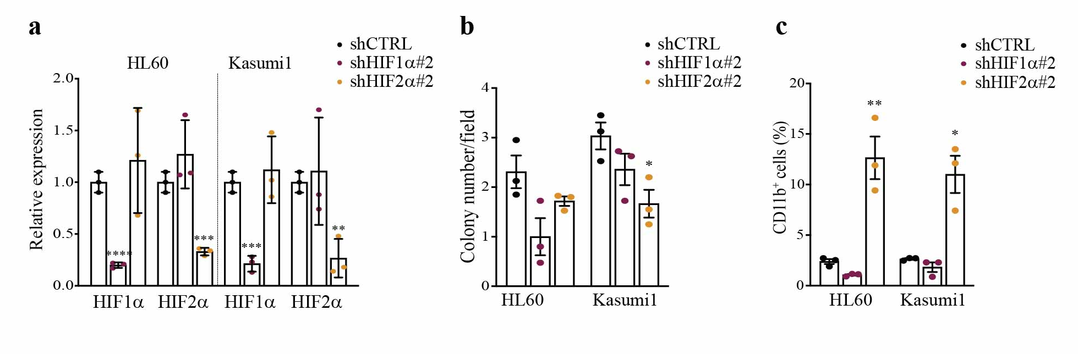
Supplementary Fig. 3 Colony formation and differentiation analysis upon HIF1α and HIF2α silencing with an independent set of shRNAs. a Fold change expression of HIF1α and HIF2α upon silencing with two independent shRNAs (shHIF1α#2 and shHIF2α#2) compared to control (shCTRL) cells. b Colony forming capability of indicated AML cell lines expressing shHIF1α#2, shHIF2α#2, or shCTRL. Shown is the average number of colonies in 20 fields (10x objective). c Percentage of CD11b⁺ in indicated AML cell lines expressing shHIF1α#2, shHIF2α#2, or shCTRL. All data represent the mean ± SD of 3 biological replicates. Statistical significance was determined by two-sided Student’s t-test.

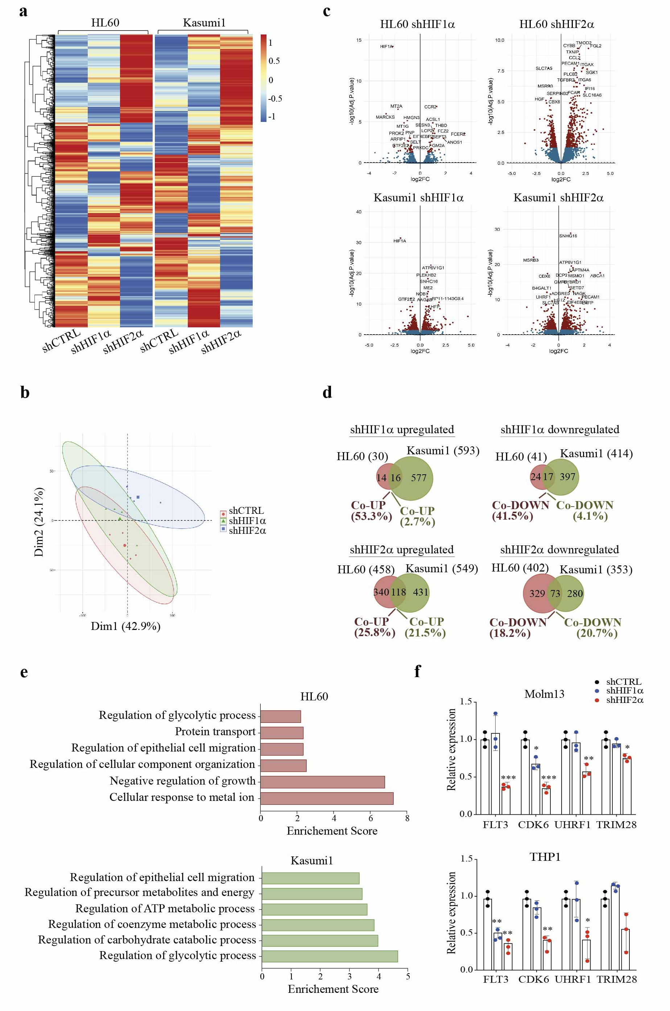
Supplementary Fig. 4 Global changes in gene expression upon HIF1α or HIF2α silencing in AML cells. a Unsupervised hierarchical clustering of differentially expressed genes (DEGs) in HL60 and Kasumi1 cells following HIF1α or HIF2α silencing. A red-blue color scale was used to reflect normalized RPKM, with red indicating genes with higher expression and blue indicating genes with lower expression. Each column represents the average of two independent experiments. b Principal component analysis (PCA) on DEGs in shHIF1α, shHIF2α, and shCTRL HL60 and Kasumi1 cells. Ellipses identify clusters, the centroid represents the barycenter of the points belonging to the same cluster. c Volcano plots depicting DEGs in shHIF1α and shHIF2α HL60 and Kasumi1 cells with respect to shCTRL cells. Red and blue dots correspond respectively to significantly and non-significantly deregulated genes. A significant threshold of 0.05, adjusting the p-value by FDR (False Discovery Rates), was established to identify DEGs. d Venn diagrams showing the number of DEGs commonly upregulated and downregulated in HL60 and Kasumi1 cells upon shHIF1α (top) or shHIF2α (bottom). Common/total deregulated genes in each cell line are indicated as percentages. e Representative Gene Ontology (GO) terms within the most significant families of downregulated genes in shHIF1α HL60 and Kasumi1 cells. Data are presented as enrichment score (–log₁₀(p-value)) over shCTRL cells. f Fold change expression of the indicated genes in Molm13 and THP1 cells expressing shHIF1α or shHIF2α compared to shCTRL cells. Data in (f) represent the mean ± SD of 3 biological replicates and statistical significance was determined by two-sided Student’s t-test.

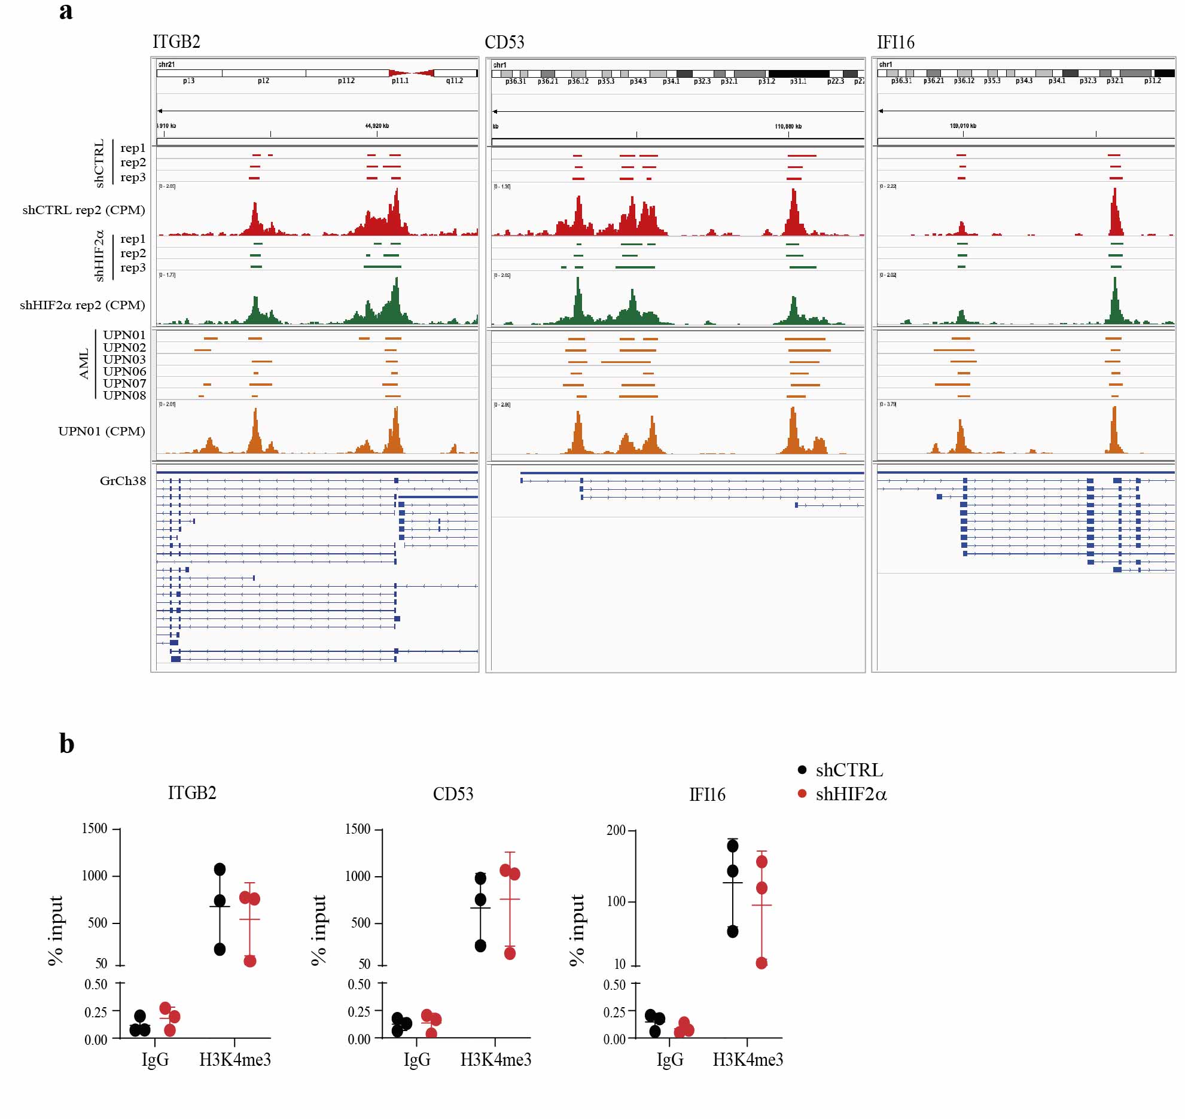
Supplementary Fig. 5 ATAC sequencing profiles and H3K4me3 deposition at regulatory regions of ITGB2, CD53 and IFI16 genes. a Chromatin accessibility evaluated by ATAC sequencing at the regulatory regions of differentiation genes ITGB2, CD53, and IFI16. Upper panels show genes position on chromosomes. Open chromatin peaks of Kasumi1 cells are indicated in red for shCTRL and green for shHIF2α. Triplicate experiments and a representative alignment (normalized CPM values) of each condition are shown. Open chromatin peaks of 6 primary AML cells (obtained from GSE197416)³ are indicated in orange and a representative alignment is shown. Lower panels represent the corresponding gene annotation from GrCh38 human reference. b H3K4me3 deposition at the regulatory regions of indicated genes in Kasumi1 cells was measured by ChIP-qPCR upon shCTRL or shHIF2α. IgG was used as negative control. Results are represented as % over input. Data represent the mean ± SD of 3 biological replicates.

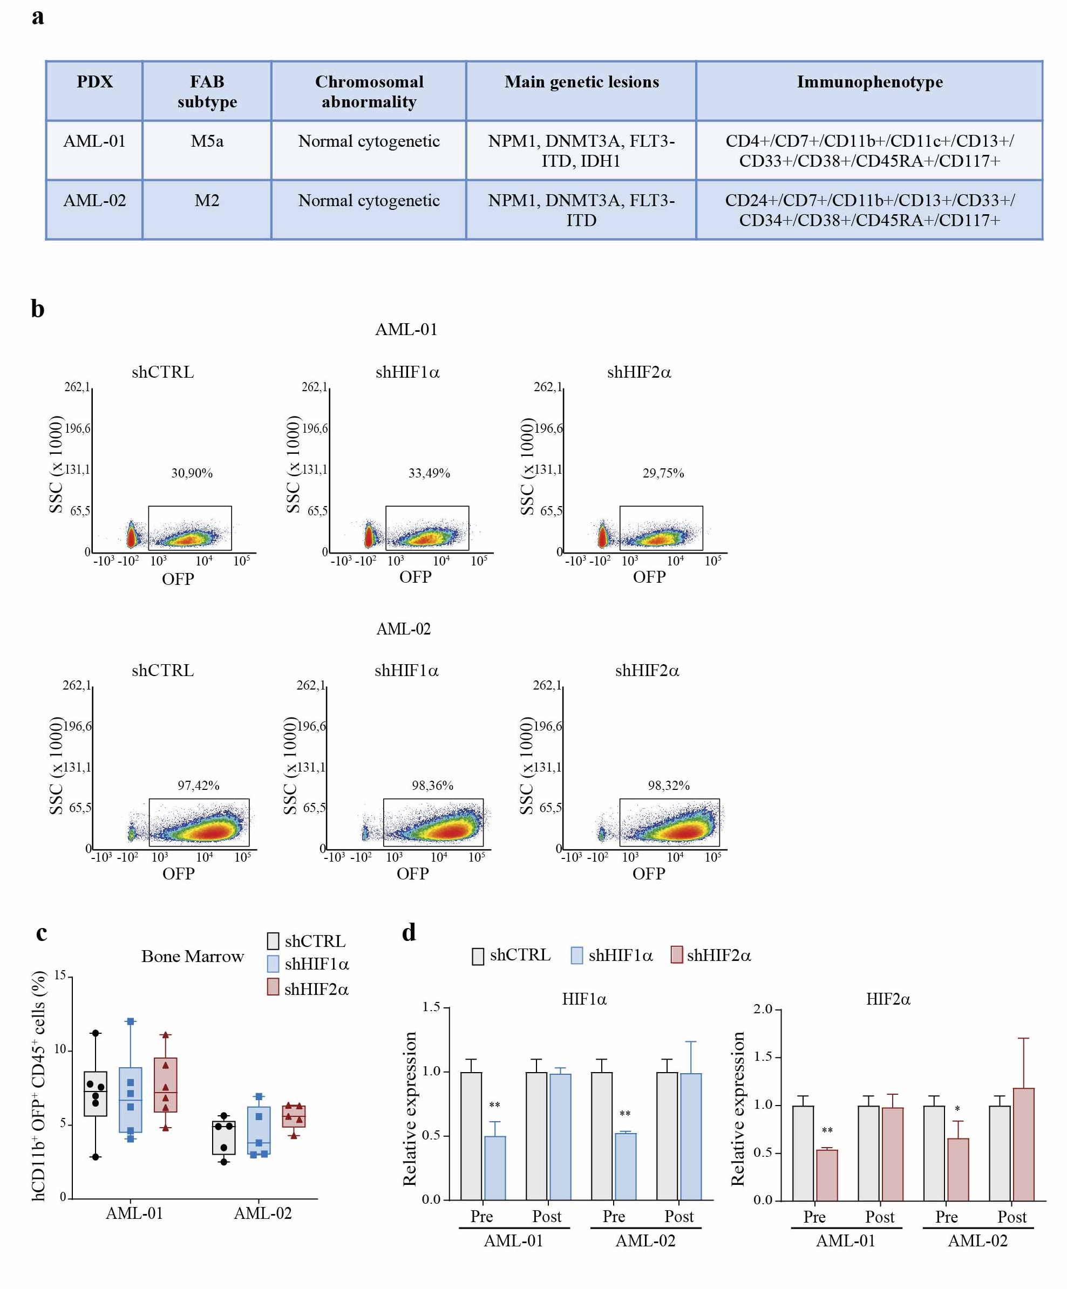
Supplementary Fig. 6 Silencing of HIFα factors in PDX-derived AML cells. a Morphological, genetic and immunophenotypic features of the two AML PDX models utilized in this work. b FACS analysis performed at 96 hours after infection of AML-01 and AML-02 cells with lentiviral vectors carrying specific shRNAs and orange fluorescent protein (OFP). Shown is the transduction efficiency in AML-01 and AML-02 cells. Data are representative of one out of three experiments with similar results. c Percentage of leukemic cells expressing the myeloid differentiation marker CD11b (hCD11b⁺OFP⁺CD45⁺) in the bone marrow of mice transplanted with AML-01 (n=6) and AML-02 (n=5) carrying shCTRL, shHIF1α, or shHIF2α. d qPCR of HIF1α and HIF2α genes in AML-01 and AML-02 cells carrying shCTRL, shHIF1α, and shHIF2α. Pre and Post indicate OFP⁺ cells sorted prior to transplantation and isolated from the BM of leukemic mice at experimental endpoint respectively. Values indicate fold changes in gene expression compared to shCTRL cells. Data are representative of one experiment out of two. Two-sided Student’s t-test was used in (d). Data from (c) and (d) represent the mean ± SD.

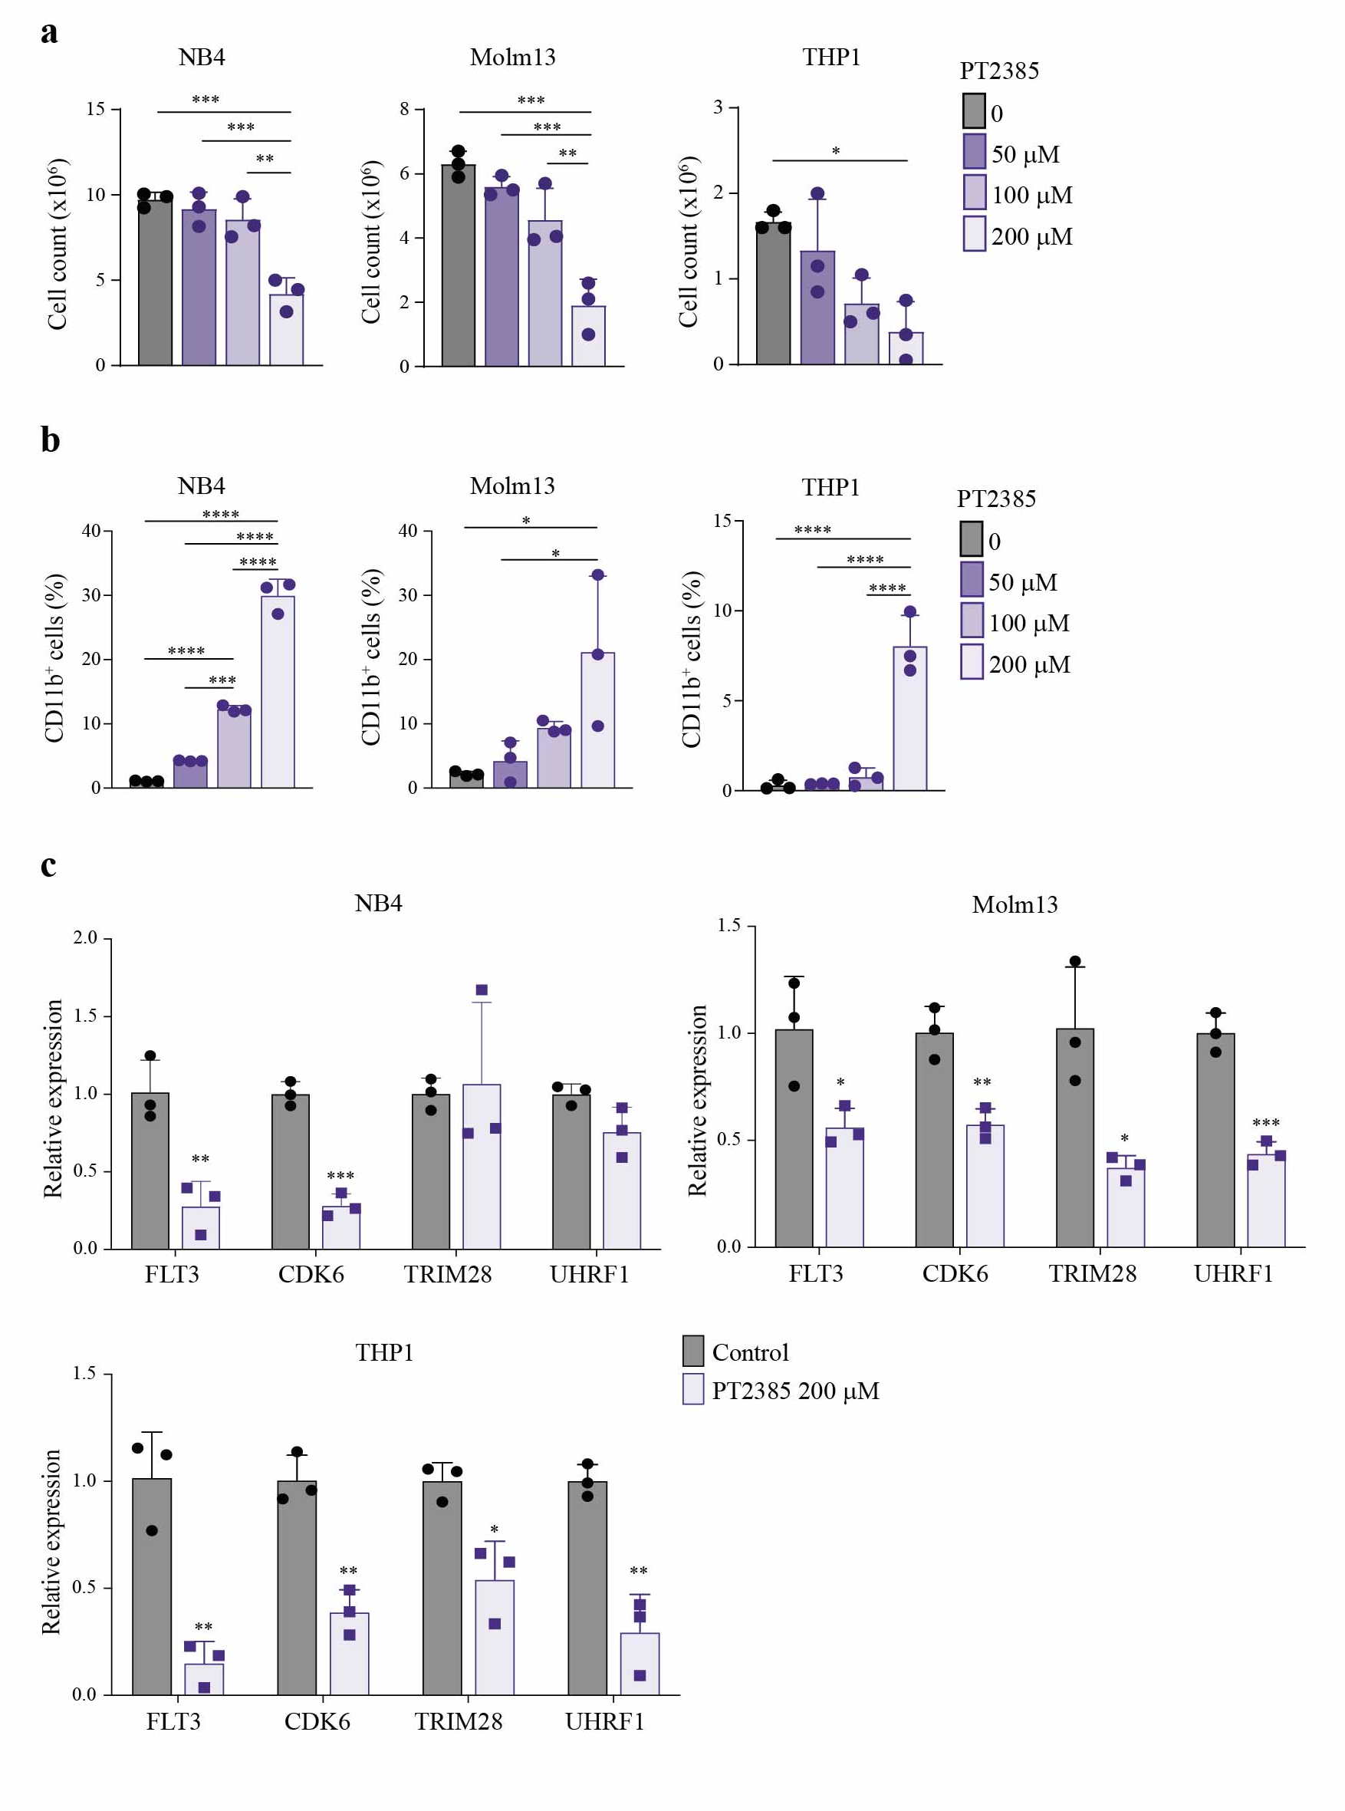
Supplementary Fig. 7 Treatment of NB4, Molm13, and THP1 cells with the specific HIF2α inhibitor PT2385. a Cell numbers of the indicated AML cell lines 48 hours after treatment with PT2385 at the indicated doses. b Percentage of CD11b⁺ AML cells 48 hours after treatment with PT2385 at the indicated doses. c qPCR analysis of the indicated genes in AML cell lines 48 hours after treatment with 200 μM PT2385. Values are represented as fold change in gene expression compared to control cells. One-way ANOVA followed by Tukey’s multiple comparison test was used in (a) and (b). Two-sided Student’s t-test was used in (c). All data represent the mean ± SD of 3 biological replicates.

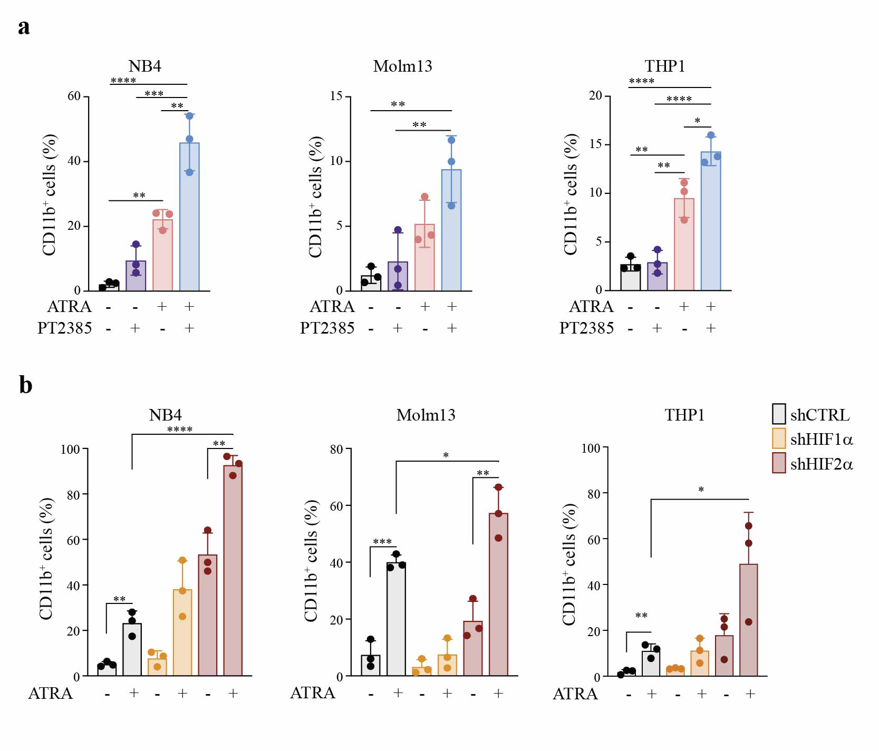
Supplementary Fig. 8 Combination of HIF2α inhibition and ATRA increases AML differentiation in NB4, Molm13, and THP1 cells. a Percentage of CD11b⁺ cells following treatment with 50 μM PT2385, 1 μM ATRA, or drug combination for 24 hours in the indicated cell lines. b Percentage of CD11b⁺ cells in the indicated AML cell lines upon specific silencing of HIF1α or HIF2α and treatment with 1 μM ATRA for 24 hours. One-way ANOVA followed by Tukey’s multiple comparison test was used in (a). Two-sided Student’s t-test was used in (b). All data represent the mean ± SD of 3 biological replicates.

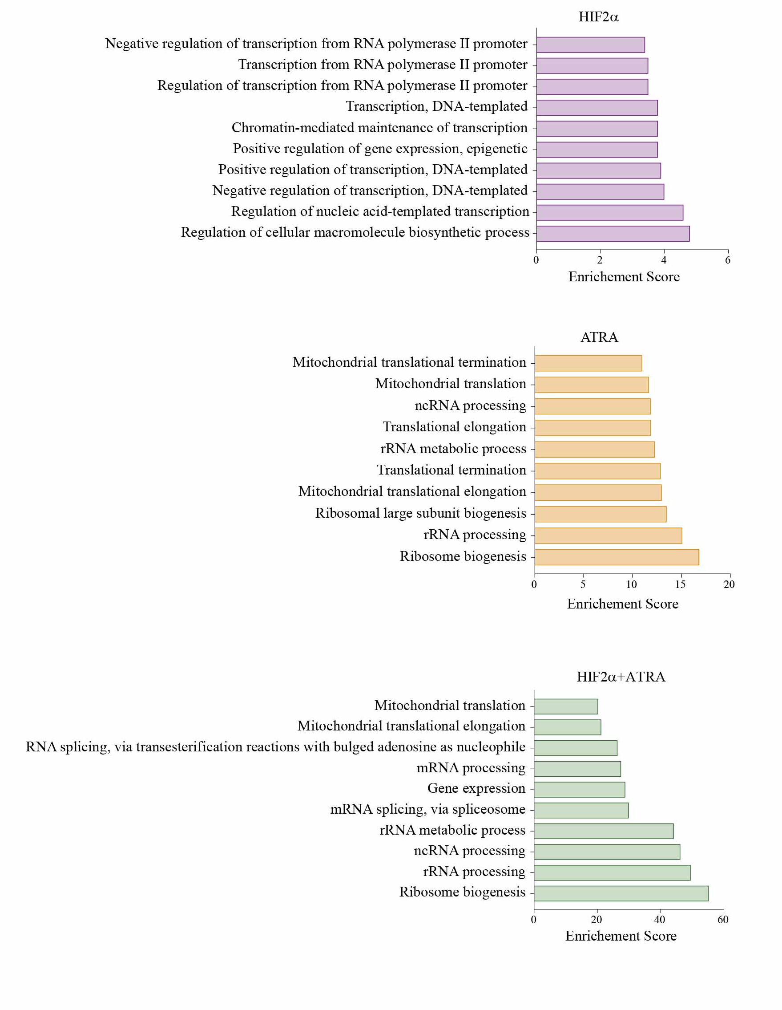
Supplementary Fig. 9 Gene sets negatively regulated upon HIF2α inhibition and ATRA treatment. List of the top 10 enriched GO terms found downregulated in Kasumi1 cells upon silencing of HIF2α (purple), treatment with 1 μM ATRA for 24 hours (orange), or combination of both (green). Significance for each condition was calculated with respect to shCTRL Kasumi1 cells and expressed as enrichment score (-log₁₀ (p-value)).

Supplementary Tables
Supplementary Table 3. Probes for qPCR.
Gene | Assay ID
EPAS1 | Hs01026142_m1
HIF1A | Hs00936371_m1
FLT3 | Hs00174690_m1
CDK6 | Hs01026371_m1
TRIM28 | Hs00232212_m1
UHRF1 | Hs01086727_m1
PGK1 | Hs00943178_g1
PDK1 | Hs01561847_m1
18s | Hs03003631_g1

Supplementary Table 4. Sets of primers for ChIP experiments.
Primers | Sequence (5’-3’)
CD53 forward | ATGACTGAGGTTGCATGGACT
CD53 reverse | TGCTCCAGGGCATAATCAAGT
HIF2α forward | CCCCAACCCTTTCTGTGTAC
HIF2α reverse | GGACCCATGAGTTTCACAGG
IFI16 forward | ACATCCTGCGGTTCCGTTT
IFI16 reverse | GAACAGTACTCACCTCACTGGA
ITGB2 forward | ATGGTGTGCATGTATGGTGCA
ITGB2 reverse | ACATACAACAGACTCCCCACA
MYT1 forward | ACAAAGGCAGATACCCAACG
MYT1 reverse | GCAGTTTCAAAAAGCCATCC
RARβ forward | TCCTGGGAGTTGGTGATGTCAG
RARβ reverse | AAACCCTGCTCGGATCGCTC
α-satellite forward | CTGCACTACCTGAAGAGGAC
α-satellite reverse | GATGGTTCAACACTCTTACA

Supplementary References
1. Tyner, J. W. et al. Functional genomic landscape of acute myeloid leukaemia. Nature 562, 526–531 (2018).
2. Cerami, E. et al. The cBio cancer genomics portal: an open platform for exploring multidimensional cancer genomics data. Cancer Discov. 2, 401–404 (2012).
3. Gambacorta, V. et al. Integrated Multiomic Profiling Identifies the Epigenetic Regulator PRC2 as a Therapeutic Target to Counteract Leukemia Immune Escape and Relapse. Cancer Discov. (2022) doi:10.1158/2159-8290.CD-21-0980.

