Supplementary material

This online resource has been provided by the authors to give readers additional information about their work.

Supplement to: Predicting health services utilization using a score of perceived barriers to medical care: evidence from rural Senegal

Contents:
Page 2: Appendix A1. Members of the UNISSAHEL Study Group
Page 3-5: Appendix A2. Definitions of all variables used
Page 6: Appendix A3. Results of the explanatory factor analysis
Page 7: Appendix A4. Summary statistics
Page 8-11: Appendix A5. Predictive validity of the score: graphical representation of the univariate regression results
Page 12-16: Appendix A6. Confirmation of the score on the ANRS12356 AmBASS dataset

Appendix A1. Members of the UNISSAHEL Study Group
Project coordination: MP. BA (UGB), E. BONNET (RESILIENCE, IRD), F. CHABROL (CEPED, IRD), A. DESGREES DU LOU (CEPED, IRD), A. DUMONT (CEPED, IRD), F. EBOKO (CEPED, IRD), A. FILLOL (CEPED, IRD), D. MANOUFI (BASE), V. RIDDE (CEPED, IRD), K. SOW (CRCF), L. TOURE (MISELI), B. VENTELOU (AMSE, CNRS).
Project members: Mohammad ABU ZAINEH (AMSE), Malick Ousman AHMAT (BASE), Sameera AWAWDA (AMSE, IRD), El Hadj BA (VITROME, IRD), Pauline BOIVIN (MISELI), Marwân-al-Qays BOUSMAH (CEPED, IRD), Sylvie BOYER (SESSTIM, Aix-Marseille Université), Valérie DELAUNAY (LPED, IRD), Fatimatou DIA (UGB), Mariama DIEDHIOU (CRCF), Rama Sao DIOP (UGB), Fatou DIOP (CRCF), Cheikh Mouhamadou Falilou Mb. FALL (UGB), Laurence FLEURY (LPED, IRD), Idriss Ali Zakaria GALI-GALI (BASE), Lara GAUTIER (UDEM), Wendyam Charles Paulin Didier KABORE (CEPED, IRD), Yamba KAFANDO (independent consultant), Richard LALOU (MERIT, IRD), Ramadan KAGONTA (BASE), Gabrièle LABORDE-BALEN (TRANSVIHMI, IRD), Fatou Bintou NIANG (UGB), Ratnan NGADOUM (Université de N’Djamena), Khady Seck NGOM (CRCF), El Hadji Ibrahima Kady SARR (UGB), Mathieu SEPPEY (UDEM), Cheikh SOKHNA (VITROME, IRD), Souleymane SOW (CRCF), Bernard TAVERNE (TRANSVIHMI, IRD), Cheikh TINE (MERIT, IRD), Grâce-à-Dieu TOULAO (IRD), Bintou RASSOUL TOP (CRCF), Mamadou YATOUDEME (IRD).
Acronyms: AMSE (France): Aix-Marseille School of Economics, CEPED (France): Centre Population et Développement, CNRS (France): Centre National de la Recherche Scientifique, CRCF (Senegal): Centre Régional de Recherche et de Formation à la Prise en Charge Clinique de Fann, LASDEL (Niger): Laboratoire d'Etudes et de Recherche sur les Dynamiques Sociales et le Développement Local, LPED (France): Laboratoire Population Environnement Développement, SESSTIM (France): Sciences économiques et sociales de la santé et traitement de l’information médicale, UDEM (Canada): Université de Montréal, UGB (Sénégal): Université Gaston Berger de Saint Louis.

Appendix A2. Definitions of all variables used
Variable group | Variable | Type | Definition | N | Percentage of population or sub-population
Determinants of healthcare-seeking | Had primary education or higher | Binary | None (=reference category); Primary school or higher | 1787 | 83.77; 16.23
Determinants of healthcare-seeking | Was a woman | Binary | Man (=reference category); Woman | 1787 | 45.89; 54.11
Determinants of healthcare-seeking | Was in a union | Binary | Not in a union (=reference category); In a union | 1787 | 9.78; 90.22
Determinants of healthcare-seeking | Age | Continuous | Age (in years) | 1787
Determinants of healthcare-seeking | Was poor (monetary poverty, HH level) | Binary | Household not considered as poor based on a monetary poverty indicator (=reference category); Considered as poor | 1787 | 49.09; 50.91
Determinants of healthcare-seeking | Was poor (food poverty, HH level) | Binary | Household not considered as poor based on a food poverty indicator (=reference category); Considered as poor | 1787 | 61.87; 38.13
Determinants of healthcare-seeking | Was poor (subjective poverty, HH level) | Binary | Household not considered as poor based on a subjective poverty indicator (=reference category); Considered as poor | 1787 | 70.84; 29.16
Determinants of healthcare-seeking | Monthly consumption expenditures per adult equivalent (in CFA francs) | Continuous | Total monthly consumption expenditures per adult equivalent in the household | 1787
Determinants of healthcare-seeking | Number of adult equivalents in the household (HH level) | Continuous | Number of adult equivalents in the household, calculated using the Food and Agriculture Organization (FAO)’s Adult Male Equivalent (AME) method | 1787
Determinants of healthcare-seeking | Distance to the nearest healthcare structure (in km) | Continuous | Shortest geographical distance (in km) between the household and the nearest healthcare structure (based on GPS coordinates) | 1787
Determinants of healthcare-seeking | Distance to the nearest CBHI (in km) | Continuous | Shortest geographical distance (in km) between the household and the nearest CBHI (based on GPS coordinates) | 1787
Healthcare services utilization | Forgone medical consultation (HH level) | Binary | The household did not have to forgo medical consultation in the last 12 months due to financial hardship (=reference category); The household forgone medical consultation | 1787 | 64.57; 35.43
Healthcare services utilization | Forgone medical treatment (HH level) | Binary | The household did not have to forgo medical treatment in the last 12 months due to financial hardship (=reference category); The household forgone medical treatment | 1787 | 75.85; 24.15
Healthcare services utilization | Consulted in a health structure following an episode of illness | Binary | Did not consult in a health structure in case of health problem that occurred in the last 2 months (=reference category); Consulted | 418 | 67.38; 32.62
Healthcare services utilization | Self-medicated following an episode of illness | Binary | Did not self-medicate in case of health problem that occurred in the last 2 months (=reference category); Self-medicated | 418 | 68.73; 31.27
Healthcare services utilization | Gave birth in a health facility | Binary | Delivered at home, for a live birth that occurred in the last 2 years (=reference category); Delivered in a health facility | 197 | 45.81; 54.19
Healthcare services utilization | Number of prenatal consultations | Discrete | Number of prenatal consultations (for a live birth that occurred in the last 2 years) | 197
Other potentially-associated variables | Had an at least fair knowledge of CBHI | Binary | Never heard of CBHI schemes/No knowledge (=reference category); Fair/good knowledge | 1787 | 73.88; 26.12
Other potentially-associated variables | Health insurance status | Polytomous | Not enrolled in a CBHI (=reference category); Enrolled (voluntarily); Enrolled (subsidized) | 1787 | 87.38; 4.11; 8.51
Other potentially-associated variables | Willingness to pay for CBHI (in CFA francs) | Continuous | Maximum annual premium an individual would pay to enroll in a CBHI (in CFA francs) | 1787
Other potentially-associated variables | Had a chronic illness | Binary | No chronic illness (=reference category); Chronic illness | 1787 | 91.16; 8.84
Other potentially-associated variables | Had a handicap | Binary | No handicap (=reference category); Handicap | 1787 | 95.04; 4.96
Other potentially-associated variables | Had a poorer health | Binary | Excellent/Very good health (=reference category); Good/Fair/Poor health | 1787 | 41.52; 58.48
Other potentially-associated variables | SF-12 Mental Component Summary (MCS-12) | Continuous | Mental health score calculated from the SF-12 questionnaire, ranging from 0 to 100 (higher values corresponding to better health-related quality of life) | 1787
Other potentially-associated variables | SF-12 Physical Component Summary (PCS-12) | Continuous | Physical health score calculated from the SF-12 questionnaire, ranging from 0 to 100 (higher values corresponding to better health-related quality of life) | 1787
Other potentially-associated variables | Perception of healthcare quality | Continuous | Factor-based score (higher values corresponding to a lower perception of healthcare quality), encompassing nine dimensions about the health facility the most frequently visited by the respondent (the premises, the medical material and equipment, the waiting time, the physician’s listening skills, the physical examination, the medical care provided, the medical staff guidance, the reliability of the diagnosis, and the availability of drugs) | 1787
Other potentially-associated variables | Risk tolerance | Discrete | Qualitative scale ranging from 0 (“not at all willing to take risks”) to 10 (“very willing to take risks”) | 1785
Other potentially-associated variables | Generalized trust | Discrete | Qualitative scale ranging from 0 (“you can’t be too careful in dealing with people”) to 10 (“most people can be trusted”) | 1786
Catastrophic health expenditure | Had catastrophic health expenditures, 40% threshold (HH level) | Binary | The household's out-of-pocket health expenditure did not exceed 40% of its capacity to pay (=reference category); The household's out-of-pocket health expenditure exceeded 40% of its capacity to pay | 1787 | 93.68; 6.32
Catastrophic health expenditure | Had catastrophic health expenditures, 30% threshold (HH level) | Binary | The household's out-of-pocket health expenditure did not exceed 30% of its capacity to pay (=reference category); The household's out-of-pocket health expenditure exceeded 40% of its capacity to pay | 1787 | 89.30; 10.70
Catastrophic health expenditure | Had catastrophic health expenditures, 20% threshold (HH level) | Binary | The household's out-of-pocket health expenditure did not exceed 20% of its capacity to pay (=reference category); The household's out-of-pocket health expenditure exceeded 40% of its capacity to pay | 1787 | 82.82; 17.18

Notes: All variables measured at the individual level, unless when HH-level specified. Data were weighted using sampling weights to account for choice-based stratified samples.

Abbreviations: N=number of observations, HH=household, CBHI=community-based health insurance.

Appendix A3. Results of the explanatory factor analysis

Factor analysis/correlation Number of obs = 1,787
Method: principal-component factors Retained factors = 2
Rotation: orthogonal varimax (Kaiser off) Number of params = 9

Factor Variance Difference Proportion Cumulative
Factor1 2.13304 1.08438 0.4266 0.4266
Factor2 1.04866 . 0.2097 0.6363

LR test: independent vs. saturated: chi2(10) = 2035.55 Prob>chi2 = 0.0000

Rotated factor loadings (pattern matrix) and unique variances

Variable Factor 1 Factor 2 Uniqueness
v2_A9_Q3_B 0.0775 0.8906 0.2008
v2_A9_Q3_C 0.5390 -0.3635 0.5773
v2_A9_Q3_D 0.8768 0.0606 0.2276
v2_A9_Q3_E 0.8852 0.0748 0.2108
v2_A9_Q3_F 0.5331 0.3376 0.6018
Figure A3.1. Scree plot
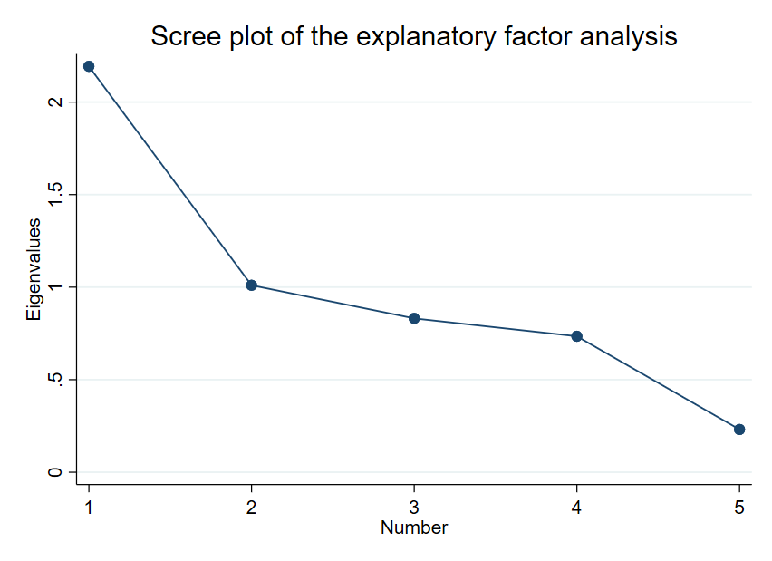
We retained factor 1 (eigenvalue = 2.13 > 1.1), which was situated right before the “elbow” of the scree plot (see Figure A2.1).
Appendix A4. Summary statistics
Variable group | Variable | Type | Mean or proportion | Standard deviation | Min | Max
Determinants of healthcare-seeking | Had primary education or higher | Binary | 0.16 | 0.37 | 0.00 | 1.00
Determinants of healthcare-seeking | Was a woman | Binary | 0.54 | 0.50 | 0.00 | 1.00
Determinants of healthcare-seeking | Was in a union | Binary | 0.90 | 0.30 | 0.00 | 1.00
Determinants of healthcare-seeking | Age | Continuous | 52.85 | 13.85 | 15.00 | 94.00
Determinants of healthcare-seeking | Was poor (monetary poverty, HH level) | Binary | 0.51 | 0.50 | 0.00 | 1.00
Determinants of healthcare-seeking | Was poor (food poverty, HH level) | Binary | 0.38 | 0.49 | 0.00 | 1.00
Determinants of healthcare-seeking | Was poor (subjective poverty, HH level) | Binary | 0.29 | 0.45 | 0.00 | 1.00
Determinants of healthcare-seeking | Monthly consumption expenditures per adult equivalent (in CFA francs) | Continuous | 16,936.27 | 10,887.67 | 2,868.00 | 162887.59
Determinants of healthcare-seeking | Number of adult equivalents in the household (HH level) | Continuous | 11.53 | 5.94 | 0.79 | 41.90
Determinants of healthcare-seeking | Distance to the nearest healthcare structure (in km) | Continuous | 3.15 | 2.19 | 0.01 | 9.40
Determinants of healthcare-seeking | Distance to the nearest CBHI (in km) | Continuous | 5.46 | 2.84 | 0.05 | 12.82
Healthcare services utilization | Forgone medical consultation (HH level) | Binary | 0.35 | 0.48 | 0.00 | 1.00
Healthcare services utilization | Forgone medical treatment (HH level) | Binary | 0.24 | 0.43 | 0.00 | 1.00
Healthcare services utilization | Consulted in a health structure following an episode of illness | Binary | 0.33 | 0.47 | 0.00 | 1.00
Healthcare services utilization | Self-medicated following an episode of illness | Binary | 0.31 | 0.46 | 0.00 | 1.00
Healthcare services utilization | Gave birth in a health facility | Binary | 0.54 | 0.50 | 0.00 | 1.00
Healthcare services utilization | Number of prenatal consultations | Discrete | 3.33 | 1.26 | 0.00 | 6.00
Other potentially-associated variables | Had an at least fair knowledge of CBHI | Binary | 0.26 | 0.44 | 0.00 | 1.00
Other potentially-associated variables | Willingness to pay for CBHI (in CFA francs) | Continuous | 3,865.83 | 3,905.57 | 0.00 | 50,000.00
Other potentially-associated variables | Had a chronic illness | Binary | 0.09 | 0.28 | 0.00 | 1.00
Other potentially-associated variables | Had a handicap | Binary | 0.05 | 0.22 | 0.00 | 1.00
Other potentially-associated variables | Had a poorer health | Binary | 0.58 | 0.49 | 0.00 | 1.00
Other potentially-associated variables | SF-12 Mental Component Summary (MCS-12) | Continuous | 47.89 | 7.81 | 18.92 | 70.56
Other potentially-associated variables | SF-12 Physical Component Summary (PCS-12) | Continuous | 49.53 | 9.52 | 17.51 | 65.27
Other potentially-associated variables | Perception of healthcare quality | Continuous | 0.52 | 0.53 | 0.00 | 2.56
Other potentially-associated variables | Risk tolerance | Discrete | 5.18 | 2.48 | 0.00 | 10.00
Other potentially-associated variables | Generalized trust | Discrete | 5.20 | 2.23 | 0.00 | 10.00
Catastrophic health expenditure | Had catastrophic health expenditures, 40% threshold (HH level) | Binary | 0.06 | 0.24 | 0.00 | 1.00
Catastrophic health expenditure | Had catastrophic health expenditures, 30% threshold (HH level) | Binary | 0.11 | 0.31 | 0.00 | 1.00
Catastrophic health expenditure | Had catastrophic health expenditures, 20% threshold (HH level) | Binary | 0.17 | 0.38 | 0.00 | 1.00

Notes: Means were computed for continuous and discrete variables, and proportions were computed for binary variables. All variables measured at the individual level, unless when HH-level specified. Data were weighted using sampling weights to account for choice-based stratified samples.

Abbreviations: N=number of observations, HH=household, CBHI=community-based health insurance.

Appendix A5. Predictive validity of the score: graphical representation of the univariate regression results

Appendix A5.1 PBMC score and determinants of healthcare-seeking

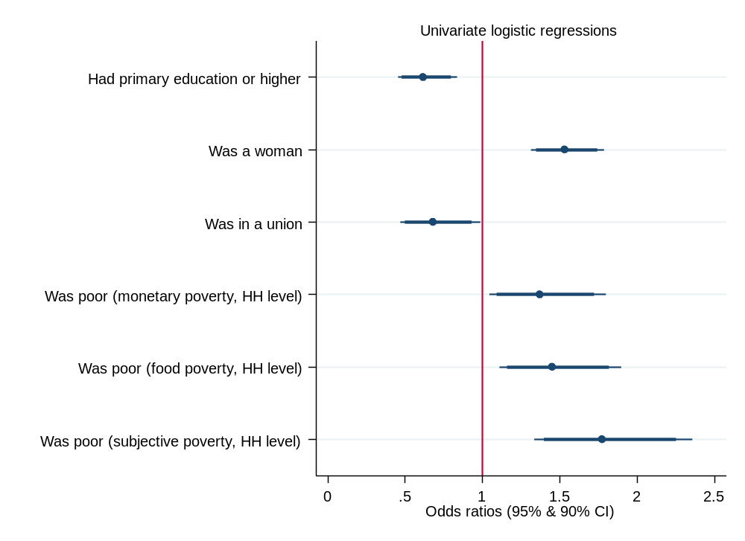

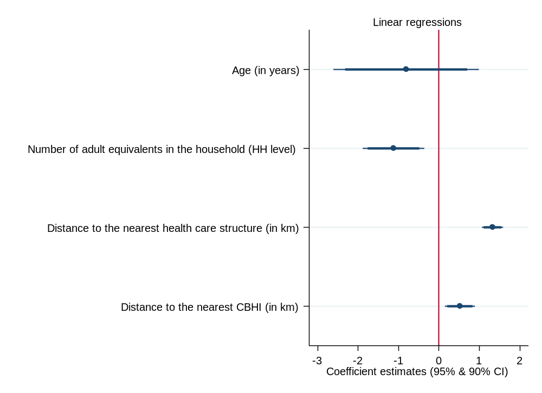
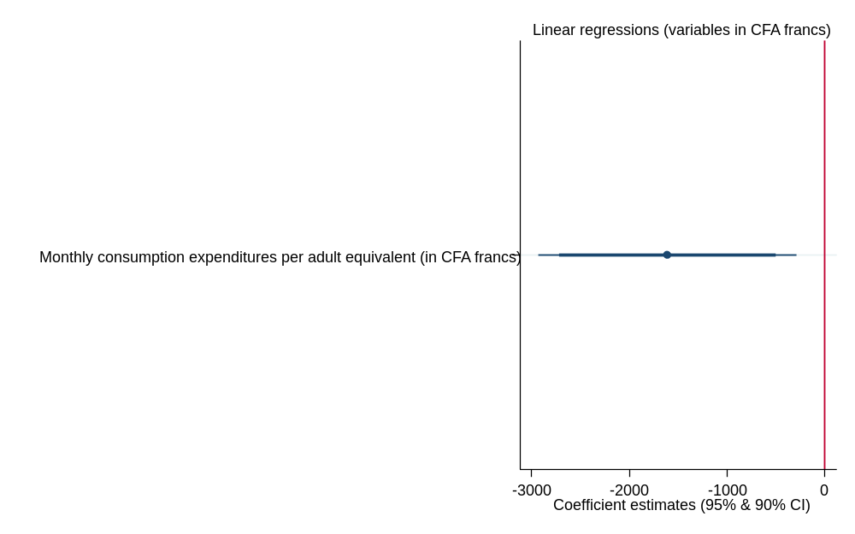

Appendix A5.2 PBMC score and health services utilization and non-utilization
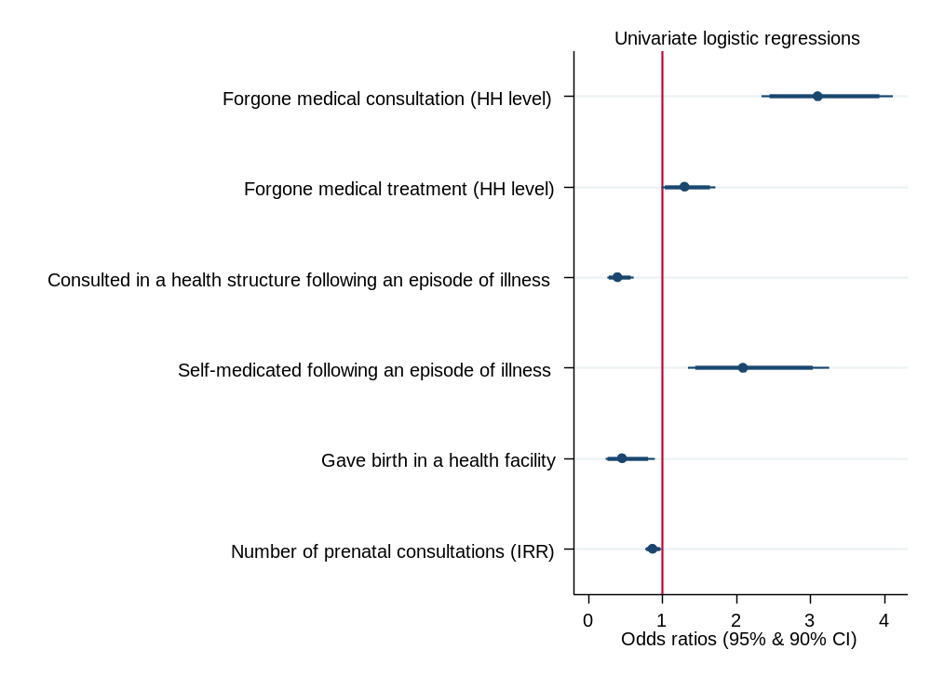

Appendix A5.3 PBMC score and other variables of interest
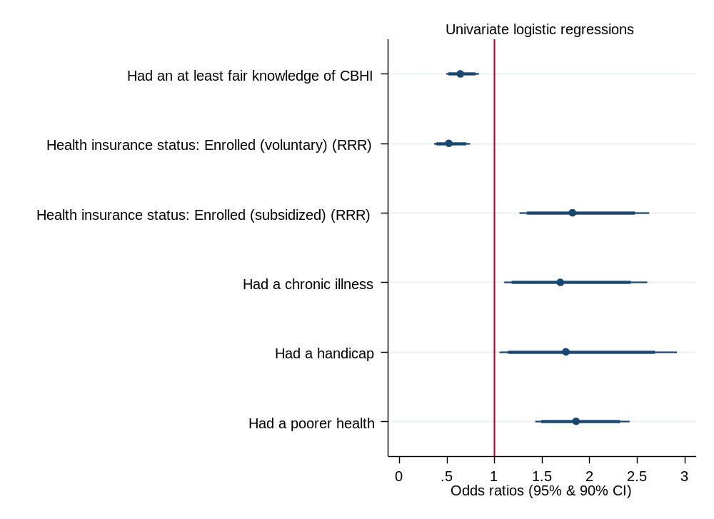

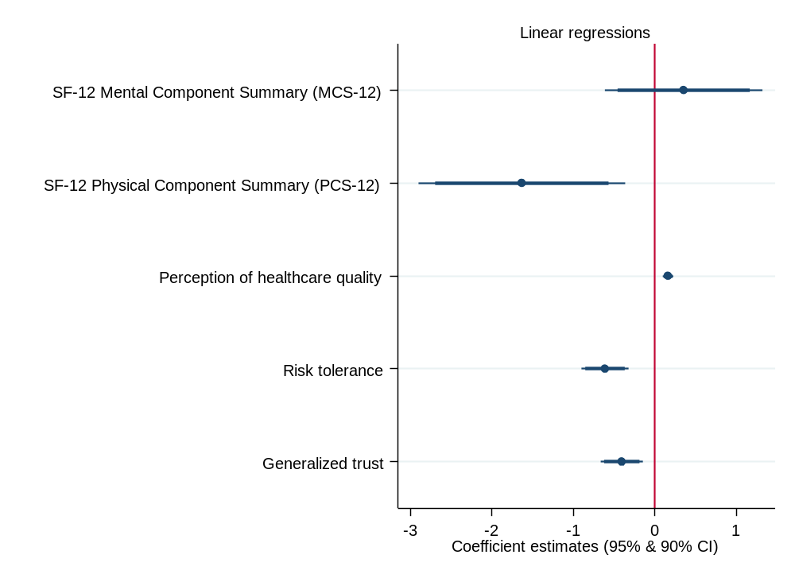
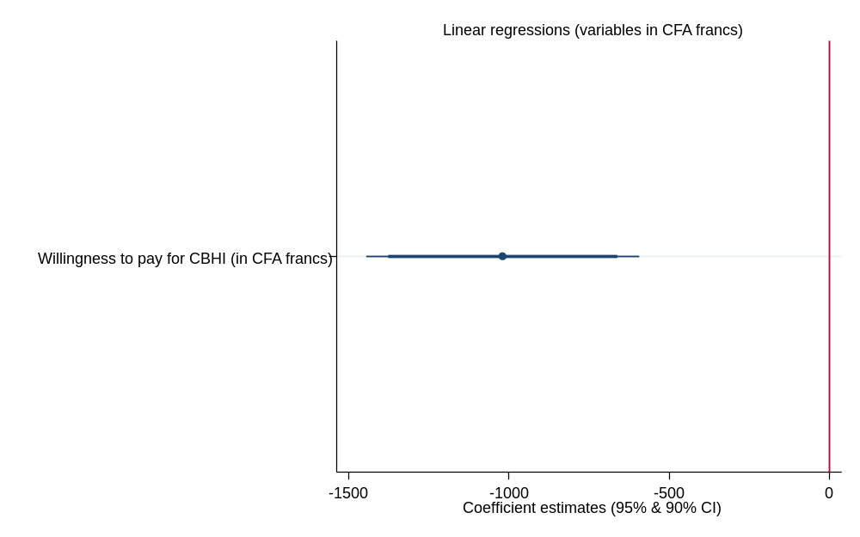

Appendix A5.4 PBMC score catastrophic health expenditures
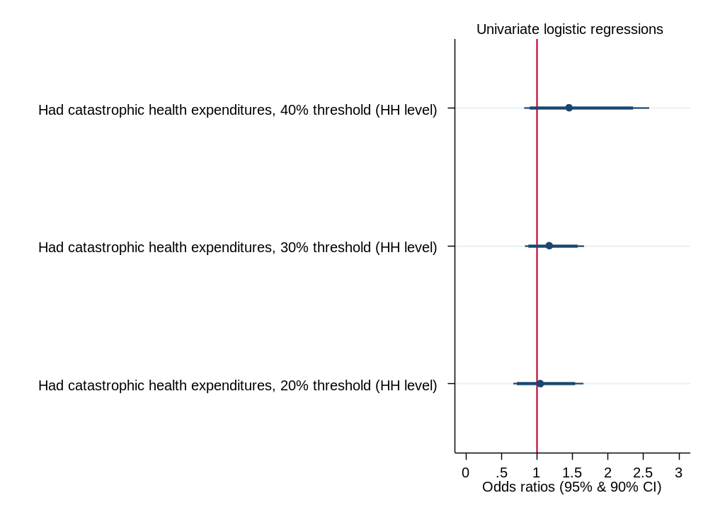

Appendix A6. Confirmation of the score on the ANRS12356 AmBASS dataset
The AmBASS survey was conducted between October 2018 and July 2019 in 12 villages of the Niakhar HDSS. Households were randomly selected, and all their residents (over 6 months of age) were invited to participate, ensuring a sample representative of people living in the Niakhar area. DHS-based items were administered to all 724 participants, age 15 and above, interviewed between January and July 2019.
- Perceived barriers to medical care in the AmBASS dataset
Compared with the CMUtuelleS dataset (see Figure A6.1.), a smaller share of participants reported having money, distance, and finding transport as a ‘big problem’ (11% vs. 55%, 5% vs. 15%, and 2% vs. 10%, respectively), and a bigger share of participants identified knowing where to go and getting the permission to go as ‘a small problem’ (13% vs. 2% and 12% vs. 1%, respectively).
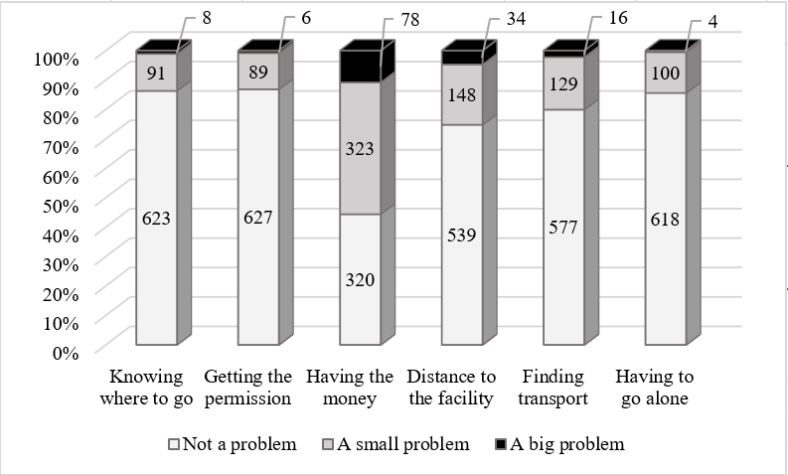
Figure A6.1. Perceived barriers to medical care (items considered for the score)

- Confirmatory factor analysis
Table A6.1 presents results from confirmatory factor analysis on the AmBASS dataset.
CFA models |  | Chi2 (p-value) | RMSEA | SRMR | CFI | TLI
(1) | AmBASS: reduced | 5.49 (0.0642) | 0.049 | 0.016 | 0.996 | 0.988
(2) | AmBASS: full | 241.943 (0.00) | 0.190 | 0.064 | 0.860 | 0.767
(3) | AmBASS: full with co-variates | 18.967 (0.00) | 0.055 | 0.019 | 0.992 | 0.981

Table A6.1. Goodness of fit measures of the CFA analysis
We first conducted CFA on the ‘reduced’ set of items validated in the CMUtuelleS survey, specifically items (3), (4), (5), and (6). Goodness of fit measures indicated an excellent fit of the data, better than when including the full set of items, and even after including co-variates (models (2) and (3) respectively).
3. Building the score in the AmBASS dataset
Our sample passed the Bartlett test of sphericity, rejecting the null hypothesis that variables are not inter-correlated (γ²=1674.965(15), p-value=0.000), and gave a value for the Kaiser-Meyer-Olkin measure sufficiently large (0.807) to justify running a factor analysis. Stepwise descendant factor analysis showed that removing any of the items would significantly reduce the quality of the factor analysis. Subsequent factor analysis was therefore conducted on all 6 items. Following EFA and scree plot analysis, only one dimension was retained (3.28 eigenvalue, explaining 55% of variations, see Figure A6.2).
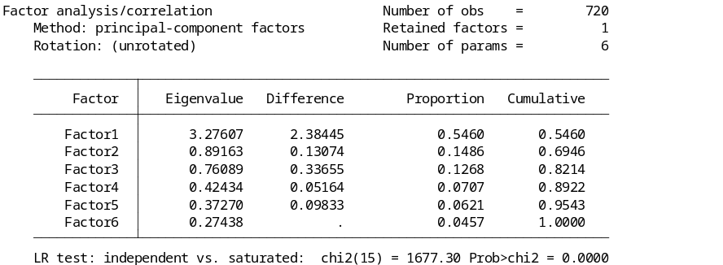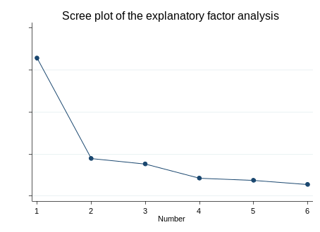

Figure A6.2 Exploratory factor & scree plot analysis

Rotations with weights revealed that all items significantly contributed to dimension one (loadings > 0.4). The 0.79 Cronbach’s alpha indicated excellent internal consistency. We, therefore, built a factor-based score with the average of items (1)-(6) on individuals without missing values (n=720). For comparison and cross-validation purposes, we also built a reduced score as the average of items (3)-(6). This reduced score exhibited good internal consistency with a 0.71 Cronbach’s alpha. Table A6.2 presents the score (bar charts are also provided in Figure A6.3).
Score | Items | Mean (min;max) | Median [IQR] | Cronbach’s α
Reduced PBMC | (3)-(6) | 0.33(0;2) | 0.25[0-1] | 0.71
Full PBMC | (1)-(6) | 0.27(0;2) | 0.17[0-0.33] | 0.79

Table A6.2. Summary statistics and internal consistency of the full and reduced PBMC scores
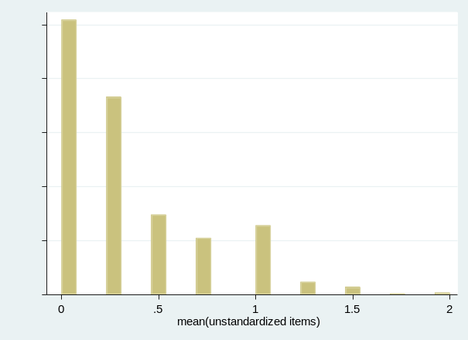
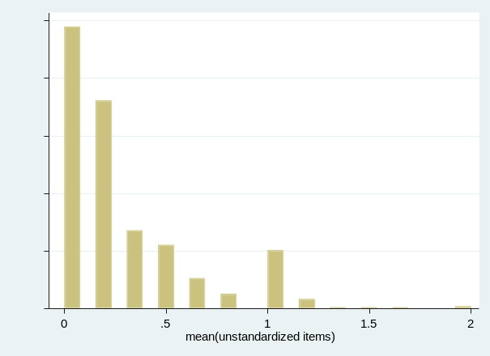
Reduced BMC score Full PBMC score
Figure A6.3 Full and reduced PBMC scores
Table A6.3 displays the results of the univariate regressions of the score on similar variables than in the main analysis. Results suggested that the choice of items can be sample dependent, but had no impact on the validity of the score (i.e., no significant differences between reduced and full PBMC scores). In conclusion, the PMBC score was valid in the general population of the Niakhar area.

Table A6.3. Univariate regressions of the full and reduced PBMC score
Variable group | Dependent variable | Model | Type of estimate | Estimates |  | N
 |  |  |  | Reduced set | Full set | N
Determinants of healthcare seeking | Had primary education or higher | Logistic | OR | 0.34***  (0.73) | 0.34***  (0.09) | 711
Determinants of healthcare seeking | Being a woman | Logistic | OR | 1.45*  (0.28) | 1.42  (0.31) | 720
Determinants of healthcare seeking | Was in a union | Logistic | OR | 1.65**  (0.42) | 1.50  (0.45) | 720
Determinants of healthcare seeking | Age | Linear | CE | 5.69***  (1.77) | 5.00**  (2.00) | 720
Determinants of healthcare seeking | Over 20 years of age | Logistic | OR | 1.78**  (0.49) | 1.75**  (0.60) | 720
Determinants of healthcare seeking | Living in a semi-urban village | Logistic | OR | 0.20***  (0.06) | 0.19***  (0.07) | 720
Determinants of healthcare seeking | Living conditions index | Linear | CE | -0.53***  (0.13) | -0.57***  (0.15) | 720
Determinants of healthcare seeking | Agricultural resources index | Linear | CE | 0.39***  (0.15) | 0.47***  (0.18) | 720
Determinants of healthcare seeking | Number of adults in the household | Linear | CE | -1.13**  (0.57) | -1.29*  (0.69) | 720
Determinants of healthcare seeking | Monetary resources (HH level) | Linear | CE | -1650719** (774846.6) | -2017058*** (936073.9) | 720
Healthcare services utilization | Consulted a shaman during a recent episode of illness | Logistic | OR | 29.03***  (17.30) | 19.64***  (18.22) | 102
Healthcare services utilization | Place of birth delivery (last pregnancy)  Ref=at home | Multinomial logistic | RRR (dispensary) | -0.37  (0.42) | -0.49  (0.49) | 180
Healthcare services utilization | Place of birth delivery (last pregnancy)  Ref=at home | Multinomial logistic | RRR (medicalized) | -2.06**  (0.84) | -2.95***  (1.06) | 180
Other potentially-associated variables | Ever heard of hepatitis B | Logistic | OR | 0.44**  (0.15) | 0.38**  (0.16) | 720
Other potentially-associated variables | Covered by insurance | Logistic | OR | 0.04***  (0.04) | 0.007***  (0.013) | 720
Other potentially-associated variables | SF-12 Mental Component Summary (MCS-12) | Linear | CE | 4.44***  (1.21) | 6.35***  (1.39) | 699
Other potentially-associated variables | SF-12 Physical Component Summary (PCS-12) | Linear | CE | -5.46***  (0.75) | -6.20***  (0.84) | 699

Notes: ∗ p < 0.1, ∗∗ p < 0.05, ∗∗∗ p < 0.01. All variables measured at the individual level, unless when HH-level specified. Robust standard errors (clustered at the household level to account for intra-household correlation) in parenthesis. Regressions were weighted using sampling weights to account for choice-based stratified samples. For linear models, predictions are linear predictions of the dependent variable. For logistic and multinomial logistic models, predictions are predicted probabilities of the dependent variable. Abbreviations: N=number of observations, HH=household, OR=odds ratio, CE=coefficient estimate, RRR=relative-risk ratio.

