Supplementary Materials:

Highly anisotropic geometrical Hall effect via f-d exchange fields

in doped pyrochlore molybdates
Hikaru Fukuda¹, Kentaro Ueda¹, Yoshio Kaneko², Ryosuke Kurihara^{2,3}, Atsushi Miyake⁴,
Kosuke Karube², Masashi Tokunaga^{2,4}, Yasujiro Taguchi², and Yoshinori Tokura^{1,2,5}
¹ Department of Applied Physics, University of Tokyo, Bunkyo, Tokyo 113-8656, Japan
² RIKEN Center for Emergent Matter Science, Wako, Saitama 351-0198, Japan
³ Department of Physics, Tokyo University of Science, Noda, Chiba 278-0022, Japan
⁴ Institute for Solid State Physics (ISSP),
University of Tokyo, Kashiwa, Chiba 277-8581, Japan
⁵ Tokyo College, The University of Tokyo, Bunkyo, Tokyo 113-8656, Japan
(Dated: June 2, 2022)

S1. Hall resistivity measurement
The magnetic anisotropy of Hall effect was investigated by rotating the sample A against the applied magnetic field, so that we can rule out the possibility of sample dependence. Fig. S1(a) shows the geometry of the sample A. It was polished into the plate-like shape whose vertical direction is along [100] crystalline axis. The electric current was flowed along $[0\overline{1}1]$ axis, about which the magnetic field was rotated. The transverse resistivity $ρ_{H}$ was measured along [011] axis which is perpendicular to both [100] and $[0\overline{1}1]$ axes. Let us take the magnetic field direction as the z-axis and the current direction as the x-axis, as depicted in Fig. S1(a). When the field is tilted by $θ$ off [100] direction, Hall resistivity $ρ_{H}$ is expressed as
(1)
$$ρ_{H}\left(θ\right)=ρ_{yx}\left(θ\right)\cos{θ}- ρ_{zx}\left(θ\right)\sin{θ.}$$
The first term is the usual Hall effect perpendicular to both magnetic field and current, which should be extracted from the measured value $ρ_{H}$. Considering the symmetry of the setup of Fig. S1(a), we obtain $ρ_{yx}\left(θ\right)=ρ_{yx}\left(-θ\right)$ and $ρ_{zx}\left(θ\right)=ρ_{zx}\left(-θ\right)$, while sin $\sin{θ}$ is odd. Therefore, we can extract $ρ_{yx}\left(θ\right)$ by averaging $ρ_{H}\left(θ\right)$ and $ρ_{H}\left(-θ\right)$ and then dividing by $\cos{θ}$. Fig. S1(c) displays the magnetization dependence of $ρ_{yx}$ for both [100] and [111] field directions, in which one can clearly see the anisotropy, as discussed in the main text.
To double-check $ρ_{yx}$ for H || [111], we prepare another sample B, whose out-of-plane axis is along [111] crystalline direction while the current direction is the same as that in sample A ($[0\overline{1}1]$). In this geometry, we can obtain $ρ_{yx}=ρ_{H}$ for H || [111] without any calculation, as plotted in Fig. S1(c). Although the chemical composition of sample B (x = 0.134) is slightly different from that of sample A (x = 0.140), $ρ_{yx}$ of sample B is remarkably similar to that of sample A for H || [111]. Thus, the anisotropy discussed in the main text is ubiquitous for the present system.

S2. Scaling Law for Hall Conductivity
In the hopping region, the anomalous Hall conductivity $σ_{xy}$ is known to follows the empirical scaling relation $σ_{xy}∝σ_{xx}^{1.6}$ where $σ_{xx}$ is longitudinal conductivity [1]. Fig. S2 shows $σ_{xy}$ normalized by magnetization as a function of $σ_{xx}$ for several different samples at 2 K and 14 T, at which the anomalous Hall contribution is dominant. One can see that $σ_{xy}∝σ_{xx}^{1.71}$ holds for a wide range of $σ_{xx}$ from 10² S/cm to 10³ S/cm. Therefore, we use n = 0.4 in eq. (1) in the main text to estimate the Karplus-Luttinger term $ρ_{yx}^{KL}$. However, the H-dependence of $σ_{xx}$ is not large, and even if there were a slight discrepancy in n, the conclusion shown in Fig.4 of the main text would be hardly affected.

S3. Calculation of the scalar spin chirality
Since the Mo magnetization in (Tb_{1−x}Ca_{x})Mo₂O₇ is negligible, as demonstrated in Fig. 2 of the main text, we can speculate the magnetic structure of the Tb tetrahedra from the magnetization and hence calculate the scalar spin chirality $χ_{ijk}$.
First we consider the case for H || [100]. At zero magnetic field, Tb magnetic moments are disordered but host 2-in 2-out (2I2O) like habit because of the ferromagnetic interaction between nearest-neighbor Tb moments. As the magnetic field increases, the number of 2I2O Tb tetrahedra, whose net magnetizations are parallel to the field direction, increases and hence the magnetization reaches the expected value of $M_{2I2O}=2\left(1-x\right)×\left(\frac{1}{\sqrt{3}}μ_{Tb}×4\right)/4=10.4\left(1-x\right)$ [μ_{B}/f.u] where μ_{Tb} = 9 [μ_{B}/Tb] (state (i) in Fig. 4(c) of the main text). With increasing field above 2 T, we speculate that the Zeeman energy overcomes the single-ion anisotropy and hence the Tb moments gradually approach the field direction. We define $θ$ as the angle between the Tb moments and the magnetic field direction (Fig. S3(a)), so that the magnetization is given as $M_{100}=2\left(1-x\right)μ_{Tb}\cos{θ}$. In this way, we estimate the tilt angle of the Tb moment from the measured magnetization to calculate $χ_{ijk}$ as discussed later.
Magnetization process for H || [111] is more complex. Similar to spin-ice materials, the magnetization for [111] field direction increases with increasing field towards $M_{KI}=2\left(1-x\right)×\left(μ_{Tb}+\frac{1}{3}μ_{Tb}\right)/4=6\left(1-x\right)$ [μ_{B}/f.u], at which the kagome ice state is realized (the state (ii) in Fig. 4(c) in the main text). In other words, the 2-in 2-out state is preserved up to M_{KI}, resulting in the nearly the same curve as the case for H || [100]. Above M_{KI}, the crossover occurs from (ii) 2-in 2-out state to (iii) 3-in 1-out state, at which the magnetization becomes $M_{3I1O}=2\left(1-x\right)×\left(μ_{Tb}+\frac{1}{3}μ_{Tb}×3\right)/4=9\left(1-x\right)$ [μB/f.u]. Eventually, as the field increases further, Tb moments deviate from the local ⟨111⟩ axes and get aligned collinearly (the state (iv) in Fig. 4(c) of the main text). Between (iii) and (iv) states, the magnetization is written as $M_{111}=2\left(1-x\right)×\left(μ_{Tb}+3μ_{Tb}\cos{θ}\right)/4$ where $θ$ is the angle between Tb moments and the field, as shown in Fig. S3(b).
Making use of the information of Tb magnetic configurations as extracted above, we calculate the spin chirality of the Tb tetrahedron averaged over four Tb sites on the vertices of one tetrahedron. According to the theoretical calculation in the weak coupling region [3], the emergent magnetic field $H_{eff}$ acting on the Mo-conducting electrons is given as
$$H_{eff}∝\left\langle χ_{ijk}\right\rangle =\frac{1}{6N}\sum_{i,j,k ∈ all sites}{S_{i}⋅\left(S_{j}×S_{k}\right)F\left(r_{i},r_{j},r_{k}\right)⋅e_{z}}$$
where
$$F\left(r_{i},r_{j},r_{k}\right)=\frac{a×b}{ab}I^{'}\left(a\right)I^{'}\left(b\right)I\left(c\right)+\frac{b×c}{bc}I\left(a\right)I^{'}\left(b\right)I^{'}\left(c\right)+\frac{a×b}{ab}I^{'}\left(a\right)I\left(b\right)I^{'}\left(c\right).$$
$e_{z}$ is the unit vector parallel to the field direction, $r_{i},r_{j}$, and $r_{k}$ are the positions of local spins at site i,j, and k, $a=r_{i}-r_{j}, b=r_{j}-r_{k}, c=r_{k}-r_{i}$ are the distances between each site, $I\left(r\right)$ is the rapidly decreasing function of r, and $I^{'}\left(r\right)=dI\left(r\right)/dr$. Thus we take into account only the nearest neighbor sites 1, 2, 3, and 4 in a single tetrahedron shown in Fig. S3(c)
$$\left\langle χ_{ijk}\right\rangle ∝\sum_{i,j,k ∈ 1,2,3,4}{S_{i}⋅\left(S_{j}×S_{k}\right)n_{ijk}⋅e_{z}}$$
where $n_{ijk}$ is the unit vector defined by right hand screw rule when orbiting the site i, j, and k. The calculated results are plotted in Fig. 4(c) in the main text. We note that the spin chirality is not calculated but just a connecting straight line drawn between M_{KI} and M_{3I1O} in H || [111] (the state (ii) and (iii) in Figs. 4(b) and 4(c)), because the detailed magnetic state is not trivial. The calculated curves of the SSC based on the above simple assumption reasonably reproduce the experimental results of geometrical Hall components.
_______________________________________
* Electronic address: ueda@ap.t.u-tokyo.ac.jp
Supplementary References.
[1] T. Miyasato, N. Abe, T. Fujii, A. Asamitsu, S. Onoda, Y. Onose, N. Nagaosa, and Y. Tokura, Phys. Rev. Lett. 99, 086602 (2007)
[2] L. Yin, J. S. Xia, Y. Takano, N. S. Sullivan, Q. J. Li, and X. F. Sun, Phys. Rev. Lett. 110, 137201 (2013).
[3] G. Tatara and H. Kawamura, J. Phys. Soc. Jpn. 71, pp. 2613-2616 (2002).
[4] J. Ye, Y. B. Kim, A. J. Millis, B. I. Shraiman, P. Majumdar, and Z. Tesanovic, Phys. Rev. Lett. 83, 3737 (1999).
[5] Y. Taguchi, Y. Oohara, H. Yoshizawa, N. Nagaosa, and Y. Tokura, Science 291, 2573 (2001).
[6] T. Sakakibara, T. Tayama, Z. Hiroi, K. Matsuhira, and S. Takagi, Phys. Rev. Lett. 90, 207205 (2003)
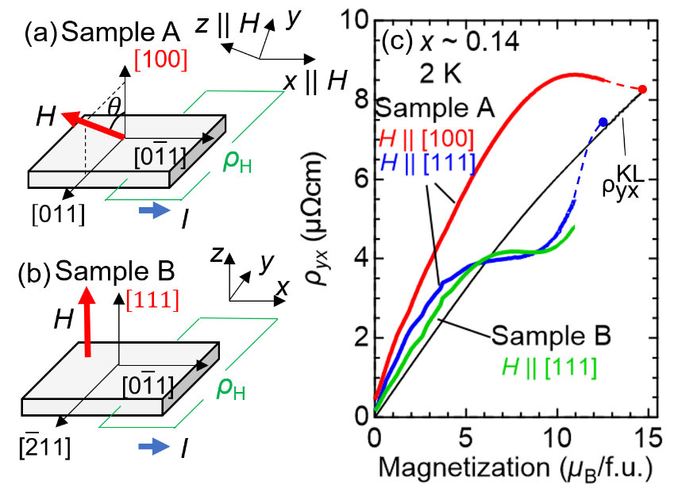
Fig. S1. Measurement setups for (a) sample A which is mainly used for the anisotropic measurement and (b) sample B for comparison. Each out-of-plane axis is along the [100] and [111] crystalline orientation, respectively. (c) Magnetization dependence of Hall resistivity for (a) and (b) setups. The red and blue curves are measured for sample A, and the green curve is measured for sample B. The black curve is Karplus-Luttinger term of Hall resistivity. For more detail, see the main text.

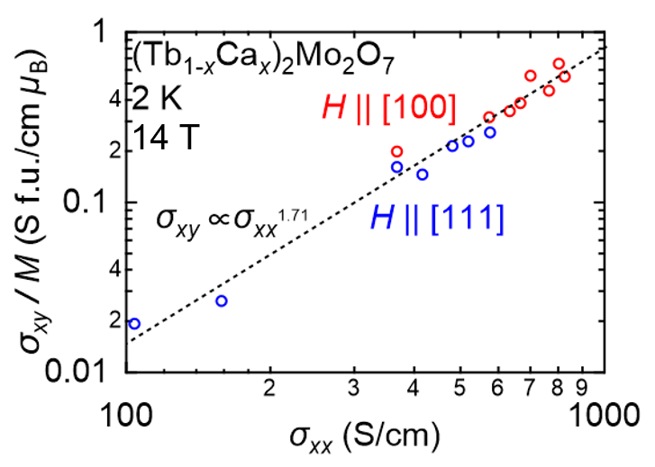
Fig. S2. Scaling plot of $σ_{xy}$ versus $σ_{xx}$ in the logarithmic scale. The red (blue) marks denote the data for H || [100] (H || [111]). The dashed line indicate the scaling relation $σ_{xy}∝σ_{xx}^{1.71}$.

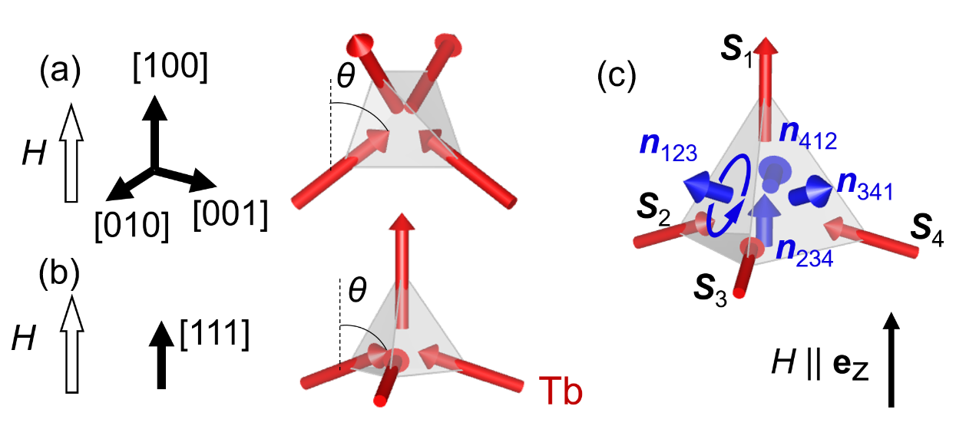

Fig. S3. Tb moments modulation for (a) H || [100] at M ≥ M_{2I2O} and (b) H || [111] at M ≥ M_{3I1O}. (c) Schematic picture of the tetrahedron for the calculation of the scalar spin chirality. Red arrows indicate the spins at each site (S₁, S₂, S₃, and S₄), and blue arrows indicate the unit vector parallel to the emergent field (n₁₂₃, n₂₃₄, n₃₄₁, and n₄₁₂).

