Table S1 Sequences for real-time PCR primers
Genes¹ |  | Primer sequence² (5′-3′) | Accession no.
GAPDH |  | F: GGGCACGCCATCACTATCTT | NM_204305
 |  | R: TCACAAACATGGGGGCATCA
IL-1β |  | F: TGCCTGCAGAAGAAGCCTCG | Y15006.1
 |  | R: GACGGGCTCAAAAACCTCCT
IL-8 |  | F: TTGGAAGCCACTTCAGTCAGAC | DQ393272.2
 |  | R: GGAGCAGGAGGAATTACCAGTT
TNF-α |  | F: GAGCAGGGCTGACACGGAT | GU230788.1
 |  | R: CAGGCACAAAAGAGCTGATGG
ZO-1 |  | F: CTTCAGGTGTTTCTCTTCCTCCTC | XM_413773
 |  | R: CTGTGGTTTCATGGCTGGATC
Occludin |  | F: TTCGTCATGCTCATCGCCTC | D21837.1
 |  | R: TCCACGGTGCAGTAGTGGTA
Claudin-1 |  | F: CACTGCCACTCCCTGATGTT | AY750897.1
 |  | R: ACCGGTGACAGACTGGTTTC
¹ GAPDH, reduced glyceraldehyde-phosphate dehydrogenase; IL, interlukin; TNF-α, tumor necrosis factor-α; ZO-1, zonula occluden 1.
² F, forward; R, reverse.

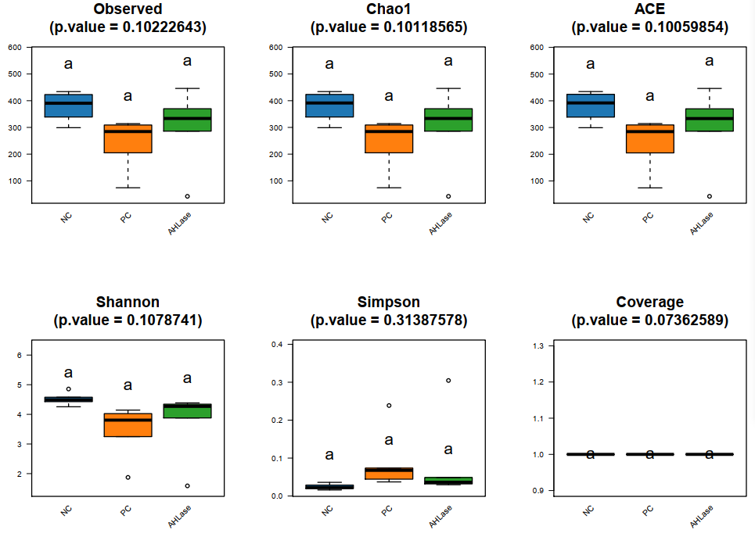
Fig. S1 Alpha-diversity analysis of gut microbiota among groups on d 10. NC, negative control (birds were free of challenge); PC, positive control (birds were challenged with S. typhimurium from 7-9 d of age); AHLase, PC broilers supplemented with 10 U/g AHLase.

 | NC group | PC group | AHLase group
Phylum | 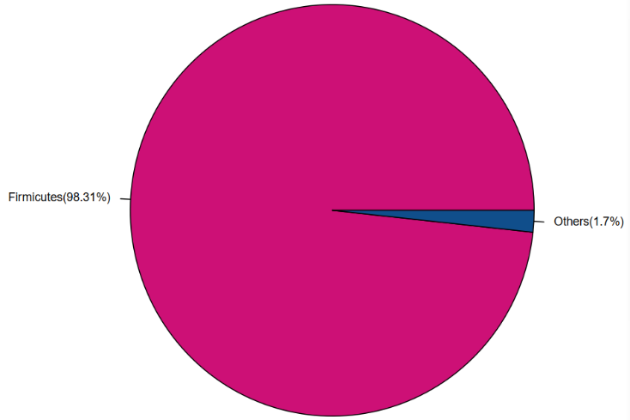 | 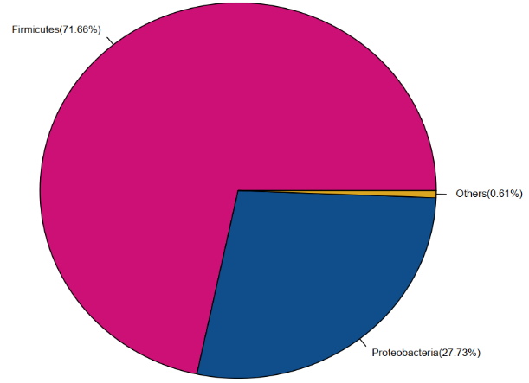 | 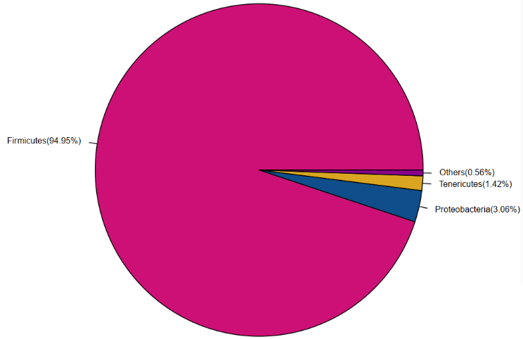
Class | 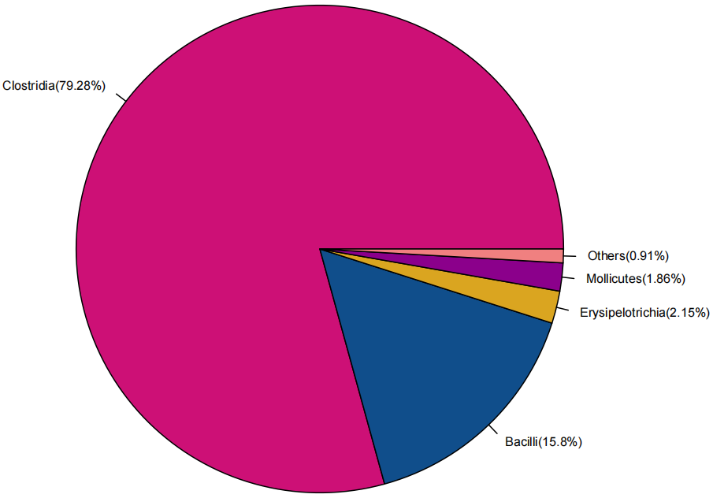 | 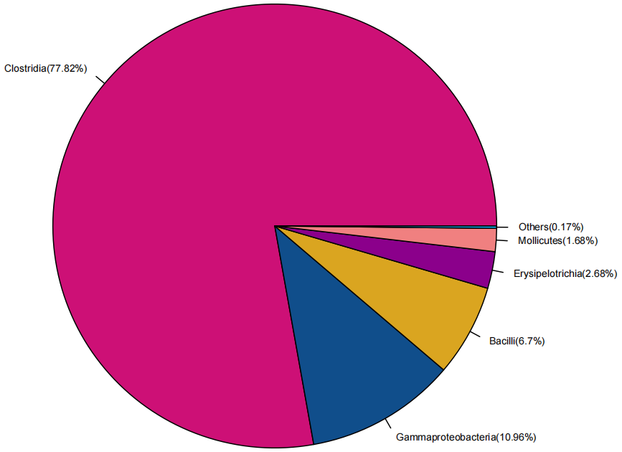 | 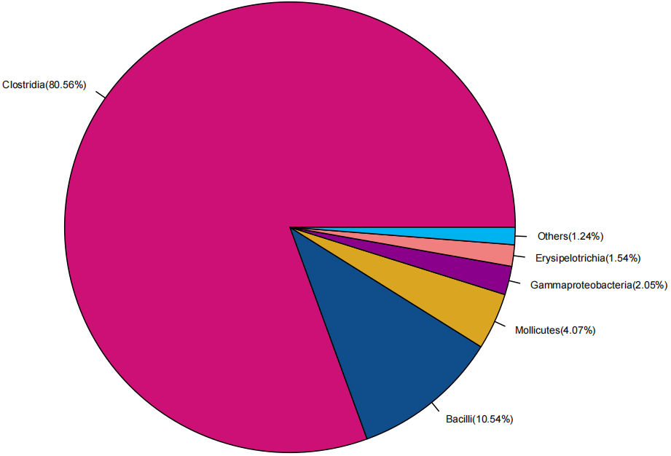
Order
Order | 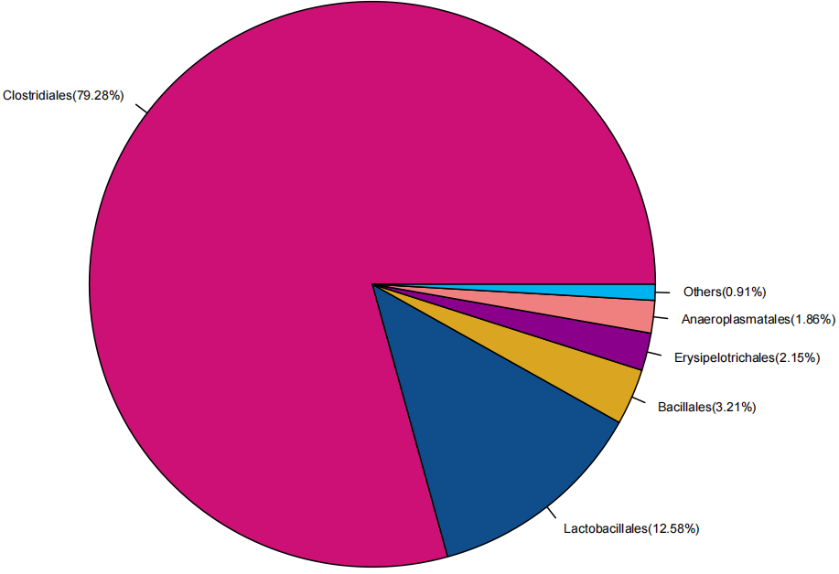 | 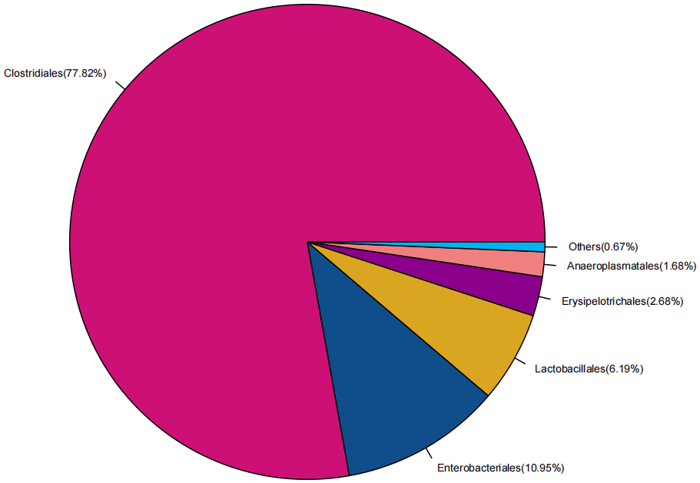 | 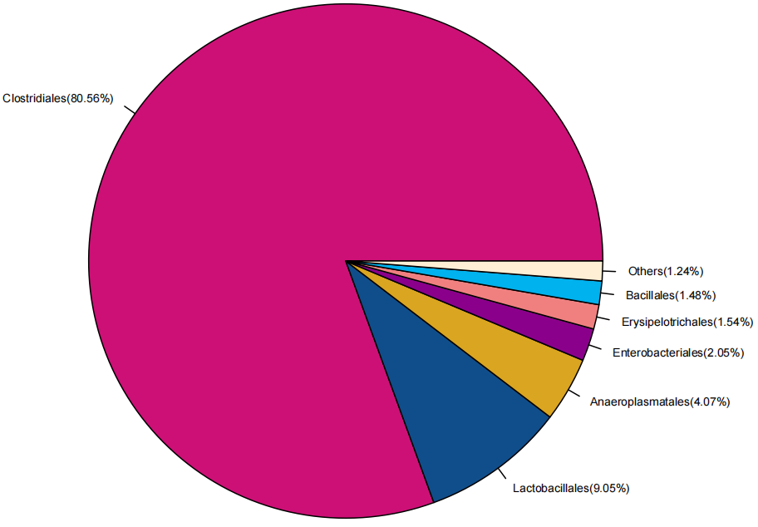
Family | 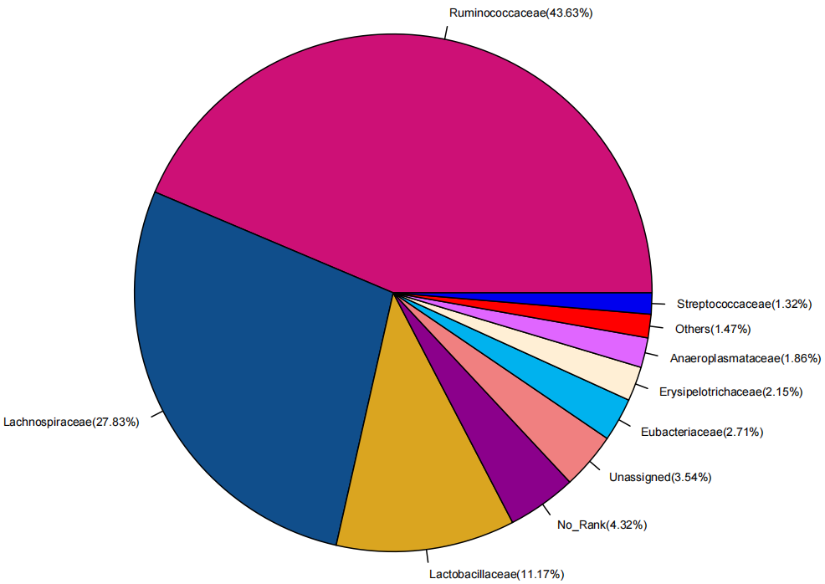 | 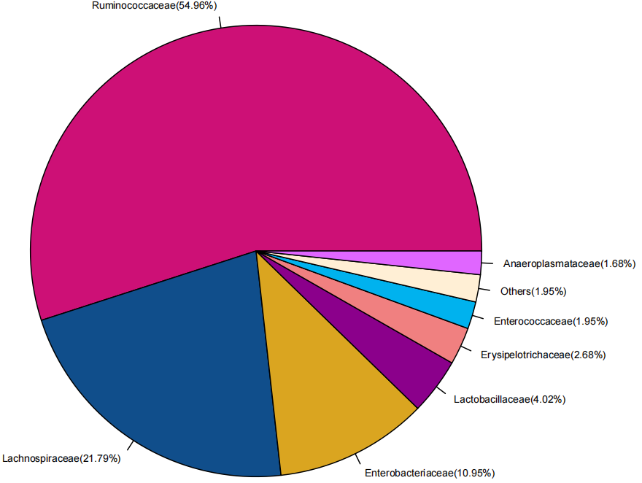 | 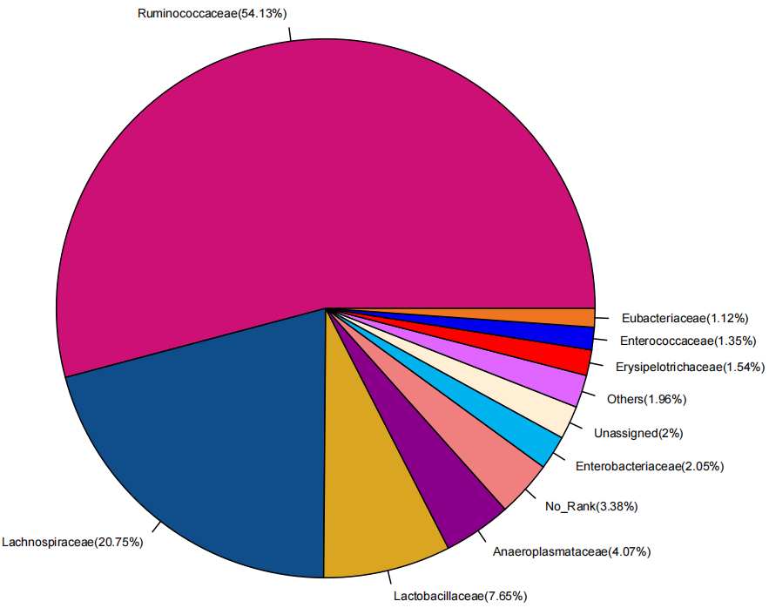
Genus | 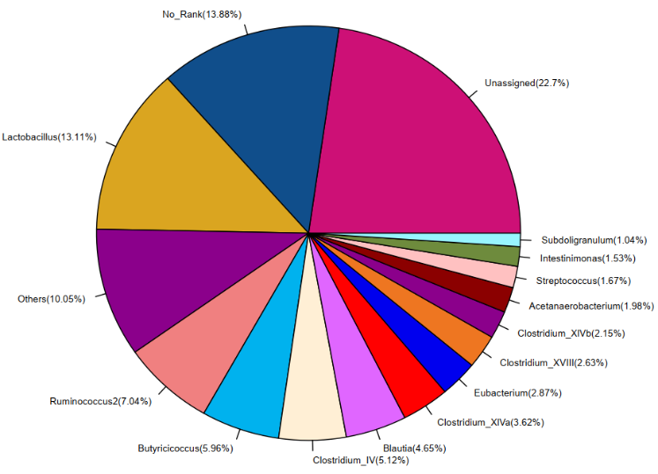 | 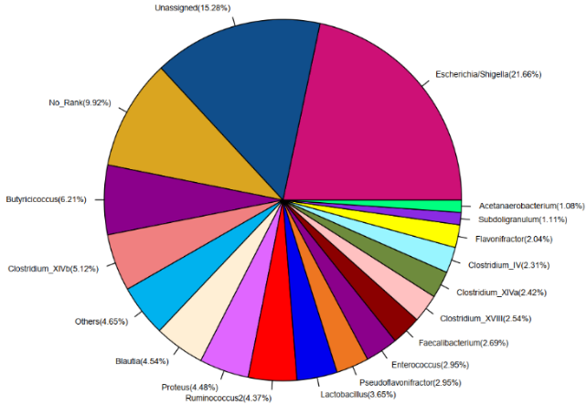 | 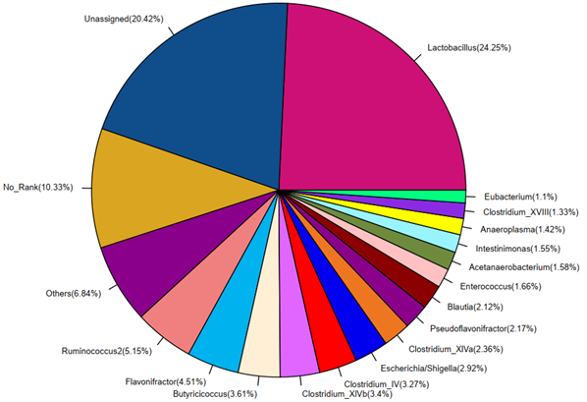
Fig. S2 Proportions (%) of bacterial members in gut microbiota among groups on d 10. NC, negative control (birds were free of challenge); PC, positive control (birds were challenged with S. typhimurium); AHLase, PC broilers supplemented with 10 U/g AHLase.
A. At class level | B. At order level
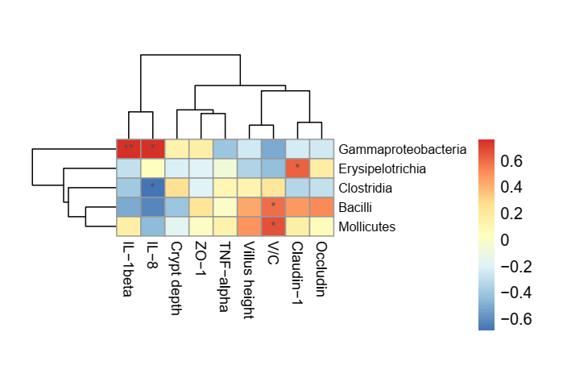 | 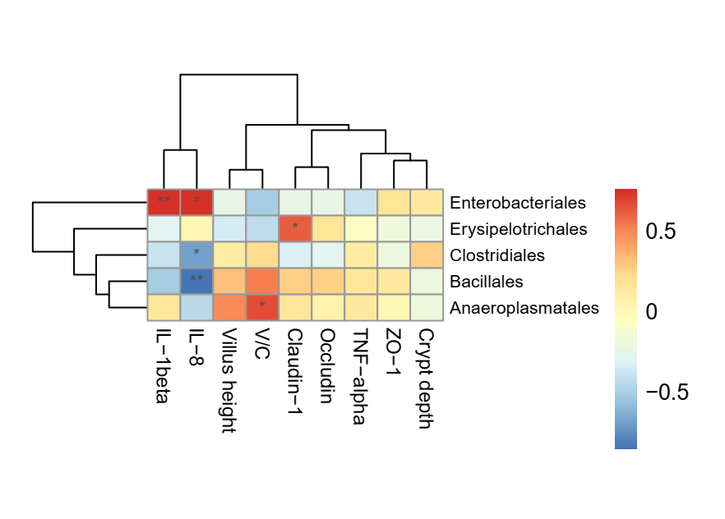
C. At family level
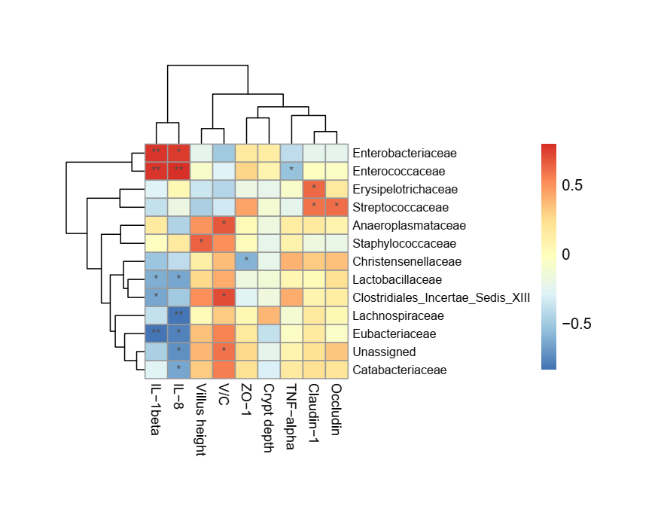
Fig. S3 Correlation analysis between gut microbiota (A, at class level; B, at order level; C, at family level) and intestinal parameters in broilers on d 10. IL, interleukin; ZO, zonula occludens; TNF, tumor necrosis factor; V/C, villus height to crypt depth ratio. The red and blue panes represent positive and negative correlations, respectively. Color intensity means the Spearman’s r-value of correlations in each panel. The asterisks indicate significant correlations (∗P < 0.05; ∗∗P < 0.01). NC, negative control (birds were free of challenge); PC, positive control (birds were challenged with S. typhimurium); AHLase, PC broilers supplemented with 10 U/g AHLase.

A. At class level | B. At order level
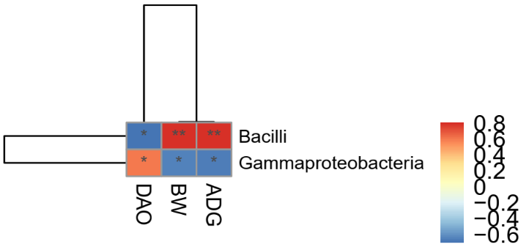 | 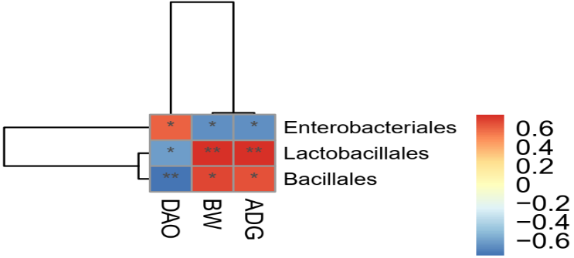
C. At family level
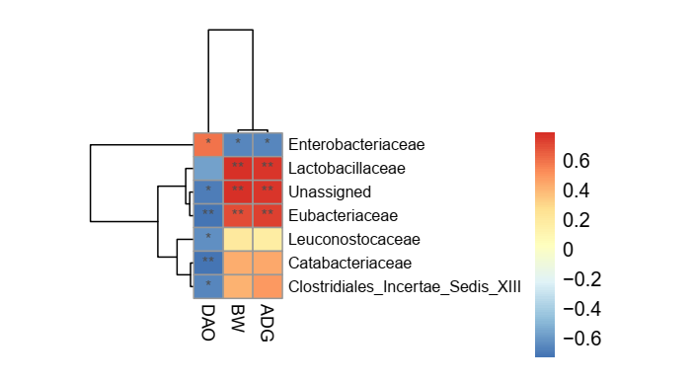
Fig. S4 Correlation analysis of gut microbiota (A, at class level; B, at order level; C, at family level) with serum diamine oxidase (DAO) activity and growth performance (BW, body weight; ADG, average daily gain) in broilers on d 10. The red and blue panes represent positive and negative correlations, respectively. Color intensity indicates the Spearman’s r-value of correlations in each panel. The asterisks indicate significant correlations (∗P < 0.05; ∗∗P < 0.01). NC, negative control (broilers were free of challenge); PC, positive control (broilers were challenged with S. typhimurium); AHLase, PC broilers supplemented with 10 U/g AHLase.

