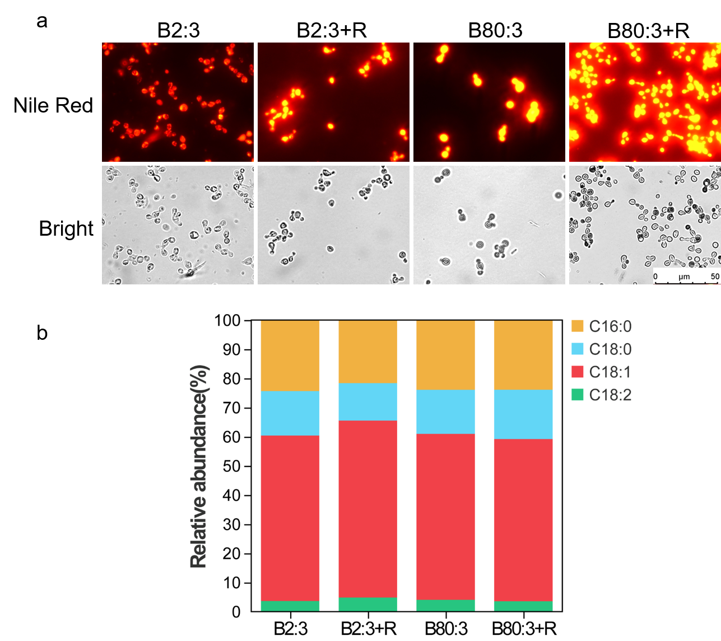
Fig. S1 Single cell lipid yield and fatty acid profile of S.podzolica zwy-2-3 cultivated in rapamycin treatment and different C/N ratio mediums. a Single cell lipid yield stained by Nile red. b Fatty acid profiles analyzed by GC-MS.

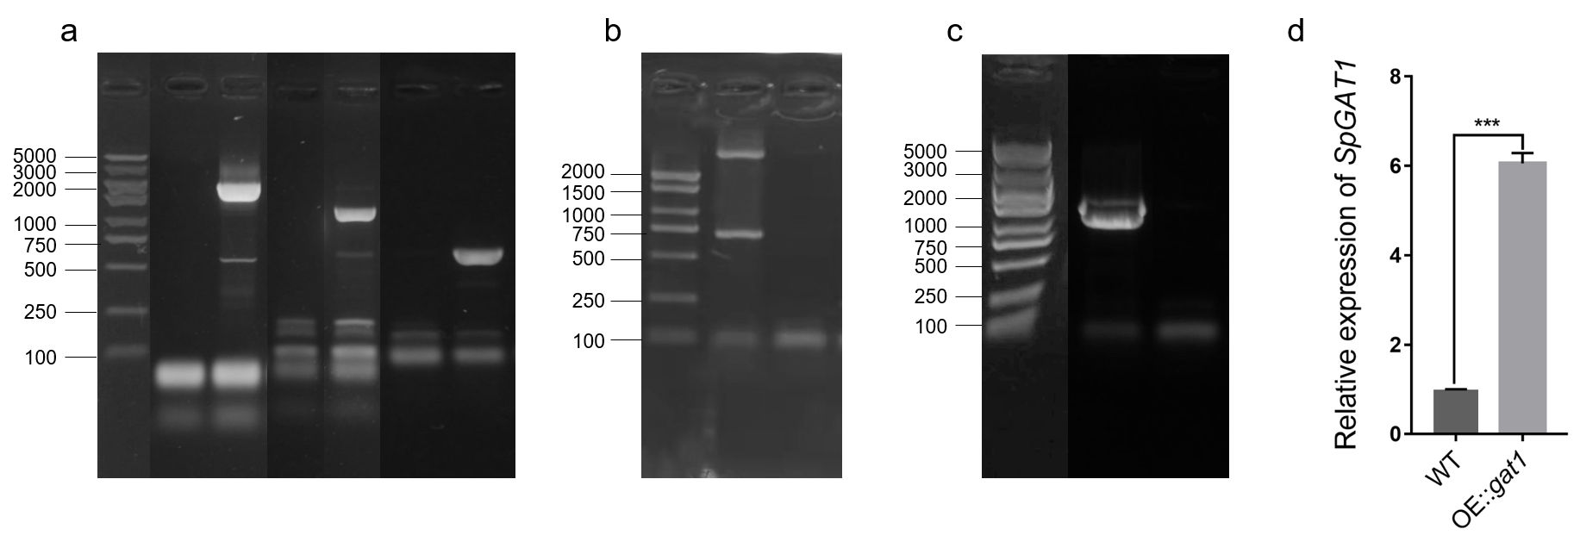
Fig. S2 Results of SpGAT1 mutant identification. a Results of amplifying hygromycin gene, homologous arm, and part of SpGAT1 gene (lane 1: marker 5000 bp, lane 2: amplifying hygromycin gene and LB homologous arm in WT, lane 3: amplifying hygromycin gene and LB homologous arm in WT, lane 4: amplifying hygromycin gene and RB homologous arm in WT, lane 5: amplifying hygromycin gene plus RB homologous arm in Δgat1, lane 6: amplifying part of SpGAT1 gene in WT, lane 7: amplifying part of SpGAT1 gene in Δgat1). b Results of amplifying SpGAT1 (lane 1: marker 2000 bp, lane 2: WT, lane 3: Δgat1). c Results of identification hygromycin gene by colony PCR (lane 1: marker 5000 bp, lane2: OE::gat1, lane 3: WT). d Detecting SpGAT1 expression level in WT and OE::gat1 by qRT-PCR.

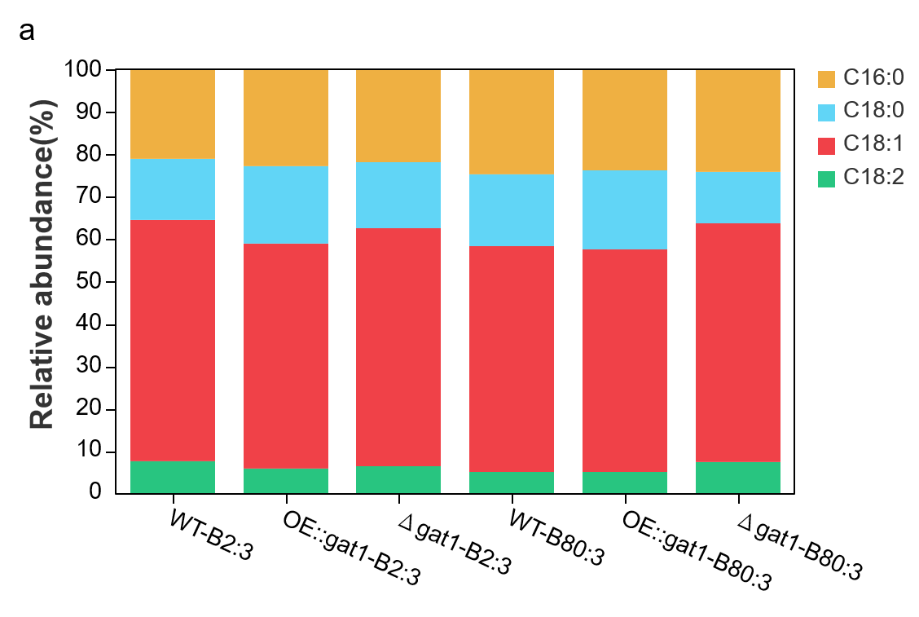

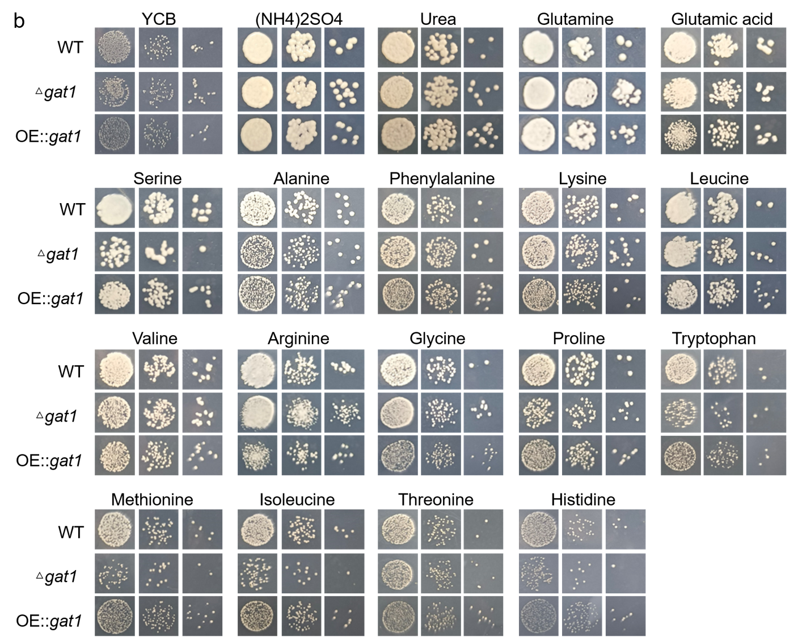
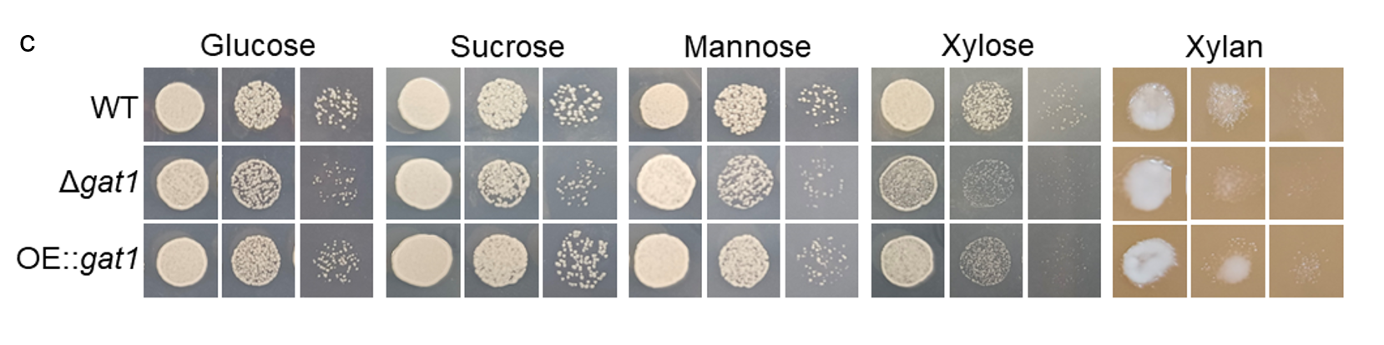
Fig. S3 Effects of SpGAT1 on fatty acid profiles and different carbon/nitrogen sources utilization in S.podzolica zwy-2-3. a Fatty acid profiles in WT, Δgat1 and OE::gat1 cultivated in low and high C/N ratio mediums. b Utilization different nitrogen sources in WT, Δgat1, and OE::gat1. c Utilization different carbon sources in WT, Δgat1, and OE::gat1.

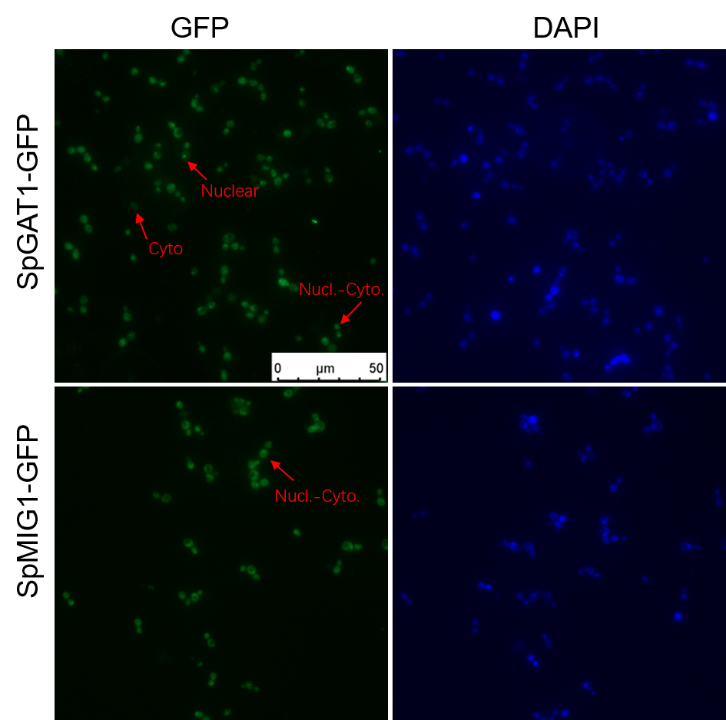
Fig. S4 Results of subcellular localization observed by fluorescence microscopy. Cyto: transcription factors were cytoplasmic localization, Nuclear: transcription factors were nuclear localization, Nucl-Cyto: transcription factors were located in cytoplasm and nuclear.

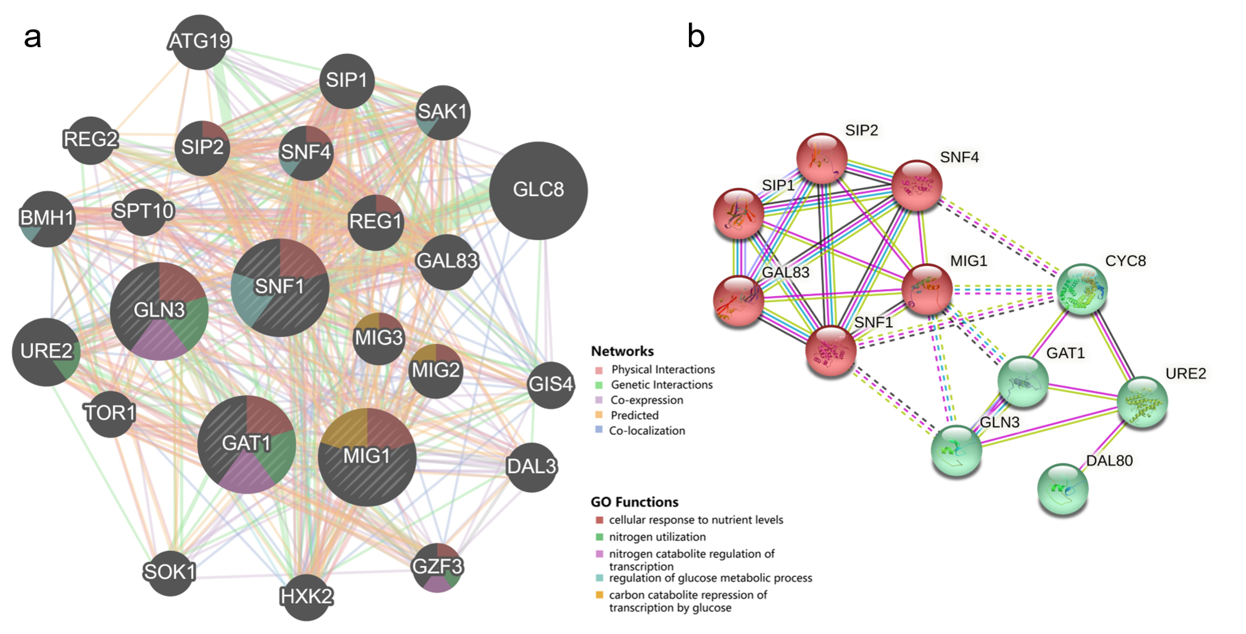
Fig. S5 Prediction of SpGAT1 interacting protein. a Predicted by GeneMANIA database, b Predicted by String database.

